

Event Driven Architecture for Banking Transformations to Hybrid Clouds

Tal Oren
Cloud Application Architect
tal.oren@ ibm.com

Alfredo Muñoz Ríos
Global Banking and Financial Markets Center of Competency
alfredomunoz@es.ibm.com

Table of Contents
1 Purpose of this Document 3
2 Problem Statement and Summary 4
3 Concept 5
4 Required Capabilities for Event Driven Architecture 6
5 Solution Architecture 9
6 Target Architecture 12
7 Architecture Overview Diagram 15
8 Key Concepts 16
9 Messaging (Message Queue) versus event streaming (Kafka) 18
10 Events Versus Rest Calls 23

Purpose of this Document
This document describes best practices and recommendations for the design of Event Driven Architecture in the context of the transformation of legacy corebanking systems to Hybrid Multi-Cloud infrastructures.

This document is a sanitized version of an actual deliverable created for a Large Bank. Names and References to the organization are removed. However, the analysis of the AS-IS situation is specific to such organization, although clearly applicable to many other banks and financial services organizations in the worlds

Problem Statement and Summary
The development of applications for Hybrid Multi Clouds means an important change on the way applications are designed and build compared with traditional core systems.
In microservices applications, the level of modularity required for it to work and take full advantage of this style.
The event-driven architecture pattern is a relatively complex pattern to implement, primarily due to its asynchronous distributed nature. When implementing this pattern, must address various distributed architecture issues, such as remote process availability, lack of responsiveness, and broker reconnection logic in the event of a broker or mediator failure.
One consideration to take into account when choosing this architecture pattern is the lack of atomic transactions for a single business process. Because event processor components are highly decoupled and distributed, it is very difficult to maintain a transactional unit of work across them.

Concept
The modern digital business works in real time. It informs interested parties of things of interest when they happen. It makes sense of and derives insight from an ever-growing number of sources. It learns, predicts, and is intelligent. By nature, it is event-driven.
An event is a way of capturing a statement of fact. An event should be as simpler as possible. Events occur in a continuous stream as things happen. By taking advantage of this continuous stream, applications can react and reason about the future based on what happened in the past.
For IT teams, embracing event-driven development is foundational to the next generation of digital business applications. IT teams must design, develop, deploy, and operate event-driven solutions in cloud-native styles.
Event-driven architectures and reactive programming models aren't new concepts. However, when we move to cloud-native architectures with microservices, container-based workloads, and serverless computing, we can revisit event-driven approaches in the cloud-native context. Thinking of event-driven architectures as extending the resilience, agility, and scalable characteristics of cloud-native architectures to also be reactive and responsive.
Two aspects of a cloud-native architecture are essential to developing an event-driven architecture:
- Microservices provide the loosely coupled application architecture that enables deployment in highly distributed patterns for resilience, agility, and scale.
- Cloud-native platforms with containers and serverless deployments provide the application platform and tools that realize the resilience, agility, and scalability of the microservices architectures.

Required Capabilities for Event Driven Architecture
The implementation of the Event Driven Architecture as described in the previous section requires some capabilities and can be summarized in:
- Event Sourcing – Records a change in the state of the aggregates in microservice
- Partition Messages - Organizing messages to maximum concurrent access.
- Replayable Events - Serves as a repository for microservices to build in-memory copies of source data, up to any point in time.
- Long-term Data Retention - Efficiently stores data for immediate access.
- Publish Subscribe – A mechanism to register and posting events.
- Event Versioning – Handling the changes in events schemas/Objects.

Event Sourcing
The core idea of event sourcing is that whenever we make a change to the state of a system/microservice, we record that state change as an event, and we can confidently rebuild the system/microservice state by reprocessing the events at any time in the future. The Event Sourcing should have a store (event store) to preserve the events. The event store becomes the principal source of truth, and the system/microservice state is purely derived from it.

Partition Messages
The scaling requirements to handle events is likely to be orders of magnitude larger than that required to support operational messages. The scalability requirement is not only limited to the producers creating messages, but also to the consumption.

When dealing with microservices and the async communication that the concept brings, the event system should be able to provide scalability for the mass transit of the events.

Replayable Events
Replayable events meaning that we can recreate historic states by replaying the event log up to a point. We can explore alternative histories by injecting hypothetical events when replaying. Replayable events are necessary when recoverying of incidences or bugs require the reprocesing of the events

Long-term Data Retention
Defines the policies of persistent data and records management for meeting legal and business data archival requirements.

Publish Subscribe
Is a pattern where producer of event, called publisher, do not program the event to be sent directly to specific consumer, called subscriber, but instead categorize published event into event hub without knowledge of which subscribers, if any, there may be. Similarly, subscribers express interest in one or more events and only receive event that are of interest, without knowledge of which publishers, if any, there are.

Event Versioning
A general rule when versioning events is that adding things does not cause a versioning conflict. Adding a new version of an event is therefore not a problem, as long as we don’t break the definition of a new version event; it must be convertible from an old version of the same event. If this is not possible, then it’s a new event. Following these rules, when old versions are read from the store, they can first be converted, or upcasted, to the latest version before handled. This means that an event handler only needs to know how to deal with the latest version, an important benefit if many new versions have been created. To be able to convert an old version of an event when a property has been added to the new version, we will use the same principle as when we add a new not nullable column to a database; we use a default value.

When dealing with event versioning monitoring is needed to determine which microservices are producing events the events that are no longer consumed. These events have to be removed and not propagated anymore.

Solution Architecture
The suggested solution is based on the required capabilities in the above section which will be the building blocks for the entire solution. The solution will introduce a set of components and use cases that will lead to the desired outcome of the Events Driven Architecture.

Whatever will be the final selection to implement the event architecture, decouple business logic from the interaction with the events (emitting or receiving). An event handler should be implemented in order to isolate the business logic from the dealing with the events. Even, if you change your event hub, business logic should not be changed.

Container Application Platform
Event Backbone
Publish
Subscribe
Partition Messages
Microservices
Events API Framework
Event Sourcing
Replayable Events
Long-term Data Retention
Event Stream Processing
Event Data Integration
Figure 1: Solution Architecture

Container Application Platform
Container Application Platform is a platform for developing and running containerized applications. It is designed to allow applications and the data centers that support them to expand from just a few machines and applications to thousands of machines that serve millions of clients.

Event Backbone
The event backbone is the center of the event-driven architecture. The backbone provides the event communication and persistence layer with these capabilities:
- Publish-and-subscribe event communication between microservices (event producers and consumers)
- An event log to persist events for a specific period
- Replay of events
- Subscriptions from consumers
The event backbone is the communication layer in the event-driven architecture. It provides the connection between event-driven capabilities. In a cloud-native architecture, it is the publish-and-subscribe communication layer for event-driven microservices. A technology that is based on event logs can provide a central component to support all these broader capabilities.
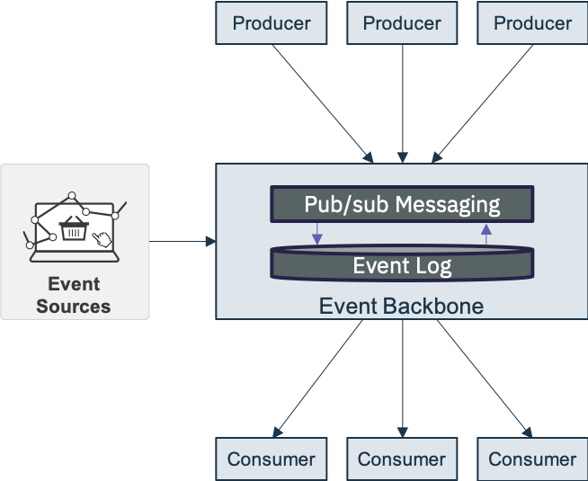

Defining the event backbone
These capabilities are essential to the event backbone:
- Provide publish-and-subscribe communication
- Support many consumers, as a shared, central source of truth
- Store events for a time (event log)
- Provide replay of events from history for evolving application instances
- Provide programmatic access to continuous event stream data
- Be highly scalable and resilient to cloud deployment levels

Microservices
To achieve the requirement of decoupling, scalability the applications for Hybrid Multi Clouds must use the event API framework which provided by the chosen technology.

Use Cases

Event Stream Processing
The Event Stream Processing (ESP) is the general idea of the data integration and analysis. The ESP flow is divided into four steps of event processing, that are Collect, Enhance, Analyze and Dispatch. The whole flow creates a non-homogeneous process in which events are acquired by the system and generate a certain output response, thanks to the processing of different services.

Event Data Integration
Event Driven integrations are triggered by an event in one system/microservice and trigger a predefined corresponding event in another. Events can really be anything that happens in a particular system/microservice that we’ve integrate. A new lead in a CRM, a new marketing lead. All these are events and that can trigger an event in another system/microservice.

Target Architecture

Container Application Platform
Event Backbone
Publish
Subscribe
Partition Messages

Microservices

Events API Framework
Event Sourcing
Replayable Events
Long-term Data Retention
Event Stream Processing
Event Data Integration
Figure 2: Target Architecture

Red Hat OpenShift
OpenShift Container Platform is a platform for developing and running containerized applications. It is designed to allow applications and the data centers that support them to expand from just a few machines and applications to thousands of machines that serve millions of clients.
With its foundation in Kubernetes, OpenShift Container Platform incorporates the same technology that serves as the engine for massive telecommunications, streaming video, gaming, banking and other applications. Its implementation in open Red Hat technologies lets you extend your containerized applications beyond a single cloud to on-premise and multi-cloud environments.

OpenShift Container Platform provides enterprise-ready enhancements to Kubernetes, including the following enhancements:
- Hybrid cloud deployments - OpenShift Container Platform clusters can be deployed to variety of public cloud platforms or in your data center.
- Integrated Red Hat technology - Major components in OpenShift Container Platform come from Red Hat Enterprise Linux and related Red Hat technologies. OpenShift Container Platform benefits from the intense testing and certification initiatives for Red Hat’s enterprise quality software.
- Open source development model - Development is completed in the open, and the source code is available from public software repositories. This open collaboration fosters rapid innovation and development.

Red Hat AMQ Streams
Red Hat AMQ Streams is a massively-scalable, distributed, and high-performance data streaming platform based on the Apache Zookeeper and Apache Kafka projects. It consists of the following main components:
- Zookeeper Service - for highly reliable distributed coordination.
- Kafka Broker Messaging - broker responsible for delivering records from producing clients to consuming clients.
- Kafka Connect - A toolkit for streaming data between Kafka brokers and other systems using Connector plugins.
- Kafka Consumer and Producer APIs - Java based APIs for producing and consuming messages to and from Kafka brokers.
- Kafka Streams API - API for writing stream processor applications.
A cluster of Kafka brokers is the hub connecting all these components.
Figure 1. Example Architecture diagram of AMQ Streams
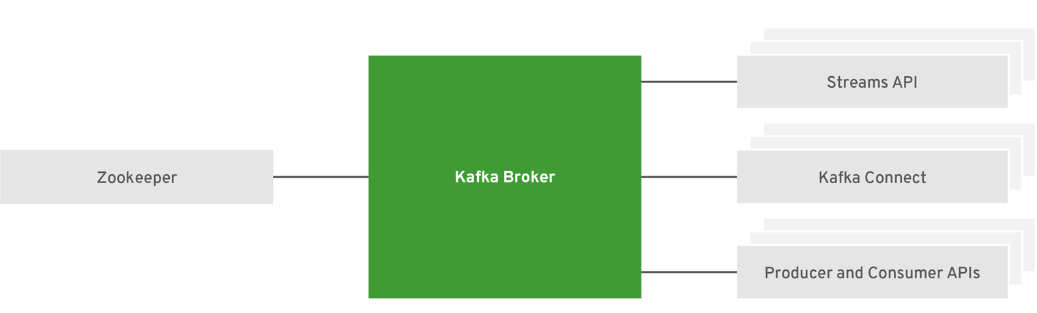

Microservices
The target Framework on which the microservices should be developed has not yet decided by the Bank.
It is described in the “Microservice Development Guidelines” that microservices will publish and subscribe to events. This publishing / subscription will be isolated from the business logic in the microservice by Event Handler components. The mission is to ensure that changes in the event infrastructure has none or limited impact in the business logic of the microservice.
The implementation of the event handler will depend on how the microservices will be developed. For example:
- Using a Development Frameework (such as IBM Financial Services Workbench – Knowis – ) abstracts the developers from the technical implementation of publishing / subscription
- Developing without a framework or with a framework with no support of events. This scenario requires architects to provide the implementation guidelines for developers to implement the publish/subscription/ governance mechanisms

Architecture Overview Diagram

The following diagram describe the overall event driven architecture (EDA)
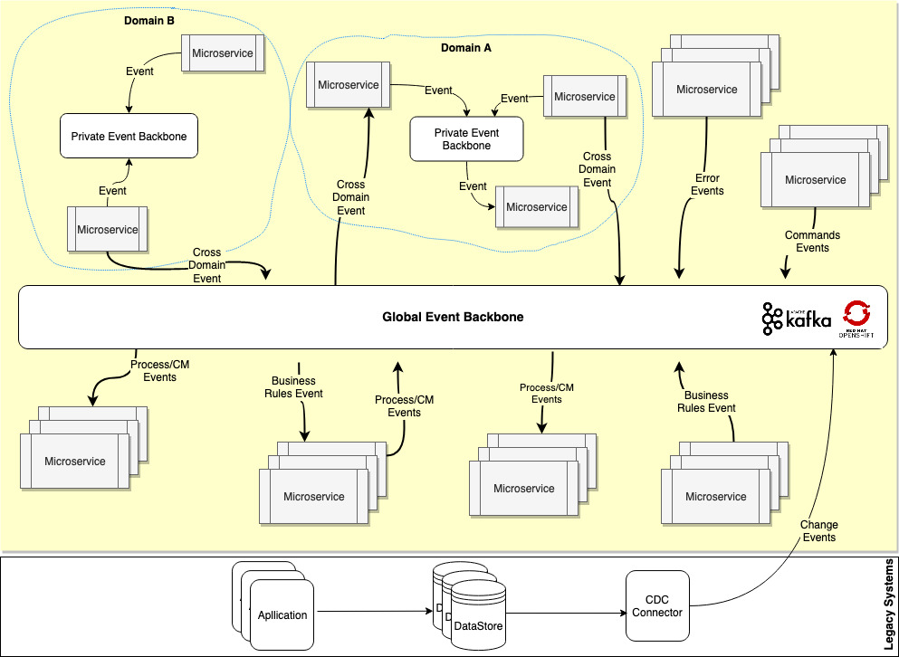

Key Concepts
To design this architecture, we will need to set up an event backbone to distribute all the events between producers and consumers, as well as an event store to store the events during a period of time.
This architecture is the basis for the asynchronous communication between microservices and ODS that is also based on asynchronous communication with events and the interaction with current models.

Global Event Backbone
The communication layer between microservices for events that cross domains. Cross domain events should be published to the global event backbone. For an example order domain service publishes an “OrderCreated”. The customer domain service consumes that event attempts to reserve credit for that order.

Private Event Backbone
Inside domain, events between microservices should be a private to the other domains and to accomplish that every domain should have an internal event store. For an example, in the loan domain the request management process publishes an event “OfferRequested” that will consume by offer management process.
This doesn´t mean that there´ll be separate instance of the backbone for each domain, but that there´ll be at least a logical isolation of privates events (so that other domains cannot consume them, or even know that they exit)

Event Notification
When a microservice sends event messages to notify other microservice of a change in its domain. A key element of event notification is that the source microservice doesn't really care much about the response. Often it doesn't expect any answer at all, or if there is a response that the source does care about, it's indirect. There would be a marked separation between the logic flow that sends the event and any logic flow that responds to some reaction to that event.

Event-Carried State Transfer
When we want to update a microservices in such a way that they don't need to contact the source system in order to do further work. A loan request microservice might fire off events whenever a customer changes the loan request (such as loan amount) with events that contain details of the data that changed. A recipient can then update its own copy of loan data with the changes, so that it never needs to talk to the main loan request in order to do its work in the future.
Event-Carried State Transfer implies a higher level of coupling between microservices, so that changes in the event structure may impact the consumer. This type of coupling constrains the ability to evolve and maintain the event provider.
However, this mechanism is more efficient than a pattern with Event Notification followed by the consumer of the event calling a RestAPI to gather the information not provided in the payload of the Event.
The architects should review and decide, in a case by case basis, the content in the payload for all Event-Carried State Transfer so that performance and coupling are properly balanced.

Business Rules Events
Business rules can trigger an event. For example, if a bank customer requests a loan more then 100,000₪ a business rule might trigger a “LargeRequest” event. That event might be consumed by a microservice in Risk Group process that checks the risk of the request.
When applying this pattern, the rules logic will be always belonging to a domain and implemented as part of a microservice of such domain. Otherwise we would be spreading business logic to integration layer, which should be forbidden.

Command Events
A command is an instruction to do something. Typically, commands are directed to a particular consumer. The consumer runs the required command or process and passes back a confirmation to the issuer. The confirmation states that the command was processed. Commands Events are used, for example, in SAGA Patterns for a microservice to trigger actions in other microservices.
A simple example for a command event could when a microservice trigger an event for the Customer communication to send an SMS to the customer. The alternative to this pattern would be calling the customer communication API, but this mechanism would be synchronous and would couple operationally both microservices, impacting the performance and availability. With the Command Event, if the Customer Communication is not available, the SMS will be triggers once it becomes available, which won´t happen in the API usage scenario

Messaging (Message Queue) versus event streaming (Kafka)

There are many different types of messages but regardless of the number, they will fall into two categories
- Operations: Messages that represent some current or future processing. For instance, a retailer may send an order request to their payment provider for processing. This message is targeted to the payment processing system with an explicit intent to be actioned.
- Events: Messages that represent the state of the system. For instance, a retailer may emit an event for each order completion. These events represent facts and are emitted with no knowledge on how they will be used.
Considering these two categories, what capabilities does a solution require to support these categories of messaging? We will focus on three key aspects, to focus our minds on the differences.

Operations
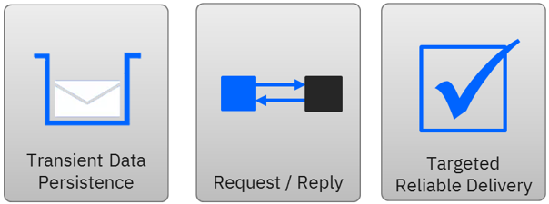
- Transient Data – data is only stored until a consumer has processed the message, or it expires. The data does not need to be persisted longer than required, and it is actually beneficial from a system resource point of view that it does not.
- Request / Reply – operations can be fire and forget, however often a request / reply interaction is desirable. Therefore, any solution should inherently support this pattern of interaction.
- Targeted Reliable Delivery – when a message is sent, it is deliberately targeted to the entity that will process the request or receive the response. This targeting can use logical addressing, and in many instances, it is preferable. Messages should also be delivered using a suitable level of reliability. Different messages will have different levels, but often once-and-once-only, assured and transactional behavior is critical.

Events
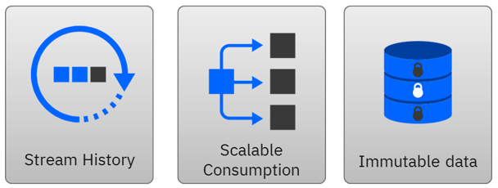

- Stream history – when retrieving events, often consumers are interested in the historical events, not only the most recent. There are many instances when this is valuable, such as retrieving the historical trends of a systems availability. Therefore, every event needs to be appended, and made available to consumers, and depending on the configuration, a certain number or volume of events will be stored prior to removal.
- Scalable Consumption – multiple events are likely to be emitted for a single operation as it passes through the network. Therefore, the scaling requirements to handle events is likely to be orders of magnitude larger than that required to support operational messages. The scalability requirement is not only limited to the producers creating messages, but also to the consumption. A single event should be available to be consumed by many consumers with limited impact as the number of consumers is increased.
- Immutable Data – when an event is emitted, it is a statement of fact, and can be considered immutable data. This enables consumers to rely on the assumption of consistent replay and reduces the impact in replicating the data from a consistency point of view.

Messaging Technologies
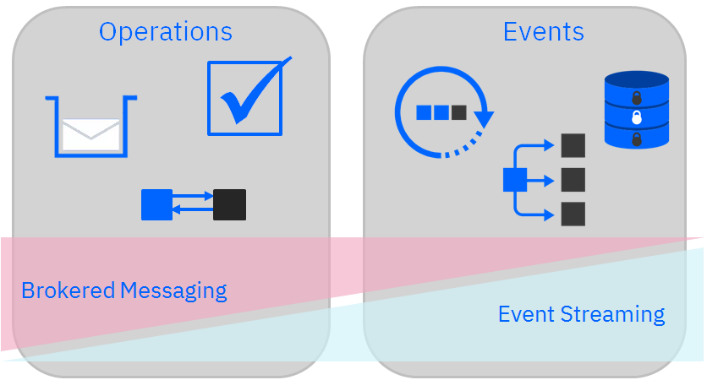

As we can see that the capabilities required to handle event and operation message types are significantly different. Therefore, it should not be surprising that different products exist for handling these categories of data. For instance, event streaming technology specializes in handling events, while brokered messaging focuses on reliably handling operation messages. This is not saying that either technology is limited to a particular use case, however it is useful to understand the use cases each technology has been specifically built to support in order to match the right solution for each requirement.

insight between messaging versus event streaming
- Messages transport a payload and are persisted until they're consumed. Message consumers are typically directly targeted and related to the producer who cares that the message was delivered and processed.
- Events are persisted as a replayable stream history. Event consumers aren't tied to the producer. An event is a record of something that happened, so it can't be changed.

Differences between RabbitMQ VS Kafka
The following tables shows the key differences between RabbitMQ and Kafka by category. Depending on the business requirements we have to implement, it can be selected one option or another option.

Messaging Scenarios
Key Item | RabbitMQ | Kafka
Streams with complex routing, throughput of 100K/sec events or more |  | X
Applications that need to support legacy protocols, such as STOMP, MQTT, AMQP, 0-9-1. | X
Applications requiring a stream history, delivered in “at least once” partitioned ordering. Clients can see a ‘replay’ of the event stream. |  | X
Granular control over consistency/set of guarantees on a per-message basis | X
Event sourcing, modeling changes to a system as a sequence of events |  | X
Stream processing data in multi-stage pipelines. The pipelines generate graphs of real-time data flows. |  | X
Complex routing to consumers | X
Applications that need a variety of publish/subscribe, point-to-point request/reply messaging capabilities. | X

Messaging Use Cases
Use Case | RabbitMQ | Kafka
Broker |  | X
Metrics, activity tracking, log aggregation, stream processing, commit logs, event sourcing |  | X
Convey a message | X
Share loads between workers under high load | X

Handling Messages
Tools | RabbitMQ | Kafka
Message Ordering | Not Supported | Provides message ordering because of its partitions. Messages are sent to topics by message key
Message Lifetime | Is a queue, so messages are done away with once consumed, and acknowledgment is provided | Is a log, which means that messages are always there. It can be managed by specifying a message retention policy
Delivery Guarantees | Doesn’t guarantee atomicity, even in relation to transactions involving a single queue | Retains order only inside a partition. In a partition, Kafka guarantee that the whole batch of messages either fails or passes
Message Priorities | It can be specified, and consumed message with a high priority at the onset | N/A

Events Versus Rest Calls
Today, with microservices, the IT community has embraced the reverse approach where services own their domain-centric logic (“smart endpoints”) and only utilize the “dumb pipes” (reference: ”Smart endpoints and dumb pipes”) as a transport mechanism. Most communications between microservices is via either HTTP request-response with resource API’s or lightweight messaging. While these two mechanisms are by far the most commonly used, they’re quite different, so the following next sections will explain when it comes to deciding between REST vs Messaging for Microservices, which scenarios call for each. It’s important to know which to use when.

Considerations When Using REST
RESTful interactions have become vital to enterprise computing as it enables many APIs on the web today. With that said, we will define what problems REST solves best:
- Synchronous Request/Reply– HTTP (the network protocol on which REST is transported) itself is a request/response protocol, so REST is a great fit for request/reply interactions.
- Publicly Facing APIs – Since HTTP is a de facto transport standard thanks to the work of the IETF (Internet Engendering Task Force), the transport layer of the APIs created using REST are interoperable with every programming language. Additionally, the message payload can be easily documented using tools such as Swagger (OpenAPI Specification). And due to the wide range of security threats present on the internet, the security ecosystem for REST is robust, from firewalls to OAUTH (Authentication/Authorization).
REST and synchronous patterns have negative consequences that apply primarily to the communication between microservice within the enterprise and that in some cases are at odds with the principles of proper microservice architecture:
- Tight Coupling –There will always be some coupling of services around the interface (specifically around the data) but when invoking a RESTful service, for an example: the developer is assuming that the message will only ever need to be delivered to one place. What happens when another service or component comes online in the future and needs the data? Sure, we can update the code to add the new endpoint, but that displays the flaw: unnecessary coupling. Soon our simple microservice has become an orchestrator which defies the microservice’s attribute “single in purpose”.
- Blocking – When invoking a REST service, the service is blocked and waiting for a response. This hurts application performance because this thread could be processing other requests.
- Error Handling – HTTP was built for the web and we have all seen our browsers get stuck trying to access a webpage. Usually we click the refresh button and the page displays. But for example, what if it fails again? Try to refresh again? The same type of issue occurs when directly invoking a RESTful service. Should this complex retry logic reside in a service’s code? If it does the service is even more tightly coupled to other services – again violating the key principle of keeping microservices architecture single in purpose and small in size.

Messaging for Event-Driven Microservices
The solution to many of the shortcomings associated with RESTful/synchronous interactions is to combine the principles of event-driven architecture with microservices. Event Driven Microservices (EDM) are inherently asynchronous and are notified when it is time to perform work. In many cases, asynchronous communications are how many of our daily interactions take place.
The benefits of messaging for event-driven microservices are many and varied:
- Loose Coupling – Using messaging, specifically publish/subscribe functionality, services do not have knowledge of other services. They are notified of new events, process that information and produce/publish new information. This new information then can be consumed by any number of services, thanks to publish/subscribe. Loose coupling allows microservices to be ready for the never-ending changes that occur within enterprises.
- Non-Blocking – Microservices should perform as efficiently as possible, and it is a waste of resources to have many threads blocked and waiting for a response. With asynchronous messaging applications can send a request and process another request instead of waiting for a response.
- Simple to scale – As applications and enterprises grow, the ability to increase capacity (or dynamically scale to optimize costs) becomes one of the most important advantages of microservice architecture. Since each service is small and only performs one task, each service should be able to grow or shrink as needed. Event driven architecture and messaging make it easy for microservices to scale since they’re decoupled and do not block. This also makes it easy to determine which service is the bottleneck and add additional instances of just that service, instead of blindly scaling up all services, which can be the case when microservices are chained together with synchronous communications.
- Greater Resiliency and Error Handling –Microservices failure scenarios become tricky when considering in-progress transactions. Messaging platforms that offer guaranteed delivery can act as the source of truth in the event of massive failures and enable rapid recovery without message loss. In the case of less massive failures (service failure) the use of messaging allows healthy services to continue processing since they are not blocked on the failed service. Once healed, the failed service will start processing the data that had accumulated during the downtime, making the system eventually consistent. Additionally, code becomes much cleaner and readable as all the cumbersome retry and error handling logic is gone. In event driven microservices the messaging tier handles the retry of failed messages (unacknowledged messages) which frees the service to be small in size and single in purpose.

Guideline for choosing between Events And REST
This section will describe the elements for choosing the proper communication technology between microservices.

 | Events Call | Rest Call
Reliability | X
Immediate response (Request/Response interaction) |  | X
Integrate with other systems |  | X
Notifications | X
Decoupling | X
Robustness | X
The response contains data |  | X
Immediate consistency |  | X
Caching – read operations (i.e. GETs) can be cached |  | X
Resilience | X

Using as a help the diagram from Archi (Loan Origination Process), the following examples will illustrate the above table:
- Microservice Credit Request Analysis publish a notification event “Risk Analysis Updated” which consumed by Credit Offer microservice.
- The business logic “Get Payment Schedule” in Credit Offer is invoking a REST API “Repayment-Schedules” at Loan microservice.
- The business logic Create Request in Customer Request microservice is invoking a REST API “eligibility-analysis” at microservice Eligibility Evaluation for Credit Products.
- Business flow, Approve Case in Underwriting microservice publish notification event “Case Approved” which consumed by Product Agreement microservice

