

Mainframe Integration in Banking Applications Transformations to Hybrid Clouds

Yann Kindelberger
Executive Architect - IBM Z Banking Lead Architect
IBM

Alfredo Muñoz Ríos
Global Banking and Financial Markets Center of Competency
alfredomunoz@es.ibm.com

Table of Contents
1 Purpose of this Document 3
2 Problem Statement and Summary 4
3 IBM reference integration architecture for IBM Z 5
4 The Target Mainframe Integration Architecture 9
5 Assessment and recommendations for the Mainframe Access Layer solution 12
6 Mainframe Integration Patterns 18

Purpose of this Document
This document describes the IBM reference integration architecture for IBM Z as well as the target integration architecture for IBM Z in the context of the new architecture style(microservices) for Hybrid Clouds

This document provides recommendations regarding the different solutions to integrate with IBM Z.

Finally, the document details practical integration patterns for reference.

This document is a sanitized version of an actual deliverable created for a Large Bank. Names and References to the organization are removed. However, the analysis of the AS-IS situation is specific to such organization, although clearly applicable to many other banks and financial services organizations in the world.

Problem Statement and Summary
The development of a Microservice Architecture in Hybrid Clouds means an important change on the way applications are designed and build compared with traditional core systems.
With the need for this new architectural style, easy access must be provided to the Mainframe transactions and data from the newly developed applications.

It becomes key to unlock the IBM Z assets and improve consume ability, control and insight to accessing existing IBM Z assets.

API Management on IBM Z is critically important. With this capability, the IBM Z assets continue to be leveraged by businesses to deliver new and/or improved services via new delivery channels.

Many technologies and solutions can be used to enable REST integration with the care banking applications. The best solution depends on a number of factors. This document describes and assesses the recommended solutions for the Mainframe integration.

IBM reference integration architecture for IBM Z
Today, companies are exposing their IBM Z applications as APIs. The mainframe today is capable of servicing REST requests, and also consuming REST APIs. Which brings to the main question: ‘What is the best way to do REST with the mainframe?’
Many technologies and solutions can be used to enable REST integration with the legacy applications, including web APIs, services, connectors and so on. The best solution depends on a number of factors, including the type of application, the age of the application, where the application runs and the software currency of the subsystem middleware. It also depends on the customer propensity for ‘turnkey’ solutions vs DIY (‘Do It Yourself’) solutions.
Let’s look at the different modalities to REST API enable the mainframe.

The different modalities to REST API enable the mainframe
Basically, we can consider three different architecture models, as shown below.

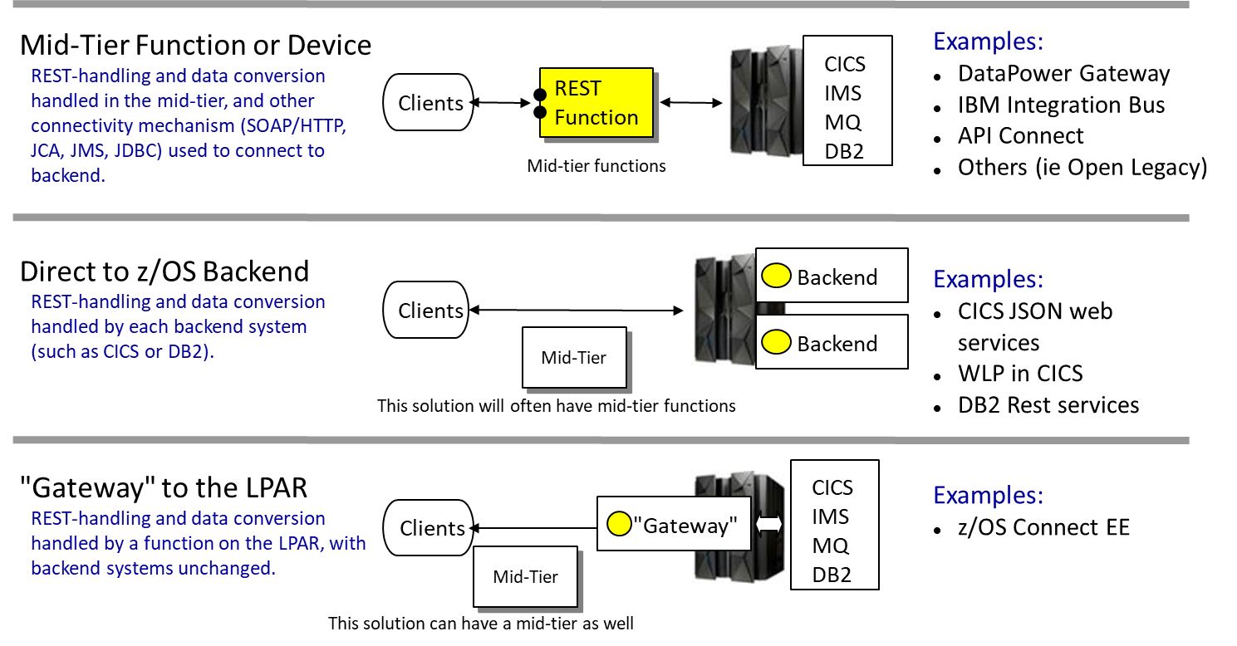

The first approach is to handle the REST call on a mid-tier device or function, and process non-REST calls to CICS from there. For example, the mid-tier device could be a DataPower appliance, IBM Integration Bus, or Open Legacy and the protocol to the back-end could be messaging, HTTP...

The second approach is to bring the REST directly into CICS. For example, bringing the REST call directly into a CICS region configured with JSON web services, or implementing the REST call within a WebSphere Liberty Profile inside CICS using JAX-RS standard. This solution may consist of a mid-tier function that proxies the REST request to the back-end. This is the most direct approach, but it means that a different solution is required for each type of mainframe application.

The third approach is to provide a “gateway” on the LPAR and handle all REST requests there. This is the z/OS Connect model. An often-cited reason for this approach is it provides a controllable entry point to the LPAR … you can accept or reject at this “gateway” based on your criteria, and you can capture audit records about the access through this function. When either of the first two approaches is used there is the potential of having multiple protocols and multiple pathways in, and the challenge of keeping track of it all increases.

This third approach is the IBM strategic approach to integrate the IBM Z assets with microservices architecture.

Note that the different models are not mutually exclusive, and it is quite possible to have a blended solution of all three.

The Hybrid Integration Architecture for API Management and IBM Z integration
A hybrid integration architecture must offer flexibility for applications within the enterprise and users beyond it.
The major components of hybrid integration architecture are shown in the figure below:

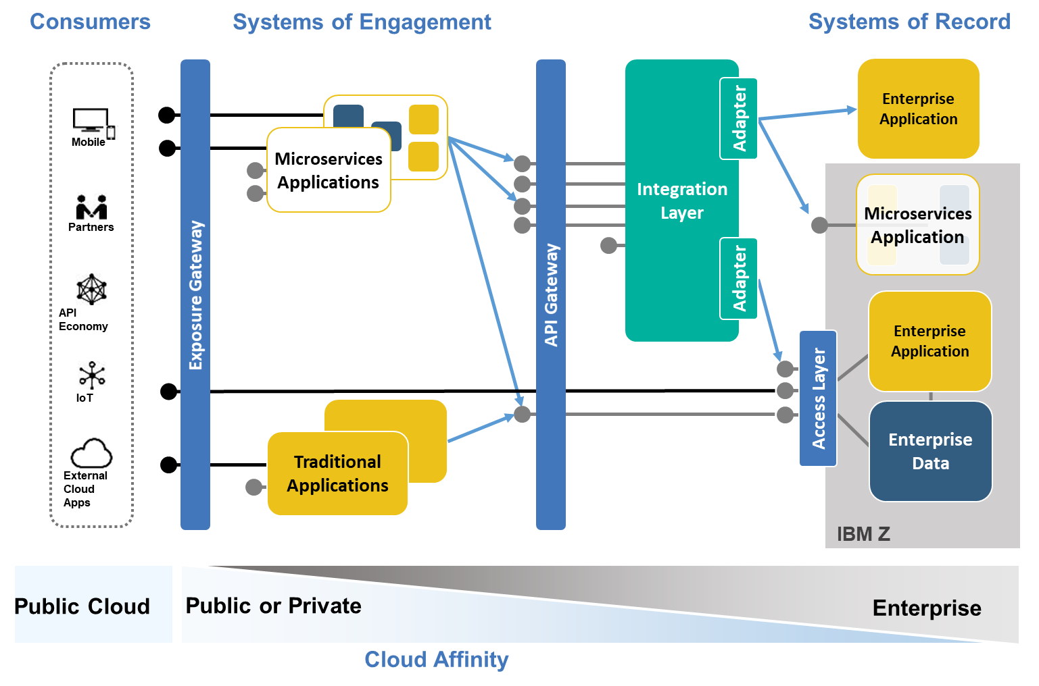
The key components of the hybrid integration architecture are described next.

The Access Layer
The Access Layer offers several mechanisms to access the core banking application assets (transactions, data) by providing interfaces that are well-defined using REST standard.

As described in the previous chapter, this access layer can be implemented
- by a mid-tier component
- or directly by the enterprise applications or the enterprise data,
- or by using gateway components

Alternatively, the core banking applications might already have been service-enabled by using SOAP web services. Although the new microservice applications might consume these services directly, an increasing trend is to exploit RESTful APIs. In this case, an integration component (which might be in the API gateway or the integration layer) is required to map the API onto the
web service.

However, making a REST service available directly might be more convenient and streamlined.

The Integration Layer
The integration layer, also known as the Enterprise Service Bus of the Service Oriented Architecture, provides a means to connect service requesters and providers. Each invocation from a service requester (for example, the microservices applications) results in one or many invocations out to a service provider (CICS, IMS…).

With the microservice architecture, the recommendation is to move to a lightweight integration and to access directly the Access Layer or the API Gateway from the microservices application.

In some cases, the integration layer can handle APIs composition, event handling, complex message transformation, and data synchronization.

The microservices architecture does not make of the ESB an outdated technology. In fact, both are perfectly compatible and can work in coordination.

API Gateway
The API gateway provides access to APIs and essential services, such as security, governance, monitoring, and analytics.
For example, metering API invocations enable rate limiting to be applied and API use to be charged.
The API gateway can also provide the underlying technology to support message-format translation and version and change management.

Exposure Gateway
The most effective mechanism to ensure that proper access management policies are enforced is by using a centralized exposure gateway. The gateway serves as an entry point for requests from external application traffic into the enterprise. It delivers a configurable set of capabilities to protect and enhance SoE interactions from beyond the enterprise.
The exposure gateway acts as the policy enforcement point for all authentication and authorization decisions that are related to in-bound and out-bound traffic. This architecture allows enterprises to decouple the enforcement of security policy from the underlying application.

The Target Mainframe Integration Architecture

Example of a Typical Mainframe Integration Architecture
The figure below shows the mapping of an example of typical integration architecture with the IBM reference hybrid architecture.
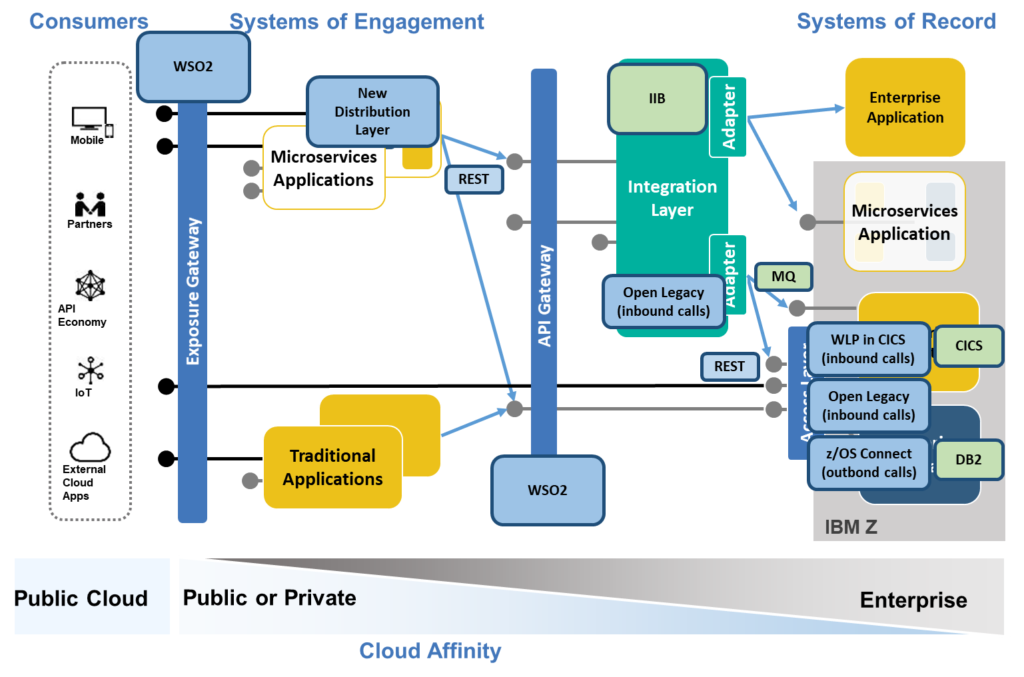
In the Access Layer, the integration architecture used as example are relying on 3 different solutions:
For the inbound calls, it may use 2 options:
- WebSphere Liberty Profile in CICS: CICS provides a web container that can run lightweight Java servlets and JavaServer Pages. Developers can use the rich features to write modern web applications to expose CICS transaction as Web services using the Java API for RESTful Web Services (JAX-RS) standard. This solution is in production today.
- Open Legacy: Open Legacy provides an API integration platform to create and manage APIs that deal with different operating systems and programming languages. This solution is not yet in production.
For the outbound calls, it uses z/OS Connect Enterprise Edition, that gives the power to call external APIs from your core banking applications and expose the IBM Z assets as easily-consumable RESTful APIs.

About the API Gateway, the bank relies on WSO2 API Management solution. Basically, most of the API exposed from the Mainframe using WebSphere Liberty Profile in CICS or Open Legacy will be exposed and published through WSO2 before being consumed by the microservices applications.

About the Exposure Gateway, the bank relies on the API Gateway (WSO2 API Management) to expose APIs outside of the bank.

About the Integration Layer, it relies on IBM Integration Bus (IIB). IIB is mainly used to exposed SOAP web services. The front-end applications that require to consume web services, connect to IIB and then to CICS using the WMQ technology. In certain condition like event handling, message enrichment or complex transformation, this integration layer can be used to also exposed RESTful service. In the target architecture, those RESTful services will be then exposed via the WSO2 API Gateway.

About the microservices applications, whenever possible, will consume directly the RESTfuls services exposed through the API Gateway (WSO2).

Gap analysis and recommendation of a example of the Mainframe Integration Architecture versus IBM reference architecture
Most of Mainframe Integration Architecture in most of the bank will be globally well aligned with the IBM reference architecture. There is no significant gap between the 2 architectures.
Only a few gaps usually exist between the 2 architectures:
- The example architecture is using the same component to expose internal and external APIs, whereas the IBM reference architecture position 2 different components. The software solution used for exposing the external and internal APIs can be the same (i.e WSO2 API Management solution), but the IBM recommendation would be from a security standpoint to separate the 2 components from an operational model perspective.
- The example architecture is using multiple software solutions for some of the key components. For a sake of simplicity, management and cost, IBM would rather try to limit a single software solution per component:
  - IIB versus Open Legacy as the Integration Layer
  - Open Legacy versus z/OS Connect versus CICS WLP for the Access Layer.

As depicted in the diagram hereabove, there are 2 options to access the IBM Z legacy applications exposed as RESTful services from the applications in cloud(s) platforms. Either by going through the API Gateway and then through
- the Integration Layer and the Access Layer or
- directly through the Access Layer

The IBM recommendation is to use whenever possible the direct access from the API Gateway to the Access Layer. Using a direct access from the API Gateway to the Access Layer has several advantages:
- It will simplify the end-to-end architecture
- It will simply the development by reducing the number of artifacts to be developed.
- It will improve the overall response times of the applications by reducing the number of layers to be crossed.
- Lastly, it will improve end-to-end availability by reducing the number of components to managed in a highly available manner.
In some very specific cases such as event handling, message enrichment or complex transformation requirements, the applications on cloud(s) platforms(s) may have to access the core banking application through the Integration Layer. This option should not be the default option and should be limited only to the specific requirements describes hereabove.

Assessment and recommendations for the Mainframe Access Layer solution

The strategy points and main capabilities for the Access Layer to the Mainframe
The high-level strategy points as well as the main capabilities required for an Access Layer to the Mainframe are described below:
- The solution should provide a “Fully RESTful” enablement of the major z/OS subsystems. The z/OS applications should appear as any other REST Provider. The solution should hide all of the complexities of the underlying service implementation.
- The solution should provide inbound (API provider) and outbound (API requester) calls capabilities. The solution should make requests to external APIs from CICS and batch applications.
- For API provider, the design principles are to enable developers to self-discover APIs into a CICS application, whilst never needing to change the underlying COBOL code.
  - No Backend Application Changes
  - The creation of services to CICS or to other middleware should rely on a common API Toolkit that simplifies the definition and the deployment of application services.
- For API requester, the design principles are to minimize the application changes. A simple call should be added to an existing application in order to invoke an external API. The complexity of data and protocol transformation should be managed by the Access Layer solution.
- The solution should support the Open Standard Open API Doc (aka Swagger) for integration with other products. The solution should provide a simple integration into the enterprise API management solutions like WSO2.
- The solution should provide agile (dynamic) API creation, simple testing and easy deployment. The solution should be easily integrated in the end-to-end DevOps practices and tooling in order to build, test and deploy the artifacts generated by the Access Layer solution.

The major challenges
The list below describes the major challenges that need to be carefully taken in account when implementing an Access Layer:
- How to secure APIs?
- How to scale with the Access Layer?
- How to provide high availability of the Access Layer?
- How to monitor the API workloads?
- How to incorporate mainframe APIs into the DevOps process?

How to secure APIs?
Before designing an end to end security solution, it is necessary to clearly define the security requirements. A complete security solution will put mechanisms in place to achieve the following objectives:
- Identification: the ability to assign an identity to the user who is invoking the API.
- Authentication: the process of validating the identity claimed by the user.
- Authorization: the process of checking whether a user should be given access to a resource.
- Integrity: to ensure that transmitted messages are not altered in an unauthorized or accidental manner.
- Confidentiality: to ensure that an unauthorized party cannot read the transmitted messages.
- Auditing: the process of recording who has invoked the API.
About Identification and Authentication, the solution should support the 3 different mechanisms:
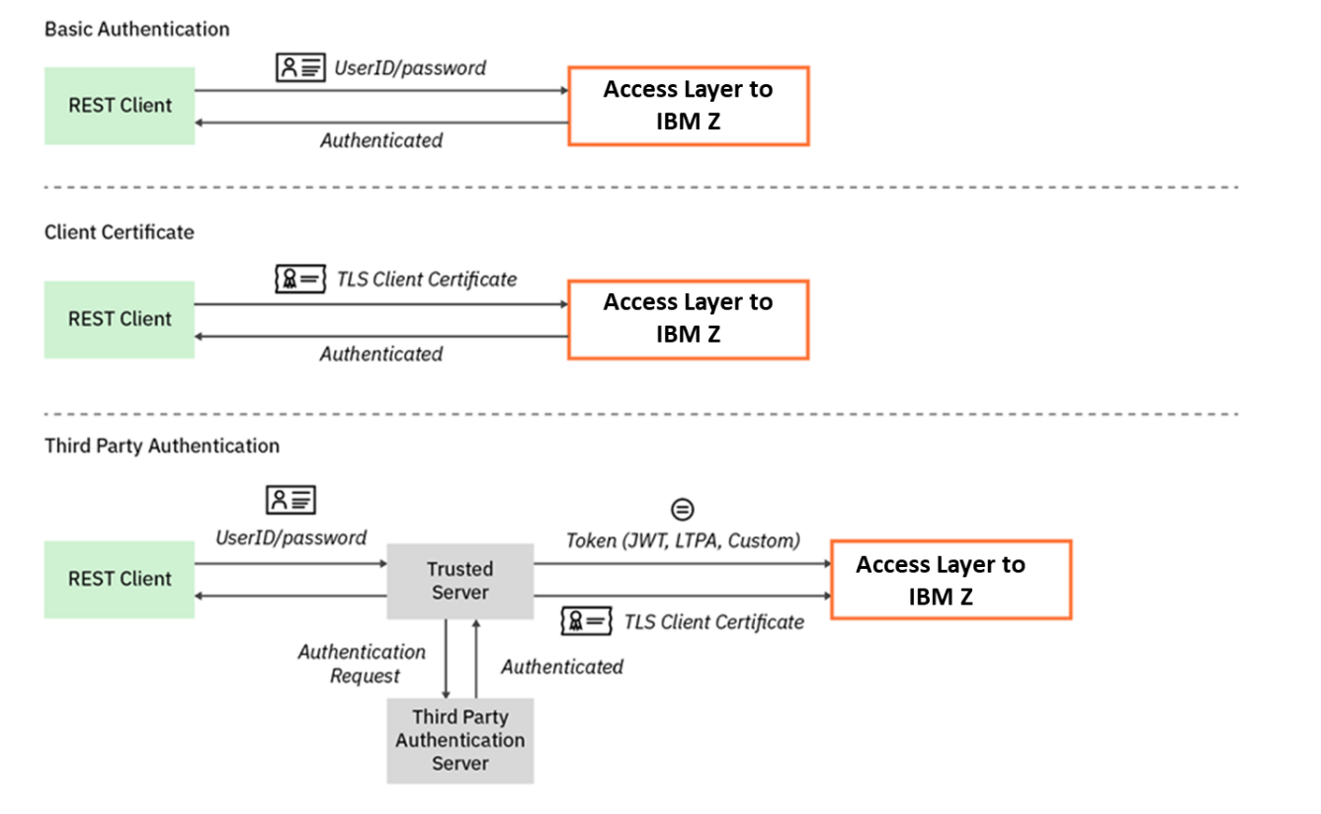
There are basically 3 different manner to perform the authentication to the IBM Z core banking application using either:
- A generic RACF User ID, often called application User ID or technical User ID, which will be used by all the user or REST Client to authenticate to the CICS application or
- A specific RACF User ID for each client or
- A RACF User ID for group of clients belonging to the same organization (company, partner, department, business unit…)
The first one is the option that was commonly used with traditional JEE or .Net applications which were accessing the IBM Z legacy application using a generic RACF User ID. With the API economy, using the same RACF User ID to authenticate all the different clients accessing the legacy application might not be the most appropriate solution, especially for monitoring and auditing purpose. The IBM recommendation is not to use this option of the generic RACF User ID to authenticate to the core legacy application exposed as RESTful APIs.
The second option is probably the most relevant from a security perspective especially from an auditing standpoint, but it would require creating as much as RACF User ID as clients. This could be envisaged for internal application with a limited number of users but not really for APIs exposed outside the bank. This option would also require to get the distributed user directory (LDAP, Active Directory…) in sync with RACF, which might be fairly tricky.
IBM recommendation would be to rely on the third option, consisting in mapping the client distributed ID to a specific RACF User ID according to his organization (company, partner, department, business unit…). RACF support this with the RACMAP command and allow to make a one-to-one or many-to-one mapping to map all the identities associated to a specific organization (company, partner, business unit, department) to the same RACF user ID.
In addition, most of the organizations are today choosing a Third Party Authentication mechanism relying on the JWT (JSON Web Tokens) standard with solution like OAuth 2.0 or OpenID Connect.
So, the Access Layer should be able to handle different types of token like JWT and should be able to map the token to an identity in the RACF user registry. There are basically 2 options for this support: either the Access Layer solution supports this mapping natively or this mapping has to be implemented manually.
The recommendation would be to rely on a solution that supports this mapping natively.

How to scale with the Access Layer?
The solution for the Access Layer should demonstrate its ability to scale.
It’s important to ensure that the solution demonstrates good scalability, and especially by demonstrating the following proof points:
- Increasing the number of clients (future development) running in parallel do not compromise the transaction rate.
- Increasing the number of clients (future development) running in parallel do not degrade the response times.
- Increasing the number of clients (future development) running in parallel result in little or no change in CPU Cost Per Transaction.
It’s key to validate those proof points with different message size to better understand the impact of the size of the message on the performances.
The recommendation is to perform stress tests to validate those proof points.

How to provide high availability of the Access Layer?
The solution for the Access Layer should demonstrate its ability to be deployed in a highly available configuration.
High availability should be considered very early in the infrastructure architecture design.
A solution allowing multiple active runtime environments of the Access Layer to guarantee high availability and scalability will be the preferred option.

How to monitor the API workloads?
As the organizations prepare to deploy APIs to the Access Layer, they should consider how to monitor API workloads, perform operational analytics and also track API requests across the enterprise.
The chosen solution should be able to integrate easily in the end-end monitoring tools of the enterprise in order to see quickly the health status of the solution and to diagnose the API failures.
The monitoring solution should be able to show to the operational staffs the following metrics:
- the request counts,
- the error counts
- the response times,
- the timeouts.

How to incorporate mainframe APIs into the DevOps process?
Enterprises need a DevOps toolchain to support agile development, testing, and deployment of services and APIs. When changes are made to the Access Layer, the Access Layer artifacts (services, APIs) should be managed by the enterprise source code management (SCM) system and the DevOps solution, to support updates, testing, and deployment in a continuous delivery process.
The solution should provide some automation tooling to build the API artifacts for the applications that will be exposed as part of an API and to build the API requester artifacts to enable the z/OS application (CICS, batch) to call an API.

IBM recommendations
Many Integrations Architecture rely today on 3 different solution for their Access Layer to API enable the CICS applications and make requests to external APIs from CICS and batches:
- WebSphere Liberty Profile in CICS
- Open Legacy
- z/OS Connect Enterprise Edition

The first recommendation would be to rationalize the way to API enable the core banking application.
Using three different solutions has the following drawbacks:
- Need to master 3 different tools/IDE for the development of the APIs
- Need to manage and operate 3 different environments
- Cost of the solution might be higher because of the multiplication of licenses cost for the different solutions

From an IBM standpoint solution and based on the criteria discussed in the previous chapter, the recommendation is to prefer z/OS Connect Enterprise Edition to WebSphere Liberty Profile in CICS.
z/OS Connect Enterprise Edition is clearly the strategic solution from IBM to API enable the Mainframe as API requester and API provider.
WebSphere Liberty Profile in CICS is not really a tool driven solution, it requires some effort to develop the mapping between the Cobol copybook and the JSON message. In addition, WebSphere Liberty Profile in CICS is a CICS only solution, meaning if in a near future the bank wants to API enable another z/OS subsystem like Db2 (see chapter Error: Reference source not found), another solution will have to be implemented.
For those 2 major reasons, the recommendation is to use z/OS Connect Enterprise Edition.

About z/OS Connect Enterprise Edition versus Open Legacy, the recommendation is also to prefer z/OS Connect Enterprise Edition to Open Legacy for the following main reasons:
- z/OS Connect Enterprise Edition enables the Mainframe to be APIs requester and APIs provider, whereas Open Legacy only enable the Mainframe as an API provider.
- From a security perspective, z/OS Connect Enterprise Edition provides built-in capabilities to support JWT (JSON Web Tokens) and to map a distributed identity to a RACF user ID. Whereas Open Legacy does not provide any built-in capability. The bank will have to implement and maintain this mapping functionality.
- z/OS Connect Enterprise Edition will be able to API enable other z/OS subsystems like Db2. Even if this functionality is not required by the bank yet, it is potentially a future requirement – (see chapter Error: Reference source not found).
- As of today, z/OS Connect Enterprise Edition is already in production whereas Open Legacy is not.
- Lastly, z/OS Connect Enterprise Edition demonstrated extremely good performance and scalability – see picture below about the performance of the solution. The performance of Open Legacy will have to be verified.

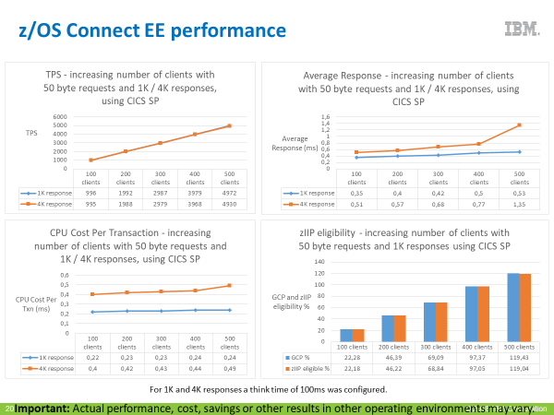

Mainframe Integration Patterns

Description of the patterns
The next chapters describe the different integration patterns between the applications in the cloud and the existing core system on the IBM Z.
- UC1: Access functionality in Mainframe
- UC2: Mainframe security integration
- UC3: External Service Call from the Mainframe
- UC4: Data propagation from new Products Catalog solution including fees setting to existing fees calculation solution on the Mainframe.
- UC5: Coexistence and bi-directional synchronization between Native to applications on cloud(s) platforms(s)
- UC6: Coexistence between former integration layer scenario and new integration solution for an existing CICS application already exposed as a webservice
- UC7: Coexistence between former integration layer scenario and new integration solution for an existing CICS application not exposed as a webservice

The next chapters describe the technical architecture that would be required for each of those patterns in order to properly integrate the IBM Z assets including both transaction and data with the applications in the cloud.

UC1: Access functionality in Mainframe
This use case describes how to consume a core banking functionality developed in CICS/Cobol from a microservice application deployed on an OpenShift environment.
The next chapters show how to integrate with the mainframe using the 2 options:
- Open Legacy
- z/OS Connect Enterprise Edition

Integration option with Open Legacy
The following diagram describes the major nodes, software components as well as application components involved in this integration pattern.
This integration pattern is aligned with the description of the target mainframe integration architecture used as example(chapter 4)

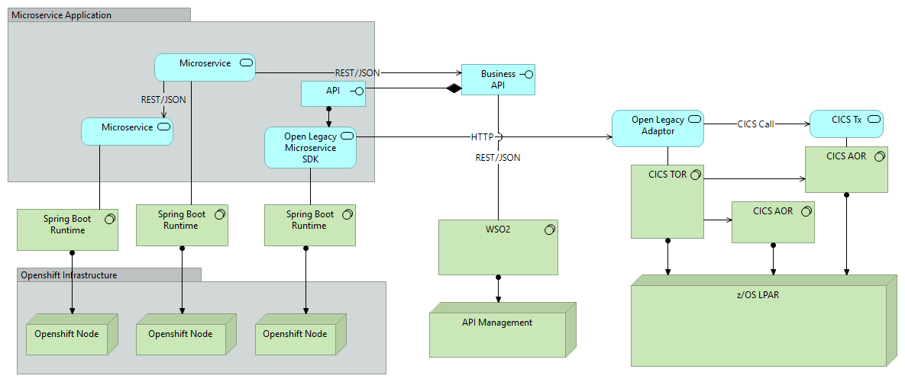

- The CICS/Cobol transaction running in a CICS AOR will be accessed by the Open Legacy Adaptor hosted in a CICS TOR.
- The Open Legacy Microservice SDK, performing the mapping between the Cobol copybook and the JSON message is deployed in a Spring Boot runtime hosted in an OpenShift node. This Open Legacy Microservice SDK is connecting to the Open Legacy Adapter using HTTP protocol.
- The API representing the CICS transaction and calling the Open Legacy Microservice SDK is also deployed in a Spring Boot runtime hosted in an OpenShift node.
- The business API is created from the API representing the CICS transaction and deployed to WSO2.
- The New Distribution Layer microservices application is consuming the business API exposed through WSO2.

Integration option with z/OS Connect
The following diagram describes the major nodes, software components as well as application components involved in this integration pattern.
This integration pattern is aligned with the description of the target mainframe integration architecture used as example(chapter 4).

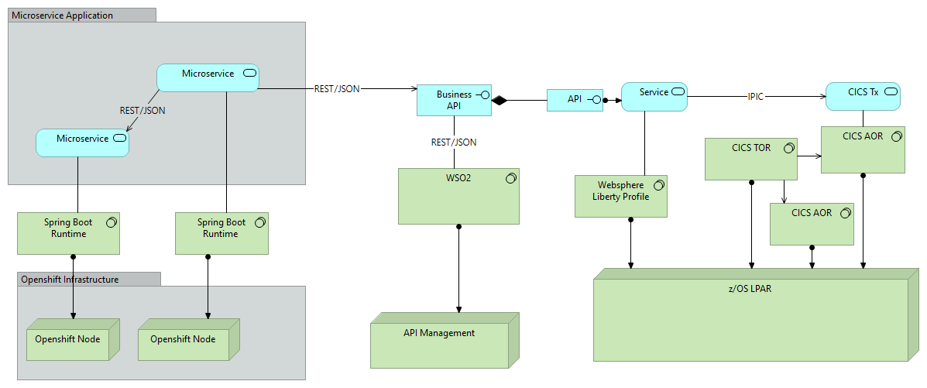
- The CICS/Cobol transaction running in a CICS AOR will be accessed by z/OS Connect Enterprise Edition hosted in a WebSphere Liberty Profile using IPIC protocol.
- The z/OS Connect Enterprise Edition service, performing the mapping between the Cobol copybook and the JSON message is deployed in z/OS Connect Enterprise Edition.
- The API representing the CICS transaction is also deployed in z/OS Connect Enterprise Edition.
- The business API is created from the API representing the CICS transaction and deployed to WSO2.
- The New Distribution Layer microservices application is consuming the business API exposed through WSO2.

UC2: Mainframe security integration
This use case describes how to securely integrate a core banking functionality developed in CICS/Cobol consumed from a microservice application deployed on an OpenShift environment.
OpenID Connect and OAuth 2.0 have become the leading standard for single sign-on and identity provision on the Internet. Its formula for success: simple JSON-based identity tokens (JWT), delivered via OAuth 2.0 flows designed for cloud native applications.
The next chapter explains more in details what a third-party authentication security model is.
Then, the 2 next chapters show how to securely integrate with the IBM Z using the 2 integration options:
- Open Legacy
- z/OS Connect Enterprise Edition

Description of a third-party authentication security model
Third party authentication also known as identity delegation plays more and more a key role in enterprise security. OAuth was the first step toward identity delegation standardization.
OpenID Connect (OIDC) is an identity protocol and open standard more and more adopted by the enterprises that is built on top of the OAuth 2.0 protocol.
With OAuth 2.0, the security token that is used to authorize a user to access a resource is known as an access token. This token type is ‘opaque’ to applications, that is, applications cannot directly consume the token. With OIDC, the security token used is a JSON Web Token (JWT) which can be consumed directly by applications.
OAuth 2.0 is an open standard that allows an end user to securely share access to information with a third party. It simplifies the user experience by avoiding the need of managing many different credentials for multiple web sites. The goal of OAuth 2.0 is to enable a web site to request user information from another site, whilst allowing the end user to control access to the information.
The following example show how OAuth can be used to secure access to an API.
- The microservices application authenticates with the Authorization End Point of the OAuth Provider API. This Authorization End Point could be WSO2. The microservices application sends a GET request to the Authorization End Point and receives a redirect URI to a login form to allow the end user to enter his credentials securely. Once the credentials have been validated and optionally the type of information that the end user will share accepted, the Authorization End Point responds to the microservices application with a grant code.
- The microservices application requests the Token End Point of the OAuth Provider for tokens, with the following information:
- Microservices application credentials
- grant code
- The Token End Point validates the microservices application credentials and grant code and sends back an access token and refresh token to the microservices applications. The microservices application now has the access token to put in the Authorization header to call the API. The API gateway receives the request from the microservices application with the access token in the request. The API gateway then sends the token to the Introspection End Point of the OAuth Provider API which is able to validate the token, and return all the necessary information, such as the username, scopes and validity.
- If the access token is valid and if the scope matches with the API scope, the API gateway processes the request, otherwise it refuses the request.

When using OIDC the ID token is a JWT which contains a header, payload and signature. The payload contains the claims. Claims are statements about an entity (typically, the user) and additional metadata.

Basically, the security design to authenticate to the mainframe will have to follow those principles:
- Authentication will be performed by an OIDC or OAuth Provider.
- User authorization can be done at one or many enforcement points. However, in order to authorize in the backend system like CICS, it will be necessary to map the credentials used for user authentication to a user in the RACF registry. There are 2 options for this credential mapping, either the mapping is managed by the infrastructure (i.e z/OS Connect Enterprise Edition) or the mapping needs to be implemented programmatically in the application (Open Legacy Service or API…).

Implementation of a third-party authentication security model using z/OS Connect
The following diagram describes the major nodes, software components as well as application components involved in this authentication pattern using z/OS Connect Enterprise Edition.
This pattern is aligned with the description of the target mainframe integration architecture described as example (chapter 4).
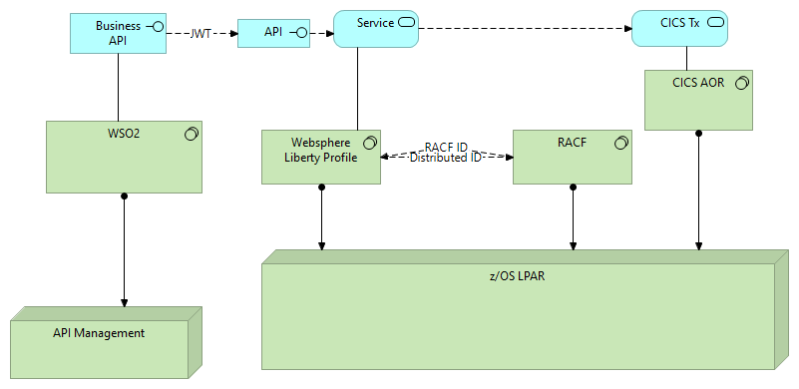
- WSO2 is used as the OIDC or OAuth Provider.
- The WSO2 API Gateway performs the validation of the JWT (Signature, Issuer, Audience, Expiration)
- WSO2 calls the API exposed through z/OS Connect EE, passing the JWT.
- z/OS Connect EE performs several security functions:
  - Validates the JWT and extracts the distributed identity
  - Calls RACF to map the distributed ID to a RACF user ID
  - Calls RACF to check that the user is authorized to invoke the API
  - Audits the request to record who invoked the API
  - Propagates the distributed user ID to CICS
- RACF is used for the mainframe user registry, mapping distributed IDs to RACF user IDs and for authorizing API calls
- CICS maps the distributed ID to a RACF ID and performs further authorization checks to make sure that the mapped RACF user ID is authorized to access CICS resources

Implementation of a third-party authentication security model using Open Legacy
The following diagram describes the major nodes, software components as well as application components involved in this authentication pattern using Open Legacy.
This pattern is aligned with the description of the target mainframe integration architecture used as example (chapter 4).

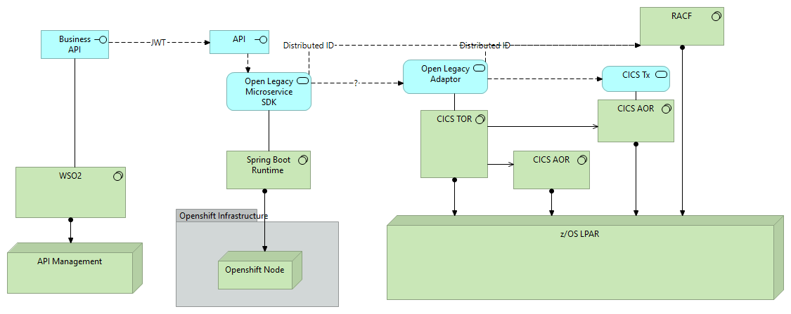
- WSO2 is used as the OIDC or OAuth Provider.
- The WSO2 API Gateway performs the validation of the JWT (Signature, Issuer, Audience, Expiration)
- WSO2 calls the API exposed through Open Legacy, passing the JWT.
- As of today, it is not known if Open Legacy will be able to perform the following security functions:
  - Validates the JWT and extracts the distributed identity
  - Check that the user is authorized to invoke the API
  - Propagates a RACF user ID to the Adaptor and then to CICS.
It is very unlikely that Open Legacy is able to perform natively those security functions, especially the interaction with RACF. Those functions will have to be implemented programmatically at the application level.
Accessing the RACF database from distributed system might be challenging. Using a LDAP SDBM on z/OS could be an option. This topic needs to be more investigated if this pattern is the chosen pattern.

UC3: External Service Call from the Mainframe
This use case describes how a Cobol/CICS application is calling a RESTful API exposed through the API Gateway.
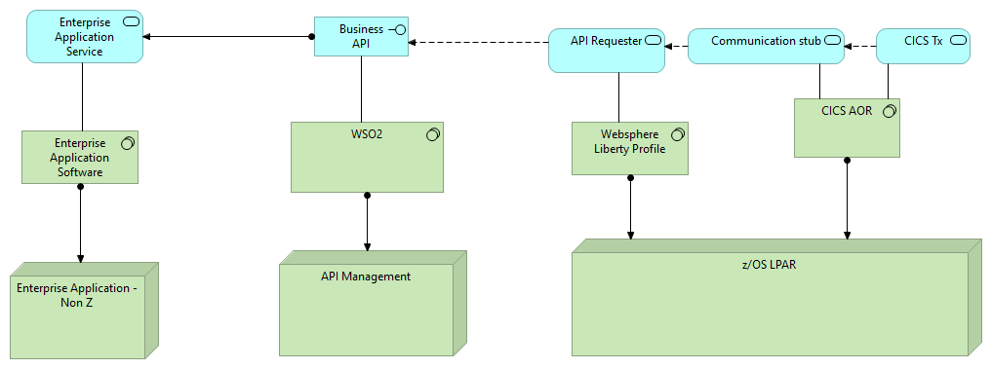
- The CICS/Cobol application calls the communication stub provided by z/OS Connect EE.
- The communication stub sends the data to the z/OS Connect EE server.
- The z/OS Connect EE server performs the data transformation between the Cobol copybook and the JSON message.
- The z/OS Connect EE creates the HTTP request and sends it to the API exposed through WSO2.

UC4: Data propagation from new Products Catalog solution including fees setting to existing fees calculation solution on the Mainframe.
This use case describes how a microservices application is able to synchronize data with DB2 on z/OS using 2 different integration patterns:
- Event driven computing and publish / subscribe integration pattern
- Change Data Capture and near real time ETL

Publish / Subscribe Event Driven Pattern
Event driven computing and publish/subscribe is critical to the new world of Cloud.
In publish/subscribe architecture somebody publishes some information on a topic and others who are interested in that information find about it pretty much instantly ideally at the same exact time by simply subscribing to the topic.

In this pattern, the data propagation procedure is triggered by the microservices application.

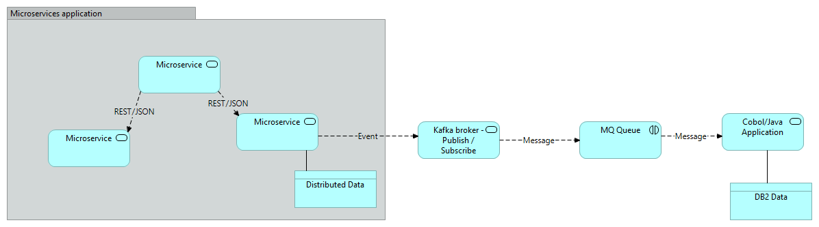
- The new Products Catalog microservice application publishes an event to a topic into the messages broker solution (i.e.Kafka). The published event describes the data that has been changed in the Products Catalog application like the fees of a product. This change has to be propagated to the Mainframe.
- Previously, the core banking application will have subscribed to the specific topic.
- The event will be propagated to a MQ queue on z/OS.
- A Cobol or Java application running on z/OS consumes the MQ message and inserts or updates the DB2 data according to the content of the message.

As described before, in this pattern, the data propagation procedure is triggered by the microservices application, meaning some developments are required to publish the event at the microservice application level. In addition, when consuming the events, some new functionalities will have to be implemented to perform the appropriate actions on the target data.

Changed Data Capture and Near Real Time ETL
Change Data Capture or CDC as it is known, is a method that observes and captures all changes occurring in a database with the purpose of applying these changes in the order of occurrence to other systems.

Every change identified is published as a CDC event, which a given system can react on. CDC events can be notified to multiple components or applications that can act upon the event and trigger some processing like Extract Transform Load (ETL) processes.

In this data propagation pattern, the population procedure is not triggered by the microservice application, but by a change event from the database.

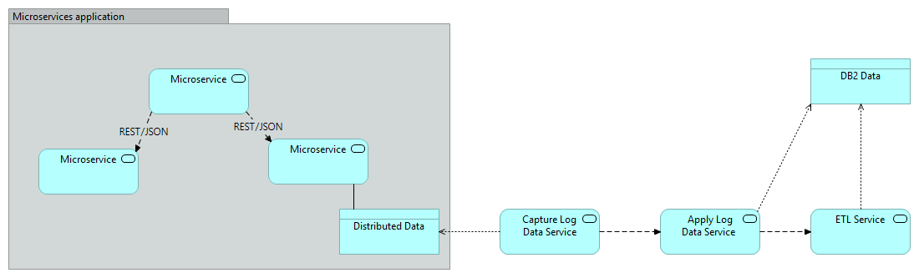
- When the new Products Catalog microservice application updates its database, the CDC Capture Log Service captures the individual changes being committed to the data source and makes it available to the Apply Log Data Service.
- According to the type of update and the transformation required between the source and the target the Apply Log Data Service can:
  - Update directly the target database, if no important transformation of data is required.
  - Trigger an Extract Transform Load (ETL) process to perform a data transformation and then update the target database

In this pattern, the data propagation procedure is triggered by a change event in the database. This integration pattern is less intrusive than the previous pattern. There is no need to change the microservice application or the structure of the existing data.

UC5: Coexistence and bi-directional synchronization between Native to applications on cloud(s) platforms(s)
This use case describes a coexistence pattern between Native and the New Distribution Layer for the loan origination process.
In this use case, we are considering that the new application for the loan origination is deployed in the New Distribution Layer.
We assume that the loan origination process can be continued through another channel. We also assume that some other channels still rely on the old Native application.

Using other channels relying on the old Native application for a loan origination initiated in the applications on clouds platforms require that the data be replicated from the cloud to the Native application. The replication mechanism could be one of the patterns described in the chapter 6.5 – see diagram below.
Once the loan origination process is continued through the old Native application, the updated data from the old Native application will also have to be replicated to the applications on clouds platforms. The replication mechanism could be similar to one of the patterns described in the chapter 6.5 – see diagram below.
Bidirectional synchronization, meaning data changes need to be migrated from new to old system as well as from old to new system, may lead to complex data integration architecture between the core banking application and the new microservices application. Additionally, such complex data integration architecture will only be implemented for a short period of time, only during the coexistence period between the old and the new systems.
The recommendation is to prevent whenever possible to implement such complex bi-directional synchronization.
In this use case, when the loan origination started with one channel / application such as the applications on cloud platforms, the recommendation is to continue with the same channel / application; especially if in the future, the old application will be removed from the Mainframe and replaced by the microservices application. This will avoid the implementation of complex bidirectional synchronization mechanisms between both application / environment.
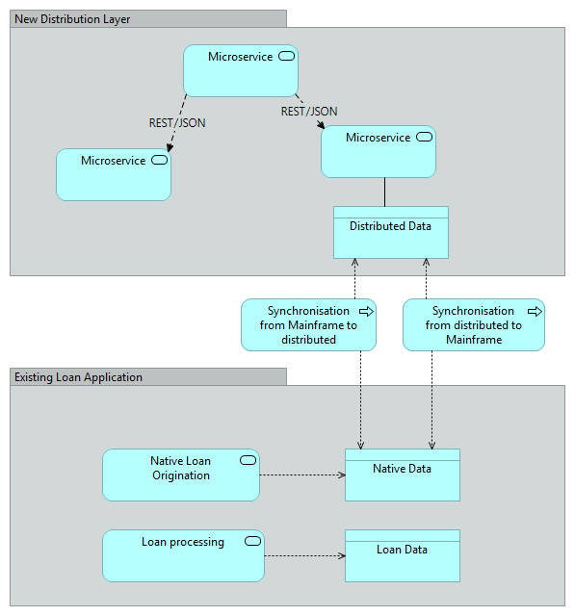

UC6: Coexistence between former integration layer scenario and new integration solution for an existing CICS application already exposed as a webservice
This use case describes a coexistence scenario with an existing Cobol/CICS application that has been exposed as a SOAP/HTTP webservice using the IIB integration layer and the same Cobol/CICS application that needs to be exposed for the applications in cloud as a RESTful API using the new integration pattern relying on the Access Layer.
In this use case, we are considering z/OS Connect EE for the Access Layer. The use case would have been very close with Open Legacy as the solution for the Access Layer.
The following diagram describes the major nodes, software components as well as application components involved in this coexistence use case.
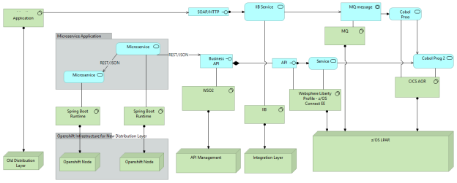
As shown in the diagram hereabove, the same Cobol program will be exposed and will be called through 2 different manners:
- Via MQ using the IIB application. A MQ message will be put by the IIB service, then the CICS transaction will get this message and execute the Cobol program.
- Via z/OS Connect EE when the New Distribution Layer will consume an API exposed through WSO2 and the Access Layer.
Exposing the existing Cobol application as a RESTful API does not require any modification of the application itself, meaning that the exposition of the existing Cobol application will not impact the existing SOAP/HTTP webservice exposition and the IIB flows. And therefore, it will not impact the existing front-end application.
Consequently, the 2 different channels (new and existing distribution layer) will be tied together. As an example, if the Cobol application has to be modified for the applications on cloud platforms, the front-end application of the existing distribution layers will also be impacted. From a DevOps perspective; the lifecycle of the generated artifacts of the 2 integration paths (IIB & z/OS Connect) have to be managed together.
If for any reason, the core legacy applications called by applications on cloud platforms and the existing front-end application need to have their own lifecycle, then the Cobol application will have to be duplicated and there will be 2 distinct instances of the Cobol application with their own DevOps lifecycle. As a recommendation and for a sake of simplicity such situation should be avoided whenever possible.

UC7: Coexistence between former integration layer scenario and new integration solution for an existing CICS application not exposed as a webservice
This use case describes a scenario where the core application consists in several Cobol applications calling each other. In this scenario, the entry point of the core application is exposed as a SOAP/HTTP webservice using the IIB integration layer to the existing front-end application.
During the modernization exercise consisting in refactoring and modularizing the existing core application, one of the called Cobol/CICS application has to be exposed as a RESTful API using the new integration pattern relying on the Access Layer.
In this use case, we are considering z/OS Connect EE for the Access Layer. The use case would have been very close with Open Legacy as the solution for the Access Layer.
The following diagram describes the major nodes, software components as well as application components involved in this coexistence use case.
As shown in the diagram hereabove, a Cobol program calls another Cobol program (Cobol Prog 2). In this use case the calling Cobol application is already exposed via MQ using the IIB application. The MQ message will be put by the IIB service, then the CICS transaction will get this message and execute the Cobol program that will call the second program (Cobol Prog 2).
Let’s assume that the refactorization of the core banking legacy application implied a split between the Cobol programs. Only the “Cobol Prog 2” will be exposed via z/OS Connect EE to the New Distribution Layer and will consume an API exposed through WSO2 and the Access Layer.
Basically, the exposition of the existing Cobol application (“Cobol Prog 2”) as a RESTful API should not require any modification of the application itself, meaning that the exposition of this Cobol application will not impact the existing Cobol calling application.
Like with the previous use case, the applications on cloud platforms and the existing distribution layer will be tied together. If the Cobol application (“Cobol Prog 2”) has to be modified for the applications on cloud platforms, the calling Cobol application may also be impacted. From a DevOps perspective; the lifecycle of the generated artifacts of the 2 integration paths (IIB & z/OS Connect) will have to be managed together.
If for any reason, the Cobol application (“Cobol Prog 2”) and the existing calling Cobol program and existing “Cobol Prog 2” application need to have their own lifecycle, then the “Cobol Prog 2” program will have to be duplicated and there will be 2 distinct instances of this Cobol program with their own DevOps lifecycle. As a recommendation and for a sake of simplicity such situation should be avoided whenever possible.

