**Node Js and Express Js with MySql**

Node.js, Express, and MySQL are commonly used together to build robust, full-stack web applications. Here’s a detailed overview of each component and how they work together.

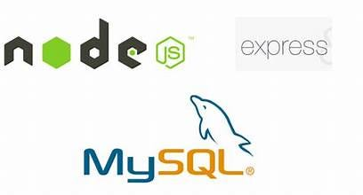

**1. Node.js**

**What is Node.js?**

* Node.js is a JavaScript runtime environment built on Chrome’s V8 JavaScript engine. It allows developers to use JavaScript for server-side scripting, enabling the creation of scalable and high-performance web applications.

**Key Features:**

* **Asynchronous and Event-Driven**: Node.js handles multiple requests without waiting for previous ones to complete, making it highly efficient for I/O-heavy tasks.
* **Single-Threaded but Scalable**: Uses non-blocking I/O operations that allow a single thread to handle multiple concurrent connections.
* **NPM (Node Package Manager)**: Provides access to thousands of libraries and modules that simplify development.
* **Cross-Platform**: Runs on various platforms including Windows, macOS, and Linux.

**Use Cases:**

* Building RESTful APIs
* Real-time applications (e.g., chat apps, online games)
* Command-line tools
* Microservices

**2. Express.js**

**What is Express.js?**

* Express.js is a minimal and flexible Node.js web application framework that provides a robust set of features for building web and mobile applications. It simplifies the process of setting up routes, handling requests, and managing middleware.

**Key Features:**

* **Middleware**: Functions that execute during the lifecycle of a request to the server. They can modify the request and response objects, end requests, or call the next middleware function.
* **Routing**: Easily define URL routes to handle different HTTP methods (GET, POST, PUT, DELETE).
* **Template Engines**: Integrates with various template engines like EJS, Pug, or Handlebars to generate dynamic HTML.
* **Error Handling**: Provides robust mechanisms to manage errors and respond appropriately.
* **Built-in Features**: Simplifies working with cookies, sessions, form data, and file uploads.

**Use Cases:**

* Building APIs
* Single Page Applications (SPA)
* Server-side rendering
* Middleware-based web applications

**3. MySQL**

**What is MySQL?**

* MySQL is an open-source relational database management system (RDBMS) that uses Structured Query Language (SQL) for managing and manipulating data. It’s widely used for its reliability, performance, and ease of use.

**Key Features:**

* **Relational Database**: Stores data in tables with defined relationships, making data retrieval efficient and organized.
* **Scalability**: Supports large databases and high-volume applications.
* **ACID Compliance**: Ensures data integrity through Atomicity, Consistency, Isolation, and Durability properties.
* **Secure**: Provides strong data protection with access control, data encryption, and user authentication.
* **Extensive Support**: Wide community support, extensive documentation, and integration with various programming languages.

**Use Cases:**

* Web applications (e.g., content management systems, ecommerce platforms)
* Data warehousing
* Embedded applications
* Online transaction processing (OLTP)

**How They Work Together**

* **Node.js** provides the runtime environment to execute JavaScript code on the server.
* **Express.js** acts as the web server framework, allowing easy setup of routes, middleware, and request handling.
* **MySQL** is used as the backend database to store, retrieve, and manage application data.

Together, Node.js, Express, and MySQL form a powerful stack for building full-fledged web applications, enabling developers to create server-side logic, manage data efficiently, and handle client requests seamlessly. This combination is particularly effective for building RESTful APIs, data-driven applications, and microservices.

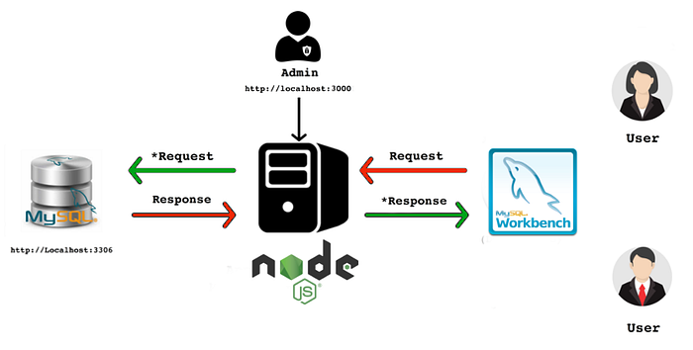

**Step 1: Install MySQL and MySQL Workbench**

* Download MySQL from the official website: [MySQL Downloads](https://dev.mysql.com/downloads/mysql/).
* After installation, add MySQL to your PATH in .zshrc (mac os)

export PATH=$PATH:/usr/local/mysql-9.0.1-macos14-x86_64/bin

* Restart the terminal or source the file:(mac os)

source ~/.zshrc

* Log into MySQL using:

mysql -u root -p

* Create a new database:

CREATE DATABASE mynode;  
SHOW DATABASES;

**Windows installation**

* On windows download the installer .msi and select mysql and work bench with arrow from server and application
* Keep config. as default and use strong password and keep in note
* MySQL80 as service name rest keep it default
* Grant full permission
* Install MySQL Workbench to view and manage your database.

**Download and Install MySQL Workbench (mac os)**

1. **Download MySQL Workbench** from the official MySQL website: [MySQL Workbench Downloads](https://dev.mysql.com/downloads/workbench/).
2. **Install MySQL Workbench** by opening the downloaded .dmg file and dragging the MySQL Workbench icon into your Applications folder.
3. **Launch MySQL Workbench**

* Open **MySQL Workbench** from your Applications folder.
* -Upon first launch, you might be prompted with a security warning; click “Open.”

**Set Up a New Database Connection**

Click on the **“+”** sign next to **“MySQL Connections”** to create a new connection.

**Configure the Connection Settings**:

* **Connection Name**: Give your connection a name (e.g., Local MySQL).
* **Connection Method**: Choose Standard (TCP/IP).
* **Hostname**: localhost (if running MySQL locally).
* **Port**: 3306 (default port for MySQL).
* **Username**: root (or the user you've set up).
* **Password**: Click **“Store in Keychain”** and enter your MySQL password

**Test Connection**:

* Click **“Test Connection”** to verify that the connection settings are correct.
* If the connection is successful, you’ll see a confirmation message. If not, double-check your hostname, port, username, and password.
* Click **“OK”** to save the connection.

**Connect to the Database**

* After saving the connection, you’ll see it listed under **MySQL Connections** on the main screen.
* **Double-click the connection** you just created (Local MySQL) to connect to your MySQL server

Now, you can perform

* Creating a Database and Tables from workbench
* Importing and Exporting Data
* Managing Users and Permissions
* Backing Up Your Database

**Step 2: Setup Node.js Project with Typescript**

* Install Node.js and npm on your machine.
* Verify installations:

node -v  
npm -v

* Initialize a new project and install Express:

npm init -y  
npm install mysql2  
npm install express typescript ts-node @types/node @types/express --save-dev

* Create and update tsconfig.json

npx tsc – init

{  
 "compilerOptions": {  
 "target": "es6",  
 "module": "commonjs",  
 "outDir": "./dist",  
 "strict": true,  
 "esModuleInterop": true,  
 "skipLibCheck": true,  
 "forceConsistentCasingInFileNames": true  
 },  
 "include": ["src/**/*.ts"],  
 "exclude": ["node_modules"]  
}

**Project Structure**

* /node-mysql-app

│  
├── controllers  
│ └── employee.ts  
│  
├── routes  
│ └── employee.ts  
│  
├── database  
│ └── db.ts  
│ └── config.ts  
|  
├── helper  
│ └── helper.ts  
|  
└── index.tsx

**Step 3: Database Connection (src/**database/db.ts**)**

import mysql from "mysql2/promise";  
import config from "./config";  
async function query(sql:string, params:any) {  
 const connection = await mysql.createConnection(config.db);  
 const [results] = await connection.query(sql, params);  
 return results;  
}  
   
export default {  
 query,  
};

**Step 4: Define config (src/**database/config.ts**)**

const config = {  
 db: {  
 host: "localhost",  
 user: "root",  
 password: "admin",  
 database: "nodemysql",  
 },  
 port: 3000,  
 listPerPage: 100  
};  
export default config;

**Step 5: Define Routes (src/**routes/employee.js**)**

with all CRUD operation

import express, { NextFunction, Request, response, Response } from "express";  
import employee from "../controller/employee";  
  
const router = express.Router();  
//create employee  
router.post(  
 "/create",  
 async (req: Request, res: Response, next: NextFunction) => {  
 try {  
 res.status(200).json(await employee.create(req.body));  
 } catch (err) {  
 next(err);  
 }  
 }  
);  
// get employee by id  
  
router.get("/all", async (req: Request, res: Response, next) => {  
 try {  
 const emp = await employee.getAllEmployees(req);  
 res.json(emp);  
 } catch (err: any) {  
 console.error(`Error while getting Records `, err.message);  
 next(err);  
 }  
});  
  
//update employee by id  
  
router.put("/:id", async (req: Request, res: Response, next: NextFunction) => {  
 try {  
 const emp = await employee.update(req.params.id, req.body);  
 res.json(emp);  
 } catch (err: any) {  
 console.error(`Error while getting Records `, err.message);  
 next(err);  
 }  
});  
  
// Delete employee by id  
router.delete("/:id", async (req: Request, res: Response,next:NextFunction) => {  
 try {  
 const emp = await employee.remove(req.params.id);  
 res.json(emp);  
 } catch (err: any) {  
 console.error(`Error while getting Records `, err.message);  
 next(err);  
 }  
});  
  
export default router;

**Step 6: Create Controller (src/**controllers/employee.ts**)**

import db from "../database/db";  
import { emptyOrRows } from "../helper/helper";  
import { IEmployee } from "../models/IEmployee";  
  
async function getAllEmployees(req: any): Promise<IEmployee[]> {  
 const rows = await db.query(`SELECT * FROM employee`);  
 const data: IEmployee[] = emptyOrRows(rows);  
 return data;  
}  
async function getEmployeeByID(req: any): Promise<IEmployee[]> {  
 const rows = await db.query(  
 `SELECT * FROM employee WHERE id=${req.params.id}`  
 );  
 const data: IEmployee[] = emptyOrRows(rows);  
 return data;  
}  
async function create(payload: any): Promise<Object> {  
 const data = {  
 name: payload.name,  
 email: payload.email,  
 };  
 const result: any = await db.query(`INSERT INTO employee SET ?`, data);  
 let message = "Error in creating Record";  
 if (result.affectedRows) {  
 message = "Record created successfully";  
 }  
 return { message };  
}  
async function update(id: string, payload: any): Promise<Object> {  
 const data = {  
 name: payload.name,  
 email: payload.email,  
 };  
 const result: any = await db.query(`UPDATE employee SET? WHERE id = ?`, [  
 data,  
 id,  
 ]);  
 let message = "Error in updating Record";  
 if (result.affectedRows) {  
 message = "Record updated successfully";  
 }  
 return { message };  
}  
async function remove(id: string): Promise<Object> {  
 const result: any = await db.query(`DELETE FROM employee WHERE id=?`, [id]);  
 let message = "Error in deleting Record";  
 if (result.affectedRows) {  
 message = "Record deleted successfully";  
 }  
 return { message };  
}  
export default {  
 getAllEmployees,  
 create,  
 update,  
 remove,  
 getEmployeeByID,  
};

**Step 7: Main Server File (src/**index.ts**) and package.json**

import express, { NextFunction, Request, Response } from "express";  
const app = express();  
import db from "./database/config";  
import employee from "./routes/employee";  
const port = db.port;  
app.use(express.json());  
app.use(express.urlencoded({ extended: true }));  
   
app.use("/employee", employee);  
/* Error handler middleware */  
app.use((err: any, req: Request, res: Response, next: NextFunction) => {  
 const statusCode = err.statusCode || 500;  
 res.status(statusCode).json({ message: err.message });  
 return;  
});  
app.listen(port, () => {  
 console.log(`Example app listening at http://localhost:${port}`);  
});

Create Helper file at **src/helper/helper.ts** to check the empty rows form the database response.

export function emptyOrRows(rows: any) {  
 if (!rows) {  
 return [];  
 }  
 return rows;  
}

* **Update the package.json**

"main": "index.ts",  
...   
"scripts": {  
 "test": "echo \"Error: no test specified\" && exit 1",  
 "start": "ts-node src/index.ts",  
 "build": "tsc",  
 "serve": "node dist/index.js"  
 },

* **Start the server:**

node index.js

* Open your browser/postman and visit http://localhost:3000/create to create the employee .

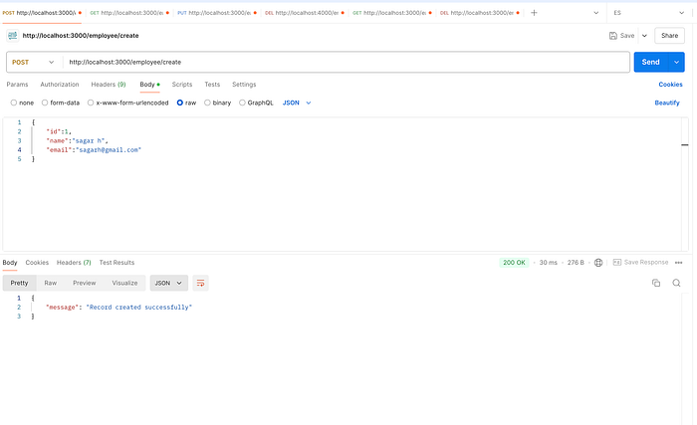

Now, View database and table to see the records in mysqlworkbench

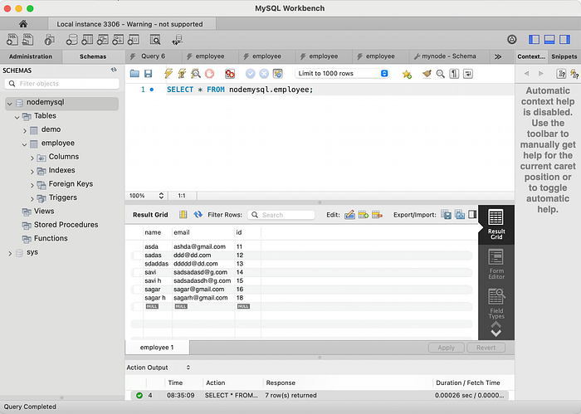

**Conclusion**

We now have a functioning API server that uses Node.js and MySQL with TYpoescript. This tutorial taught us how to set up MySQL and MySQL Workbench as a free service. We then created an Express.js server that can handle various HTTP methods (GET, POST,PUT,DELETE) concerning how it translates to SQL queries.

Happy Coding ….!

**Github Project :** <https://github.com/sagarhudge/Node-Express-Mysql>