User Manual – Si5351 + ATtiny1614 Frequency Generator

1. Introduction
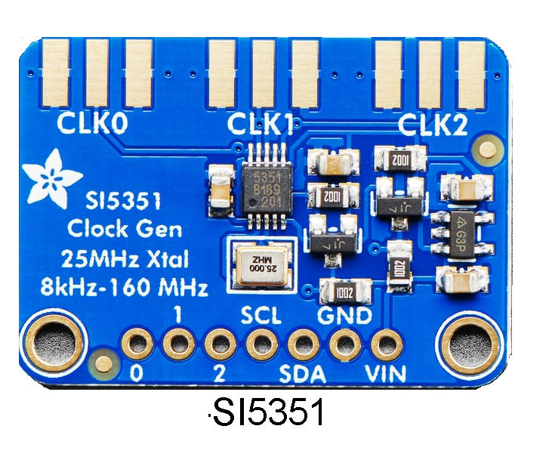This frequency generator is built around the ATtiny1614 microcontroller and the Si5351 clock generator module, capable of producing three independent outputs (CLK0, CLK1, CLK2) with frequencies ranging from 8 kHz to 150 MHz. The user interface consists of a 16x2 I2C LCD display and a rotary encoder with push button. The device allows frequency adjustment, step selection, output enable/disable, and crystal calibration.

2. User Interface
[ATtiny1614 Pinout]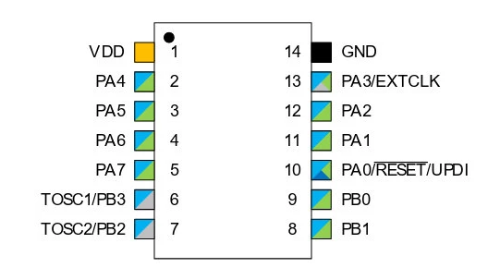

[Rotary Encoder]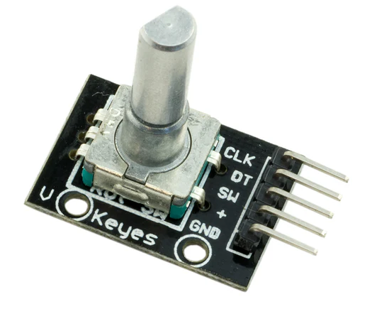
[LCD 1602 I2C] 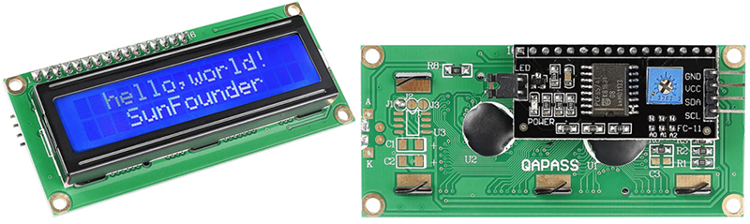
- Rotary encoder: navigation and value adjustment
- Encoder button: selection and return
- 16x2 LCD: displays menus and values

3. Menu Navigation
- Rotate encoder: change option
- Press encoder: enter submenu or confirm
- "bak": return to previous menu

4. Main Menu
At startup, the following options are available: CLK0, CLK1, CLK2, and Calib. Rotate the encoder to select, press to enter.

5. CLK Menu
- Each output provides:
- Freq (frequency adjustment)
- OnOff (enable/disable)
- Step (step size selection)
- bak (return)

6. Frequency Editing
Frequency is adjusted by rotating the encoder. Limits: 8 kHz – 160 MHz. Display format: MHz with 6 decimals, kHz with 3 decimals. Frequency is automatically saved to EEPROM.

7. Step Selection
- Available steps:
- 1 Hz
- 10 Hz
- 100 Hz
- 1 kHz
- 10 kHz
- 100 kHz
- 1 MHz

8. Output Enable/Disable
Allows switching each CLK output between ON and OFF.

9. Calibration Menu
Allows adjusting the Si5351 crystal calibration value. Changes apply in real time and are saved automatically.

10. EEPROM Storage
- Automatically stored:
- Frequencies
- ON/OFF state
- Selected step
- Calibration value

11. Frequency Display Format
- MHz: X.YYYYYYMHz
- kHz: XXX.XXXkHz

12. Recommendations and Limits
- Do not set frequencies below 8 kHz
- Do not exceed 160 MHz
- Use a high-quality 25 MHz crystal
- Recalibrate periodically if drift is observed

