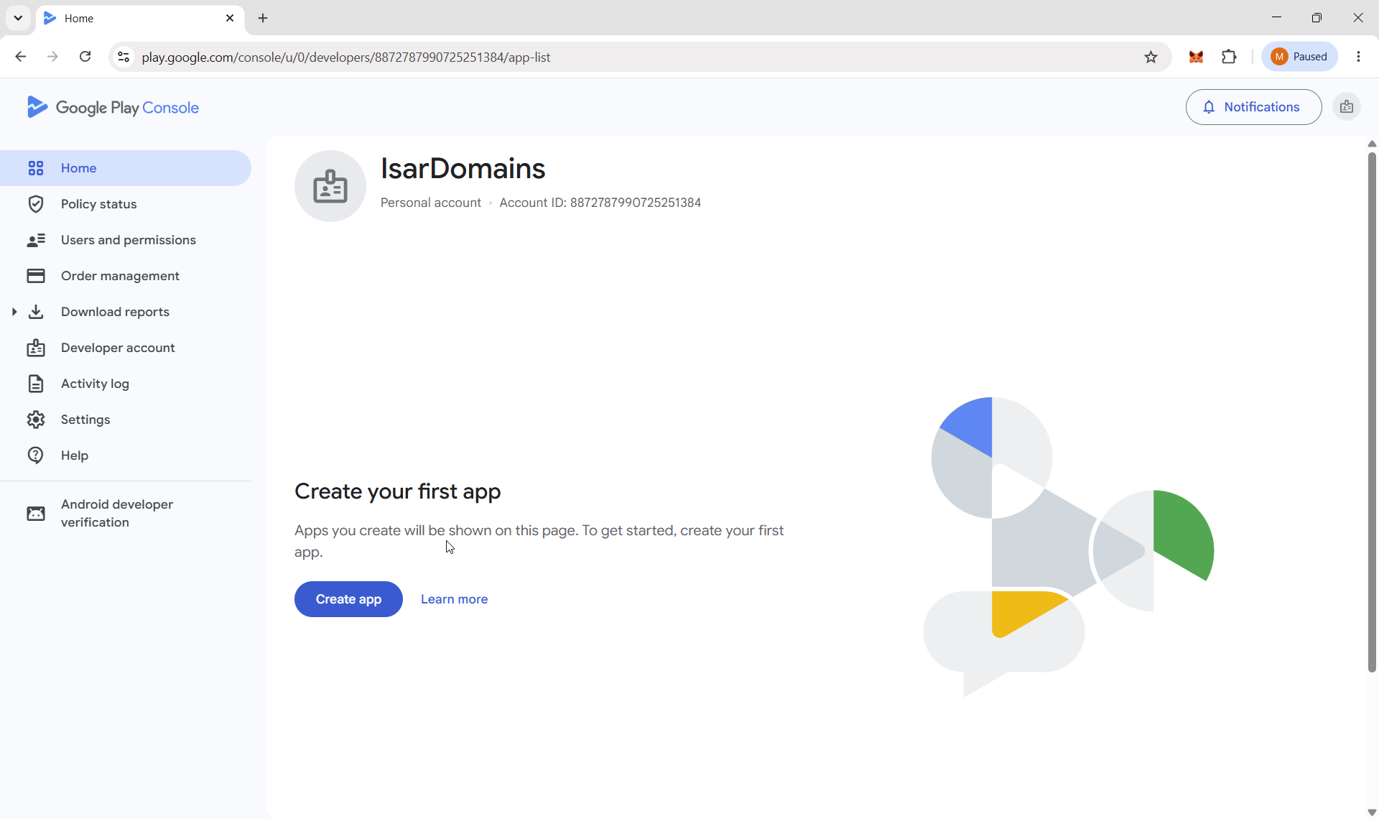
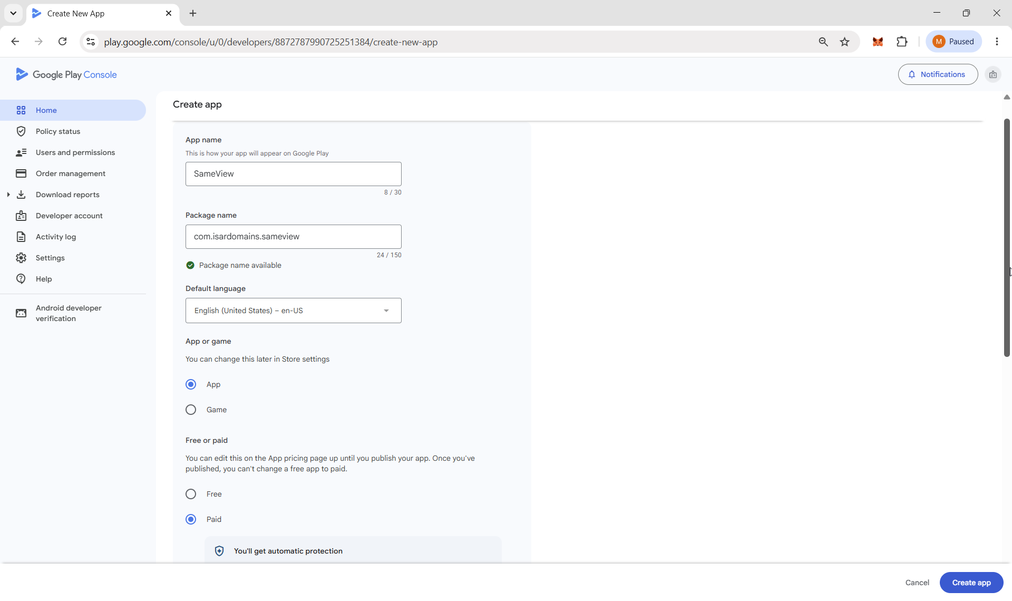
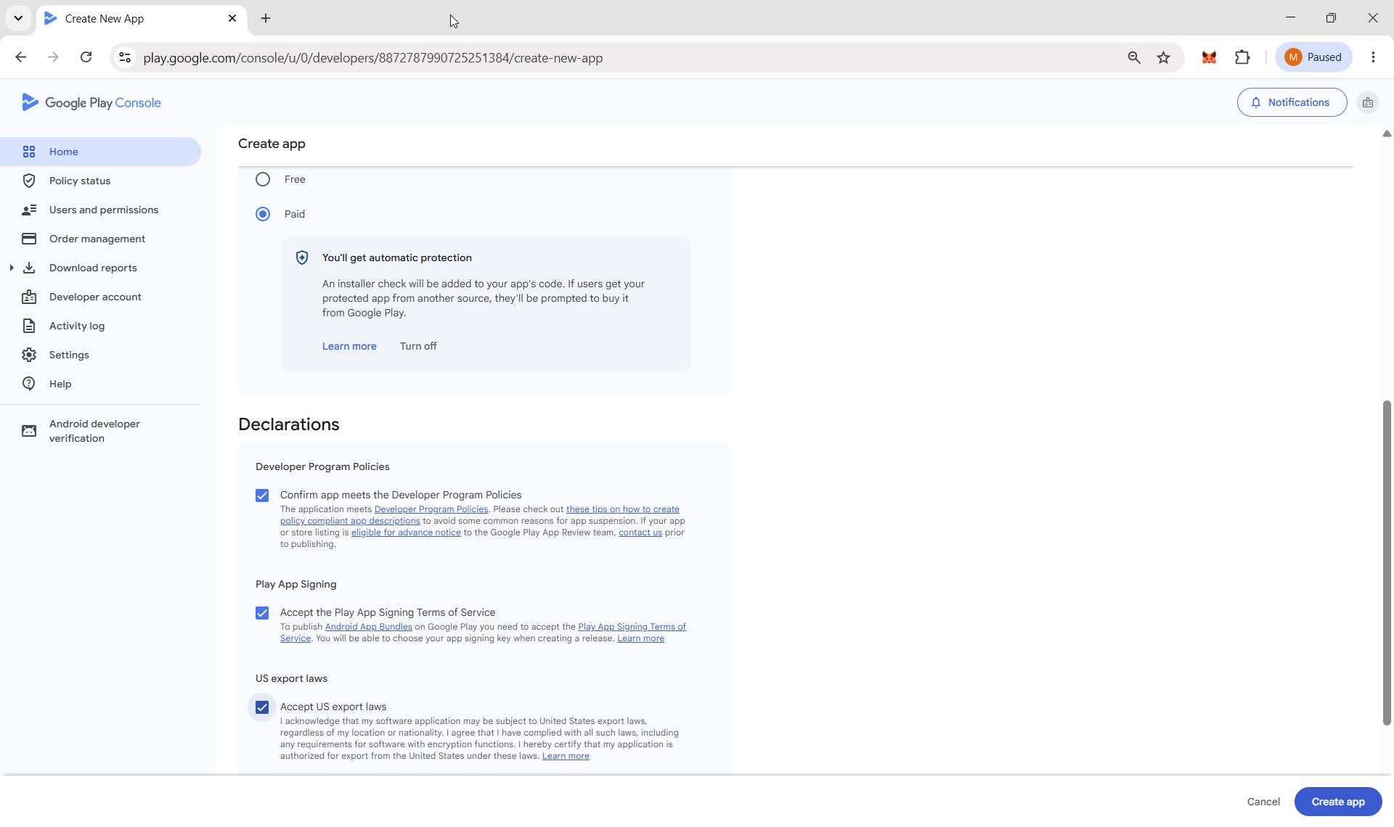

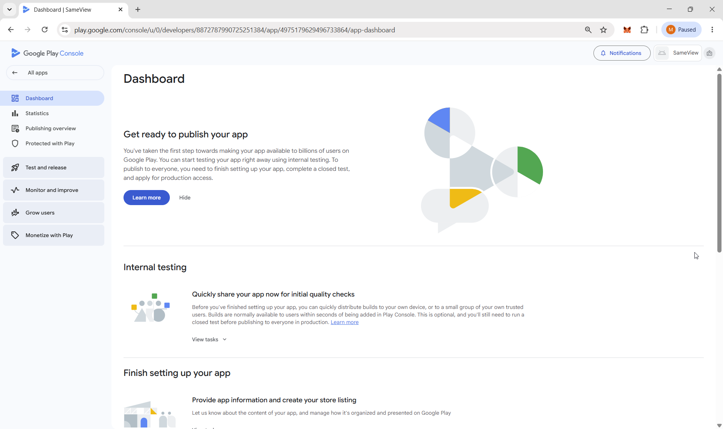
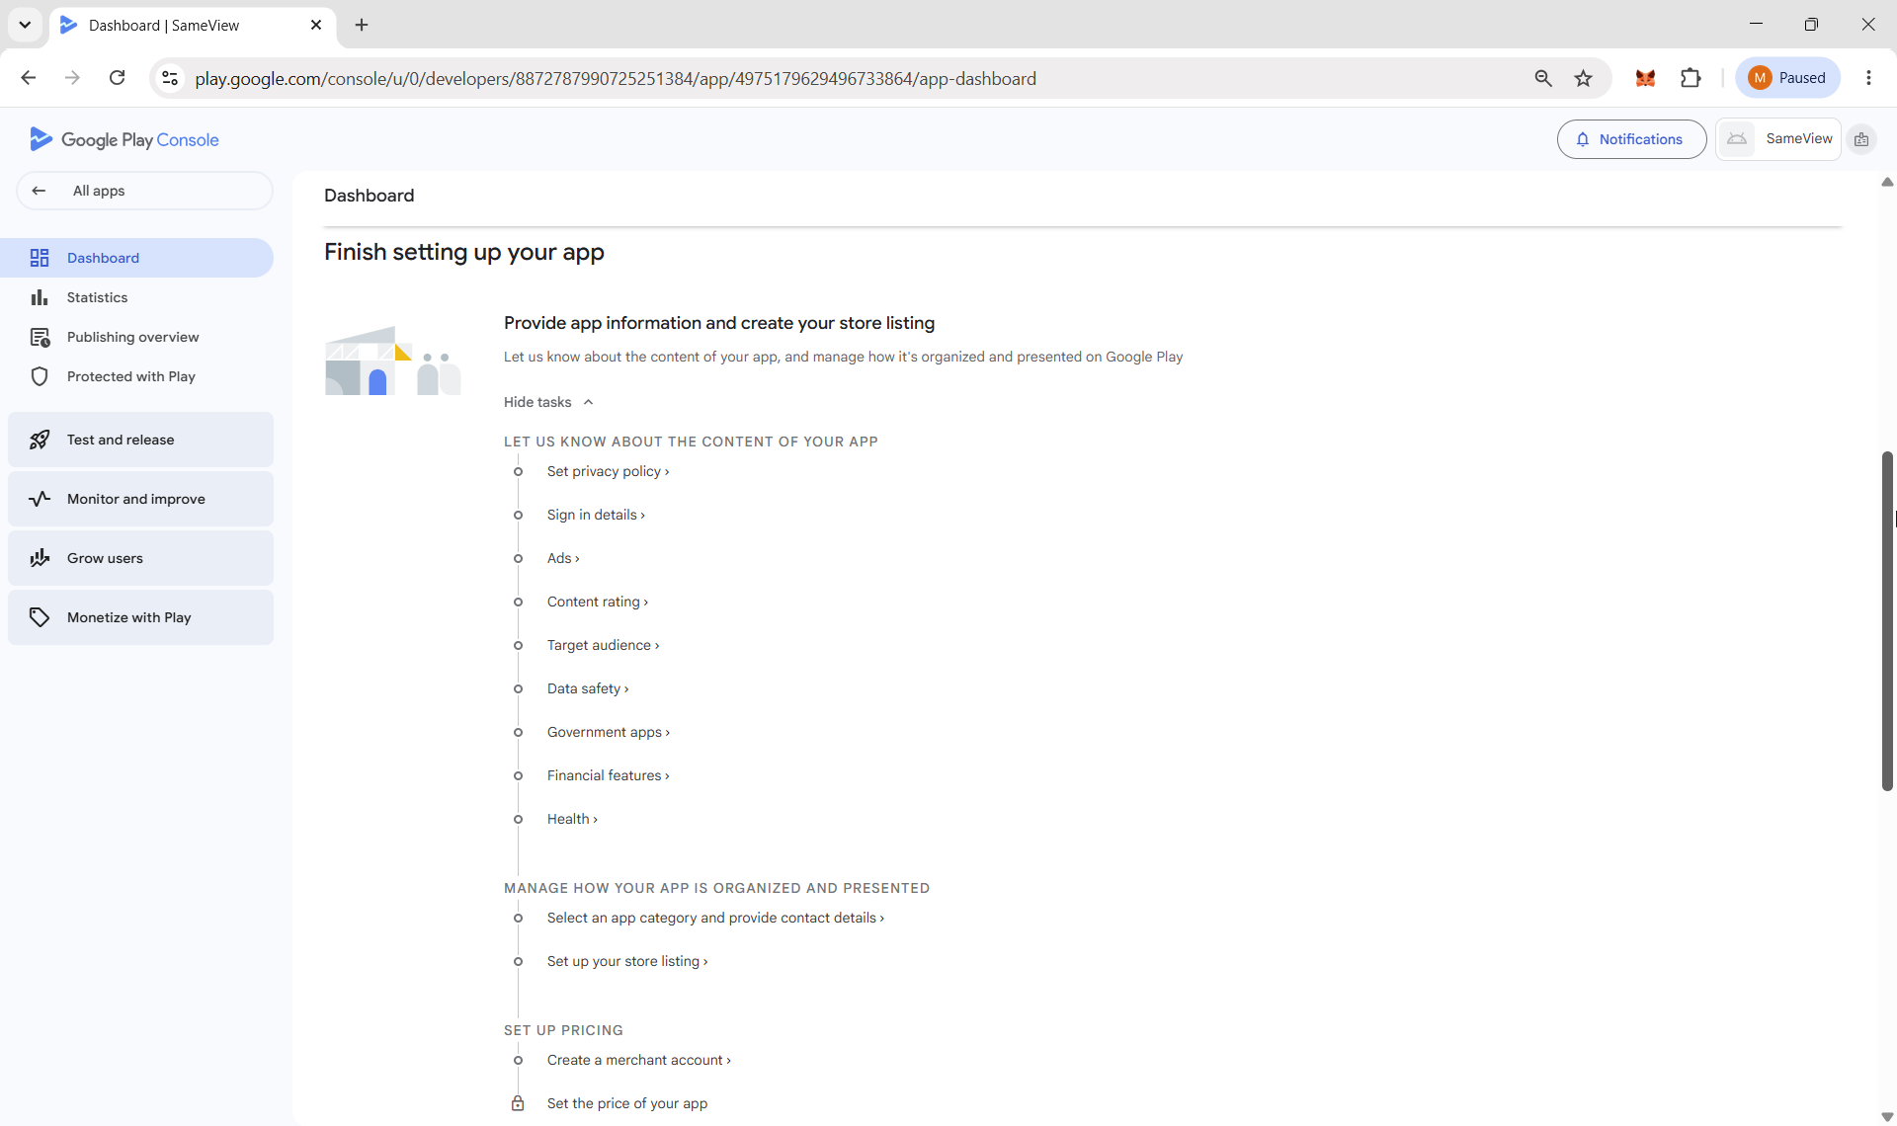

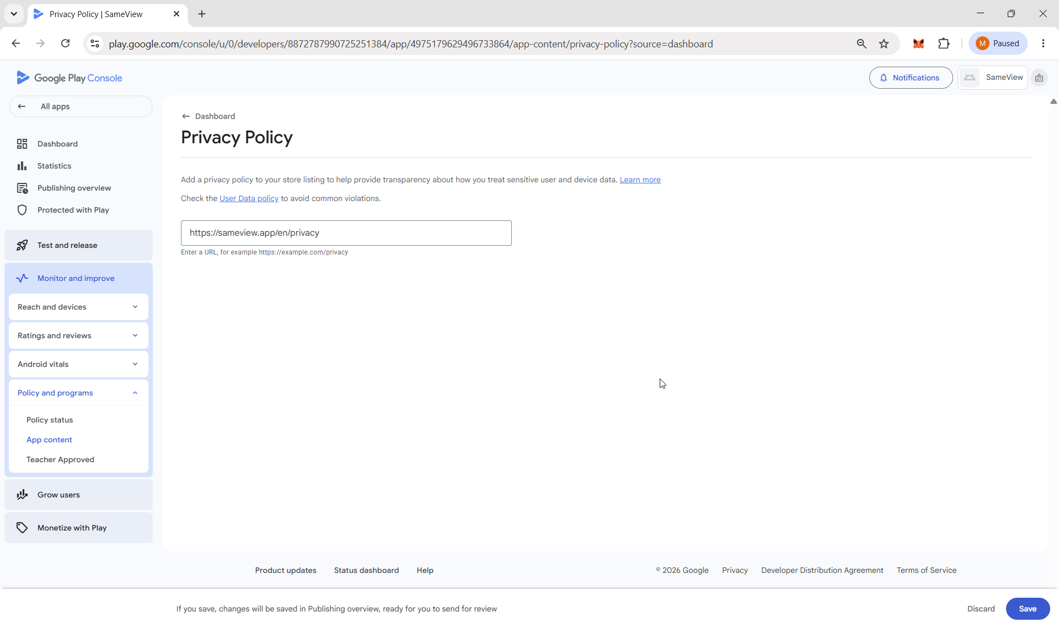
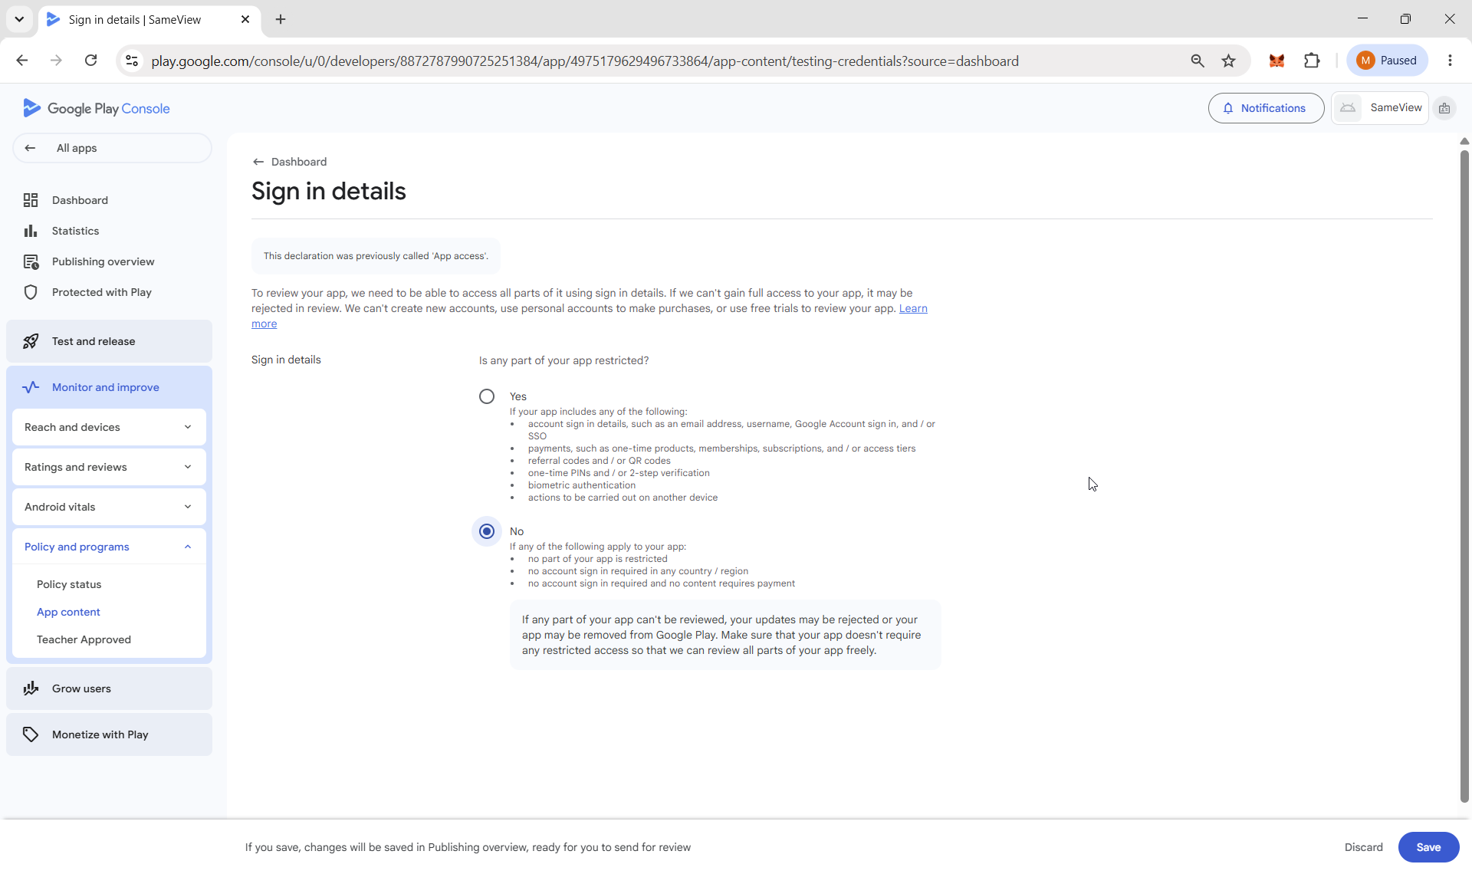

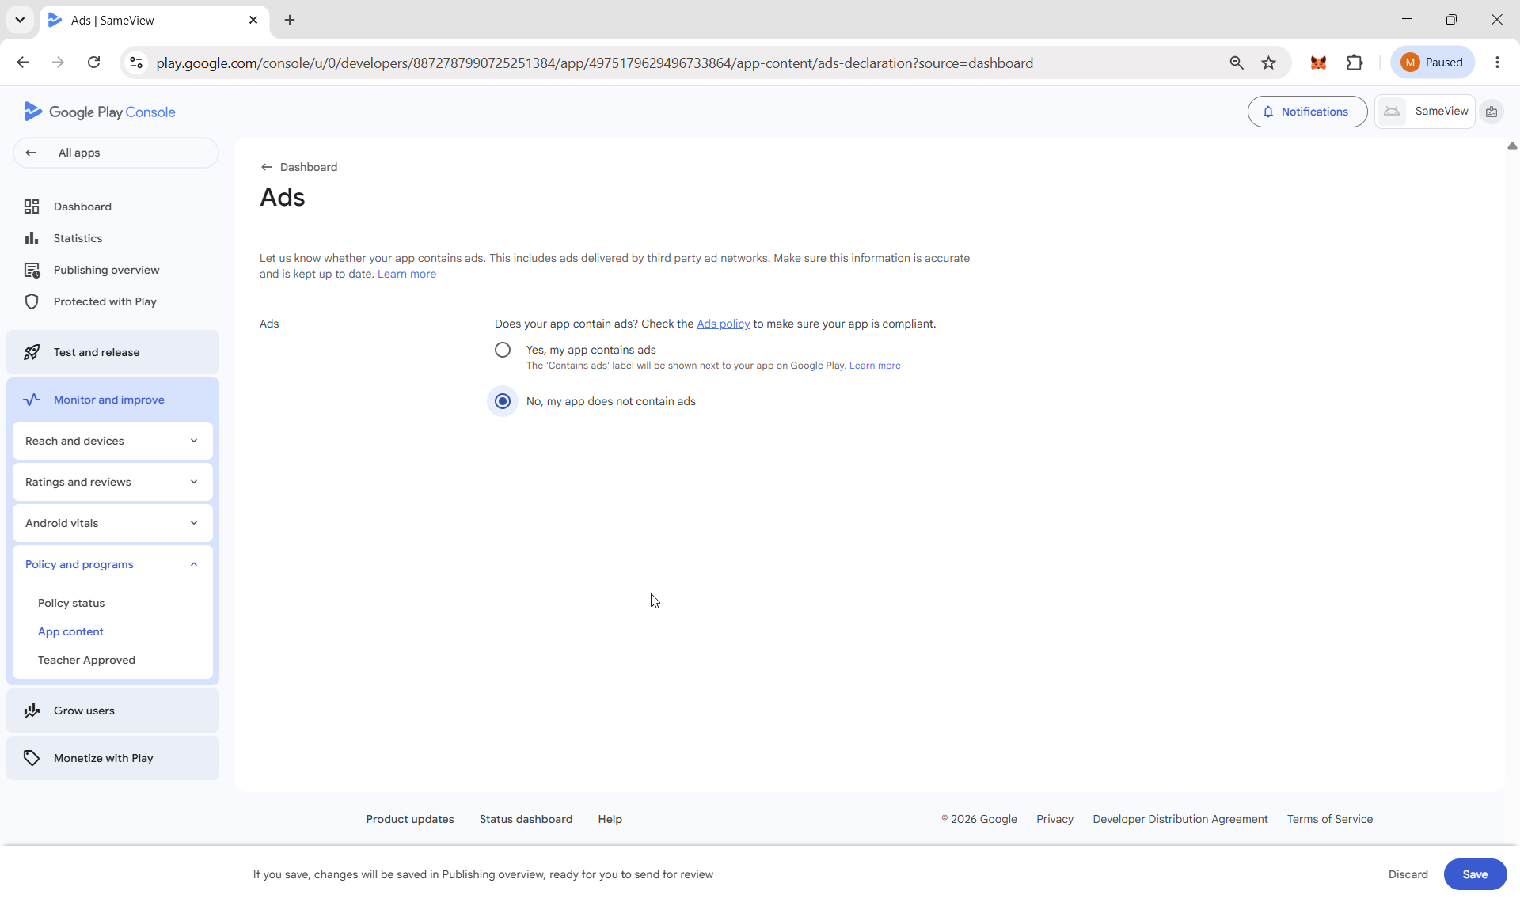

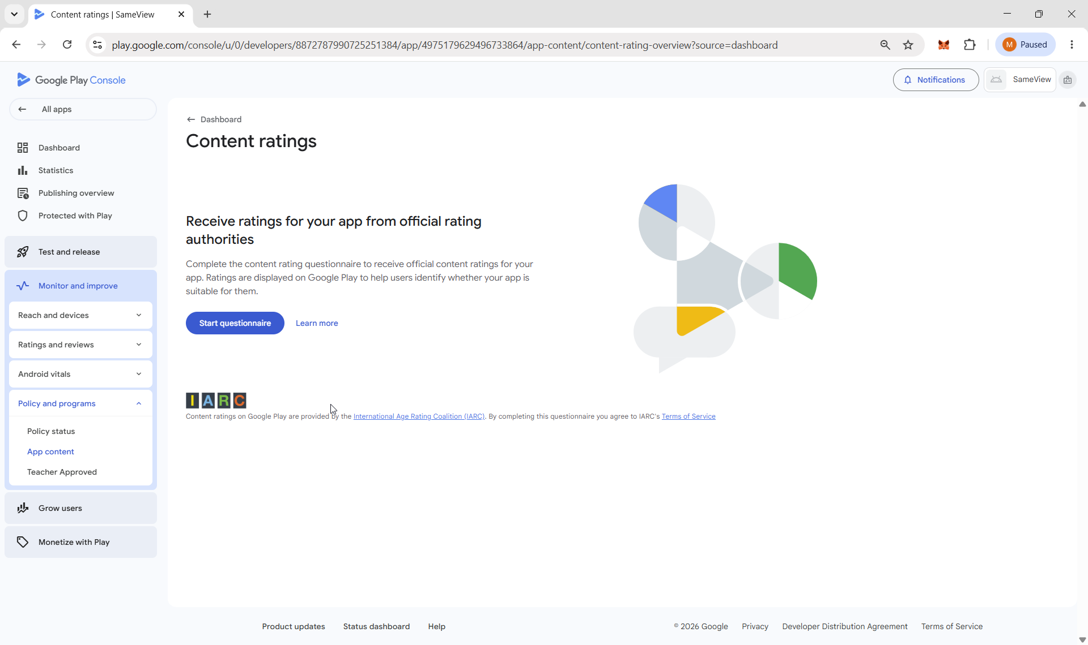

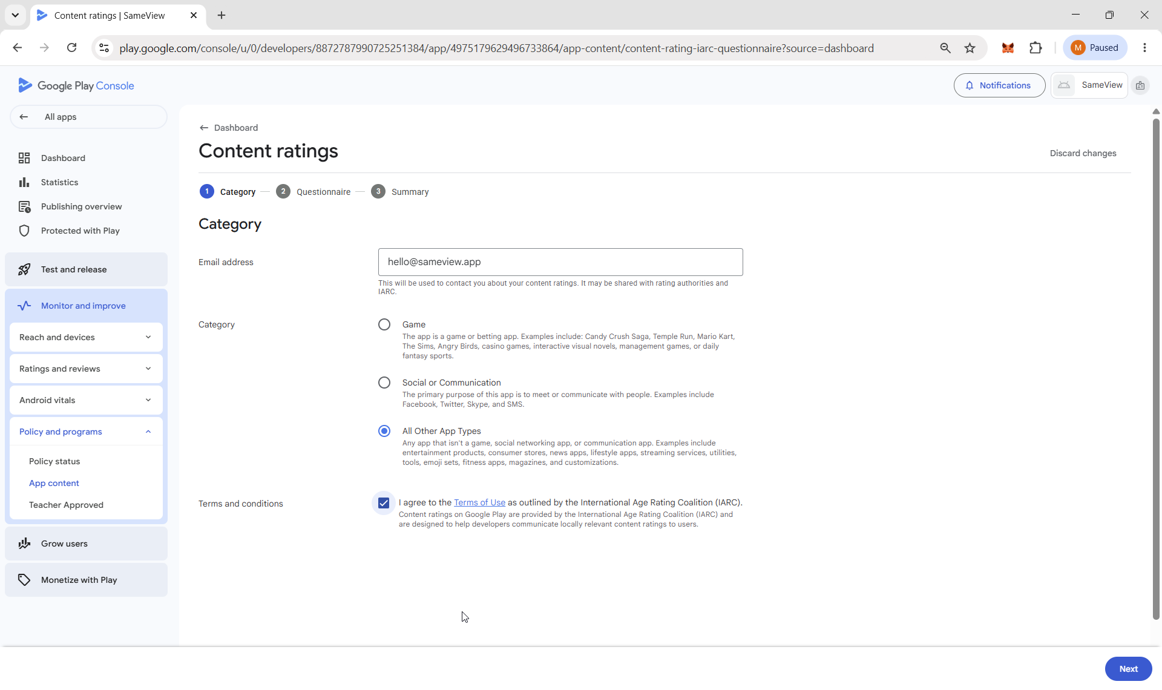

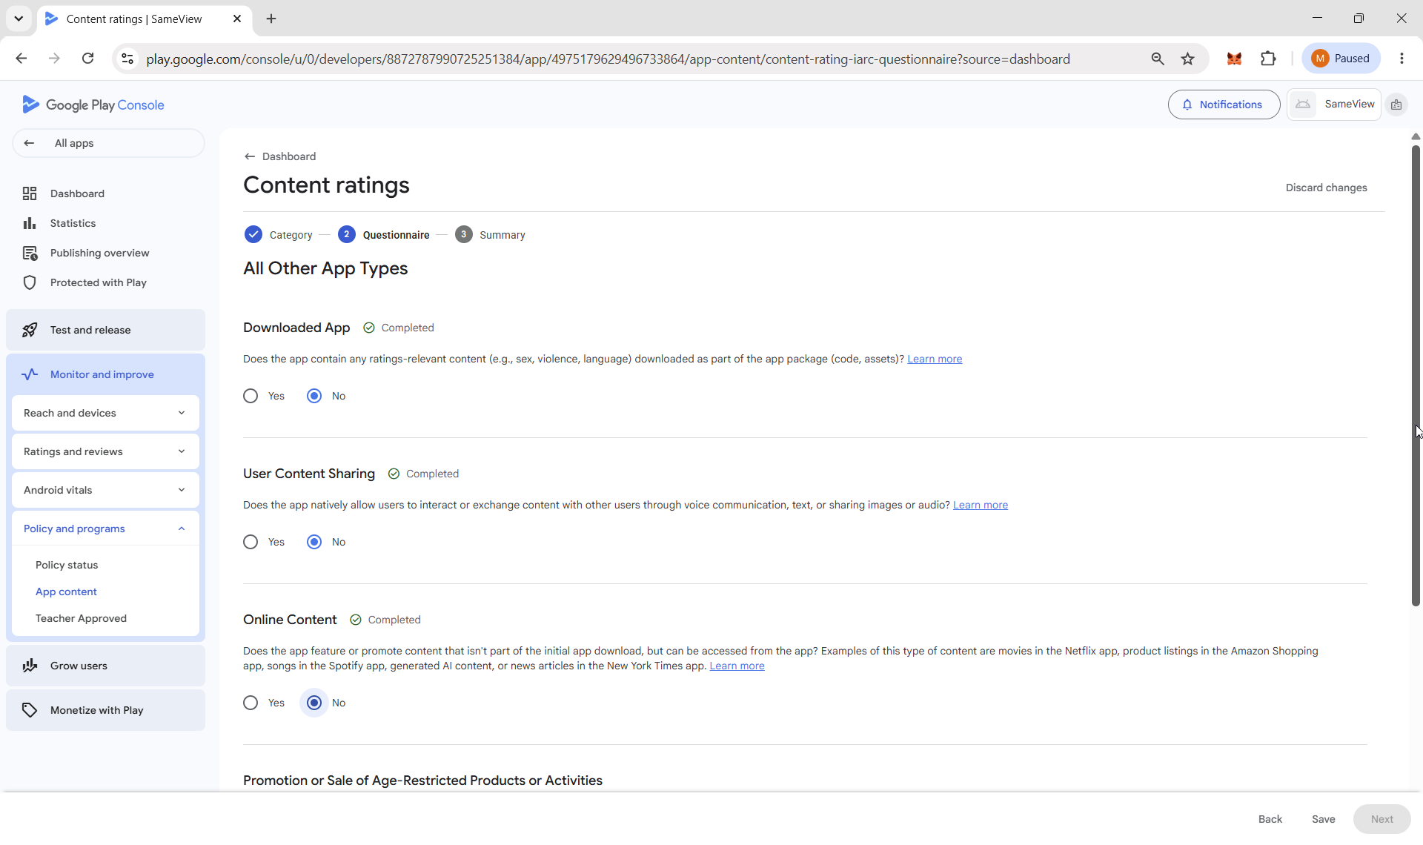

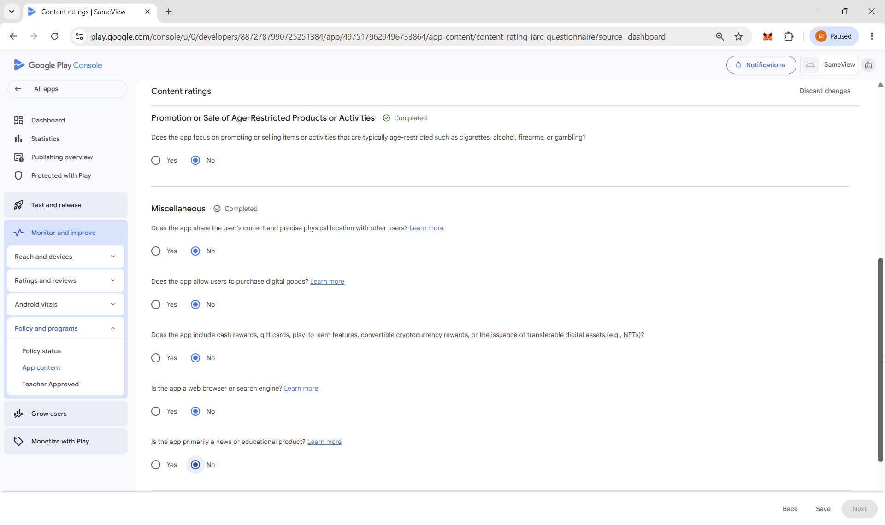

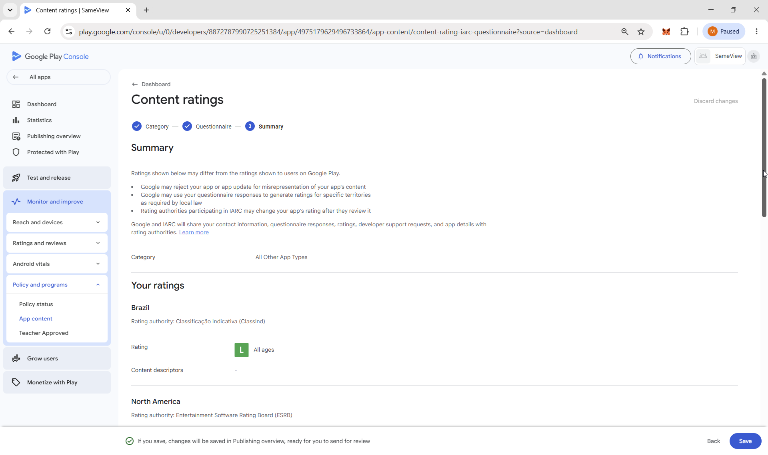

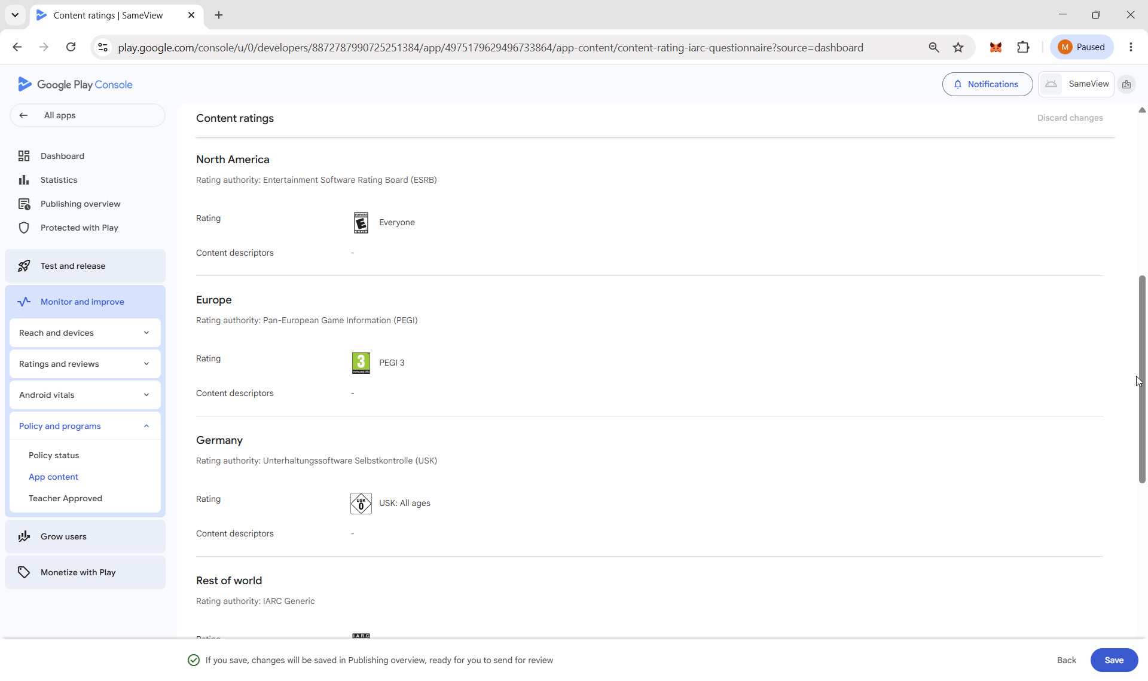

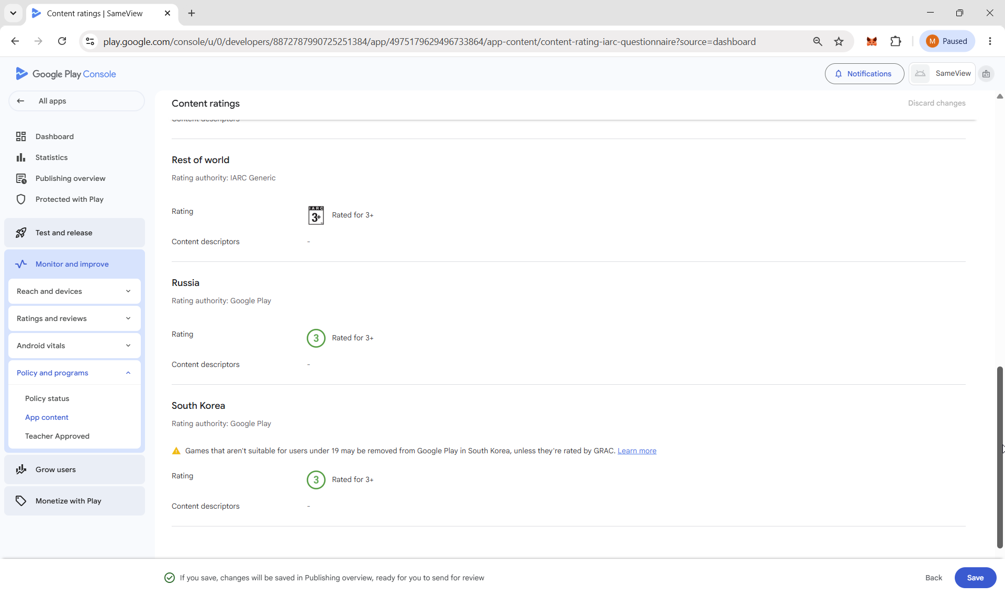

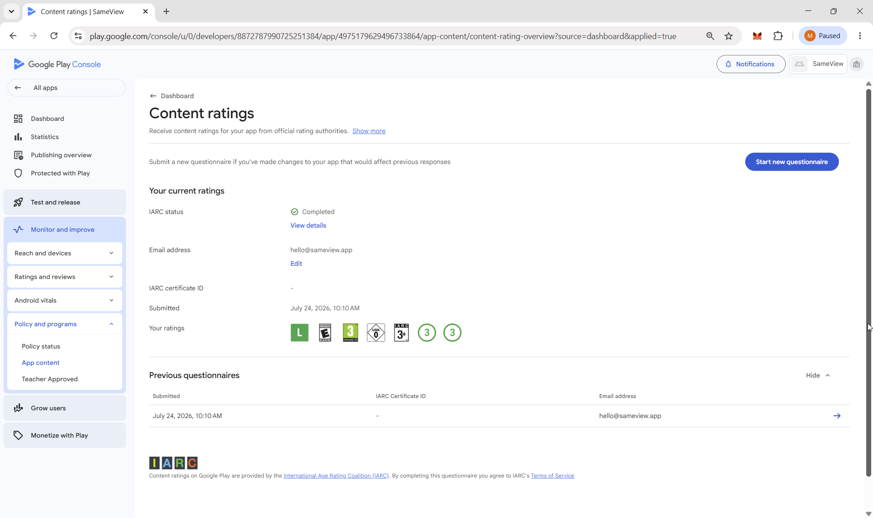

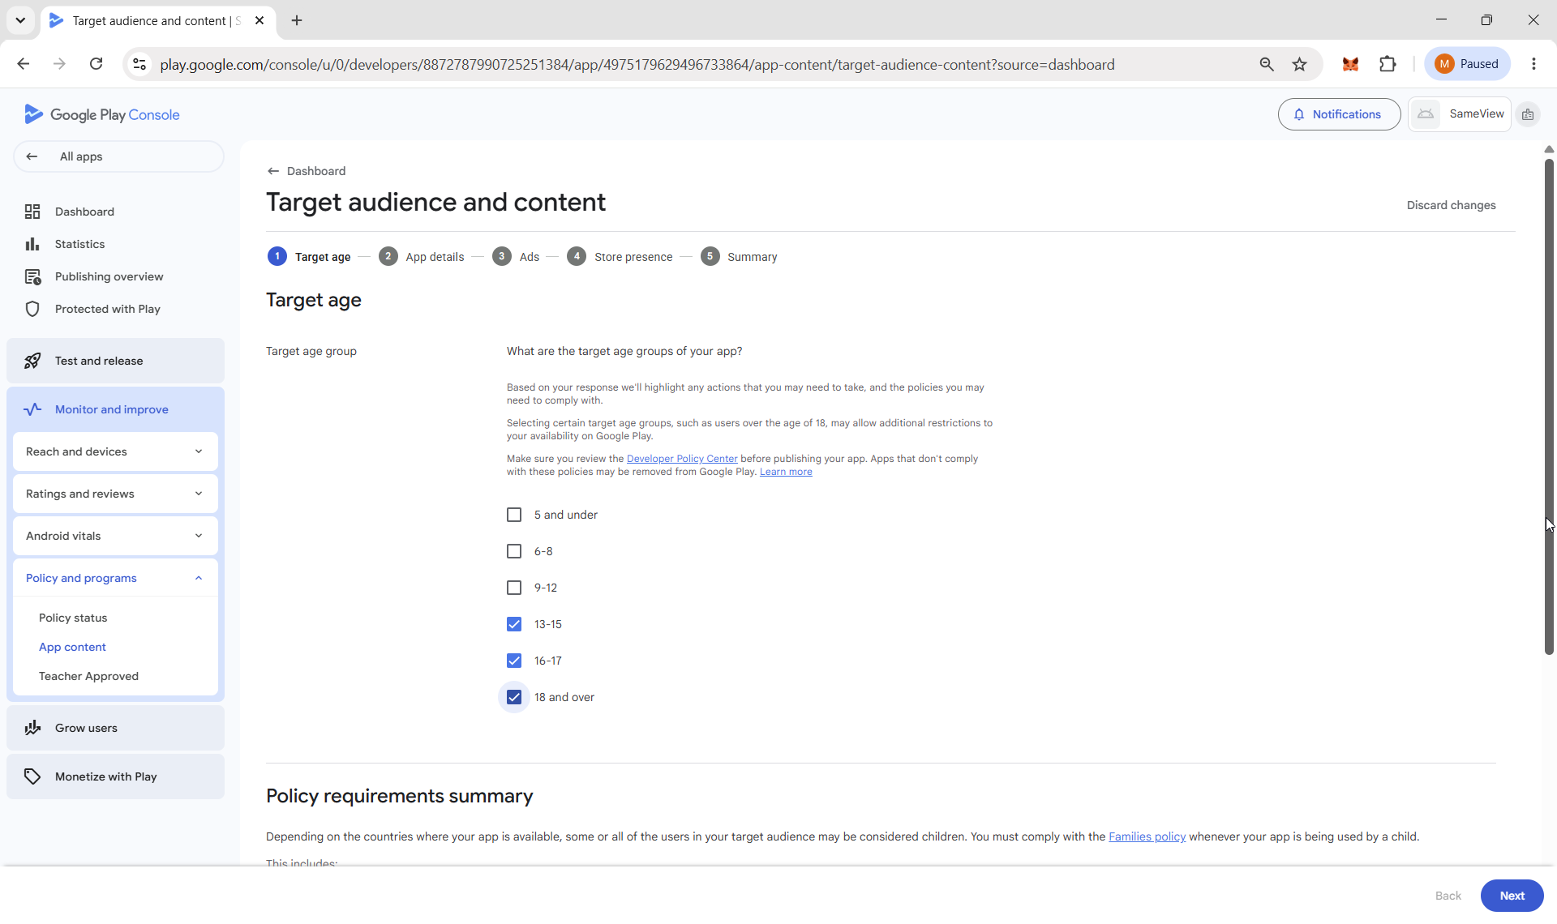

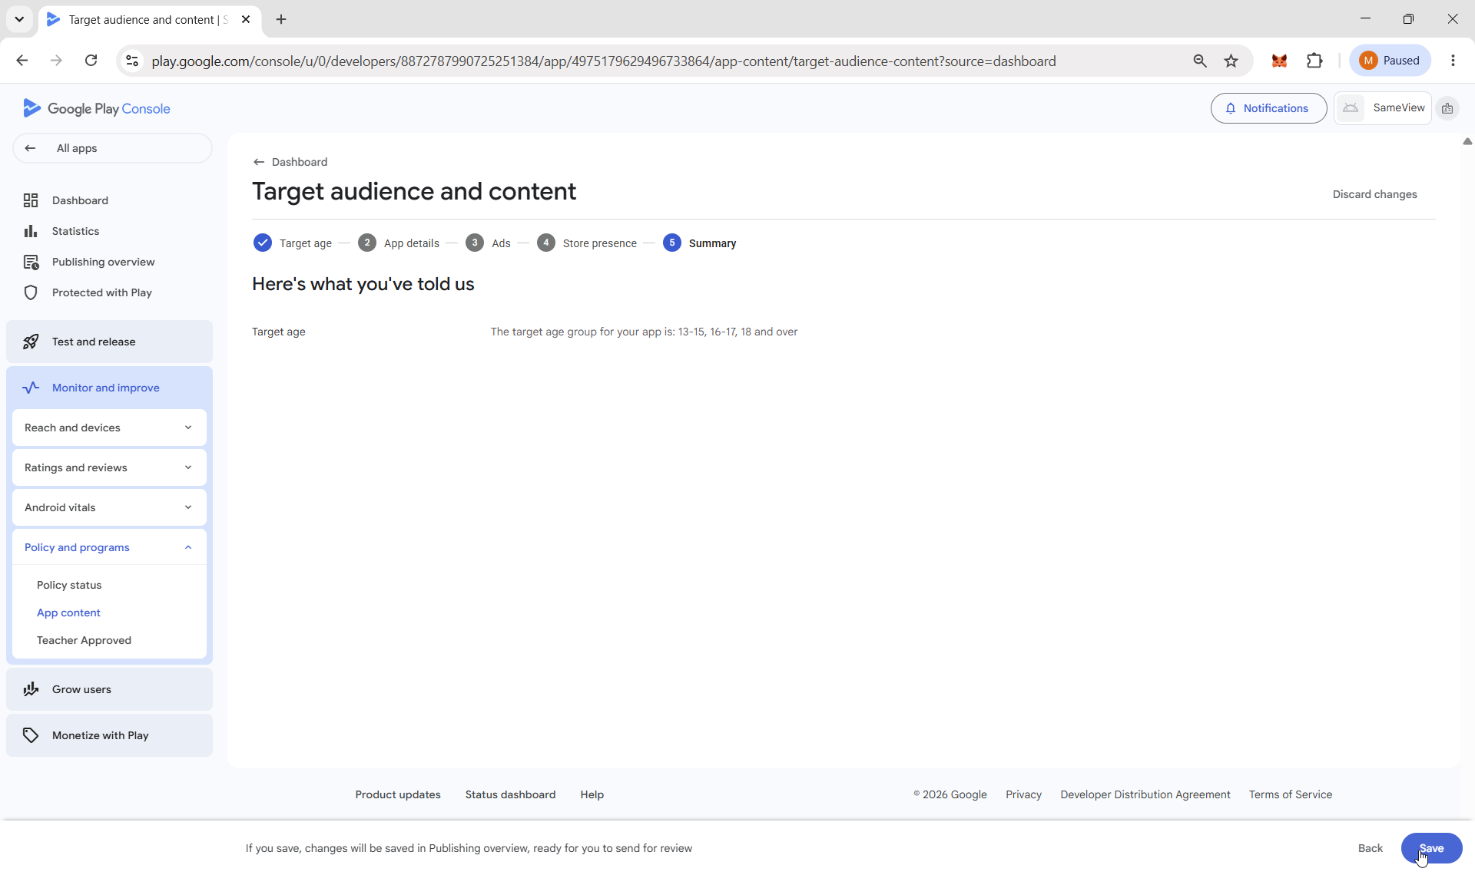

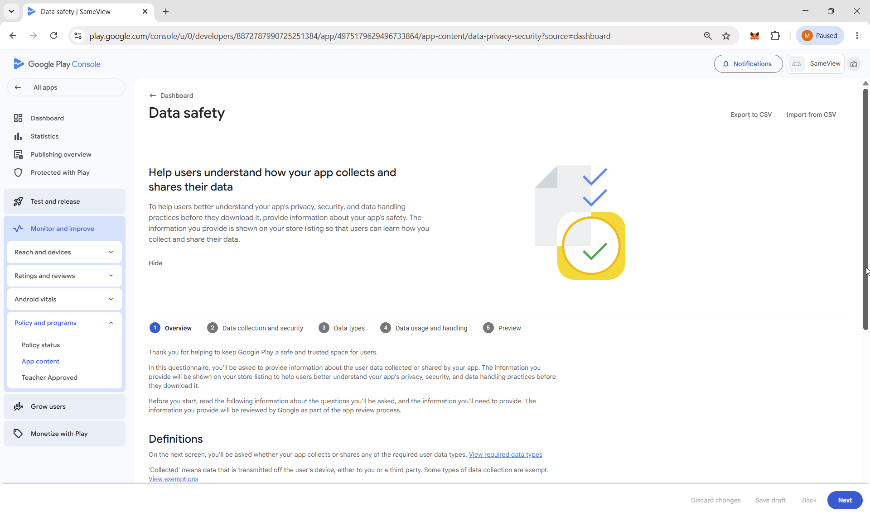

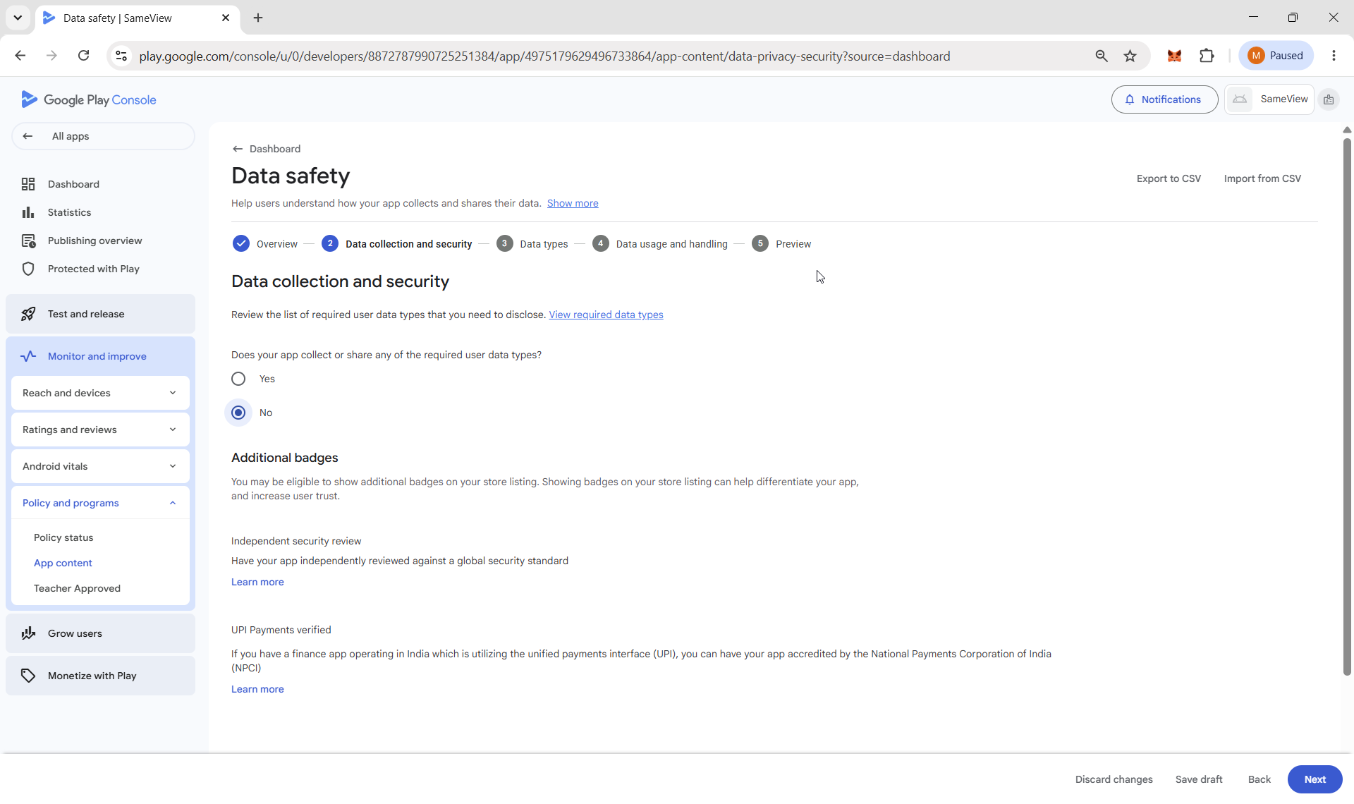

No data types are selected because SameView processes all user data exclusively on the user's device. The app has no INTERNET permission, does not transmit data off-device, and therefore does not collect or share user data as defined by the Google Play Data Safety policy.
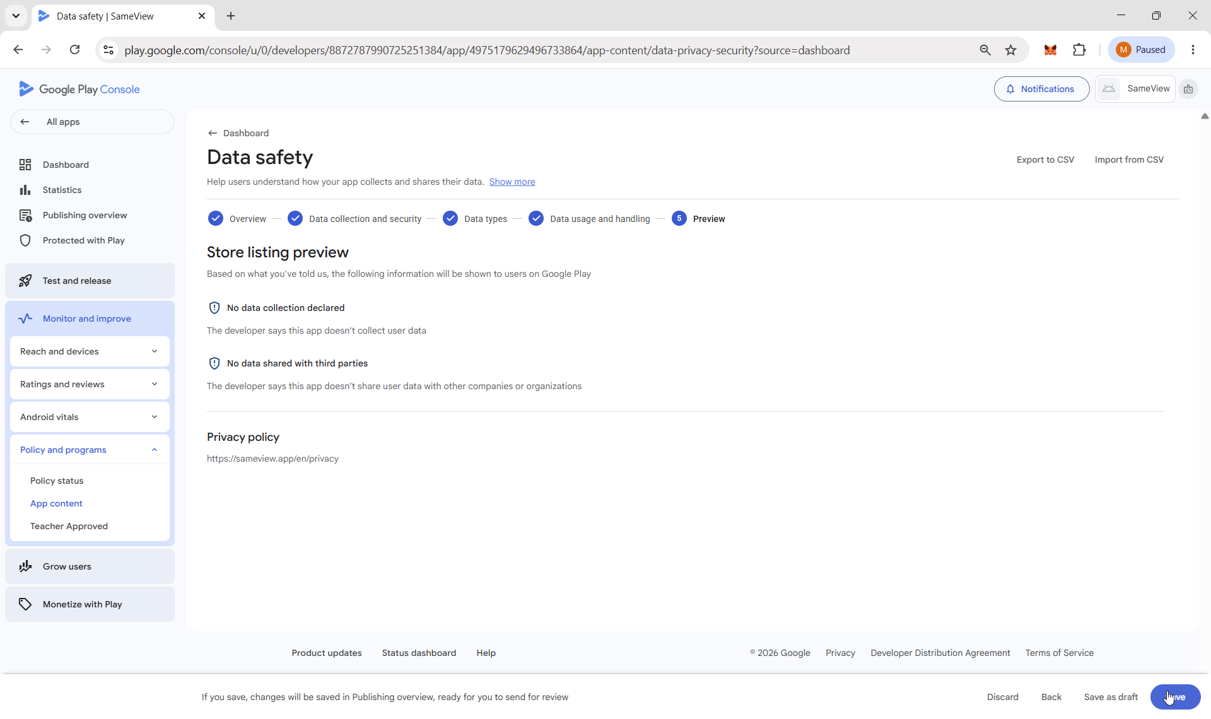

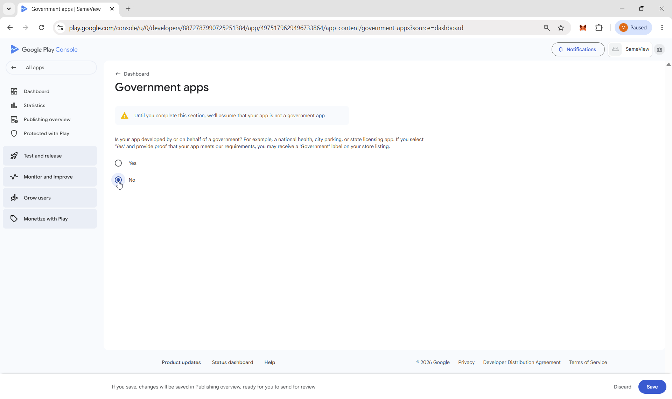

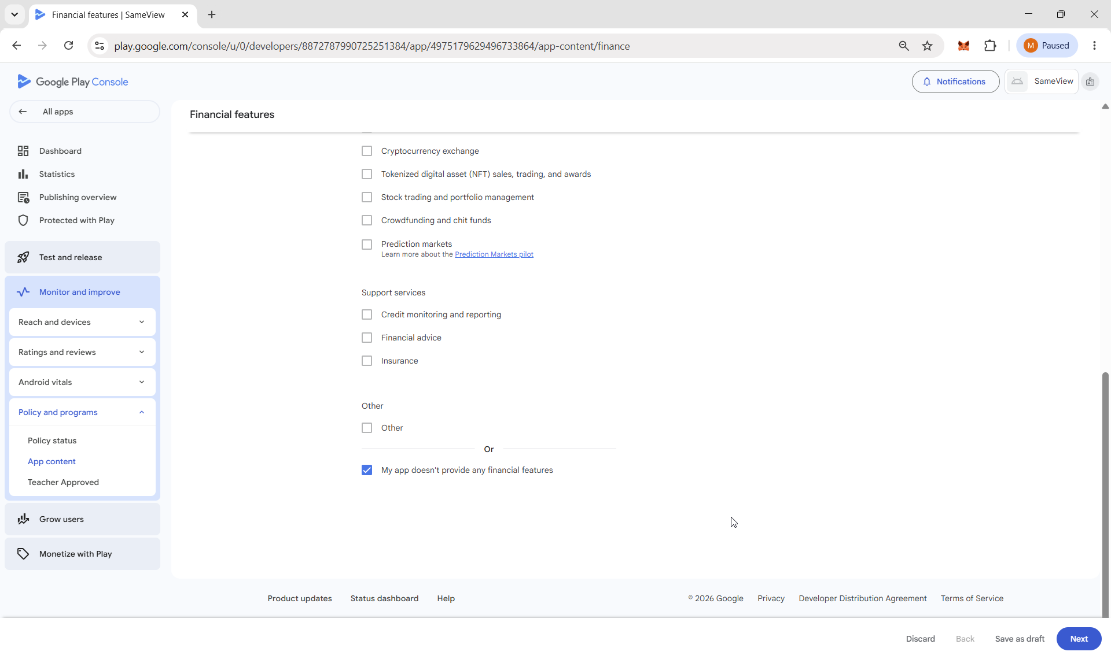

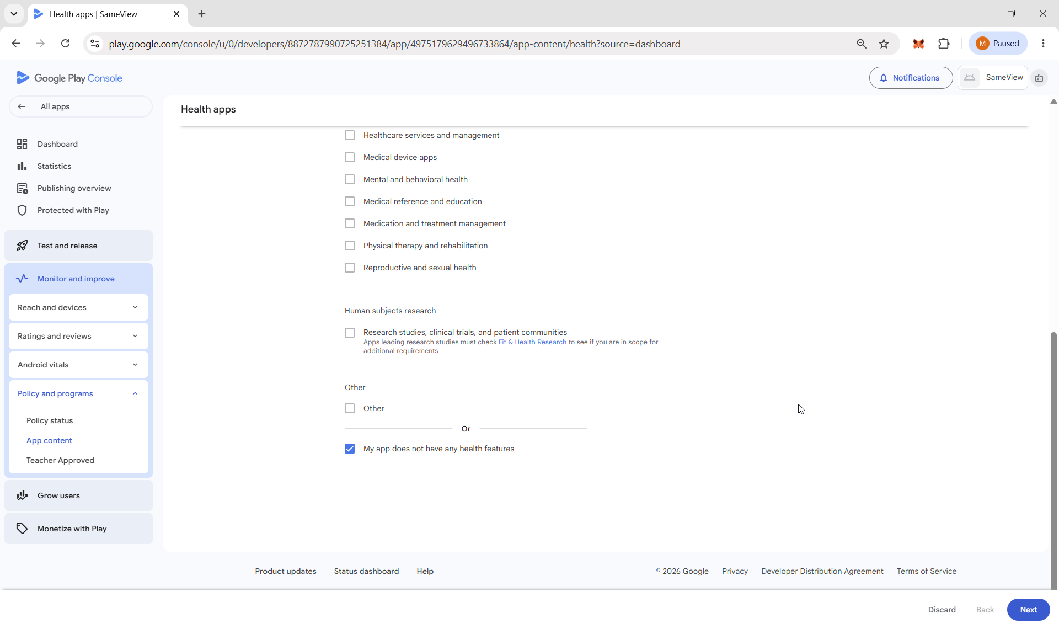

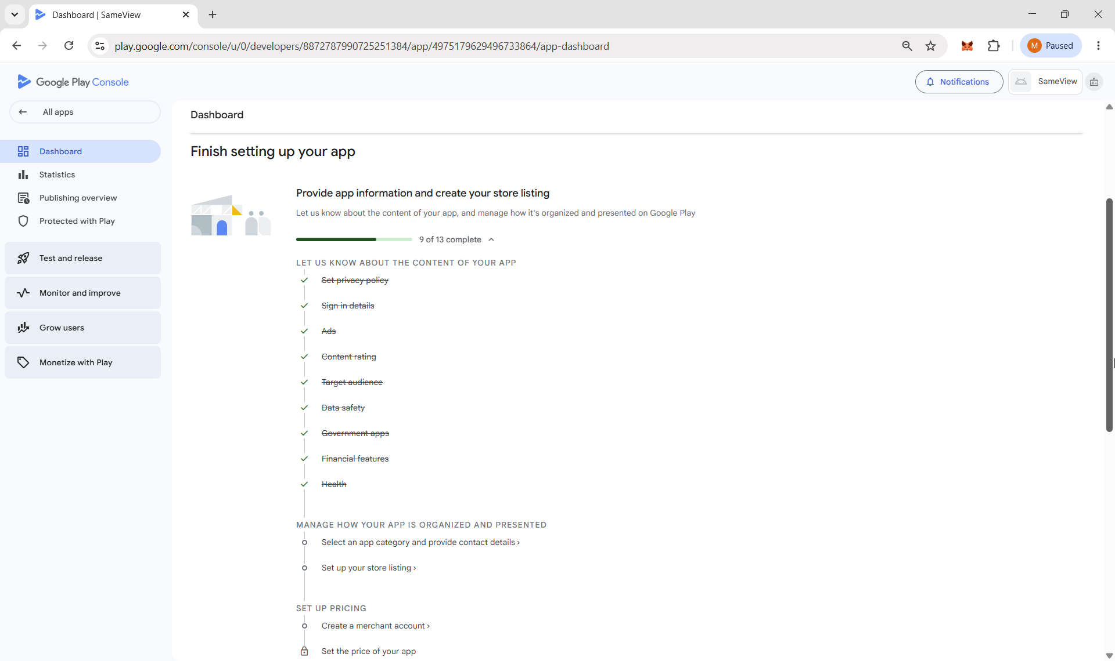

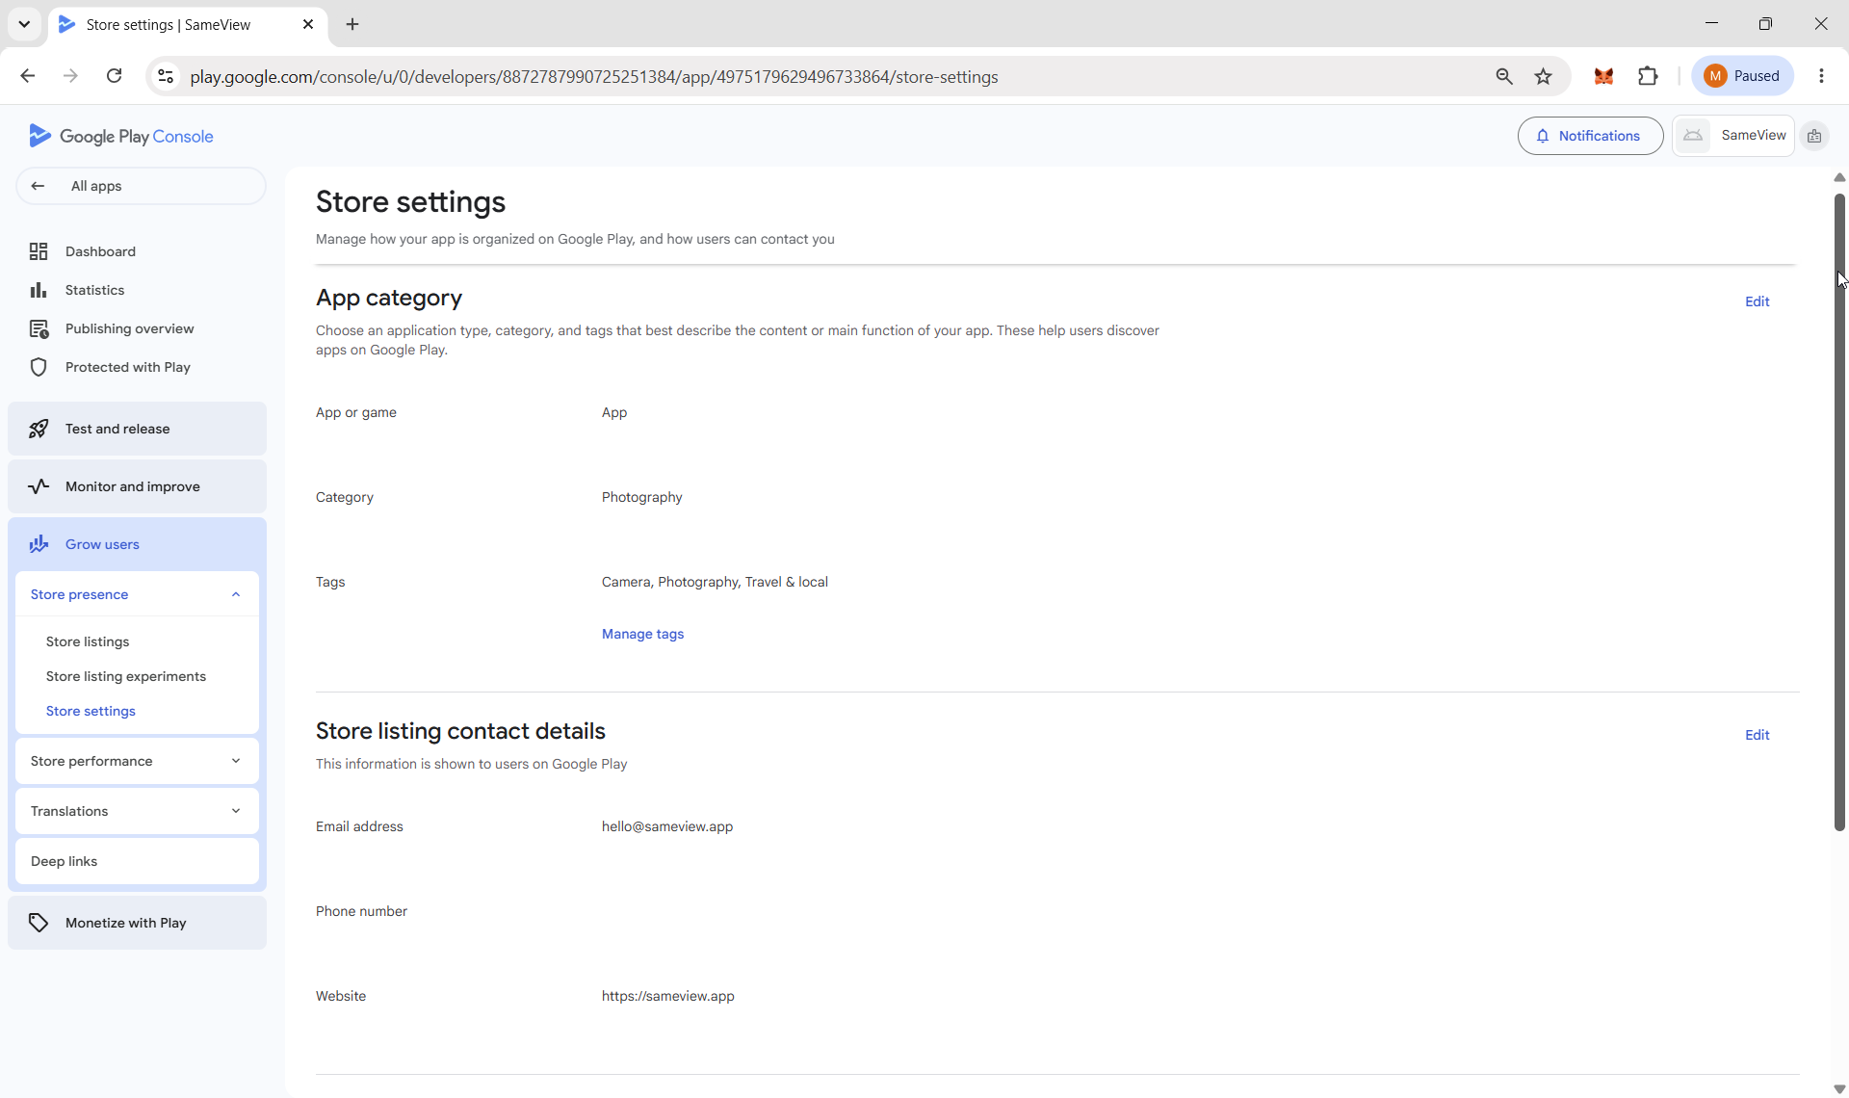

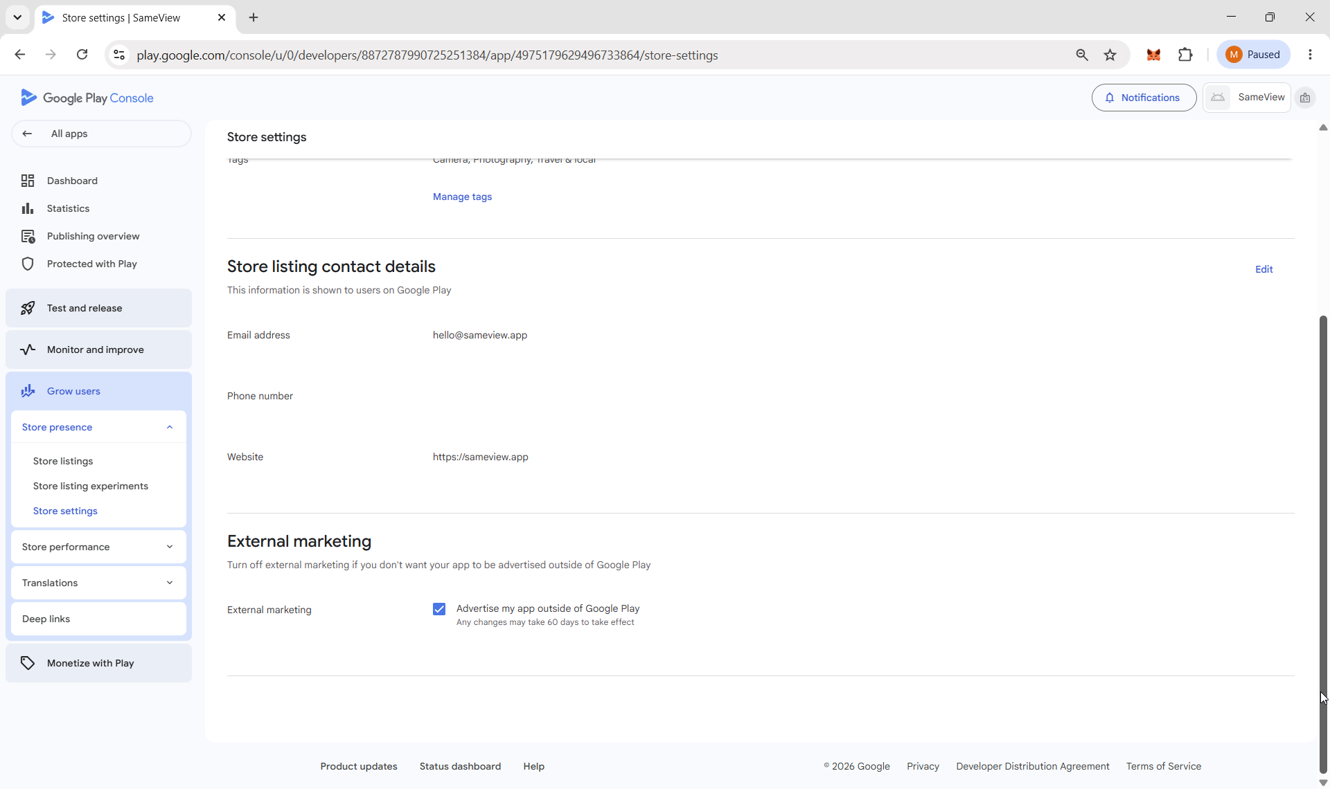

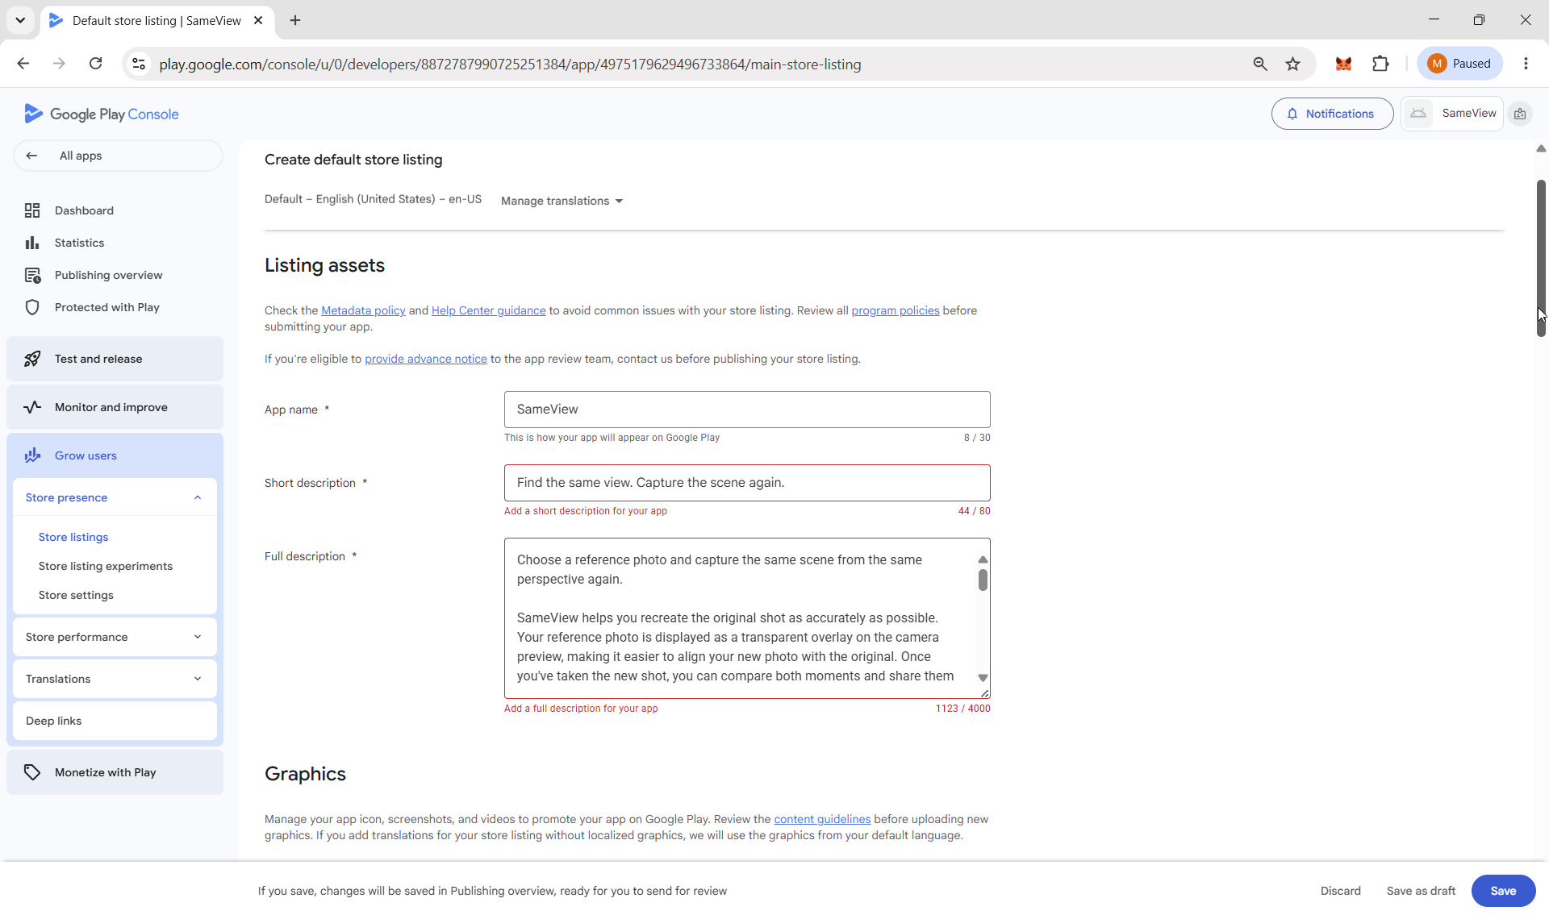

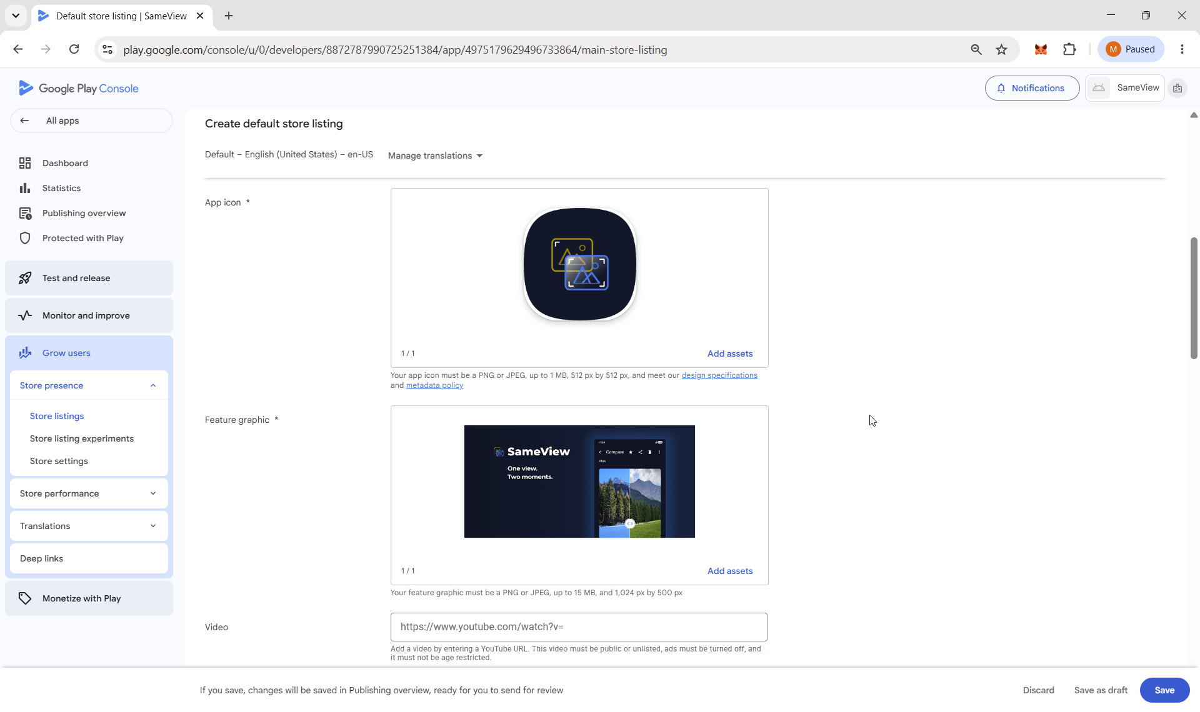

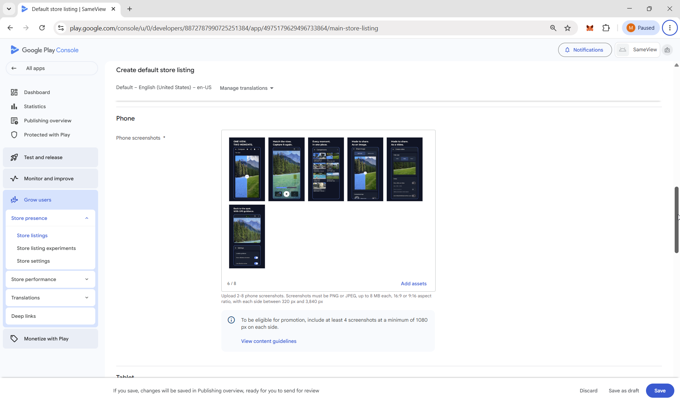

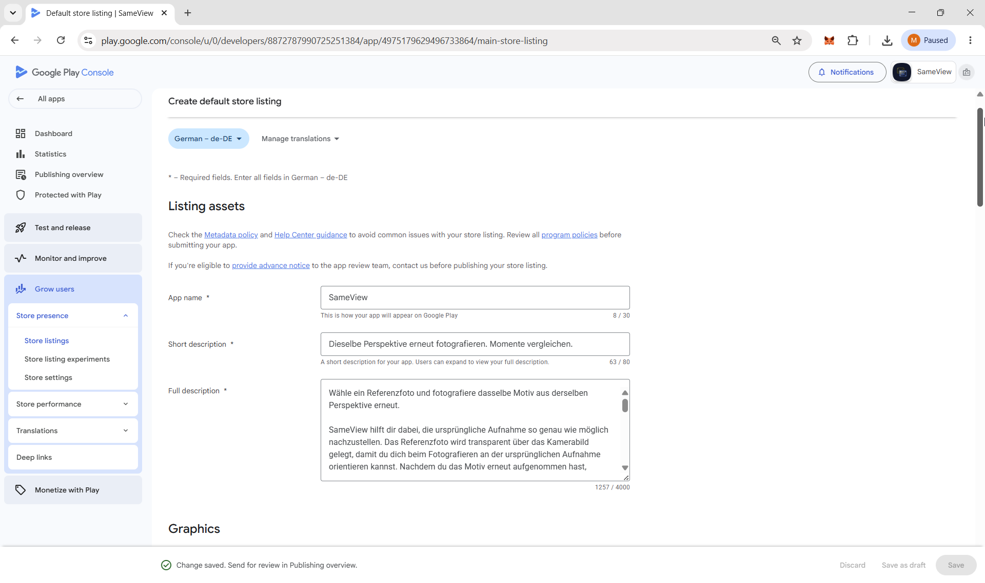

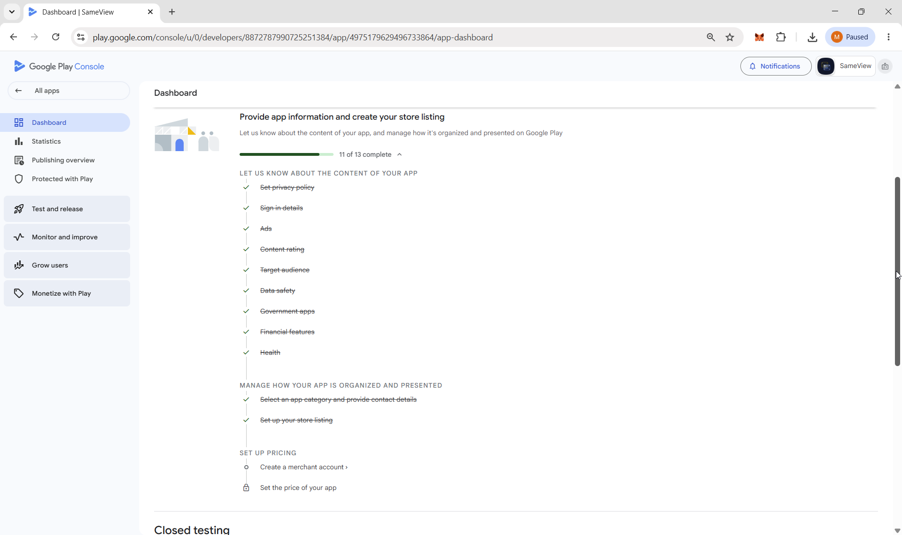

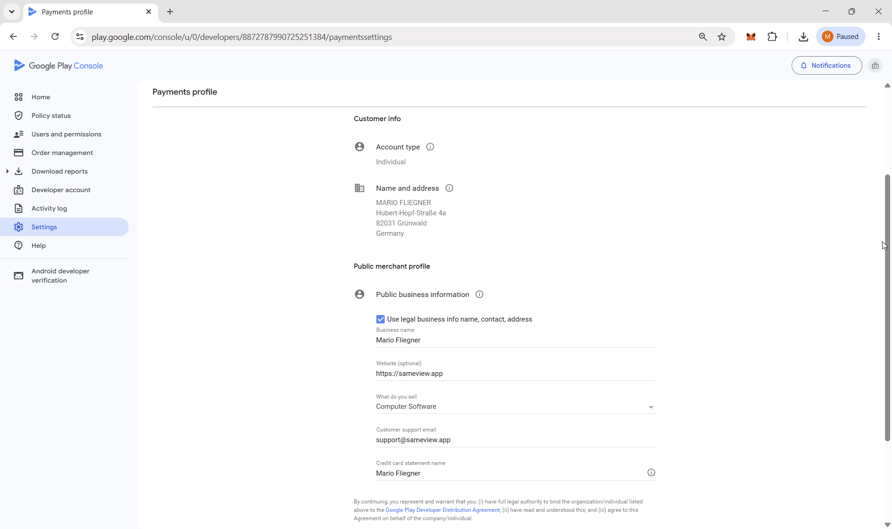

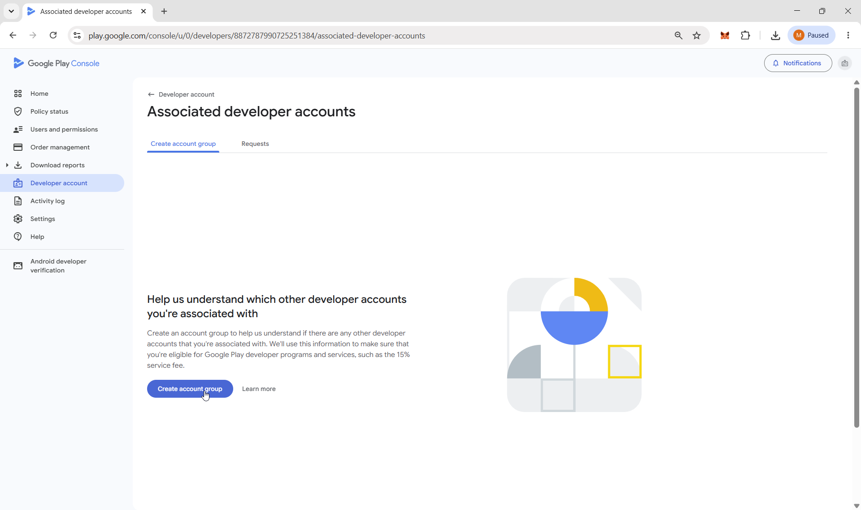

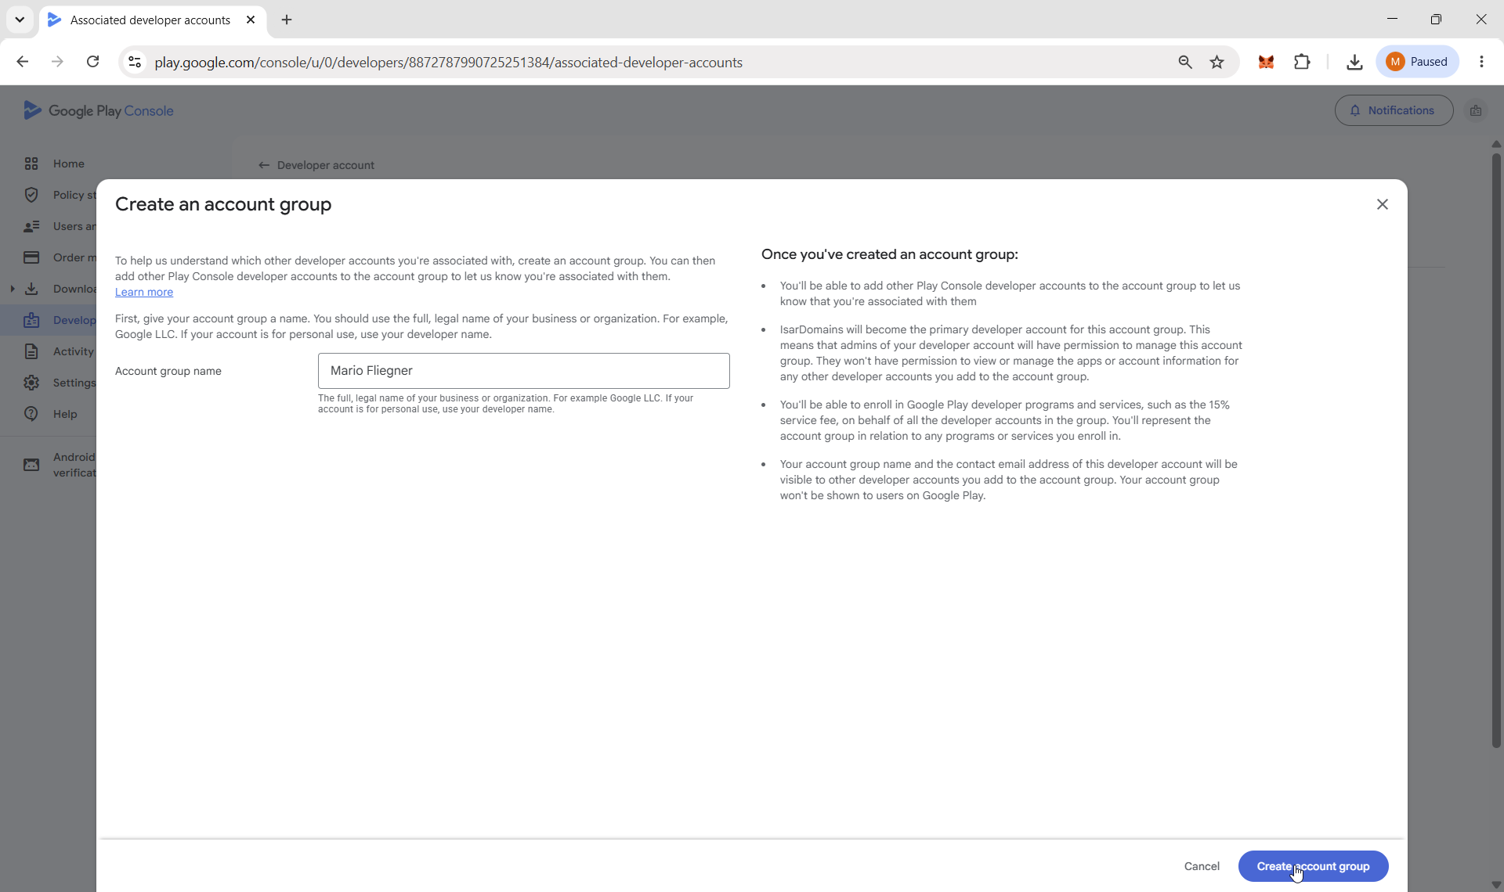

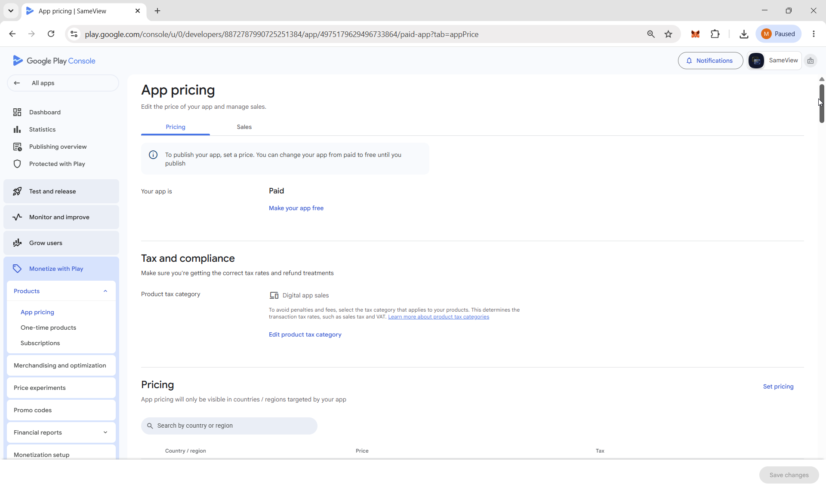

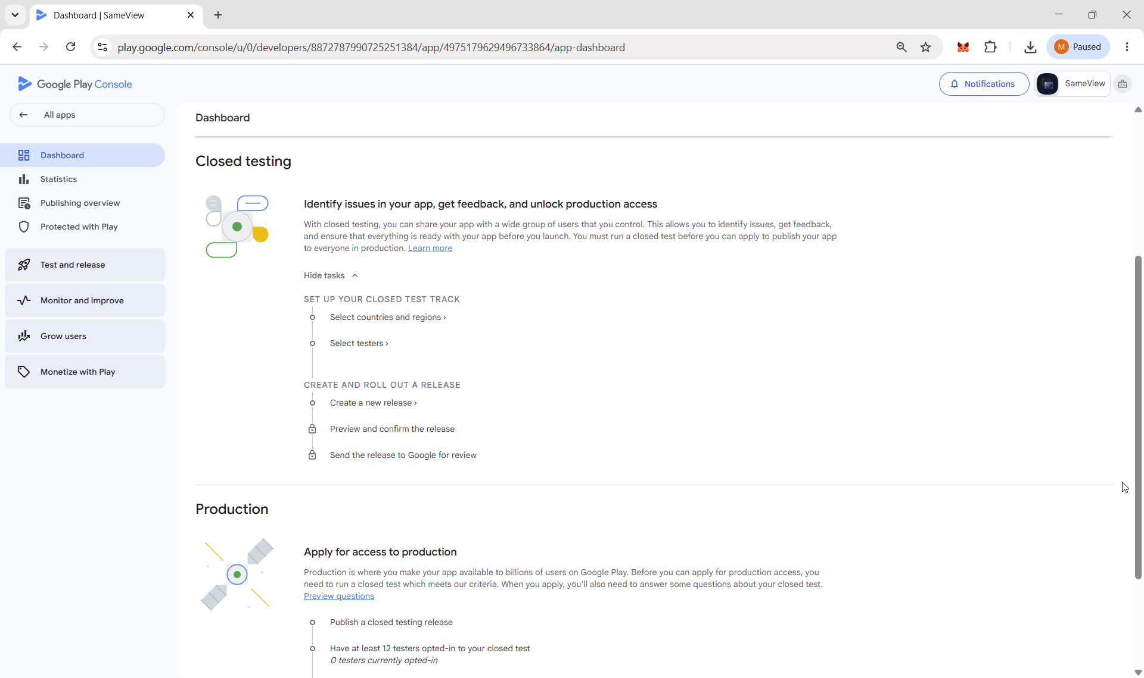

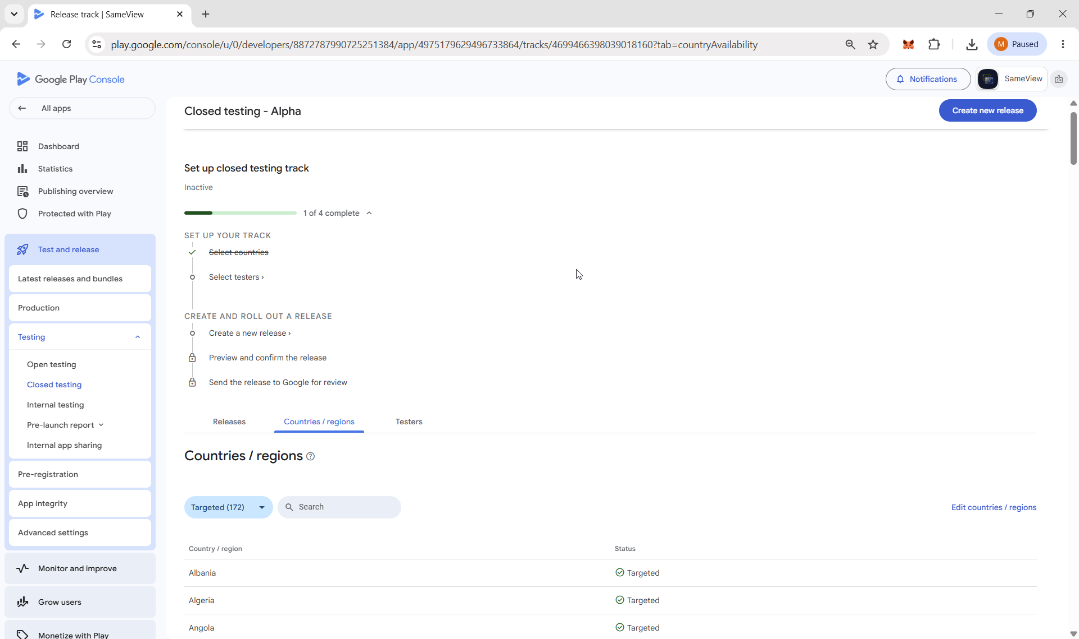

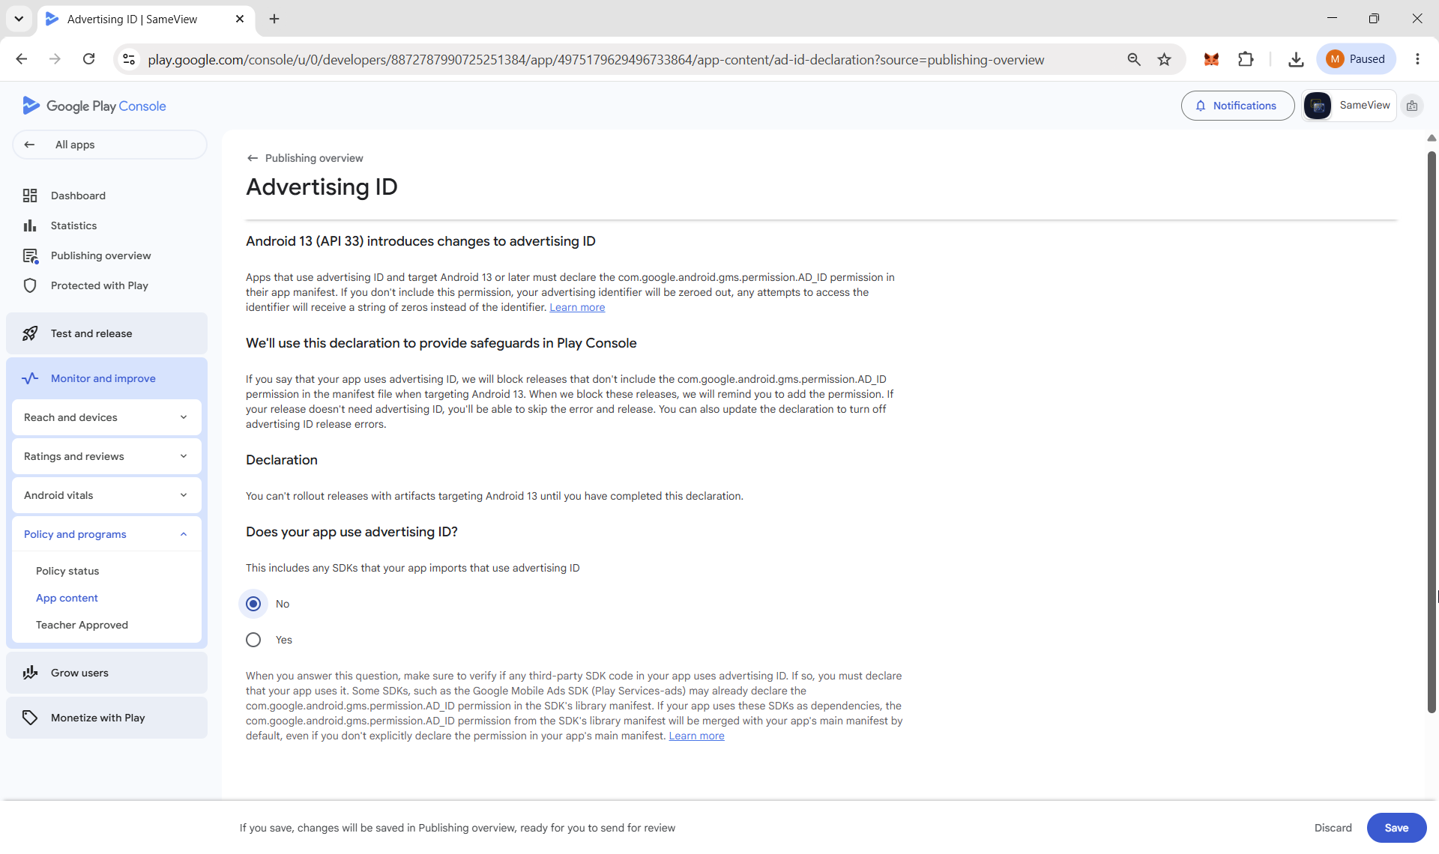

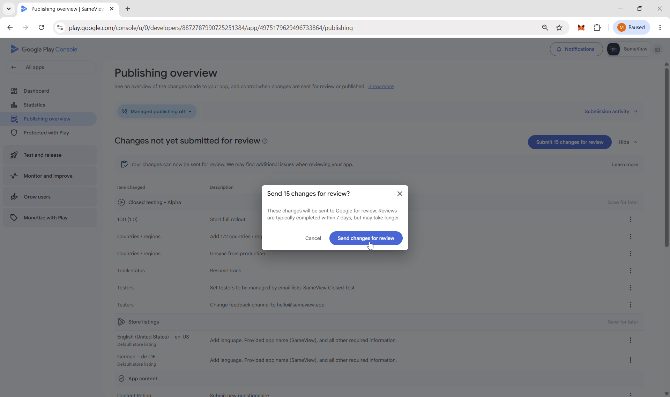

Verified & Link available
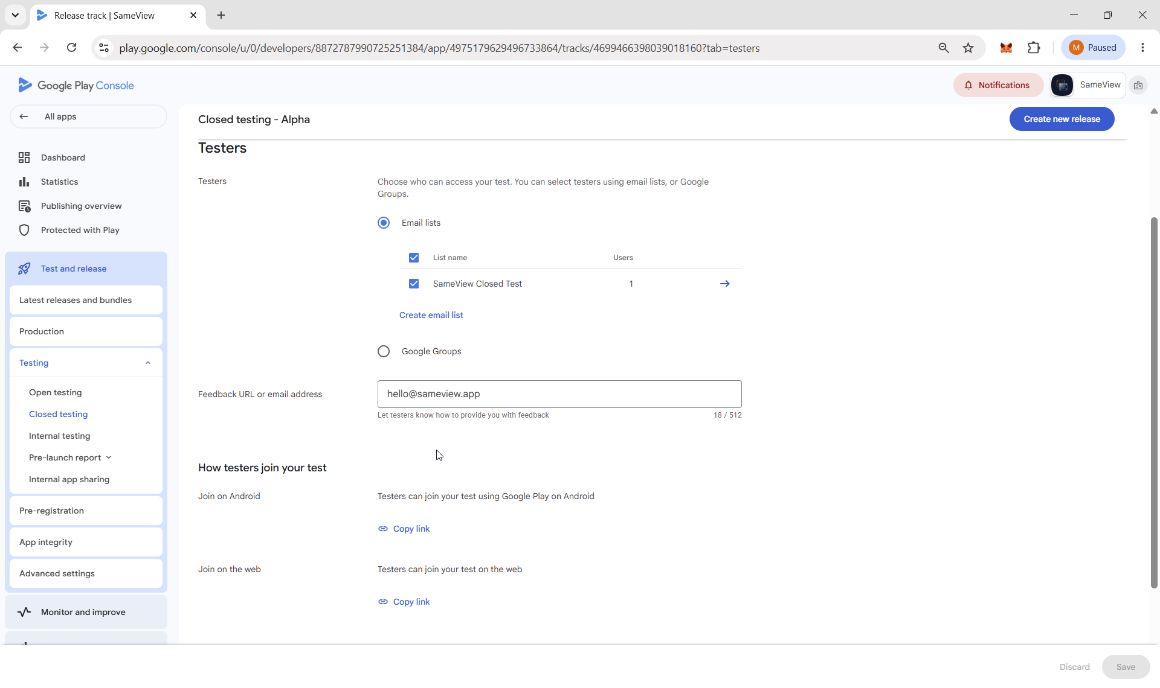

Become a tester with „Join on the web” from mobile phone:
https://play.google.com/apps/testing/com.isardomains.sameview
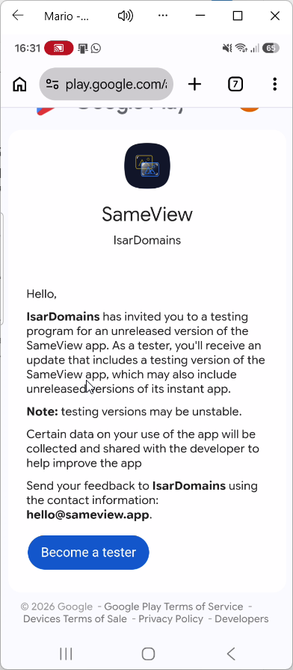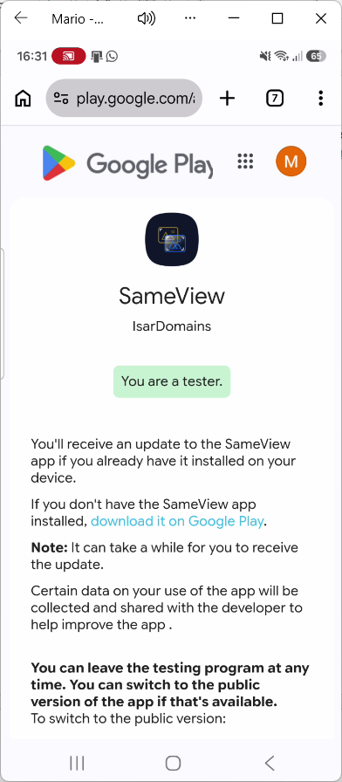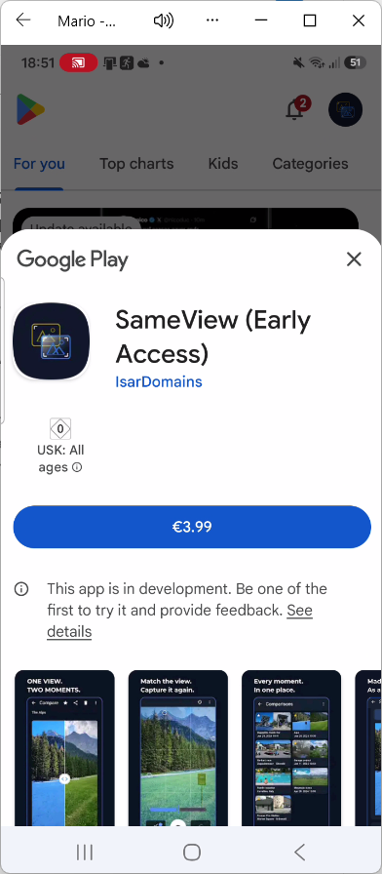
Used service https://closedtest.app for 29 EUR and 16 testers for 14 days.
Ready for Apply for Production on August, 12th 2026:
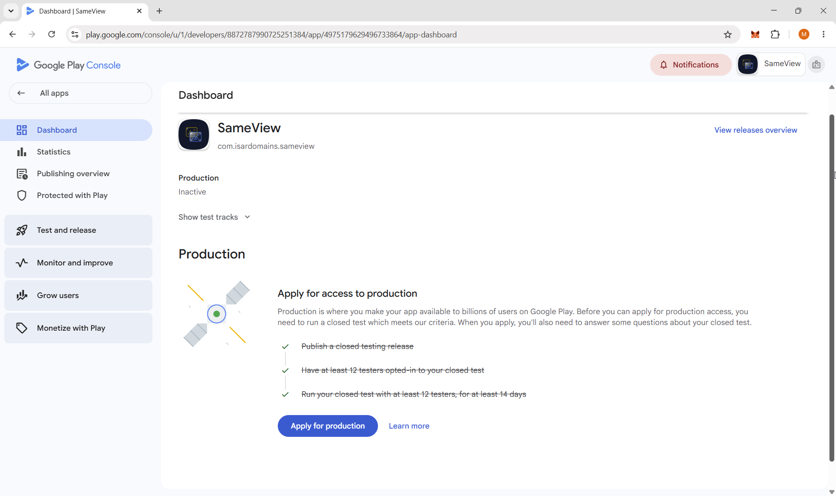
Questions and submitted answers as text from the images below:
How did you recruit users for your closed test? For example, did you ask friends and family, or use a paid testing provider?
I used a paid testing provider (ClosedTest.app) to recruit independent Android testers for the closed test. Testers joined through the Google Play closed testing track and tested the app on their Android devices.

How easy was it to recruit testers for your app?
Neither difficult or easy
Describe the engagement you received from testers during your closed test
Include whether or not testers utilized all of the features in your app, and whether tester usage was consistent with how you would expect a real user to use your app. If not, describe the differences you would expect to see.
Testers used the app on different Android devices and tested the main flow: selecting a reference photo, recreating it using the camera overlay, comparing both images, and managing sessions. The testing covered the app's core functionality and reflected typical real-world usage.

Provide a summary of the feedback that you received from testers. Include how you collected the feedback.
Feedback was collected through the testing provider. Testers found issues with location and date validation and suggested improvements to shared comparison images. No critical or blocking issues were reported. The findings were reviewed and documented for future updates.
Who is the intended audience of your app?
SameView is intended for people who want to recreate and compare photos taken at different times. This includes users documenting changes to places, landscapes, buildings, projects, travel memories, or other subjects over time.

Describe how your app provides value to users
SameView helps users recreate an earlier photo from the same perspective by displaying the reference image as an adjustable camera overlay. Users can then compare both photos, document changes over time, manage comparisons, and create shareable images or videos.
How many installs do you expect your app to have in your first year?
0 - 10K
What changes did you make to your app based on what you learned during your closed test?
Some non-critical areas for improvement, including location/date validation and shared comparison images, were identified. These were reviewed and prioritized for future updates. No critical or blocking issues were identified that prevented the app's core functionality from working as intended.
How did you decide that your app is ready for production?
The app completed closed testing without critical or blocking issues. Testers successfully used the core photo recreation and comparison workflow, history management, and video generation. Based on the stable test results and positive overall assessment, I consider the app ready for production.

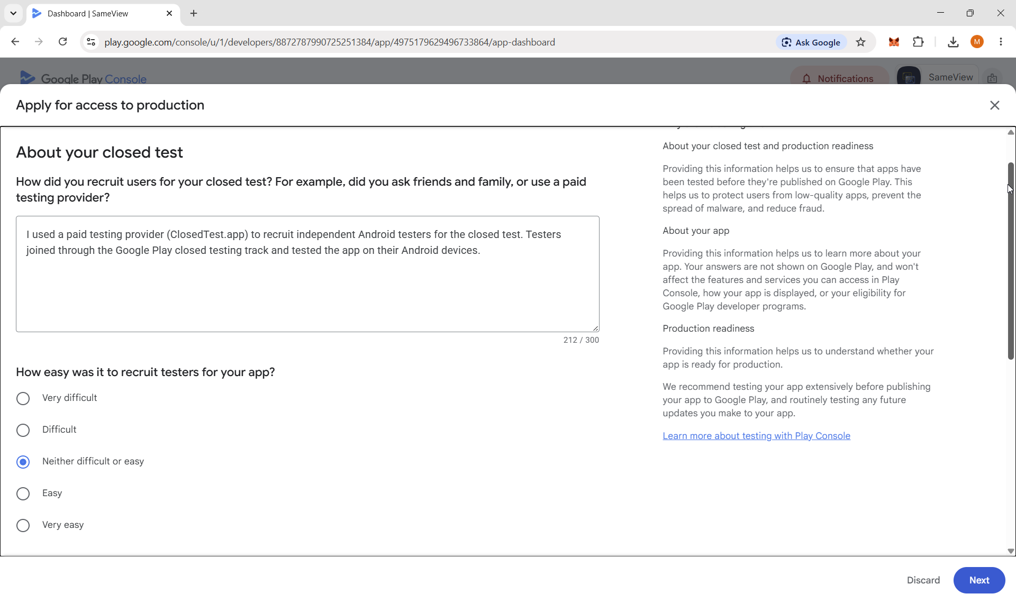

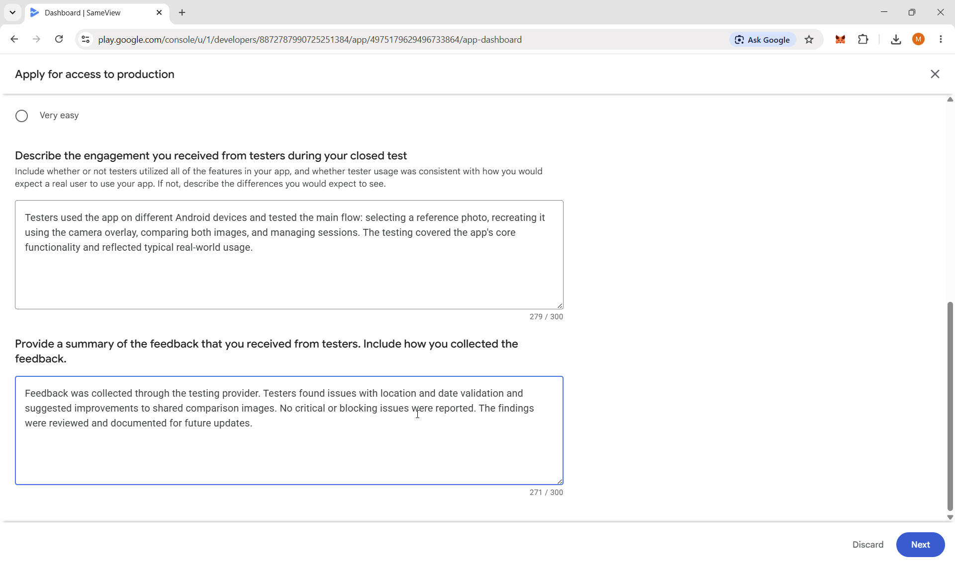
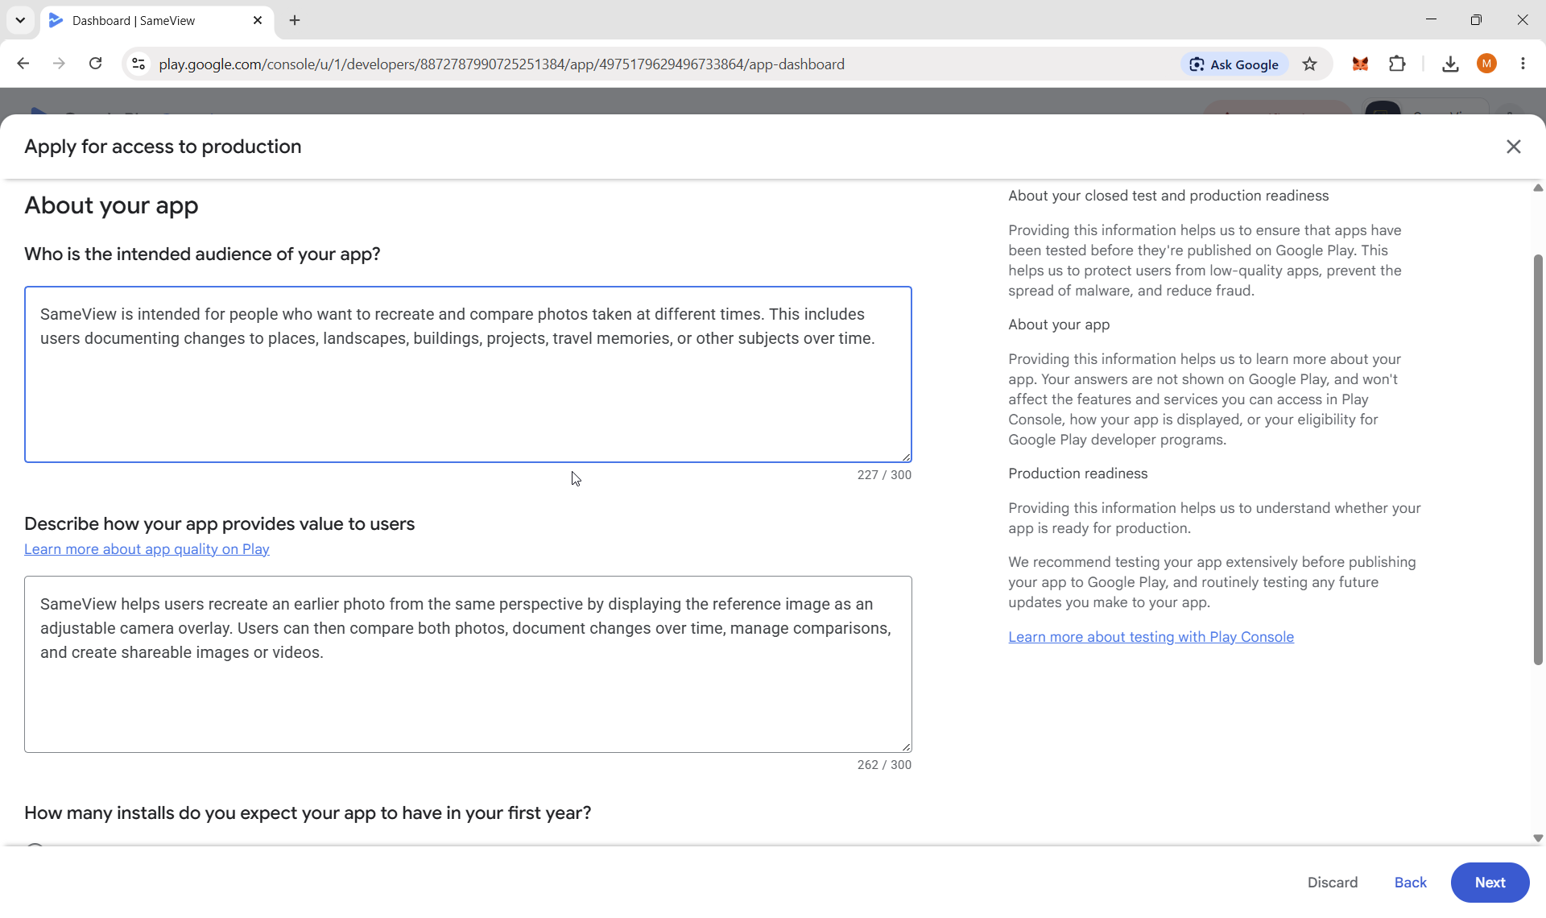

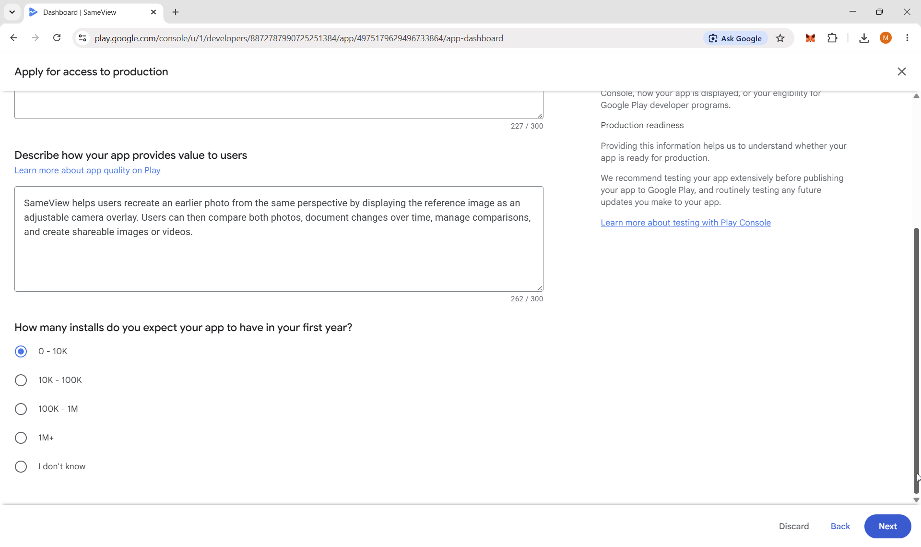
App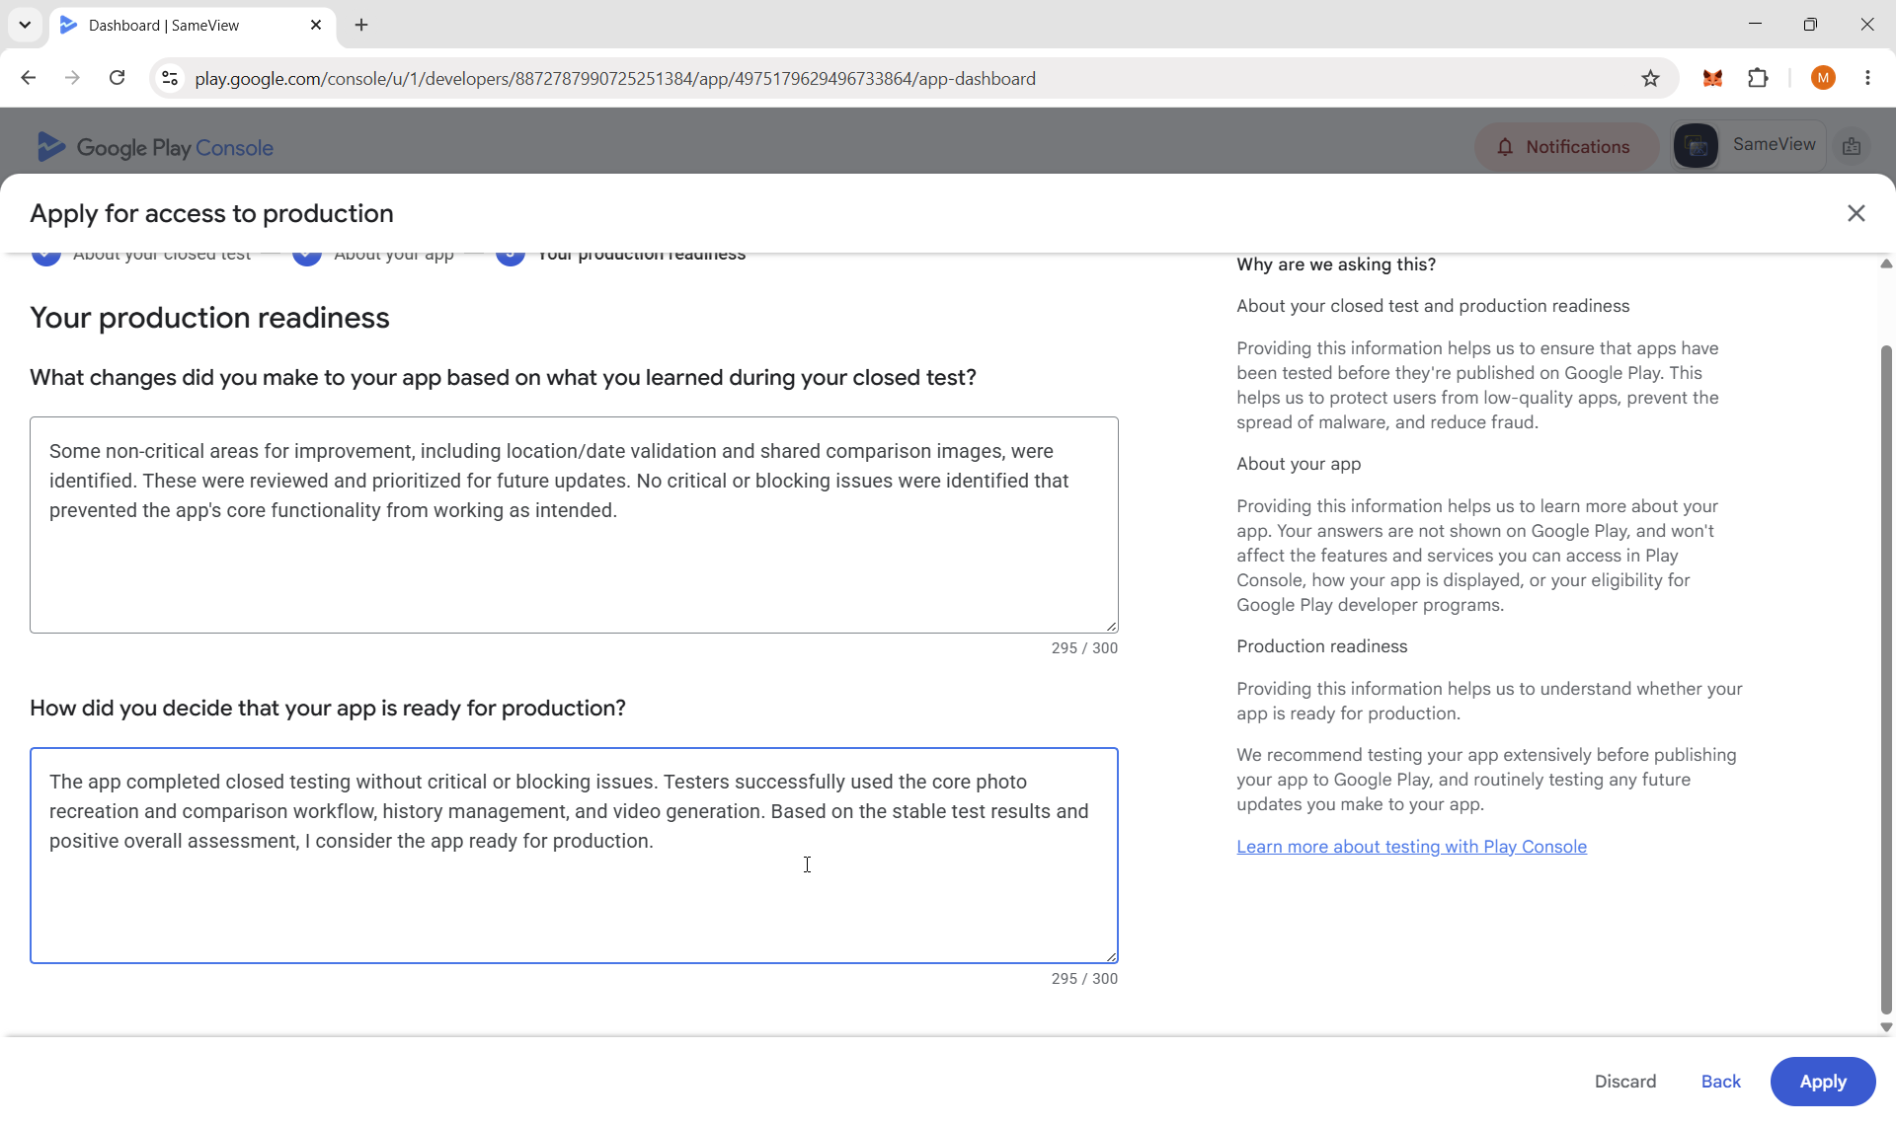
Application done:
