Reporte de la practica 2

Mario Fernando Cárdenas Pérez

Aquí se muestran los topics que cree (users y pageviews)

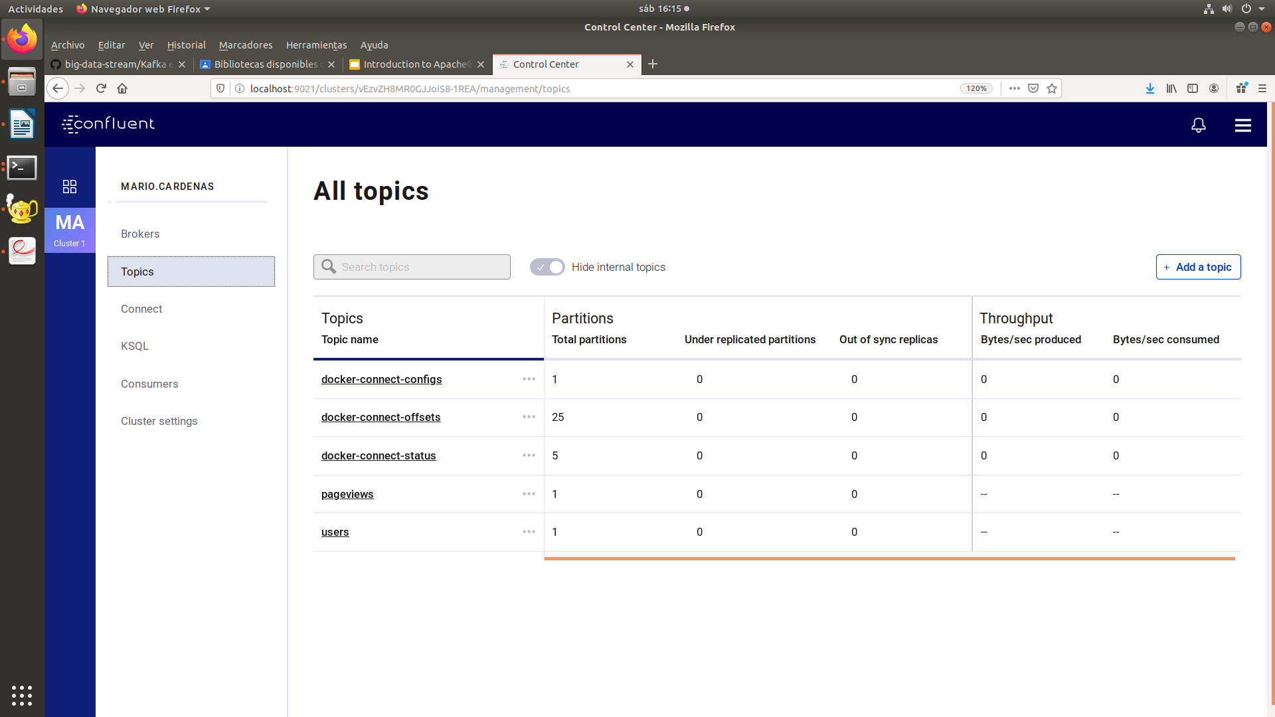

Se crearon los nuevos conectores (datagen – useres, datagen - pageviews )
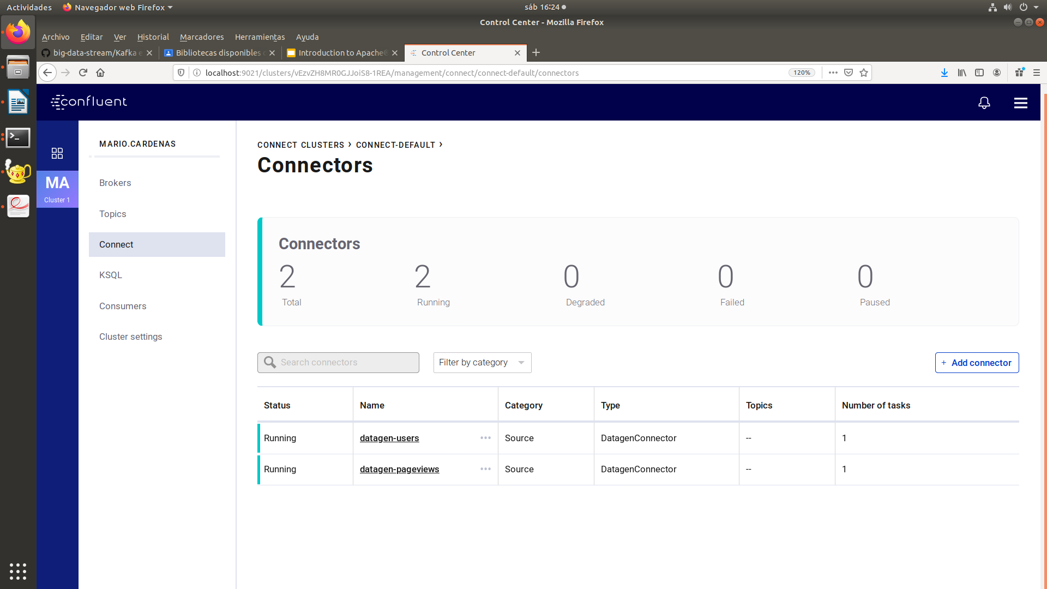

Se creo un stream en KSQL:

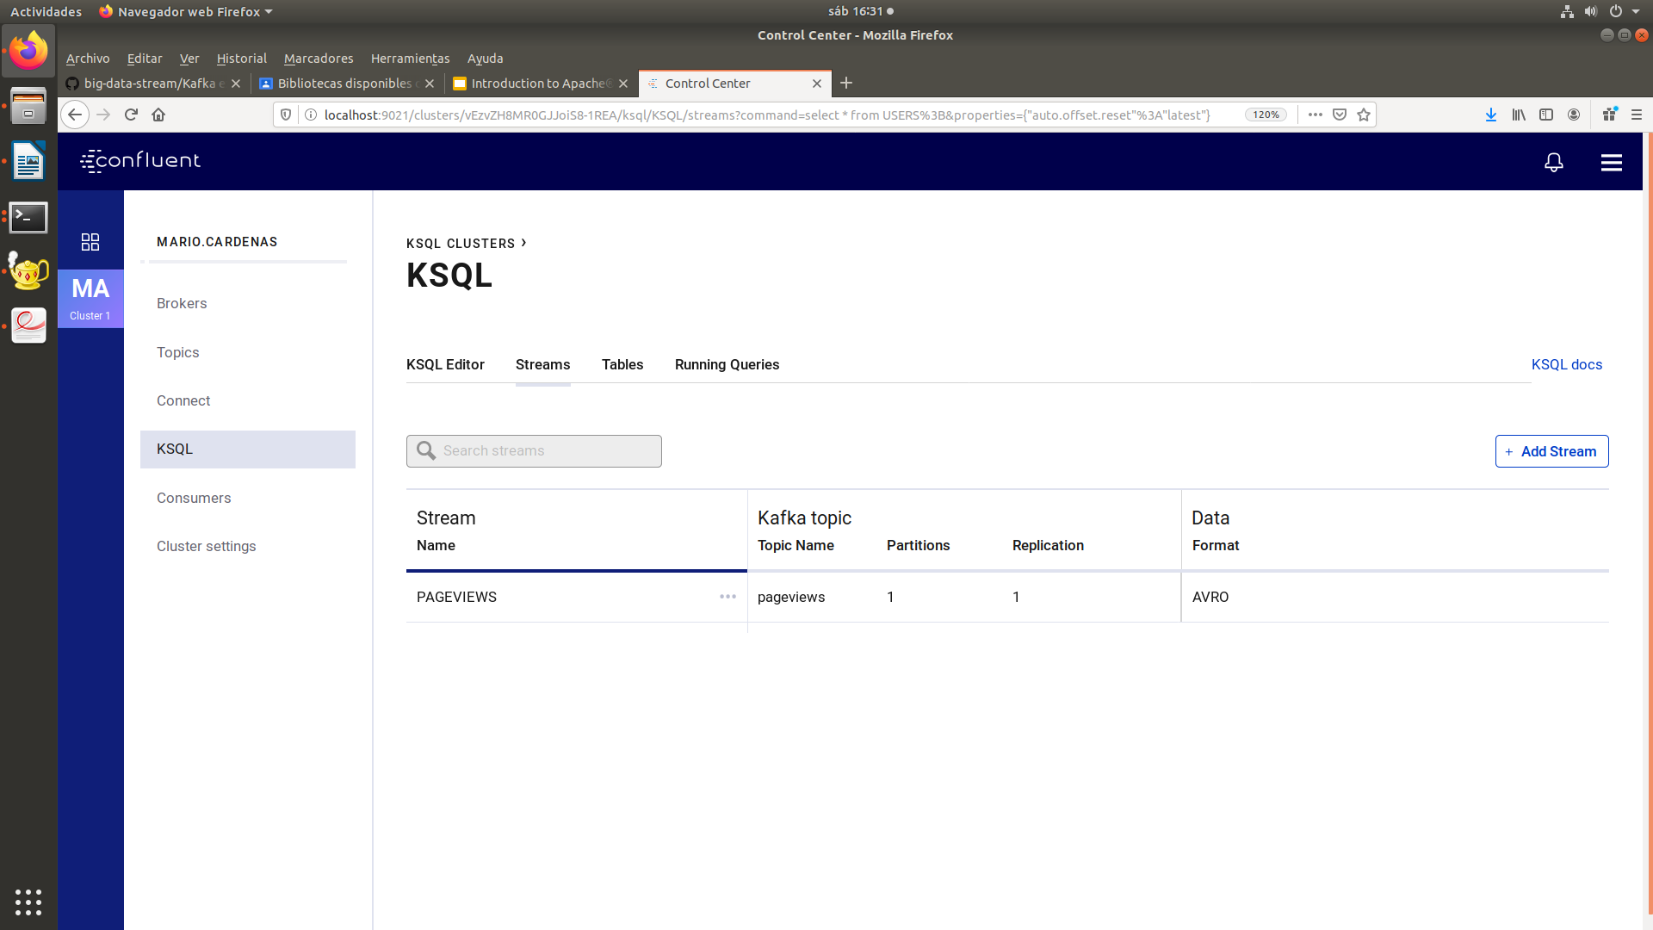

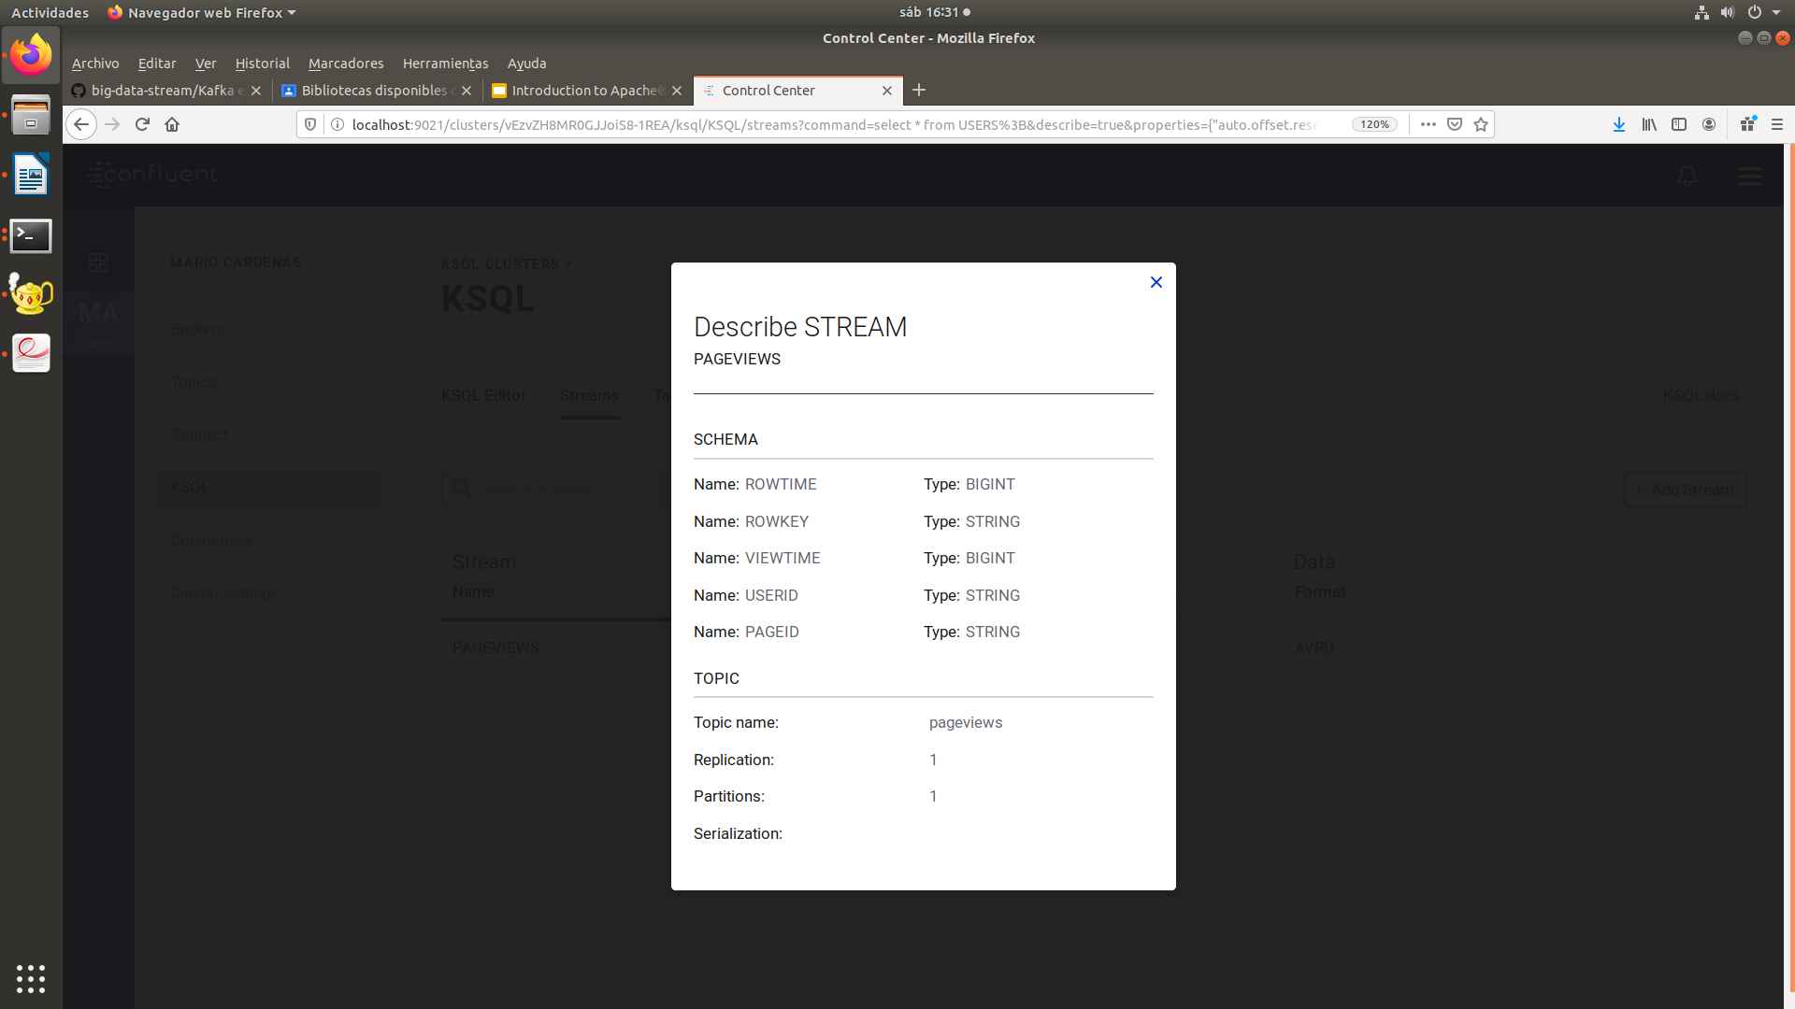
Tambien se creo la tabla users:

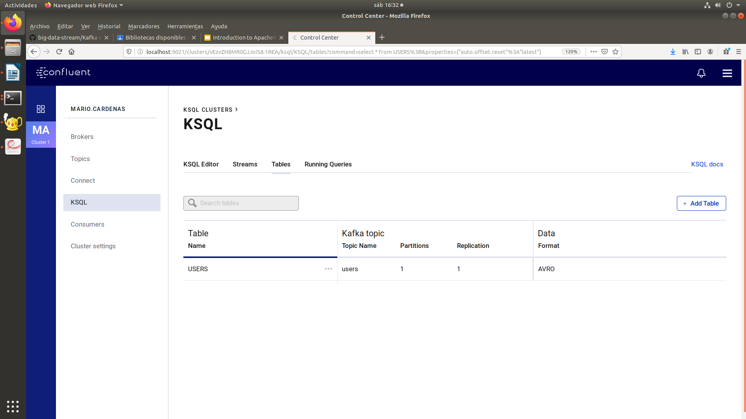

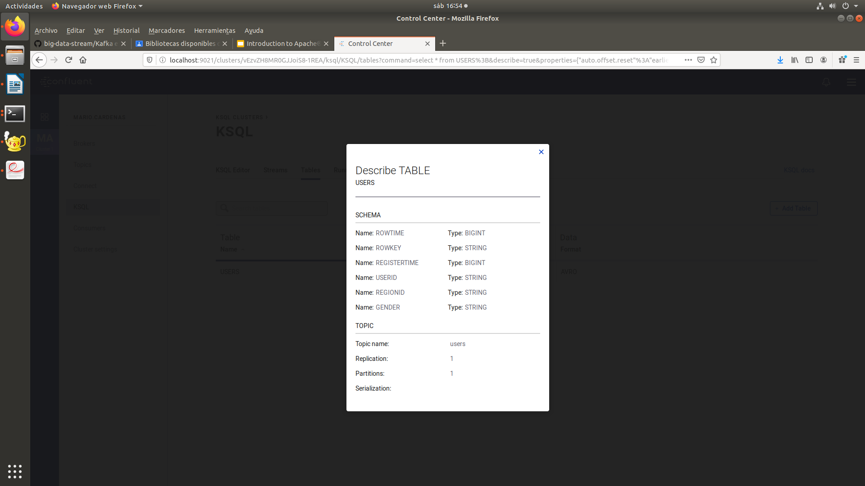

Ahora haremos varios querys en KSQL:
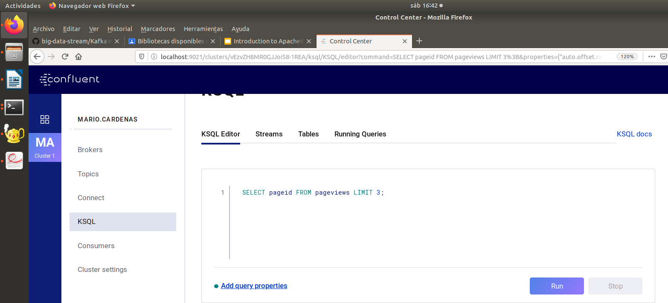

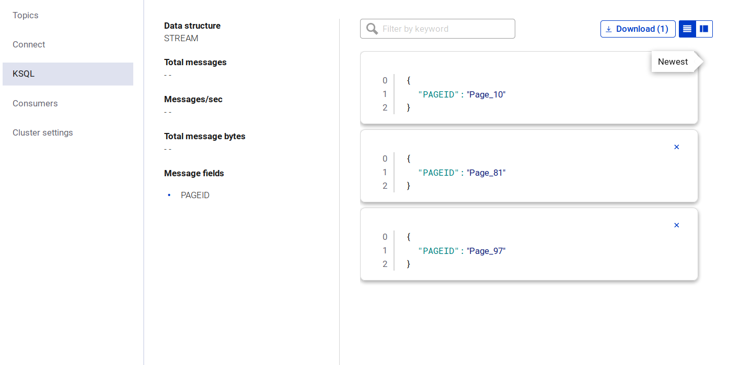

CREATE STREAM pageviews_female AS SELECT users.userid AS userid, pageid, regionid, gender FROM pageviews LEFT JOIN users ON pageviews.userid = users.userid WHERE gender = 'FEMALE';
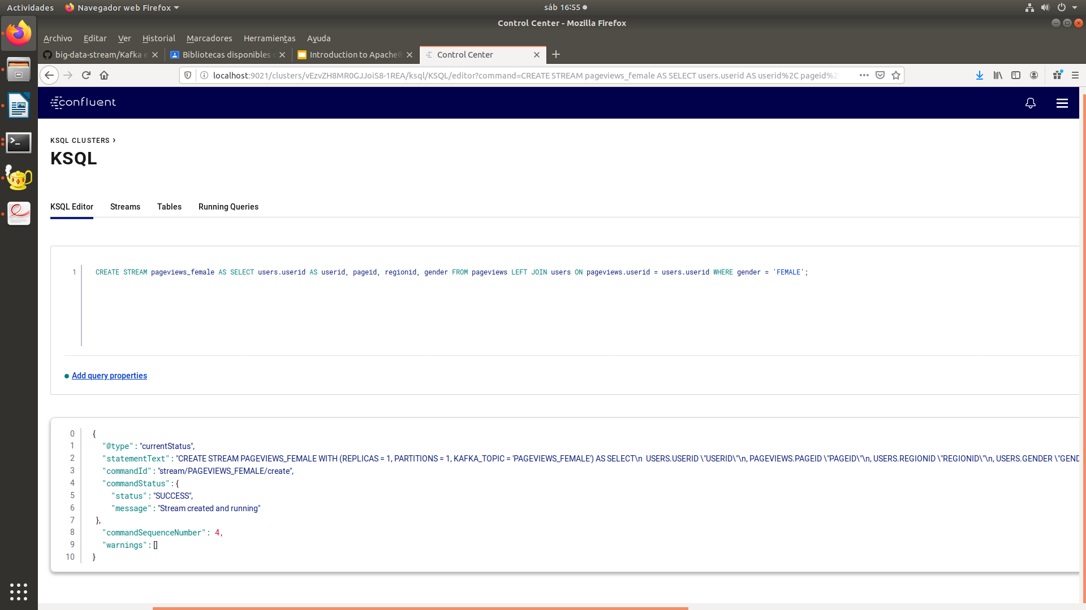

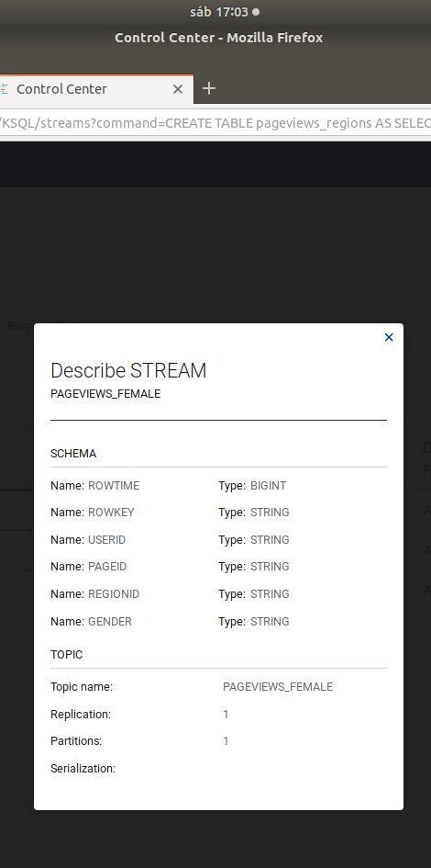

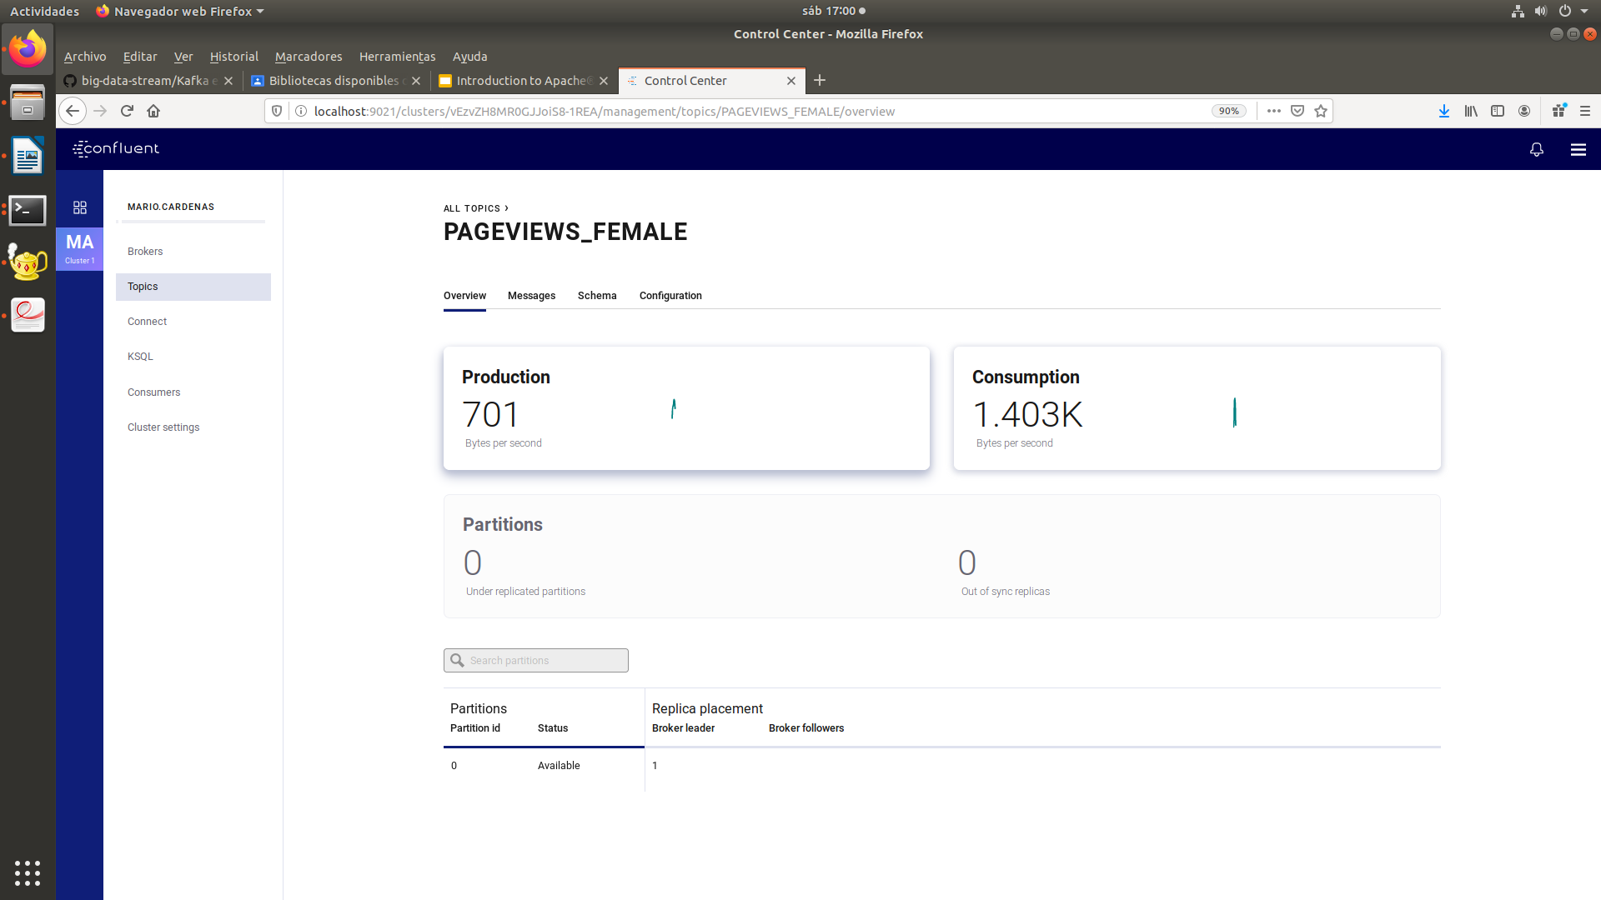

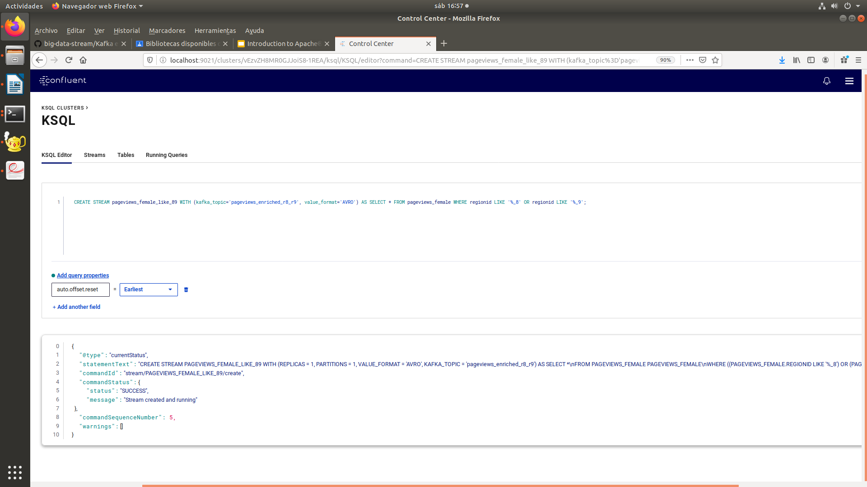
CREATE STREAM pageviews_female_like_89 WITH (kafka_topic='pageviews_enriched_r8_r9', value_format='AVRO') AS SELECT * FROM pageviews_female WHERE regionid LIKE '%_8' OR regionid LIKE '%_9';

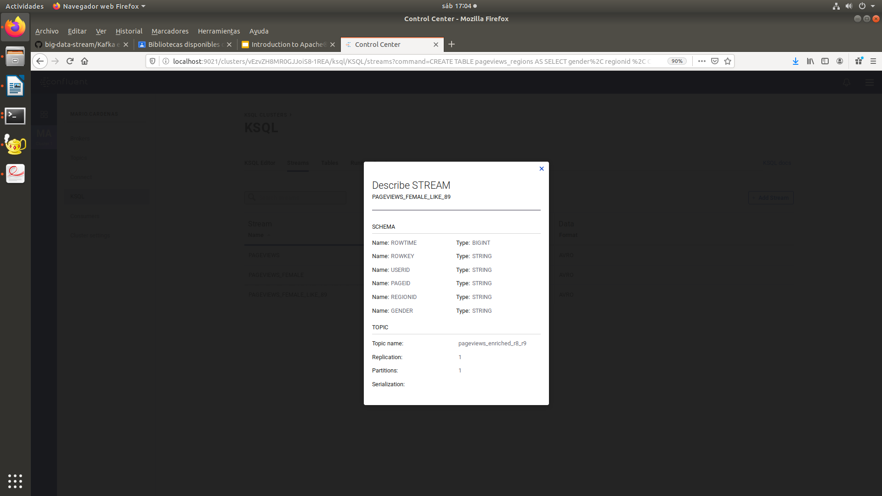

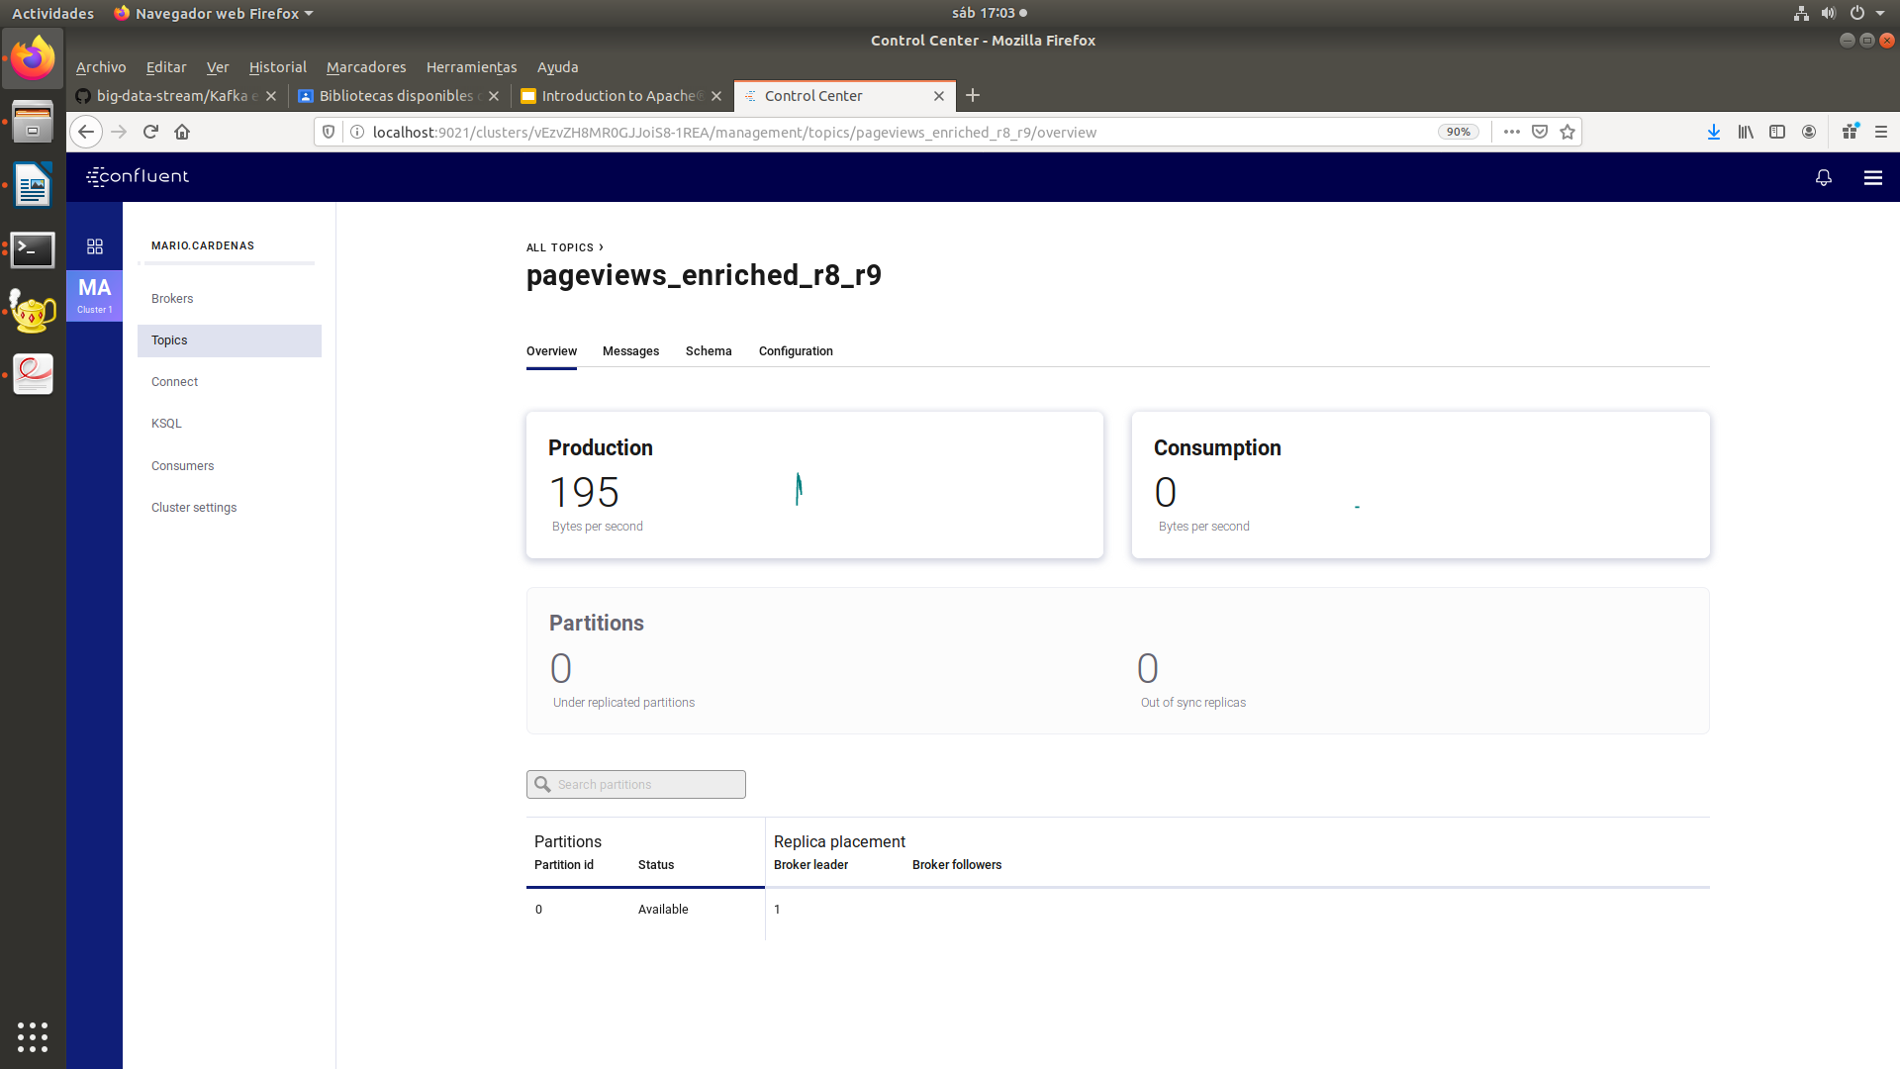

CREATE TABLE pageviews_regions AS SELECT gender, regionid , COUNT(*) AS numusers FROM pageviews_female WINDOW TUMBLING (size 30 second) GROUP BY gender, regionid HAVING COUNT(*) > 1;

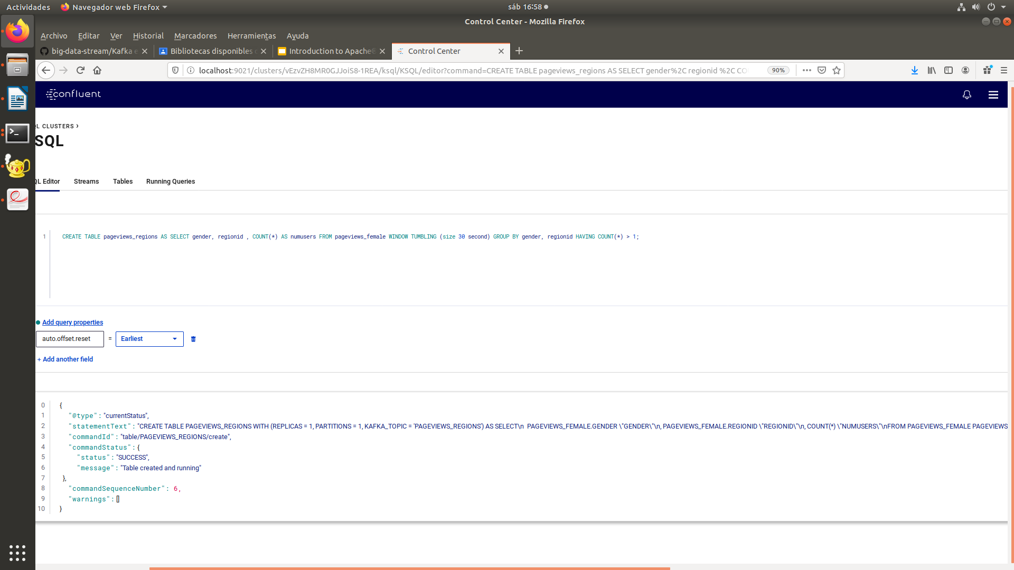

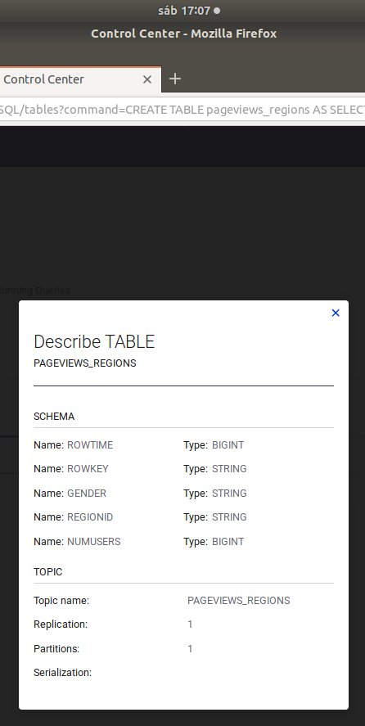
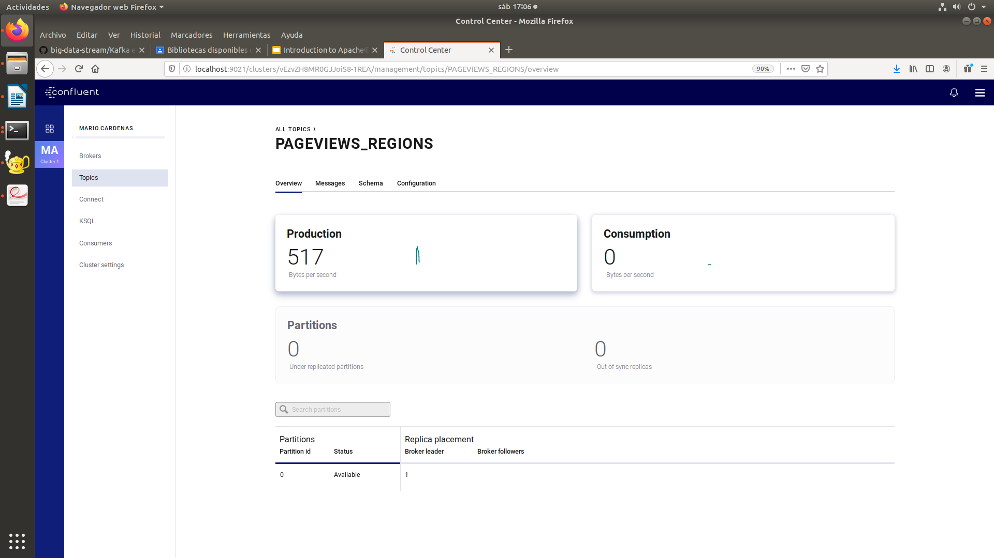

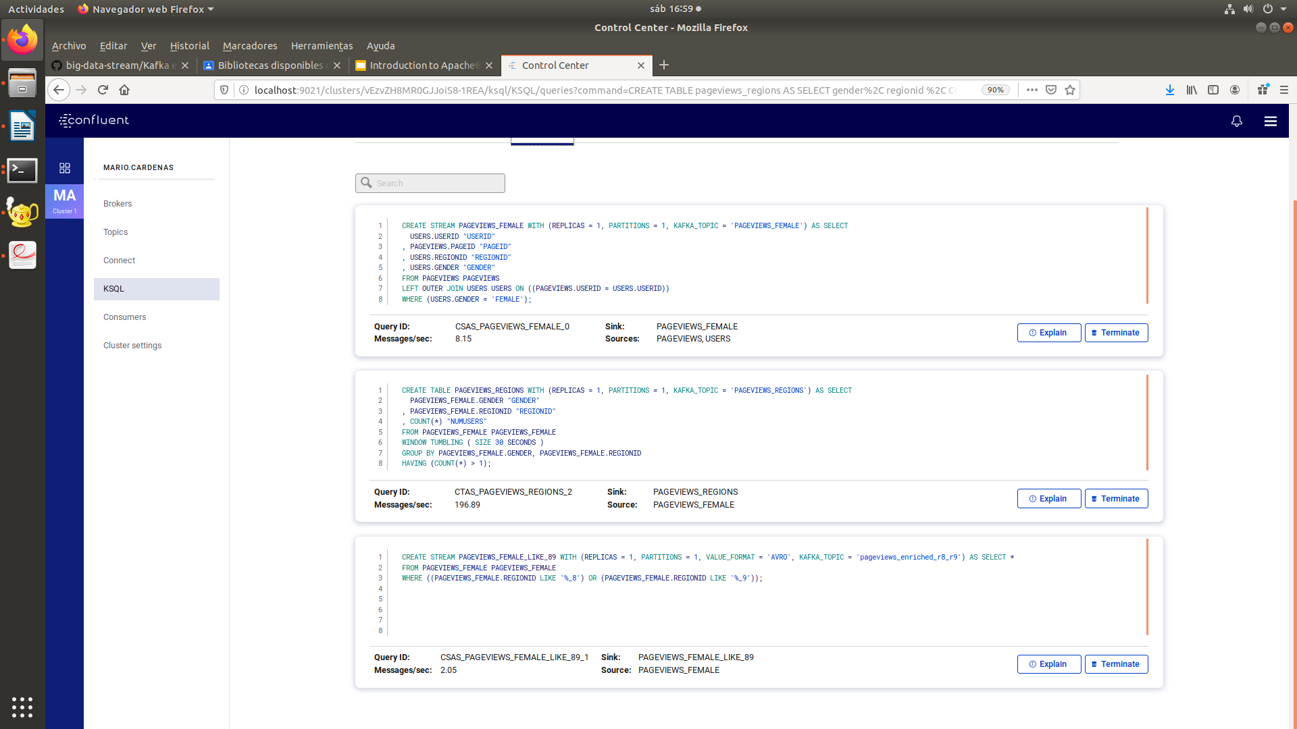

http://localhost:9021/monitoring/consumer/lag/consumerGroups

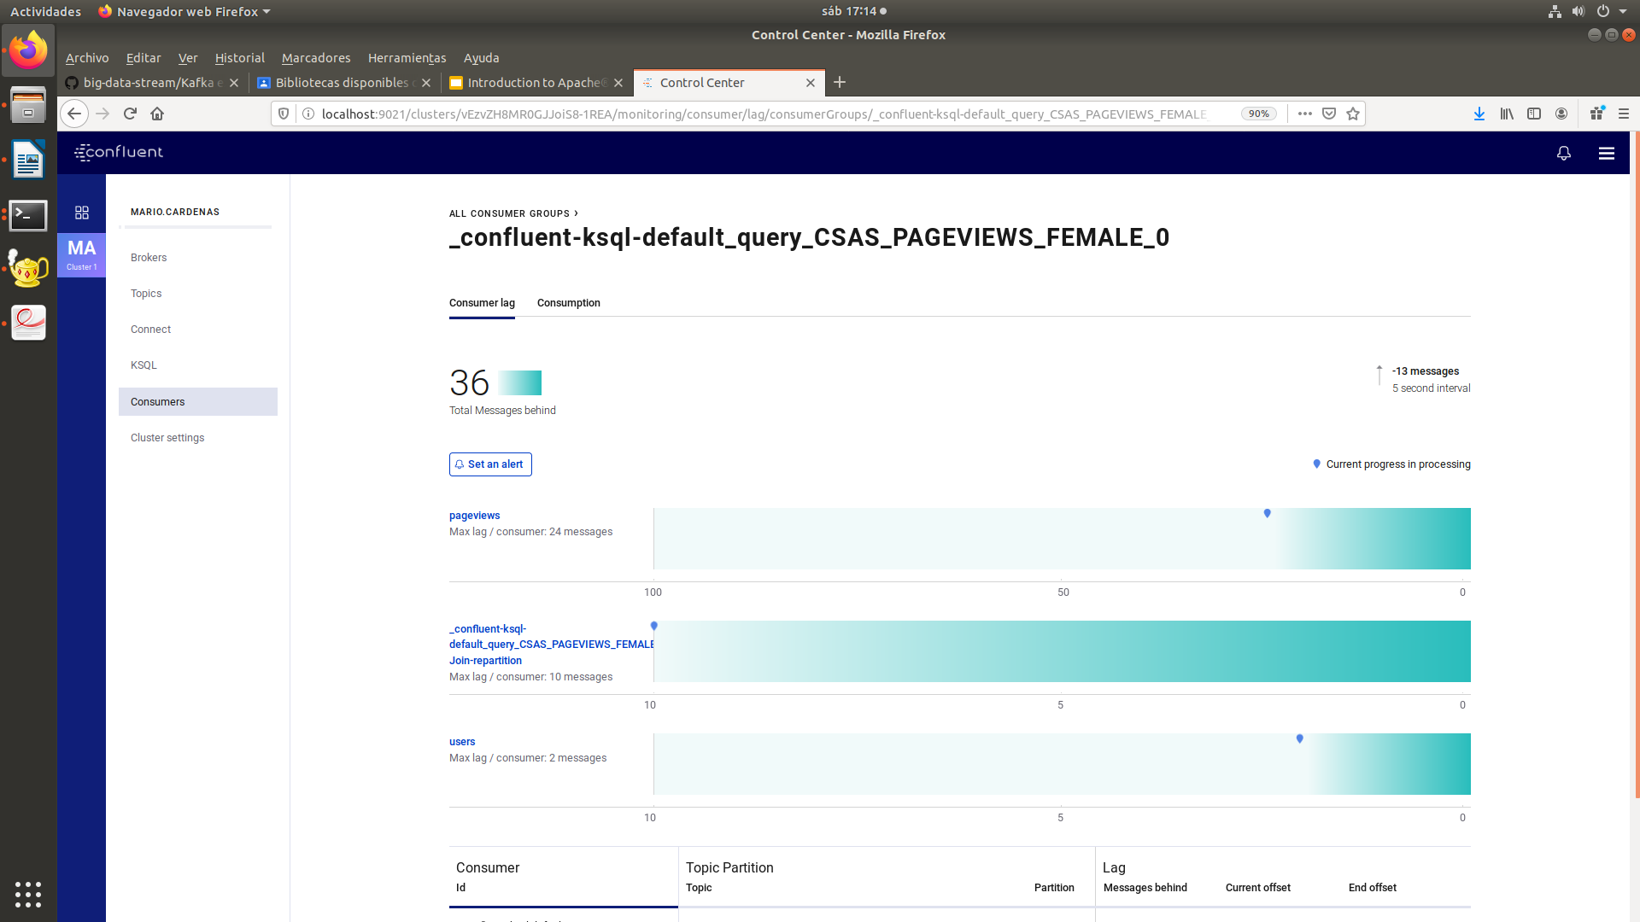

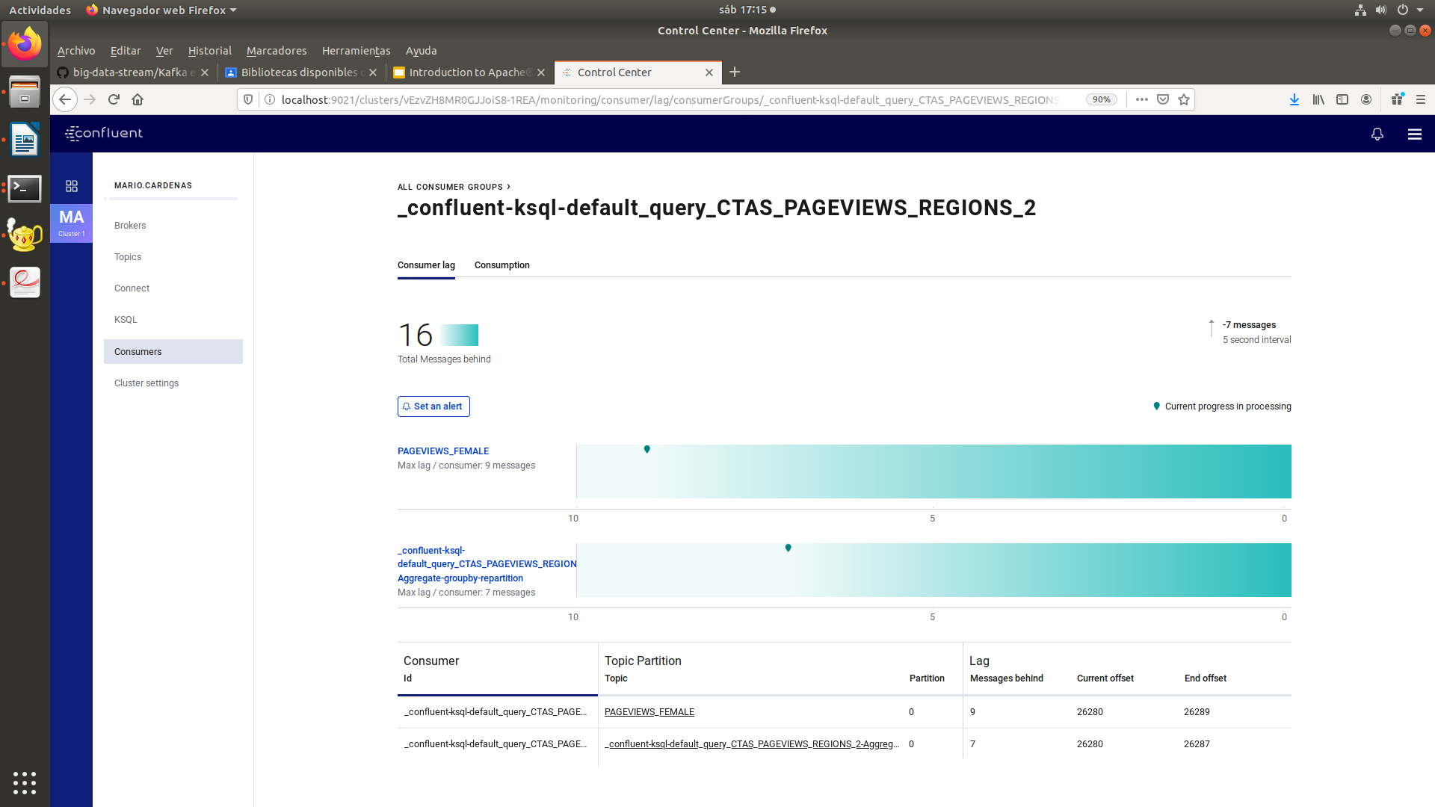
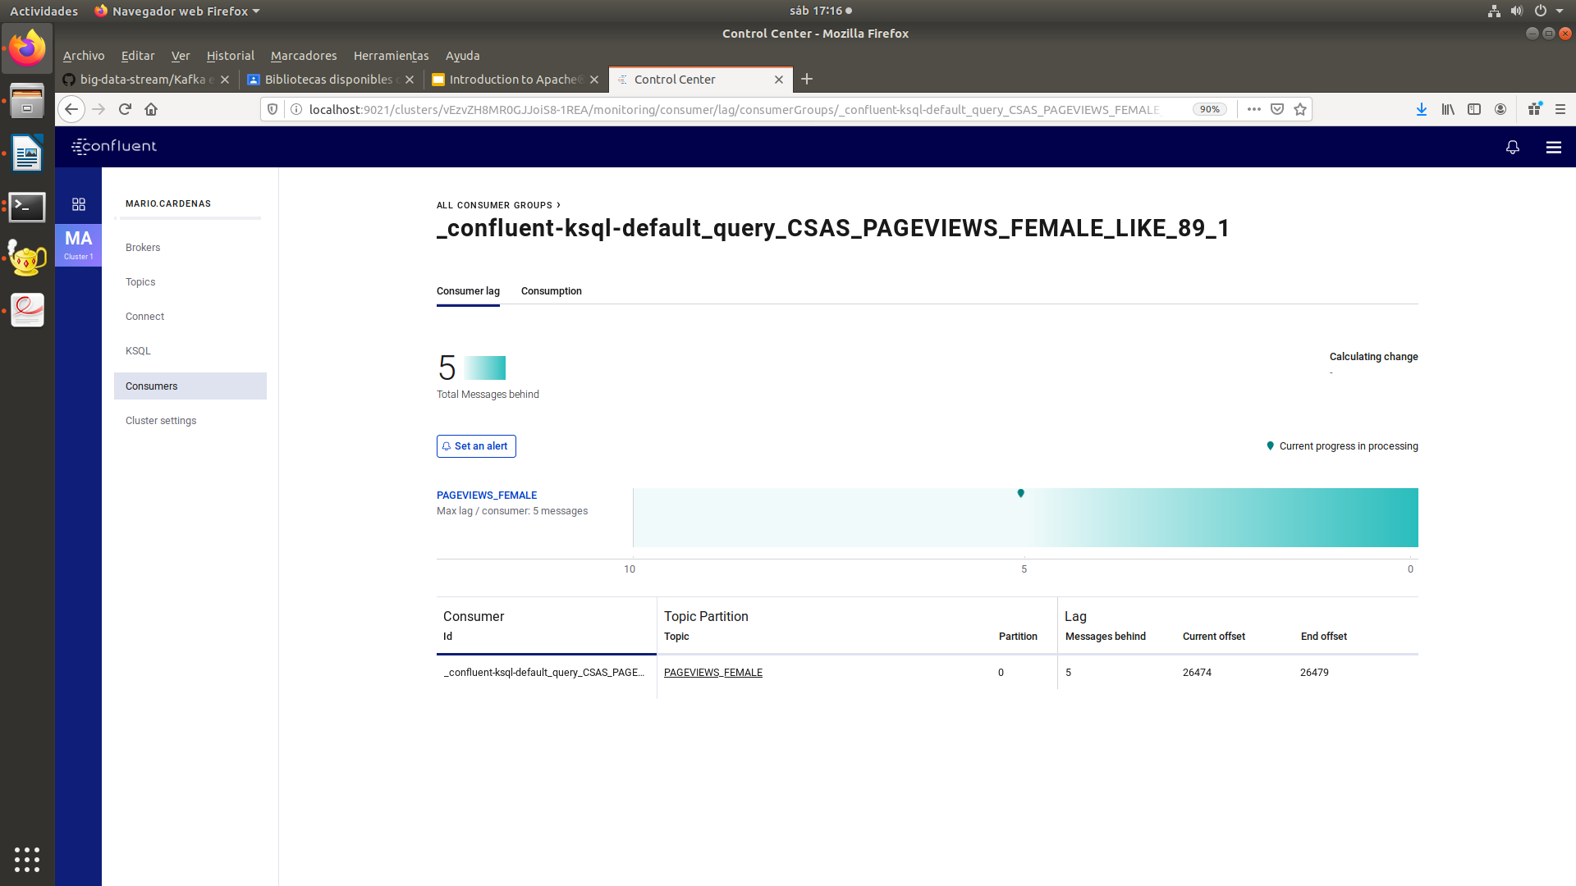

Ahora bajamos el docker:

docker container ls -aq o docker-compose down
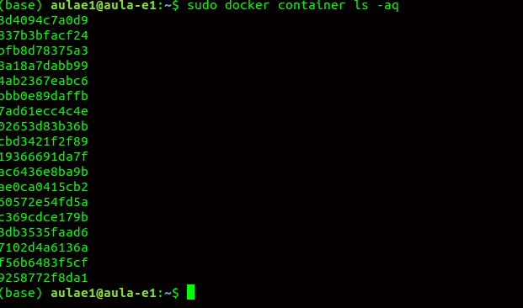

docker container stop $(docker container ls -a -q -f "label=io.confluent.docker")

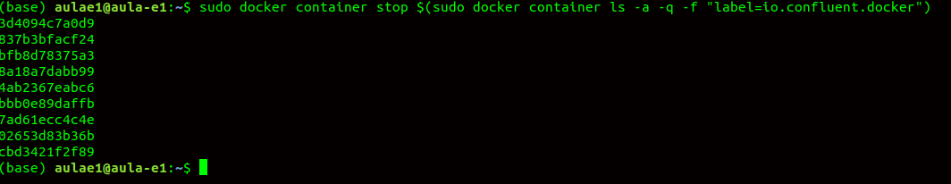

docker container stop $(docker container ls -a -q -f "label=io.confluent.docker") && docker system prune -a -f –volumes
