**Screenshots:**

**Selenium IDE:**

Deema:

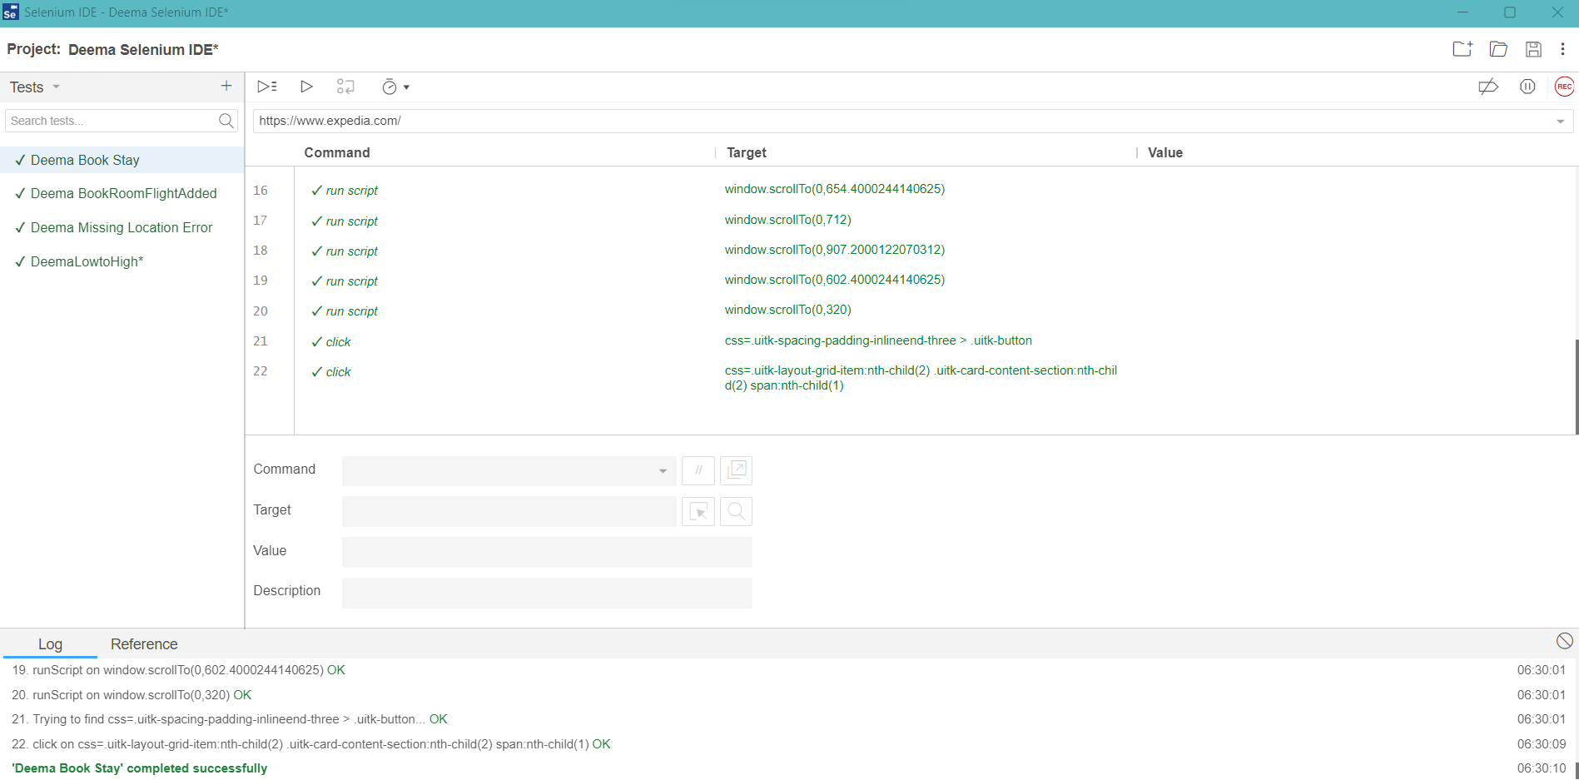

Mario:

Mahmoud:

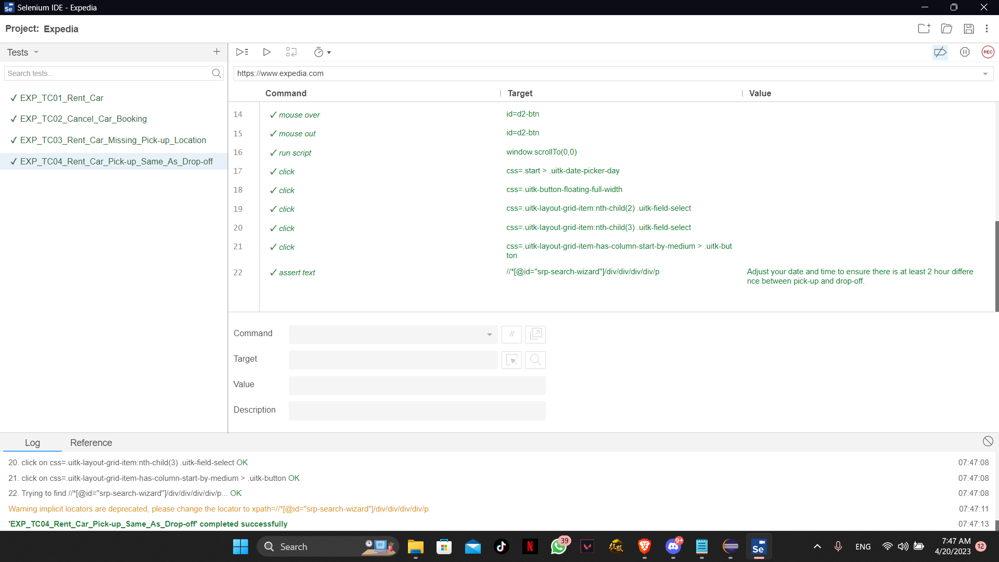

WebDriver & TestNG:

During the testing of the website (Expedia) it kept blocking the automated test and showing no results when trying to type or search for anything, and after restarting it prompted a "Verify Human" test which cannot be solved using any automated test software. Even when we tried to remove apart from the automated test and do it manually, it still did not show any results since we were in the automated test browser mode.

**JMeter:**

Accommodations:

Help Center:

Sitemap:

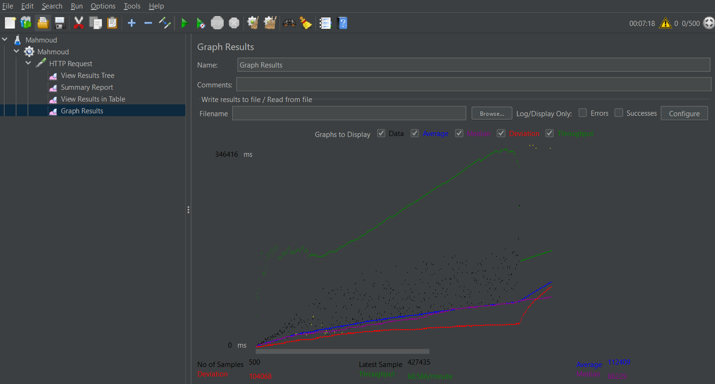

USA Travel Guide:

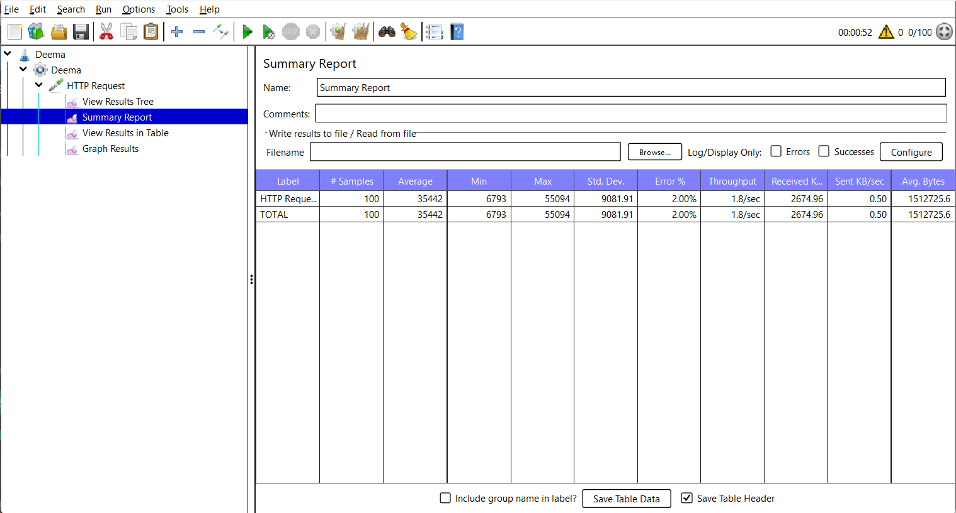

**Summary Report:**

**Issues & Difficulties:**

* Starting with the selenium IDE, we faced a lot of issues while executing the test cases, the test cases were all recorded multiple times to ensure that there is no error in the recording, but in the executing keeps getting error that there is no target with this ID or timeout.
* In WebDriver, we faced an issue with the compatibility with the drivers although we have tried multiple times to install the right ChromeDriver but it kept getting errors and we could not execute for a while.
* In addition, when trying to run both WebDriver and TestNG, we often faced a problem with the website, where it kept blocking the execution of test since they were automated, and right after it fails to execute it always prompts a “Verify you’re a human” test in which the automated test will not be able to pass.