**E-Spotter**

**Mario Orbegoso, Graciany Lebrón, and Carlos Ojeda**

**mario.orbegoso@upr.edu, graciany.lebron@upr.edu, carlos.ojeda4@upr.edu**

**1.** **Introduction**

Currently, there are many student associations in the University of Puerto Rico at Mayaguez that have different activities every day. Nowadays, the most common way to learn about these activities is by either checking your emails sent by “el cartero” to see if you have received information about the activity or by checking the Facebook page of each corresponding association. This method is not efficient because students receive multiple emails every day and will probably skip over the emails announcing the associations’ activities. The other alternative is by checking Facebook for information about the event but you need to know the association’s name. Our product aims to ease these problems and help the student body by creating a web app that will consolidate and facilitate all of the associations’ announcements of their events and let the students track and discover events that they find attractive all in one place. On a more technical note, we will implement the front-end with HTML5, CSS3 and Javascript, using the view library ReactJS together with Redux and Bootstrap for styling. The server side application is going to be implemented in Node.js and the actual database will be managed with the relational database system called PostgreSQL.

**2.** **Client App Description**

There will be two ways to sign up in our app, as a regular user or as an official student association. Both signup processes require email verification, in the case of an association account there will be further verification to validate their legitimacy. The regular user will be able to view all of the events that registered associations have at the time being and also give a review of them. These events appear by most viewed, most recent, most interested and closest date depending on the tab that the user is currently viewing. In addition, he may also follow any of the associations in the app, this way the user will be informed immediately when their preferred associations will have a new event or if they have made any updates to their existing events only if they flagged it as “interesting”. As a result, it will appear in a special tab where they can view the events carefully since some events will require payment and attendance confirmation.

On the other side, the associations will take a more active role than that of a regular user since they are the ones who can create and post the events that the regular user will react to. The registered associations will have access to statistics regarding their event such as the number of users that are interested, user payment transactions and the amount of users who confirmed their attendance. Meanwhile they can also keep updating the events if any unpredicted changes occur prior to the activity.

There are various technologies used to create the front-end of an application. We will implement the front-end with HTML5, CSS3 and Javascript, using the view library ReactJS together with Redux and Bootstrap for styling to helps us develop all of these features that our users will interact with.

**3.** **Server Side Description**

The server side application is going to be implemented in Node.js which will hold all the business logic of the application. It will also provide a RESTful API that will respond to our client’s request. Furthermore, we will be using the relational database system called PostgreSQL to store and manage all the sensitive information of our application. For signup and account confirmation and to support payment in our application a third party API is most likely going to be used such as Paypal and SendGrid. The server will contain ten tables. These tables are Users, Associations, Live Events, Transactions, Statistics, Past Events, Sponsors and Faculties.

Table Descriptions:

1. Users - this table will include all the attributes that identifies the regular user in our system.
2. Associations - this table will include the list of associations that are registered in our system and it will include all the attributes that describe an association and will differentiate it from a regular user.
3. Events - this table will include all of the events with their start date and end date..
4. Transactions - this table will include all of the transactions that happened prior the event.
5. Sponsors - this table will have the list of companies that sponsor the associations.
6. Location - this table will have the location of the associations and the location of the events.
7. Reviews - this table will have the reviews that the user will write to rate the association.
8. Account - this table will have the email and password of all associations and users.
9. Image - this table will include all of the different images that a user, event and association can use.
10. Notifications - this table will include the different notification types that an association .
11. Reviews- this table will include the review that the regular user can post about an association.

**4.** **E-R Diagram**

Present your E-R diagram and explain it.

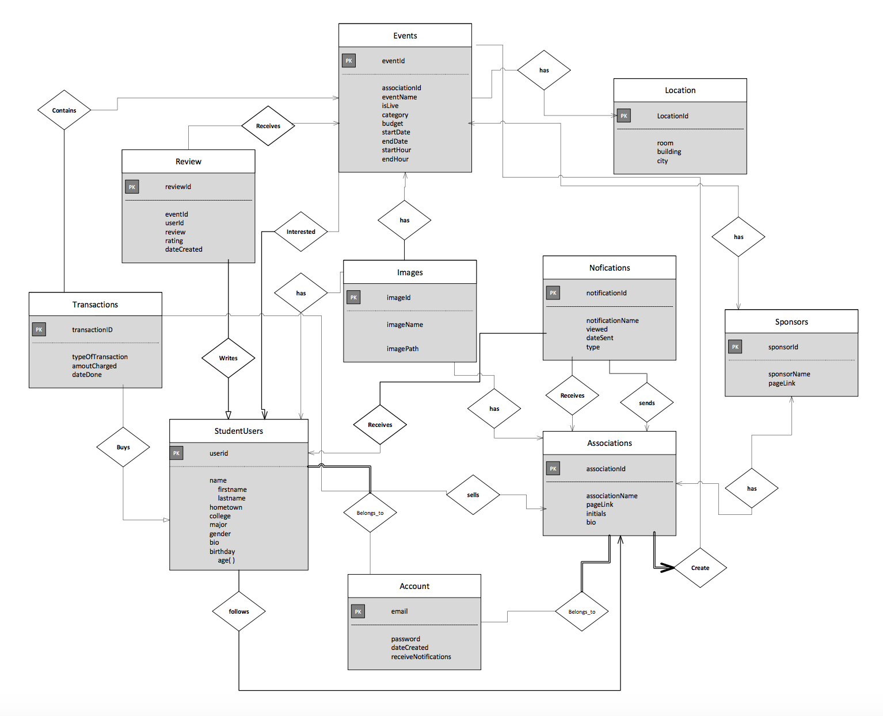

ER Diagram Explanation:

In our Entity Relationship diagram we have 3 main entities that are the center of the application, these are the association users, the student users and the events themselves, these entities are the ones that make our app the way it is. The association and student user entities have similar relationships with the other entities the only difference is that the associations have more creative power overall since they are the one who actually create the events. There are relationships that are necessary to have full participation relationship and that is to have an account, without it any type of user will not be able to do anything within our application and also every user should have a one to one relationship with their account. In addition the associations should also have full participation with the event entity since they are supposed to post their events to motivate the students to join and interact with them. It is important to note that the events and associations have a many to one relationship respectively since we are forcing a constraint that two or more associations can’t host the same event for now. Overall the student user with its relationships with the other entities he or she can the following: they can write reviews to provide feedback of the events , follow various associations, be interested in different events, do various payments within the Transaction entity, use images for his or her profile picture, and receives notifications of their interested events and associations. On the other hand an Association can create the events, have sponsors, be followed by the students, receive and send notifications, have a location for their main offices, use images on their profile and when they post their events, and they also sell tickets for their events using the Transaction entity. Finally the event entity should have their sponsors as well, the events can’t have various locations if the last more than one day that’s why we are forcing a one to many relationship with location and events respectively for now , the events also receives various reviews from a user, have an images as their flyers, they are interested by the users and created by the associations. As a result this is the overall dynamic that our application has due to the different relationships that each entity has with each other

**5.** **Client – Side Screen Shots**

**Profile Page**

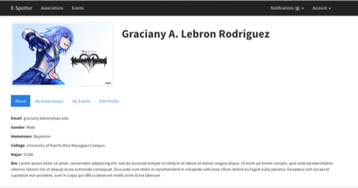

This page shows the structure for the user profiles. It will include all personal information as well as the associations and events the user is currently following.

**All Events Page**

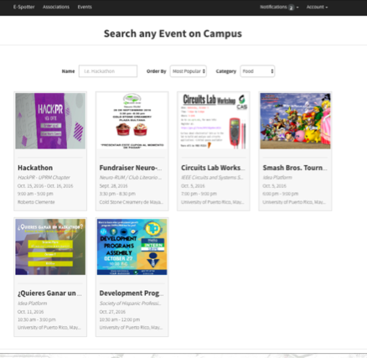

This page shows all of the available events that are created in our application. The user will be able to select any event and see all the the event’s information.

**All Associations List**

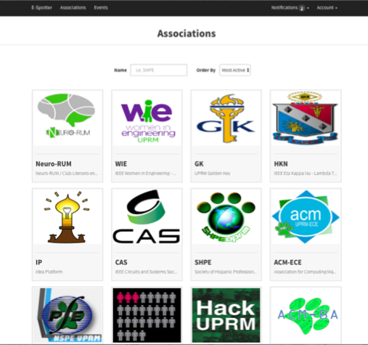

This page shows all of the available student associations that have profiles in our application. The user will be able to select any association and enter its profile.

**Individual Events**

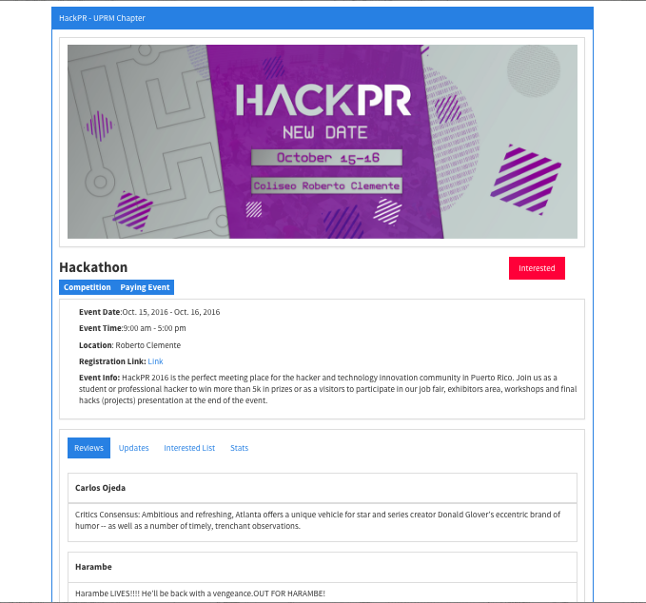

This page shows the information for each event will be structured. It will also have reviews, updates, a list of the interested people and a graph showing the total interest.

**Association Page**

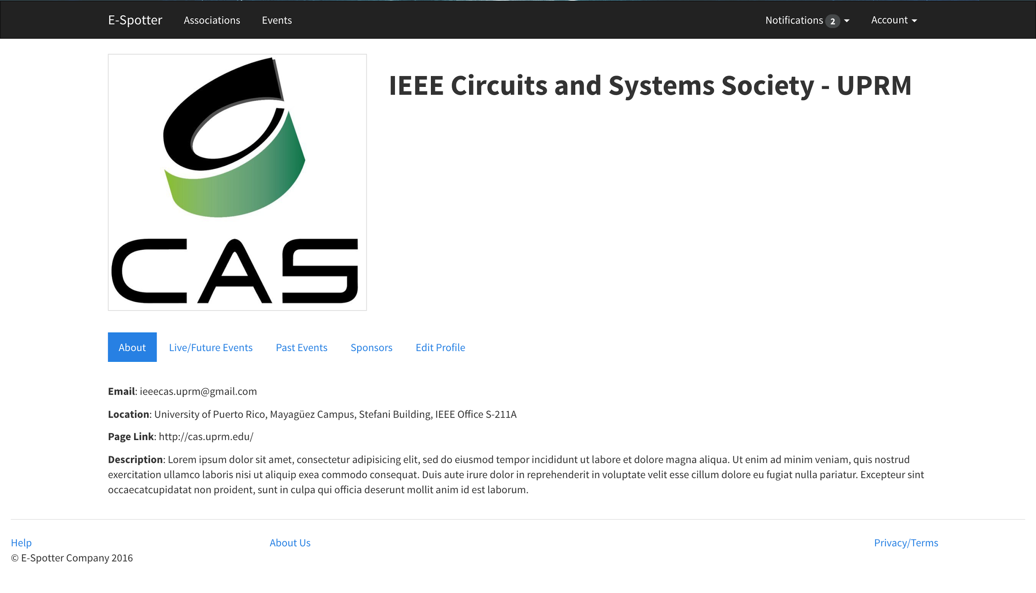

This page shows how the information of a particular association. Any user will be able to see the events they are hosting or have hosted in the past, as well as a list of their sponsors. Later on there will be another tab to display a graph that will show how active they are based on how often the association host events.