

**Cairo University  
Faculty of Computers and Artificial Intelligence  
CS-213   
second year**

**Assignment 2 – Task2,3**

**Section: S27  
Subjected To: Dr Mohamed EL Ramly**

|  |  |  |
| --- | --- | --- |
| **Youssef Hossam Ibrahim** | **20230490** | [**yh55694@gmail.com**](mailto:yh55694@gmail.com) |
| **Mario Dawod Botros** | **20230304** | [**mariodawod12@gmail.com**](mailto:mariodawod12@gmail.com) |
| **Fatma Hashim Mohamed** | **20230285** | [**fatma.hashim20233@gmail.com**](mailto:fatma.hashim20233@gmail.com) |

**UML design for the relation of the classes:**

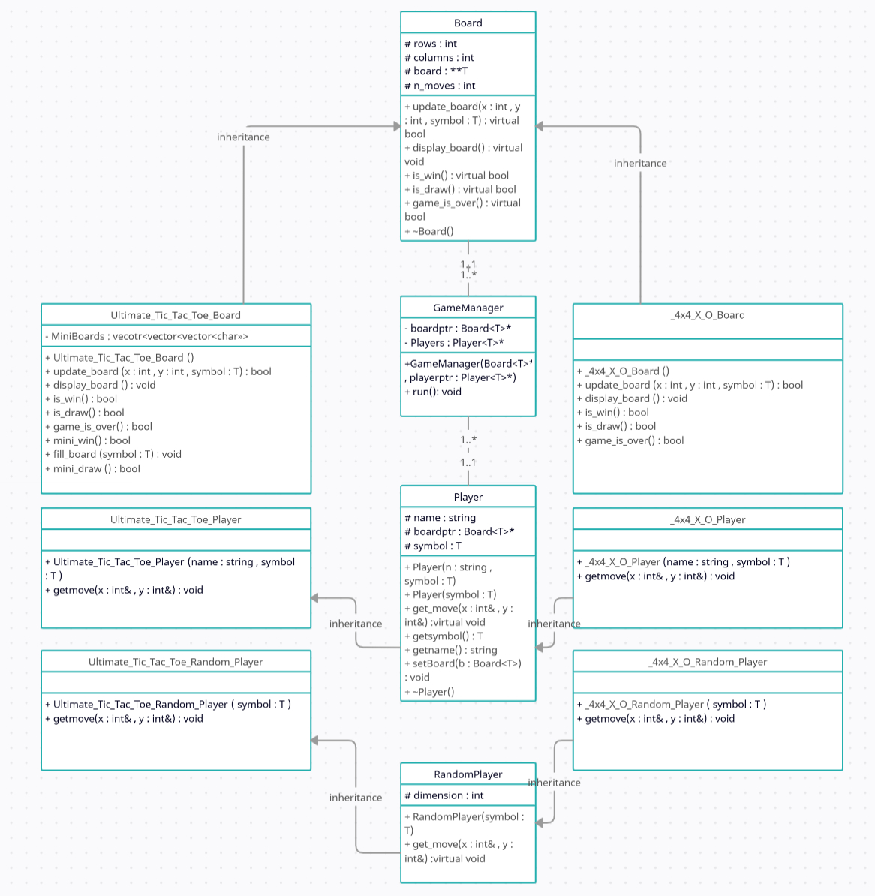

**Work break-down table:**

**The whole team collaborate in each function to create the vole machine perfectly but to be more specified:**

|  |  |  |
| --- | --- | --- |
| **Mario Dawod Botros** | **Youssef Hossam Ibrahim** | **Fatma Hashim Mohamed** |
| **Did these 3 games**   1. **Four-in-a-row** 2. **Numerical Tic-Tac-Toe** 3. **Ultimate Tic Tac Toe** | **Did these 3 games**   1. **5 x 5 Tic Tac Toe** 2. **Misere Tic Tac Toe** 3. **4 x 4 Tic-Tac-Toe** | **Did these 2 games**   1. **Pyramic Tic-Tac-Toe** 2. **Word Tic-tac-toe** |

**Report of the quality of the code of other members:**

|  |  |  |
| --- | --- | --- |
| **Mario Dawod Botros** | **Youssef Hossam Ibrahim** | **Fatma Hashim Mohamed** |
| **1-Pyramic tic-tac-toe:**  **Works well but didn’t use inheritance for the game manager.**  **2-5X5O tic-tic-tac-toe:**  **The code is**  **mostly fine and**  **the game works**  **well without any**  **issues to**  **address.**  **3-WordBoard tic-tac-toe:**  **The game works**  **fine but changed**  **Game Manger**  **implementation.**  **4-Misere Tic-Tac-Toe:**  **The game works**  **fine.** | **For ultimate tic-tac-toe**   1. **Perfect code and clean code** | **All the games work very well.** |

**GitHub Work:**

[**https://github.com/mario985/BoardGame**](https://github.com/mario985/BoardGame)

