Mexico

Mexico is a federal republic of 32 federal entities located at the north of Latin America. It has an estimated population of over 120 million, which makes it the eleventh most populous country and the most populous Spanish-speaking country in the world, as well as the second most populous country in Latin America, behind Brazil. Mexico is a member of the United Nations, the World Trade Organization, the G20, the Pacific Alliance and a founding member of the Open Government Partnership. Mexico joined the Organization for Economic Co-operation and Development (OECD) in 1994, later joined by Chile, the only other Latin American country in the Organization.

The center-left Institutional Revolutionary Party (PRI) ruled the country from its foundation in 1929 to 2000, when it was defeated by the center-right National Action Party in 2000. The PRI returned to power in 2012 with the election of President Enrique Peña Nieto, whose single six-year term ends in 2018.

Mexico is the second biggest economy of the Latin America and is classified as an upper-middle income country by the World Bank. (World Bank website). It has the fifteenth largest nominal GDP and the eleventh largest by purchasing power parity in the world. Mexico could become the world's seventh largest economy in 2050, but it is decelerating with an annual GDP growth of 2.3 percent in 2016, down from 2.6 percent in 2015. This is due to a global environment of modest growth and stagnant trade and a further economic slowdown is expected from a slowdown of investment from the uncertainty of a potential renegotiation of the North American Free Trade Agreement (NAFTA). However, there is another variable that obstructs the full economic potential of Mexico. The think thank Mexican Institute for Competitiveness (IMCO) estimates that corruption is costing Mexico from 2 to 9 percent of potential GDP growth.

Corruption in Mexico

As graph xx shows, Mexico suffered the worst decrease in the region regarding the Control of Corruption Indicator from 2006 to 2015. Other evaluations from international organizations go in the same direction. According to the Heritage Foundation, widespread corruption has increased public dissatisfaction about the effectiveness of anticorruption efforts by weak government institutions. Mexico ranks 123 of 176 in 2016’s Corruption Perceptions Index of Transparency International with a score of 30, a decrease of 5 points and 28 places compared to 2015. In its Integrity Review of Mexico, the OECD warned that if corruption is not tackled effectively, it will be impossible to effectively address many of the other dire challenges facing the country: slumping productivity and competitiveness, stubborn inequality, serious regional security issues and more. The following graph xx shows the fall in the World Bank’s Control of Corruption Indicator. Mexico decreased from a 4.49 in 2006 in the recoded version of the index to 3.51 in 2015, almost a one-point decrease.

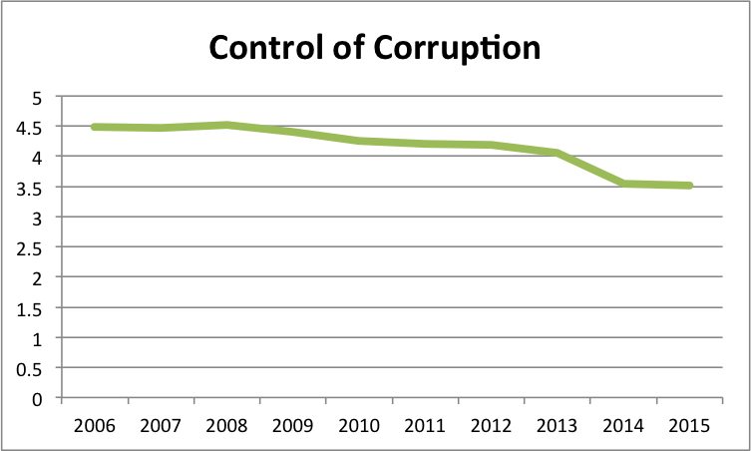

Graph xx

In the same sense, public perception about corruption reflects a negative trend. On the National Survey of Quality and Governmental Impact (ENCIG) of 2015, corruption is cited as the second most important problem with 51 percent, just behind insecurity and crime. In the 2013 survey, 49 percent reported that they believed corruption was a major issue in their state. Similarly, in the 2015 Latinobarometro survey, only 3.9 percent of Mexican respondents declared having high confidence in government, 17.1 percent some confidence, while 35.2 and 42.4 percent declared having low and no confidence respectively.

The drop in indexes and confidence might be related to recent high-profile corruption scandals that have dominated news cycles. In November of 2014, journalist Carmen Aristegui published a report exposing a company with government contracts that owned a mansion designed for the presidential family and described by the First Lady as the “real family home” in a society magazine. In August of 2015, the President was cleared of any wrongdoing by Comptroller Virgilio Andrade, a presidential appointee. Two years later, during the signing of General Law of the National Anticorruption System (NACS) in 2016, the President acknowledged that the scandal had hit his government's credibility, while claiming that his family had done nothing illegal. The biggest drop in graph xx is recorded in 2014, the year of the corruption allegations against President Peña Nieto.

Two of the other most well known cases of corruption are from members of President Peña Nieto’s PRI, although corruption is not limited to that party and there have been cases of politicians from other parties as well. The former governor of Tamaulipas, was indicted by a jury in the US on charges of drug smuggling, bank fraud, racketeering, money laundering and from taking millions of dollars in bribes from the Gulf Cartel and other traffickers since 1998, when he was the mayor of Matamoros. After almost five years on the run, Yarrington was arrested in Italy on April of 2017.

After an investigative report on the website Animal Politico, Javier Duarte, the former governor of Veracruz, fled the country at the end of his term in 2016 amongst allegations of corruption, involvement in organized crime and embezzling millions of dollars. Further fueling citizen’s anger, the new governor Miguel Angel Yunes accused Duarte’s government of giving water instead of chemotherapy to children with cancer. A few days later from Yarrington’s arrest, Duarte was apprehended on Guatemala. The common theme of these cases is that the investigations for corruption did not come from the Mexican political system, like oversight authorities or opposition parties, but in two cases from the media and in another from judicial authorities from the US.

The aforementioned NACS is just the latest of reforms that aims to fight corruption in the country. According to the OECD, the eight laws that create the System aim to overcome “key shortcomings of the past” by addressing fragmentation in policies and developing a more comprehensive approach to integrity; avoiding implementation gaps by improving co-ordination across and between levels of government, and by bringing states under the system; strengthening enforcement mechanisms for investigating and sanctioning integrity breaches by public officials and firms under administrative and criminal jurisdictions; and, reinforcing oversight through greater transparency, expanded auditing powers and involvement of civil society. (OECD report)

Specifically, the laws include a governance structure comprised of a NACS Co-ordination Committee, a Citizen Participation Committee, and ethics committees in ministries. They also involve a revamping of codes of conduct for public officials, as well as the federal manual for internal control and risk management standards. Also, the development of an online platform comprised of key databases of sanctions and procurement, to support better detection and oversight. (OECD Report)

Furthermore, the law requires that states develop their Local Anti-corruption Systems (LACS) and respective committees. It will oblige more rigorous asset and interest declarations of all officials, and both government employees and firms involved in public sector activities will be subject to a new disciplinary regime for integrity violations. Finally, it demands the enlisting of Specialized Anti-corruption Prosecutors to prosecute acts of corruption. (OECD report)

Nonetheless, it appears that NACS got off on the wrong foot. In April of 2017, the president of the Citizen Participation Committee Jaqueline Peschard denounced that the System was instated without the Specialized Anti-corruption Prosecutor, nor the regional authorities in charge of imposing sanctions to public servants that commit serious offenses. Mexico’s main parties had not agreed on the designation of the Prosecutor, which shows a lack of political will to implement the NACS. (El Financiero)

Political Finance

Political finance reform was an integral part of the transition of Mexico to a multi-party system. The formulation of some public funding for political parties started in the 1960s and political reform was accelerated during the 1990s in a crisis of credibility of the PRI and the incorporation of the country to NAFTA. Electoral reforms in the decade prohibited public entities from contributing to political parties and banned contributions by businesses, individuals who live or work outside of Mexico, churches and foreign entities. Moreover, the reforms mandated reports from parties to electoral authorities detailing private contributions and all expenditures. (Reporte chido)

In efforts to further improve the political finance system, comprehensive reforms were passed after 2005, which are reflected in graph xx. Given the sensibility of our Public Finance Regulation Index to the most recent amendments to existing laws, it reacts to the most recent reforms in the matter.

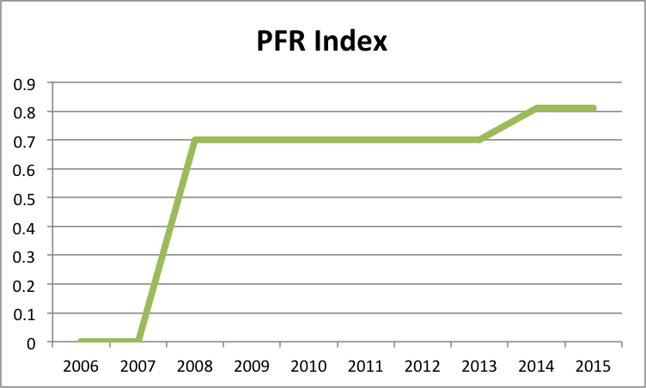

Graph xx

The reform of 2007, implemented after the contentious 2006 presidential election in which Felipe Calderon became president, altered the financing of political campaigns. It changed the formula for the allocation of public funds to political parties and increased the importance of makes winning seats doubly important, as it shapes both political power and future funding. It also limited private contributions to 10 percent of the money spent in the previous presidential campaign. (CFR)

In a similar way, the most recent political reform, of 2014, introduced a new national electoral body to organize election all over the country and allows the reelection for Senators and Deputies for up to 12 years. Also, it amplified regulation by increasing the grounds for annulment of election, specifically if there are excesses on the funding, as well as expanding the definitions under which a public servant might break electoral rules. Furthermore, it introduced the figure of coalition governments, increased the voting choices for Mexicans voting abroad, gender parity rules and increased the threshold of votes for a party to maintain registry and public funding. Finally, in response to a push by civil society, independent candidates can participate in elections and receive public and private funds. (Mexico Institute Guide for Mexican elections)

Nevertheless, according to the literature on Latin America and the findings on this thesis, these efforts seem to be ineffective to counter corruption. The problem is the enforcement of the rules. Electoral authorities don’t have the tools necessary to truly monitor the campaign financing process, which could be constituted by illegal campaign contributions at more than four times the legal amounts. Also, they fail to address two of the worst problems for democracy in Mexico, vote buying and the infiltration of drug money in campaigns. (CFR)

Judicial Independence

Foreseeing that his party was going to become the opposition for the first time in its existence, former President Ernesto Zedillo pushed for a reform in 1994 aimed at the independence of the Supreme Court. The downward tendency of the WEF’s Judicial Independence indicator in graph xx might have be related do with the intervention of President Peña Nieto and the three nominations that he’s made to the eleven judge body. All of these nominations have been criticized by civil society organizations for responding to partisan quotas and the lack of transparency of the confirmation process on the Senate. (mexico evalua)

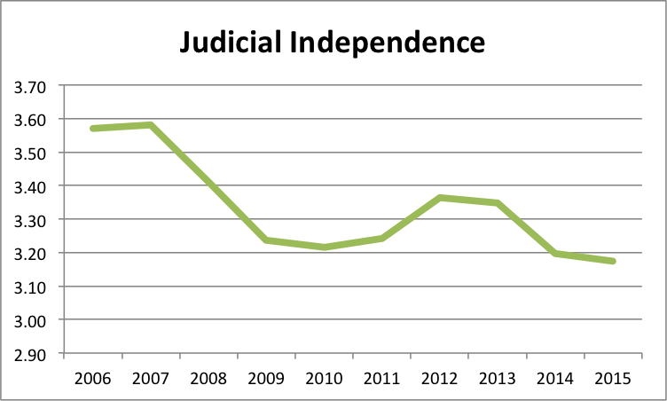

graph xx

However, the downward trend starts before Peña Nieto’s rise to power. This might have to do with the start of the drug war by former President Felipe Calderon. The inability of the judicial sector to assume responsibility over security was one of the reasons Calderon decided to use the Army in policing activities against drug cartels in the country. In its efforts towards ending drug trafficking, Calderon often bypassed national courts and extradited drug traffickers to the US almost immediately after being captured. According to Council on Foreign Relations, “Mexico’s security crisis is due not only to a lack of compliance with the law, but also to the failure of the government to enforce the law faithfully, effectively, and fairly.” It is worth noticing that the security situation did not show any signs of ending with President Peña Nieto, which further undermined Mexico’s judicial independence.

Aware of the problem, Mexican authorities pushed for the most significant change to the judicial system, a 2008 amendment requiring that all state and federal judicial systems transition from a written-based inquisitorial system to an oral-based accusatorial. States that have complied with the reform say that it has help them with a better allocation of criminal justice resources. However, reports denounced that the reform does not do enough on corrupt judges. (Insight Crime)

Public Investments

Lastly, the indicator of public investment, which is based on data on Capital Expenditures of the ECLAC, shows an overall increase of spending in the matter in absolute terms since 2006, as shown on graph xx. There was a decrease in spending following the 2008 international financial crisis, but this kind of spending has not decreased below 2.48 percent of the GDP. After this bump, public investment further increased when President Peña Nieto took power. An example of this kind of investment under his term is the new airport of Mexico City, with a cost of 9.4 billion USD and expected to open in 2020. To keep this trend in a context of low income from oil exports, the government has been increasing the national debt. In March of 2017, debt stood at 9.68 trillion MXN (522 billion USD). (Nota sobre la deuda)

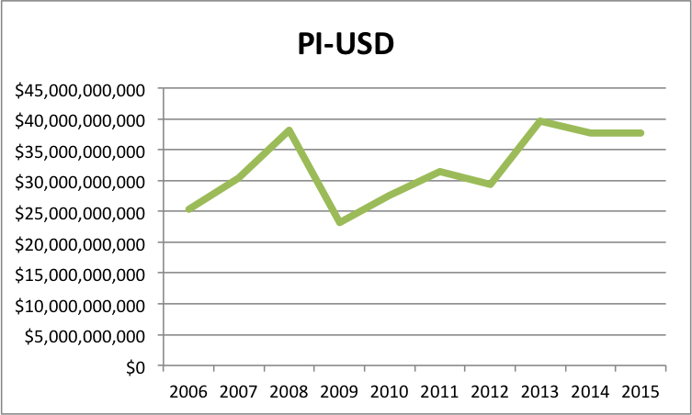

graph xx

As specified above, public investment acts as an opportunity of corruption if the procurement process allows corrupt public officials to favor specific companies in which they have a stake. Also, it is important to highlight that the scandal of President Peña Nieto is related with this type of corruption. According to the United Nations Office on Drugs and Crime, there exist some legislative gaps in the matter, although it recognized that the Mexican government follows international standards in its procurement process. (UNODC)

Recommendations

Describe differences between latin America

Check report on judiciary

Get more advice from civil society