Party finance regulation

Alvaro Lopez, Mario Rodriguez and Mariano Valentini

March 28, 2017

# Abstract

Abstract.

*Key words: Control of corruption, Party finance, Democracy promotion,*

# Party finance regulation index (PFRI)

## Model: Global.

### Descriptive statistics.

#### Tables.

Tables...

#### Grafico de lineas de evolucion en el tiempo del PFR dividido por regiones: America, Europa, Africa, Oceania, Asia.

This graph shows the ...

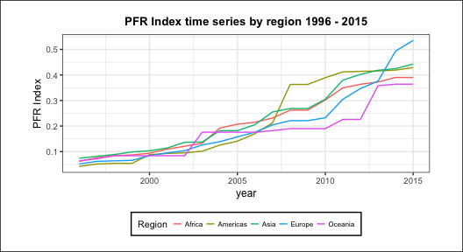

#### Grafico de lineas de evolucion de los subindices: America, Europa, Africa, Ocean??a, Asia.

This graph shows ...

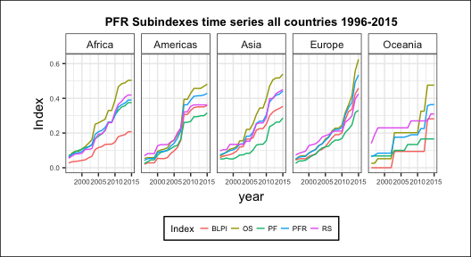

#### Grafico de barras diferencia PFR 1996-2015, dividido por categoria y dentro de cada categoria las cinco regiones.

This graph shows that ...

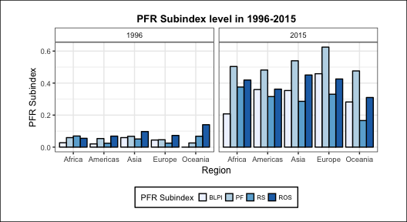

### Modelo de regresion global.

#### Variable description and linear model equation.

*Dependent Variable:* World Bank Control of Corruption Index, from the World Governance Indicators database *CoC*.

*Explanatory Variable:* The main independent (explanatory) variable used for our research is Party Finance Regulation Index, written as *PFR*.

*Control Variables:*.

*Regression Equation:* The regression equation is written as follows: $$CoC_{ij}=β_{i}(country_{i})+β_{1}(PFR_{ij})+ϵ$$

## Modelo de regresion Latin America.

### Descriptive statistics.

#### Tables.

Tables...

#### Grafico de lineas de evoluci??n en el tiempo del PFR dividido por regiones: South America and Central America.

This graph shows the ...

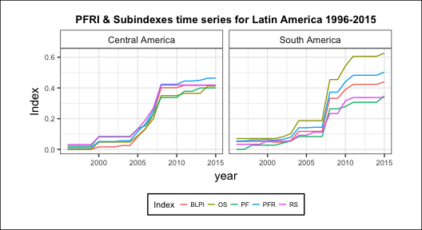

#### gr??fico de barras, evoluci??n PFR Index 96-15, dividido por pa??ses con la media de LA. (Gr??fico 5 Gtvo.)

This graph shows the ... 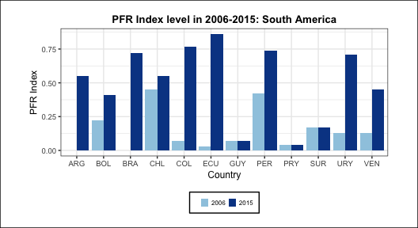

#### gr??fico de barras, evoluci??n PFR Index 96-15, dividido por pa??ses con la media de LA. (Gr??fico 5 Gtvo.)

This graph shows the ...

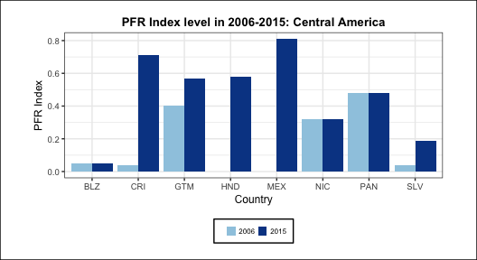

#### grafico in law effort and Coc change by country, 2006-15 ...

This graph shows the ...

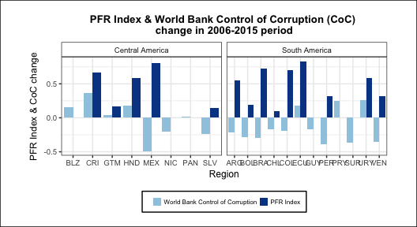

### Modelo de regresion Latin America.

#### Variable description.

*Dependent Variable:* World Bank Control of Corruption Index, from the World Governance Indicators database *(CoC)*.

*Explanatory Variable:* The main independent (explanatory) variable used for our research is Party Finance Regulation Index *(PFR)*. In adition Public investment from the Cepal database is used as a proxy for ... *(PI)*.

*Control Variables:* Independence of the judiciary, from World economic forum database *(wefji)*

*Regression Equation:* The regression equation is written as follows: $$CoC_{ij}=β_{0}+β_{1}(PFR_{ij})+β_{2}(PI_{ij})+β_{3}(WEFJI_{ij})+β_{4}(PFR_{ij})(WEFJI_{ij})+β_{5}(PI_{ij})(WEFJI_{ij})+ϵ_{ij}$$

#### Regression Model.

##### Estimation output.

##### Marginal effects.

