REGION SOUTH  Visual Style Guide  User Edition  A practical guide for consistent Region South presentations, dashboards, data stories, and AI-generated graphics. |   

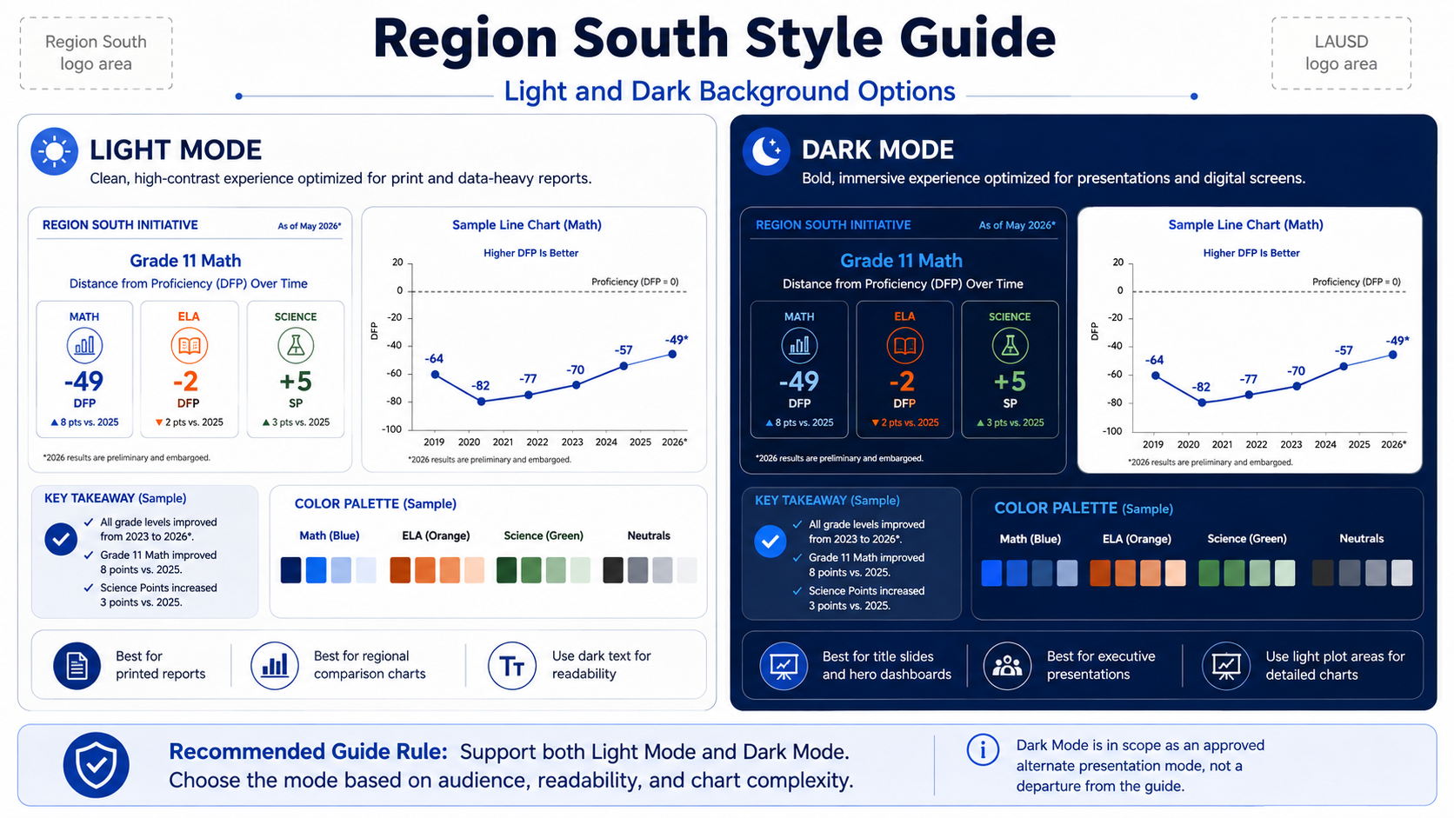
Professional | Data-driven | Student-centered | Modern | Optimistic | Clear

Quick Start
The rules most users need before creating a Region South graphic.
Core priority: Data accuracy > Brand compliance > Readability > Correct subject identity > Student representation > Aesthetic polish.
1. Choose a display mode  Light Mode or Dark Mode must be chosen before final generation. If the user has not specified one, ask. | 2. Resolve metadata  Ask for Source and download/data-as-of Date when missing. Explicitly allow either to be omitted if not pertinent.
3. Identify the subject  Math = blue. ELA = orange. Science/CAST = green. Subject determines the color family. | 4. Select a template  RS-01 Hero Data, RS-02 Regional Comparison, or RS-03 Cohort Analysis.
5. Use approved terminology  P+A = Proficient + Advanced; DFP = Distance from Proficiency; SP = Science Points. | 6. Verify before publishing  Check data values, definitions, authentic logos, contrast, source/date, and embargo restrictions.

Do not improvise brand rules when a Region South standard already exists.

1. Brand Foundation
The Region South visual system is a presentation and communication framework operating within the LAUSD brand environment. It does not replace the official LAUSD identity.
- Professional
- Data-driven
- Student-centered
- Modern
- Optimistic
- Clear

Official brand assets
Use the canonical Region South and LAUSD logo files. Never redraw, recolor, distort, crop, or approximate official logos.
If an AI cannot reproduce an authentic logo, reserve clean space and insert the official asset afterward. An authentic missing logo is better than an inaccurate generated logo.

Brand hierarchy
LAUSD -> Region South -> specific program, subject, or data story.

2. Approved Display Modes

LIGHT MODE  Best for print, dense analytical charts, regional comparisons, detailed tables, and maximum color contrast. | DARK MODE  Best for presentations, executive dashboards, hero graphics, title slides, student photography, and large-screen display.
Required interaction: If the user has not specified Light or Dark Mode, ask. If they request a recommendation, recommend one and obtain confirmation before final generation.

3. Color System
Subject determines the color family. Region determines the shade.
Color | Hex | Use
LAUSD Navy | #00237A | Math anchor / institutional blue
Bright Blue | #0089FF | Math secondary / digital accent
LAUSD Green | #00602D | Science / CAST anchor
LAUSD Orange | #FF4D00 | ELA anchor
LAUSD Gold | #FF9C00 | Highlight
LAUSD Red | #FF0000 | Warning / decline

Locked regional comparison palette
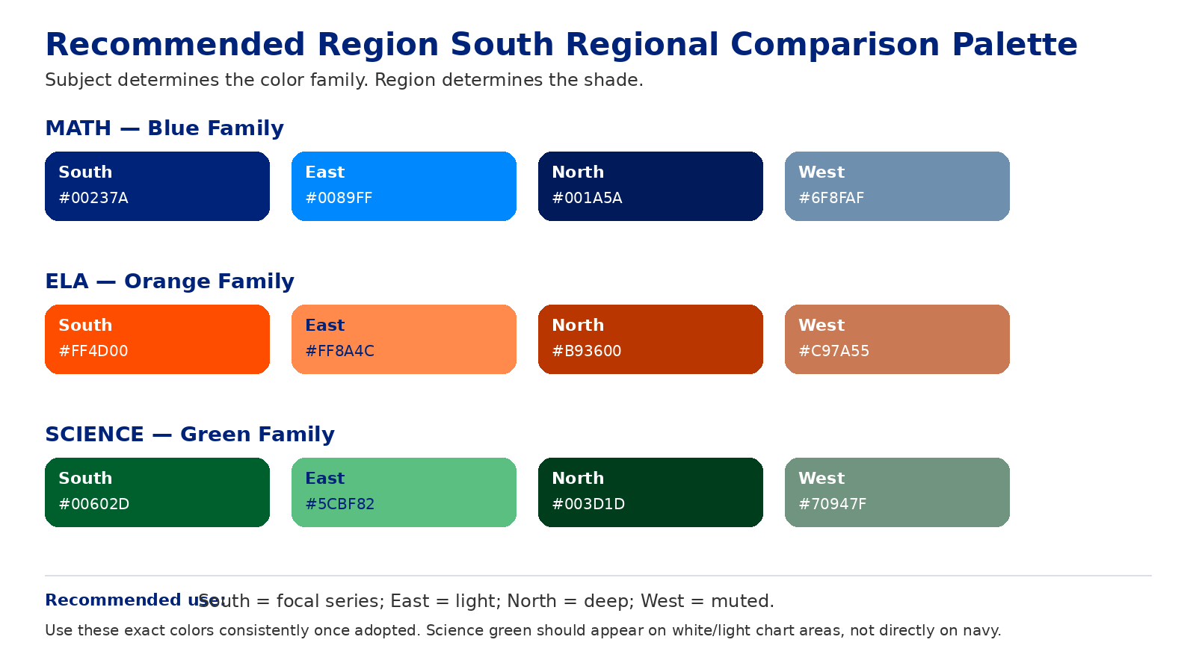
Exact regional colors should not drift once adopted. The same region color must be used consistently across all charts in the same visual.

4. Typography
Primary presentation/data typeface: Poppins. Open Sans may be used for digital body text; Arial is the fallback.
Use | Recommended weight
Major title | Bold / ExtraBold
Section heading | Bold
Subtitle | Medium
Chart title | SemiBold
Large metric | Bold / ExtraBold
Body | Regular
Chart labels | Medium
Footer / source | Regular

5. Photography and Student Representation
Student imagery should be photorealistic, age-appropriate, diverse, academically engaged, and natural rather than posed. Students should support the instructional context or data story rather than function as decoration.
ELA  Reading, annotating, discussing text, or writing in response. Icon: open book in LAUSD Orange. | Math  Solving equations, calculator use, graphing, collaborative problem-solving. Icon: calculator in LAUSD Navy.
Science  Experiments, measuring liquids, recording observations, discussing results. Icon: beaker, flask, or microscope in LAUSD Green. | Placement  Prefer left, lower-left, or lower-third. Blend photography into the composition; data readability always takes precedence.
Science green #00602D should not sit directly on navy. Put a green Science icon inside a white or light container when the overall slide is dark.

6. Core Layout Templates
RS-01 — Hero Data  PHOTO | PRIMARY DATA | KEY TAKEAWAY  Use for SBA trends, CAST, attendance, and single-subject dashboards. | RS-02 — Regional Comparison  P+A | DFP or SP | REGION SOUTH STORY  Use for East/North/South/West comparisons. Light plotting areas are preferred.
RS-03 — Cohort Analysis  MULTIPLE GRADE PANELS + STUDENT IMAGE | KEY TAKEAWAY  Use common axes when cross-panel comparison is intended. | Dashboard proportion  Top 15–18% title/subtitle; middle 60–68% visualization/photo; bottom 12–18% takeaway/logo/source/notes.

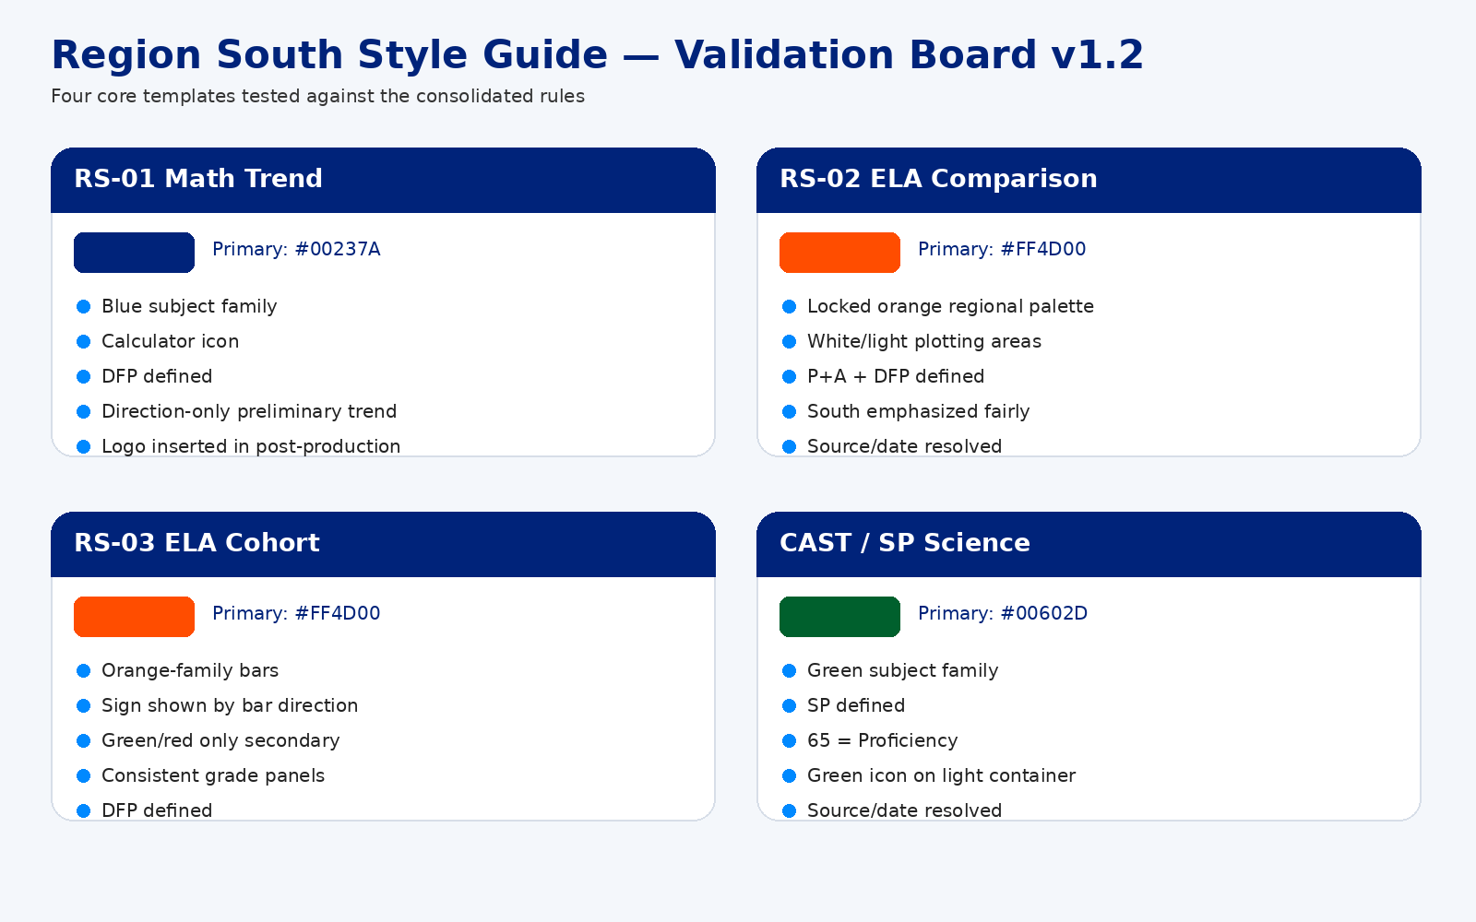

7. Terminology and Measures
Full term | Short form | Use
Proficient + Advanced | P+A | Higher is better. Use percentage points for differences between rates.
Distance from Proficiency | DFP | Higher is better. Values closer to 0 are closer to proficiency; positive values are above proficiency.
Science Points | SP | Higher is better. Scale is 0–100; 65 = Proficiency.

Whenever P+A, DFP, or SP appears anywhere in a visual, the full definition must also appear somewhere in that same visual.
Do not display PoA in Region South-facing visuals unless reproducing a source verbatim. Use Proficient + Advanced or P+A instead.
Use Distance from Proficiency, not Distance from Standard.

8. Data Visualization Standards
- Use accurate scales, minimal clutter, selective direct labeling, and fair comparison.
- P+A: higher is better. Describe differences between percentages as percentage points.
- DFP: higher is better. Keep negative signs. Use 0 = Proficiency when relevant. Do not reverse the axis.
- SP: scale 0–100. Use a benchmark at 65 labeled Proficiency. Never label it Proficiency Floor.
- Regional comparison: South receives the strongest emphasis without suppressing other regions.
- Cohort-change bars: preserve the subject color family as the primary encoding; bar direction communicates sign.
- Benchmarks should be subordinate to data: thin, dashed, and directly labeled.

Trend language
Term | Meaning
Improvement | Favorable directional movement.
Growth | Improvement across multiple periods.
Average annual change | Endpoint-based annual rate: (final - start) / elapsed years.
Linear trend slope | Regression-based rate using all observations.
Acceleration | The rate of improvement itself is increasing; not a synonym for ordinary growth.
Claims such as largest, highest, lowest, fastest, strongest, or most improved must state the comparison period.

9. Preliminary, Embargoed, and Internal Data
When an actual value is restricted, the visual must not reveal the value directly or indirectly.
- Do not print the restricted value.
- Do not terminate a trend arrow at a meaningful y-axis coordinate.
- Do not align the arrow with a gridline from which the value can be estimated.
- Prefer a direction-only arrow in a separate Preliminary Trend zone or use generalized text such as improving trend.
Preferred wording: Preliminary results remain embargoed and are shown only as a generalized trend.
For stronger internal notices, use: PRELIMINARY — INTERNAL USE ONLY.

10. Footer and Metadata
Preferred footer architecture:
- Left: brand identity
- Center: definitions, methodology, confidentiality/embargo note
- Right: source and date
If Source and/or Date are not provided, prompt the user before finalizing. Explicitly offer the option to omit either item if it is not pertinent. Never invent a source or date.
Approved date labels include Data as of [date], Downloaded [date], and Results through [date]. Use the label that accurately describes the date.

11. Using the Guide with AI
For ChatGPT, Claude, Gemini, or another image/design assistant.
A Region South AI workflow should resolve the following before generating a final data graphic:
- Display Mode: Light or Dark
- Source: provide or omit
- Date: provide or omit
- Preliminary/embargo status, when relevant
- Subject and required measures

Required AI behavior
- Ask the user to choose Light or Dark Mode if missing.
- Ask for Source/Date if missing and allow omission.
- Apply the locked subject and regional colors.
- Use Poppins as the preferred presentation font.
- Define P+A, DFP, and SP in the same visual whenever abbreviated.
- Use authentic logos only; reserve space if authentic insertion is not possible.
- Verify every value, label, benchmark, takeaway, and superlative.
AI priority order: Data accuracy > Brand compliance > Readability > Correct subject identity > Student representation > Aesthetic polish.

12. Approved Example Workflow
A generated composition is a draft until it passes post-production review.
Brand  Authentic logos; correct display mode; locked subject and regional colors. | Typography  Poppins hierarchy; readable labels; compliant small-text colors.
Data  Values verified; fair axes; correct benchmarks; claims supported. | Metadata  Source/date resolved; definitions present; embargo rules followed.

Only visuals that pass all current checks should be placed in the Approved Examples gallery.

13. Reference Checklist
Use this before sharing or publishing any Region South visual.
- □ Light or Dark Mode was selected by the user.
- □ Subject color family is correct.
- □ Regional colors match the locked palette when regions are compared.
- □ Subject icon is correct.
- □ Poppins hierarchy is applied or an approved fallback is used.
- □ P+A / DFP / SP are defined if abbreviated.
- □ Numbers, signs, axes, benchmarks, and takeaways were verified.
- □ Source is supplied or intentionally omitted.
- □ Date is supplied or intentionally omitted.
- □ Embargo/preliminary restrictions are followed.
- □ Authentic Region South / LAUSD logos are used, or clean space is reserved for them.
- □ Student imagery is age-appropriate, academically engaged, and diverse.
- □ Every visual element supports instructional context, the data story, or Region South identity.

Every visual element should support either instructional context, the data story, or Region South identity. If it does none of those three things, remove it.
Canonical online assets and the machine-readable specification are maintained in the Region South style-guide repository.

