Are newer buildings more energy efficient?

Surbhi Singla

Carnegie Mellon University

[surbhis@andrew.cmu.edu](mailto:surbhis@andrew.cmu.edu)

# INTRODUCTION

The adoption of green construction technologies and LEED paradigm in the recent decades aims to reduce building energy consumption both across commercial and residential sectors. While it has been investigated considerably for commercial buildings, the adoption of LEED design and energy efficient practices is still understudied for the residential sector. Based on the energy consumption data available from Residential Energy Consumption Survey 2009 conducted by EIA, the effect of age of the building on its total energy consumption is studied in this project.

# DATA & METHODOLOGY

## Data Normalization

The 2009 RECS survey contains the building characteristics and the corresponding energy consumption data. The YEARMADE: year in which the building was constructed, the TOTALBTU: total energy consumption from different sources like electricity, natural gas, fuel oil, kerosene etc. and TOTSQFT: total square footage area were the main parameters used for the project. To normalize the data, data from a single climate region 1 was used to ensure that the buildings experienced similar weather and temperature ranges.The second normalization was done with respect to the total area of the building by diving Totalbtu by Totsqft to get the ***Energy utilization intensity***.

## The LASSO

The LASSO(Least Absolute Shrinkage and Selection Operator) shrinkage was also used to identify the most important parameters that account for the total energy consumption. LASSO method shrinks the least square error and the sum of absolute values of coefficients. Therefore, according the value set for the tuning parameter it results in parameter selection by setting the non important coefficients to zero. The list of 15 parameters selected for LASSO shrinkage was chosen manually based on their thought-of effect on energy consumption.

Table . Parameters for LASSO shrinkage

|  |  |  |  |
| --- | --- | --- | --- |
| Parameters |  |  | Description |
| TEMPHOME |  |  | Temperature set when at home in daytime |
| TEMPGONE |  |  | Temperature set when not at home in daytime |
| TEMPNITE |  |  | Temperature set at nighttime |
| ACROOMS |  |  | No of rooms with AC |
| WINDOWS |  |  | No of windows |
| NHSLDMEM |  |  | No of members in the household |
| TOTSQFT |  |  | Total Area |
| STORIES |  |  | No of stories in a single family home |
| MONEYPY |  |  | Total income |
| HEATROOM |  |  | No of rooms heated |
| EQUIPAGE |  |  | Age of main space heating equipment |
| NUMH2ONOTNK |  |  | No of tankless water heaters |
| NUMH2OHTRS |  |  | No of storage water heaters |
| LGT4 |  |  | Number of lights turned on 4 to 12 hours during a typical summer day |

# RESULTS

## LASSO Results

Following table shows the 15 parameters with coefficient values :

Table . Coefficients results

|  |  |  |  |
| --- | --- | --- | --- |
| Parameters |  |  | Coefficient |
| TEMPHOME |  |  | 0 |
| TEMPGONE |  |  | 80.18667055 |
| TEMPNITE |  |  | 0 |
| ACROOMS |  |  | 0 |
| WINDOWS |  |  | 633.74024584 |
| NHSLDMEM |  |  | 0 |
| TOTSQFT |  |  | 18.60369738 |
| AGE |  |  | 228.79345981 |
| STORIES |  |  | 6.94659615 |
| MONEYPY |  |  | 0 |
| HEATROOM |  |  | 0 |
| EQUIPAGE |  |  | 0 |
| NUMH2ONOTNK |  |  | 0 |
| NUMH2OHTRS |  |  | 0 |
| LGT4 |  |  | 0 |

As observed from the coefficient values above, the age of the building is the second most important parameter after the number of windows in the building. Other significant inputs are the total area, the temperature set when house is empty during daytime and the number of stories in the building.

## Linear Regression

The age of the building(in years) and the energy utilization intensity(EUI in BTU/sqft) raw data was plotted to observe the trends. A second degree polynomial was also fitted to the data for future prediction. Following graphs shows the comparison between the fitted values and raw data:

Fig 1. EUI vs Building age,2009 data

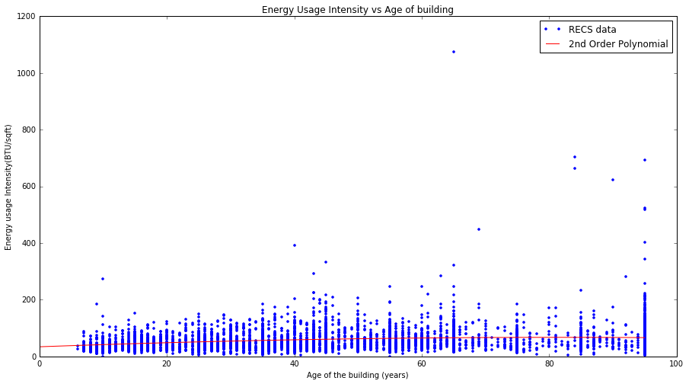

Captions should be The average EUI of old buildings is higher than the newer ones as shown by the slightly upward sloping curve. Although, for majority of the buildings there is a low value of EUI (<75) , most buildings with very high EUI values are more than 30 years old. Also, the buildings built in last 10 years tend to have a lower EUI than all other ages except for 5 to 6 outliers which indicates that recently constructed buildings do tend to consume less energy per square footage.

# VALIDATION

The RECS 2005 data was used to validate the linear regression model established in previous section. Due to lack of data on exact age, the average age was taken for all the corresponding ranges of the year building was constructed in. For example, in the YEARMADE column code 2 corresponds to building made in 1940-1949, so the age of all buildings with label 2 was taken as 70.Therefore, in the graph shown we see raw data only at five years intervals.The polynomial fitted from 2009 data also results in a reasonable prediction values for 2005 data for corresponding ages.Also, the 2005 data validates our findings that buildings more than 30 years old have a higher EUI than recent buildings(less than 20 years age).It also shows an increasing average trend (except at 70 years) of energy intensity with increasing age.

Fig 2. EUI vs Building age, 2005 data

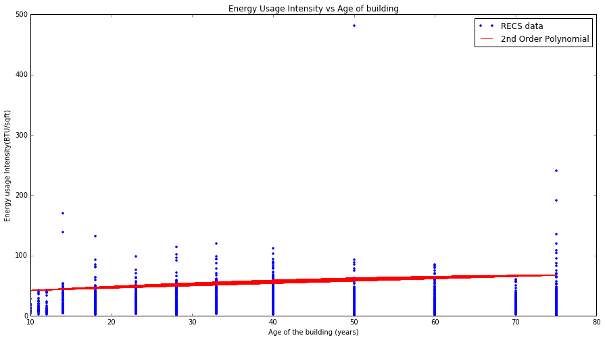

The heading of a section should be in Times New Roman 12-point bold in all-capitals flush left with an additional 6-points of white space above the section head. Sections and subsequent sub- sections should be numbered and flush left. For a section head and a subsection head together (such as Section 3 and subsection 3.1), use no additional space above the subsection head.

# ACKNOWLEDGMENTS

A big thanks to Prof. Mario Berges for guiding me throughout the project.

# REFERENCES

1. Clinton J. Andrews, Uta Krogmann, Explaining the adoption of energy-efficient technologies in U.S. commercial buildings, Energy and Buildings, Volume 41, Issue 3, March 2009, Pages 287-294, ISSN 0378-7788, http://dx.doi.org/10.1016/j.enbuild.2008.09.009.
2. Luis Pérez-Lombard, José Ortiz, Christine Pout, A review on buildings energy consumption information, Energy and Buildings, Volume 40, Issue 3, 2008, Pages 394-398, ISSN 0378-7788, http://dx.doi.org/10.1016/j.enbuild.2007.03.007.