Assignment_2

Mario Colon

February 24, 2018

# Load Packages

library(tidyverse)  
library(Ecdat)  
library(plm)  
library(lmtest)  
library(quantreg)  
library(car)  
library(boot)  
library(nlstools)

# Task 3

Fish stuff

fish <- read_csv("fish_catch.csv")  
  
fish_fun <- fish %>%   
 select(Wild_Catch, Farmed_Fish, Total_Fish_Produced, Year1)  
  
fish_fun  
  
ggplot(fish_fun, aes(x = Year1, y = Wild_Catch)) +  
 geom_point()

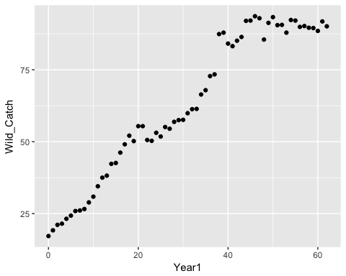

r_est <- lm(log(fish_fun$Wild_Catch[1:7]) ~ fish_fun$Year1[1:7])  
r_est  
  
#Ct = A / (1 + Be^-rt)  
  
#Estimate for K ~ 88  
#Estimate for C0 ~ 17.2  
#Estimate for B (K-C0)/C0 = 4.2  
  
#Estimate for A ~ 88  
#Estimate for B ~ 4.2  
#Estimate for r ~ .06407  
  
fish_fit <- nls(Wild_Catch ~ A / (1 + B*exp(-r*Year1)),  
 data = fish_fun,  
 start = list(A = 88, B = 4.2, r = .06407),  
 trace = TRUE  
 )  
  
  
A <- coef(fish_fit)[1]  
B <- coef(fish_fit)[2]  
r <- coef(fish_fit)[3]  
  
time_seq <- seq(0, 100, length = 300)  
time_seq  
  
  
fish_pred <- A/(1+B*exp(-r*time_seq))  
fish_pred  
  
pred_df <- data.frame(time_seq, fish_pred)  
pred_df  
  
ggplot(fish_fun, aes(x=Year1, y=Wild_Catch)) +  
 geom_point(color = "blue", size = 3) +  
 theme_bw() +  
 geom_line(data = pred_df, aes(x = time_seq, y = fish_pred), color = "red") +  
 xlab("Time (years)") +  
 ylab("Wild Catch (million tons)") +  
 ggtitle("Prediction of Wild Fish Catch Per Year")

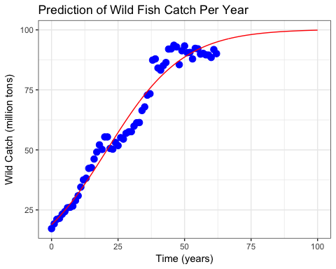

**Figure 1. Prediction of Wild Fish Catch** Wild fish caught per year has increased logistically over time (Time adjusted; 1950 = 0). Despite more fish caught, the rate of capture has decreased over time, with a carrying capacity of 100 million tons of wild fish caught per year possible in the near future.

*Final Equation: Wild Fish Catch = 88 / (1 + 4.2e^-.06407t)*

# Task 4

In the study, 22 of 36 surveyed UCSB community members (61%) identifying as genderqueer responded that they had personally experienced “exclusionary, offensive, hostile or intimidating conduct” (compared to 26% and 19% for those identifying as women and men, respectively).

Create a vector reflecting the collected survey data, then find the bootstrapped 95% confidence interval for the proportion of genderqueer individuals experiencing exclusionary conduct based on the 2014 UCSB survey data.

#n=35  
#nq = 22 = 61%  
  
n=36  
exclusion <- sample(1, n, TRUE)  
exclusion[sample(1:36, .39 * n, FALSE)] <- 0  
table(exclusion)

## exclusion  
## 0 1   
## 14 22

mean_exclusion <- function(x,i) {mean (x[i])}  
  
bootex_10000 <- boot(exclusion, mean_exclusion, R = 10000)  
hist(bootex_10000$t)

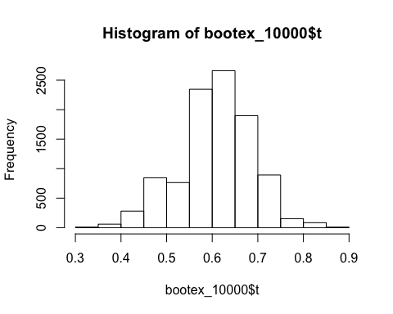

bootex_graph <- data.frame(bootex_10000$t)  
  
ggplot(bootex_graph, aes(bootex_10000$t)) +  
 geom_histogram(binwidth = .03, fill = "darkgreen", colour = "black") +  
 xlab("Proportion") +  
 ylab ("Frequency") +  
 ggtitle ("Genderqueer Individuals Experiencing Hostility") +  
 theme_bw()

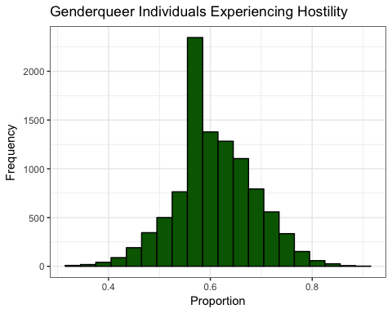

ex_ci <- boot.ci(bootex_10000, conf = .95, type = "perc")  
ex_ci

## BOOTSTRAP CONFIDENCE INTERVAL CALCULATIONS  
## Based on 10000 bootstrap replicates  
##   
## CALL :   
## boot.ci(boot.out = bootex_10000, conf = 0.95, type = "perc")  
##   
## Intervals :   
## Level Percentile   
## 95% ( 0.4444, 0.7500 )   
## Calculations and Intervals on Original Scale

**Figure 2. Genderqueer individuals experiencing hostility** Results of bootstraped data (CI = 95%) from survey exploring the proportions of individuals who identify as genderqueer (61%) who experienced “exclusionary, offensive, hostile or intimidating conduct” (n = 36) at UCSB. Source: 2014 UCSB Campus Climate Project Final Report (prepared by Rankin & Associates Consulting

# Task 5

### [d]

library(tidyverse)

### [e]

ca_pest <- read_csv("ca_pest.csv")  
ca_pop <- read_csv("ca_pop.csv")

### [f - i]

ca_merge <- full_join(ca_pest, ca_pop) %>%   
 mutate(PesticidePounds_SqMile = PestPounds/CountyArea) %>%   
 mutate(Population1 = Population/1000) %>%   
 mutate(MedFamilyIncome1 = MedFamilyIncome/1000) %>%   
 arrange(desc(PesticidePounds_SqMile)) %>%   
 select(County, PesticidePounds_SqMile, Population1, MedFamilyIncome1)

## Joining, by = "County"

ca_merge

## # A tibble: 58 x 4  
## County PesticidePounds_SqMile Population1 MedFamilyIncome1  
## <chr> <dbl> <dbl> <dbl>  
## 1 San Joaquin 8643 701 59.6  
## 2 Fresno 5342 949 50.0  
## 3 Sutter 5013 95.1 58.4  
## 4 Kings 4956 151 50.2  
## 5 Stanislaus 4734 523 55.4  
## 6 Merced 4627 262 47.7  
## 7 Madera 4485 152 50.0  
## 8 Santa Cruz 4286 267 81.5  
## 9 Sacramento 4173 1450 64.5  
## 10 Ventura 3544 836 86.9  
## # ... with 48 more rows

## [j]

ggplot(ca_merge, aes(x = MedFamilyIncome1, y = PesticidePounds_SqMile, size = Population1)) +  
 geom_point(colour = "purple", alpha = .8) +  
 labs(size = "Population Size \n(thousands)") +  
 ylab("Pesticide Load (1000 lbs/square miles)") +  
 xlab("Annual Medium Family Income (thousands)") +  
 ggtitle("Pesticide Concentration by County") +  
 annotate("text", x = 68, y = 8700, label = "San Joaquin", size = 4) +  
 geom_smooth(method = lm, se = FALSE, show.legend = FALSE) +  
 theme_bw()

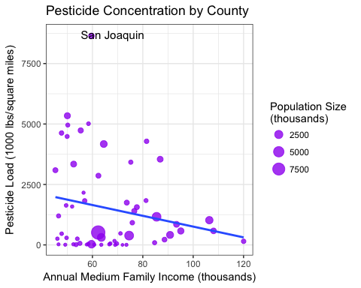

**Figure 3. Pesticide Concentration by County** Pesticide concentrations per county decreases as medium famiy income increase. Outlier of San Joaquin County exists, witha pesticide use of 8,645,000 lbs/square mile a medium family income of $59,600 per year Source: Pesticide data: 2014 CA pesticide application (by county) from the California Department of Pesticide Regulation & California population & income data: U.S. Census Bureau. American Community Survey, 2010- 2014 American Community Survey 5-Year Estimates