

Desktop Application Framework
v1.0.6

Viewa framework 1.0.6
1.Introduction 4
2.Installation 7
3.Getting Started 7
3.1.Adding a view 12
3.2.Creating actions 14
4.Application 16
4.1.Lifecycle 16
4.2.ApplicationContext 17
4.3.Visibility 17
5.Launchers 18
6.View 19
6.1.View Lifecycle 19
6.2.Ways of adding a ViewContainer 20
6.3.@View 21
6.4.Type of views 22
6.5.Some useful methods 23
6.6.Action Descriptors 24
6.6.1.Adding action descriptors declaratively 25
6.7.SystemTray 29
6.8.Perspectives 31
6.9.View resources and internationalization 33
6.10.View Messages 33
6.11.Resouce converters 34
6.11.1.ViewResourceBooleanConverter 36
6.11.2.ViewResourceColorConverter 36
6.11.3.ViewResourceDimensionConverter 36
6.11.4.ViewResourceIconConverter 36
6.11.5.ViewResourceImageConverter 36
6.11.6.ViewResourcePrimitiveBooleanConverter 36
6.11.7.ViewResourceStringConverter 37
6.12.Delegators 37
7.Controller 39
7.1.AbstractViewController and AbstractViewControllerWorker 39
7.1.1.AbstractViewController 39
7.1.2.AbstractViewControllerWorker 40
7.2.Connecting controllers to components: The ViewControllerDispatcher 42
7.3.@Controllers and @Controller 43
7.4.Accessing the views 44
7.5.Accessing UI components 45
8.Model 47
9.Testing 48
9.1.Trappers 49
10.APPENDIX A: Maven Repository 51
10.1.QuickStart archetype 51
10.2.Remote repository 51
11.APPENDIX B : viewaframework-spring 52
11.1.Maven dependencies 52
12.APPENDIX C: viewaframework-docking 53
12.1.1.MyDoggy 53
12.1.2.Docking Frames 54
12.2.Maven dependencies 54
13.APPENDIX D: viewaframework-widget 56
13.1.Maven dependencies 56
13.2.MasterView and DetailView 56
13.2.1.MasterView 56
13.2.2.DetailView 58
13.3.SwingBuilder 61
13.4.DynamicTable and DynamicTreeTable 61
13.4.1.DynamicTable 61
13.4.2.DynamicTreeTable 61

Introduction

Viewa is a framework made for building desktop applications using swing. It tries to separate the
model-view-controller layers of a given application to make the application development easier.

Why Viewa ?

Well, if you have experienced developing in swing , you know how cumbersome could be to create a
component, adding some functionality, and make the application scalable or reusable, this seems
more difficult if you come from web developing.

There are more frameworks that try to accomplish this problem, but the main reason Viewa has been
built is to be more like a web framework for the Swing based applications, trying to tear down the
wall between desktop and web development.

If you want to know more about Viewa architecture then keep on reading, but if you want start
coding, then go to the getting started chapter.

Viewa is based in the following ideas:

- To write as few lines of code as you can: We have tried to make this happen. In the getting started chapter I try to make this affirmation real. If you don't think so please let me know.
- The framework is web inspired: What the heck does it mean? Right now the most important area of developing is the web, and there are hundreds of web frameworks that evolve day by day, why don't use their experience in ease of use and increase of productivity? Right now it's very difficult for a Java web programmer to be productive programming a Swing application development because its different perspective. Viewa tries to be “More web programming friendly”.
- Re-usability: Every UI component used in Viewa doesn't have to know anything about its behavior, the last one is injected to that component in runtime execution. You can build a bunch of widgets you can use though the whole application without customization.
- Easy internationalization: Nowadays many applications should be internationalized. Viewa accomplish this requirement in an easy way.

Those ideas are implemented in the following schema. It shows the most important elements of the
framework:

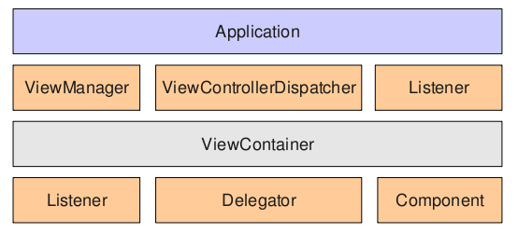
- org.viewaframework.core.Application: All the modelviewcontroller layers are joined here, and also application startup and shutdown.

- org.viewaframework.view.ViewManager: This interface adds and removes views from application and also initializes and finalizes every view added or removed from application (Adds the controllers to the view's components , executes the view's delegators...).

- org.viewaframework.controler.ViewControllerDispatcher: Like a web framework this dispatcher makes relationships between views and controllers without harcoding this relationship in the UI component (like if we were adding an ActionListener to a JButton for example).

- org.viewaframework.view.ViewContainer: Using this interface (well some specialization of it) we are going to build up the application gui. A view usually has an identifier, that is used for handling the view through all the application, and a graphical java.awt.Component which is what the user is going to see (it's usually a java.awt.Container). The view has all its functional and ui information separated in order to enable reusable graphical and functional components.

- org.viewaframework.view.delegator.Delegator: This interface is used to add some extra functionality to a specific type of view. Delegators are executed twice for each view, the first time when the view is added to the current perspective and a second time when is removed. The list of delegators is executed forward the first time and on reverse when the view is closed.

Application and ViewContainer have associated listeners for their life cycle events. Both will be
described later.

Of course Viewa is not a solution for all kind of cases, I'm not so vain, in fact I'm aware that it is just
a baby and there's still a lot of work to do, but the only thing I want you to notice is that it tries to
make Swing development easier and fun.

The best way to explain something is by examples. We are going to create a Hello World example to
expose core concepts of Viewa.

Installation

For the getting started chapter you will need to download and put as dependencies the following
libraries:

- viewaframework-api
- viewaframework-core
- viewaframework-widget
- commons-logging

You can download the libraries above and create a new Java project in your favorite IDE including
all the libraries in the project class path.

If you are comfortable using maven you can also create a maven project using the quick-start
archetype using the following command:

mvn archetype:generate -DgroupId=yourgroup -DartifactId=yourartifact -DarchetypeGroupId=org.viewaframework -DarchetypeArtifactId=viewaframework-quickstart -DarchetypeVersion=1.0.6 -DarchetypeRepository=http://www.viewaframework.org/m2-repo

IMPORTANT: From version 1.0.1 the archetype goal has changed from “create” to “generate” because “create” is deprecated.

For more maven information please refer to http://maven.apache.org

Getting Started

For getting started we're going to use the quickstart maven archetype. You have to be sure to configure maven (version 2.0.8+). Then write in your console:

mvn archetype:generate -DgroupId=yourgroup -DartifactId=yourartifact -DarchetypeGroupId=org.viewaframework -DarchetypeArtifactId=viewaframework-quickstart -DarchetypeVersion=1.0.6 -DarchetypeRepository=http://www.viewaframework.org/m2-repo

If everything went OK, you will see a BUILD SUCCESSFUL message coming at the end of the command execution.

At this moment a folder called “yourartifact” has been created. It will look like this:

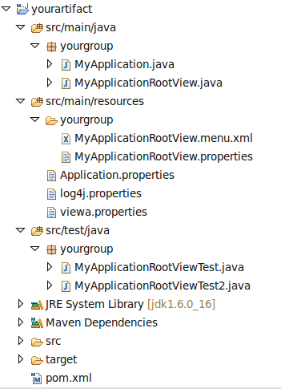

Every Viewa project has a viewa.properties in the class path. This file is used for startup options, like the locale, and the properties that are going to be showed in the splash-screen (if any). It has the following properties:

application.name=yourartifact
application.version=1.0-SNAPSHOT
application.locale=
application.splash=false

In this case the application is called “yourartifact” in version 1.0-SNAPSHOT , it's not going to translated in different languages and there's no splash screen yet.

The quick-start archetype also built a main entry point called MyApplication.java.

package yourgroup;

import org.viewaframework.annotation.View;
import org.viewaframework.annotation.Views;
import org.viewaframework.core.DefaultApplication;
import org.viewaframework.core.DefaultApplicationLauncher;

/**
* This is the main entry point of the application
*
* @since 1.0-SNAPSHOT
*
*/
@Views({
@View(type=MyApplicationRootView.class,isRoot=true)
})
public class MyApplication extends DefaultApplication{
public static void main(String[] args) throws Exception {
new DefaultApplicationLauncher().execute(MyApplication.class);
}
}

The org.viewaframework.core.DefaultApplication class is a default implementation of
org.viewaframework.core.Application interface which configures and builds the application.
Inside the main method we can see this call

new DefaultApplicationLauncher().execute(MyApplication.class);

The ApplicationLauncher class is a helper class for executing the application keeping the UI
initialization apart from the non UI initialization classes. It creates different threads to do this job.
If you execute the code you will see this:

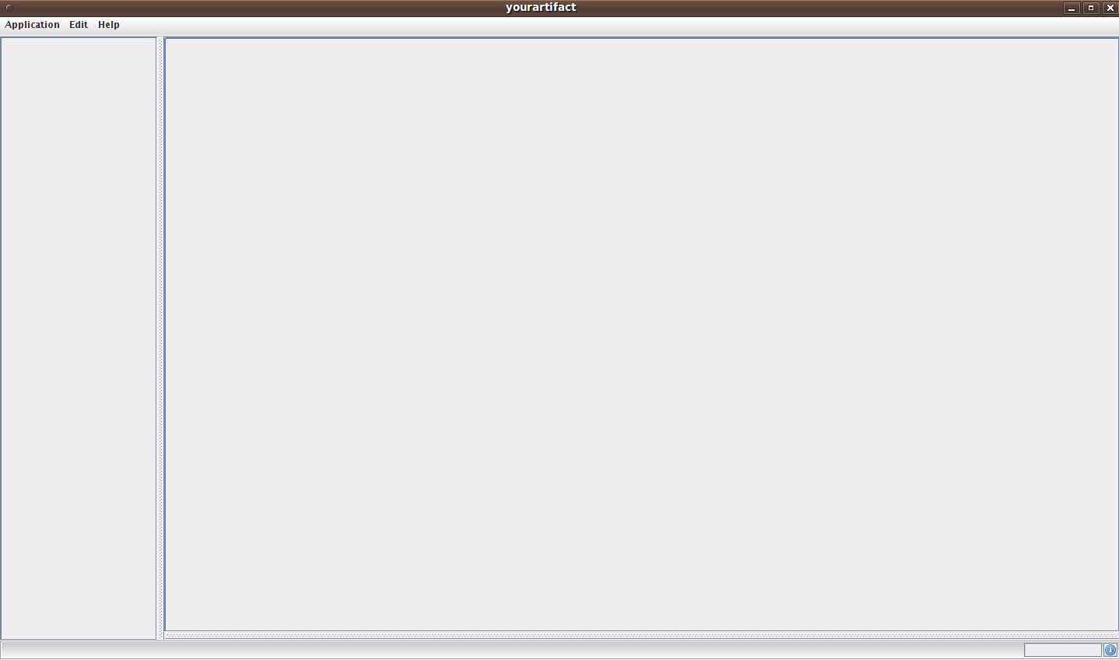
Every application has a “rootView”. In this case there's a MyApplicationRootView.java declared as the root view but if no view is declared every org.viewaframework.core.DefaultApplication has a org.viewaframework.view.DefaultViewContainerFrame which create a default perspective.

Perspectives are explained more detailed in their own chapter, now just get the idea that a
perspective is a set of views, in this case you can add views in different areas (Since 1.0.2 all perspective implementations have the same available constraints):

- PerspectiveConstraint.LEFT
- PerspectiveConstraint.RIGHT
- PerspectiveConstraint.BOTTOM
- PerspectiveConstraint.TOP

MyApplicationRootView.java is the root view of the application. This is the code built by the quickstart archetype:

package yourgroup;

import org.viewaframework.annotation.Controller;
import org.viewaframework.annotation.Controllers;
import org.viewaframework.view.DefaultViewContainerFrame;

import org.viewaframework.widget.controller.EditActionController;
import org.viewaframework.widget.controller.ExitActionController;
import org.viewaframework.widget.controller.AboutActionController;

import static org.viewaframework.widget.controller.EditActionController.EDIT_PATTERN;
import static org.viewaframework.widget.controller.ExitActionController.EXIT_PATTERN;
import static org.viewaframework.widget.controller.AboutActionController.HELP_PATTERN;

/**
* This View is the root view of the application. All views are nested inside this one.
*
* @since 1.0-SNAPSHOT
*
*/
@Controllers({
@Controller(type = EditActionController.class, pattern = EDIT_PATTERN),
@Controller(type = ExitActionController.class, pattern = EXIT_PATTERN),
@Controller(type = AboutActionController.class, pattern = HELP_PATTERN)
})
public class MyApplicationRootView extends DefaultViewContainerFrame { }

This view extends DefaultViewContainerFrame. And it has some annotated controllers for handling the behavior of some ui components. It this case the three declared controllers handle the application menu items. By default DefaultViewContainerFrame has three menus: root, edit and help which can be internationalized using the Application.properties file.

The Application.properties files can be used for internationalizing root view messages, resources (images, colors...etc) and also can be used for setting up default values for all views (All view's property files inherits Application.properties).

The Application.properties file has the following areas:

- Common Properties: Here you can set default values for all views and resources. It's also the place where you can set the application's title.
- AboutView properties: In the quick-start application the AboutView is embedded and here is the only place to configure the closing button and the image you want to appear in that view.

If you want to set the properties in other language, the only thing you have to do is to create an Application_es.properties (if you want to translate the application to spanish for example) and set the application.locale=es inside the viewa.properties file.

Every view can have its own properties file, in this case our MyApplicationRootView,java has its own MyApplicationRootView.properties which has to be located in the same package as the view it supports. As you may guess the only rule is that the properties file must have the same name (case sensitive) as the view it supports and it has to be located at the same package.

Since version 1.0.2 you also have the menu descriptor files which have the suffix menu.xml. These descriptor files define the structure of the menu-bar and the tool-bar of the view they are supporting. The same rules apply, they must have the same name (case sensitive) as the view they support and they have the suffix menu.xml (MyApplicationRootView.menu.xml in this case).

The structure is pretty basic, the only mandatory rule is that all tags must be enclosed by <menuBar></menuBar>. See ActionDescriptor chapter for more information about defining menus.

Finally there're two tests which basically do the same, but the point is that they do it in different ways. MyApplicationRootViewTest uses the classical TestCase class structure with the setUp() and tearDown() methods for initializing and destroying the application, while MyApplicationRootViewTest2 uses the new annotation approach of Junit 4.7. Both approaches are explain in the Testing chapter.

Adding a view

Once we have the main window running we want to create our first view, and we want it to appear
when the application starts.

Since version 1.0.2 the better way of doing this is through annotations. All we have to do is to create our new view:

package yourgroup;

import org.viewaframework.view.DefaultViewContainer;

public class NavigationView extends DefaultViewContainer{

public static final String ID = "NavigationViewID";

public NavigationView() {
super(ID,new NavigationPanel());
}
}

A view is a very simple class. In our constructor we have called to the DefaultViewContainer constructor which needs the view's id and the graphic component showed by that view (in this case the NavigationPanel). Notice that the view's id is declared as a public constant, that's because the id is needed to show or remove the view from the application.

The NavigationPanel looks like this:

package yourgroup;

import org.jdesktop.swingx.JXHyperlink;
import org.jdesktop.swingx.JXTaskPane;
import org.jdesktop.swingx.JXTaskPaneContainer;

public class NavigationPanel extends JXTaskPaneContainer{
private static final long serialVersionUID = 1L;

private JXTaskPane textTaskPanel;
private JXHyperlink textPanelLink;

public NavigationPanel(){
super();
init();
}

private void init() {
this.setName("navigationPanel");
this.textPanelLink = new JXHyperlink();
this.textPanelLink.setName("textPanelLinkName");
this.textPanelLink.setText("Show text panel");
this.textTaskPanel = new JXTaskPane();
this.textTaskPanel.setName("imageView");
this.textTaskPanel.setTitle("Images");
this.textTaskPanel.add(textPanelLink);
this.add(this.textTaskPanel);
}
}

In order to create this panel you need to download the swingx component's library at http://www.swinglabs.org (if you didn't use maven).

It shows a simple task container with a single action “Show text panel”. It's very important to set the names of the components because is the only link between the components and the rest of the application (properties files, controllers and so on). The rest of the component's properties is just for initializing the component but you can change it later through the view's property file.

Only rest to add the view to the application using the @View annotation.

@Views({
@View(type=MyApplicationRootView.class,isRoot=true),
@View(type=NavigationView.class,position=PerspectiveConstraint.LEFT)
})
public class MyApplication extends DefaultApplication{
public static void main(String[] args) throws Exception {
new DefaultApplicationLauncher().execute(MyApplication.class);
}
}

The new thing here is the position attribute which uses the PerspectiveContraint enumeration constraints. In this case we want the view to be placed in the navigation area. Now run again the application:

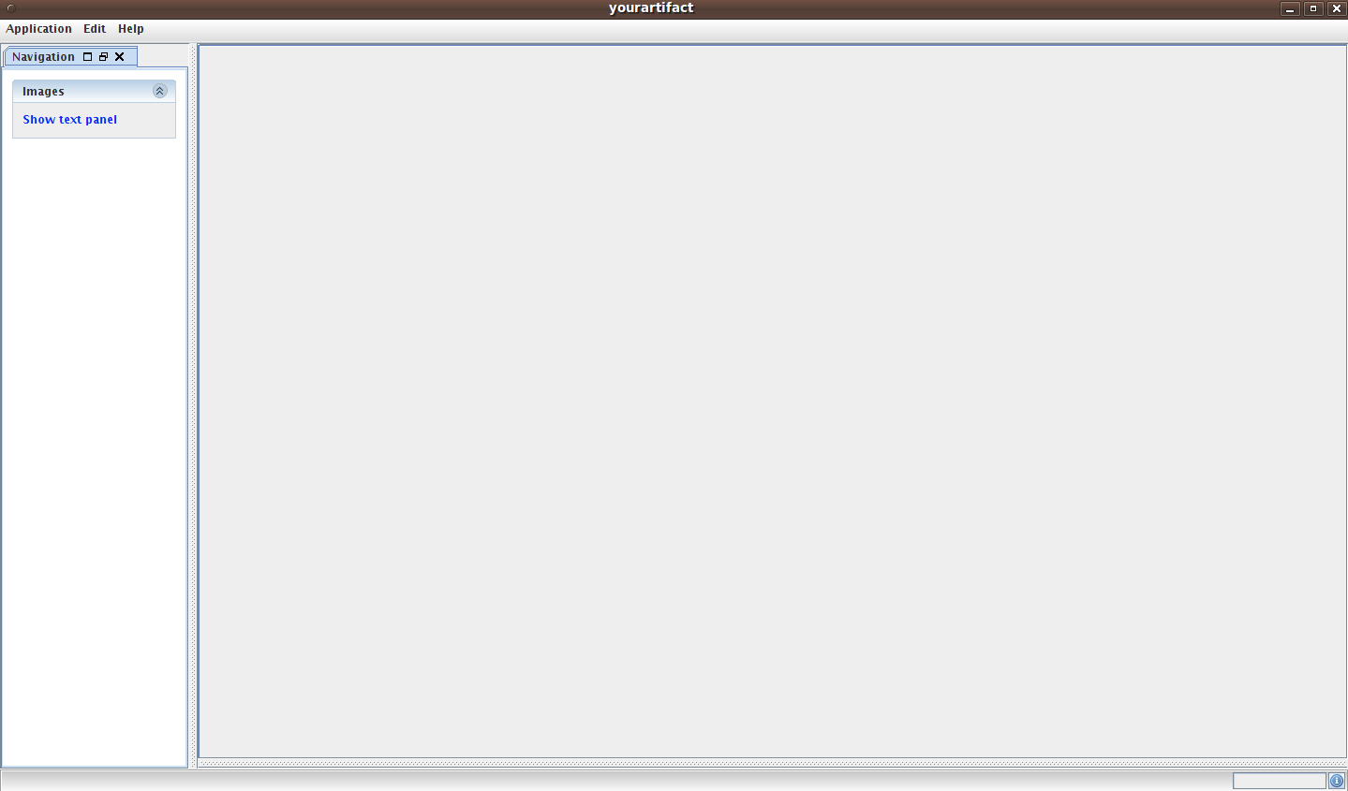
Now we have the navigation view ready to go. But... what is an application which doesn't do anything? Now it last to add some actions to the “Show text panel” link.

Creating actions

All controllers in Viewa inherit from AbstractViewController. The main important methods are:

- getSupportedClass: Mandatory. This method is a little bit boring, it should return the listener type'class.
- preHandlingView: This method handles view related initialization. Those actions that have to do with the UI before executing a background action. It's not mandatory.
- handleView: This method is made for implementing long term actions. Those actions that can freeze the UI.It's not mandatory.
- postHandlingView: This method is made for leaving the UI in its final state once the long term action has been executed.It's not mandatory.

Now you can use all of them or just a few. Anyway getSupportedClass method is mandatory, and it
should return the correct listener's class.

When an AbstractViewController is called by the event of a given component it executes the
methods in the following order.

- preHandlingView
- handleView
- postHandlingView

To show how to add a behavior to the “Show text panel” link we have to build a new controller.

package yourgroup;

import java.awt.event.ActionEvent;
import java.awt.event.ActionListener;

import org.viewaframework.controller.AbstractViewController;
import org.viewaframework.view.ViewContainer;
import org.viewaframework.view.ViewException;
import org.viewaframework.view.perspective.PerspectiveConstraint;

public class TextPanelLinkController extends AbstractViewController<ActionListener,ActionEvent>{

public Class<ActionListener> getSupportedClass() {
return ActionListener.class;
}

@Override
public void postHandlingView(ViewContainer view, ActionEvent eventObject)
throws ViewException {
this.getViewManager().
addView(new TextPanelView(),PerspectiveConstraint.RIGHT);
}
}

As it may seemed it shows a text panel in the edition area. The right way for adding new views from controllers is inside the postHandlingView() method using the ViewManager instance.

In Viewa is forbidden to add two views instances with the same view id. So if you try to add twice the text panel you will get a ViewException. You can avoid that asking if there's a view with some id before trying to add it:

ViewManager manager = this.getViewManager();

if (locate(TextPanelView.ID) == null){
manager.addView(new TextPanelView(),PerspectiveConstraint.RIGHT);
}

Here you have the TextPanelView code:

package yourgroup;

import javax.swing.JTextPane;

import org.viewaframework.view.DefaultViewContainer;

public class TextPanelView extends DefaultViewContainer{
public static final String ID = "TextPanelViewID";

public TextPanelView(){
super(ID,new JTextPane());
}
}

Finally we have to tell the view what controller it has to use when the “Show text panel” link is being pressed.

package yourgroup;

import org.viewaframework.annotation.Controller;
import org.viewaframework.annotation.Controllers;
import org.viewaframework.view.DefaultViewContainer;

@Controllers({
@Controller(type=TextPanelLinkController.class,pattern="textPanelLinkName")
})
public class NavigationView extends DefaultViewContainer{

public static final String ID = "NavigationViewID";

public NavigationView() {
super(ID,new NavigationPanel());
}
}

We have used the @Controllers and @Controller annotations. See why you have to be worried about the name of the component (the “Show text panel” link has the name “textPanelLinkName”), it's the argument of the pattern attribute, that way the application knows where the controller has to be added. You can use regular expressions in the pattern attribute to match more than one component (for example “textPanelLinkName|otherComponentName”).

Application

The Application interface (org.viewaframework.core.Application) is where all the pieces are
integrated. The org.viewaframework.core.Application interface is the main entry point to your
application. It configures some init configuration, the locale and it has access to the ViewManager
for adding and removing views.

Lifecycle

Every Viewa application starts executing the following methods;

- prepare() : this method is called before the UI appears. Should be used if some background actions want to the done. It also initializes the ApplicationContext if it wasn't initialized yet.
- prepareUI(): This method should be used for initializing UI components. Executed in the Event Dispatch Thread.
- InitUI(): This method is used by the DefaultApplication for making visible the main frame. Executed in the Event Dispatch Thread.

This methods are executed by a specific implementation of the org.viewaframework.core.Launcher
which executes them in the right thread. Default implementation is DefaultApplicationLauncher.
The application is also responsible for handling the locale of the application through its getLocale()
and setLocale(..) methods. Usually set in the viewa.properties file.

The user usually access the application instance though a given view. All views have access to the
application though the method getApplication().

ApplicationContext

Since Viewa 1.0.2 the org.viewaframework.core.ApplicationContext interface represents an application' scope where the programmer can store and retrieve objects. The ApplicationContext interface has the following methods:

public void setAttribute(String name,Object value);
public void removeAttribute(String name);
public Object getAttribute(String name);

As you may guess the setAttribute(...) method stores a given value with a given name, removeAttribute(...) sets to null a value which had a given name, and getAttribute(...) retrieves an object stored with a given name (or null if nothing is found).

Visibility

Since version 1.0.5 the Application interface has the following methods:

public boolean isVisible();
public void setVisible(boolean visible);
public boolean hideOrRestore();

The isVisible() method returns true if the application is visible, false otherwise. The setVisible(boolean visible) makes the application visible or not depending on the value passed as parameter. The hideOrRestore() method is a shortcut of setVisible(...) without asking whether the application is visible or not.

Launchers

All applications are executed using an implementation of org.viewaframework.core.ApplicationLauncher. Most of the time you will use the class org.viewaframework.core.DefaultApplicationLauncher or any class extending DefaultApplicationLauncher. The typical launching code:

package org.viewaframework.common;

import org.viewaframework.annotation.View;
import org.viewaframework.annotation.Views;
import org.viewaframework.annotation.ViewsPerspective;
import org.viewaframework.core.DefaultApplication;
import org.viewaframework.core.DefaultApplicationLauncher;
import org.viewaframework.view.perspective.DefaultPerspective;
import org.viewaframework.view.perspective.PerspectiveConstraint;

@ViewsPerspective(DefaultPerspective.class)
@Views({
@View(type = TestView.class, position = PerspectiveConstraint.LEFT),
@View(type = MyTrayView.class, isTray = true)
})
public class TestApplication extends DefaultApplication {
public static void main(String[] args) throws Exception {
new DefaultApplicationLauncher().execute(TestApplication.class);
}
}

Why would we want to extend DefaultApplicationLauncher? Well we could want to establish the startup look and feel. This could be done this way:

package org.viewaframework;

import javax.swing.LookAndFeel;

import org.viewaframework.core.DefaultApplicationLauncher;

import com.jgoodies.looks.plastic.PlasticLookAndFeel;
import com.jgoodies.looks.plastic.theme.LightGray;

public class MyApplicationLauncher extends DefaultApplicationLauncher{
@Override
public LookAndFeel getLookAndFeel() {
PlasticLookAndFeel lnf = new PlasticLookAndFeel();
PlasticLookAndFeel.setCurrentTheme(new LightGray());
return lnf;
}
}

In this example we want to use the JGoodies (http://www.jgoodies.com/) library to set our look and feel.

This couldn't be done until version 1.0.5 because DefaultApplicationLauncher was declared final.

View

Views are the center of this framework. Although the code you have to write to build a ViewContainer is going to be very few lines, the understanding of this element is crucial for the rest
of the application.

For building a ViewContainer you usually are going to extend some of the current default views that
exists in the framework, the most common is DefaultViewContainer.

As we saw in the getting started chapter the only thing you have to do is to provide an ID to the view
and the visual component the user is going to see.

package examples;

import org.viewaframework.view.DefaultViewContainer;

public class NavigationView extends DefaultViewContainer{
private static final String ID = "navigationView";
public NavigationView(){
super(ID,new NavigationViewPanel());
}
}

When the view is added to the current application, some things have to be done before the user see
the view.

View Lifecycle

When the view is added to the application via its ViewManager the last one injects some objects and
executes some methods of the ViewContainer. The process is the following:

- The ViewManager gives the view some objects for its initialization (model, controllers, resources...) and executes an initialization method from the view (viewInit()). Once this happens the view show up and the user can interact with it.
- When some of the available actions for closing the view are triggered the view executes some cleaning operations before it is hidden.

The initialization follows this path:

- The developer wants to add a new view through ViewManager.add(ViewContainer)
- ViewManager gets all the model objects and all controllers registered for the current view
- ViewManager injects the Application object to that view.
- ViewManager registers that view
- ViewManager injects the controllers and the view models into the view
- ViewManager initializes the view calling to the viewInit method from ViewContainer. This where the most important things happen like the injection of the controllers to the visual components, internationalization of the visual components, etc. Here the view executes its delegators, which are and advanced way of changing the behavior of the views (This is an advanced feature that will probably have its own chapter). Delegators are executed in the order they were added to the view.
- ViewManager arranges the component of the view depending on the component nature (if its a Frame, a Dialog o any other Container component).

And the opposite is:

- The developer wants to remove the view through ViewManager.remove(ViewContainer)
- The ViewManager first calls to the ViewContainer.viewClose() method for cleaning resources from the view. Delegators are executed on reverse order.
- The ViewContainer is hidden
- The ViewManager unregisters the view

Ways of adding a ViewContainer

Most of the time views are going to be added or removed from a controller. The vast majority of the
controllers extends AbstractViewController, and every method of that class has the ViewContainer
where the event has been triggered from. Having that in mind, you can use always this sentence:

@Override
public void postHandlingView(ViewContainer view, ActionEvent eventObject)throws ViewException {
this.getViewManager().addView(myCustomView);
}

Remember that adding a view may throw a ViewException if something wrong happens during the
initialization of the view.

It's very important if you add a view from a controller that put the sentence in the postXXX() or
preXXX() methods, why? Because this methods are executed in the EventDispatchThread and we
want all our UI components are going to be added in that thread (I'll try to explain this widely in the
controllers chapter)

Also as you saw in the getting started chapter a view can be added from the Application object. That
could be helpful if you want to start the application with some views in place or if you want to add a
login dialog before the application begins (since version 1.0.2 is better to use annotations: see @View).

public void prepareUI() {
try {
this.getViewManager().addView(
new NavigationView(),
PerspectiveConstraint.LEFT);
} catch (ViewException e) {
//...
}
}

This time is also important to do this task in the prepareUI() method for the same reasons as I said
in controllers.

@View

The @View annotation helps programmer to add ViewContainer classes to the application at startup. It has the following attributes:

- type: This attribute is mandatory. It's the type of the ViewContainer you want to add to the application.
- viewId: This attribute can be used to set the view's id. Although this attribute is not mandatory remember that all views must have an id.
- id: This attribute can be used if the application is using an inversion of control container. This id must be the id of the ViewContainer you want to retrieve from the IOC context.
- position: This attribute can be used to arrange the view in a specific area of the root view, using the given perspective's constraints. Since 1.0.2 all perspective implementations have the same possible constraints given by the PerspectiveConstraint enumeration type.
- isRoot: This attribute must be used to mark which of the added views is the root view (if any). By default it is false.

All @View annotations must be nested inside a @Views annotation as its value. Watch the example of the @View annotation from the getting started chapter:

package examples;

import org.viewaframework.annotation.View;
import org.viewaframework.annotation.Views;
import org.viewaframework.core.DefaultApplication;
import org.viewaframework.core.DefaultApplicationLauncher;
import org.viewaframework.view.perspective.PerspectiveConstraint;

@Views({
@View(type=MainView.class,isRoot=true),
@View(type=NavigationView.class,position=PerspectiveConstraint.LEFT)
})
public class MyApplication extends DefaultApplication{
public static void main(String args[]) throws Exception {
new DefaultApplicationLauncher().execute(MyApplication.class);
}
}

This code adds two views to the application. The first one is the root view (isRoot=true) of type MainView. The second one is a view of type NavigationView and it is going to be located in the navigation area of the current perspective (PerspectiveConstraint.LEFT).

Type of views

All views came from the interface org.viewaframework.view.ViewContainer, and there is a default
implementation in org.viewaframework.view.DefaultViewContainer. Here you have the most
common implementations:

- org.viewaframework.view.DefaultViewContainer
- org.viewaframework.view.DefaultViewContainerEditor
- org.viewaframework.view.DefaultViewContainerFrame
- org.viewaframework.view.AbstractViewContainerDialog (Is an abstract class)

DefaultViewContainer receives two arguments in its constructor the ID of the view and the visual
component the user is going to use. We've already used it in the getting started application.

public DefaultViewContainer()
public DefaultViewContainer(String id,Component component)
public DefaultViewContainer(String id,String title,Component component)

DefaultContainerEditor is exactly the same as DefaultViewContainer, it implements ViewContainerEditor which is just a flag. It's a semantic meaning for perspectives implementations.

Let me explain, if you are using a docking framework, you can distinguish regular views (navigation views for example) from content views (a master table) making the last one as an editor view. In the DefaultPerspective all DefaultViewContainerEditor are added to the topright area as a tab component.

DefaultContainerFrame are used for building the root view, as you may guess this is where all the subsequent view components are going to be added finally. Use it if you want to customize the application's Frame.

AbstractViewContainerDialog is the base for building dialog views.

public AbstractViewContainerDialog(String id,Component component)
public AbstractViewContainerDialog(String id,Component component,Boolean modal)

It has a JDialog where the component the view receives in its constructor, is added. Here is an
example.

public class AboutView extends AbstractViewContainerDialog{
public static final String ID ="aboutViewId";
public AboutView() {
super(ID,new AboutPanel(),true);
}

}

This AboutView uses the (String id,Component component,boolean modal) from the
AbstractViewContainerDialog interface and builds a dialog modal view with the id “aboutViewId”
and a content panel AboutPanel, this shows a modal dialog window. If no other way of closing this
window has been provided, a special controller is always injected to the dialog and frame views.
This controller closes the view calling to the ViewManager.remove(ViewContainer) method when
the user clicks the X button of the window.

Some useful methods

When using a DefaultViewContainer you can always use the following methods:

public getMessage(String key)

This method can be used to get internationalized messages from the view resource bundle. Resource
management will be explain later, but only say that if you have a properties file with the same name
as your view in the same package as the view, the view will be able to get all the information from
this file (For example having an AboutView.properties in the same package as AboutView class).

public Component getComponentByName(String name)
public List<Component> getComponentsByName(String name)

This two methods are really useful because you can retrieve all components within a view by its
name (Renember to name all your components if you want to retrieve them later). Since version
1.0.1 there's a shorter way of retrieve your component through the ComponentFinder object (See
accessing UI components).

Action Descriptors

Action descriptors are a fast way of building view menus and tool bars. ActionDescriptor object can
be built with string expressions. These expressions are built like an Xpath expression.

Every ViewContainer has a JToolbar and a JMenubar and both are filled with the information of
action descriptors.

They can be added to the ViewContainer through setActionDescriptors(List<ActionDescriptor>
descriptors) or overriding the getActionDescriptors() method as you can see in the following code:

public List<ViewActionDescriptor> getActionDescriptors() {
List<ViewActionDescriptor> descriptors = new ArrayList<ViewActionDescriptor>();
descriptors.add(new ViewActionDescriptor("/detailViewActions[@text='detailViewActions' and @visible='false']"));
descriptors.add(new ViewActionDescriptor("/detailViewActions/saveAction[@toolBarGroup='1' and @text='saveAction' and @icon='img/page/page_save.png']"));
descriptors.add(new ViewActionDescriptor("/detailViewActions/helpAction[@toolBarGroup='1' and @text='helpAction' and @icon='img/misc/help.png']"));
descriptors.add(new ViewActionDescriptor("/detailViewActions/cancelAction[@toolBarGroup='1' and @text='cancelAction' and @icon='img/door/door.png']"));
return descriptors;
}

It becomes the following:

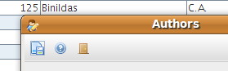

Action Descriptors follow a hierarchical order, for example, you can create a new menu:

new ViewActionDescriptor("/crudActions[@text='crudActions' and @visible='false']")

This menu is not visible (@visible='false'), but it represents a JMenu object with name
“crudActions” and default text “crudActions” (@text) , it only acts as root for subsequent action
descriptor children. Once you have created a parent you can for example create a child action:

new ViewActionDescriptor("/crudActions/save[@text='save' and @toolBarGroup='1' and @icon='img/save.png']")

The code above builds a JMenuItem and a tool bar item with name “save” (.../save) and default text
“save” (@text='save'). It belongs to the first group of the tool bar (if @toolBarGroup='2' exists a
separator will be placed between both groups), and the item's icon can be found in 'img/save.png'
(@icon='...' it must be available within the class path).

All action descriptors are processed in order they were added to the ViewContainer. You can also
add separators between action descriptors.

new ViewActionDescriptor("/crudActions/separator")

Adding action descriptors declaratively

Since 1.0.2 action descriptors can be added, removed or modified declaratively through XML files. The basic structure is:

<?xml version="1.0" encoding="UTF-8"?>
<menuBar>
<!-- INSERT MENUS HERE -->
</menuBar>

Let's create a simple menu called “file” with two items called “open” and “new”. Then the menu file should look like this:

<?xml version="1.0" encoding="UTF-8"?>
<menuBar>
<file>
<open/>
<new/>
</file>
</menuBar>

That's enough to link controllers and establish internationalized text through the view's properties file. The name of the tag becomes the name of the component.

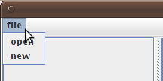

For prototyping you can add the text attribute to every tag for initializing the item text. You can also add keystrokes to the items of each menu with the keystroke attribute.

<?xml version="1.0" encoding="UTF-8" standalone="no"?>
<menuBar>
<file text="File">
<open text="Open..." keyStroke="CTRL_O"/>
<new text="New..." keyStroke="CTRL_N"/>
</file>
</menuBar>

And the result will be:
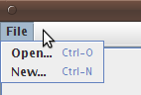
Now you can also add icons to that items through the icon attribute:

<?xml version="1.0" encoding="UTF-8" standalone="no"?>
<menuBar>
<file text="File">
<open text="Open..." keyStroke="CTRL_O" icon="org/viewaframework/widget/icon/fan/img/folder/folder.png"/>
<new text="New..." keyStroke="CTRL_N" icon="org/viewaframework/widget/icon/fan/img/folder/folder_add.png"/>
</file>
</menuBar>

The path of the icon is inside the class-path. This time we're using the icons contained within the viewaframework-widget module. Now the application is getting better:

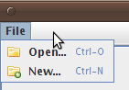
We still want to add a separator between the open and the new items, then we just need to add a separator tag between them.

<?xml version="1.0" encoding="UTF-8" standalone="no"?>
<menuBar>
<file text="File">
<open text="Open..." keyStroke="CTRL_O" ...
<separator/>
<new text="New..." keyStroke="CTRL_N" ...
</file>
</menuBar>

And the separator becomes visible:
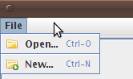
So far so good. Now we want to create a submenu. It as simple as nesting tags. We are going to add an export submenu which has two items pdf and excel.

<?xml version="1.0" encoding="UTF-8" standalone="no"?>
<menuBar>
<file text="File">
<open text="Open..." keyStroke="CTRL_O" icon="org/viewaframework/widget/icon/fan/img/folder/folder.png"/>
<separator/>
<new text="New..." keyStroke="CTRL_N" icon="org/viewaframework/widget/icon/fan/img/folder/folder_add.png"/>
<!-- **** NEW SUBMENU **** -->
<export text="Export">
<pdf text="Export to pdf"/>
<excel text="Export to excel"/>
</export>
</file>
</menuBar>

And we'll get the following screen-shot:

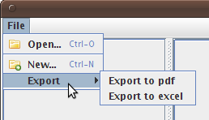
Sub-menus can have text and icon attributes but the can't have a keystroke attribute. In general menus and sub-menus have in common the following attributes:

- text: The default text. It can be internationalized by the view's property file
- icon: The icon class-path associated to that menu or menu-item
- enabled: true if the menu or menu-item is going to be enabled, false if you want to disable it.
- visible: true if you want the menu or menu-item to be visible.

Only menu items have:

- keyStroke: It builds a key shortcut to execute a given menu-item.
- toolBarMenu: It's the number of the tool-bar menu the current menu-item belongs.
- enableToolButtonText: The tool-bar buttons have the same text and icon as their counterparts in the menu-bar. Most of the time you may want the icon but not the text.

In order to create a tool-bar we use the toolBarMenu attribute. Imagine you want the open and new menu-items to be part of the first tool-bar and the pdf (we have added an icon to it) to be part of the second tool-bar, then you will write:

<?xml version="1.0" encoding="UTF-8" standalone="no"?>
<menuBar>
<file text="File" icon="org/viewaframework/widget/icon/fan/img/folder/folder_add.png">
<open toolBarGroup="1" text="Open..." keyStroke="CTRL_O" icon="org/viewaframework/widget/icon/fan/img/folder/folder.png"/>
<separator />
<new toolBarGroup="1" text="New..." keyStroke="CTRL_N" icon="org/viewaframework/widget/icon/fan/img/folder/folder_add.png"/>
<!-- NEW SUBMENU -->
<export text="Export">
<pdf toolBarGroup="2" text="Export to pdf" icon="org/viewaframework/widget/icon/fan/img/page/page_white_acrobat.png"/>
<excel text="Export to excel" />
</export>
</file>
</menuBar>

And then get:

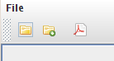
The enableToolButtonText attribute hides the button text from the tool-bar elements. In the previous example there weren't any text because we didn't write the items' text in the view's properties file. If you do it then you'll see something like this:

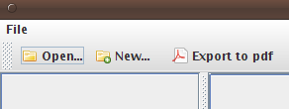
Maybe you like it that way, but if you want to hide the text from the tool-bar items just add enableToolButtonText=”false” to that items.

By default the tool-bar is floatable, if you don't want the tool-bar to be floatable you can set it up in the current view's property file toolBar.floatable=false

SystemTray

Nowadays many commercial applications use the system tray to add more functionality to their behavior. For example you can hide or restore the application's window or refresh some data or even receive some notifications.

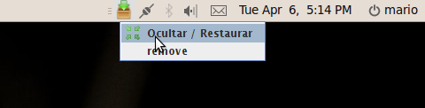
From version 1.0.5 all Viewa applications can create a tray icon in the system tray through xml descriptive files as we do with ActionDescriptor items.

First thing to do is to create a new view class. This class has to extend the abstract class org.viewaframework.view.AbstractViewContainerTray.

package org.viewaframework.common;

import org.viewaframework.annotation.Controller;
import org.viewaframework.annotation.Controllers;
import org.viewaframework.view.AbstractViewContainerTray;

@Controllers({
@Controller(type=MyTrayViewController.class,pattern="hiderestore")
})
public class MyTrayView extends AbstractViewContainerTray{

public static final String ID = "MyTrayViewID";

public MyTrayView(){
super(ID);
}
}

Once we have created the view we have to build the descriptor file. As we did with action descriptors we create in the same package of the view an xml file with the same name as the View with the menu.xml suffix. This way we will have a MyTrayView.menu.xml:

<?xml version="1.0" encoding="UTF-8" standalone="no"?>
<!-- *********************************************************************************** -->
<!-- ****************************** TRAY ICON CONFIGURATION **************************** -->
<!-- *********************************************************************************** -->
<!-- **** In this file you can define the system tray icon for this application. * -->
<!-- *********************************************************************************** -->
<trayIcon>
<leftMenu>
<sendMessage text="Send Message..."/>
<refresh text="Refresh Message List"/>
<delete text="delete" />
<edit text="edit"/>
<separator/>
<configuration/>
</leftMenu>
<rightMenu>
<hiderestore text="Hide / Restore" icon="org/viewaframework/common/img/restore.png"/>
<remove/>
</rightMenu>
</trayIcon>

As you can see the internal structure differs from the previous xml files we used to describe action descriptors. The file has a root tag called <trayIcon> and this tag has two nested tags called <leftMenu> and <rightMenu>. These two tags represents two contextual popup menus, depending whether the user is click over the tray icon with the right or the left button.

Both <leftMenu> and <rightMenu> are optionals. You can omit one of them if you want to show just one contextual menu.

Within <leftMenu> and <rightMenu> all menu elements must be established. Same rules as action descriptors apply but, in this case only text and icon attributes are allowed, rest of attributes will be ignored.

You can't also nest elements.

Finally you have to config the application in order to show our tray view.

package org.viewaframework.common;

import org.viewaframework.annotation.View;
import org.viewaframework.annotation.Views;
import org.viewaframework.annotation.ViewsPerspective;
import org.viewaframework.core.DefaultApplication;
import org.viewaframework.core.DefaultApplicationLauncher;
import org.viewaframework.view.perspective.DefaultPerspective;
import org.viewaframework.view.perspective.PerspectiveConstraint;

/**
* @author Mario Garcia
* @since 1.0.2
*/
@ViewsPerspective(DefaultPerspective.class)
@Views({
@View(type = TestView.class, position = PerspectiveConstraint.LEFT),
@View(type = MyTrayView.class, isTray = true)
})
public class TestApplication extends DefaultApplication {
public static void main(String[] args) throws Exception {
new DefaultApplicationLauncher().execute(TestApplication.class);
}
}

As we do whenever we want to show a view at startup we add our tray view with a @View annotation telling the application this is going to be the tray icon view (isTray=true).

Impotant: There's only one tray icon view per application.

Perspectives

Perspectives are a way of grouping views in some way.

You can implement your own perspective, or make a custom integration with an existing docking
framework (see viewaframework-docking module).

To add a view to a specific area you must use the following method from org.viewaframework.view.ViewManager

public void addView(ViewContainer view,PerspectiveConstraint constraint) throws ViewException

Where the second argument is the object constraint, in the default perspective are the constraints
above, in other cases just check the perspective documentation.

The default perspective is org.viewaframework.view.perspective.DefaultPerspective. All perspective implementations have the same type of constraints areas contained in the enum PerspectiveContraint:

package org.viewaframework.view.perspective;

/**
* This enumeration type represents all possible constraints in a given perspective
*
* @author mario
* @since 1.0.2
*/
public enum PerspectiveConstraint {
LEFT,
LEFT_TOP,
LEFT_MIDDLE,
LEFT_BOTTOM,
BOTTOM,
RIGHT,
RIGHT_TOP,
RIGHT_MIDDLE,
RIGHT_BOTTOM,
TOP
}

The reason of this change is to create a unique way of arranging views through different types of perspectives. This way Viewa will have a better user experience. In the DefaultPerspective this constraints are located this way:

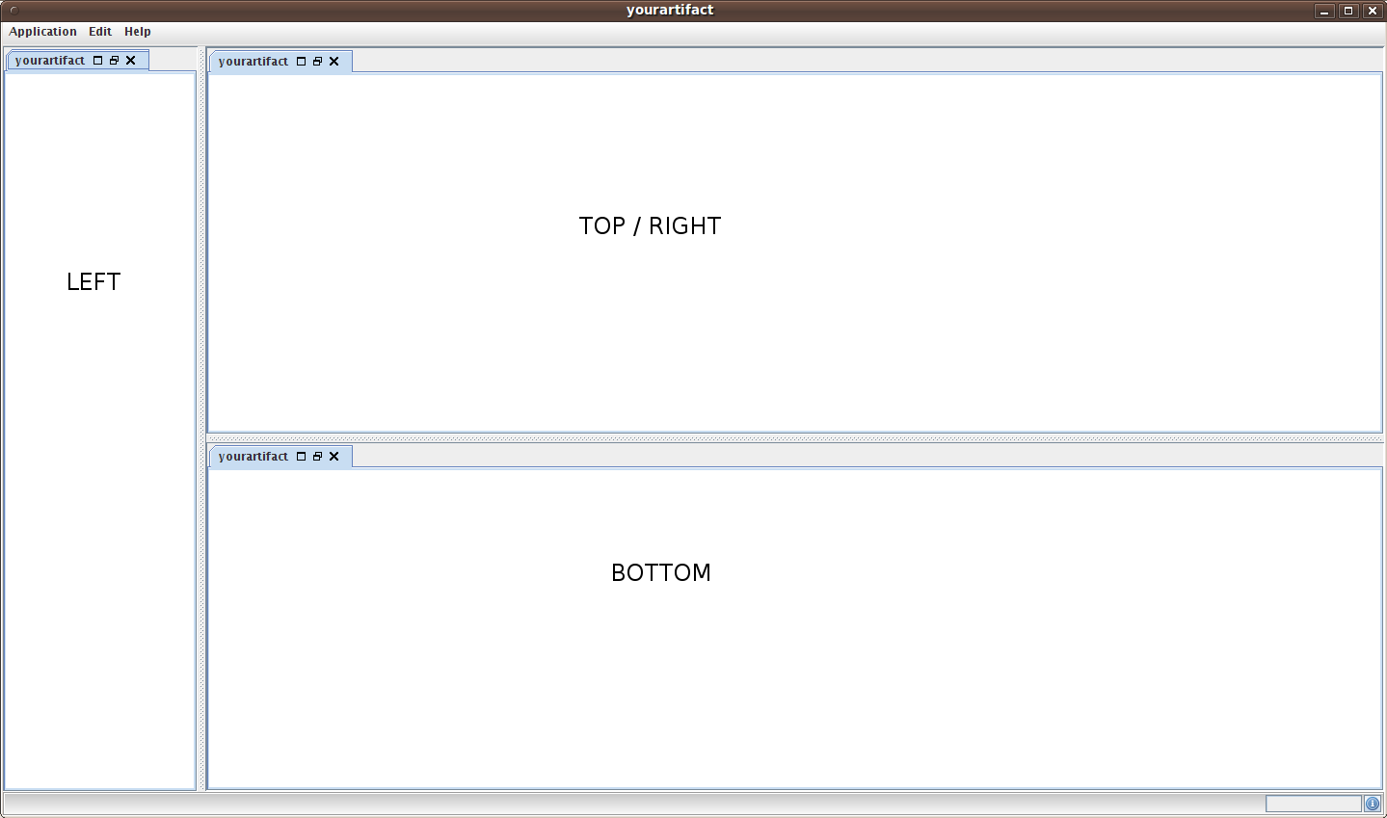
These views are added as tab components to those areas. Every view has three tab buttons:

- Maximize button: Maximizes the selected view
- Restore button: Restores all areas
- Close button: Closes the selected view

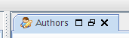

At the beginning the PerspectiveConstraint.BOTTOM area is not visible if no view has been added to that area. This area won't appear until a view is added to it.

DefaultPerspective is a basic implementation of what you can do with the Perspective interface. You
can make an integration with your favorite docking lib. If you want to customize the view's icon you have to setup the property iconImage in the view's property file setting the URL path.

View resources and internationalization

Nowadays most applications have to deal with handling different user languages. Viewa supports
internationalization using :

- Application.properties
- Specific view's property file

The locale of the application must be set up in the viewa.properties file

application.name=Getting Started
application.version=1.0-SNAPSHOT
application.locale=es
application.splash=false

As you can see inside viewa.properties we are going to search all property files with the “es”
suffix (Application_es.properties ... and so on).

Application.properties should be used for the application's root view and common properties shared
between views. If you want to establish specific properties or override Application.properties for a
given view, you should create a properties file with the same name (is case sensitive, so if the view
class is AboutView, the properties file should be AboutView.properties) in the same package.

View Messages

Once you have written internationalized messages and resources in the properties view, this
properties can be retrieved from the view using:

public String getMessage(String key)
public ResourceBundle getMessageBundle()

The first method retrieves the property with the given key as a String. The second one returns the
whole ResourceBundle.

These methods are very useful for example when executing a controller and you want to show a
specific message in a specific component:

protected void postHandlingViewAccept(ViewContainer view,ActionEvent eventObject) throws Exception {
Jlabel.class.cast(view.getComponentByName(“status”)).
setText(view.getMessage("country.save.ok"));
}

Resouce converters

Inserting resources not only means that we write messages but also colors, images... etc. Viewa
address that with the use of delegators, in fact this is made by the DefaultViewResourceDelegator. This delegator reads the view associated property file and converts the property value to an object through the right ViewResourceConverter.

package org.viewaframework.view.delegator;

public interface ViewResourceConverter {

public abstract Class<? extends Object> getDestinationClass();
public abstract Object convert(Object arg0, Class<? extends Object> arg1);

}

Converters receive a property value from a specific view's properties file (or from Application.properties) and checks what type of value requires the object's method. Then it tries to convert the property's value into the method's argument type.

- getDestinationClass(): It must return the type of the method's argument the property wants to change. If we want to change a JMenuItem background color we need a converter whose getDestinationClass() will return a java.awt.Color.
- convert(): The first argument is the String value written in the properties file. The second argument is not used anymore and will be deleted from future releases. This method must return the transformed object.

There are some built in converters:

- ViewResourceBooleanConverter
- ViewResourceColorConverter
- ViewResourceDimensionConverter
- ViewResourceIconConverter
- ViewResourceImageConverter
- ViewResourcePrimitiveBooleanConverter
- ViewResourceStringConverter

Since version 1.0.1 you can add new converters to your application easily adding a new converter
declaration inside viewa.properties. But notice that declaring new converters overrides the default converters for that types.

application.name=Getting Started
application.version=1.0-SNAPSHOT
application.locale=es
application.splash=false

java.awt.Color=org.mycompany.viewa.converters.MyColorConverter

In the example we are mapping all property values pointing at a java.awt.Color field to
MyColorConverter class which has to inherit from ViewResourceConverter interface. The
MyColorConverter could be like the following snippet:

import java.awt.Color;
import org.viewaframework.view.delegator.ViewResourceConverter;

public class MyColorConverter implements ViewResourceConverter{
public Object convert(Object arg0, Class<? extends Object> arg1) {
if (arg1.equals(this.getDestinationClass())){
if (arg0!= null && arg0.toString().equalsIgnoreCase("red")){
return Color.RED;
}
}
return Color.BLACK;
}
public Class<? extends Object> getDestinationClass() {
return Color.class;
}
}

The getDestinationClass() tells what kind of object this converter can handle. The most important part is the convert method. The first parameter is the value that comes from the property file, in this case if the value is “red” then the converter will return a Color.RED object otherwise it will return a Color.BLACK.

ViewResourceBooleanConverter

This class can convert any argument that can be evaluated by Boolean.valueOf(..) method and create a java.lang.Boolean object.

ViewResourceColorConverter

This class can parse HTML color expressions like #000000 and create a java.awt.Color object from those expressions.

ViewResourceDimensionConverter

This class converts an input string of type 200,150 representing width and height into a java.awt.Dimension instance.

For example you have a given property like viewDialog.size= 300,250 then the expression will become something like viewDialog.setSize(new java.awt.Dimension(300,250));

ViewResourceIconConverter

This converter can convert an icon path in a java.awt.Image object. It's very flexible you can use a complete url string to point to the specific resource, for example, valid locations could be:

- file://home/myuser/images/myImage.png
- classpath://org/myproject/images/myImage.png
- http://www.anypictureweb.com/images/myImage

ViewResourceImageConverter

It behaves exactly the same as ViewResourceIconConverter

ViewResourcePrimitiveBooleanConverter

This class can convert any argument that can be evaluated by Boolean.valueOf(..) method and create a primitive boolean value.

ViewResourceStringConverter

It's the default converter. Converts the passed argument as a java.lang.String

Delegators

Well if you have read carefully until this chapter you may have read something about delegators
more than once.

Delegators are one of the most powerful concepts in Viewa, because they can change the behavior
of a given view in many ways. For example they are used for injecting the resources from the
properties files, or for injecting controllers to the visual components...etc. This delegators are built
in such a way that every behavior they give to the view should be cleaned from it once the view has
been closed.

All delegators are based in the following interface:

package org.viewaframework.view.delegator;

import org.viewaframework.view.ViewContainer;
import org.viewaframework.view.ViewException;

public interface Delegator {

public void inject(ViewContainer viewContainer) throws ViewException;
public void clean(ViewContainer viewContainer)throws ViewException;

}

All delegators that belong to a given view are executed when the view is initialized in the order they
were added to the view, executing the inject(...) method . And when the view closes then they are
executed in the opposite direction executing the method clean(...).

You can add as many delegators as you want to a view, but it's very important the order you are
going to use.

It's very important knowing what delegators are used by the default views:

- org.viewaframework.view.AbstractViewContainer
  - org.viewaframework.view.delegator.ActionDescriptorDelegator
  - org.viewaframework.view.delegator.NamedComponentsDelegator
  - org.viewaframework.view.delegator.ViewContainerControllerDelegator
  - org.viewaframework.view.delegator.DefaultViewResourceDelegator

- org.viewaframework.view.DefaultViewContainer (it uses the same delegators as the AbstractViewContainer)

- org.viewaframework.view.AbstractViewContainerDialog
  - org.viewaframework.view.delegator.ActionDescriptorDelegator
  - org.viewaframework.view.delegator.NamedComponentsDelegator
  - org.viewaframework.view.delegator.DefaultViewResourceDelegator
  - org.viewaframework.view.delegator.DialogViewClosingWindowDelegator
  - org.viewaframework.view.delegator.ViewContainerControllerDelegator

Now Viewa doesn't relay in any IO (Inversion of control) container by default, but many of the things can be done declaratively using any of the IO containers you can find out there.

Controller

What is an application if you can't do anything with it? That's when it comes the controllers. The
benefit Viewa brings to developers is that they will never have to learn all the methods of the
different listeners Swing can have, they are only going to face a single object the
AbtractViewController.

AbstractViewController and AbstractViewControllerWorker

AbstractViewController

The signature of the class is

public abstract class AbstractViewController<EL extends EventListener,EO extends EventObject>
implements ViewController<EL,EO>,ViewContainerLocatorAware

Let's explain that with an example. Suppose you want to add an action to a button component called
cancel, then you know it needs an ActionListener, and every ActionListener handle ActionEvent
objects. Then you extend and AbstractViewController like this:

import java.awt.event.ActionEvent;
import java.awt.event.ActionListener;

import org.viewaframework.controller.AbstractViewController;

public class CancelButtonController extends
AbstractViewController<ActionListener, ActionEvent> {
public Class<ActionListener> getSupportedClass() {
return ActionListener.class;
}
}

As you see the only you have to do is to fill the generic information of the class with the listener
and events you are going to handle. Also is mandatory to inform the class again what kind of
listener it is going to look like.

Having this in mind every AbstractViewController has three methods where the user can write its
logic depending if it's a long task or if it is just an UI update.

Methods where the user should update the GUI are :

public void preHandlingView(ViewContainer view, EO eventObject)
public void postHandlingView(ViewContainer view, EO eventObject)
public void postHandlingViewOnError(ViewContainer view,EO eventObject,BackgroundException ex)

The method where the user should write the code for long running tasks is:

public void handleView(ViewContainer view, EO eventObject)throws BackgroundException

The order this three methods are executed is

- preHandlingView
- handleView
- postHandlingView / postHandlingViewOnError (If the handleView method throws a BackgroundException then postHandlingViewOnError will be called otherwise postHandlingView will be the next called method)

The three methods are executed sequentially, but the first and the last one are executed in the event
dispatch thread while handleView is executed in other different thread.

AbstractViewControllerWorker

The approach the AbstractViewController gives should fit most of the needs of the developer, but if
you need more control over a long task, for monitoring purposes, you can use the
org.viewaframework.controller.AbstractViewControllerWorker which extends SwingWorker and has additional methods for controlling tasks asynchronously.

The Signature of the class is the following:

public abstract class AbstractViewControllerWorker<EL extends EventListener,EO extends
EventObject,T,V> extends SwingWorker<T,V> implements ViewController<EL,EO>

It scares a little bit but let's do the cancel button controller example with this case:

import java.awt.event.ActionEvent;
import java.awt.event.ActionListener;
import java.util.List;

import org.viewaframework.controller.AbstractViewControllerWorker;
import org.viewaframework.view.ViewContainer;

public class CancelButtonController extends
AbstractViewControllerWorker<ActionListener, ActionEvent, String, String> {

public Class<ActionListener> getSupportedClass() {
return ActionListener.class;
}

@Override
public void handleViewProgress(ViewContainer view, ActionEvent eventObject,
Integer progress) {
}

@Override
public void handleViewPublising(ViewContainer view2,
ActionEvent eventObject2, List<String> chunks) {
}
}

Here there are two more mandatory methods:

public void handleViewProgress(ViewContainer view, EO eventObject,Integer progress)
public void handleViewPublising(ViewContainer view2,EO eventObject2, List<V> chunks)

The first one receives information from the SwingWorker method setProgress(int progress). The
second one handles the objects published for the SwingWorker method publish(V value). The S
element in the SwingWorker signature is the value that doInBackground method returns, but, in this
implementation, that method executes handleView method and returns null.

Then, the developer should use the following methods:

- public void handleView(ViewContainer view, EO eventObject): (No EDT) For executing background tasks. You can use setProgress(int progress)(It will call handleViewProgress(...)) or publiesh(V value)(It will call handleViewPublishing(...)) to update the GUI.
- public abstract void handleViewProgress(ViewContainer view, EO eventObject,Integer progress): It receives the current progresion of the background task. (EDT)
- public abstract void handleViewPublising(ViewContainer view2, EO eventObject2,List<V> chunks) : It receives the current element published from the background tasks (EDT)
- public void postHandlingView(ViewContainer view, EO eventObject) : Executed once the baskground task has finished (EDT)
- public void preHandlingView(ViewContainer view, EO eventObject) : It is executed when the SwingWorker has been initialized and before handleView is executed (EDT)

EDT = Executed in EventDispatchThread

AbstractViewControllerWorker is still in beta development. It creates a new SwingWorker object
every time the controller is executed.

Connecting controllers to components: The ViewControllerDispatcher

Since version 1.0.2 the recommended way of attaching controllers to a view is through annotations (Chapter 6.3).

Once you have created a controller, the way you have to connect it to a specific component is done
through the application's org.viewaframework.controller.ViewControllerDispatcher.

In a default application the most common way of adding a controller is getting the default controller
dispatcher and add a controller entry within the prepareUI method:

@Override
public void prepareUI() {
try {
//...
ViewControllerDispatcher dispatcher = this.getControllerDispatcher();
dispatcher.addController(ViewManager.ROOT_VIEW_ID + "." + "exit",new
ExitController());
} catch (ViewException e) {
System.out.println(e.getMessage());
}
}

Or adding an already prepared java.util.Map with all the entries with the
ViewControllerDispatcher.setControllers(Map<String,ViewController>) doing it in one step.
As you can see all you have to do is adding a ViewController with an specific key. This key must
follow this rule:

“idOfTheView” + “.” + “nameOfTheComponent”

The second part of the key can use Java regular expression, that way you can write a key like
“navigationViewId.*Action” which matches all the components within the view with the id
“navigationViewId” that end with “Action” (exitAction, deleteAction...).

Take notice that “*” is going to be translated in “.*” because it would be very ugly an
expression like “navigationViewId..*Action”.
May be in later versions the second part of the sentence could be changed to avoid this
translation.

When an action is initialized the application ask the view controller dispatcher what expressions
match the view, the view controller dispatcher gives them to the application, the application gives
them to the ViewManager and finally the controllers are injected to the named components within
the ViewContainer.

Using The ViewControllerDispatcher you can share controllers between different views. And is the
recommended way of adding controllers to the application. There could be different cases:

- Little application: Adding controllers in the prepareUI method through the addController(...) method
- Bigger applications: Having a class that handles a Map with controllers, and adding that map in the prepareUI method through ViewDispatcher.setControllers(Map) method.

Anyway I always recommend the second approach.

However if you want to use a given set of controllers for a specific view you can provide a map of
ViewController object using one of the following methods:

public void setViewControllerMap(Map<String,List<ViewController<? extends EventListener,?extends EventObject>>> viewControllerMap)

public Map<String,List<ViewController<? extends EventListener,? extends EventObject>>>getViewControllerMap()

Or setting the viewControllerMap in the view constructor through the setViewControllerMap(...)
method.

@Controllers and @Controller

Since version 1.0.2 controllers can be attached to specific views through annotations. A ViewContainer can have a @Controllers annotation with nested @Controller annotations. Each @Controller annotation represents an AbstractViewController.

The @Controllers annotation can only have an array of @Controller annotations. @Controller annotation has the following attributes:
- type: It's a required attribute. It's the class of the Controller you want to add to this view.
- pattern: Mandatory. It's the pattern that matches the components this controller is going to listen at.
- viewId: You can use it to apply this controller to a different view, other than the view you are annotating.
- id: If the application is using an inversion of control container, this must be the id of the object you want to retrieve from the ioc context.

Watch the following code:

package examples;

import org.viewaframework.annotation.Controller;
import org.viewaframework.annotation.Controllers;
import org.viewaframework.view.DefaultViewContainer;
import org.viewaframework.view.ViewManager;

@Controllers({
@Controller(type=AddViewController.class,pattern="addViewButton"),
@Controller(viewId=ViewManager.ROOT_VIEW_ID,type=ExitController.class,pattern="exit")
})
public class NavigationView extends DefaultViewContainer{
public static final String ID = "navigationView";
public NavigationView(){
super(ID,new NavigationViewPanel());
}
}

Here you have a view with two controllers, the first one is applied to components of this view with name “addViewButton” and it's class is AddViewController. The second one is not applied to the current view but to the root view (viewId=ViewManager.ROOT_VIEW_ID), it's class is ExitController and the controller is going to be triggered by components having “exit” as their name.

Accessing the views

Suppose your are within a controller and you want to access a given view which is not the view the
controller gave you. You can access by two means to other ViewContainer.

First way is accessing the current view map, which has all available views in application.

@Override
protected void postHandlingViewCancel(DetailView<Book> view,
ActionEvent eventObject, Book value) throws Exception {
BookMasterView.class.cast(view.
getApplication().
getViewManager().
getViews().
get(BookMasterView.ID)).
getModel().addAll(this.bookList);
}

That was the “hard” way. The easy way is available since version 1.0.1. Since version 1.0.1 all controllers that inherit from AbstractViewCotroller have a few new methods that makes retrieving
views easier:

public <U extends ViewContainer> ViewContainerLocator<U> locate(Class<U> clazz);
public ViewContainer locate(String name);
public ViewContainerFrame locateRootView();

The following example finds a view of type BookMasterView with name BookMasterView.ID.

@Override
protected void postHandlingViewCancel(DetailView<Book> view,
ActionEvent eventObject, Book value) throws Exception {
locate(BookMasterView.class).
named(BookMasterView.ID).
getModel().addAll(this.bookList);
}

locate(Class<U> clazz) returns a ViewContainerLocator where <U> is the type of the
ViewContainer you want to retrieve. ViewContainerLocator has a method called named(String
viewId) that returns the view that matching the name passed as parameter.

Accessing UI components

As you noticed at the bottom of a DefaultApplication there are a message zone (bottomleft) and a
progress bar with an info button (bottomright). By default the info button and the progress bar are
just components doing nothing by theirselves.

I can access them by the useful methods I mentioned before, but accessing them from the rootView
and giving their component name. Names are:

- StatusBar.STATUS_BAR_NAME: The progress bar (JprogressBar)
- StatusBar.LEFT_PANEL_LABEL: The left message area. Is a JLabel component
- StatusBar.PROGRESS_INFO_BUTTON: The progress info button

For example for getting the JProgressBar the roor view:

(JProgressBar) DefaultViewContainerFrame.
class.cast(view.getApplication().getViewManager().getRootView()).
getComponentByName(StatusBar.STATUS_BAR_NAME)

A little bit ugly right?

Well, since version 1.0.1 there is a class called org.viewaframework.util.ComponentFinder that helps
you finding UI components and casting them to their right type.

It comes very handy in controllers but it can be used in any place where a ViewContainer instance
exists. All you have to do is make a static import of the find method of ComponentFinder. Let me
show you the new version of getting the JProgressBar object.

import static org.viewaframework.util.ComponentFinder.find;
//....
controllerProgress = find(JProgressBar.class).
in(view).named(StatusBar.STATUS_BAR_NAME);

It builds a more natural way of retrieving ui objects. The find method needs the type you expect the
component will be. The in method receives the ViewContainer where the component lives, and
finally the named method returns the component which name matches with its parameter.

The example can now be read like “find a JProgressBar.class within that view which name is
StatusBar.STATUS_BAR_NAME”

Model

Right now the model support available for views is limited, is planned to make a binding solution
between components and the objects stored within the view.

You can add model objects and remove them to and from a view. For example if you are in a
controller which is going to add a view, you can add as many objects as you like to that view before
opening it (Of course it must be instantiated first), or even if the view is already visible.

public void addModelValue(String alias, Object object)

Every object should be added to a view with an unique id. That way once we are in the scope of the
view we can retrieve a given object by its key with the method.

public synchronized Object getModelValue(String alias)

Testing

Every application should be tested very often. Viewa has a specific testing module (viewaframework-test) based on Junit (http://www.junit.org/ ). This module has classes and methods that will make testing Viewa applications easier.

A JUnit test for Viewa should have the current structure:

import org.junit.AfterClass;
import org.junit.BeforeClass;
import org.viewaframework.test.ApplicationTrapper;

public class CountryMasterViewTest {

private static ApplicationTrapper appTrapper;

@BeforeClass public static void initialization() throws Exception{
// Building the ApplicationTrapper
}

//...Tests using the @Test annotation

@AfterClass public static void finalization(){
// Closing the application
}
}

Because of Viewa's startup lifecycle, the creation of the application should be placed in a method with the @BeforeClass annotation. When all tests has been executed application should be closed within a
static method with the @AfterClass annotation.

This way you can run all tests against one instance application.

You can use classical JUnit test cases but you will be running one application instance per test using the setUp() method for creating the application, and tearDown() for shutting the application down. It's not recommended to create an application instance at the constructor because at the end you will have to release it by hand.

public class MyApplicationRootViewTest extends TestCase{

private ApplicationTrapper app;

/* (non-Javadoc)
* @see junit.framework.TestCase#setUp()
*/
public void setUp()throws Exception{
/* Creating a new application before each test */
app = new ApplicationTrapper(new DefaultApplicationLauncher().
execute(MyApplication.class));
/* Setting delay between calls */
app.getSettings().setTimeBeforeNextEvent(2500);
}

//...Tests using the testXXX() method convention

/* (non-Javadoc)
* @see junit.framework.TestCase#tearDown()
*/
public void tearDown(){
/* At the end of every test the application is closed */
app.close();
}

}

Using the maven's quick-start archetype there's one example for each testing way.

Trappers

Inspired in Fest testing Viewa has its Trappers (TestWrappers) for wrapping application's common
types with additional methods. Those methods brings testing capabilities to the objects they
represent.

First Application object should be created and wrapped in an ApplicationTrapper.

@BeforeClass public static void initialization() throws Exception{
appTrapper = new ApplicationTrapper(new SpringApplicationLauncher().
execute(ConceptApplication.class));
appTrapper.getSettings().setTimeBeforeNextEvent(2500);
}

In the example and in most of cases application instance should be retrieved from the
execute(...) method from the given AbstractApplicationLauncher implementation (This time is a
SpringApplicationLauncher).

That application instance is wrapped inside an ApplicationTrapper. This trapper is the most
important because all the rest of trappers are created from it.

Viewa testing is also focused in views. Application trappers can create view trappers and at this
scope components that belong to that view can be tested.

How can be tested ? The following code block tests a button that belongs to a specific view.

@Test public void genreWindow() throws Exception{
appTrapper.view(NavigationView.ID).
button("country").
requireEnabled().
click(10000);
}

The test checks that button “country” should be enabled before performing a click on it. Finally if
the assertion (requireEnabled()) went OK, the test performs the click and waits ten seconds until the
next action is performed.

APPENDIX A: Maven Repository

QuickStart archetype

You can create a startup application using the quick start archetype using the following command:

mvn archetype:generate -DgroupId=yourgroup -DartifactId=yourartifact -DarchetypeGroupId=org.viewaframework -DarchetypeArtifactId=viewaframework-quickstart -DarchetypeVersion=1.0.5 -DarchetypeRepository=http://www.viewaframework.org/m2-repo

This will create a basic application skeleton and it also configures the Viewa's public repository. If
you want to use Viewa with other projects don't forget to configure the Viewa remote repository.

Remember since version 1.0.2 the right goal is archetype:generate instead of archetype:create.

Remote repository

Viewa libraries are also exposed as maven dependencies. All you have to do in order to use them is
to declare the Viewa public repository in your pom.xml file or in you settings.xml

<repositories>
<repository>
<id>viewasourceforge</id>
<name>viewa</name>
<url>http://viewaframework.sourceforge.net/m2repo</url>
</repository>
</repositories>

APPENDIX B : viewaframework-spring

This module haven been made for integration with the Spring framework. Right now it only has a
specific implementation of the org.viewaframework.core.AbstractApplicationLauncher. It looks for
any viewa.xml through all the application class path and charges all the bean information within
them.

A viewa.xml having the application class declaration should be placed in the class path root. The rest
could be placed as you like depending on your development requirements. It has to be used as the
rest of launchers:

public static void main(String[] args) throws Exception{
new SpringApplicationLauncher().execute(ConceptApplication.class);
}

Maven dependencies

If you have create your maven project with the quickstart archetype you only have to add the
following dependency to your pom.xml

<dependencies>
<dependency>
<groupId>org.viewaframework</groupId>
<artifactId>viewaframeworkspring</artifactId>
<version>1.0.5</version>
</dependency>
<dependencies>

Please check first if you have declared the Viewa public repository first (APPENDIX A).

APPENDIX C: viewaframework-docking

This module has been created for integrating docking frameworks. Now there are two docking intergrations available, the first one is MyDoggy framework (http://mydoggy.sourceforge.net/). The other one is Docking Frames (http://dock.javaforge.com/).

Both integrations can be done thanks to the interface Perspective. This interface should be implemented in order to teach de ViewManager in how to add Views to the application.

To use any of the integrations all you have to do is to annotate the application like this:

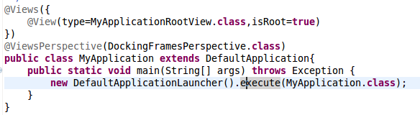
One you have added the initial views thanks to the @Views and @View annotations then use the @ViewsPerspective to use the Perspective you want to use, just pass the annotation the class which implements the Perspective interface.

Since version 1.0.4 there's a enum type which declares which areas can be used to dock components. This were done to keep all integrations with the same functionality. These areas are:

- LEFT,
- LEFT_TOP,
- LEFT_MIDDLE,
- LEFT_BOTTOM,
- BOTTOM,
- RIGHT,
- RIGHT_TOP,
- RIGHT_MIDDLE,
- RIGHT_BOTTOM,
- TOP

MyDoggy

All ViewContainerEditor views are automatically added to the TOP area as a tab panel. The rest of
views are added depending on the PerspectiveConstraint you use. If none is declared the LEFT area is supposed. The picture shows two views added, one on the LEFT area and the other one is added as a tabular data because it extends DefaultViewContainerEditor.

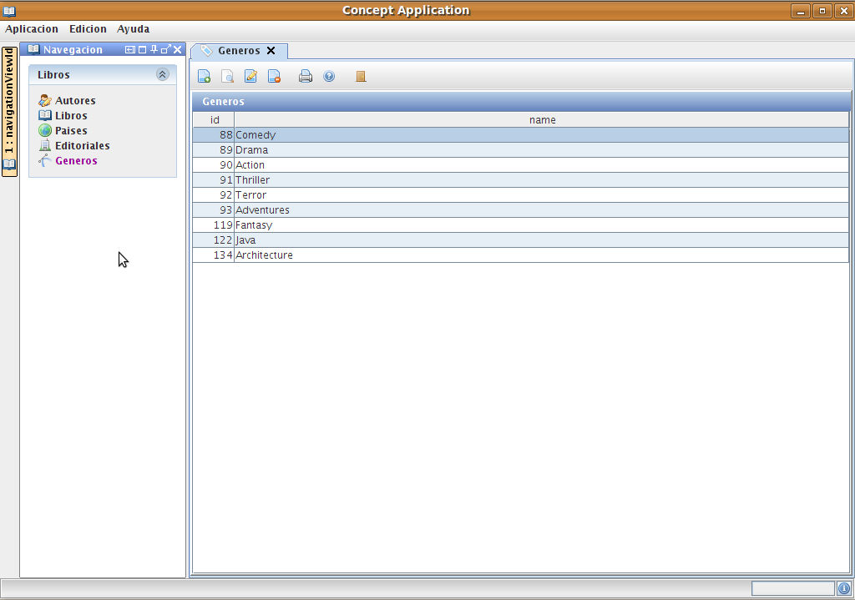
Of course if you want to use this perspective you have to add MyDoggy project as a dependency.
If you want your application to use this perspective you have to annotate it with the @Perspective annotation and add as parameter the MyDoggyPerspective class.

Docking Frames

Using Docking Frames integration won't be any different from MyDoggy integration, One you have declared the type of perspective you want to your application, you only have to worry where these areas want to be added at.

If you want the application to use this perspective you have to annotate it with the @Perspective annotation and add as parameter the DockingFramesPerspective class.

Docking Frames integration is still unstable

Maven dependencies

If you have create your maven project with the quickstart archetype you only have to add the
following dependency to your pom.xml

<dependencies>
<dependency>
<groupId>org.viewaframework</groupId>
<artifactId>viewaframework-docking</artifactId>
<version>1.0.5</version>
</dependency>
<dependencies>

This dependency has transient dependencies from MyDoggy and Docking Frames projects. If you are using Viewa version 1.0.5 or later you no longer have to download these dependencies. Otherwise you should download and install them in your local repository.

Please check first if you have declared the Viewa public repository first (APPENDIX A).

APPENDIX D: viewaframework-widget

Well this module is a kind of lab for experimenting new ideas. It's also a repository for icons. It has
many icons from http://www.famfamfam.com/lab/icons/ which until today are distributed as free.

As experimental many of the topics in this module may change, be removed or if they work could be
added to the core module.

Maven dependencies

If you have create your maven project with the quick start archetype you only have to add the
following dependency to your pom.xml

<dependencies>
<dependency>
<groupId>org.viewaframework</groupId>
<artifactId>viewaframework-widget</artifactId>
<version>1.0.5</version>
</dependency>
<dependencies>

Please check first if you have declared the Viewa public repository first (APPENDIX A).

MasterView and DetailView

MasterView and DetailView are an experimental views for rapid crud applications. Both type of
views have specific type of controllers for handling them (MasterViewController and
DetailViewController) but others can be implemented.

MasterView

This two implementations of org.viewaframework.view.ViewContainer are very useful when creating
master view type views.

The MasterView class configures a button tool bar with the most common actions for a master
screen and it also configures a table for receiving a specific type of object.

package examples;

import java.util.Arrays;

import org.viewaframework.widget.view.MasterView;
import org.viewaframework.widget.view.ui.MasterViewColumn;
/**
* @author mario
*
*/
public class GenreMasterView extends MasterView<Genre>{
public static final String ID ="genreMasterViewId";
/**
*
*/
public GenreMasterView() {
super(ID,Arrays.asList(
new MasterViewColumn("id",50),
new MasterViewColumn("name",50)));
}
@Override
public Class<Genre> getMasterType() {
return Genre.class;
}
}

This example configures a master view for handling a list of objects of type “Genre”. This object
has two properties “id” and “name”. Both properties are added as master columns
(MasterViewColumn) to the view with the preferred with (JTable doesn't respect very well the
preferred view).

Notice that a getMasterType() is required because the view can't guess through generics in runtime
execution what kind of object it has to handle.

Column names can be internationalized via view's property file (It has two follow the convention
column.nameOftheColumn=internationalizedName).

Once you have added the view to the current perspective you can add a list of objects through the
MasterView model, for example:

this.getGenreMasterView().getModel().addAll(this.genreList)

When adding a list to the model, please do it in a AbstractViewController.postHandlingViewMethod (well i mean in the EDT).

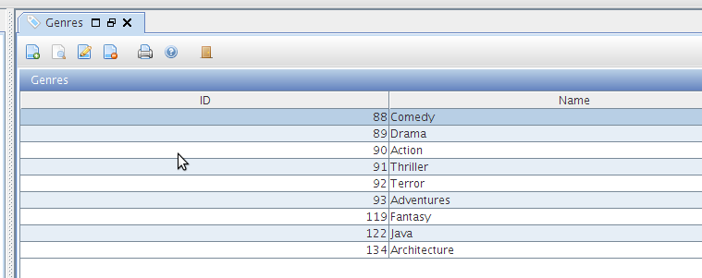

DetailView

This view can be used to show a record detail from a master view. It has a limited functionality, but
for some purposes could be very useful.

Basically a DetailView binds all the properties of the object configured for that view, with the UI
fields.

package examples;

import org.viewaframework.widget.view.DetailView;

public class EditorialDetailView extends DetailView<Editorial>{
public static final String ID ="editorialDetailViewId";
public EditorialDetailView() {
super(ID, new EditorialPanel());
}
/* (non-Javadoc)
* @see org.viewaframework.widget.view.DetailView#getDetailType()
*/
@Override
public Class<Editorial> getDetailType() {
return Editorial.class;
}
}

This example shows that this DetailView is going to handle Editorial objects. It also has a special
panel for showing that information (EditorialPanel which has been built using NetBeans 6.5).

For linking a master view with a detail view a MasterViewController must be used. The
DetailView you want to handle should be set to this controller.

MasterViewController has methods for almost all crud actions (handleViewAdd, handleViewEdit...) and it injects to the DetailView the current selected object from the MasterView.

Before opening a DetailView the model object, and all its relationships have to be added to the
DetailView (Using the MasterViewController):

protected void handleViewEdit(MasterView<Editorial> masterView,ActionEvent eventObject) {
/* To paint relationships we need to add comboboxes values*/
Map<String,Object> relationShips = new HashMap<String,Object>();
relationShips.put("country",this.countryManager.listAll(0,40));
this.getDetailView().addModelValue("relationships",relationShips);
}

In the example we are going to add a country relationship to the relationships map and then add the
last one to the model value called “relationships”.

No need for adding the detail view in the postHandlingViewXXX method, MasterViewController
does it for us.

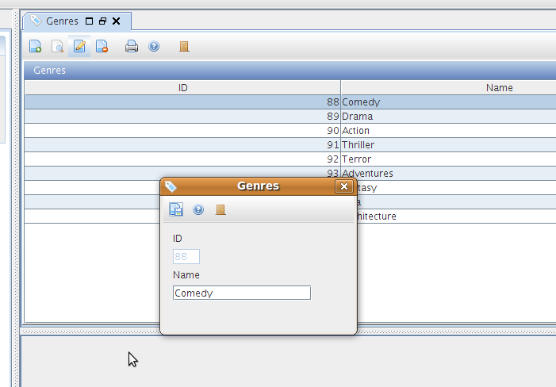

SwingBuilder

SwingBuilder is a helper class to build some UI parts in an easy way. It's inspired in the SwingBuilder class from Groovy. Right now the number of components that can be built with it is limited.

DynamicTable and DynamicTreeTable

This two classes are Swing components that render a table and a tree table respectively. Both classes try to build full functional tables in very few lines. That's it, initializing the table with all column and rendering characteristics very quick.
DynamicTable and DynamicTreeTable were created to decouple the rendering logic from the MasterView and, this way, allowing this two components to be used anywhere.

DynamicTable

DynamicTreeTable

