YOUNG’S FUNERAL HOME

Website: http://www.youngsfuneralhome.net

LOGGING INTO ADMIN SITE

Website: http://www.youngsfuneralhome.net/wp-admin
Username: kyoung
Password: 6017854948

UPDATING PAGES

- Go to Pages.
- Find the page name that you are trying to update.
- Make changes in the content field.
- Click the blue Update button on the right.

ADDING A DECEASED INDIVIDUAL TO THE WEBSITE

- Log into the admin site.
- Go to Posts (view image below).

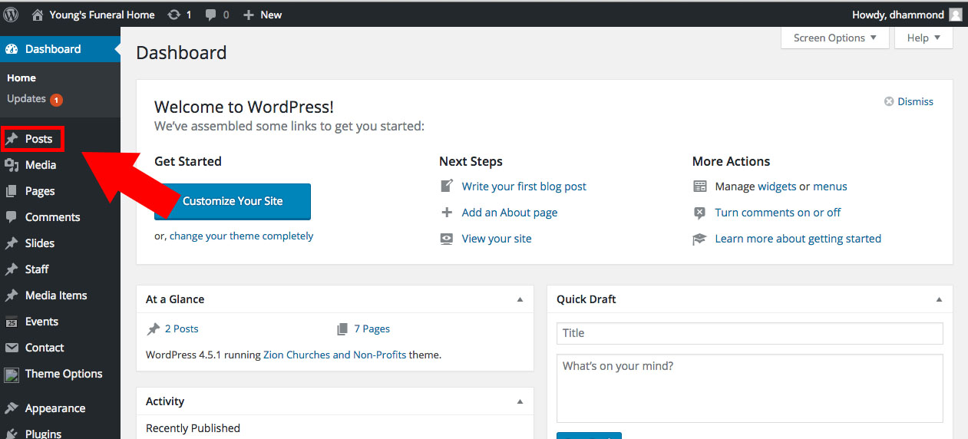

- Click Add New
- Enter data in post fields (view image below).

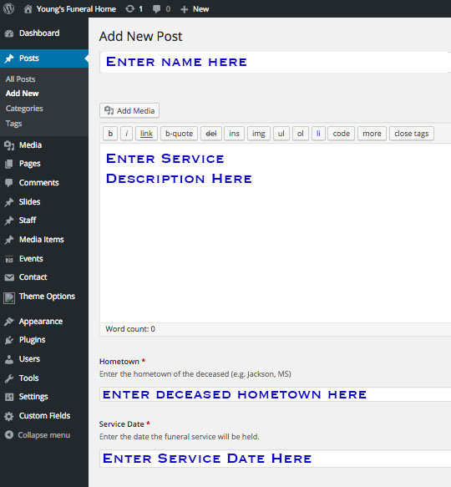

- Click blue Publish button on the right.

