CARLOS III UNIVERSITY OF MADRID

HIGHER TECHNICAL SCHOOL



MASTER IN CYBERSECURITY

MASTER THESIS

TARGETED EXERCISER FOR ANDROID MALWARE AND GRAYWARE

**Author**: Mario Herreros Díaz

**Mentors**: Juan E. Tapiador, Guillermo Suarez-Tangil

**September, 20th, 2016**

**Abstract**

Nowadays each person has one or more mobile device (smartphones, tablets, wearables, etc) with similar characteristics and performance of a personal computer. Many people use these devices to check their email or make bank transfers. For this, these devices store a lot of sensitive information that it could be very attractive to an attacker.

Mobile devices share same security troubles can be found in a conventional computer as malware hidden inside apps or users that don’t use nor protect their correctly.

Malware has evolved and is able to by pass protection systems and works only under certain circumstances to avoid detection. Some kind of malware is activated depends of network connection, device location, apps installed, calls received or other type of events.

The purpose of this Master Thesis is to study the behavior of malware on mobile devices depending of the device context, focusing on Android operating system. It has developed a system that allows dynamic and automatic generation of many different contexts to study the behavior of Android malware in each of the scenarios.

It has been designed a technique based on new language which defines each of the scenes and events to execute over the device to analyze the malware, in order to study their behavior depending on the characteristics of each context. In this way, it can detect the context features that makes triggering the malicious malware or greyware actions.

This Thesis focuses on analyzing all possible Android events to define a language and developing a system available to understand it and generate automatic executions to launch these events. With this system it is possible detect malware and grayware that a convetional static and dynamic analysis could not detect.

*Keywords: Malware, Greyware, Android, Context, Malware detection, Dynamic analysis, Mobile device, Malware behaviour*

1. **Introduction**

**Nowadays mobile devices are very present within society and every people uses them in their personal and laboral life.**

**The most popular smartphone OS is Android with a market share between 82 – 84 %, for this reason Android is the platform most targeted by malware and greyware.**

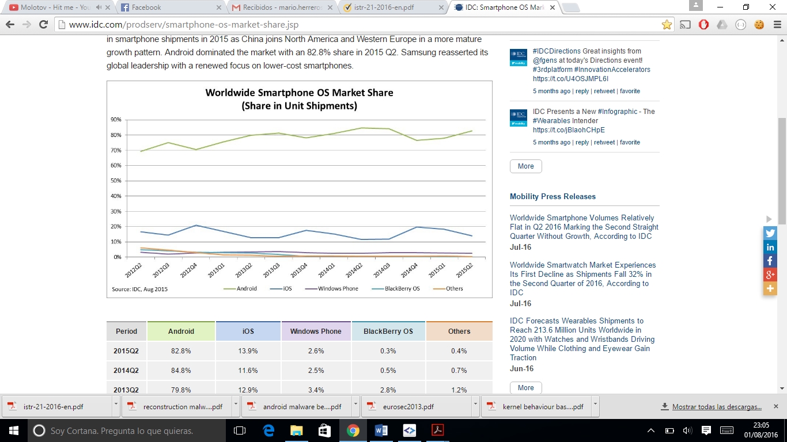

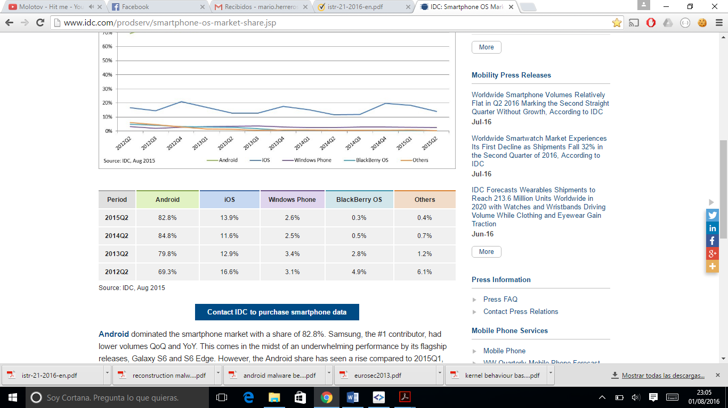

[**http://www.idc.com/prodserv/smartphone-os-market-share.jsp**](http://www.idc.com/prodserv/smartphone-os-market-share.jsp)

**El número de familias de malware en Android se ha incrementado muy notablemente durante los últimos años, habiéndose clasificado al menos 295 familias disintas.**

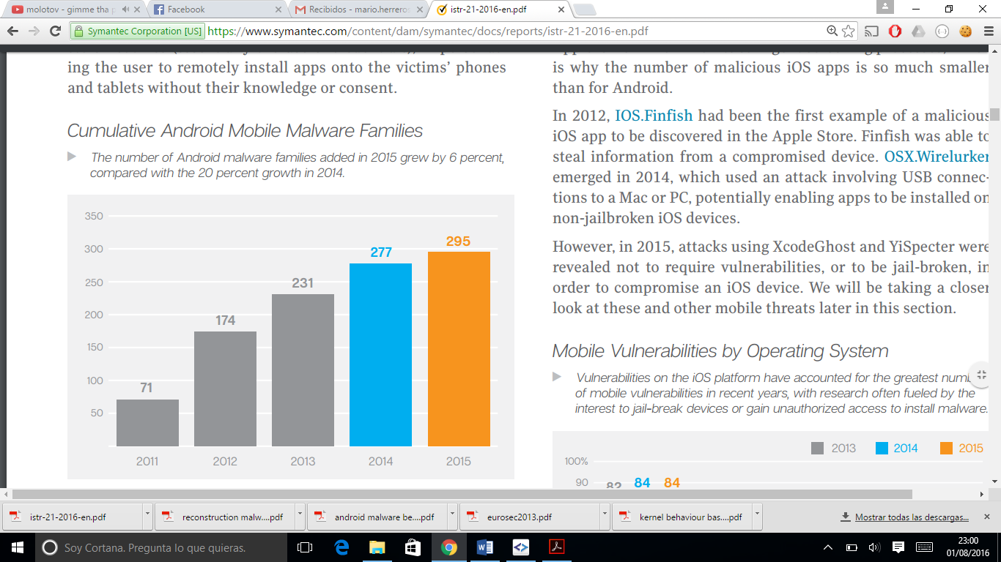

Durante el año 2015 se ha incrementado muy notablemente las variantes de malware que afectan a Android, dificultando la detección de los mismos.

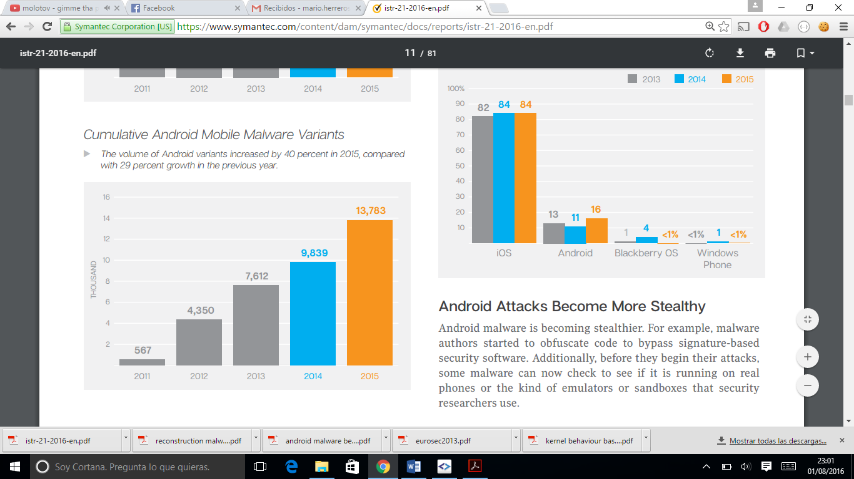

The powerful capabilities of mobile devices in networking, computing and sensing has increased the complexity, power and variability of malware.

Esto permite que el malware evolucione y puede adoptar funcionalidades muy específicas. Existe un tipo de malware que se centra en unas víctimas concretas, conocido como malware targeted. Este tipo de malware se centra en el comportamiento del usuario con el Smartphone y otros factores relativos al usuario, como su localización, la información que maneja o las aplicaciones que tiene instaladas.

Existen muchos ejemplos de malware

La principal ventaja del targeted malware frente a los sistemas de seguridad es su difícil detección. Ésto es debido a que solo ejecutan su código malicioso si se cumple un contexto concreto. Esta situación provoca la necesidad de utilizar una gran cantidad de recursos para poder detectar este tipo de malware.

En los stores de aplicaciones se reciben cada día un gran número de aplicaciones que deben ser analizadas antes de su publicación. Esto provoca que no se realicen análisis de malware lo suficientemente exhaustivos para detectar targeted malware.

Este problema se puede paliar utilizando técnicas de análisis dinámico que permita la generación de distintos contextos y comportamientos de una manera ágil y automática.

1. *Motivation*

Las carencias en los sistemas de detección de malware y el fuerte crecimiento de la potencia y complejidad del malware ha provocado la existencia de una importante amenaza de seguridad en los dispositivos móviles.

El análisis del targeted malware supone una labor costosa en recursos, por lo que el desarrollo de un sistema que permita agilizar y automatizar el análisis puede paliar este problema de seguridad existente en la actualidad.

Poniendo el foco en el sistema Android, que es uno de los OS más afectados por el malware en dispositivos móviles, se ha definido un sistema capaz de definir y ejecutar comportamientos y contextos diferentes, de una manera eficaz utilizando una sandbox virtual.

1. *Main contributions*

This work provides the following contributions:

1. An analysis and study of Android system and architecture for inject different kind of events and context.
2. Ans analysis and study of targeted malware, centrándose en nlos principales comportamients y contextos que utilizan para trigger el malware.
3. Generación de un nuevo lenguaje que permita definir de manera sencilla una serie de escenarios basados en distintos comporatmientos y contextos.
4. An analysis and developing of a new system, based in Targetdroid, capaz de computar el nuevo lenguaje definido y generar un análisis dinámico basándose en los contextos y comportamientos.
5. *Structure of the document*

The remainder of this document is structured as follows. First, section II presents the related work regarding Android targeted malware and Targetdroid.

Finally, Section III presents a series of recommendations and discusses about the importance of the security measures in Android malware and other Smartphone systems, and Section IV concludes the work.

Additionaly, two appedix…

1. **Related Work**
2. **TargetDroid**
3. *What is?*
4. *Events*
5. *Contexts (t= -1, t = 0, t > 0)*
6. **Discussion**
7. **Conclusion**
8. **Future Works**

**References**

**Appendix A : json-schema**

**{**

**"$schema": "http://json-schema.org/draft-04/schema#",**

**"id": "input JSON to configure a scenario and launch android events",**

**"type": "object",**

**"required": ["name", "time"]**

**"properties": {**

**"name":{**

**"id": "scenario name",**

**"type": "string"**

**},**

**"time": {**

**"id": "definition of context in every execution time",**

**"type": "object",**

**"oneOf": [**

**{**

**"type": "object",**

**"required": ["id"],**

**"properties": {**

**"id": {**

**"id": "execution time",**

**"type": "integer",**

**"enum": [-1]**

**},**

**"emulator": {**

**"id": "emulator configuration params",**

**"properties": {**

**"name": {**

**"id": "emulator name",**

**"type": "string"**

**},**

**"port": {**

**"id": "emulator port",**

**"type": "integer"**

**},**

**"sdk_version": {**

**"id": "emulator android version",**

**"type": "string",**

**"enum":["android-8", "android-10", "android-15", "android-16", "android-17", "android-18", "android-19", "android-20", "android-21", "android-22", "android-23"]**

**}**

**}**

**},**

**"phone": {**

**"id": "phone properties",**

**"type": "object",**

**"properties": {**

**"brand": {**

**"id": "phone brand name",**

**"type": "string"**

**},**

**"device": {**

**"id": "phone device name",**

**"type": "string"**

**},**

**"hardware": {**

**"id": "phone hardware name",**

**"type": "string"**

**},**

**"imei": {**

**"id": "phone imei",**

**"type": "string"**

**},**

**"imsi": {**

**"id": "phone imsi",**

**"type": "string"**

**},**

**"network_provider": {**

**"id": "phone network provider name",**

**"type": "string"**

**}**

**}**

**},**

**"network": {**

**"id": "network properties",**

**"type": "object",**

**"properties": {**

**"IP": {**

**"id": "phone IP",**

**"type": "string"**

**},**

**"DNS": {**

**"id": "phone DNS server",**

**"type": "string"**

**}**

**}**

**},**

**"ini_properties":{**

**"id": "properties to configurate the emulatore",**

**"type": "object",**

**"properties": {**

**"cpu_arch": {**

**"id": "The CPU Architecture to emulator",**

**"type": "string"**

**},**

**"cpu_model": {**

**"id": "The CPU model (QEMU-specific string)",**

**"type": "string"**

**},**

**"ram_size": {**

**"id": "Device ram size",**

**"type": "integer"**

**},**

**"screen_type": {**

**"id": "Defines type of the screen",**

**"type": "string"**

**},**

**"main_keys": {**

**"id": "Hardware Back/Home keys",**

**"type": "boolean"**

**},**

**"track_ball": {**

**"id": "Track-ball support",**

**"type": "boolean"**

**},**

**"keyboard": {**

**"id": "Whether the device has a QWERTY keyboard",**

**"type": "boolean"**

**},**

**"keyboard_lid": {**

**"id": "Whether the QWERTY keyboard can be opened/closed",**

**"type": "boolean"**

**},**

**"keyboard_charmap": {**

**"id": "Name of the system keyboard charmap file",**

**"type": "string"**

**},**

**"d_pad": {**

**"id": "Whether the device has DPad keys",**

**"type": "boolean"**

**},**

**"gsm_modem": {**

**"id": "phone DNS server",**

**"type": "string"**

**},**

**"gps": {**

**"id": "Whether there is a GPS in the device",**

**"type": "boolean"**

**},**

**"battery": {**

**"id": "Whether the device can run on a battery",**

**"type": "boolean"**

**},**

**"accelerometer": {**

**"id": "Whether there is an accelerometer in the device",**

**"type": "boolean"**

**},**

**"audio_input": {**

**"id": "Whether the device can record audio",**

**"type": "boolean"**

**},**

**"audio_output": {**

**"id": "Whether the device can play audio",**

**"type": "boolean"**

**},**

**"sd_card": {**

**"id": "Whether the device supports insertion/removal of virtual SD Cards",**

**"type": "boolean"**

**},**

**"sd_card_path": {**

**"id": "SD Card image path",**

**"type": "string"**

**},**

**"cache": {**

**"id": "Whether we use a /cache partition on the device",**

**"type": "boolean"**

**},**

**"cache_path": {**

**"id": "Cache partition to use on the device",**

**"type": "boolean"**

**},**

**"cache_size": {**

**"id": "Cache partition size",**

**"type": "string"**

**},**

**"lcd_width": {**

**"id": "LCD pixel width",**

**"type": "integer"**

**},**

**"lcd_height": {**

**"id": "LCD pixel height",**

**"type": "integer"**

**},**

**"lcd_depth": {**

**"id": "LCD color depth",**

**"type": "integer"**

**},**

**"lcd_density": {**

**"id": "Abstracted LCD density",**

**"type": "integer"**

**},**

**"lcd_backlight": {**

**"id": "LCD backlight",**

**"type": "boolean"**

**},**

**"gpu": {**

**"id": "Enable/Disable emulated OpenGLES GPU",**

**"type": "boolean"**

**},**

**"camera_back": {**

**"id": "Configures camera facing back",**

**"type": "string"**

**},**

**"camera_front": {**

**"id": "Whether the device can run on a battery",**

**"type": "string"**

**},**

**"heap_size": {**

**"id": "Max VM application heap size",**

**"type": "integer"**

**},**

**"sensor_proximity": {**

**"id": "Whether there is an proximity in the device",**

**"type": "boolean"**

**},**

**"sensor_magnetic_field": {**

**"id": "Provides magnetic field sensor values",**

**"type": "boolean"**

**},**

**"sensor_orientation": {**

**"id": "Provides orientation sensor values",**

**"type": "boolean"**

**},**

**"sensor_temperature": {**

**"id": "Provides temperature sensor values",**

**"type": "boolean"**

**},**

**"use_ext4": {**

**"id": "Specifies which file system to use: ext4 of yaffs2",**

**"type": "boolean"**

**},**

**"kernel_path": {**

**"id": "Path to the kernel image",**

**"type": "string"**

**},**

**"kernel_parameters": {**

**"id": "kernel boot parameters string",**

**"type": "string"**

**},**

**"ram_disk_path": {**

**"id": "Path to the ramdisk image",**

**"type": "string"**

**},**

**"system_partition_path": {**

**"id": "Path to runtime system partition image",**

**"type": "string"**

**},**

**"system_partition_init_path": {**

**"id": "Initial system partition image",**

**"type": "string"**

**},**

**"system_partition_size": {**

**"id": "Ideal size of system partition",**

**"type": "integer"**

**},**

**"data_partition_path": {**

**"id": "Path to data partition file",**

**"type": "string"**

**},**

**"data_partition_init_path": {**

**"id": "Initial data partition",**

**"type": "boolean"**

**},**

**"data_partition_size": {**

**"id": "Ideal size of data partition",**

**"type": "integer"**

**},**

**"snap_storage_path": {**

**"id": "Path to snapshot storage",**

**"type": "string"**

**}**

**}**

**}**

**}**

**},**

**{**

**"type": "object",**

**"required": ["id"],**

**"properties": {**

**"id": {**

**"id": "execution time",**

**"type": "integer",**

**"enum": [0]**

**},**

**"install_app": {**

**"id": "apks to install",**

**"type": "string"**

**},**

**"timezone": {**

**"id": "timezone for the emulator",**

**"type": "string"**

**},**

**"telnet": {**

**"id": "telnet commands",**

**"type": "object",**

**"properties": {**

**"power": {**

**"id": "power properties",**

**"type": "object",**

**"properties": {**

**"ac": {**

**"id": "ac properties",**

**"type": { "enum": ["on", "off"] }**

**},**

**"capacity": {**

**"id": "capacity properties",**

**"type": "integer"**

**},**

**"health": {**

**"id": "power health properties",**

**"type": {"enum": ["unknown", "good", "overheat", "dead", "overvoltage", "failure"] }**

**},**

**"present": {**

**"id": "battery presence",**

**"type": "boolean"**

**},**

**"status": {**

**"id": "battery status",**

**"type": { "enum": ["unknown", "charging", "discharging", "not-charging", "full"] }**

**}**

**}**

**}**

**}**

**}**

**}**

**},**

**{**

**"type": "object",**

**"required": ["id"],**

**"properties": {**

**"id": {**

**"id": "execution time",**

**"type": "integer",**

**"minimum": 1**

**},**

**"telnet": {**

**"id": "telnet commands",**

**"type": "object",**

**"properties": {**

**"power": {**

**"id": "power properties",**

**"type": "object",**

**"properties": {**

**"ac": {**

**"id": "ac properties",**

**"type": { "enum": ["on", "off"] }**

**},**

**"capacity": {**

**"id": "capacity properties",**

**"type": "integer"**

**},**

**"health": {**

**"id": "power health properties",**

**"type": {"enum": ["unknown", "good", "overheat", "dead", "overvoltage", "failure"] }**

**},**

**"present": {**

**"id": "battery presence",**

**"type": "boolean"**

**},**

**"status": {**

**"id": "battery status",**

**"type": { "enum": ["unknown", "charging", "discharging", "not-charging", "full"] }**

**}**

**}**

**},**

**"gsm": {**

**"id": "calling events",**

**"type": "object",**

**"properties": {**

**"call": {**

**"id": "call to a number",**

**"type": "string"**

**},**

**"accept": {**

**"id": "accept a call",**

**"type": "string"**

**},**

**"busy": {**

**"id": "busy a call",**

**"type": "string"**

**},**

**"cancel": {**

**"id": "cancell a call",**

**"type": "string"**

**},**

**"data": {**

**"id": "data connection status",**

**"type": { "enum": ["unregistered", "home", "roaming", "searching", "denied", "off", "on"] }**

**},**

**"voice": {**

**"id": "voice connection status",**

**"type": { "enum": ["unregistered", "home", "roaming", "searching", "denied", "off", "on"] }**

**}**

**}**

**},**

**"sms": {**

**"id": "send a sms message",**

**"type": "object",**

**"properties": {**

**"number": {**

**"id": "number phone to send a sms",**

**"type": "string"**

**},**

**"text": {**

**"id": "message",**

**"type": "string"**

**},**

**"required": [ "number", "sms" ]**

**}**

**},**

**"geo": {**

**"id": "location events",**

**"type": "object",**

**"properties": {**

**"fix": {**

**"id": "http://jsonschema.net/t1/geo/fix",**

**"type": "object",**

**"properties": {**

**"longitude": {**

**"id": "longitude",**

**"type": "string"**

**},**

**"latitude": {**

**"id": "latitude",**

**"type": "string"**

**},**

**"altitude": {**

**"id": "altitude",**

**"type": "string"**

**},**

**"required": [ "longitude", "latitude" ]**

**}**

**},**

**"nmea": {**

**"id": "nmea",**

**"type": "string"**

**}**

**}**

**}**

**}**

**},**

**"adb": {**

**"id": "adb popular commands",**

**"type": "array",**

**"properties": {**

**"action": {**

**"id": "adb action name",**

**"type": "string",**

**"enum": ["connect_wifi", "lock_screen", "unlock_screen", "volume_up", "go_home", "take_screenshot", "start_clock_app", "stop_clock_app", "start_wifi", "wifi_status", "enable_wifi", "disable_wifi", "enable_mobile_data", "disable_mobile_data"]**

**}**

**}**

**},**

**"intents": {**

**"id": "intents commands",**

**"type": "array",**

**"properties": {**

**"type": {**

**"id": "intent type",**

**"type": "string",**

**"enum": ["start", "start_service", "broadcast"]**

**},**

**"params": {**

**"id": "intent params",**

**"type": "string"**

**}**

**}**

**},**

**"monkey": {**

**"id": "monkey script events",**

**"type": "object",**

**"properties": {**

**"path":{**

**"id": "path to monkey script",**

**"type": "string"**

**},**

**"package": {**

**"id": "apk package where run monkey script",**

**"type": "string"**

**}**

**}**

**}**

**}**

**}**

**]**

**}**

**}**

**}**

**Appendix B: event list**

# Eventos de configuración del entorno

|  |  |  |
| --- | --- | --- |
| Atributo | Valores | Descripción |
| emulator |  |  |
| Emuator.name | String | Nombre del AVD a crear |
| Emulator.port | Integer | Puerto en el que escuchará el AVD |
| Emulator.sdk_version | String  "enum":[  "android-8", "android-10", "android-15", "android-16", "android-17", "android-18", "android-19", "android-20", "android-21", "android-22", "android-23"] | Versión del Android SDK utilizado por el emulador |
| phone |  | |
| phone.brand | string | Indica la marca comercial del dispositivo emulado |
| phone.device | String | Indica el modelo del dispositivo emulado |
| phone.imei | String | Indica el valor IMEI que tendrá el dispositivo emulado. |
| Phone.imsi | String | Indica el valor IMSI que tendrá el dispositivo emulado. |
| Phone.provider | string | Indica el nombre del proveedor de red del emulador |
| Network |  | |
| Network.IP | String | Indica la dirección IP del dispositivo emulado |
| Network.DNS | string | Indica las direcciones DNS a utilizar por el dispositivo emulado. Puede ser una lista de hasta cuatro direcciones IP o hostnames separado por comas. |
| ini_properties |  |  |
| ini_properties. cpu_arch | String | Indica el tipo de la arquitectura de la CPU del emulador. |
| ini_properties. cpu_model | String | Indica el modelo de la CPU |
| ini_properties. ram_size | Integer | Indica el tamaño de la memoria RAM |
| ini_properties. screen_type | String  "enum":[  "touch",  "multi-touch", "no-touch"] | Define el tipo de pantalla |
| ini_properties. main_keys | Boolean | Activa/desactiva los botones de Volver/Inicio |
| ini_properties keyboard | Boolean | Indica si el emulador utiliza es un teclado QWERTY |
| ini_properties.keyboard_lid | Boolean | Permite abrir el teclado QWERTY o no |
| ini_properties.keyboard_charmap | string | Nombre del sistemat charmap del teclado |
| ini_properties.d_pad | Boolean | Indica si el dispositivo presenta teclas DPad |
| ini_properties.gsm_modem | String | Indica el módem GSM del dispositivo |
| ini_properties.gps | Boolean | Indica la presencia de GPS en el dispositivo |
| ini_properties.battery | Boolean | Indica la presencia de batería en el dispositivo |
| ini_properties.accelerometer | Boolean | Indica la presencia de acelerómetro en el dispositivo |
| ini_properties.audio_input | Boolean | Indica la pesencia de entrada de audio en el dispositivo |
| ini_properties.audio_output | Boolean | Indica a presencia de salida de audio en el dispositivo |
| ini_properties.sd_card | Boolean | Indica si el dispositivo soporta el uso de tarjetas SD |
| ini_properties.sd_card_path | String | Presenta la ruta de la imagen de la tarjeta SD a utilizar |
| ini_properties.cache | Boolean | Indica el uso de una partición cacheada en el dispositivo |
| ini_properties.cache_path | String | Presenta la ruta de la cache a utilizar |
| ini_properties.cache_size | String | Es el valor del tamaño de la caché |
| ini_properties.lcd_width | Integer | Ancho del pixel LCD |
| ini_properties.lcd_height | Integer | Alto del pixel LCD |
| ini_properties.lcd_depth | Integer | Profundidad de color LCD |
| ini_properties.lcd_density | Integer  "enum":[  120,  160,  240,  213,  320 | Densidad LCD |
| ini_properties.lcd_backlight | Boolean | Presencia de LCD Backlight |
| ini_properties.gpu | Boolean | Indica el uso de una OpenGLES GPU emulada |
| ini_properties.camera_back | String | Configuración de la cámara trasera |
| ini_properties.camera_front | String | Configuración de la cámara frontal |
| ini_properties.heap_size | Integer | Define el tamaño máximo del heap del emulador |
| ini_properties.sensor_proximity | Boolean | Presencia de sensor de proximidad |
| ini_properties. sensor_magnetic_field | Boolean | Presencia de sensor magnético |
| ini_properties. sensor_orientation | Boolean | Presencia de sensor de orientación |
| ini_properties. sensor_temperature | Boolean | Presencia de sensor de temperatura |
| ini_properties. use_ext4 | Boolean | Indica que sistema de ficheros utilizar:  Ext4/ yaffs2 |
| ini_properties. kernel_path | String | Presenta la ruta de la imagen del kernel a utilizar |
| ini_properties. kernel_parameters | String | Indica los parámetros a pasar al boot kernel |
| ini_properties. system_partition_path | string | Indica la ruta de la partición del sistema |
| ini_properties. system_partition_init_path | String | Indica la ruta de la partición del sistema inicial |
| ini_properties. system_partition_size | Integer | Tamaño del sistema de partición |
| ini_properties. data_partition_path | String | Indica la ruta de la partición de datos |
| ini_properties. data_partition_init_path | String | Indica la ruta de la partición de datos inicial |
| ini_properties. data_partition_size | Integer | Tamaño de la partición de datos |
| ini_properties. snap_storage_path | String | Indica la ruta del snapshot a almacenar |

# Eventos de configuración inicial del contexto

|  |  |  |
| --- | --- | --- |
| Atributo | Valores | Descripción |
| Intall_app | String | Instala la apk indicada (acepta el path) |
| Timezone | string | Configura la franja horaria del dispositivo |
| power |  | |
| power.ac | On  off | Indica si el dispositivo está conectado a la corriente eléctrica |
| Power.capacity | integer | Indica la capacidad de carga de la batería |
| Power.health | Unknown  Good  Overheat  Dead  Overvoltage  failure | Indica el estado de salud de la batería |
| Power.present | Boolean | Indica la presencia de batería o no en el dispositivo |
| Power.status | Unknown  Charging  Discharging  not-charging  full | Indica el estado de la batería |

# Eventos de configuración de contexto

|  |  |  |
| --- | --- | --- |
| Atributo | Valores | Descripción |
| power |  | |
| power.ac | On  off | Indica si el dispositivo está conectado a la corriente eléctrica |
| Power.capacity | integer | Indica la capacidad de carga de la batería |
| Power.health | Unknown  Good  Overheat  Dead  Overvoltage  failure | Indica el estado de salud de la batería |
| Power.present | Boolean | Indica la presencia de batería o no en el dispositivo |
| Power.status | Unknown  Charging  Discharging  not-charging  full | Indica el estado de la batería |
| Gsm |  | |
| Gsm.Call | String | Llamada al número indicado |
| Gsm.Accept | String | Acepta una llamada desde el número indicado |
| Gsm.Busy | String | Rechaza una llamada desde el número indicado |
| Gsm.Cancel | String | Cancela una llamada desde el número indicado |
| Gsm.Data | Unregistered  Home  Roaming  Searching  Denied  Off  on | Define el estado de la conexión de datos |
| Gsm.Voice | Unregistered  Home  Roaming  Searching  Denied  Off  on | Define el estado de la conexión de voz |
| Sms |  | |
| Sms.number | String | Indica el número al que se va a enviar el SMS |
| Sms.message | String | Contenido del SMS |
| Geo |  | |
| geo.fix.longitude | String | Indica la longitud en la geolocalización |
| geo.fix.latitude | String | Indica la latitud en la geolocalización |
| geo.fix.altitude | String | Indica la altitud en la geolocalización |
| Geo.nmea | String | Emulación NMEA |
| Intents |  |  |
| Intents.type | String | Tipo de intent |
| Intents.params | String | Parámetros del intent |
| Adb |  |  |
| Adb.action | String  Enum = [  “connect_wifi”,  “lock_screen”,  “unlock_screen”,  “volumen_up”,  “go_home”,  “take_screenshot”,  “start_clock_app”,  “stop_clock_app”,  “start_wifi”,  “enable_wifi”,  “wifi_status”,  “enable_mobile_data”,  “disable_mobile_data”  ] | Tipo de comando a ejecutar |
| Monkey |  |  |
| Monkey.path | String | Path del script monkey |
| Monkey.package | String | Package sobre el que se ejecutará el script |

**Appendix C: Planning and budget**

In order to comply with the regulations of MsC Thesis by Universidad Carlos III de Madrid, this appendix presents the Planning and Budget of the Thesis.

First, it is going to be presented a planning that defines this project in different tasks. It has been generated a typical Gantt chart presenting in a graphical form the duration of each phase.

The resume of the phases is shown in Figure X with its start and end date. Gantt chart with detailed information is shown in Figure X+1.

|  |  |  |  |
| --- | --- | --- | --- |
|  | Duration (days) | Start Date | End Date |
| Definition of goals | 27 | 16/01/2016 | 23/02/2016 |
| Analysis | 34 | 01/03/2016 | 15/04/2016 |
| Design | 14 | 24/05/2016 | 10/06/2016 |
| Development | 16 | 13/06/2016 | 04/07/2016 |
| Testing | 4 | 5/07/2016 | 10/07/2016 |
| Report | 34 | 18/07/2016 | 1/09/2016 |

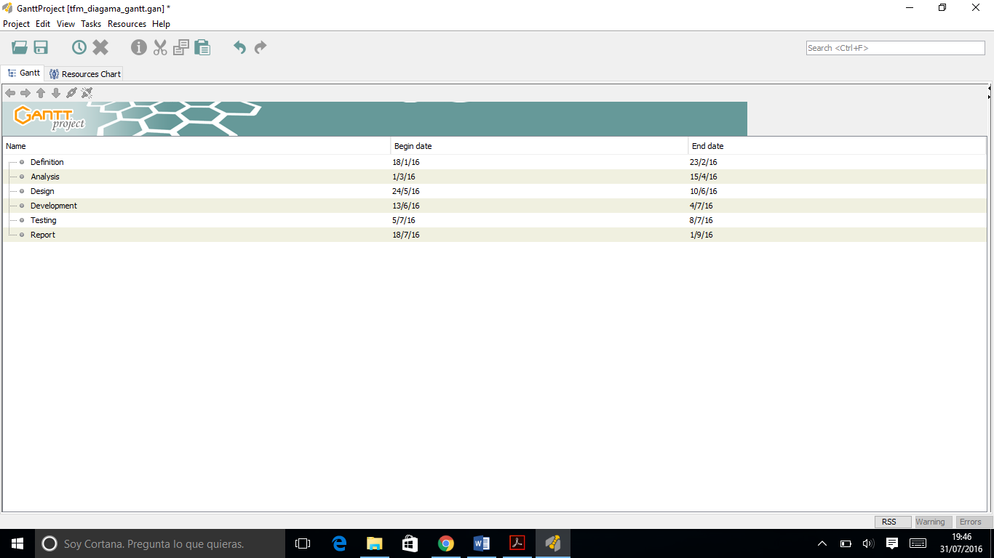

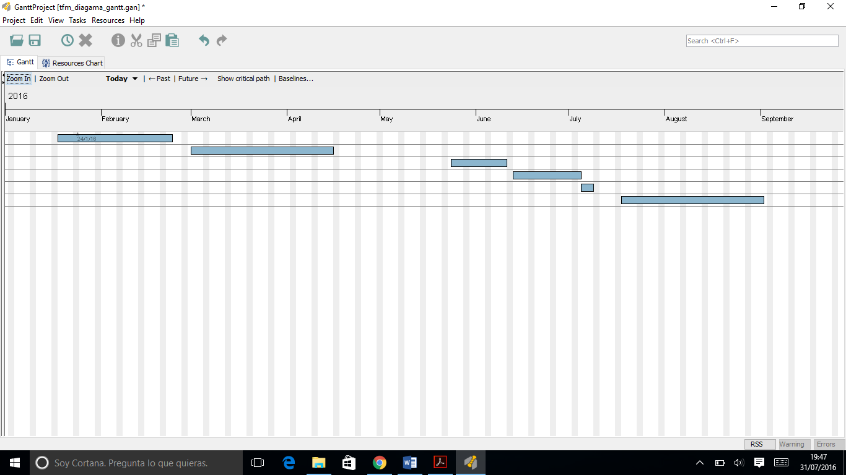

Last, it is going to be presented the budget. It is broken down into various estimations by type cost:

* Personal cost: 31.600 €
* Hardware cost: 30 €
* Software cost: 0 €
* Indirect cost: 301 €
* Total cost: 31.600 €

Note: VATs are included.

|  |  |  |  |
| --- | --- | --- | --- |
| Concept | Time (hours) | Fees | RRHH cost |
| Security Engineer | 500 | 50 €/hour | 25.000 € |
| PhD | 120 | 55 €/hour | 6.600 € |
| TOTAL | | | 31.600 € |

|  |  |  |  |  |  |
| --- | --- | --- | --- | --- | --- |
| Concept | Units | Unit price | Estimated life time | Airtime (months) | Cost |
| Acer Aspire 5740 | 1 | 600 € | 60 months | 4,3 | 30 € |
| TOTAL | | | | | 30 € |

|  |  |  |  |  |  |
| --- | --- | --- | --- | --- | --- |
| Concept | Units | Unit price | Estimated life time | Airtime | Cost |
| Ubuntu Linux | 1 | 0 € | - | 4,3 | 0 € |
| Sublime Text 3 | 1 | 0 € | - | 4,3 | 0 € |
| SmartGit Hg 7.1 | 1 | 0 € | - | 4,3 | 0 € |
| Github | 1 | 0 € | - | 4,3 | 0 € |
| Bitbucker | 1 | 0 € | - | 4,3 | 0 € |
| MiKTeX | 1 | 0 € | - | 4,3 | 0 € |
| TeXnic Center | 1 | 0 € | - | 4,3 | 0 € |
| Adobe Reader | 1 | 0 € | - | 4,3 | 0 € |
| Google Chrome | 1 | 0 € | - | 4,3 | 0 € |
| TOTAL | | | | | 0 € |

|  |  |  |  |
| --- | --- | --- | --- |
| Concept | Monthly price | Airtime (months) | Cost |
| Electricity | 40 € | 4,3 | 172 € |
| Internet | 30 € | 4,3 | 129 € |
| TOTAL | | | 301 € |

|  |  |
| --- | --- |
| Concept | Amount |
| Personal cost | 31.600 € |
| Hardware cost | 30 € |
| Software cost | 0 € |
| Indirect cost | 301 € |
| TOTAL | 31.931 € |