Summary: AgriFleet Analytics – traceable farm fleet maintenance
Private portfolio project. The four machines and their telemetry are simulated. The as-is process and the stakeholder needs come from the author's own farm experience and have not been validated in interviews with other farmers or workshops.
Problem  On a small hay and dairy farm, machines get serviced when someone remembers a due interval or when they break during work. Nothing is recorded, and the workshop gets only a verbal description. | Approach  Requirements engineering end to end: stakeholder analysis, BPMN as-is and to-be, a user story map (19 stories) and 22 requirements with MoSCoW priority, traced from each need to code and tests.
Solution  Every morning the farmer opens one dashboard that ranks the four machines and shows status, a service recommendation and the measured reason behind every flag. No hidden scoring, no machine learning. | Result  The Must release runs as a distributed system of three Spring Boot modules. Of the 22 requirements, 18 are verified by unit tests and 4 by inspection or demonstration.

Aspect | As-Is | To-Be with AgriFleet
Trigger for a check | Hour meter from memory, or a breakdown | Daily check of the ranked fleet
Order across the fleet | None; each machine judged alone | Priority rank from flags and load
Info for the workshop | Verbal problem description | Counter, value and threshold
Usage record | Nothing is recorded | Automatic hourly history
Unchanged by design: manufacturer service intervals stay a manual hour-meter check, and performed maintenance is still not recorded.
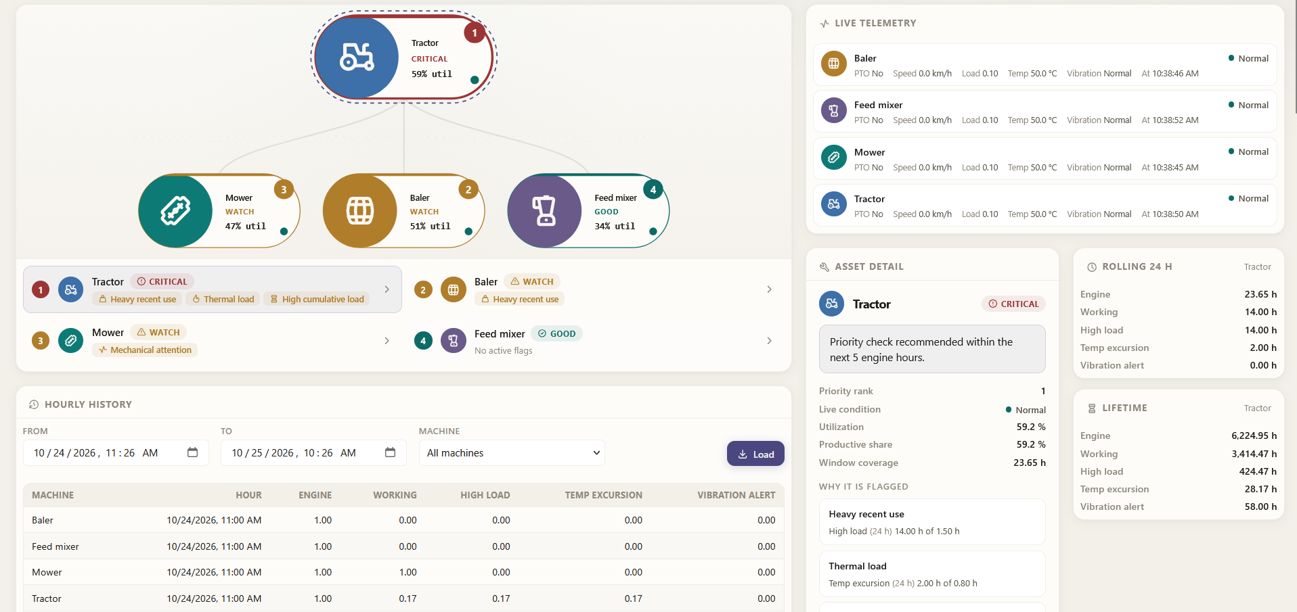
Dashboard: fleet ranked by urgency, live telemetry and the reason behind each flag.
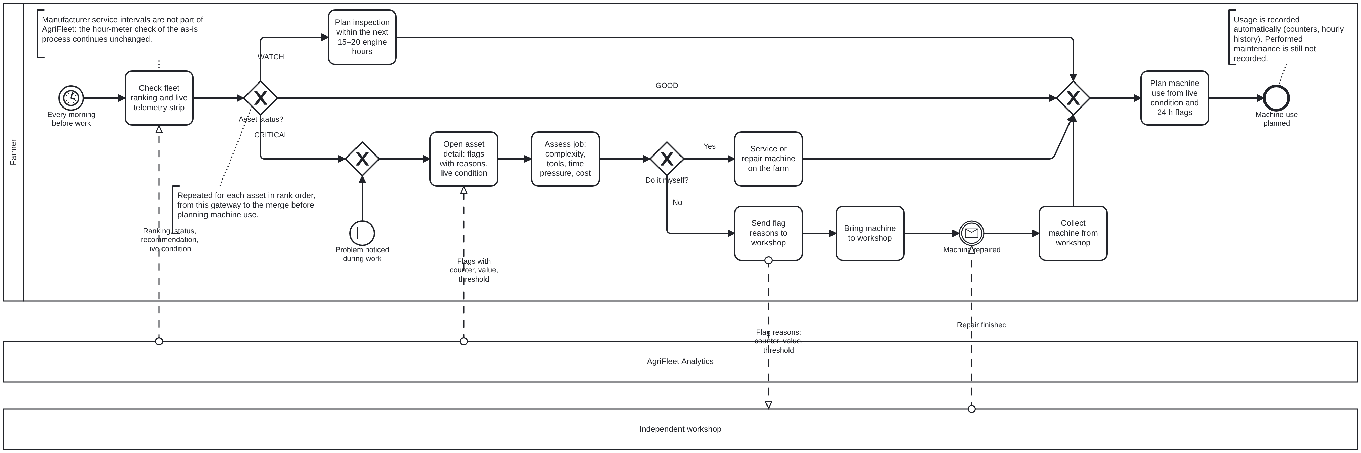
To-Be: each machine is handled by status; the workshop gets flag reasons, not a verbal description.
Stack: Java 25, Spring Boot, RabbitMQ, PostgreSQL, Docker Compose Mario Lagger · github.com/mariolagge

