Redesigning the 'Match Talents' process at easystaff
University case study about easystaff human & resources GmbH, based on publicly available information. All numbers and process data are assumptions. This project is not affiliated with or endorsed by easystaff.

Disclaimer
University case study about easystaff human & resources GmbH created as my final project in the lecture “Business Process Engineering” at UAS Technikum Wien, based on publicly available information. All numbers and process data are assumptions. This project is not affiliated with or endorsed by easystaff.
All values below are either calculated (flow analysis, data/kpis.json) or simulated (BIMP simulator, data/simulation_results.json).

Process scope
"Match Talents" turns a client's staffing request into a confirmed team of talents and sends everyone a briefing.
Table 1: Content and interfaces of process “Match Talents”
Element | Definition
Trigger | Client request received: the client sends its staffing needs (number of staff, qualifications, timeframe, location).
First step | Create requirements list: Sales turns the request into a structured list in the CRM.
Last step | Send briefings: HR e-mails job instructions to the booked talents and a confirmation to the client.
Preceding process | Recruit talents: new candidates are screened and added to the HRIS talent pool.
Following process | Deploy talents: the booked talents work the assignment at the client's site.

As-Is process model
Today the process runs on e-mail: HR asks talents and the client for answers by e-mail and waits.
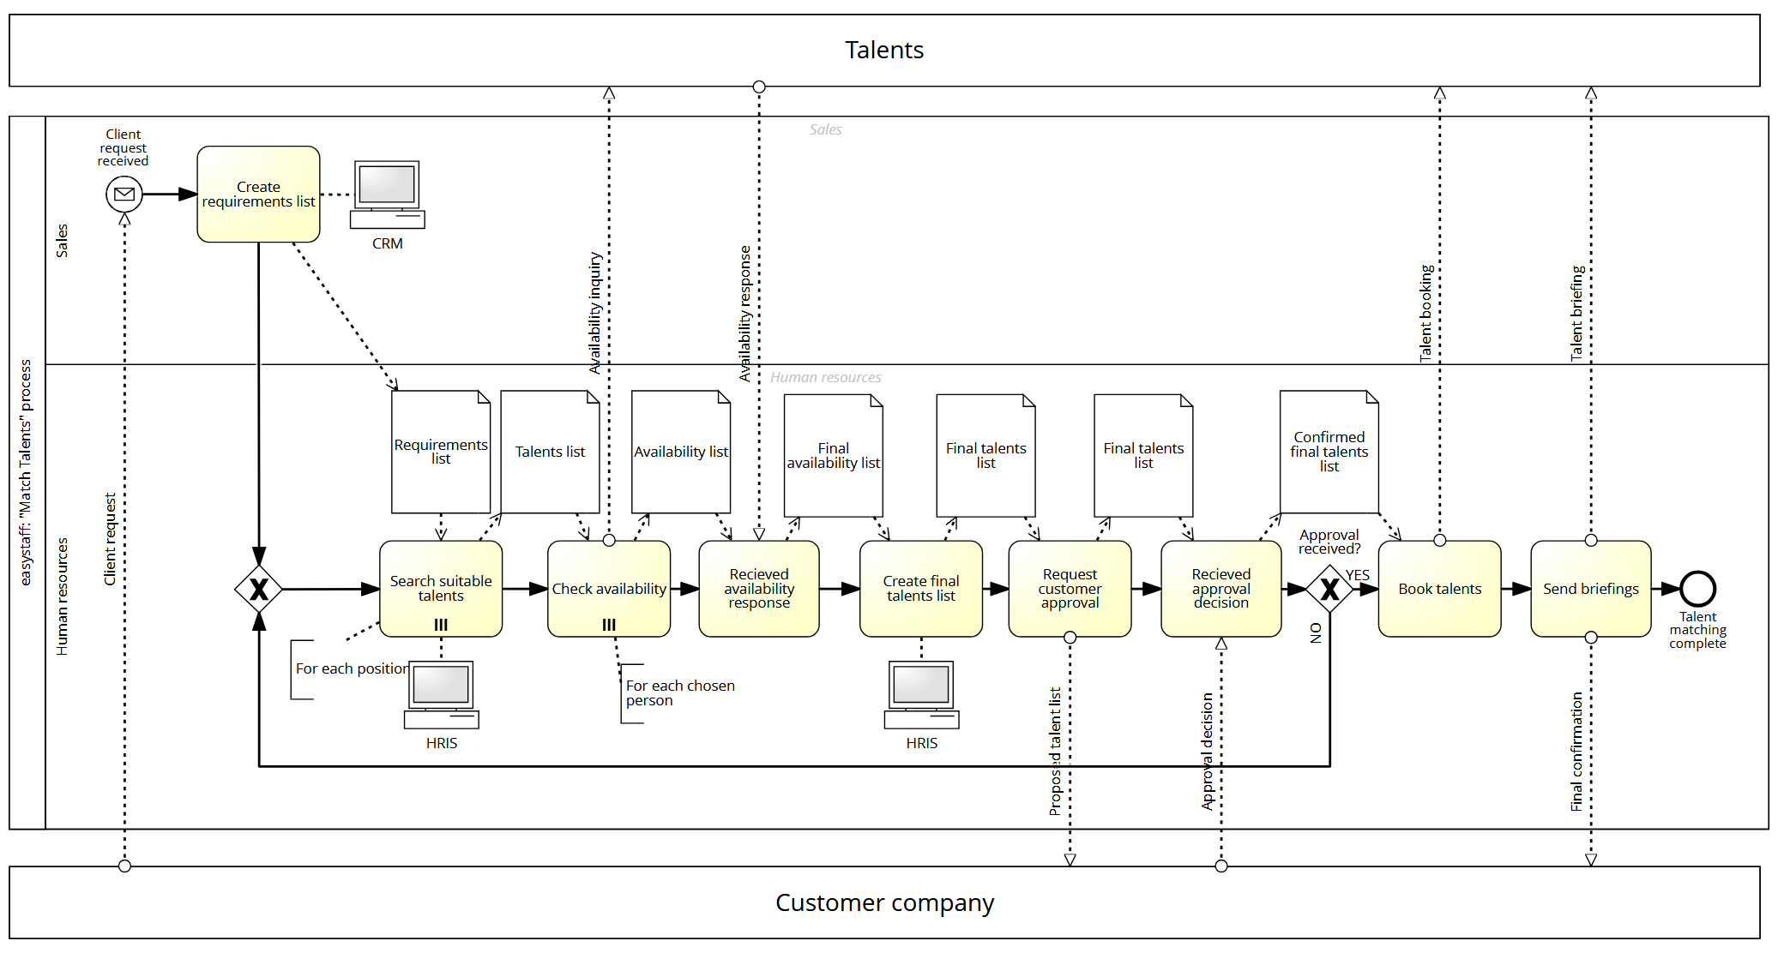
Figure 1: As-Is BPMN model of the Match Talents process with the pools Talents, easystaff (lanes Sales and Human resources) and Customer company

Sales creates the requirements list, then HR searches the HRIS, checks availability per talent and compiles a final list. The client approves or rejects the list by e-mail. A rejection sends the case back to the talent search.
Note: the model files spell two task names "Recieved…". This document uses the correct spelling "Received…".

As-Is flow analysis
A staffing order takes 6.9 working days (calculated), but only 5.9 h of it is actual work: a cycle time efficiency (CTE) of 11 %.
Input values per task (one working day = 8 h):
Table 2: Input values per task of the As-Is process
Block | Task | Cycle time (working days) | Processing time (h) | Resource
1 | Create requirements list | 0.25 | 0.5 | Sales
2 | Search suitable talents | 0.5 | 1.5 | HR
2 | Check availability | 0.125 | 0.5 | HR
2 | Received availability response (incl. waiting) | 2.0 | 0.25 | HR
2 | Create final talents list | 0.25 | 0.5 | HR
2 | Request customer approval | 0.125 | 0.5 | HR
2 | Received approval decision (incl. waiting) | 2.0 | 0.25 | HR
3 | Book talents | 0.25 | 0.5 | HR
3 | Send briefings | 0.125 | 0.5 | HR

Block 2 is a rework block: with a probability of r = 20 %, the client rejects the list and block 2 runs again.
Rework block: T_block2 = sum(T_tasks) / (1 - r)
Cycle time (CT) = 0.25 + (0.5 + 0.125 + 2.0 + 0.25 + 0.125 + 2.0) / (1 - 0.2) + (0.25 + 0.125) = 6.9 working days
Processing time (PT) = 0.5 + (1.5 + 0.5 + 0.25 + 0.5 + 0.5 + 0.25) / (1 - 0.2) + (0.5 + 0.5) = 5.9 h
CTE = PT / (CT x 8 h) = 11 %
Resource cost per case = PT x hourly rate (Sales 40 EUR/h, HR 50 EUR/h) = 289 EUR

Pain points
Three issues explain most of the gap between working time and cycle time.
Table 3: Pain points of the As-Is process
 | Cause | Effect | Number
1 | Availability checks and client approval run by e-mail. | HR waits for replies; clients receive confirmations late. | Two waits of 2.0 working days each, repeated in 20 % of cases.
2 | HR keeps talent, availability and final lists by hand. | High manual workload and risk of copy errors. | HR performs 8 of 9 tasks at 50 EUR/h; total 289 EUR per case.
3 | Sales copies each e-mail request into the CRM by hand. | Incomplete requirements cause clarification loops and rework. | Extra handover step of 0.5 h; rework rate r = 20 %.

Simulation
The simulation shows that HR capacity is not the bottleneck: four times the demand leaves the cycle time unchanged.
Table 4: Simulation results of the As-Is process (BIMP)
Simulated (BIMP, 50 cases each) | Simulation 1 | Simulation 2
Requests per week | 10 | 40
Average cycle time | 6.8 calendar days | 6.8 calendar days
Average duration (processing incl. queueing) | 5.6 h | 7.9 h
Average cost per case | 277 EUR | 280 EUR
HR utilization | 9 % | 27 %

HR is busy on average only 27 % of its time, even at 40 requests per week. The cycle time stays the same because the waits for talents and clients dominate. The cause of long cycle times is waiting for external replies, which is exactly what the redesign targets.
The average duration rises with load because BIMP adds the time a task waits for a free HR employee. The activities themselves do not take longer. The simulated cost of 277 EUR is below the calculated 289 EUR: in the simulation fewer cases were reworked than the expected 20 %.
Unit note: BIMP measures elapsed calendar time, including nights and weekends. The flow analysis uses 8 h working days. The calculated 6.9 working days and the simulated 6.8 calendar days are therefore not comparable and do not confirm each other.

To-Be process model
The redesign replaces e-mail with a digital platform for talents and clients and removes the Sales handover.
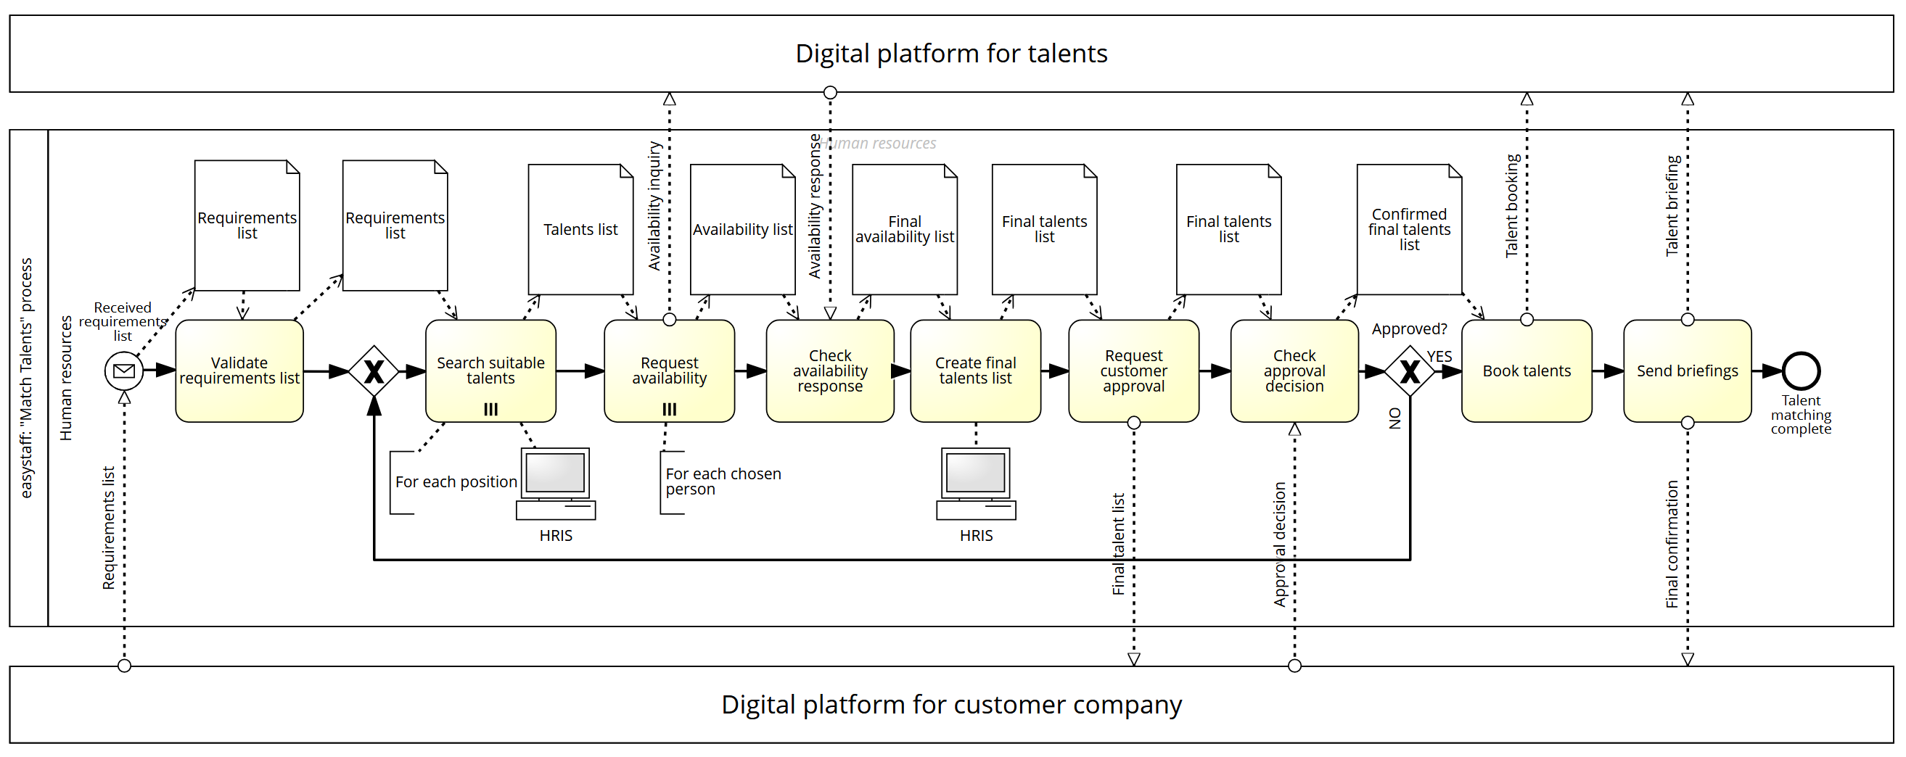
Figure 2: To-Be BPMN model of the Match Talents process with the pools Digital platform for talents, easystaff (lane Human resources) and Digital platform for customer company

- Change 1 — Sales step removed: the client enters the staffing request in a structured form on the platform. HR only validates it ("Validate requirements list").
- Change 2 — Platform replaces e-mail: HR sends availability requests and the shortlist for approval through the platform ("Request availability", "Request customer approval"). Talents and the client answer there.
- Lists generated by the system: talent, availability and final lists are created from the platform data instead of by hand.
Each change applies one redesign heuristic (Dumas et al., 2018): case-based work for Change 2, activity elimination for Change 1 and for the manual lists.

To-Be flow analysis
The redesign cuts the cycle time from 6.9 working days to 3.3 working days (−52 %), calculated with the same method and the assumptions below.
Table 5: Task values and assumptions of the To-Be process
To-Be task | Replaces | Cycle time (working days) As-Is → To-Be | Processing time (h) As-Is → To-Be | Assumption
Validate requirements list (HR) | Create requirements list (Sales) | 0.25 → 0.0625 | 0.5 → 0.25 | Client submits a structured form; HR only checks completeness.
Search suitable talents | same | 0.5 → 0.5 | 1.5 → 1.5 | Unchanged; no automated matching assumed.
Request availability | Check availability | 0.125 → 0.0625 | 0.5 → 0.25 | One bulk request via the platform instead of single e-mails.
Check availability response | Received availability response | 2.0 → 1.0 | 0.25 → 0.0 | 24 h response deadline in the talent app; answers recorded automatically.
Create final talents list | same | 0.25 → 0.125 | 0.5 → 0.25 | System pre-selects confirmed talents.
Request customer approval | same | 0.125 → 0.0625 | 0.5 → 0.25 | Approval request with one click.
Check approval decision | Received approval decision | 2.0 → 1.0 | 0.25 → 0.0 | Approval within 1 working day (service level); recorded automatically.
Book talents | same | 0.25 → 0.125 | 0.5 → 0.25 | Booking from the approved list.
Send briefings | same | 0.125 → 0.0625 | 0.5 → 0.25 | Briefings generated from case data; HR reviews.
Rework probability r | Approval received? = NO | 20 % → 10 % | – | Structured input means fewer clarification loops.

Table 6: KPI comparison As-Is vs. To-Be
KPI (calculated) | As-Is | To-Be | Change
Cycle time | 6.9 working days | 3.3 working days | −52 %
Processing time | 5.9 h | 3.3 h | −45 %
Cycle time efficiency | 11 % | 12 % | +1 pp
Resource cost per case | 289 EUR | 163 EUR | −44 %

Table 7: Achievement of the process goals
Process goal | Target | Result
Cycle time | ≤ 3.5 working days | Met (3.3 working days)
Manual effort (processing time per case) | −30 % | Met (−45 %)
Error rate | < 5 % | Not measured

The CTE rises only from 11 % to 12 %. Most of the remaining time is still waiting for talents and clients, now capped by deadlines. The gain comes from shorter waits and less manual work, not from faster HR.

Trade-off
Time, cost and quality improve, while flexibility drops slightly. Standardized forms and fixed platform workflows leave less room for informal, case-by-case agreements. Clients who prefer phone or e-mail must adapt.

Rollout
The platform should be introduced in three steps to keep daily operations safe.
- Pilot: run availability checks and client approval on the platform for a limited number of staffing requests.
- Parallel run: keep the e-mail process as a fallback until the platform works reliably.
- Full rollout: move all requests to the platform, connect it to the CRM and HRIS, and train HR staff.
Two risks need attention:
- User adoption: HR staff, talents and clients may resist changing established communication habits.
- Data protection: centralizing personnel data requires GDPR-compliant access rights and storage.

Limitations
All results rest on assumptions, not on measurements at easystaff.
- Process data (volumes, task times, rework rate, hourly rates) are assumed for a university course.
- The To-Be values are calculated, not simulated and not observed.
- The error rate goal cannot be evaluated without real data.
- Implementation and licence costs of the platform are not estimated.

