**MANUAL QA**

***Homework - Lesson 11***

**Student Name:** Mario Lima

***ANSWERS***

***Level 1:***

***1. Which statement about the state transition diagram and the table with test cases is correct?***

A. These test cases cover valid and invalid transitions in the chart.

B. These test cases show all possible valid transitions on the chart.

C. These test cases cover some valid transitions on the chart.

D. These test cases cover pairs of transitions in the diagram.

***2. Employees of the company are issued bonuses if they have worked for more than a year and have fulfilled the goals set in advance.***

***Which scenario that is likely in real life is omitted in the table?***

A. Condition 1 = YES, Condition 2 = NO, Condition 3 = YES, Action = NO

B. Condition1=YES,Condition2=YES,Condition3=NO,Action=YES

C. Condition1=NO,Condition2=NO,Condition3=YES,Action=NO

D. Condition1=NO,Condition2=YES,Condition3=NO,Action=NO

***Level 2:***

***1. Complete the task of the previous level.***

***2. Make a state and transition diagram for testing the following video game:***

*After starting the game, you find yourself in the Castle of Mysteries, in a room with two corridors — to the right and to the left.*

*If you go to the right, you will get to the dragon. The dragon gives you a riddle. If the answer is correct — you leave the castle and win. If not, the dragon gives another riddle. If you answer incorrectly for the second time, the dragon will eat you and you lose.*

*If you go to the left, you will get to the witch. The witch gives a riddle. If the answer is correct, you leave the castle and win. If the answer is wrong, the witch takes you to the dragon.*

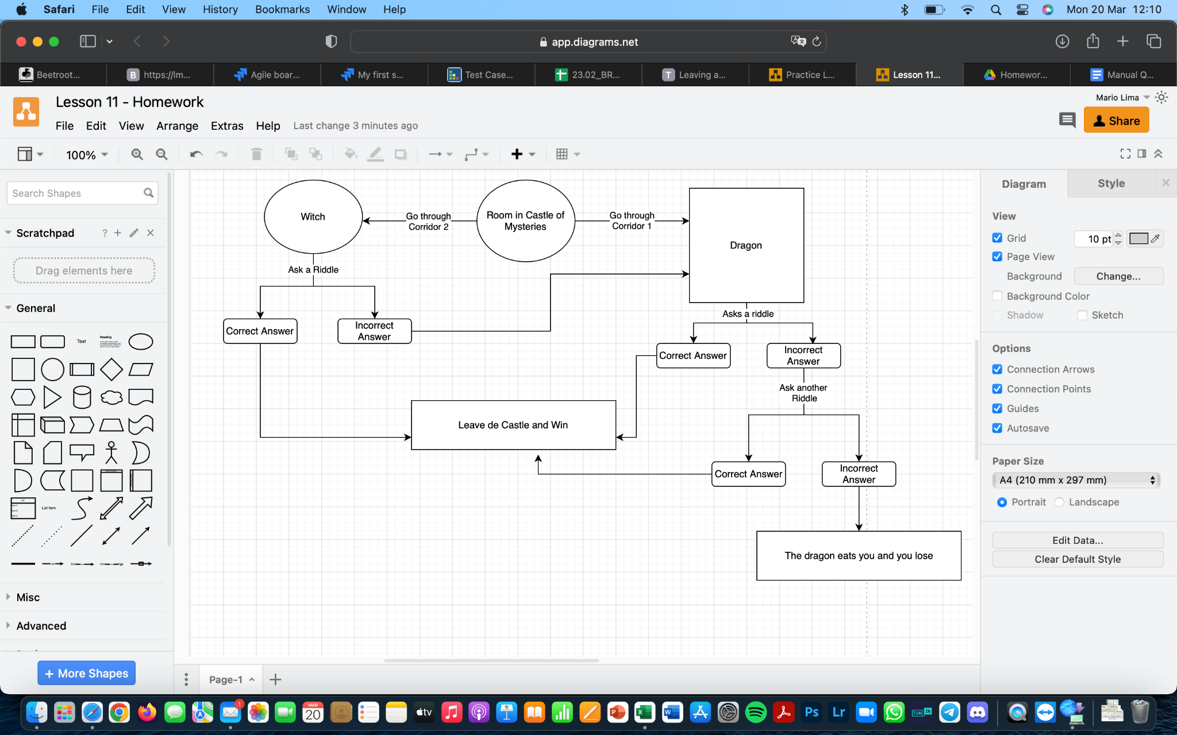

**Diagram in the following link:**

*https://drive.google.com/file/d/1VBWFDOBdtYi_f2sZ24-VpN-HMHRoVm7L/view?usp=sharing*

***3. How many test cases, according to the diagram, will be enough to test this game?***

5 test cases

7 Test Cases

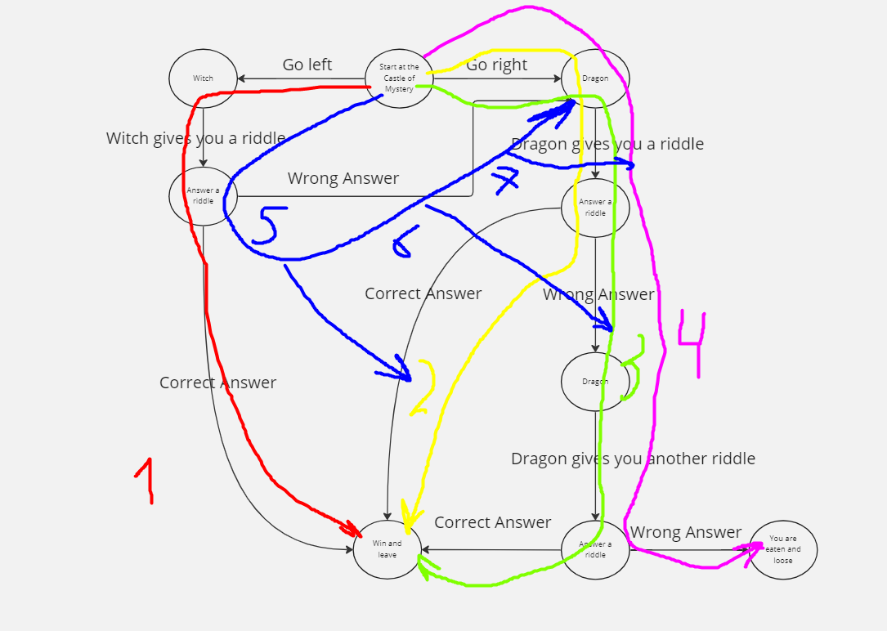

***Level 3:***

***1. Complete the tasks of the previous two levels.***

***2. We Continue To Develop A Cat Photo Sharing App.***

***a. Write 5 use cases for how a typical user of your app would behave.***

**Use case 1**

A user wants to upload a photo of their cat and share it with friends on the app.

**Use case 2**

A user sees a cute cat photo and wants to leave a like and a comment.

**Use case 3**

A user wants to create an account to be part of the cat photo sharing app community.

**Use case 4**

A user wants to add friends to his profile on the app.

**Use case 5**

A user wants to send a private message to his friends on the app.

***b. Draw a state transition diagram based on the written user scenarios and make a decision table for one of the options.***

Diagram for Use Case 1:

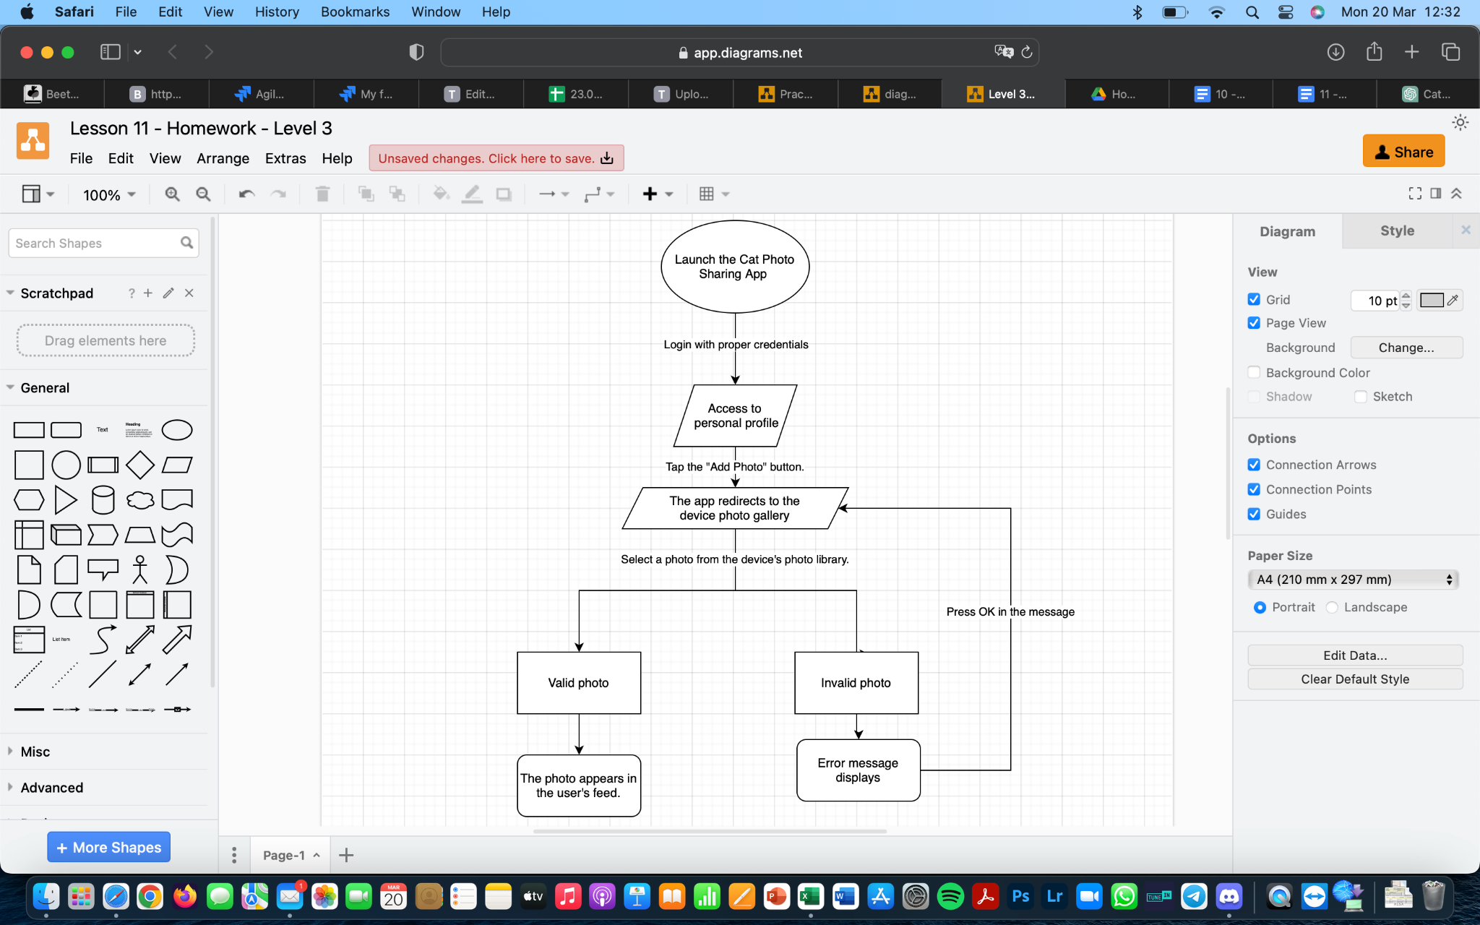

**Diagram in the following link:**

https://drive.google.com/file/d/12xeeDdJMSWCNOMDEvNL9zks60hx7cz_C/view?usp=sharing