

WAX+

User Documentation

- 22.05.2013 -

Version 4.1.0
Name | Telephone | Email address
IT-Hotline | 04531 / 803 – 777 | IT-Hotline@minimax.de

Address:

MINIMAX GmbH & Co. KG – GB Technologies – IT Services
Industriestrasse 10-12
23840 Bad Oldesloe, Germany
Phone 04531 / 803 -0
Fax 04531 803 / 803 - 669

Additional contact persons not for „WAX third parties“ :

Name | Telephone | Email address
Name | Telefon | Email Adresse
Jörg Hildebrandt | 04531 / 803 – 8049 | HildebrandtJ@minimax.de
Christian Neils | 04531 / 803 – 799 | NeilsC@minimax.de

Additional contact persons only for „WAX third parties“:

Name | Telephone | Email address
Helge Hansen | 04531 / 803 – 292 | SmakJ@Viking-EMEA.com

Table of contents

1 Installation of WAX+ 4
1.1 Hard- and Software requirements for WAX+ 4
1.2 WAX+ Installation 4
1.3 Install additional software 4
1.4 WAX+ start the first time 4
1.5 Update of WAX+ 5
2 General information about WAX+ 6
2.1 Context Menu 6
2.2 Clipboard 6
2.3 Short cut keys 6
2.4 Online help 7
2.5 Version history 7
3 Functions of WAX+ 8
3.1 General functions description 8
3.1.1 Tasks of the WAX+ Programme 8
3.1.2 Order processing in WAX+ 8
3.1.3 Work orders and projects 8
3.1.4 Joint orders 10
3.1.5 Structure of the input screens 10
3.1.6 Approval of the data for production 29
3.2 Detailed functions description 29
3.2.1 Project menu 29
3.2.2 Processing 32
3.2.3 HTML Menu (only selectable via the symbol list) 33
3.2.4 Price enquiries 33
3.2.5 System administration 34
3.2.6 View 34
3.2.7 Window 35
3.2.8 Info about WAX+ 35
3.3 Specialist WAX+ functions (partly only selectable via the symbol function) 35
3.3.1 Show prices (only chosen in the NL and Segment version) 35
3.3.2 Process new work orders (only chosen in the segment version) 35
3.3.3 Process my work orders (only chosen in the segment version) 35
3.3.4 Interface for SAP (only chosen in the segment version) 35
3.3.5 Interface for Excel 36
3.3.6 Monitor for pipelines (only chosen in the segment version) 36
4 System parameters 38
4.1 Tab "General" 38
4.2 Tab "View" 39
4.3 Tab "System parameters - enhanced view" 40
4.4 Table overview of all parameters 41
5 Manufacturing notes 44
5.1 Lengths for supports which exceed the 50 mm top pipe 44
5.2 Overview of the possible pipe layers 44
5.2.1 Radiation 44
5.2.2 To galvanize 44
5.2.3 Powder layers 45
5.2.4 Transport protection coat 45
5.3 Description of spark average value formation 45
6 Tips and tricks 47
6.1 Simultaneous processing of several projects 47
6.2 Team work and data exchange 47
6.3 Project processes 47
6.4 Use more databases on one PC 47
6.5 Settings in Internet Explorer for optimum printouts 47

Installation of WAX+
The programme and the important components are supplied on CD. The table is organised into two columns: First the „WAX+ Installation“ is carried out through the set-up Programme which installs the programme WAX+ and the component data bases once on the PC (or network server). At the same time the additional programmes ( Auto-desk Viewer / Internet Explorer / data base driver) are installed on every personal computer in case these are still not available.

Hard- and Software requirements for WAX+
The minimum requirements correspond to those of Windows NT. To reach a reasonable operational speed we recommend the following minimum components: a PC with Pentium processor > 1 GHz, 256 MB and a 17" monitor (preferably 19" ). Internet Explorer 6.0.2800.xxxx (or higher) and Auto-desk Express Viewer (Version 3.1) are provided as preferred software.

WAX+ Installation
This installation must be carried out only once from the installation CD onto the Server!
- Register as administrator on the PC.
- Start the set-up programme from the installation CD.
- Follow the instructions on the screen.

Install additional software
- Register as administrator in Windows NT/2000/XP. System data is installed for which administrator rights are required.
- Autodesk Express Viewer

- Internet Explorer 6.0 (Only carry out if IE smaller Version 6.0 is installed)
- [CDLW:]\IE60SP1\IE6SETUP.EXE

- ODBC Driver (MySQL)
- [CDLW:]\ODBC\MyODBC-3.51.05.exe

WAX+ start the first time
To start WAX+ you must select the symbol WAX+ with a double click with the left mouse key on the work surface. During the first starts the important system parameters are automatically generated in the system (registry). Now the path to the user data database (WAXuser.mdb) is adjusted (see section 3.2.5.2). Alternatively a second user database can be defined. Then a choice between a "local version" and a "network version" is possible. This can be required with laptops. The selection dialogue then appears with the next programme start. The user data base contains the system parameters. These are important for the control and the correct functioning of the programme (see section 4).
When WAX+ starts the master data is automatically loaded from a database (Wax master.data). With the first start of the programme the user name for Windows is entered into the user data base. Then the user information such as the user name and the telephone extension is required. This information can also be changed later via the menu point "System administration/Parameters" in the main menu.

Update of WAX+
Updates of WAX+ or the master data are regularly released through memos. Next to information about the update these memos also contain installation instructions. As a rule the following actions are required:
- Issuing of a back up copy of the old version (programme and master data base)
- Copying of the update data into the installation directory for WAX

General information about WAX+

Context Menu
A context menu is principally opened with the right mouse key. It contains menu points for processing. Additional classifications and orders with different work contract types (e.g. distributor and range pipe) can be added to the tree. Likewise the intermediate storage functions can always be requested. The functions displayed always relate to the current selection.

Clipboard
The clipboard is an area in which data can be deposited which should be used again in other programmes and programme areas. It is comprehensively valid for windows. For instance a commentary for to the orders from Microsoft word can be deposited in the clipboard and included in WAX+ in the order or vice versa. Also WAX+ - objects e.g. individual positions can be included in the clipboard. These are then available for other projects. These data types are of course only recognised by WAX+.

The clipboard functions are:
- Copying: Copies the marked area into the clipboard.
- Add: Adds the content of the clipboard to the current cursor position.
- Withdrawal: Shifts the marked area into the clipboard and the marked text is deleted.

Short cut keys
The following short cut keys are defined analogous to the Microsoft products in WAX+. These are applicable to objects in WAX+ such as work contracts or positions:
- Strg+N New
- Strg+O Open
- Strg+S Save
- Strg+P Press
- Strg+P Opens or closes the view of the tree structure
- Strg+Incl. copying ( or Strg+C )
- Shift+Incl adding ( or Strg+V )
- Shift+Entf Withdrawal ( or Strg+X )
- F2 unnamed
- F3 Access (e.g. work order)
- F5 Update (e.g. work order status)
- F6 Changes between a marked tab and the corresponding object in the tree.
- Alt+F4 WAX+ end
- Incl. Includes a new position with the marked tab and the focus remains with the tab.
In addition the following short cut keys apply for particular operations:
- Strg+Fx includes in the marked subdivision in the tree...
- Strg+F1 ...a new group order
- Strg+F2 ...a new threaded pipe
- Strg+F3 ...a new commercial length
- Strg+F5 ...a new station distributor
- Strg+F6 ...a new range pipe
- Strg+F7 ... a new distributor
- Strg+F8 ... new moulded part/fittings
- Strg+F9 ...a new take-up line-DWB
- Strg+F10 ... a new test line for pump
- Strg+F11 ... a new pump manifold
- Strg+F12 ... a new work order/work plan

If a position in the tree is marked a similar position can be included with the key "incl". With the key "Entf" a marked position in the tree can be deleted. The addition also functions if a tab is marked. This tab is then automatically marked with the new position.
In addition the combination "Alt + underlined letter" is available. This is always linked to the active window, dialogue or tab. A change between the tabs is always possible with the arrow keys for left/right. In the tree view the tree with the arrow keys for left/right can be opened and closed. Several entries (24) are skipped with page - up/down.

Online help
No online help is consciously integrated into WAX+. This documentation is reached via the menu point - User documentation Direct contact has proven its value with questions and instructions. However, some input fields possess a "Pop-up - help". This appears in a small window if the mouse pointer touches the input field for a short time.

Version history
About the menu point In the "version history" the whole version history is attainable. The changes of the programmes between the versions are documented in this.

Functions of WAX+

General functions description

Tasks of the WAX+ Programme
In the branches the WAX+ programme takes over the task of an order programme, on the other hand the role of a tool for the preparation of pipe connections. It contains knowledge about the production requirements which can protect against incorrect orders.
In the segments of the plant in Bad Oldesloe WAX+ fulfils the task of preparing orders for production and to transfer the orders to the production machines and the SAP system.

Order processing in WAX+

Processing in the NL - Version / WAX for third parties version
Firstly a project is presented (see section 3.2.1.5). The project management card applying to the whole project is to be filled out here (see section 3.1.3). Now the project can be divided as required e.g. in building sections (see section 3.2.2.2). Under every bullet point several factory orders can be presented (see section 3.2.2.3). A preferred order type is to be chosen for this. Should only one position of a particular order type be issued this can be chosen directly. However, if it is required to add additional similar positions e.g. distributors under one work order a so called joint work order must be added (see section 3.1.4). Now the data for the work order can be entered via the corresponding tab. On the one hand the general data such as layer, comment or reports (see section 3.1.5.1) on the other hand the specialist data for construction of piping (see sections 3.1.5.2 to 3.1.5.11). Sometimes it can arise that a distributor of WAX+ cannot be correctly displayed. Then the distributor is to be entered as far as can be correctly displayed Or no construction data will be given. Then this position is to be recorded as a special order (see section 3.1.5.12). In every case an illustration is to be sent (see also section 3.1.5) or faxed. After all important data has been entered into a work order or joint work order this can be approved in the NL Version (see section 3.1.6). According to OD the order is transferred and stored in a database. Afterwards the processing of the segment follows (see section 3.1.2.2). Afterwards the current processing status can be requested at any time (see section 3.1.5.1). In the version „WAX for third parties“ the data is sent for a price request or order to Bad Oldesloe by email.

Processing in Segment version
First the new factory orders from the database must be loaded from the database (see section 3.2.1.1). Here every type of order is assigned to a responsible clerk from the segment. The responsible clerk and the current processing date is automatically stored in the database. Thereby no approval of the orders is necessary. Then an order table is to produced about all the new orders (see section 3.3.5.1). The WAX+ data generated with the new work orders can be closed at any time. Now every responsible clerk opens the work orders allocated to him in the segment (see section 3.2.1.2). The following things must be tested: the material lists, the work plan, the special costs and the price calculation. Of course it is to be tested whether the pipe constructions can be finished as specified. The work plan and the special costs can be changed or enhanced. If a construction has to be changed the work plan and the list with the special costs is to be generated again for the whole work order. Afterwards all important lists and graphics can be printed out. If necessary all data for the production systems can be generated (see section 3.3.5.2). Afterwards the order can be saved for reading in SAP (see section 3.3.4.2). The writing in SAP data can happen several times before import.

Work orders and projects
In WAX+ several work orders can be filed into a file. This data is allocated to a project and therefore belongs to an order. As project number the PSP element or a CO order number can be inputted. This parameter leads to an improvement of the order and thereby increases the security and productivity. The project creation can be established through the project management card (image 3.1). This applies to all work orders in the data.
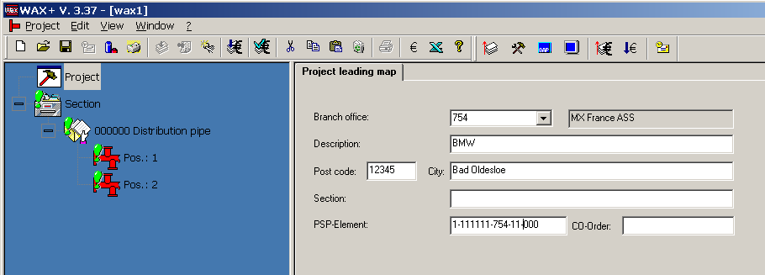
Image 3.1: Project management card

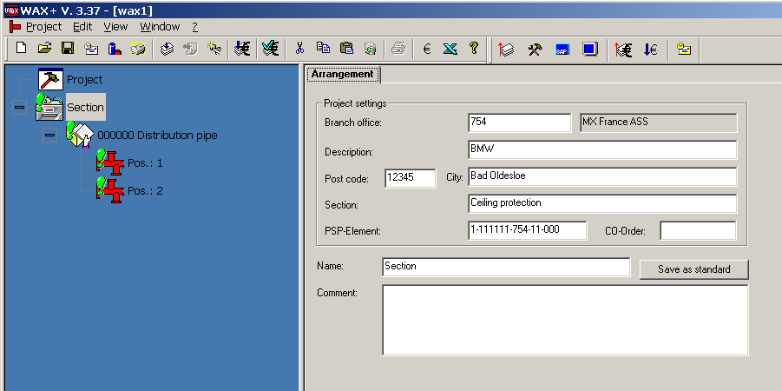Within a WAX+ project the work projects can be grouped as required into a tree structure. In addition there is a classification position which serves the logical division and arrangement. The number of the hierarchy levels is not limited. Therefore a division in building sections can be carried out (image 3.2). This classification position only serves the logical division within the data. The building section can be assigned a preferred description which will be stored as standard description. The project settings are no longer changeable here. The entry in the field "building section" is passed onto all orders within the section. In the field "Description" the title is inputted for the tree view.

Image 3.2: Building section

The project tree can be processed through a context menu. Functions are e.g. copying, deletion and adding. Through 'Drag and Drop' work orders can be suitably arranged.
Within a building section the work contracts are gathered. Hereby there is an automatically a large number of position numbers with new positions. An overwriting of the positions number is always more possible. However, in the joint order no double position numbers can be given. If no description for the work order is given this is automatically generated and displayed: "Positions number: Order type". However, the description can be overwritten.
A work contract can contain:
- a threaded pipe or
- a commercial length or
- a range pipe or
- a distributor or
- a station distributor or
- moulded parts/fittings or
- an extraction line-DWB or
- a test line for pump or
- a pump manifold or
- a special order according to illustration named APAX or
- a joint order.

Therefore every work order can only contain one distributor or one range pipe etc. in preferred quantities. The joint order described in the following serves as a summary of several different distributors under one SD order number.

Joint orders
Several different distributors or range pipes can be combined in one joint contract. However, only identical work orders can be combined. The reason for this is the joint production of the pipe constructions in one segment. Orders in one joint order can only be approved jointly. In the segments they contain a joint order number (WA - number).

Structure of the input screens
All types of work orders are operated in the same way. For every work order there are tabs which are arranged from left to right. Through this clear arrangement the input of data is simple. Below the tab an illustration can be displayed every time so far as the corresponding data has been inputted. If the illustration display is too small the button "Graphic Display" can be pressed to switch from the tool bar to the graphic full view.
Every work order has a management card which contains all headers. Fields for the production status are planned. The fields which contain the data from the project guide card are included in grey and can not be changed. In addition the fields for the status information are grey. Also these cannot be changed directly.
Further input screens follow for the work order. These are dependent on the type of work order. However, mostly a screen for the layer and the input of a comment as a note for the production is available.
In addition there is a mask for every work order type through which data as an appendix can be given to the work order. For example an Auto-cad - drawing can be stored here for specialist processing. However, the size of the appendix is limited to 16 megabytes.
In the segment version of the WAX+ programme additional input screens are available for the arrangement of materials and the issuing of a work plan.

Input screens for the work order or joint order
Every work order possesses a guide card (image 3.3) and a tab "layer/note" (image 3.4). The management card processes the data of the project management card. In addition data such as SD numbers are entered here. Also it contains information about the processing status of the order.
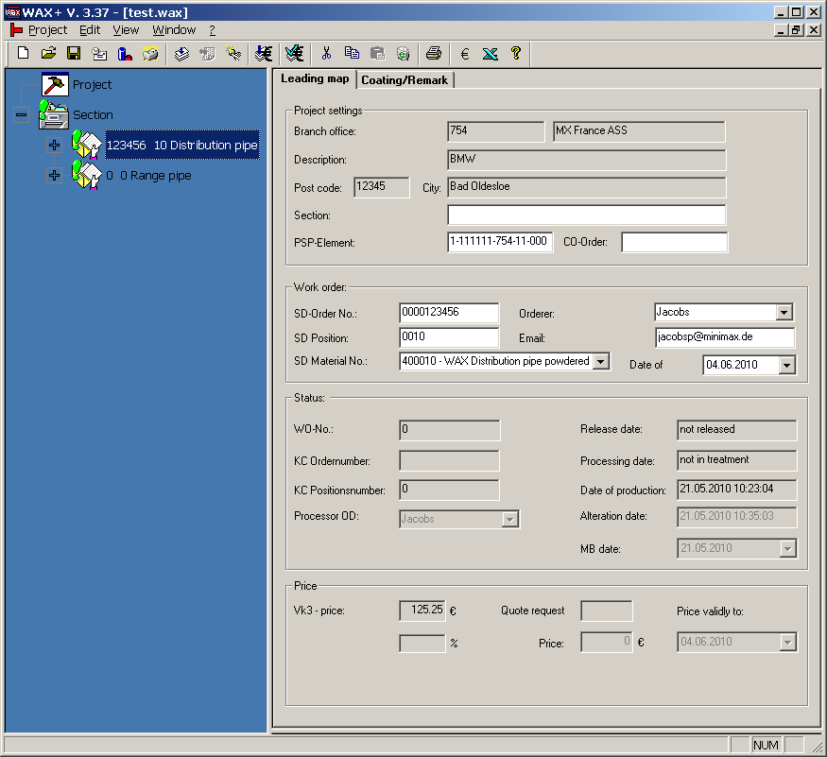
Image 3.3: Management card from work order
A selection of the layer is first possible with the tab "Layer/Comment" (Image 3.4). In addition the possible layer types and the current colour tones are contained in a list box as pre-selection. MINIMAX - Standard colours are „powdered white (similar RAL 9010)“ and „powdered red (similar RAL 3000)“. All other colour tones are linked with special costs. If other colour tones are wanted "powdered" is to be configured and the colour tone entered or chosen via a button. A comment with production or packaging notes can be inputted.
In addition the following settings are possible: "Admission entity", "in visual range", "report" and "caps colour". If "report" is chosen the report point receives a copy of the order from the work preparation. The field "in visual range" is chosen if the pipes lie visibly in close vicinity to the customer. Hereby attention is paid to the correct laying of pipes at the delivery points of the powder installation. In addition to this the cap colour for all the positions now included in the joint order can be specified. Otherwise the cap colour remains changeable at every individual position. Therefore the colour is not set at a new request of this tab.

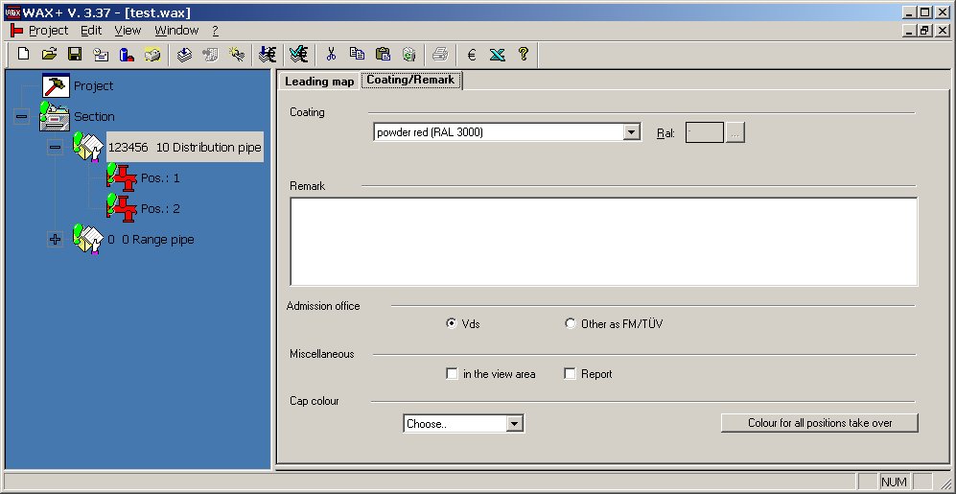
Image 3.4: Tab "layer" from work order

Distributor 
Distributors are defined via the tab "Distributor" (Image 3.5) and "Elements" (Image 3.6). Only lengths of up to 12,000 mm can be delivered. Longer pipes must be sub-divided into individual pipe parts. The lengths of the pipe sections are given in a field through space separated after one another. Here attention should be paid to the connection type. The production only works with pipes which are approximately 6000 mm in length. Therefore pipes between 6000 and 12000 mm are now automatically subdivided and bound with a welding seam. If that is not wanted the pipes are to be separated and if necessary entered as individual distributor positions. Within a joint order the pipe quality with all positions is the same and is specified with the first. With the following positions this can no longer be changed. A start and end element can be chosen. With pipe quality "DIN 2458 standard welded usual wall" and the pipe width DN32 to DN50 no thread can be directly taken. (For notes about the pipe quality also see section Error! Source could not be found Error: Reference source not found). However, if this is wanted for the start of the pipe a groove is to be chosen. A connection piece with groove and thread can be ordered in addition. The length of the fitting piece is to be considered with the length details of the distributor. Attention: From the version 1.98 the combined pipe quality "DIN 2440/2458..." is again available with distributors. This is found at the end of the selection list. The text corresponds to the special qualities however, this is also automatically adapted according to configured nominal diameter as before. In addition a production note can be documented which is displayed with the print out under the illustration.

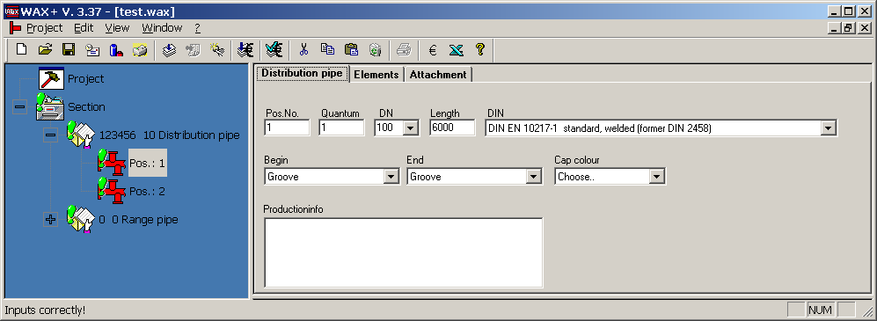
Image 3.5: Tab "Distributor"

The branches are recorded with the tab "Elements" (Image 3.6). The available elements can be chosen from a list box. After input of the data this can be recorded in the list as a new position. The buttons serve to process the positions in the list. With the right mouse click on a position in the list a popup menu is opened that offers the same functionality. The connection DN is first automatically set. This nominal diameter always corresponds with the nominal diameter of the element onto which the new element is connected. The beginning of the nominal breadth of the piping established in the tab "Distributor". However, the previously established value is changeable. The Checkbutton "appendix" is only active in the segment version. With these the elements are set which will be processed with the welded pipes network. For this the current elements in the list are to be marked, the flag put in place and then the position changed.
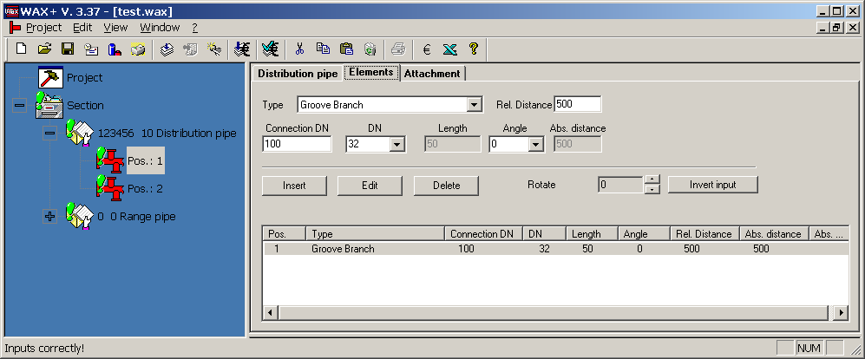
Image 3.6: Tab "Elements"

Standard distributor 
Standard distributors are produced with the piping network. The standard distributor can not be directly added as such. Attention should be paid to ensuring that the elements to be processed in the system must be correspondingly set (see section 3.1.5.2). The following conditions are linked to the processing on the distributor piping network:
- Piping nominal breadths DN 65 – 150
- Piping lengths 1500 - 6000 mm
- Pipes according to DIN 2448 and DIN 2458
- Threads nominal breadth 11/4“ to 2“ (DN 32 – 50 )
- Branches nominal breadth DN 32 – 150
- Distances of the branches min 500 mm
- Maximum 3 thread/branch sizes per pipe.
- Maximum 5 thread/branches per pipe

If these requirements are fulfilled to the maximum by the distributor it is then required to produce these via the installation for production technical and economic reasons. The angle with the standard elements always corresponds to 0°.

Commercial length 
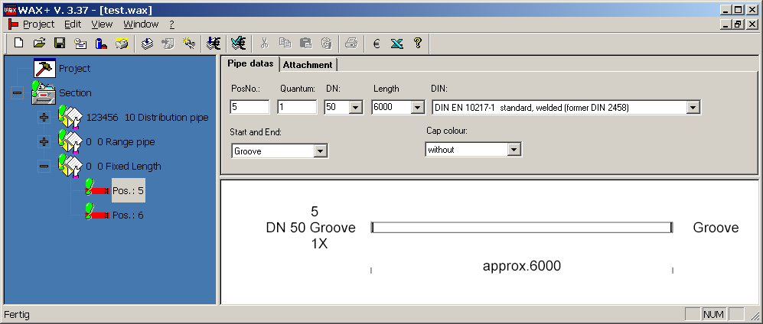
The commercial length is fully separated from the distributor. This means both can no longer be jointly dealt with in a joint order. The commercial length differs from the distributor in so far that a completion type can only (grooved or smooth) be jointly chosen for the start and the end . Only up to approx. 6000 mm length can be specified (see image 3.7).

Image 3.7: Tab "Commercial length"

Range pipe 
Hereby all range pipes are dealt with. At the same time distributors are issued which can be produced with the range pipe network. The following conditions are linked to the processing on the range pipe network:
- Pipe nominal diameter DN 32 – 65
- Pipe length 1400 – 12000 mm
- Pipes according to DIN 2440, DIN 2448 and DIN 2458
- Threads nominal breadth DN 10 – 25 or boreholes 24, 31 and 35 mm
- Special threads nominal breadth DN 10 – 25 length OK pipe – OK thread 10 – 80 mm
- Distances of the branches min. 300 mm
- Maximum 1 nominal breadth of the threads per pipe
- Maximum 10 threads per pipe
If these conditions are fulfilled as far as possible by a pipe construction it is therefore required for production technical and economic reasons to establish this as a range pipe in WAX+. With the tab "data" the master data for the position analogous to the tab "distributor" is established (see under 3.1.5.2). Within a joint contract the pipe quality as well as the nominal breadth are identical. In addition "dry systems" can be chosen here (see image 3.8). The production note can not be given with the individual positions since with the range pipes without reconditioning a list in table form instead of an illustration is printed out.
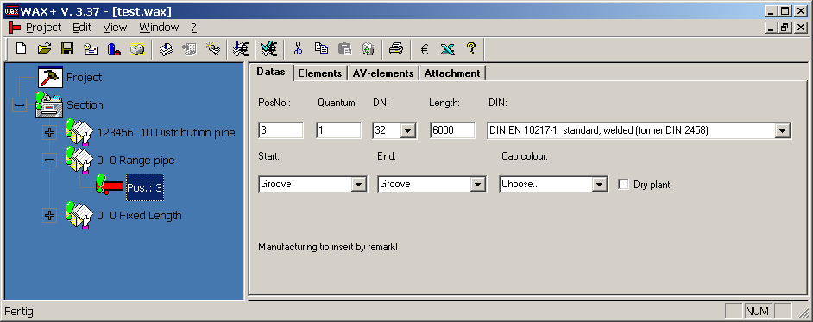
Image 3.8: Tab "Data" with range pipe.

The tab "H.-elements" (image 3.9) serves as inputting of branches. These branches are processed with the branch pipes. It can only be chosen between "pipe sleeve" and "borehole". The branch type chosen with the first position is always the same within a joint order. With the standard elements the angle always corresponds to 0°. With boreholes the diameters 24 and 31 mm can be chosen.
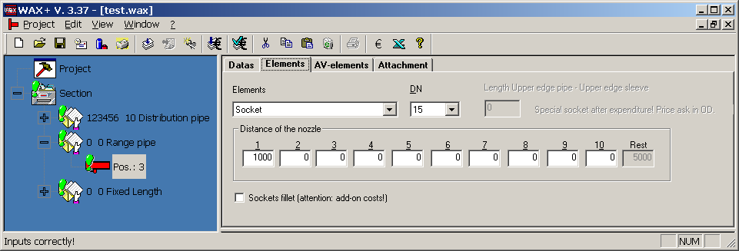
Image 3.9: Tab "H-elements" with branch pipe

Other angle positions and other branch types can be given as so called AV elements via the corresponding tab. Up until the flag "reconditioning with drawing" this tab is identical with the tab "elements" of the distributor (see section 3.1.5.2). If this flag is chosen then a drawing is to be saved as data in the tab "appendix" or faxed directly to the segment in OD. If this is the case no additional AV elements can be given at this position. Within a joint order range pipes can only be installed with or without reworking. Therefore the production processes are significantly improved. This means that with reworking in the joint order with all positions either the flag "reworking with illustration" must be chosen or the AV elements must be given. The flag "socket" is only active in the Segment - Version. It determines whether flat or keyed sockets are processed with the order.

Station distributor

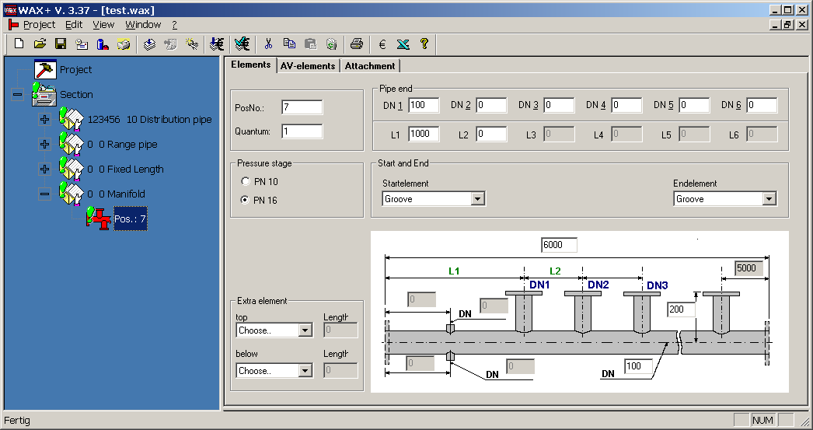
The tab "H-elements" (image 3.11) serves the construction of the station distributor with standard elements (pipe branches + flange with angle 0° and optionally an extra branch with angle 0° or 180°).

Image 3.11: Tab "H-elements" with station distributor.

Other angle positions and other branch types can be entered as so called AV elements via the corresponding tab. Up until the flag this tab is "reworking with illustration" identical with the tab "elements" of distributor (see section 3.1.5.2). If this flag is chosen an illustration as data in the tab "Appendix" is to be saved or faxed directly to the segment in OD. If this is the case no further AV elements can be given with this position. Within a joint order only station distributors with or without reworking can be laid out Thus the production processes are significantly improved. This means that with reworking in the joint order either the flag "reworking with illustration" must be chosen with all positions or ZV elements must be given.
However, it is recommended to add station distributors with reworking as distributors.

Threaded pipe 
A galvanisation is not required since the threaded pipe production already works with the galvanised pipes. The following pipe qualities find use according to system type and layer:
- Water sprinkler galvanised Pipe DIN 2440 galvanised
powdered Pipe DIN 2440 moderately welded
however, under 1" (DN25) PipeDIN2440 galvanised
- CO2 high pressure 90 bar Pipe DIN 2458 galvanised 90 bar

The pipe quality is also automatically set and is not visible. The thread always comes with a protective cap! The cap colour can be chosen, standard value is "none" (see image 3.12). Also here a production note is given. In addition the sealer is to be chosen. The value of the sealer only relates to the screwed threads. If the open threads have to be prepared for another sealer this is to be given in the comments field. The following overview shows the use of sealers according to installation type and the agents used with MINIMAX. Within a joint order installation type and sealer are always identical. Hemp and putty with screwed threads is linked with additional costs.

Table 3.1: Sealer
Application | Sealer | MINIMAX Standard
Water sprinkler installation | Loctite AVX 586 (only galvanised) | X
 | Hemp and putty
CO2 HD 90 bar | Hemp and putty
 | Synthesol Vlies
 | Teflon tape 12x0,08 | X

Special features with sealers:
- Teflon tape (PTFE tape) - sealer for pipe connections. Ensure roughness on the thread. Cleaning of the connection point of foreign objects and grease, e.g through pressurised air. Turning connection backwards means loss of sealing.
- Loctite Typ AVX 586 - extra strong, difficult to detach red sealer. Temperature range – 55°C to 150°C T > 5°C in the hardening phase (12-24h). Maximum permissible play (D-d)/2: 0.20 mm Use of <= M 56 <_ R 2“. Coating layer parts are to be pretreated with an activator. Shear strength see M 1-1-1. Cleaning of the connection points of foreign bodies and fat e.g through compressed air.
- Hemp and putty - hemp and putty are used together. Cleaning of the thread of foreign bodies e.g. through pressurised air. Ensure roughness on the threads. Note: Here the thread must be bigger since hemp and putty take up more room than loctite.
- Synthesolvlies - application with CO2. Cleaning of the connection points of foreign bodies and grease e.g through compressed air.
- Silicon - if silicon free is required (order component KFZ industry) consultation with the segment, see also Z.No. 81 5586.
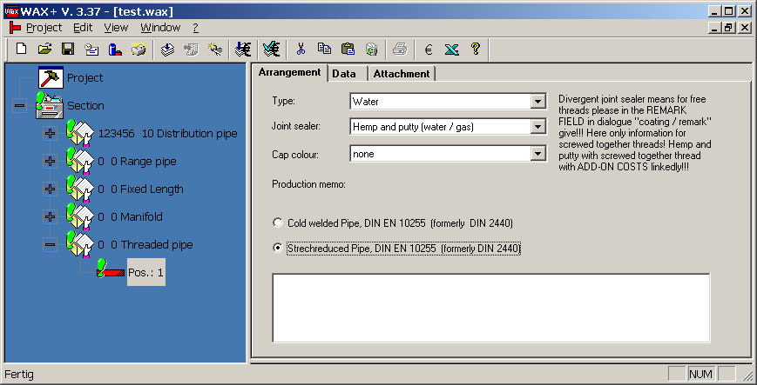
With orders see work norm M 1-1-4 (sealing materials).
Image 3.12: Tab "Installation" with threaded pipe

With tab "data" (image 3.13) the pipe parts are fixed with start and end. Otherwise the fittings are dealt with here. The left end is only selectable for the first pipe section and only when it does not start with a fitting. All further pipe sections have a thread automatically on the left. The right end of every pipe section is determined via the selection in the material tree, of course thread with fitting. The Z mass is always automatically deducted. This means the length from pipe start or middle of the fitting left until pipe end or middle of the fitting is to be given on the right. For the first pipe section the Z mass deduction can be specified. Should two fittings be joined with one another '0' is to be entered with the length. There are two material trees for the fitting selection. If a T unit is selected the head fitting is to be added in addition. Should two fittings not be directly connected with one another in the pipe direction the next fitting is to be selected from the tree "fitting above". Hereby the first fitting must be a T or cross piece. Many fittings can be preferably hung behind each other. However, only the first is specified. All additional ones are labelled through the GF label. If no Fitting is marked in the tree only a pipe section without fitting is included on the right. The end is determined through the end element marked in the tree. If nothing is marked a smooth end is implemented as standard. If there is no fitting on the right this position is completed. The nominal breadth is automatically adapted to the recently selected fitting. However, the nominal breadth is changeable. After the change of the nominal breadth or the lengths the trees are newly filled. Therefore only fittings with matching nominal breadths and matching threaded connection are specified in the trees. With the row of tabs all buttons accept the button "Add" are transferred so the entry can proceed more rapidly.
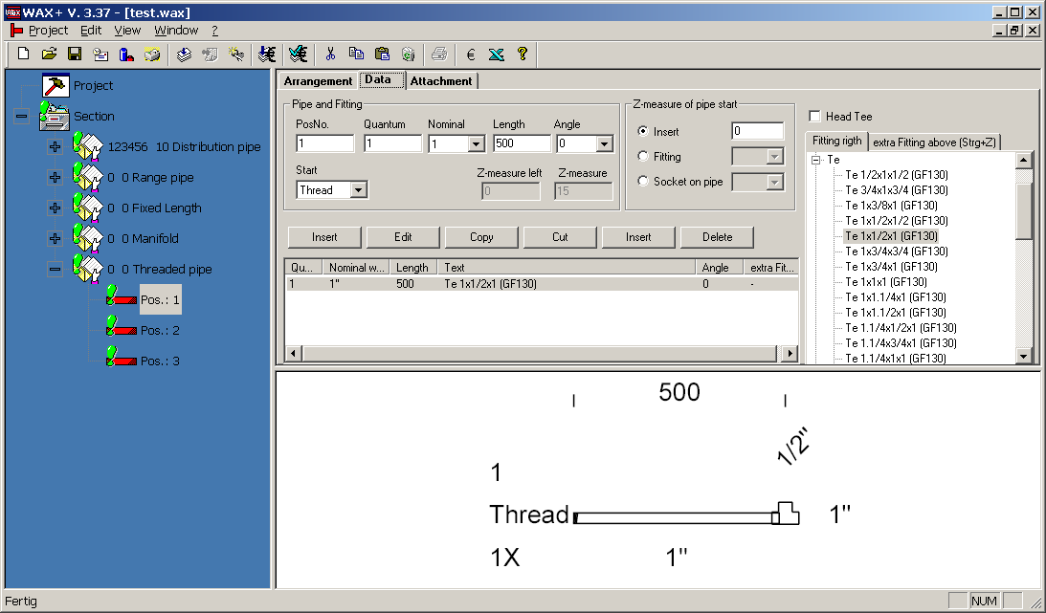
Image 3.13: Tab "Data" with threaded pipe
The list can be processed with the upper buttons. A pop up menu offers the same functionality which appears with a click of the right mouse button. With a double click on a fitting in the list the data from the input fields can be directly recorded in the list. Alternatively Fitting and Alt+Enter can be selected. With the addition of a fitting from the tree "zus. Fitting above" the corresponding button is used.
- Z-Mass with pip sleeve on distribution pipe (only possible with left end of the first pipe section)
DN | DNVL | Z-Mass
10 | 65 | 43
10 | 80 | 50
10 | 100 | 62
10 | 125 | 75
10 | 150 | 89
10 | 200 | 115
10 | 250 | 142
15 | 65 | 46
15 | 80 | 53
15 | 100 | 65
15 | 125 | 78
15 | 150 | 92
15 | 200 | 118
15 | 250 | 145
20 | 65 | 50
20 | 80 | 57
20 | 100 | 69
20 | 125 | 82
20 | 150 | 96
20 | 200 | 122
20 | 250 | 149
25 | 65 | 52
25 | 80 | 59
25 | 100 | 71
25 | 125 | 84
25 | 150 | 98
25 | 200 | 124
25 | 250 | 151
32 | 65 | 66
32 | 80 | 73
32 | 100 | 85
32 | 125 | 98
32 | 150 | 112
32 | 200 | 138
32 | 250 | 165
40 | 65 | 66
40 | 80 | 73
40 | 100 | 85
40 | 125 | 98
40 | 150 | 112
40 | 200 | 138
40 | 250 | 165
50 | 65 | 70
50 | 80 | 77
50 | 100 | 89
50 | 125 | 102
50 | 150 | 116
50 | 200 | 142
50 | 250 | 169
Table 3.2: Z-Mass with sleeve on distribution pipe
- Z-mass of the fittings according to catalogue of the company „WOESTE“. Deviating masses according to agreement with the thread pipe production.
Short text: | dn1 | dn2 | dn3 | dn4 | zmass1 | zmass2 | zmass3 | length
Double nipple "D" | 15 | 0 | 0 | 0 | 18 | 0 | 0 | 44
Double nipple | 15 | 0 | 0 | 0 | 18 | 0 | 0 | 44
Double nipple "D" | 15 | 8 | 0 | 0 | 10 | 0 | 0 | 33
Double nipple "D" | 20 | 0 | 0 | 0 | 17 | 0 | 0 | 47
Double nipple | 20 | 0 | 0 | 0 | 17 | 0 | 0 | 47
Double nipple | 25 | 0 | 0 | 0 | 19 | 0 | 0 | 53
Double nipple "D" | 25 | 0 | 0 | 0 | 19 | 0 | 0 | 53
Double nipple "D" | 32 | 0 | 0 | 0 | 19 | 0 | 0 | 57
Double nipple | 32 | 0 | 0 | 0 | 19 | 0 | 0 | 57
Double nipple "D" | 40 | 0 | 0 | 0 | 21 | 0 | 0 | 59
Double nipple | 40 | 0 | 0 | 0 | 21 | 0 | 0 | 59
Double nipple | 50 | 0 | 0 | 0 | 20 | 0 | 0 | 68
Double nipple "D" | 50 | 0 | 0 | 0 | 20 | 0 | 0 | 68
Cap | 15 | 0 | 0 | 0 | 11 | 0 | 0 | 24
Protective cap yellow | 15 | 0 | 0 | 0 | 0 | 0 | 0 | 0
Cap "D" | 15 | 0 | 0 | 0 | 11 | 0 | 0 | 24
cap | 20 | 0 | 0 | 0 | 11 | 0 | 0 | 36
Protective cap yellow | 20 | 0 | 0 | 0 | 0 | 0 | 0 | 0
Cap "D" | 20 | 0 | 0 | 0 | 11 | 0 | 0 | 26
Cap | 25 | 0 | 0 | 0 | 12 | 0 | 0 | 29
Protective cap yellow | 25 | 0 | 0 | 0 | 0 | 0 | 0 | 0
Cap "D" | 25 | 0 | 0 | 0 | 12 | 0 | 0 | 29
Cap | 32 | 0 | 0 | 0 | 13 | 0 | 0 | 32
Cap "D" | 32 | 0 | 0 | 0 | 13 | 0 | 0 | 32
Protective cap yellow | 32 | 0 | 0 | 0 | 0 | 0 | 0 | 0
Cap | 40 | 0 | 0 | 0 | 13 | 0 | 0 | 32
Protective cap yellow | 40 | 0 | 0 | 0 | 0 | 0 | 0 | 0
Cap "D" | 40 | 0 | 0 | 0 | 13 | 0 | 0 | 32
Cap | 50 | 0 | 0 | 0 | 13 | 0 | 0 | 37
Protective cap yellow | 50 | 0 | 0 | 0 | 0 | 0 | 0 | 0
Cap "D" | 50 | 0 | 0 | 0 | 13 | 0 | 0 | 37
Cap | 65 | 0 | 0 | 0 | 14 | 0 | 0 | 44
Cross piece | 15 | 15 | 15 | 15 | 15 | 15 | 0 | 28
Cross piece | 20 | 20 | 20 | 20 | 18 | 18 | 0 | 33
Cross piece | 25 | 25 | 25 | 25 | 21 | 21 | 0 | 38
Cross piece | 32 | 25 | 32 | 25 | 21 | 25 | 0 | 40
Cross piece | 32 | 32 | 32 | 32 | 26 | 26 | 0 | 45
Cross piece | 40 | 25 | 40 | 25 | 23 | 29 | 0 | 42
Cross piece | 40 | 40 | 40 | 40 | 31 | 31 | 0 | 50
Cross piece | 50 | 25 | 50 | 25 | 20 | 35 | 0 | 44
Cross piece | 50 | 50 | 50 | 50 | 34 | 34 | 0 | 58
Socket, sleeve, bushing | 15 | 0 | 0 | 0 | 10 | 0 | 0 | 36
Socket, sleeve, bushing "D" | 15 | 0 | 0 | 0 | 10 | 0 | 0 | 36
Socket, sleeve, bushing | 20 | 0 | 0 | 0 | 9 | 0 | 0 | 39
Socket, sleeve, bushing "D" | 20 | 0 | 0 | 0 | 9 | 0 | 0 | 39
Socket, sleeve, bushing | 25 | 0 | 0 | 0 | 11 | 0 | 0 | 45
Socket, sleeve, bushing "D" | 25 | 0 | 0 | 0 | 11 | 0 | 0 | 45
Socket, sleeve, bushing "D" | 32 | 0 | 0 | 0 | 12 | 0 | 0 | 50
Socket, sleeve, bushing | 32 | 0 | 0 | 0 | 12 | 0 | 0 | 50
Socket, sleeve, bushing "D" | 40 | 0 | 0 | 0 | 17 | 0 | 0 | 55
Socket, sleeve, bushing | 40 | 0 | 0 | 0 | 17 | 0 | 0 | 55
Socket, sleeve, bushing "D" | 50 | 0 | 0 | 0 | 17 | 0 | 0 | 65
Socket, sleeve, bushing | 50 | 0 | 0 | 0 | 17 | 0 | 0 | 65
Red socket, sleeve, bushing | 15 | 10 | 0 | 0 | 13 | 0 | 0 | 36
Red socket, sleeve, bushing | 20 | 10 | 0 | 0 | 14 | 0 | 0 | 39
Red socket, sleeve, bushing | 20 | 15 | 0 | 0 | 11 | 0 | 0 | 39
Red socket, sleeve, bushing | 25 | 15 | 0 | 0 | 15 | 0 | 0 | 45
Red socket, sleeve, bushing "D" | 25 | 20 | 0 | 0 | 13 | 0 | 0 | 45
Red socket, sleeve, bushing | 25 | 20 | 0 | 0 | 13 | 0 | 0 | 45
Red socket, sleeve, bushing | 32 | 15 | 0 | 0 | 18 | 0 | 0 | 50
Red socket, sleeve, bushing "D" | 32 | 20 | 0 | 0 | 16 | 0 | 0 | 50
Red socket, sleeve, bushing | 32 | 20 | 0 | 0 | 16 | 0 | 0 | 50
Red socket, sleeve, bushing | 32 | 25 | 0 | 0 | 14 | 0 | 0 | 50
Red socket, sleeve, bushing | 40 | 32 | 0 | 0 | 17 | 0 | 0 | 55
Red socket, sleeve, bushing | 50 | 32 | 0 | 0 | 22 | 0 | 0 | 65
Red socket, sleeve, bushing | 50 | 32 | 0 | 0 | 22 | 0 | 0 | 65
Red socket, sleeve, bushing | 50 | 40 | 0 | 0 | 22 | 0 | 0 | 65
Red. Nipple "D" | 15 | 8 | 0 | 0 | 10 | 0 | 0 | 22
Red. Nipple | 15 | 10 | 0 | 0 | 10 | 0 | 0 | 24
Red. Nipple "D" | 15 | 10 | 0 | 0 | 10 | 0 | 0 | 24
Red. Nipple | 20 | 15 | 0 | 0 | 10 | 0 | 0 | 26
Red. Nipple "D" | 20 | 15 | 0 | 0 | 10 | 0 | 0 | 26
Red. Nipple | 25 | 10 | 0 | 0 | 10 | 0 | 0 | 29
Red Nipple "D" | 25 | 10 | 0 | 0 | 10 | 0 | 0 | 29
Red. Nipple "D" | 25 | 15 | 0 | 0 | 10 | 0 | 0 | 29
Red. Nipple | 25 | 15 | 0 | 0 | 10 | 0 | 0 | 29
Red. Nipple | 25 | 20 | 0 | 0 | 10 | 0 | 0 | 29
Red. Nipple "D" | 25 | 20 | 0 | 0 | 10 | 0 | 0 | 29
Red. Nipple "D" | 32 | 20 | 0 | 0 | 10 | 0 | 0 | 31
Red. Nipple | 32 | 25 | 0 | 0 | 10 | 0 | 0 | 31
Red. Nipple "D" | 32 | 25 | 0 | 0 | 10 | 0 | 0 | 31
Red. Nipple | 40 | 20 | 0 | 0 | 10 | 0 | 0 | 31
Red. Nippel "D" | 40 | 20 | 0 | 0 | 10 | 0 | 0 | 31
Red. Nipple | 40 | 25 | 0 | 0 | 10 | 0 | 0 | 31
Red. Nipple "D" | 40 | 25 | 0 | 0 | 10 | 0 | 0 | 31
Red. Nipple | 40 | 32 | 0 | 0 | 10 | 0 | 0 | 31
Red. Nipple "D" | 40 | 32 | 0 | 0 | 10 | 0 | 0 | 31
Red. Nipple | 50 | 15 | 0 | 0 | 10 | 0 | 0 | 35
Red. Nipple "D" | 50 | 25 | 0 | 0 | 10 | 0 | 0 | 35
Red. Nipple | 50 | 32 | 0 | 0 | 10 | 0 | 0 | 35
Red. Nipple "D" | 50 | 32 | 0 | 0 | 10 | 0 | 0 | 35
Red. Nipple | 50 | 40 | 0 | 0 | 10 | 0 | 0 | 35
Red. Nipple "D" | 50 | 40 | 0 | 0 | 10 | 0 | 0 | 35
Red. Nipple | 65 | 50 | 0 | 0 | 10 | 0 | 0 | 44
Red. Nipple "D" | 65 | 50 | 0 | 0 | 10 | 0 | 0 | 44
Threaded plug | 10 | 0 | 0 | 0 | 14 | 0 | 0 | 24
Threaded plug | 15 | 0 | 0 | 0 | 20 | 0 | 0 | 26
0 (P) | 15 | 0 | 0 | 0 | 20 | 0 | 0 | 26
Threaded plug | 20 | 0 | 0 | 0 | 17 | 0 | 0 | 32
Threaded plug | 25 | 0 | 0 | 0 | 19 | 0 | 0 | 36
Threaded plug "D" | 25 | 0 | 0 | 0 | 19 | 0 | 0 | 36
Threaded plug "D" | 32 | 0 | 0 | 0 | 20 | 0 | 0 | 39
Threaded plug | 32 | 0 | 0 | 0 | 20 | 0 | 0 | 39
Threaded plug | 40 | 0 | 0 | 0 | 22 | 0 | 0 | 41
Threaded plug "D" | 40 | 0 | 0 | 0 | 22 | 0 | 0 | 41
Threaded plug | 50 | 0 | 0 | 0 | 24 | 0 | 0 | 48
0 (P) | 50 | 0 | 0 | 0 | 24 | 0 | 0 | 48
Threaded plug | 65 | 0 | 0 | 0 | 30 | 0 | 0 | 60
T-Units "D" | 15 | 15 | 15 | 0 | 15 | 15 | 15 | 28
T-Unit | 15 | 15 | 15 | 0 | 15 | 15 | 15 | 28
T-Unit | 15 | 20 | 15 | 0 | 18 | 15 | 18 | 31
T-Unit | 15 | 20 | 20 | 0 | 18 | 18 | 18 | 31
T-Unit | 15 | 25 | 15 | 0 | 21 | 15 | 21 | 34
T-Unit | 20 | 15 | 15 | 0 | 15 | 18 | 15 | 30
T-Unit "D" | 20 | 15 | 20 | 0 | 15 | 18 | 15 | 30
T-Unit "D" | 20 | 20 | 20 | 0 | 18 | 18 | 18 | 33
T-Unit | 20 | 20 | 20 | 0 | 18 | 18 | 18 | 33
T-Unit | 20 | 25 | 20 | 0 | 21 | 18 | 21 | 36
T-Unit | 25 | 10 | 25 | 0 | 13 | 22 | 13 | 30
T-Unit | 25 | 15 | 15 | 0 | 15 | 21 | 15 | 32
T-Unit | 25 | 15 | 25 | 0 | 15 | 21 | 15 | 32
T-Unit "D" | 25 | 20 | 25 | 0 | 18 | 21 | 18 | 35
T-Unit | 25 | 20 | 25 | 0 | 18 | 21 | 18 | 35
T-Unit | 25 | 25 | 25 | 0 | 21 | 21 | 21 | 38
T-Unit "D" | 25 | 25 | 25 | 0 | 21 | 21 | 21 | 38
T-Unit | 25 | 32 | 25 | 0 | 25 | 21 | 15 | 42
T-Unit | 25 | 40 | 25 | 0 | 29 | 23 | 29 | 46
T-Unit | 32 | 10 | 32 | 0 | 13 | 26 | 13 | 32
T-Unit | 32 | 15 | 25 | 0 | 15 | 25 | 15 | 34
T-Unit | 32 | 15 | 32 | 0 | 15 | 25 | 15 | 34
T-Unit "D" | 32 | 20 | 25 | 0 | 17 | 26 | 18 | 36
T-Unit | 32 | 20 | 25 | 0 | 17 | 26 | 18 | 36
T-Unit "D" | 32 | 20 | 32 | 0 | 17 | 26 | 17 | 36
T-Unit | 32 | 20 | 32 | 0 | 17 | 26 | 17 | 36
T-Unit | 32 | 25 | 25 | 0 | 21 | 25 | 21 | 40
T-Unit | 32 | 25 | 32 | 0 | 21 | 25 | 21 | 40
T-Unit "D" | 32 | 25 | 32 | 0 | 21 | 25 | 21 | 40
T-Unit | 32 | 32 | 15 | 0 | 26 | 26 | 25 | 45
T-Unit | 32 | 32 | 25 | 0 | 26 | 25 | 25 | 45
0 (P) | 32 | 32 | 32 | 0 | 26 | 26 | 26 | 45
T-Unit | 32 | 32 | 32 | 0 | 26 | 26 | 26 | 45
T-Unit | 32 | 40 | 25 | 0 | 29 | 27 | 29 | 48
T-Unit | 32 | 40 | 32 | 0 | 29 | 27 | 29 | 48
T-Unit | 32 | 50 | 32 | 0 | 35 | 24 | 35 | 54
T-Unit | 40 | 10 | 40 | 0 | 15 | 32 | 15 | 34
T-Unit | 40 | 15 | 32 | 0 | 17 | 29 | 17 | 36
T-Unit | 40 | 15 | 40 | 0 | 17 | 29 | 17 | 36
T-Unit | 40 | 20 | 32 | 0 | 19 | 29 | 17 | 38
T-Unit "D" | 40 | 20 | 40 | 0 | 19 | 29 | 19 | 38
T-Unit | 40 | 20 | 40 | 0 | 19 | 29 | 19 | 38
T-Unit | 40 | 25 | 25 | 0 | 23 | 29 | 21 | 42
T-Unit | 40 | 25 | 32 | 0 | 23 | 29 | 21 | 42
T-Unit | 40 | 25 | 40 | 0 | 23 | 29 | 23 | 42
T-Unit | 40 | 32 | 32 | 0 | 27 | 29 | 26 | 46
T-Unit | 40 | 32 | 40 | 0 | 27 | 29 | 27 | 46
T-Unit | 40 | 40 | 25 | 0 | 31 | 31 | 29 | 50
T-Unit | 40 | 40 | 32 | 0 | 31 | 31 | 29 | 50
T-Unit "D" | 40 | 40 | 40 | 0 | 31 | 31 | 31 | 50
T-Unit | 40 | 40 | 40 | 0 | 31 | 31 | 31 | 50
T-Unit | 40 | 50 | 32 | 0 | 36 | 28 | 36 | 55
T-Unit | 40 | 50 | 40 | 0 | 36 | 28 | 36 | 55
T-Unit | 50 | 15 | 40 | 0 | 14 | 35 | 17 | 38
T-Unit | 50 | 15 | 50 | 0 | 14 | 35 | 14 | 38
T-Unit | 50 | 20 | 40 | 0 | 16 | 35 | 19 | 40
T-Unit | 50 | 20 | 50 | 0 | 16 | 35 | 16 | 40
T-Unit | 50 | 25 | 40 | 0 | 20 | 35 | 23 | 44
0 (P) | 50 | 25 | 50 | 0 | 20 | 35 | 20 | 44
T-Unit | 50 | 25 | 50 | 0 | 20 | 35 | 20 | 44
T-Unit | 50 | 32 | 32 | 0 | 24 | 35 | 26 | 48
T-Unit | 50 | 32 | 40 | 0 | 24 | 35 | 27 | 48
T-Unit | 50 | 32 | 50 | 0 | 24 | 35 | 24 | 48
0 (P) | 50 | 32 | 50 | 0 | 24 | 35 | 24 | 48
T-Unit | 50 | 40 | 32 | 0 | 28 | 36 | 26 | 52
T-Unit | 50 | 40 | 40 | 0 | 28 | 36 | 31 | 52
0 (P) | 50 | 40 | 50 | 0 | 28 | 36 | 28 | 52
T-Unit | 50 | 40 | 50 | 0 | 28 | 36 | 28 | 52
T-Unit | 50 | 50 | 25 | 0 | 34 | 34 | 35 | 58
T-Unit | 50 | 50 | 32 | 0 | 34 | 34 | 35 | 58
T-Unit | 50 | 50 | 40 | 0 | 34 | 34 | 36 | 58
T-Unit | 50 | 50 | 50 | 0 | 34 | 34 | 34 | 58
T-Unit "D" | 50 | 50 | 50 | 0 | 34 | 34 | 34 | 58
Screws | 15 | 0 | 0 | 0 | 22 | 0 | 0 | 48
Screws | 15 | 0 | 0 | 0 | 53 | 0 | 0 | 66
Screws "D" | 15 | 0 | 0 | 0 | 22 | 0 | 0 | 48
Screws "D" | 15 | 0 | 0 | 0 | 53 | 0 | 0 | 66
Screws | 20 | 0 | 0 | 0 | 22 | 0 | 0 | 52
Screws "D" | 20 | 0 | 0 | 0 | 22 | 0 | 0 | 52
Screws | 20 | 0 | 0 | 0 | 57 | 0 | 0 | 72
Screws | 25 | 0 | 0 | 0 | 24 | 0 | 0 | 58
Screws | 25 | 0 | 0 | 0 | 63 | 0 | 0 | 80
Screws "D" | 25 | 0 | 0 | 0 | 24 | 0 | 0 | 58
Screws "D" | 32 | 0 | 0 | 0 | 27 | 0 | 0 | 65
Screws | 32 | 0 | 0 | 0 | 71 | 0 | 0 | 90
Screws | 32 | 0 | 0 | 0 | 27 | 0 | 0 | 65
Screws "D" | 40 | 0 | 0 | 0 | 32 | 0 | 0 | 70
Screws | 40 | 0 | 0 | 0 | 32 | 0 | 0 | 70
Screws | 40 | 0 | 0 | 0 | 76 | 0 | 0 | 95
Screws | 50 | 0 | 0 | 0 | 30 | 0 | 0 | 78
Screws | 50 | 0 | 0 | 0 | 82 | 0 | 0 | 106
Screws "D" | 50 | 0 | 0 | 0 | 30 | 0 | 0 | 78
Angle "D" | 15 | 0 | 0 | 0 | 15 | 0 | 0 | 28
Angle | 15 | 0 | 0 | 0 | 15 | 0 | 0 | 28
Angle "D" | 20 | 0 | 0 | 0 | 18 | 0 | 0 | 33
Angle | 20 | 0 | 0 | 0 | 18 | 0 | 0 | 33
Angle | 20 | 10 | 0 | 0 | 13 | 18 | 0 | 28
Angle | 20 | 15 | 0 | 0 | 15 | 18 | 0 | 30
Angle | 25 | 0 | 0 | 0 | 21 | 0 | 0 | 38
Angle "D" | 25 | 0 | 0 | 0 | 21 | 0 | 0 | 38
Angle | 25 | 10 | 0 | 0 | 13 | 22 | 0 | 30
Angle | 25 | 15 | 0 | 0 | 15 | 21 | 0 | 32
Angle | 25 | 20 | 0 | 0 | 18 | 21 | 0 | 35
Angle | 32 | 0 | 0 | 0 | 26 | 0 | 0 | 45
Angle "D" | 32 | 0 | 0 | 0 | 26 | 0 | 0 | 45
Angle | 32 | 15 | 0 | 0 | 16 | 25 | 0 | 35
Angle | 32 | 20 | 0 | 0 | 17 | 26 | 0 | 36
Angle | 32 | 25 | 0 | 0 | 21 | 25 | 0 | 40
Angle "D" | 40 | 0 | 0 | 0 | 31 | 0 | 0 | 50
Angle | 40 | 0 | 0 | 0 | 31 | 0 | 0 | 50
Angle | 40 | 10 | 0 | 0 | 13 | 29 | 0 | 32
Angle | 40 | 20 | 0 | 0 | 19 | 29 | 0 | 38
Angle | 40 | 25 | 0 | 0 | 23 | 29 | 0 | 42
Angle | 40 | 32 | 0 | 0 | 27 | 29 | 0 | 46
Angle "D" | 50 | 0 | 0 | 0 | 34 | 0 | 0 | 58
Angle | 50 | 0 | 0 | 0 | 34 | 0 | 0 | 58
Angle "D" | 50 | 25 | 0 | 0 | 20 | 35 | 0 | 44
Angle | 50 | 25 | 0 | 0 | 20 | 35 | 0 | 44
Angle | 50 | 32 | 0 | 0 | 24 | 35 | 0 | 48
Angle | 50 | 40 | 0 | 0 | 28 | 36 | 0 | 52
Angle | 15 | 0 | 0 | 0 | 9 | 0 | 0 | 22
Angle | 25 | 0 | 0 | 0 | 11 | 0 | 0 | 28
Angle | 32 | 0 | 0 | 0 | 14 | 0 | 0 | 33
Angle | 40 | 0 | 0 | 0 | 17 | 0 | 0 | 36
Angle | 50 | 0 | 0 | 0 | 19 | 0 | 0 | 43
Angle | 15 | 0 | 0 | 0 | 15 | 0 | 0 | 28
Angle | 15 | 20 | 0 | 0 | 15 | 0 | 0 | 30
Angle | 20 | 0 | 0 | 0 | 18 | 0 | 0 | 33
Angle | 25 | 0 | 0 | 0 | 21 | 0 | 0 | 38
Angle | 32 | 0 | 0 | 0 | 26 | 0 | 0 | 45
Angle | 40 | 0 | 0 | 0 | 31 | 0 | 0 | 50
Angle | 50 | 0 | 0 | 0 | 34 | 0 | 0 | 58
Angle screws | 15 | 0 | 0 | 0 | 45 | 15 | 0 | 76
Angle screws | 15 | 0 | 0 | 0 | 45 | 15 | 0 | 58
Angle screws | 20 | 0 | 0 | 0 | 47 | 18 | 0 | 62
Angle screws | 20 | 0 | 0 | 0 | 47 | 18 | 0 | 82
Angle screws | 25 | 0 | 0 | 0 | 55 | 21 | 0 | 72
Angle screws | 25 | 0 | 0 | 0 | 55 | 21 | 0 | 94
Angle screws | 32 | 0 | 0 | 0 | 63 | 26 | 0 | 82
Angle screws | 32 | 0 | 0 | 0 | 63 | 26 | 0 | 107
Angle screws | 40 | 0 | 0 | 0 | 71 | 31 | 0 | 90
Angle screws | 40 | 0 | 0 | 0 | 71 | 31 | 0 | 115
Angle screws | 50 | 0 | 0 | 0 | 76 | 34 | 0 | 100
Angle screws | 50 | 0 | 0 | 0 | 76 | 34 | 0 | 128
Table 3.3: Z-Mass of the fittings

Moulded parts and fittings 
An order "Moulded parts and fittings" only consists of a pure material order. The material is chosen from the material tree next to the tab "Material list" (Image 3.14). The list can be processed with the upper button. In addition per double click a material can be chosen and through Alt+Enter in the tree the data can be transferred to the list. With the same articles the number is automatically increased. In addition a quick selection is above the tree.

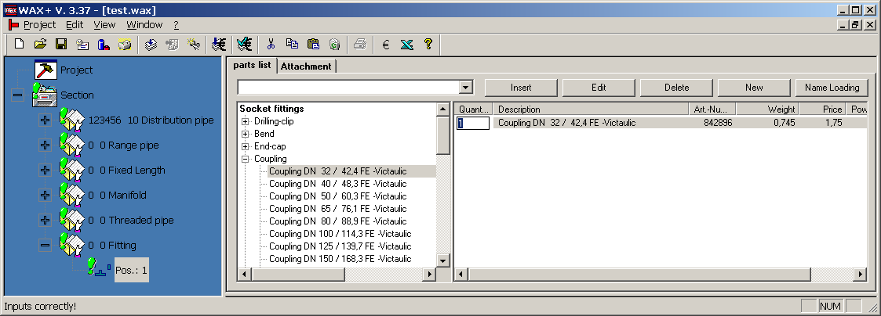
Image 3.14: Tab "Material list" with moulded parts/fittings

Above the button "New" a new article can be included. The price can only be set in the segment version (image 3.15). Once added only the number can be changed in the branch version.
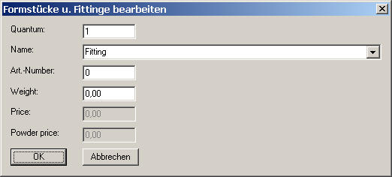
Image 3.15: Add new article

Discharge pipe - DWB 
With tab "Data" (image 3.16) the data for a discharge pipe-DWB is given.

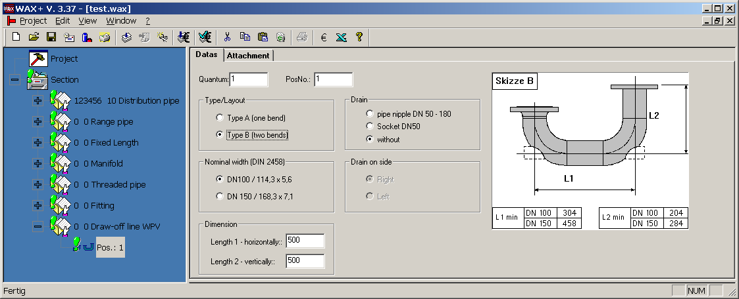
Image 3.16: Tab "Data" with discharge pipe-DWB

One or two arcs can be differentiated between the types.
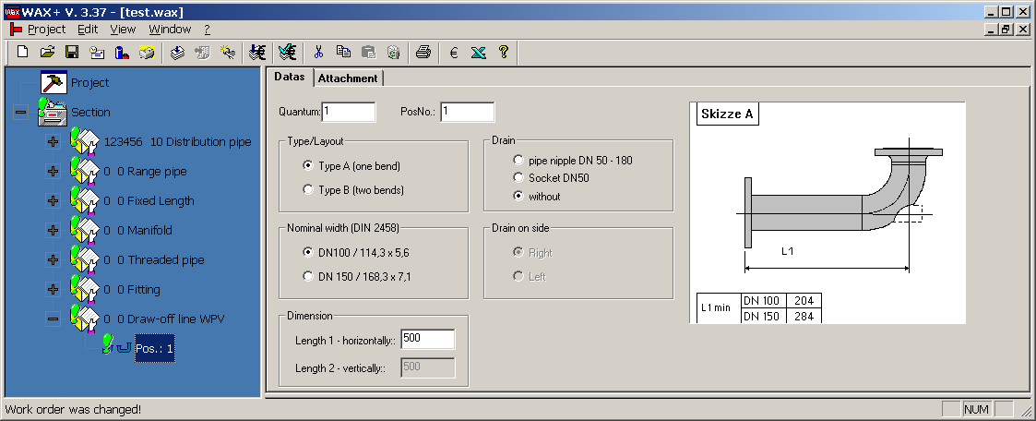
Image 3.17: Tab "Data" with discharge pipe -DWB

Test line for pump 
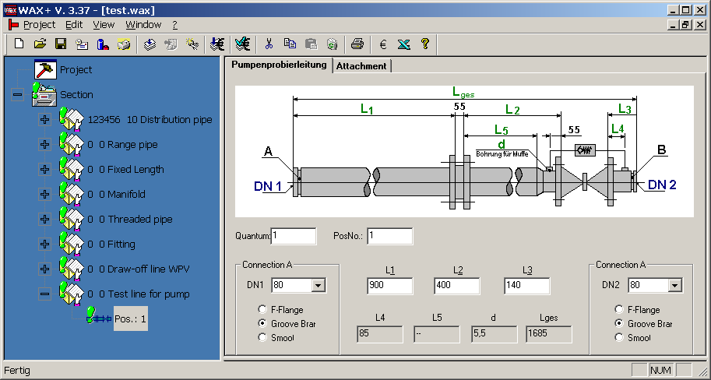
The data for a test line pump is given via the tab "Test line pump" (image 3.18).

Image 3.18: Tab "Test line pump"

Pump manifold 
Under the tab "Pump manifold" (image 3.19) the data for a pump manifold is given.

Length of reduction according to nominal width combination:
DN1 – DN3 | Length Red. Amount
50 – 80 | 90
50 – 100 | 100
65 – 80 | 90
65 – 100 | 100
80 – 100 | 100
80 – 150 | 140
100 – 150 | 140
125 – 150 | 140
125 – 200 | 152
150 – 200 | 152
Table 3.4: Length of reduction

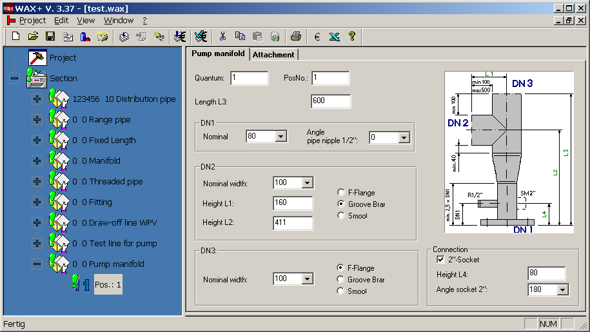
Image 3.19: Tab " Pump manifold"

The types with or without reduction can be differentiated between.
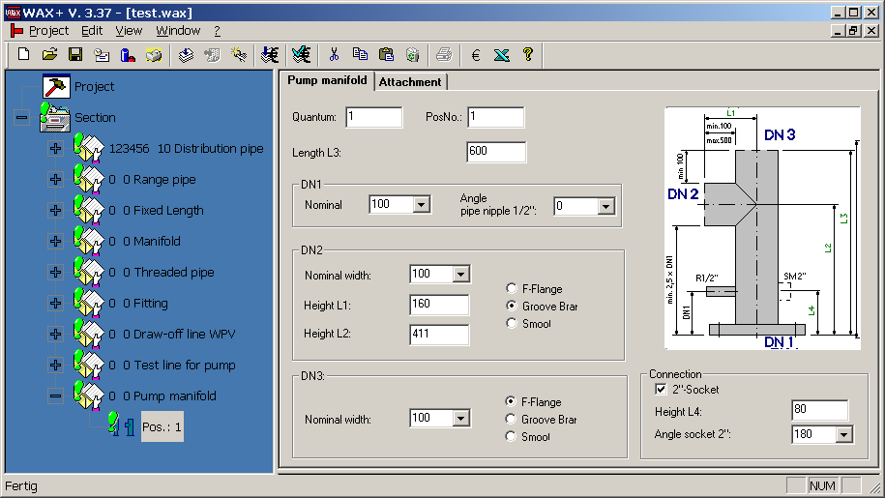
Image 3.20: Tab "Pump manifold"

Special order according to illustration (Work order/work plan) 
A special order contains a work order which is prepared according to the illustration. Here all pipe constructions and other constructions are processed which cannot be graphically represented in WAX+. However, the order can already be created in the NL. The illustration must no longer be faxed but can be stored as an attachment (see image 3.21) with the order. For this a hand sketch is to be scanned or an AutoCAD - drawing in DWF- format produced. The formats DWF or PDF can be saved.

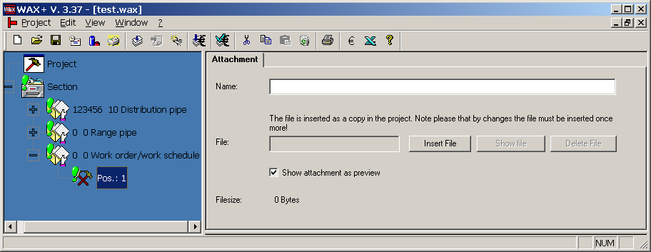
Image 3.21: Tab "Annex" with work order/work plan

Approval of the data for production
The transfer of data to production proceeds through the function 'Approval'. With the approval the data of the work order is transferred via the WAN connection to the WAX server. A database works on this server which contains all production orders (see section 3.2.2.5.).
An approval can follow as required so long as the data is not processed in the segments. In general the data is imported on the morning of the following day. Afterwards the new work orders are processed by the employees of the segments. The first stage of this processing is the issuing of a so called WA number. This WA number serves as identification of an order. Every work contract which was once approved is tested during renewed approval whether a WA number was given. If this is the case further approval is prevented. The status actualisation can also be implemented with loading of a project. Through this you receive information about whether the order is already being processed and which expert is responsible for questions. Please first call or mail this expert first with questions or changes. So far as the expert in the segment has not ended the order processing in WAX+ and has not transferred the order to SAP this can again reset the processing status. The WA number is again set at "0". After a renewed status update by the expert in the NL this can again process the order and approve once again.
If the server data base is not available (e.g. local installation without network connection) the project data can be sent as an email to production in Bad Oldesloe.

Detailed functions description
The programme with an empty interface. An available order can be immediately loaded and enhanced. If no project data is opened the main menu is active. The system can be configured via the main menu. The functions for the loading of work orders from the database in the NL version not chosen freely. In the segment - version orders from the server database can be loaded immediately. The segment can also create and approve projects or individual orders for the subsidiaries.

Project menu

Process new work orders (only selectable in the segments)
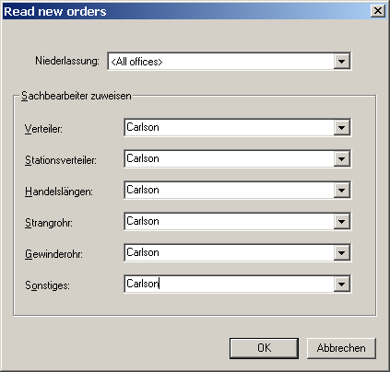
Approved orders can be loaded from the database for defined subsidiaries and engineering offices. At the same time a specialist from the segments can be assigned for every type of order. This is entered automatically in all orders. So that the responsible clerk can load the orders assigned to him all work orders must first be approved again for the responsible clerk to save them in the database. All orders are now displayed in a tree structure. ( Menue only existing in german program version ! )

Image 3.22: Dialogue "Load work orders from the database - new work orders"

Process my work orders (only selectable in the segments)
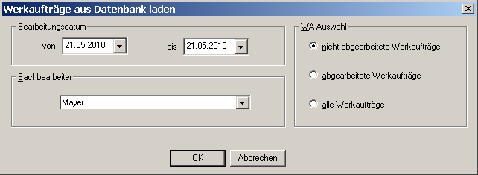
If the orders are allocated to a responsible clerk from the segment all "individual" work orders for further processing can be loaded (see section 3.3.3) / ( Menue only existing in german program version ! )
Image 3.23: Dialogue box "Load Work orders from the database - my work orders"

Process work orders (only selectable in the segments)
This is a menu with which you can load orders from the database via a specialist selection screen. E.g a defined work order or all work orders of a subsidiary or a responsible clerk from the segment.
( Menue only existing in german program version ! )
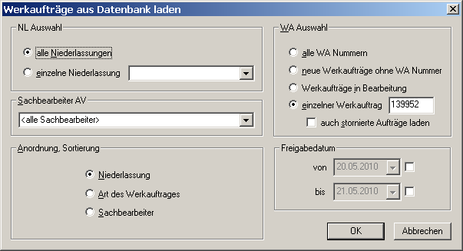
Image 3.24: Dialogue "Load Work orders from the database"

Issue project data according to PSP element (only chosen in the segments)
This functions enables the loading of a complete project with all work orders which were defined under a PSP-element from the database. ( Menue only existing in german program version ! )
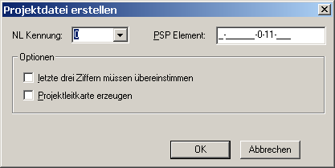
Image 3.25: Dialogue box "Issue Project data "

New:
Opening of a new project. The project management card and 1 section is displayed as standard for classification. The description of the classification can be accessed in the management card for the standard of other classifications. The project management card contains the information for the construction sites such as addresses and PSP elements. In addition commentary with the classification which is printed out can be accessed. Via the context menu an individual work order or a joint order can be created. Depending on the work orders diverse tabs appear in which the detailed information about layers, pipe definitions etc must be made.

Opening , storage or storage under , closing and printing
In the meantime these points are available for every windows software. These are adequately known and therefore do not need to be explained in detail at this point.

Send project as email
If the server database is not available (e.g. local installation without network connection or in WAX for third parties) the project data can also be sent to production in Bad Oldesloe.

List of the last projects
Up to 10 projects are specified here in a list for quick access (history).

Processing
This menu is only visible when a project was loaded. The menu points relate to the administration and processing of the project tree.

Cutting out , copying , adding and deletion
With the help of these menu points or the Windows short cut keys elements in the tree can be deleted or duplicated via the clipboard.

Attach new classification
Attach a classification in the project. Therefore a division in building sections or lots is made.

Attach new order type
Attach a new order type to the project below the marked classification point or in the marked joint work contract.

Include new object (only selectable via symbol system)
Here a similar object as the that just marked in the tree can be included. This can be a classification or a work order. That means the same order type is of course automatically generated as with the marked position in the work order.

Release
The release has a different significance for the subsidiary and segment version .
The release in the subsidiary version is the sending of orders to production in OD. The data is written via the WAN connection in a database on the WAX server and read and processed by the segments on the next work day (also see section 3.1.6).
In the segment version the release can only proceed if something was changed on the order. Therefore it is guaranteed that the most current processing status is stored in the database.

Redefinition
Leave objects in the tree unnamed e.g. for the creation of a project structure according to the building sections.

Update status
With the status update the status information for an order is retrieved from the database via WAN management. In the status fields you can see who last processed the order in the segments. Apart from that the work order number is transmitted. The WA number is the central number next to the order description in the communication between purchaser and employee of the segment when it concerns changes or questions.

HTML Menu (only selectable via the symbol list)
Via this menu the HTML view of the print preview can be controlled. A maximum of 30 positions per HTML page can be specified. If more positions are found with the joint order in the print preview several HTML datas are generated.

With the buttons „Start , „previous printout“ , „next printout“ and „End“ the current printouts can be changed. With the menu point „display all pages “ the printouts are suspended behind one another in a data file and displayed together. This is required when several printouts have been generated first but the whole work order should be printed with side numbering since the print copy only shown on the print preview is printed.
In addition the printout with "Print preview in Internet Explorer" can be displayed with IE. The page break is only visible before printing.

Price enquiries

In Wax price enquiries can be made to segment Rohr. The segment then assigns an offer price for the enquiry

Price enquiry

Add a price enquiry in the tree. Via the right mouse key click on "new price enquiry". A folder price enquiry is presented. Again via the right mouse key joint orders with positions under the price enquiry can be added.
The price enquiry can be released via the button . In addition the folder price enquiry must
be marked.

Input new price enquiries (only selectable in the segments)
Via the button the new price enquiries are inputted.

Release offer price (only selectable in the segments)
For every joint order of the price enquiry give an offer price. Via the button the price enquiry is released.
In addition mark the price enquiry folder must be marked. After the release the email programme is automatically opened with the address of the purchaser. An info about the giving of a price can now be sent.

Accept offer
Update the project value via the button. If the price enquiry is clicked on

the offer price is shown on the management card. The price is accepted via the button and the order is released for production.

Cancel offer

A price enquiry or offer can only be cancelled by the segment. Please contact the segment.

System administration

Parameter
Here the important programme settings for WAX+ are carried out (see section 4).

Database
In the menu point "Settings..." 2 user data bases can be configured. If 2 databases are defined the switch "Database selection at programme start" can be activated. Then a selection box appears at the programme start. The menu point "selection" can switched between both the databases. The menu point "Info" gives information about data bases linked to WAX+.

View

Symbols
Switch the symbol function which contains the piktogramme for the important functions on and off.

Status function
Switch the status function on the lower window edge in which instruction are given on and off.

Show full graphic image
Blend out the input screens and enlarge the image on the screen.

Print preview
According to the branch or segment version the available print lists can be chosen from here. These are then shown on the screen as preview.

Graphic window under the entry
Shows the image on the screen and updates the view with every change. The input is faster if the image is switched off. (Recommended for old PC's)

Open image with viewer
Starts the viewer and shows the image with this.

Window
This menu point is only visible if at least 1 project is loaded. It enables a set-up of the window on the monitor.

Info about WAX+
Here you receive information about WAX+-version and about software developers. In addition these user documentation and the version history can be opened here.

Specialist WAX+ functions (partly only selectable via the symbol function)
These functions via the symbol function. Also these are partly only selectable in the segment version since these are functions which are only needed in the production.

Show prices (only chosen in the NL and Segment version)
Here the price (WAP/VK) relating to the selection (cursor position) is shown in the tree. In the segment version a list for material and work processes inclusive of prices can be viewed.

Process new work orders (only chosen in the segment version)
For a defined period all new work orders which are released from the branches can be loaded from the database. At the same time a responsible clerk from the segments is assigned to every order type which is automatically entered in all orders. All orders are now shown in a tree structure (see section 3.2.1.1).

Process my work orders (only chosen in the segment version)
If the orders are assigned to a responsible clerk from the segment all "individual" work orders can be loaded for further processing (see section 3.2.1.2).

Interface for SAP (only chosen in the segment version)

Read SAP orders
Here the data for the management card of a work order can be read from data produced by SAP.

Transfer order to SAP
Here the data set of the work order for SAP is issued and written in a text data file. This first follows when the order in the segment is in process. This is the case if a WA number given is entered by the responsible clerk of the segment and the processing date is set.

Interface for Excel

Issue order table
Here the order table is issued in Excel format for the daily planning of the machine allocation. For every order type a table is generated. In this the most important data of every work order is written. The order tables are issued after the new work orders have been loaded and these have been assigned to the responsible clerk from the segments (see section 3.3.2). The tables are stored in the folder „..\WAXplus\Excel“. In the branch version an overview of the ordered work orders can be issued over the entire project.

Release order for "Machine X"(only chosen in the segment version)
These menu points issue the data sets for the pipelines controlled by WAX+ programme (saw groove installations, distribution pipe lines and branch pipelines)> The data for the saw groove installation is in text format, the remainder in Excel format. This can first follow if the the order is being processed in the segment. This is the case when, WA number given, the responsible clerk of the segment is registered and has set the processing date.

Monitor for pipelines (only chosen in the segment version)
For the pipe networks controlled by WAX+ -Programme (saw groove installations, distribution pipe lines and branch pipelines) there is a monitor dialogue (image 3.23). The dialogue shows the orders in their respective state of completion. In the folder of released work orders marked orders can be deleted. In the folder of processed orders marked orders can be activated. In the archive folder which is not shown by the monitor the orders should be regularly stored together in a compressed archive data.
Terms of the folder:
- Released Order is released from the segment for the processing on the machine
- Active Order is currently processed by the machine
- Stopped Order was stopped by the machine operator
- Processed Order is processed by the machine

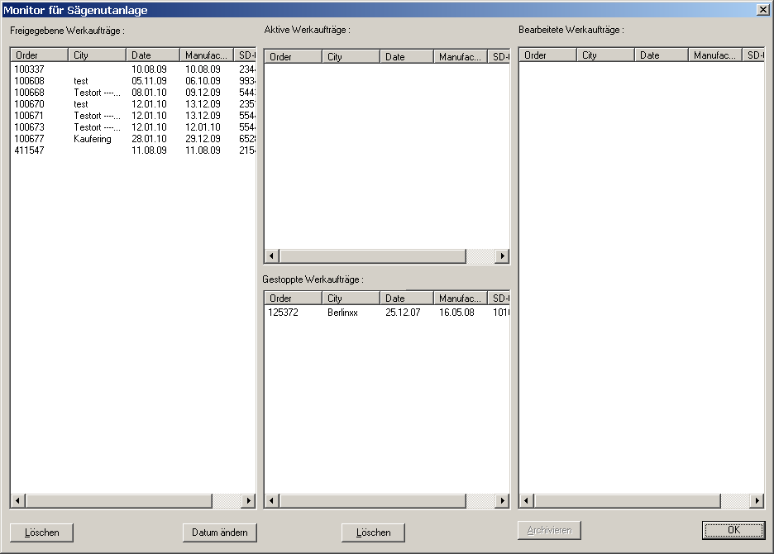

Image 3.26: Monitor dialogue for the monitoring of the saw groove installation

System parameters

The system parameters are parameters with which the representation of the programme and the programme functions can be changed. The programme is therefore configured with them. Parameters which are user dependent e.g. the background colour of the tree are stored in the registry of windows. Settings which apply to the respective computer are stored in an Ini-data file. The remaining parameters are posted in the user database „WAXuser.mdb“. But also the value set which applies for the entire location or only for the registered user can be set within the parameters of the user data base.
At the parameter settings the menu point "System administration - parameters" is reached. However, this can only be viewed if no WAX data is opened. In the dialogue box the parameters with individual tabs are arranged in the respective application areas. The button "Set Standard values" makes it possible to transfer the parameters in the default setting.
In the following some tabs are explained more closely as an example.

Tab "General"

When opening the dialogue tab "General" is active. Here the programme language can be set. If the language is changed the master data is automatically reloaded. In addition a minute entry can be set which should be automatically saved in the background at whatever distance. Here an "0) means "no special automatic saving". In addition a change of the password is possible here. The password is needed to be able to see and set the non user dependent parameters.

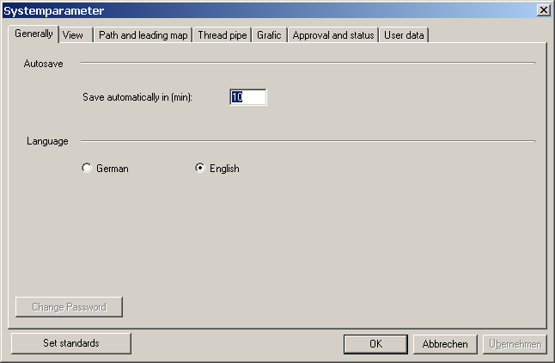
Image 4.1: Parameters settings "General"

Tab "View"

The following things can be set in this dialogue:
- The background colour of the tree
- Whether an image window under the entry dialogue should be displayed.
- And whether released positions in the tree should be automatically opened if the tree view is updated.
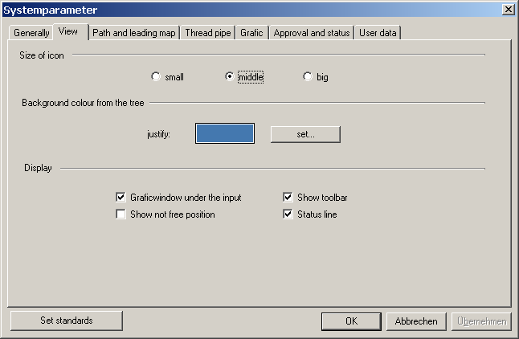
- The size of the icon
- Blending of symbols and status functions.

Image 4.2: Parameter settings "View"

Tab "System parameters - enhanced view"

This tab is only visible for the input of the valid password. Here all parameters from the user database and the user dependent parameters from the registry are represented in the table format. Here all parameters can be changed or deleted or newly included.
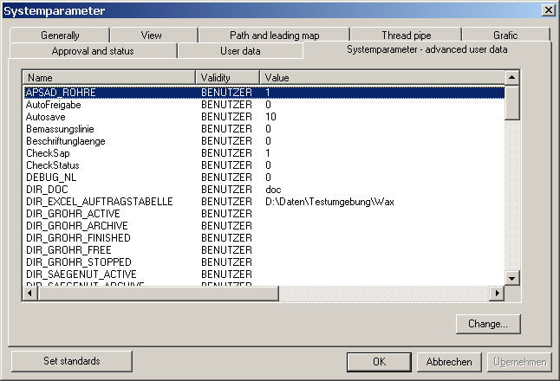
Image 4.3: Parameter settings "System parameters - advanced view"

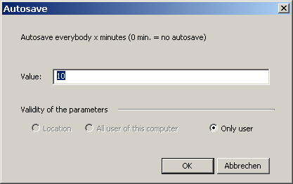
Through clicking on the button "Process" a dialogue about every parameter is opened individually and can be processed.

Image 4.4: Parameter settings "System parameters - processing: auto-save parameters here"

Table overview of all parameters
In these tables all parameters are presented with a notice text.
All parameters in blue which is only valid for the segments.

Name | Remarks
AUTO_RELEASE | 1: Test whether modified work orders should be released
AV_INIT_MBAPPOINTMENT | If > ) then during the loading of work orders in the segments for the MB appointment automatically counts for the value in days for the system date.
CheckSAP | 0. SAP Fields (PSP Element, SD numbers) are not tested before release  1: SAP Fields (PSP Element, SD numbers) are tested before release
DIR_EXCEL_ORDERTABLES | Path for Excel-order tables
DIR_GROHR_ACTIVE | Path for thread pipe installation of the the active work orders
DIR_GROHR_ARCHIVE | Path for thread pipe installation of the archived work orders
DIR_GROHR_FINISHED | Path for thread pipe installation of the processed work orders
DIR_GROHR_FREE | Path for thread pipe installation of the released work orders
DIR_GROHR_STOPPED | Path for thread pipe installation of the stopped work orders
DIR_SAEGENUT_ACTIVE | Path for the saw groove installation of the active work orders
DIR_SAEGENUT_ARCHIVE | Path for the saw groove installation of the archived work orders
DIR_SAEGENUT_FINISHED | Path for the saw groove installation of the processed work orders
DIR_SAEGENUT_FREE | Path for the saw groove installation of the released work orders
DIR_SAEGENUT_STOPPED | Path for the saw groove installation of the stopped work orders
DIR_SAPTOWAX | Path for data name for the transfer of the management cards from SAP  System Old name: \waxdat.txt
DIR_STRANG_ARCHIVE | Path for the archived branch pipe orders
DIR_STRANG_FREE | Path for the released work orders
DIR_STRANG1_ACTIVE | Path for the branch pipe path 1 of the active work orders
DIR_STRANG1_FINISHED | Path for the branch pipe path 1 of the processed work orders
DIR_STRANG1_STOPPED | Path for the branch pipe path 1 of the stopped work orders
DIR_DISTRIBUTOR_ARCHIVE | Path for the archived distributor orders
DIR_DISTRIBUTOR_FREE | Path for the released work orders
DIR_DISTRIBUTOR1_ACTIVE | Path for the distributor installation 1 of the active work orders
DIR_DISTRIBUTOR1_FINISHED | Path for the distributor installation 1 of the processed work orders
DIR_DISTRIBUTOR1_STOPPED | Path for the distributor installation 1 of the stopped work orders
DIR_WAXAPAX | Path for the Apx data
DIR_WAXAPAX_OLD | Path for the Apax data
DIR_WAXKOMP | Path for the components
DIR_WAXPRJ | Path for the projects
DIR_WAXTOSAP | Path and data name for the transfer of the work orders into the SAP system Old Name : c:\mz\was400.all
DWF_VIEWER | Possible entries:  zing -> The Zingviewer is used for the printout  voloview -> Voloview is used for the printout  adview -> Autodesk viewer is used for the printout  default ->uses the standard installed viewer
DWF_VIEWER_WAXGL | possible entries  zing -> Zingviewer is used for the image  voloview -> voloview is used for the image  adview -> Autodesk Viewer is used for the image  default -> Uses the standard installed viewer
EMAIL_ADDRESS | Email address for the sending of orders to production at Bad Oldesloe
EMAIL_DISPLAYNAME | Text, which is displayed as email name if an order is sent by email
EMAIL_SUBJECT | Text which is displayed as subject if the order is sent  by email
GF_DIMENSIONINGLINE | 0. Dimensioning line is not displayed 1: Dimensioning line is displayed
GF_LABEL_PIPE LENGTH | Image: Activates the label fot the pipe length.  0 : Pipe length is not displayed  1 : Pipe length is displayed
GF_PRINT_WITH_FRAMES | Image: Printout with frames around the image  0: without frames  1 : with frame
GF_FONTSIZE | Font size of the lettering in the image.  Valid values are 4-14
GF_IMAGE_DIVIDING LINE | Image: Switches the dividing line between the individual images  0: no  1: no
GROHR_DN_2_ZOL | 0: The DN value is displayed in the image 1: The values displayed in inches
GROHR_GRAPHIK_ZMASSABZUG | Print list 'threaded pipe image':  0: Mass without Z-mass deduction (values as inputted)  1. Mass with Z-Mass deduction
GROHR_LISTE_ZMASSABZUG | Print list 'Threaded tube list'  0: Mass without Z-mass deduction (values as given)  1: Mass with Z mass deduction
GROHR_NENNWEITE_TRENNZEICHEN | With the specified characters the nominal diameters in the fitting text are separated from one another. Standard is "x"!
GROHR_WINKEL_AUSRICHTUNG | 0: Angle details 1: Installation details in print lists (Example: 90° bzw. above)
IB_NL_KENNUNG | Branch number for the allocation of orders
SHORTTEXT_PART | Establishes the form of the short text with mould parts and fittings.  L(long) : T-piece1.1/2x1.1/2x1.1/2 (B1/GF 130) galvanized  M(middle): T-piece 1.1/2x1.1/2x1.1/2 (GF 130)  S(short) : T 1.1/2-1.1/2-1.1/2 (130)  Attention: Master data must be reloaded
Term of delivery | The delivery date desired is set on the current date plus set value in days
LOGDB | Path for log database
REL_ABST_CHANGE | States whether the inclusion of elements with the distributor or in  input dialogue for AV elements should be aligned to the absolute distances  0: the absolute distances are adapted  1: the relative distances are adapted
JOINTORDER_MAXPOS | Specifies the maximum number of positions in a joint order.
SERVERDB | Path for service data base
SHOW_NO_RELEASE_POS | Automatic opening of non released joint orders in  the tree during loading of the project  0: is not opened  1: is opened  Default 0
STAMMDB | Path for master database  e.g. M:\WAXplus\WaxStamm.dat
WANR_OHNE_RELEASE | 1. work orders with Wanr. without release
Table 4.1: Special parameters (blue: Parameters only for segment version)

Manufacturing notes

Lengths for supports which exceed the 50 mm top pipe
Formula linked to the axle: 1 = 50 mm + (d/2)

Nominal breadth (DN) | Diameter [mm] | Wall strength | Pipe length | linked to the vertical line [mm]
32** | 42.4 | 3.25 | 71.20
40** | 48.3 | 3.25 | 74.15
50** | 60.3 | 3.65 | 80.15
65 | 76.1 | 2.60 | 88.05
80 | 88.9 | 2.90 | 94.45
100 | 114.3 | 2.90 | 107.15
125 | 139.7 | 3.60 | 119.85
150 | 168.3 | 4.00 | 134.15
200 | 219.1 | 4.50 | 159.55
250 | 273.0 | 5.00 | 186.50
300 | 323.9 | 5.60 | 211.95
Table 1: ** as WN - supports

Note: The dimensioning always proceeds from the vertical line!

Overview of the possible pipe layers
Note: DIN 2403 controls the colour of pipes according to the flow substance.

Radiation
Special Features
- With the steel wire corn according to DIN 8201 section 4.
- Purity level SA 2 1/2 according to DIN 55 928 section 4 (SA stands for radiation).

To galvanize
Special Features
- Hot galvanized according to DIN 50 976
- Layer thickness from 50um to 70 um dependent on winding strength.
- Blemishes from the galvanization are to be rectified before the delivery.
- After delivery the client carries responsibility.
- Blemishes should amount to a maximum of 0.5% of the total surface.
- The individual surfaces should not be bigger than 100 cm² (approx. the size of hand surface)
- Attention: If blemishes are over the whole surface then it also qualifies as an actual blemish if the actual limit of 0.5% has not been exceeded.
- Size of the galvanization tub [m]: 2,7 * 1.9 * 15,5

Powder layers
Special Features
- Welded spur and distributor pipes in the colours RAL 3000 and RAL010.
- Additional colours are possible however, a high outlay is required for colour adjustment.
- The layer thickness amounts to at least 50 um however can be over 100 um.
- Powder is lead and cadmium free therefore no disposal problems.
- Attention: not UV consistent; colour and gloss level change with time
- Strength against cold shock with CO2 = -40°C

Transport protection coat
Special Features
- The threaded pipes are grounded but this is not possible for other pipes
- Colour: red - brown
- Should the surfaces of the pipes be provided with a time limited protection against corrosion this should be agreed on ordering.
- Not suitable for outer area

Description of spark average value formation
With the installation pipes with nominal breadths 25 to 300 mm or parts of those measurements amount to a maximum of 0.8 x 1.5m with production lengths of up to 12m automatically blasted and covered in powder.
The pipes are hung above one another in the goods carrier with the lifting and lowering station. If the goods carrier is filled the power + free - conveyor system transports the goods carrier in direction of the blasting cabin in which the pipes will be blasted with steel grain. The switching on and off of the blasting installation proceeds automatically via a gap control. After the blasting installation the goods carrier passes through the powder cabin. Here the pipes are covered electro-statically with powder by 6 automatic pistols. Afterwards the goods carrier passes through with the pipes to the drying oven in which the powder is baked or hardened at approx. 180 °C then connecting to the cooling area. After the pipes have cooled down to approx. 40 °C they are taken from the installation to the removal lifting and lowering station.
This process of colour layering of pipes with lead and cadmium free powder has replaced the layering with primers and varnish containing solvents.
Erdgas serves as energy provider for the drying installation.

Installation technical data:
- Work pieces: Pipes, bends, moulded parts
- Material of the work sections: Steel
- Work section measurement max: Diameter 300 mm, length maximum 12000 mm
- Work section thickness 2.3 – 10 mm
- Individual work piece weight 8 kg
- Individual work piece weight max.: 240 kg
- Hanging measurements max: Breadth 800 mm, height 1500 mm, length 12000 mm
- Fire protection in the wood materials industry: 12500 mm
- Goods carriers hanged up at 2 points at a distance of : 6000 mm
- Distance of goods carrier and top with free rail: 900 mm
- Goods carrier weight including work items max: 500 kg
- Installation use cross section Breadth 800mm, height 1500 mm
Possible applications
The powder used is a Epoxyd-Polyester mix. The powder is lead and cadmium free. Therefore the disposal of powder coated layers is unproblematical. Epoxyd-Polyester mixed powder is suitable where building elements are not directly exposed to the elements. The corrosion protection is also then provided if the parts are exposed to the elements however, the level of gloss and colour will change since UV resistance is not provided. The use of a high quality powder is possible however, requires an exact specification of the usage conditions. Furthermore increased delivery deadlines and increased prices should be counted.

Tips and tricks

Simultaneous processing of several projects
Sometimes it can be sensible to have several projects opened at the same time. Then a comparison of the projects is easily possible. Also parts of a project already issued can be easily copied and included in the other project. The WAX+- programme can also be started several times without a problem.

Team work and data exchange
With the installation of WAX+ a sub directory "Comp" is created. This directory serves the recording of components which are stored for use again. A component can be a part of the tree also a joint order whose individual position, an individual work order or even a complete building section.

Project processes
WAX+_ know no processes. You can use processes analogous to Microsoft Word as follows: Simply provide projects which should serve as submission with write protection (right mouse key in Explorer, then properties). WAX+ loads this project with the notice that the data is write-protected and that one copy was opened. Then save this data under another name.

Use more databases on one PC
If you use a laptop with network connection it can be useful to use another database according to location. For example in transit you must use a local copy while using the database on one server in the office. For this application there is the possibility to configure two databases. With the start of the programme the desired database can be chosen in a dialogue. The configuration is described in detail in the chapter "Installation of WAX+ and Configuration".

Settings in Internet Explorer for optimum printouts
In the WAX+ programme the printouts of internet explorer (IE) are embedded for display.
Therefore all print outs follow as HTML data. Since the settings for the pages format and pages view are always the same over the whole system this can be specified for the WAX+ programme via the IE. In addition IE is started by double clicking on the symbol IE on the desktop. Via the menu point "Data - pages adjust.." the following dialogue is opened and the specified settings checked.

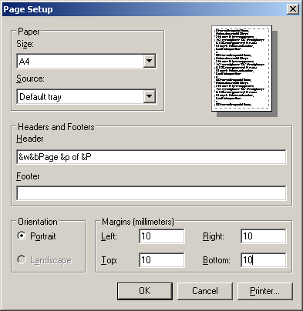

Image 5.1: IE - Dialogue "Pages setup"

In addition this can be set to very small via the menu point "View - Font size". This is the optimum setting for the print lists.

