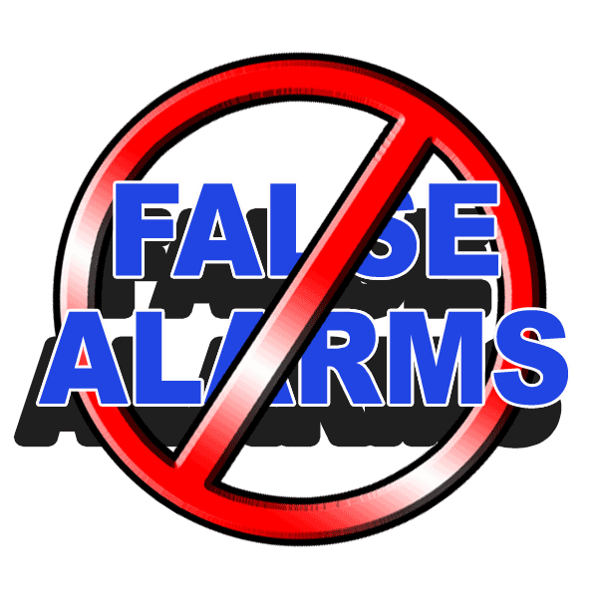
Enhanced Verification Implementation

<Company Name> has begun implementing multiple call verification on burglar alarm activations prior to police dispatch in order to reduce the number of false alarms. Our monitoring station now attempts to make a call to the premises to verify the validity of an alarm at this time. However, due to the growing number of police jurisdictions now requiring enhanced call procedures they will attempt to contact a second number prior to police notification. This number should be a number that will be most likely answered at anytime by the customer. It is suggested that this number be a cell phone that is answered by the homeowner or business manager. This procedure does not apply to fire alarm, hold-up alarm, or panic signals. This procedure shall be effective immediately upon return of this form. Please complete the form below so that we can ensure your account records are up to date.

Customer Name: (Last, First)

Physical Address:

City: | State: | Zip Code: |  | County or Township:
Premises Phone: |  | Secondary Verification Phone:
Contact Information: (List in contact order)

Contact Name: | Relationship/Personal Info: | Phone Number:

Directions & Cross Street: |  |  | Special Notes:

Thank you for your assistance in the effort against false alarms!

Please return form to:
<Company Name>
<Company Address>
<City, State Zip Code>
<Or Fax To:>

