REPORT

Task1:
parameters:
alpha = 2
delta = 0.003
round_robin initcolorselectionpolicy
Hybrid selection policy
4 partitions
3 random neighbours sample size
1000 rounds
seed 0
simulated annealing temperature: 2
uniform sample size: 6

cooling in the sample and swap.
3elt.graph
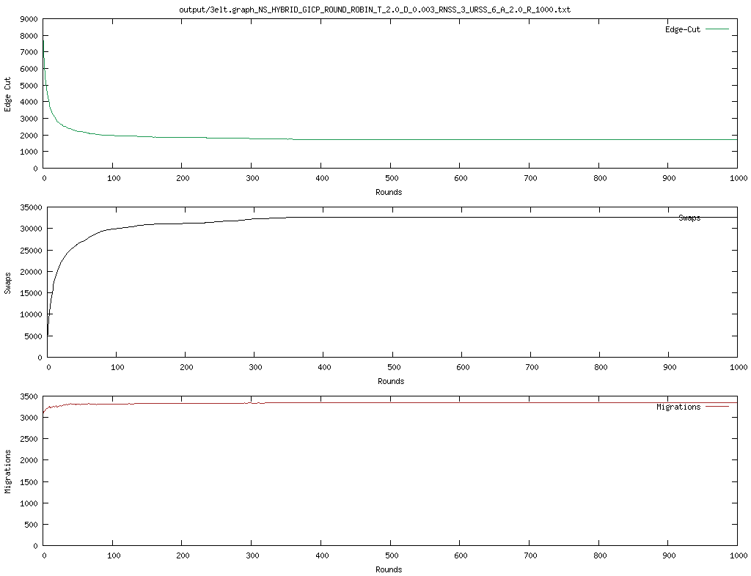

add20.graph
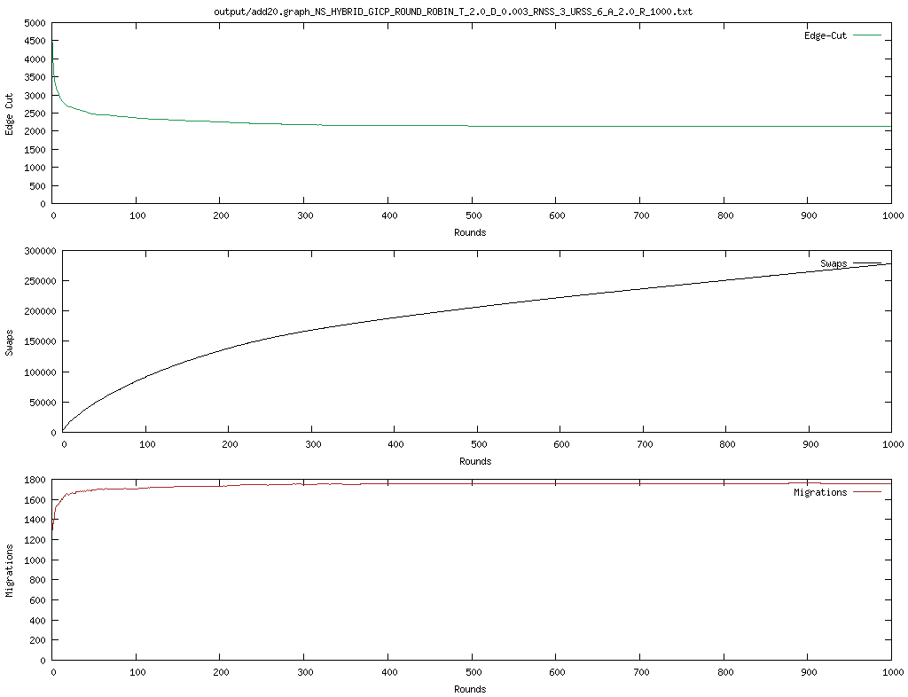
twitter.graph
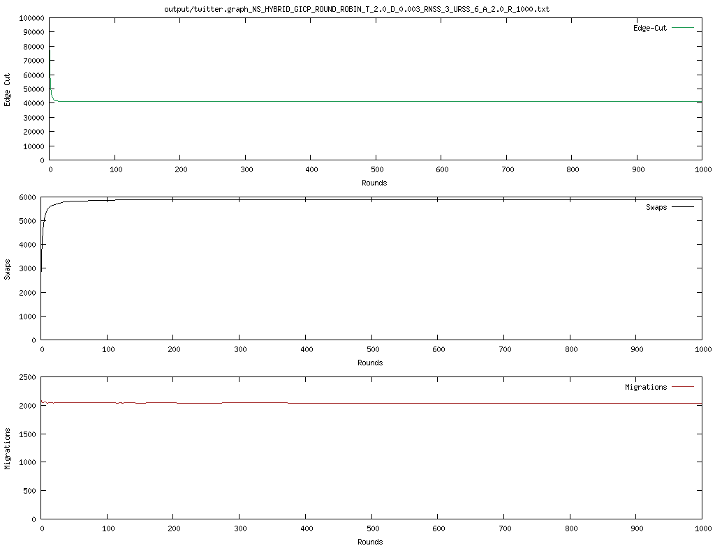

facebook.graph

cooling after the cycle
3elts
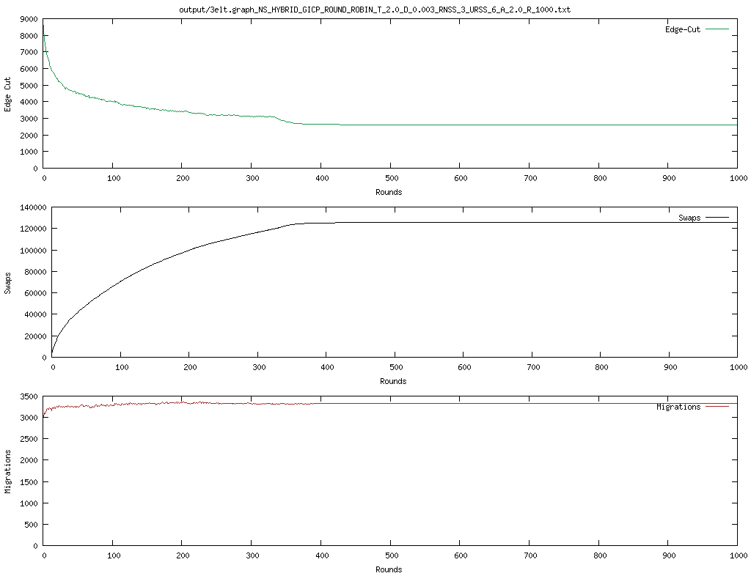

Restarting with T=2 and delta = 0:01
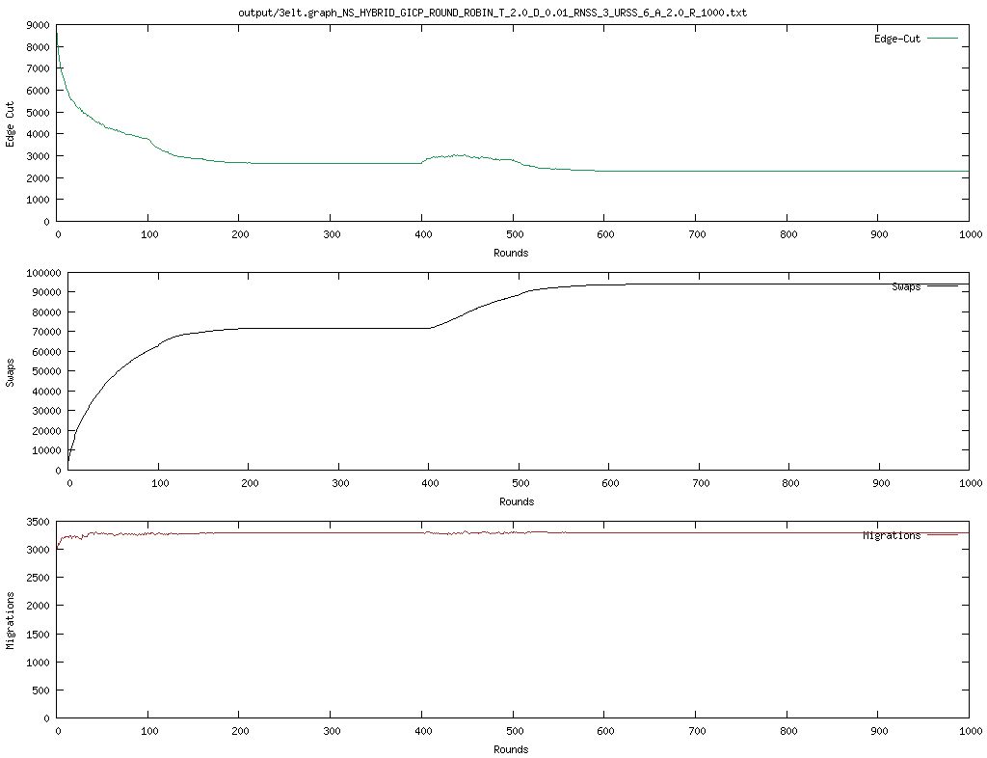

Edge cut = 2280
delta 0.01 T = 2 alpha 4

alpha 3, edge cut = 2106

same as above but with random instead of hybrid: and 800 iter 1141
same but local: 3470

