Creative Code

What is code?

Although you might not know it, you already know the answer to this question because you have been using and learning codes for a very long time. This course is all about understanding the different codes we use to communicate with computers, mobiles phones and each other. But before we get into creating our own code lets have a look at why certain codes are useful when talking to computers and not so useful in other situations like when we're talking to our friends.

Symbols

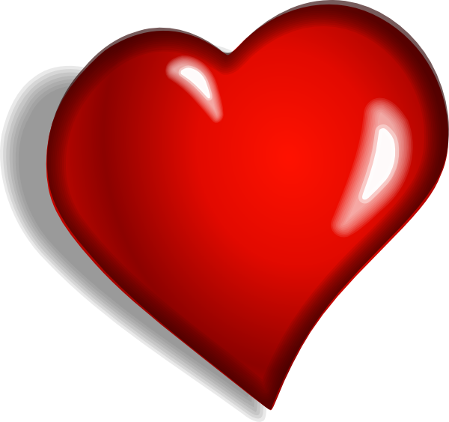
We've all used symbols before to express ourselves. For example, have you ever sent some one you like a picture of a heart? This picture is a symbol, and we use it to express feelings such as love or liking someone or something very much.
Symbols have their own meanings that we use to communicate with each other, by agreeing on what that meaning is.

Code

As we already know, symbols can be a quick and fun way of communicating with our friends. But what about when we want to express ourselves in ways that need to be described more clearly?

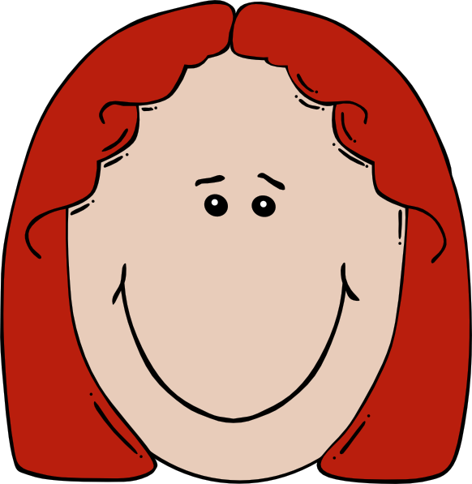
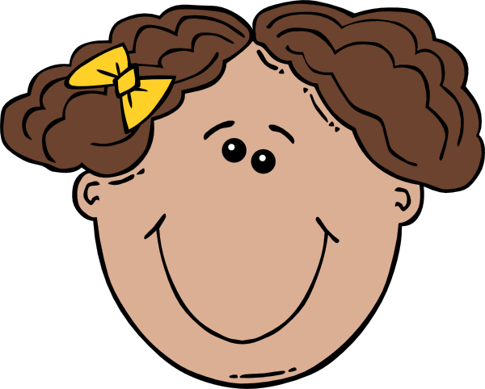
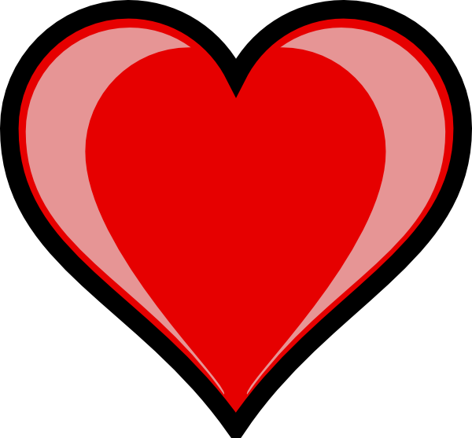

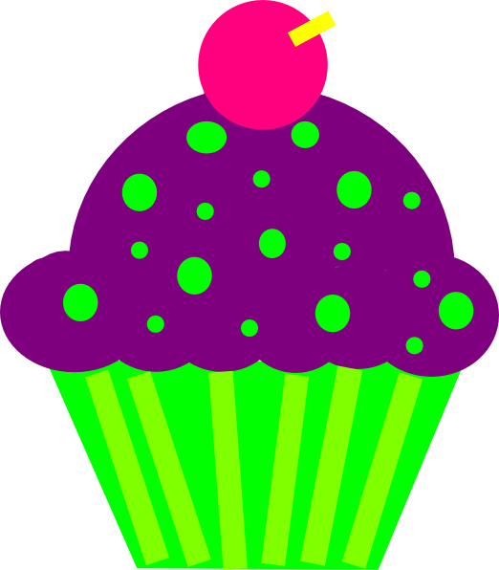

What do you think the picture above is trying to communicate with symbols?
Do you think it's saying "I love my Mom as much as I love Cupcakes"
or could it be saying "I love my Mom and I like cupcakes alot!".
Communicating only with symbols can be quite confusing when we want to be more specific. While symbols can give us a rough idea of some meaning, combining symbols to form code can be used to communicate ideas much more clearly.

More Symbols with many meanings

Symbols
south african flag
recycling logo
brrr hahaha lol
computers need more specific instructions.

