Creative Code Lessons
For Ikamva Youth
By Marion Walton &
Lyndon Daniels
Based on Marion Walton's Training Resources at https://ikamvacodes.wordpress.com/creative-code/
CREATIVE CODE is a Dr Marion Walton initiative

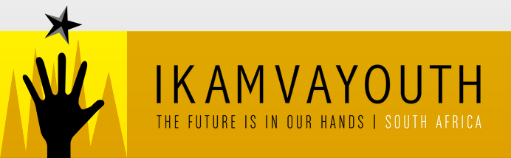
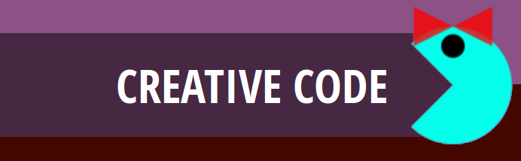

Released Under Creative Commons Attribution 4.0 International

Lyndon Daniels 2014 CC-BY-4.0
Marion Walton 2014 CC-BY-4.0

What is code?

Although you might not realize it, you already know the answer to this question. As you have been using and learning codes for most of your lifetime.

This course is all about understanding the different codes we use to communicate with computers, mobiles phones and each other. But before we get into creating our own code lets have a look at what codes are useful when talking to computers and how we can use what we already know to learn more about them.

Symbols


We've all used symbols before to express ourselves. For example, have you ever sent some one you like a picture of a heart? This picture is a symbol, and we use it to express feelings such as love or liking someone or something very much.
Symbols have their own meanings and we use those meanings to communicate with our friends by agreeing on what that symbol means.

Code

As we already know, symbols can be a quick and fun way of communicating with our friends. But what about when we want to express ourselves in ways that are more detailed or complicated?

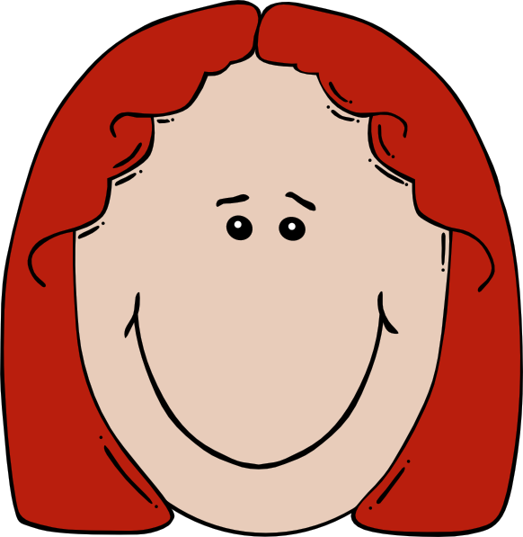

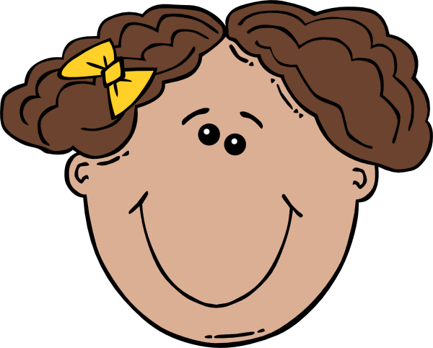


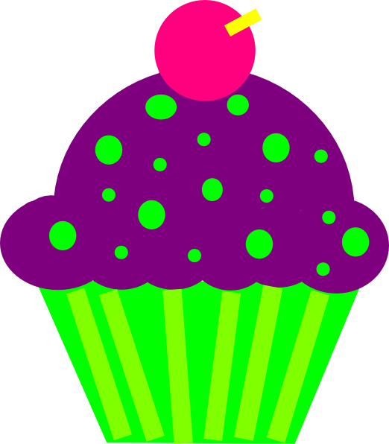

What do you think the picture above is trying to communicate with symbols?
Do you think it's saying "I love my Mom as much as I love Cupcakes"
or could it be saying "I love my Mom and I like cupcakes alot!".
Communicating with symbols alone can be quite confusing when we want to be more specific, but it certainly does make it easier to communicate more complex ideas when we combine symbols to form codes.

More Symbols with Many Meanings

We'll talk more about combining symbols to form codes a little later, but for now lets have a look at more symbols that you're already familiar with.

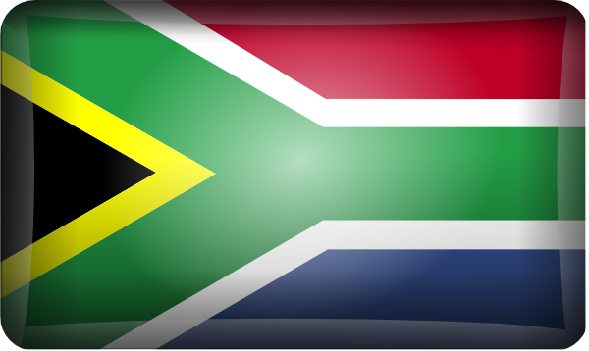
We all know that the symbol on the left is the South African flag, but have you considered that what it means for one person might be different to what it means to another?

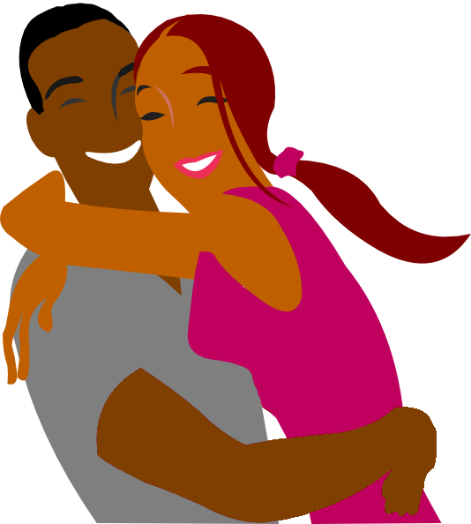
LOL
Have you ever noticed that LOL is often used in text conversations, with different meanings to different people. Does it mean "laugh out loud" or does it mean "lots of love"?

Combining Symbols to Communicate Clearly

As we discovered previously, symbols by themselves can become a little confusing especially when we need to communicate clearly.
As a result, using symbols together can help with explaining the details of what we are trying to communicate but as we've already seen this is still not enough when we need to be perfectly clear, and when we communicate with computers it's very important that we are being perfectly clear.

If we really wanted to be perfectly clear and make sure we are being understood, we would need to provide a context.

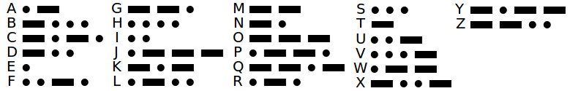

Morse Code uses combinations of 5 different symbols to form it's code. A dot an a dash are easy to recognize as symbols in this illustration, but have you considered that the spaces between the dots and dashes can also be thought of as symbols.

The Context of Codes

A context is used to describe the main idea of what we are communicating. For example, when you see the following graphic on a plastic bottle you could describe it as having three different symbols.


1. It has arrows

2. It has a number

3. It has a name

Finally, because this image appears on a plastic bottle it has a context. That context is "Recycling", and as a result we know that the meanings of the symbols used within this context are all about Recycling.

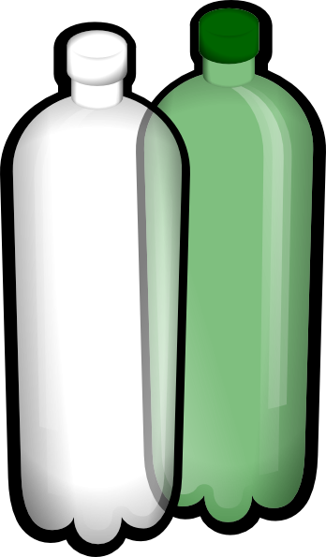
It is because of the context, that we know the number 1 is not referring to someone's age but it refers to a category that this type of plastic bottle falls into for the purposes of recycling. It is also because of the context that we know that the word PETE does not refer to someone's name but in fact it symbolizes what this plastic bottle is made up of (Polyethylene Terephthalate).
As you can see context is very important when communicating with code, it can go so far as to actually change the meanings of the symbols we use.

Communicating in Code with Computers

Symbols, code and context are equally as important when we need to communicate with computers.
Fortunately the symbols we use to communicate with a computer are often in the form of words you are already familiar with such as,

width setup draw color triangle
height curve box image rotate
background red green blue alpha

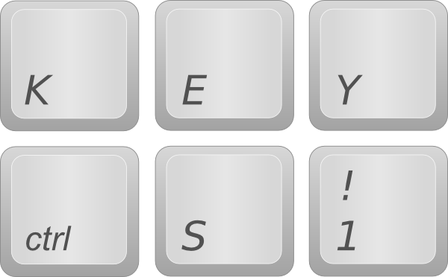
When we communicate with a computer these words symbolize commands that we use to tell a computer what we would like it to do. We string these commands together to form full lists of instructions and it is these instructions that we create to communicate with computers, that are referred to as code.

Exercise 01

Create Your Own Pixel Art with the Secret Shape Game


In this exercise you will need
- A Pen and Paper
- Various Bottle Tops
- Two Teams
Each Team has a person that will be the
Computer and another person acting as the Coder.

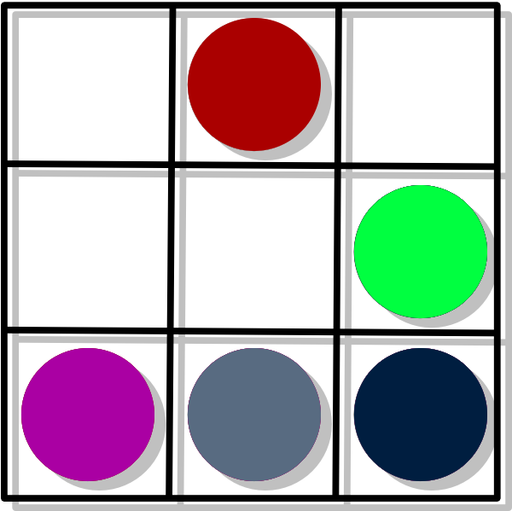
The Game Starts with the Coders.
Your job as a Coder is to write a list of
instructions on a piece of paper that will be
handed over to the other team. No Drawings!
These instructions must explain how to create
a Secret Shape using the Bottle tops.

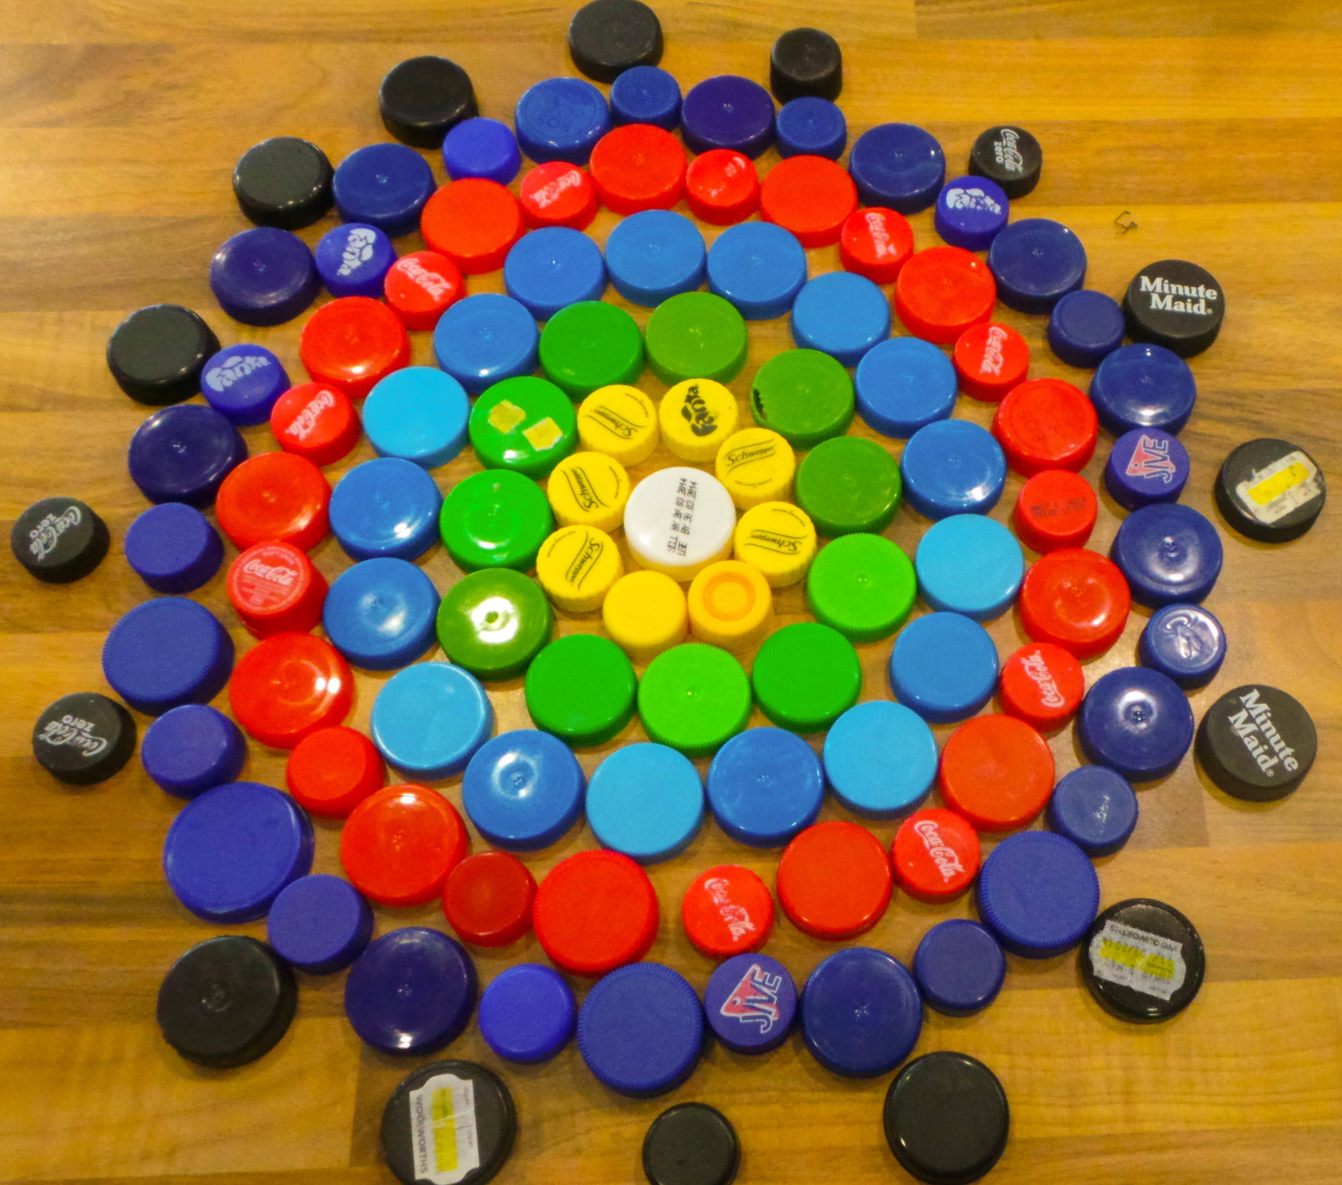
Making the Secret Shape
When the team member acting as the computer
receives the instructions, she must make the
Secret Shape by following the instructions.
The Coders are not to help the Computers.

The Winner will be Judged by
Which team finishes first.
Which team has the most beautiful shape.

