Creative Code Lessons
For Ikamva Youth
By Marion Walton &
Lyndon Daniels
Based on Marion Walton's Training Resources at https://ikamvacodes.wordpress.com/creative-code/
CREATIVE CODE is a Dr Marion Walton initiative


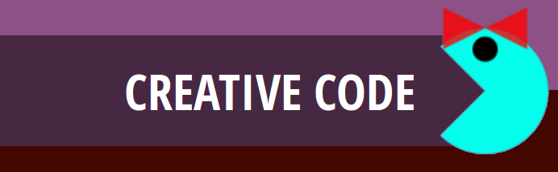

Released Under Creative Commons Attribution 4.0 International

Lyndon Daniels 2014 CC-BY-4.0
Marion Walton 2014 CC-BY-4.0

Conditionals

So far, the Processing commands that we have written have been executed one after the other, in the order they are written. This is fine for very simple programs, but mostly we want certain commands to be executed and others not to be.
To skip some commands under certain conditions, we need to have special commands called control statements which control the order in which our commands are executed in a program. The most widely used control statement is called an ‘if statement’.
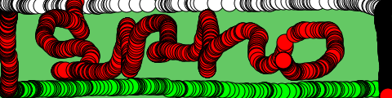
In this example by Sipho, he used an ‘if’ statement to determine what colour is drawn when the user moves the mouse around.

Sipho Msai Ngqayimbana

Checking the value of variables
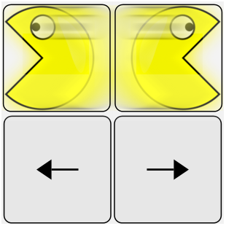
If statements are used to check the value of a variable and then execute a different set of commands depending on the value of the variable. For example, if we set a Boolean variable “direction” whenever someone presses an arrow key, then we can check that variable before we draw the Pacman.

/*this checks the value of the variable 'direction',
and whether it's true that it equals zero*/

if (direction==0)
{
//if it is true, then draw pacman arc facing right
arc(pacX, pacY, radius,radius, radians(45), radians(315));
}
else //if the condition is not true,
{
//if it is not true, then draw pacman arc facing left
arc(pacX, pacY, radius,radius, radians(225), radians(360+135));
}

You can play around with the code for this sketch in this sketchpad.

int pacX=50;
int pacY=height/2;
color pink = color(255,134,241,125);
int radius = 30; //set the radius variable for the pacman characters
Boolean female = true; //boolean to set the sex of the pacman characters
int direction=0;
PFont font;

background(0);
size(100,100);
smooth();
noStroke();
fill(pink);
if (direction==0)
{
//draw pacman facing right
arc(pacX, pacY, radius,radius, radians(45), radians(315));
}
else
{
//draw pacman facing left
arc(pacX, pacY, radius,radius, radians(225), radians(360+135));
}
//draw eyes
fill(0);
ellipse(pacX,pacY-radius/3,radius/5,radius/5);
if (female == true)
{
//draw ribbon for ms pacman
fill(255, 0, 0, 200);
triangle(pacX,pacY-radius/2,pacX+radius/3,pacY-(radius/3)*2,pacX+radius/3,pacY-radius/3);
triangle(pacX-radius/3,pacY-radius/3*2,pacX,pacY-radius/2,pacX-radius/3,pacY-radius/3);
}

fill(0, 102, 153);

//move pacman around the screen
if (keyPressed && (key == CODED)) { // If it's a coded key
if (keyCode == LEFT) { // If it's the left arrow
pacX-=5;
direction =0;
}
else if (keyCode == RIGHT) { // If it's the right arrow
pacX+=5;
direction=1;
}
if (keyCode == UP) { // If it's the left arrow
pacY-=5;
}
else if (keyCode == DOWN) { // If it's the right arrow
pacY+=5;
}
}// end if keypressed

