Creative Code Lessons
For Ikamva Youth
By Marion Walton &
Lyndon Daniels
Based on Marion Walton's Training Resources at https://ikamvacodes.wordpress.com/creative-code/
CREATIVE CODE is a Dr Marion Walton initiative


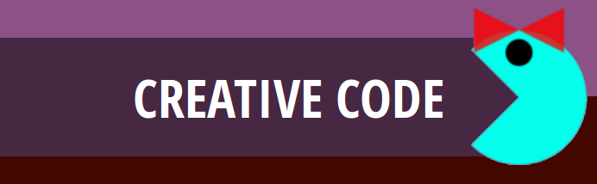

Released Under Creative Commons Attribution 4.0 International

Lyndon Daniels 2014 CC-BY-4.0
Marion Walton 2014 CC-BY-4.0

Exercise 03

Make your own version of a Pacman Mod

In this exercise we'll be using the Pixel Art Creator to design characters. Your challenge is to think of game stories which could fit the Pacman structure. Here there are three basic roles:
- The hero or she-ro (Pacman role)
- The opponent (Ghost)
- The target or goal (Pacman’s pills)

Here's an example of some previous Mods.

The Mighty Thinkers - Welcome to Khazatown

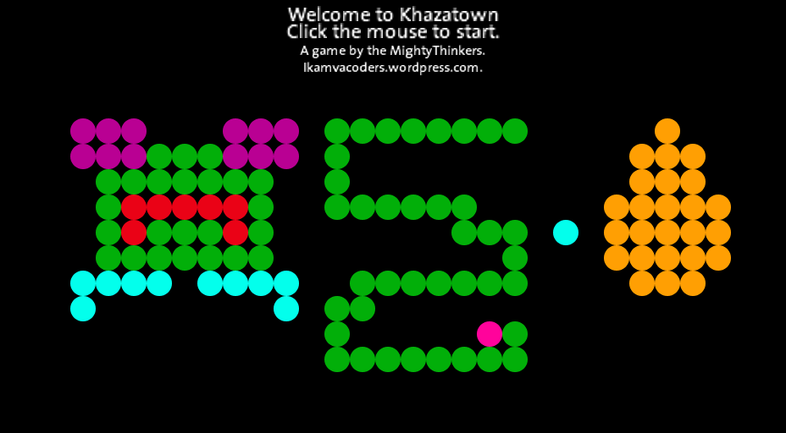
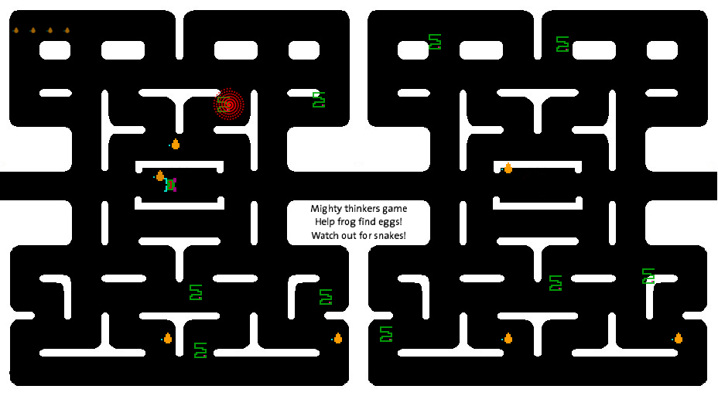
One of our groups designed three new characters. In the Mighty Thinkers’ Pacman mod, you are a frog (hero), and you have the goal of collecting golden eggs (target) while guarding yourself against the snakes (opponents) in the vicinity. These are the three characters in Welcome to Khazatown – frog, snake, and egg
Playing Welcome to Khazatown: Watch out for the snakes!
You can download the game and try it yourself. Let us know what you think and show us any mods (modifications) that you make!
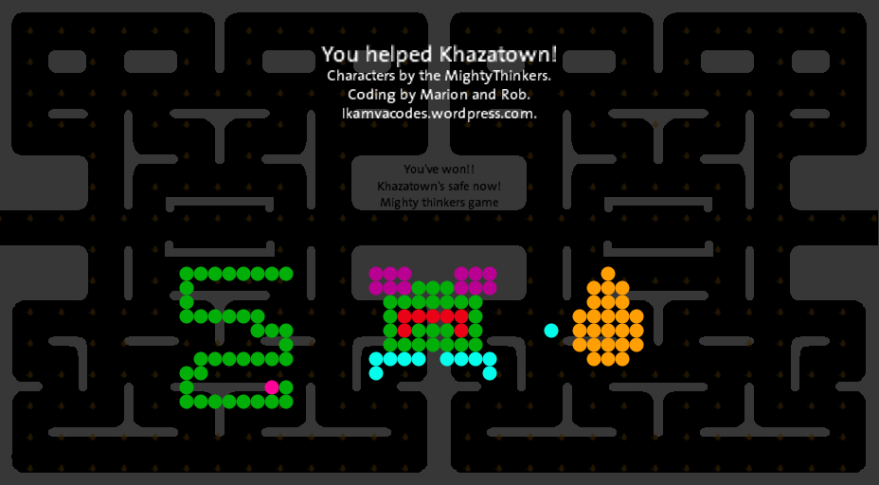
Download Welcome to Khazatown as:
- Processing source code
- Windows application
- Linux application
- Mac OS application
If you’re not ready to change the game code, why don’t you try using your own pixelart characters in our game.
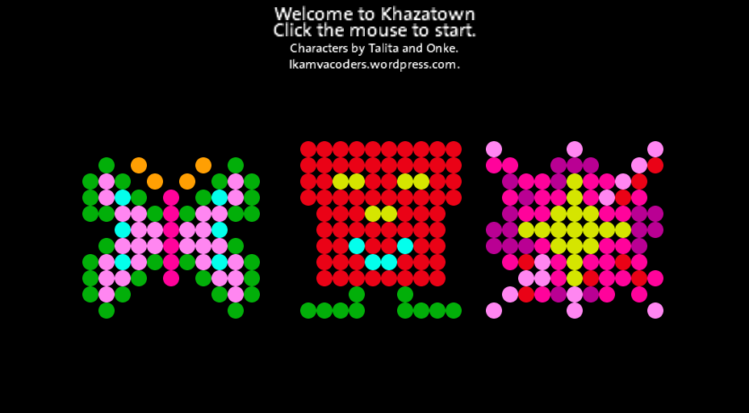
Here are characters designed by Talita and Onke – Tally the butterfly (hero) transfers pollen from one flower (goal) to the next, while the evil dustbin (opponent) gets in her way. Onke’s dustbin started life looking more friendly, but now he is Tally’s opponent.

Pixel art characters designed by Talita and Onke

