Creative Code Lessons
For Ikamva Youth
By Marion Walton &
Lyndon Daniels
Based on Marion Walton's Training Resources at https://ikamvacodes.wordpress.com/creative-code/
CREATIVE CODE is a Dr Marion Walton initiative

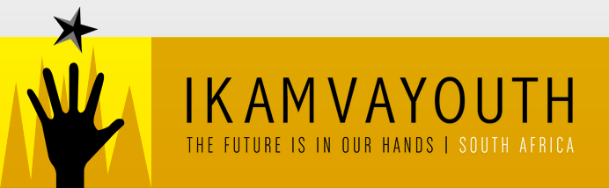
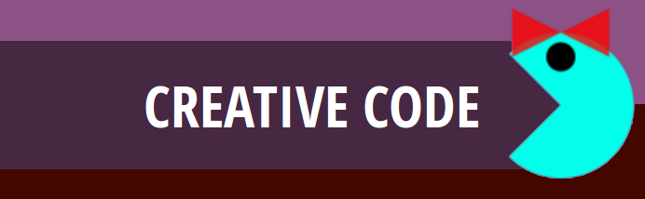

Released Under Creative Commons Attribution 4.0 International

Lyndon Daniels 2014 CC-BY-4.0
Marion Walton 2014 CC-BY-4.0

Exercise 04

Design Your Own Mario Mod Characters

In this exercise we used a Processing.js library built by Pomax. You can try Pomax's tutorial if you want to make your own Mario game.



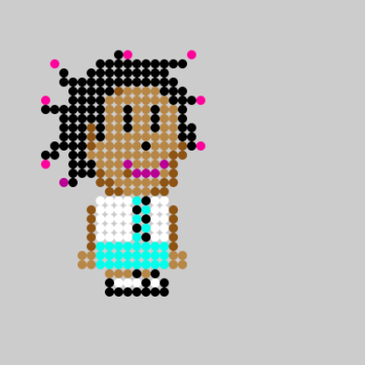
A game by Lisa, Talita, Ludwe, Lwazi, Onke and Vuyani. Ikamvacoders from Ikamva Youth.
The name of the game is Khazatown Blues. Going to school in khazatown is not a child”s play. You have to watch your back!! Bullies are out to GET YOU therefore make sure you GET all the life supporters to survive in the game.
- EAT AS MANY BOOKS AS YOU CAN!!
- In this game its all about avoiding your enemies the bullies and the evil principal.

isiXhosa
Funeka ubaleke abaxhaphazi abanomona ngemfundo yakho Kunye nenqununu engcolileyo engxothayo xa ufike emva kwexesha. Ukuze uhlale uphilile funeke utye incwdi ezininzi kangangako ukwaziyo. Funeke ungavumeli ungene kwindawo eneziyobisi ngoba uzofa.
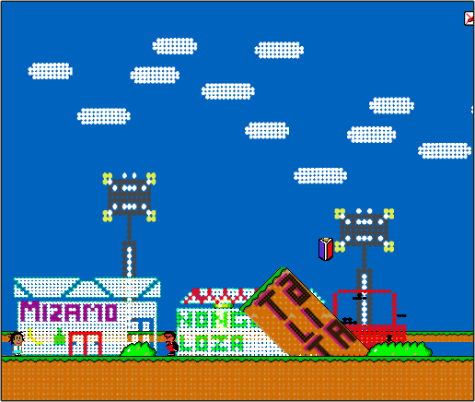
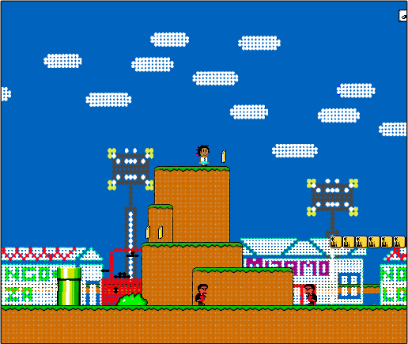
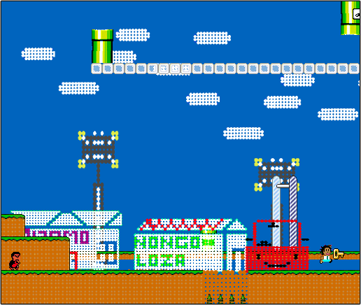

Play the game Now!

