Natural Gamma-Ray Simulation with Geant4
How the PyBorehole gamma-ray model works: inputs, geometry, physics and typical K, U, Th values
PyBorehole • October 2026

1. Summary
PyBorehole simulates what a natural gamma-ray (GR) logging tool measures in a backfilled borehole through a layered earth, with and without the borehole, so that the borehole effect can be quantified. The photon transport is done with Geant4, the Monte Carlo toolkit developed at CERN for particle and radiation physics.
Is it a 3D simulation? Yes. Every gamma photon moves in three dimensions, scatters at three-dimensional angles and is followed through three-dimensional volumes. Only the geometry is simplified: it is rotationally symmetric about the borehole axis (centred tool, horizontal layers, vertical hole). Each part of the model is a real 3D cylinder or ring, so radiation can reach the detector from any direction.

2. What Geant4 is
Geant4 is a C++ toolkit, not a ready-made program. A user writes a small application that tells Geant4 three things:
- Geometry: which volumes exist and which material fills each one.
- Physics: which particles and interactions to simulate.
- Source: where particles start, with what energy and in which direction.
Geant4 then does the transport. For each photon it samples how far the photon travels before it interacts, using the cross sections of the material it is in. It then chooses the interaction (photoelectric absorption, Compton scattering, Rayleigh scattering or pair production), computes the new energy and direction, and repeats until the photon is absorbed or leaves the model. The application records what it needs along the way, here the energy deposited in the detector crystal.
The PyBorehole application is gamma/gammalog.cc. It uses the Geant4 standard electromagnetic physics (G4EmStandardPhysics) with the G4EMLOW cross-section data, which is accurate for the 50 keV – 2.6 MeV range of natural gamma rays.

3. The detector: what the crystal is
The sensor of a gamma-ray tool is a scintillation crystal: a transparent block of sodium iodide doped with a little thallium, written NaI(Tl). It works in four steps:
- Interaction. A gamma ray that enters the crystal gives some or all of its energy to electrons in the crystal, by photoelectric absorption or Compton scattering.
- Light. These electrons excite the crystal, which emits a short flash of blue light, about 38 photons per keV of deposited energy. The amount of light is proportional to the energy deposited.
- Electrical pulse. A photomultiplier tube glued to the end of the crystal turns the flash into an electrical pulse whose height is proportional to the deposited energy.
- Counting. The electronics count the pulses and sort them by height. A gross gamma-ray tool counts all pulses above a threshold (0.1 MeV here). A spectral tool also counts the pulses in energy windows around the characteristic lines: K-40 at 1.46 MeV, Bi-214 at 1.76 MeV (uranium series) and Tl-208 at 2.61 MeV (thorium series).
NaI(Tl) is the standard logging scintillator because it is dense (3.67 g/cm³), contains a heavy element (iodine, Z = 53) that absorbs gamma rays efficiently, gives a lot of light and is inexpensive. Its energy resolution is about 7 % (full width at half maximum) at 662 keV. Denser crystals (BGO, CsI) count more efficiently but resolve energy less well; LaBr₃ resolves energy better but is expensive.
A gamma ray does not always deposit all its energy. Often it Compton-scatters once or twice and escapes, leaving only part of its energy. The spectrum therefore has a sharp full-energy peak at each line and a broad continuum below it, and most counts of a gross gamma-ray tool are in that continuum. Geant4 follows every one of these interactions inside the crystal, so the simulated spectrum has the same shape as a measured one.
The crystal size sets the count rate: a larger crystal intercepts more gamma rays and gives a smoother log for the same logging speed. In a slim borehole the crystal is limited by the hole diameter. The model uses a 38 mm × 102 mm crystal (1.5 × 4 inch), typical of slim water-well and geotechnical probes, inside a 50 mm steel housing. The centre of the crystal is the measuring point: the depth of every log value refers to it.
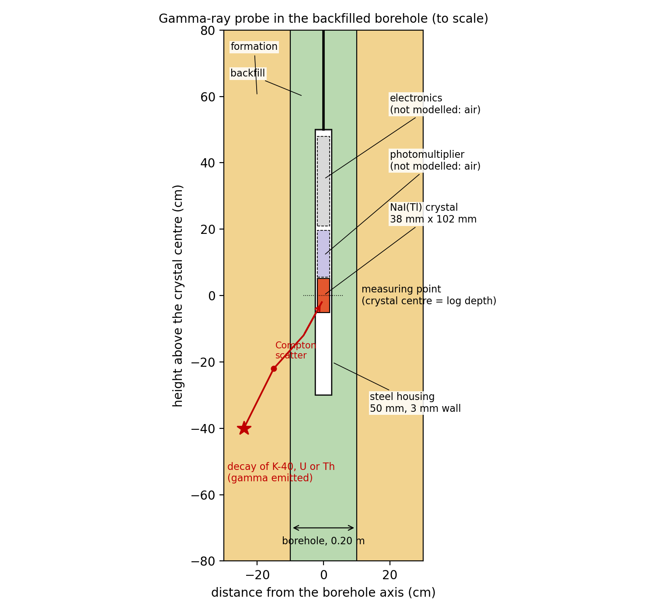
Figure 1. The gamma-ray probe in the backfilled borehole, to scale. A gamma ray emitted by a decay in the formation Compton-scatters on its way and is absorbed in the NaI(Tl) crystal. The photomultiplier and electronics are not modelled: the housing above the crystal is filled with air.

4. From Python to Geant4
The simulation is a chain of four steps:
- run_combined.py: the user’s settings (layers, K/U/Th of each layer, borehole diameter, backfill materials).
- geometry_class/gamma_geometry.py: turns the settings into numbers (material compositions, activities in decays/s/m³, gamma lines) and writes one plain-text input file per process.
- gammalog.exe: 24 copies run in parallel, each on a share of the tool stations; each writes a CSV of count rates and spectra.
- gamma_geometry.py again: reads the CSVs and converts them to count rates (counts/s), API units, apparent K, U, Th and their statistical errors.

5. Inputs

5.1 Physical inputs
Input | Where it comes from
Layer depths | Setting LAYERS (the same as for the ERT and EM simulations)
Layer material and K, U, Th | Setting GR_LAYERS; concentrations per unit bulk (wet) mass
Borehole diameter and depth | BOREHOLE_DIAM, BOREHOLE_LENGTH
Backfill material and K, U, Th | Setting GR_BACKFILL_SWEEP; one simulation per backfill
Material compositions | MATERIALS in gamma_geometry.py: minerals (quartz, clay, calcite, cement) mixed with pore water at a given porosity, which gives bulk density and element mass fractions
Activity per concentration | 1 % K = 313 Bq/kg K-40; 1 ppm U = 12.35 Bq/kg U-238; 1 ppm Th = 4.06 Bq/kg Th-232 (IAEA-TECDOC-1363)
Gamma lines | K-40 (1.461 MeV) and the main lines of the U-238 and Th-232 decay series in secular equilibrium (e.g. Bi-214 at 0.609, 1.120, 1.764 MeV; Tl-208 at 2.614 MeV)
Tool | NaI(Tl) crystal 38 mm × 102 mm in a 50 mm steel housing with 3 mm walls, centred in the hole; resolution 7 % FWHM at 662 keV
Cross sections | Geant4 data sets G4EMLOW, G4ENSDFSTATE and PhotonEvaporation
Table 1. Physical inputs of the gamma-ray simulation.

5.2 The input file
The Python wrapper writes a plain-text input file of keywords for each Geant4 process. The user never edits it, but it shows exactly what Geant4 receives:
Keyword | Example | Meaning
events | 150000 | Photons simulated per station and nuclide group
source | 1.0 0.15 0.5 | Source sphere radius (m), importance-sampling length (m), extra transport margin (m)
resolution | 0.07 | NaI resolution, FWHM/E at 662 keV
spectrum | 300 3.0 0.1 | Spectrum bins, maximum energy (MeV), gross-count threshold (MeV)
material | 3 mix 2.159 4 14 0.42 8 0.53 ... | Material id, bulk density (g/cm³), then (atomic number, mass fraction) pairs; or a Geant4 NIST material
group | K 1 1.4608 0.1066 | Nuclide group: number of lines, then (energy MeV, photons per decay) pairs
window | K_win 1.37 1.57 | Spectral window (MeV)
layer | 0 5 3 7.2e5 2.7e4 8.8e3 | Top and bottom depth (m), material id, activity of K, U, Th (decays/s/m³)
zone | 0.10 4 4.5e5 1.8e4 4.6e3 | Borehole fill: outer radius (m), material id, activities
hole | 15 | Borehole depth (m)
tool | 0.019 0.102 0.022 0.025 ... | Crystal radius and length, housing inner and outer radius, housing extent below and above the crystal centre, materials
stations | 0.5 0.6 0.7 ... | Depths of the crystal centre (m)
Table 2. Keywords of the gammalog input file.

6. How the geometry is defined
For every tool station the program rebuilds the model around the crystal (function Detector::Construct in gammalog.cc). The local origin is the crystal centre, with z pointing up. The construction has four steps:
- Collect all radial boundaries: crystal radius, housing inner and outer radius, the outer radius of each borehole fill zone, and the outer edge of the model.
- Collect all depth boundaries: layer tops and bottoms, the borehole bottom, the ground surface, and the ends of the crystal and of the housing.
- These boundaries cut space into a grid of rings. Each ring is a G4Tubs, a hollow 3D cylinder over the full 360°.
- The material of each ring is looked up at its midpoint (function RegionAt): crystal, then housing, then air above ground, then borehole fill if inside the hole, otherwise the layer at that depth.
There is no casing in the example. The borehole is open hole filled with backfill, out to the borehole wall at r = 10 cm. The only steel in the model is the 3 mm wall of the logging probe itself (Figure 2, grey). It is part of the tool, is the same with and without the borehole, and is included in the calibration, so it does not bias the borehole effect. A casing can be added as an extra fill zone (zones parameter), e.g. a PVC or steel pipe of given radius and thickness.
This gives about 50 to 100 solid 3D volumes per station. The model extends 1.5 m around the crystal. Photons emitted further away essentially never reach the detector (more than ten attenuation lengths of rock), and photons that leave the model are lost. Rebuilding the model at every station is simple and exact: as the tool moves, layer boundaries cross the housing and crystal at different heights.
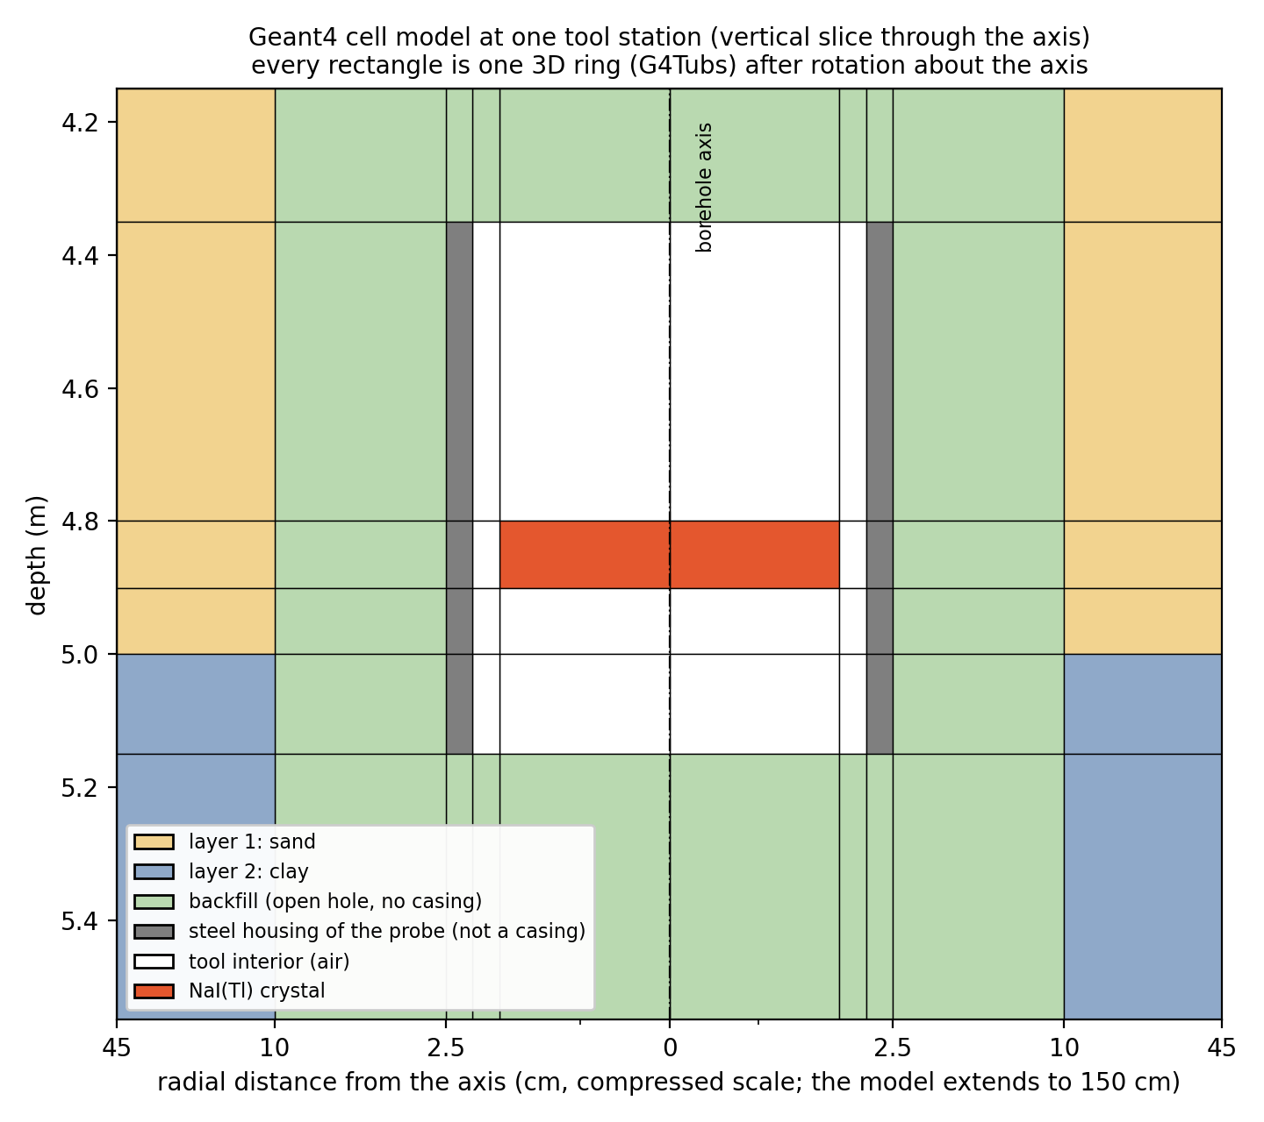
Figure 2. Vertical slice through the borehole axis at one station, with the crystal just above a sand/clay boundary. Every rectangle is one 3D ring after rotation about the axis. The grey ring is the steel housing of the probe; the hole itself has no casing. The radial axis is compressed to show the thin housing.

Radii
In the model, a radius is always a horizontal distance from the borehole axis, except the source radius, which is measured in every direction from the crystal centre. Table 3 lists all radii; Figure 3 shows them in a horizontal section through the crystal.
Radius | Value | Meaning
Crystal radius | 1.9 cm | Half the crystal diameter (38 mm); setting crystal_diameter
Housing inner / outer radius | 2.2 / 2.5 cm | Steel wall of the probe (50 mm, 3 mm wall); tool_diameter, housing_thickness
Borehole radius | 10 cm | Half of BOREHOLE_DIAM (0.20 m). Between 2.5 and 10 cm: backfill. Beyond: formation
50 % of the signal | 11 cm (18 cm) | Half of the counts come from inside this radius; no borehole (water-filled hole). See section 9
90 % of the signal | 29 cm (35 cm) | Radius of investigation of the tool; no borehole (water-filled hole)
Source radius | 1.0 m | Gamma rays are emitted within this distance of the crystal centre; source_radius
Model edge | 1.5 m | Outer radius (and half height) of the model; photons that leave it are lost
Table 3. Radii in the model.
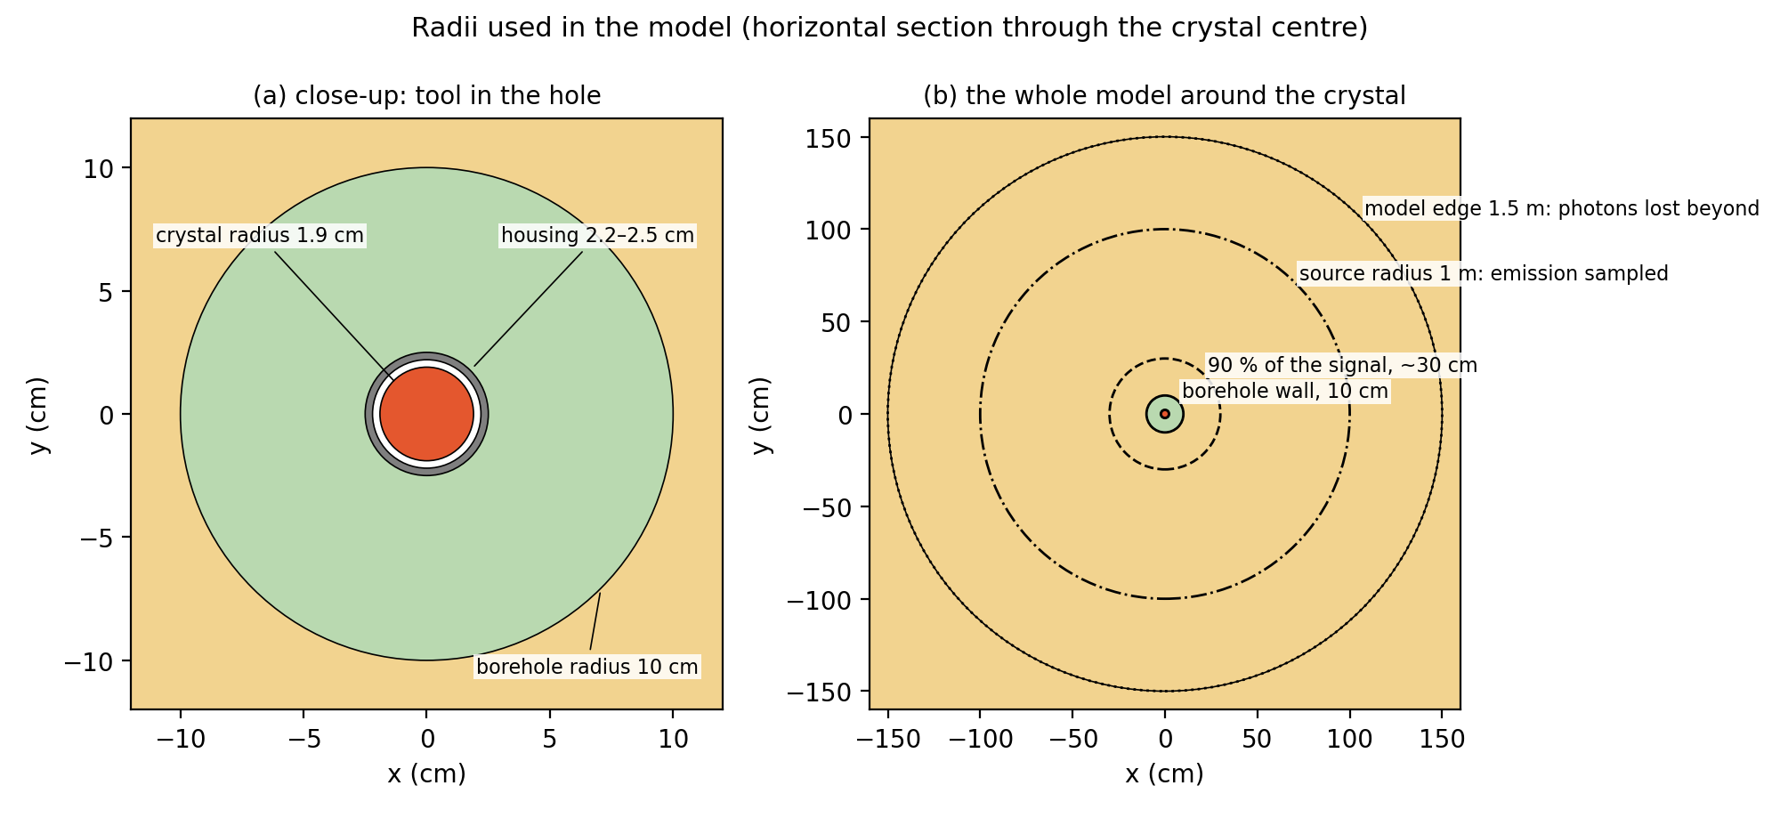
Figure 3. Horizontal section through the crystal centre. (a) The probe in the backfilled hole. (b) The whole model: 90 % of the counts come from within about 30 cm of the axis, gamma rays are emitted out to 1 m, and the model ends at 1.5 m.

7. What happens to each photon
At each station the program runs separately for the K, U and Th groups:
- Source. An emission point is chosen within 1 m of the crystal; its activity comes from the material there (zero inside the tool and in air). A gamma line of the group is picked according to its yield, and a random 3D direction.
- Transport. Geant4 moves the photon through the 3D volumes and lets it interact. Each Compton scatter changes its direction in 3D and lowers its energy.
- Detection. Every step inside the NaI crystal adds its deposited energy to the event total. At the end of the event the total is blurred by the detector resolution and becomes one pulse in the spectrum. Pulses above 0.1 MeV count in the gross count; pulses between 1.37 and 1.57 MeV also count in the K window, and so on.
- Variance reduction. Emission points near the crystal are sampled more often and given smaller weights; photons that move towards the crystal are split into copies, and photons that move away play Russian roulette. Electrons created outside the crystal are not followed, because they deposit their energy locally. These techniques make the run much faster without changing the expected result.
- Result. The sum of the pulse weights divided by the number of trials is an absolute count rate in counts per second. Repeating the run with the hole filled with formation gives the no-borehole reference; the ratio of the two is the borehole effect.

8. Is it a 3D simulation?
Fully simulated in 3D | Assumed to be symmetric
Photon paths, scattering angles and energies | The tool is centred on the borehole axis
Shielding by the backfill, the housing and the crystal from every direction | Layers are horizontal and the borehole is vertical
Radiation reaching the crystal from above, below and the sides | Each layer and fill zone is uniform all around the hole
Table 4. What is three-dimensional and what is assumed symmetric.
An off-centre tool, a dipping bed or an eccentric hole would need the geometry to be built differently (boxes or shifted cylinders instead of coaxial rings). Geant4 handles such geometries without difficulty; only the Construct and RegionAt functions would change.

9. How far the tool sees
A gamma-ray tool does not measure a point. It averages the radiation from a volume around the crystal, whose size is set by how far gamma rays travel in rock: about 10 cm on average before their first interaction. The size of this volume controls both the borehole effect (radially) and the effect of bed thickness (vertically).

9.1 Radially: radius of investigation
To measure it, the formation was made radioactive only inside a cylinder of radius R around the axis, and R was increased until the full count rate was reached (sand, K = 1.2 %, U = 1.5 ppm, Th = 6 ppm). Figure 4 shows the share of the count rate that comes from inside R.
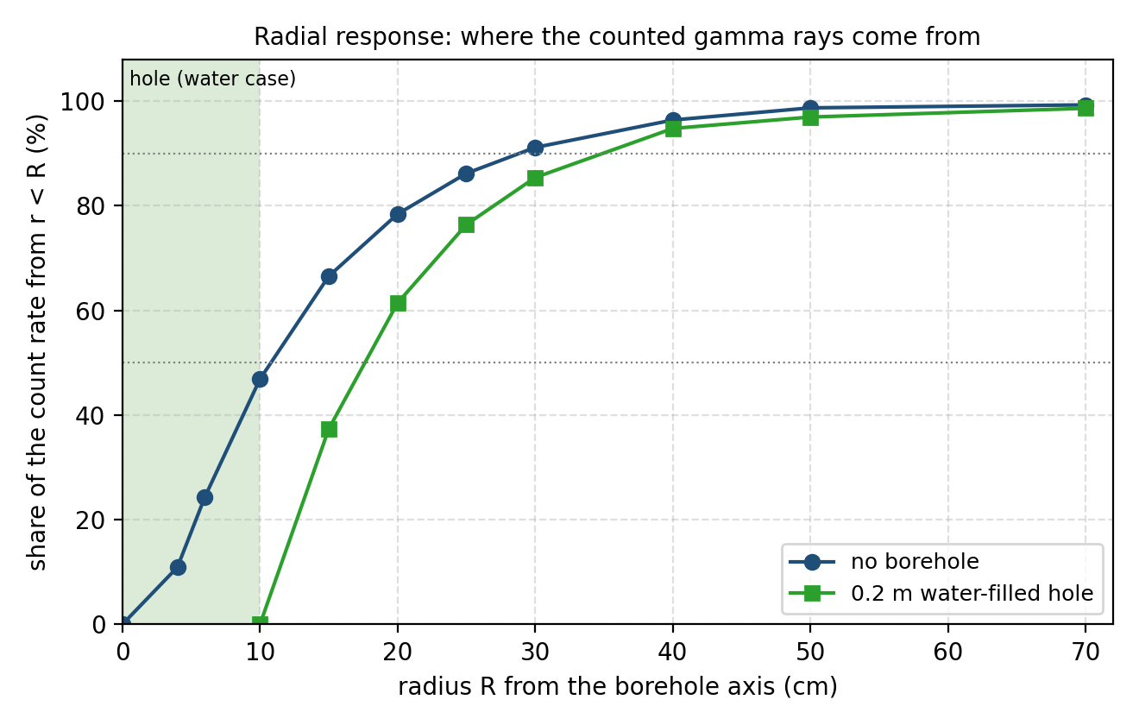
Figure 4. Radial response of the gamma-ray probe, simulated with Geant4: share of the count rate that comes from within radius R of the borehole axis.
- Without a borehole, half of the counts come from within 11 cm of the axis and 90 % from within 29 cm.
- In a 0.2 m water-filled hole, the first 10 cm are water, so the tool looks further: 50 % within 18 cm, 90 % within 35 cm.
- The backfill therefore replaces the part of the formation that the tool weights most. This is why the borehole effect is large and why the radioactivity of the backfill matters as much as its density.

9.2 Vertically: bed boundaries and bed thickness
For the same reason a bed boundary does not appear as a step on the log. Figure 5a shows the simulated logs across the clay/gravel boundary at 10 m depth. The log changes over a few decimetres, and the half-way point is exactly at the boundary: picking the half-amplitude point is the right way to place a bed boundary on a GR log.
Hole | 10–90 % transition width | Smoothing length σ
No borehole | 26 cm | 10 cm
Bentonite grout in a 0.2 m hole | 36 cm | 14 cm
Water in a 0.2 m hole | 39 cm | 15 cm
Table 5. Width of a bed boundary on the simulated GR log (fitted error-function step).
A thin bed is affected from both sides: if it is thinner than the averaging length, its reading never reaches its true value. A thin shale between sands reads too low, a thin sand between shales too high. Table 6 and Figure 5b give the reading at the centre of a bed, as a share of its true contrast with the beds around it.
Bed thickness | No borehole | Bentonite-filled hole | Water-filled hole
0.10 m | 38 % | 28 % | 26 %
0.20 m | 68 % | 53 % | 49 %
0.30 m | 87 % | 72 % | 68 %
0.50 m | 99 % | 93 % | 90 %
0.75 m | 100 % | 99 % | 99 %
1.00 m | 100 % | 100 % | 100 %
Table 6. Reading at the centre of a thin bed, as a share of its true contrast with the surrounding beds.
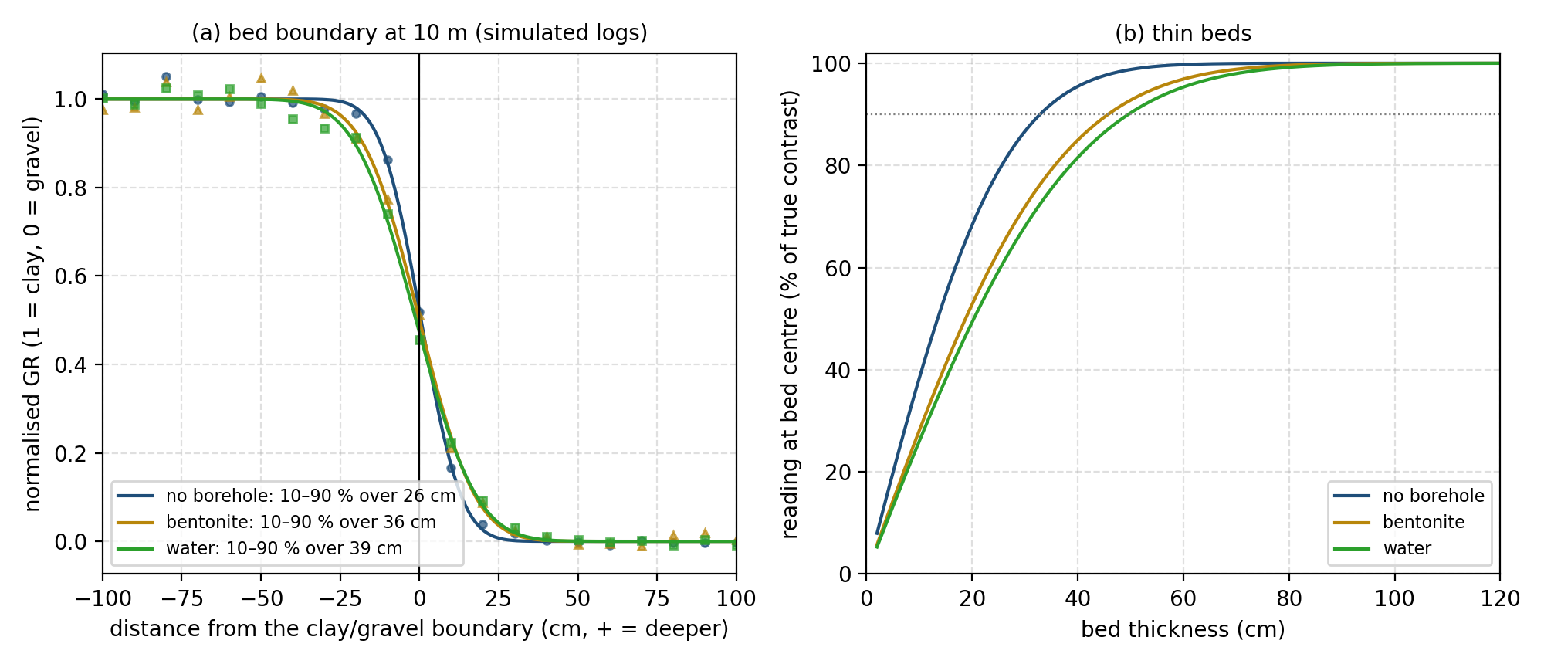
Figure 5. (a) Simulated GR across the clay/gravel boundary at 10 m (points) with fitted steps (lines), normalised to the two bed values. (b) Reading at the centre of a thin bed derived from these steps.
- Beds thicker than about 0.75 m read their true value in the middle. The 5 m beds of the example model are well above that, so their mid-bed values show the borehole effect alone.
- Beds of 0.2–0.5 m are underestimated, and the borehole makes this worse: a 20 cm shale streak shows only about half of its contrast in a water-filled hole.
- The values come from a fitted smooth step; the true response has slightly longer tails, so for 0.5–0.75 m beds the real reading may be a few percent lower. A real log is blurred further by the tool moving during the counting time, which this static simulation does not include; field gamma-ray tools quote a vertical resolution of 30–60 cm.

10. Outputs and validation
For each station, GammaGeometry.run() returns the gross count rate and its Monte Carlo error, the count rate from each nuclide group, the K, U and Th window count rates, apparent K, U and Th, the gamma ray in API units and the true API value of the layer. The conversion to API uses one calibration factor (counts/s per API), obtained from a simulated infinite formation, as for a gross-count tool calibrated in the API pit.
The simulation was checked against three references:
- In an infinite homogeneous formation the count rate per unit mass concentration does not depend on bulk density. The simulation reproduces this within 1 % from 1.6 to 2.7 g/cm³.
- A 0.2 m (8 inch) water-filled hole with a centred 50 mm tool reduces the gross count rate to 0.76 of the no-hole value; the service-company correction charts give about 0.77.
- The analog OpenMC code, run on the same problem, gives the same count rates per unit concentration within its statistical error (Geant4 / OpenMC: K 43.0 / 45.3 ± 3.6 %, U 22.2 / 21.0 ± 4.3 %, Th 8.91 / 9.22 ± 3.7 % counts/s).

11. K, U and Th of geological materials
The table gives representative concentrations of potassium, uranium and thorium in common rocks, sediments, minerals and borehole materials. Use them to fill GR_LAYERS and GR_BACKFILL_SWEEP in run_combined.py when no core or spectral gamma-ray data are available. The first number is a typical value, the range in brackets covers most published measurements. The API column is the standard estimate 16 K + 8 U + 4 Th from the typical values.
Natural variability is large: the same rock type can vary by an order of magnitude between sites. Local measurements (core assays, spectral gamma-ray logs, laboratory gamma spectrometry of the grout) should always take precedence.
Material | K (%) | U (ppm) | Th (ppm) | API | Note
Igneous rocks
Granite | 3.5 (2–5) | 4.5 (2–15) | 18 (8–50) | 164
Rhyolite | 3.6 (2–5.5) | 4.5 (2–8) | 16 (6–30) | 158
Granodiorite | 2.5 (1.5–3.5) | 2.6 (1–5) | 9 (5–20) | 97
Andesite | 1.7 (0.8–3) | 1.2 (0.5–3) | 4 (1–10) | 53
Basalt | 0.8 (0.2–2) | 0.5 (0.1–1.5) | 2 (0.5–5) | 25
Gabbro | 0.5 (0.1–1) | 0.5 (0.1–1.5) | 1.5 (0.3–4) | 18
Peridotite, dunite (ultramafic) | 0.02 (<0.1) | 0.02 (<0.1) | 0.05 (<0.2) | 1 | lowest GR of all rocks
Metamorphic rocks
Gneiss | 2.5 (1–4) | 3 (1–8) | 12 (5–25) | 112
Mica schist | 2.5 (1–4) | 2.5 (1–5) | 10 (5–20) | 100
Amphibolite | 0.6 (0.2–1.5) | 0.7 (0.2–2) | 2 (0.5–5) | 23
Quartzite | 0.4 (0.1–1.5) | 0.6 (0.2–2) | 2 (0.5–5) | 19
Marble | 0.1 (<0.5) | 1 (0.2–3) | 0.5 (0.1–2) | 12
Sedimentary rocks
Shale (world average) | 2.7 (1.5–4) | 3.7 (2–6) | 12 (8–18) | 121
Black (organic-rich) shale | 2.5 (1–4) | 20 (5–>100) | 10 (5–15) | 240 | U bound to organic matter
Mudstone, claystone | 2 (1–3.5) | 3 (1.5–5) | 10 (6–15) | 96
Siltstone | 1.8 (1–3) | 2.5 (1–4) | 8 (4–12) | 81
Greywacke | 1.5 (1–2.5) | 2 (1–3) | 7 (4–10) | 68
Arkose (feldspathic sandstone) | 2.5 (1.5–4) | 1.5 (0.5–3) | 5 (2–10) | 72 | high K from feldspar: 'hot' sand
Clean quartz sandstone | 0.3 (0.1–1) | 0.6 (0.2–1.5) | 2 (0.7–4) | 18
Limestone | 0.3 (0–1) | 2 (0.5–5) | 1.5 (0.2–3) | 27
Chalk | 0.1 (0–0.3) | 1.5 (0.5–3) | 0.8 (0.1–2) | 17
Dolomite | 0.2 (0–1) | 1.5 (0.2–4) | 0.8 (0.1–2) | 18
Phosphorite | 0.3 (0.1–1) | 100 (50–300) | 5 (1–20) | 825 | very high U
Halite, anhydrite, gypsum | 0.05 (<0.2) | 0.1 (<0.5) | 0.1 (<0.5) | 2
Sylvite, carnallite (potash salts) | 52 (15–52) | 0 | 0 | 832 | pure KCl: 52 % K
Coal | 0.2 (0.05–1) | 1.5 (0.5–5) | 3 (1–8) | 27 | rises with ash content
Clay and K-bearing minerals
Kaolinite | 0.4 (0–0.6) | 2 (1.5–3) | 12 (6–19) | 70
Illite | 4.5 (3.5–8) | 1.5 (1–5) | 15 (10–25) | 144
Smectite (montmorillonite) | 0.2 (0–1.5) | 3 (2–5) | 18 (14–24) | 99
Chlorite | 0.1 (0–0.4) | 1 (0.5–2) | 4 (3–5) | 26
Glauconite | 5 (3.2–5.8) | 1 (0.5–2) | 4 (2–8) | 104
K-feldspar (orthoclase, microcline) | 12 (10–14) | 1 (0.2–3) | 3 (0.5–5) | 212
Muscovite, biotite | 8 (6–9) | 2 (0.5–5) | 10 (1–25) | 184
Unconsolidated sediments
Glacial till, boulder clay | 1.8 (1–2.5) | 2 (1–3) | 8 (5–12) | 77
Loess | 1.8 (1.3–2.2) | 2.5 (2–3.5) | 9 (7–12) | 85
Marine / lacustrine clay | 2.2 (1.5–3) | 2.5 (1.5–4) | 10 (7–14) | 95
Fluvial sand and gravel | 0.6 (0.2–1.5) | 0.8 (0.3–1.5) | 2.5 (1–5) | 26
Peat | 0.1 (<0.5) | 1 (0.2–5) | 0.5 (<2) | 12
Heavy-mineral sand (monazite, zircon) | 0.3 | 20 (5–50) | 200 (50–>1000) | 965 | extreme Th
Borehole fill and drilling materials
Bentonite (pure clay, dry) | 0.5 (0.2–1.5) | 4 (2–8) | 20 (10–40) | 120
Bentonite grout (as mixed, ~1.4 g/cm³) | 0.3 | 2 | 8 | 53 | value used in run_combined.py
Portland cement | 0.5 (0.2–1) | 3 (1–6) | 6 (2–10) | 56
Cement grout (as mixed, ~1.85 g/cm³) | 0.35 | 2 | 4 | 38 | value used in run_combined.py
Quartz filter sand | 0.3 (0.1–0.5) | 0.5 (0.2–1) | 1.5 (0.5–3) | 15 | value used in run_combined.py
Fresh water, fresh-water mud | 0 | 0 | 0 | 0
Seawater (35 g/kg NaCl) | 0.04 | 0.003 | 0 | 1 | same GR effect as fresh water
KCl mud (5 % KCl) | 2.6 (1–4) | 0 | 0 | 42 | potassium in the hole raises the GR
Table 7. Representative K, U and Th concentrations (per unit mass) and the corresponding API gamma ray. Compiled from IAEA-TECDOC-1363 (2003), Dickson & Scott (1997), Ellis & Singer (2007), Rider & Kennedy (2011) and Serra (1984); values are rounded typical values, not measurements.
Patterns worth remembering:
- Shales and clays are radioactive mainly because of K in illite and mica and Th adsorbed on clay minerals; this is why the GR log is used as a shale indicator.
- High GR does not always mean shale: arkose (K-feldspar), mica-rich sands, glauconite, heavy-mineral sands (Th) and phosphatic or organic-rich rocks (U) are ‘hot’ without being shaly. Spectral GR (separate K, U, Th) resolves this.
- Clean quartz sand, limestone, dolomite, evaporites and coal have low GR (< 30 API).
- The Th/U ratio indicates the environment: about 3–7 in most clastic sediments, below 2 in reducing marine and organic-rich deposits (U enrichment), above 7 in strongly weathered or continental deposits.
- Water resistivity does not affect the gamma ray: salt changes resistivity a hundredfold but density by only a few percent. In a 0.2 m hole, fresh water and seawater both reduce the count rate to 0.767 ± 0.006 of the no-hole value; a 5 % KCl brine gives 0.920, because of its potassium.
- Bentonite grout and cement are moderately radioactive. In a clean formation they can raise the GR reading; in a shale they lower it. Drilling muds with KCl add potassium directly in the hole.

12. References
Agostinelli, S. et al. (2003). Geant4 – a simulation toolkit. Nuclear Instruments and Methods in Physics Research A 506, 250–303.
Allison, J. et al. (2016). Recent developments in Geant4. Nuclear Instruments and Methods in Physics Research A 835, 186–225.
Dickson, B. L. and Scott, K. M. (1997). Interpretation of aerial gamma-ray surveys – adding the geochemical factors. AGSO Journal of Australian Geology and Geophysics 17(2), 187–200.
Ellis, D. V. and Singer, J. M. (2007). Well Logging for Earth Scientists, 2nd edition. Springer.
IAEA (2003). Guidelines for radioelement mapping using gamma ray spectrometry data. IAEA-TECDOC-1363, International Atomic Energy Agency, Vienna.
Rider, M. and Kennedy, M. (2011). The Geological Interpretation of Well Logs, 3rd edition. Rider-French Consulting.
Serra, O. (1984). Fundamentals of Well-Log Interpretation, Vol. 1: The Acquisition of Logging Data. Elsevier.

