Course Two

Get Started with Python


Instructions
Use this PACE strategy document to record decisions and reflections as you work through this end-of-course project. As a reminder, this document is a resource that you can reference in the future and a guide to help consider responses and reflections posed at various points throughout projects.

Course Project Recap
Regardless of which track you have chosen to complete, your goals for this project are:
- Understand and assess the proposed scenario
- Demonstrate understanding of the form and function of Python
- Show how data professionals leverage Python to load, explore, extract, and organize information through custom functions
- Articulate findings in a professional summary for cross-functional team members

Relevant Interview Questions
Completing this portfolio project will empower you to respond to the following interview topics:
- Describe the steps you would take to clean and transform an unstructured data set.
- What specific things might you look for as part of your cleaning process?
- What are some of the outliers, anomalies, or unusual things you might look for in the data cleaning process that might impact analyses or ability to create insights?

Reference Guide
This project has five tasks; the visual below identifies how the stages of pace are incorporated across those tasks.
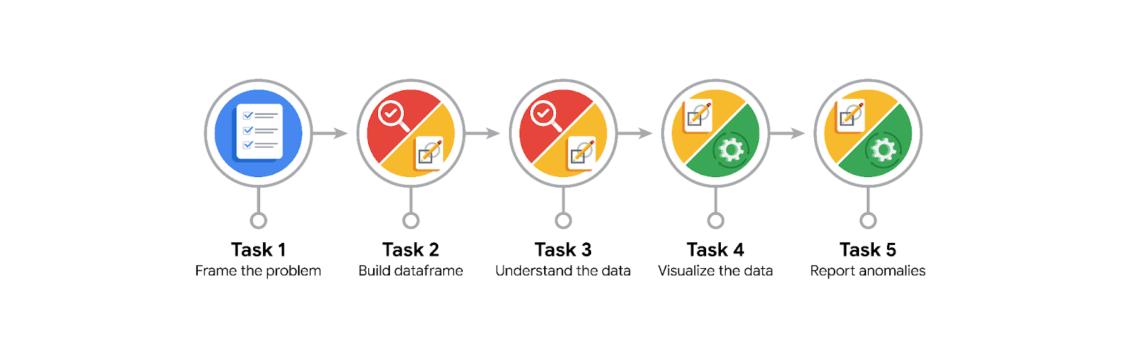

Data Project Questions & Considerations
PACE: Planning Stage

- How can you best prepare to understand and organize the provided information?

Thruought pandas does help a lot. Using functions like info(), and head() we can have a basic undertanding.

- What follow-along and self-review codebooks will help you perform this work?

Python documentation, pandas documentation, numpy documentation, Python pocket reference, Kaggle, and other websites.

- What are some additional activities a resourceful learner would perform before starting to code?
I’m on it already.

PACE: Analyzing Stage
- Will the available information be sufficient to achieve the goal based on your intuition and the analysis of the variables?

Yes. We have the data.

PACE: Constructing Stage
- How would you build summary dataframe statistics and assess the min and max range of the data?

Using the describe() function that returns formated information related to basic statistics.

- Do any data variables averages look unusual? Can you describe the interval data?

Some total amount were expensive, around 1200

PACE: Execute Stage

- Given your current knowledge of the data, what would you initially recommend to your manager to investigate further prior to performing exploratory data analysis?
Time analysis.

- What data initially presents as containing anomalies?

Trip distances.

- What additional types of data could strengthen this dataset?
Lenght of the trips.

