Course Three

Go Beyond the Numbers: Translate Data into Insights


Instructions
Use this PACE strategy document to record decisions and reflections as you work through this end-of-course project. You can use this document as a guide to consider your responses and reflections at different stages of the data analytical process. Additionally, the PACE strategy documents can be used as a resource when working on future projects.

Course Project Recap
Regardless of which track you have chosen to complete, your goals for this project are:
- Complete the questions in the Course 3 PACE strategy document. Done
- Answer the questions in the Jupyter notebook project file. Done
- Clean your data, perform exploratory data analysis (EDA) Done
- Create data visualizations Done
- Create an executive summary to share your results Done

Relevant Interview Questions
Completing the end-of-course project will help you respond these types of questions that are often asked during the interview process:
- How would you explain the difference between qualitative and quantitative data sources?
Quantitative has standard meassurements and doe snot refers to qualities, intead refers to meassurements. Qualitative meassure qualities that can be assigned by the specific use of the data.
- Describe the difference between structured and unstructured data.
Structurerd is data that has been intentionally bring to desires data types, shapes and group. The other one has no intentional organization.
- Why is it important to do exploratory data analysis?
Allows us to explore, discover and unmask trends.
- How would you perform EDA on a given dataset?
With python, pandas, numpy, excel, stadistics and visualizations. Also there is necesity to undesrtand some basic consepts.
- How do you create or alter a visualization based on different audiences?
Always having in mind what is the best way to communicate clearly.
- How do you avoid bias and ensure accessibility in a data visualization?
Use right scales, and unbias data.
- How does a data visualization inform your EDA?
Data visuals are able to explain complicated concepts

Reference Guide
This project has six tasks; the visual below identifies how the stages of PACE are incorporated across those tasks.
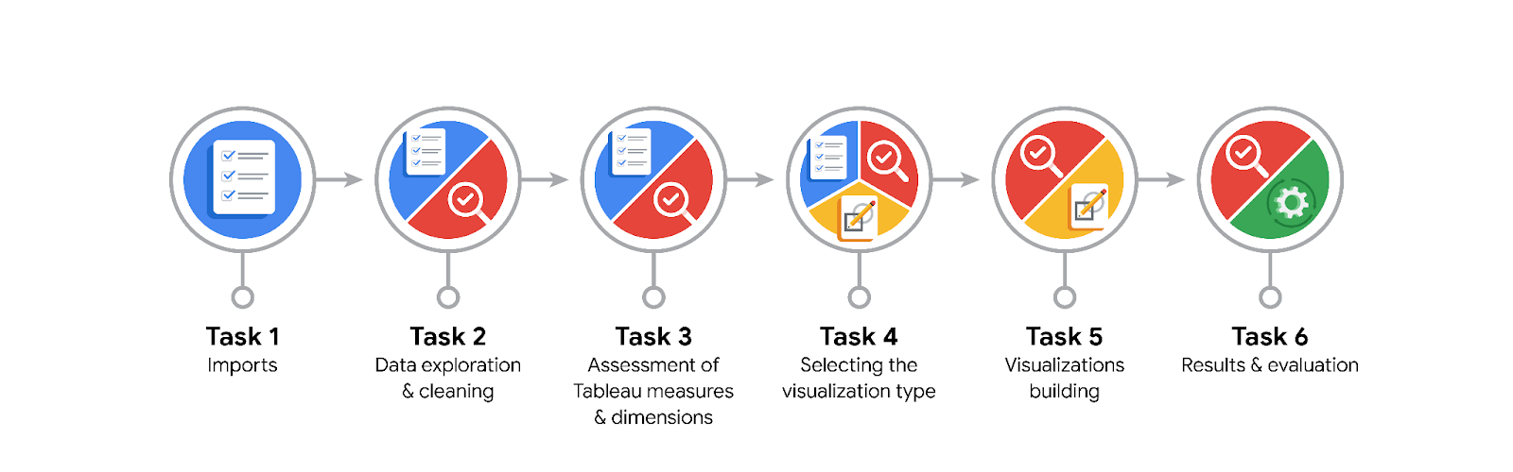
Data Project Questions & Considerations

PACE: Planning Stage
- What are the data columns and variables and which ones are most relevant to your deliverable?

'Unnamed: 0', 'VendorID', 'tpep_pickup_datetime',
'tpep_dropoff_datetime', 'passenger_count', 'trip_distance',
'RatecodeID', 'store_and_fwd_flag', 'PULocationID', 'DOLocationID',
'payment_type', 'fare_amount', 'extra', 'mta_tax', 'tip_amount',
'tolls_amount', 'improvement_surcharge', 'total_amount'

- What units are your variables in?
Unnamed: 0 int64
VendorID int64
tpep_pickup_datetime datetime64[ns]
tpep_dropoff_datetime datetime64[ns]
passenger_count int64
trip_distance float64
RatecodeID int64
store_and_fwd_flag object
PULocationID int64
DOLocationID int64
payment_type int64
fare_amount float64
extra float64
mta_tax float64
tip_amount float64
tolls_amount float64
improvement_surcharge float64
total_amount float64
travel_time int64

- What are your initial presumptions about the data that can inform your EDA, knowing you will need to confirm or deny with your future findings?
That there was no missing data, but there was missing data.

- Is there any missing or incomplete data?

Yes, the Trips with 0 distance.

- Are all pieces of this dataset in the same format?

No, some transformations were necessary.

- Which EDA practices will be required to begin this project?

Having in mind the PACE stages, the follwoing are the steps to consider for EDA

- Determineate state of the data observing
- Data types
- Missing information
- Validate inputs
- Distributions
- Detrminate Outliers
- Verify as we go
- Determinate if transformations or restructurizations are neccesary
- String data into Date/Time objects
- Creation of new columns based on known information
- Construct Visualizations

- Determinate insights, recommendations, new formulated questions from the observed

PACE: Analyzing Stage
- What steps need to be taken to perform EDA in the most effective way to achieve the project goal?

Determinate the following
- Data types
- Missing information
- Validate inputs
- Distributions
- Detrminate Outliers
- Verify as we go

- Do you need to add more data using the EDA practice of joining? What type of structuring needs to be done to this dataset, such as filtering, sorting, etc.?

- Determinate if transformations or restructurizations are neccesary
- String data into Date/Time objects
- Creation of new columns based on known information
- Construct Visualizations

- What initial assumptions do you have about the types of visualizations that might best be suited for the intended audience?

Scatterplot will show us nice info.

PACE: Constructing Stage
- What data visualizations, machine learning algorithms, or other data outputs will need to be built in order to complete the project goals?

Scatter plots, bar plots, histograms.
Statistic meassurements
modules and libreries.

- What processes need to be performed in order to build the necessary data visualizations?

Clean data, have no missing values, we can use or not outliers when visualizing.

- Which variables are most applicable for the visualizations in this data project?

Total amount, distance. Could be also time traveling.

- Going back to the Plan stage, how do you plan to deal with the missing data (if any)?

Delete them. Maybe contact NYC taxi company to obatain some clarifications on that.

PACE: Execute Stage
- What key insights emerged from your EDA and visualizations(s)?

Relationships between variables, outliers.

- What business and/or organizational recommendations do you propose based on the visualization(s) built?
So far to mantain good practices in introducing data,

- Given what you know about the data and the visualizations you were using, what other questions could you research for the team?

Usage by different time frames and adjustment nessary.

- How might you share these visualizations with different audiences?

In a way that audiencies

