

Tittle: | MNP_PORTOUT_REQ_IN_JMSQ_ERRORQ
Product: | OSB
Customer: | IMPACT
Scope Of Change: | MNP_PORTOUT_REQ_IN_JMSQ_ERRORQ
Approval:

Document Control

1.1 Version History
Sl. No | Date | Author | Version | Change Reference
 |  | Mauricio Quintero | 1.1 | ss.

1.2 Reviewers
Sl. No | Reviewer | Position | Stream | Organization

1.3 Scope and Purpose of the document
This document is intended to provide a procedure to move any messages stuck in the “MNP_PORTOUT_REQ_IN_JMSQ_ErrorQ” queue to the normal “MNP_PORTOUT_REQ_IN_JMSQ” queue for processing the messages.

1.4 Content
Table of Contents
1 Document Control 2
1.1 Version History 2
1.2 Reviewers 2
1.3 Scope and Purpose of the document 2
1.4 Content 3
2 System Overview 4
2.1 Introduction 4
2.2 System Impact 4
2.3 Operational Practice 4
2.4 Defeminations, Acronyms, Abbreviations 4
2.5 Assumptions, Dependencies, Constraints, Decisions 4
2.6 References 4
3 Step-by-step instructions 5
Appendix 7

System Overview

Introduction
The “MNP_PORTOUT_REQ_IN_JMSQ” is included in “JMS Modules”, JMS modules contain configuration resources, such as standalone queue and topic destinations, distributed destinations, and connection factories, and are defined by XML documents that conform to the weblogic-jms.xsd schema. This queue is used in creating Port-out order, “PortOut Response Message” received from API Gateway will be processed in OSB service “MNPPortOutIB” and placed in JMS “MNP_PORTOUT_REQ_IN_JMSQ” queue for Siebel consumption and processing.
In Case of Error, rollback JMS message to “MNP_PORTOUT_REQ_IN_JMSQ_ErrorQ” queue after redelivery limit reached in source “MNP_PORTOUT_REQ _IN_JMSQ” queue.

System Impact
The operational procedure in this document can be performed when messages need to be resubmitted from the “MNP_ PORTOUT _REQ_IN_JMSQ_ErrorQ” queue.

Operational Practice
It is expected that operational staff check whether, once the messages in the error queues were moved to the main or normal queue, they have finished processing or are back in the error queues, if that happens, the problem should be reported, since moving messages from the error queues is not solving the issue.

Defeminations, Acronyms, Abbreviations

Assumptions, Dependencies, Constraints, Decisions
Sl. No | Assumptions
1. | There are “messages pending” or “messages current” in any error queues: “MNP_PORTOUT_REQ_IN_JMSQ_ErrorQ”
2.

References
Sl. No | Document Name | Document Description
1.
2.

Step-by-step instructions
Steps to be followed.

- Login to OSB http://172.20.10.38:7001/console

Go to JMS Module:

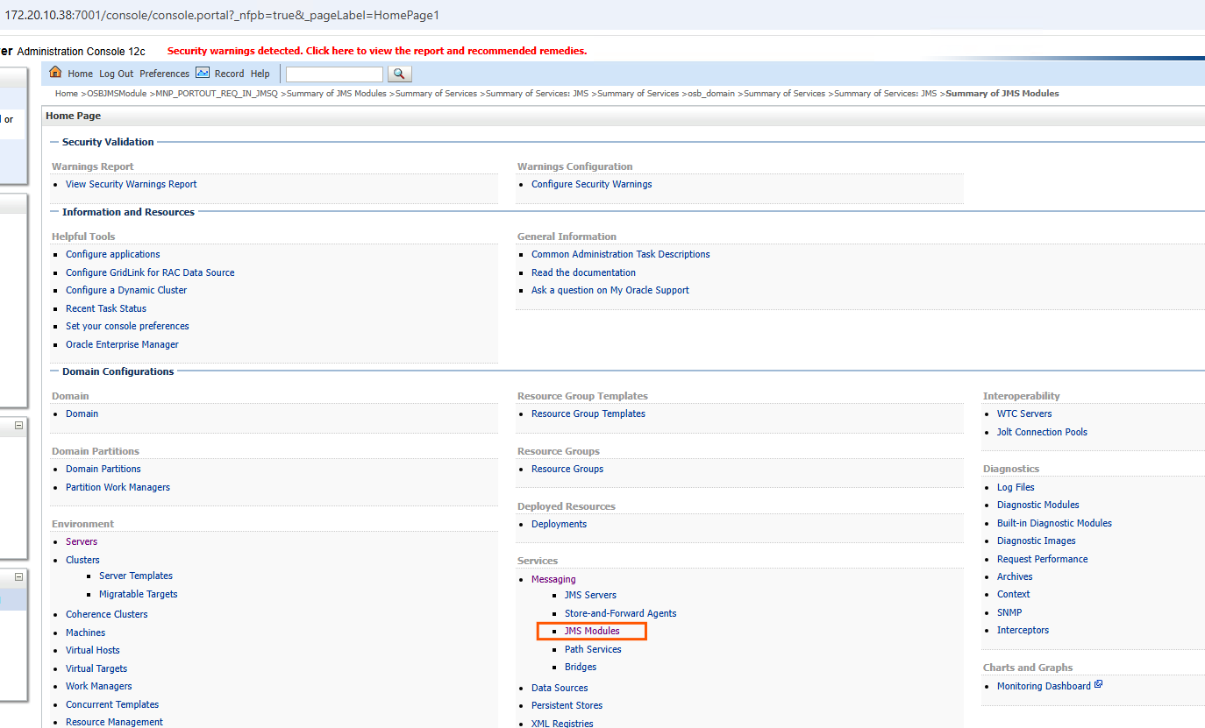

- Monitor “MNP_PORTOUT_REQ_IN_JMSQ_ErrorQ”:

Go to Summary of JMS Modules OSBJMSModule:

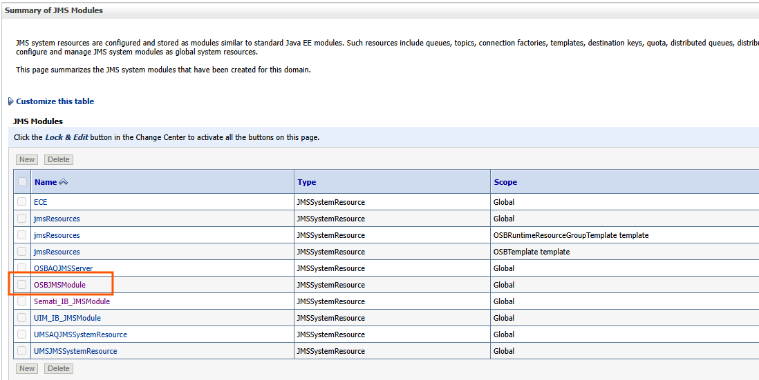

- Check if there are any messages stuck follow the bellow steps and move them to the normal queue “MNP_PORTOUT_REQ_IN_JMSQ”

Go to the error queue “MNP_PORTOUT_REQ_IN_JMSQ_ErrorQ”
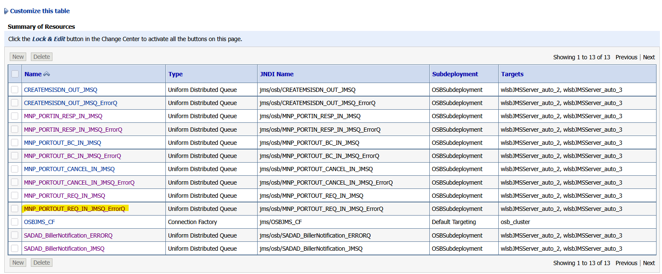

Go to “Monitoring”: Check if there are any pending messages under the Messages Current and select the check box where the count is displayed as shown below and click on “Show Messages”.

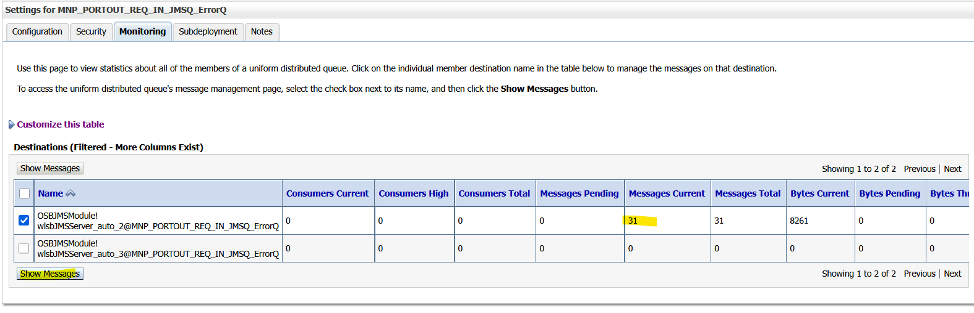
Select All and then “Move” “Move All”:
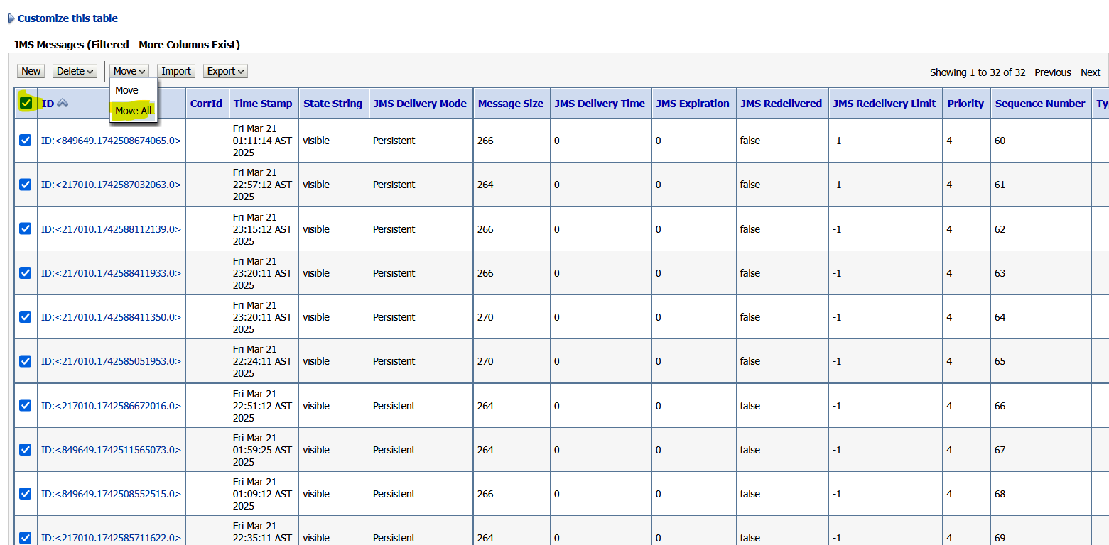
Here select the JMS Server as “wlsbJMSServer_auto_2” and click “Next” as shown below and then click on “Finish”.
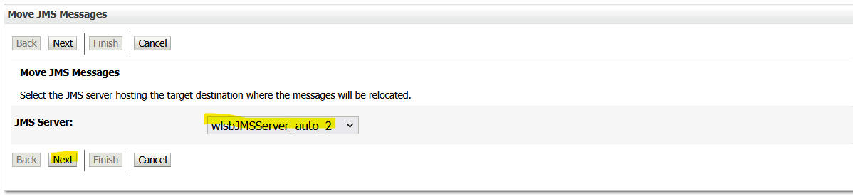

Appendix
Ongoing Work
Sl. No. | Activity | Work Description | Owner

Common problems
Sl. No. | Defect/Bug ID | Identification Phase | Issue Resolution

Known Issues
Sl. No. | Defect/Bug ID | Identification Phase | Issue Resolution

