

Tittle: | SOP_AIA_RESUME_STUCK_MESSAGES_OSM(COM/SOM) _SAF_QUEUES
Product: | AIA / OSM
Customer: | IMPACT
Scope Of Change: | SOP_AIA_RESUME_STUCK_MESSAGES_OSM(COM/SOM) _SAF_QUEUES
Approval:

Document Control

1.1 Version History
Sl. No | Date | Author | Version | Change Reference
 |  | Mauricio Quintero | 1.1 | Inclusion of technical information, scope and purpose, introduction, system impact, operational practice, and greater detail in the steps.
 |  | Balasaidulu Sadam | 1.2 | Inclusion of clean restart of moving tmp, cache and stage folder

1.2 Reviewers
Sl. No | Reviewer | Position | Stream | Organization

1.3 Scope and Purpose of the document
This document is intended to provide a procedure for resume sending stuck messages in any of the OSM SAF queues (COM/SOM) on the AIA weblogic server

1.4 Content
Table of Contents
1 Document Control 2
1.1 Version History 2
1.2 Reviewers 2
1.3 Scope and Purpose of the document 2
1.4 Content 3
2 System Overview 4
2.1 Introduction 4
2.2 System Impact 4
2.3 Operational Practice 4
2.4 Defeminations, Acronyms, Abbreviations 4
2.5 Assumptions, Dependencies, Constraints, Decisions 4
2.6 References 4
3 Step-by-step instructions 5
Appendix 9

System Overview

Introduction
OSM communicates asynchronously with Oracle AIA.
Oracle AIA delivers messages to OSM COM and SOM via Store and Forward (SAF) agent.
OSM COM, SOM consumes messages from OSM JMS Queues where AIA forwards the same via AIA SAF targeted to OSM COM and SOM SAF.

System Impact
The operational procedure in this document can be performed when AIA publishes a message to the SAF queue and this message is supposed to be pushed to the corresponding JMS queue on the OSM server, but this does not happen. So, the OSM server has not received any messages and there are no related log messages either.

Operational Practice
It is expected that operational staff check the below issues before executing this procedure:
- There are stuck messages in any of the OSM (COM/SOM) SAF queues of AIA WebLogic server (WebLogic console: ServicesMessagingStore-and-Forward AgentsmonitoringRemote Endpoints).
- Stuck messages count is increasing along with increase in the “SAF Downtime”.
- Screenshots for possible error reference, sometimes may be no error seen here and should be checked in AIA out log:

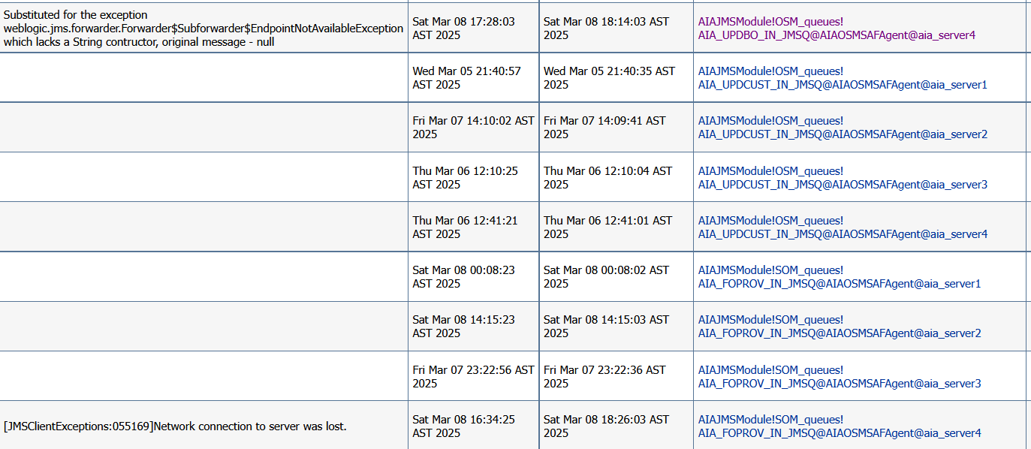

Defeminations, Acronyms, Abbreviations

Assumptions, Dependencies, Constraints, Decisions
Sl. No | Assumptions
1.
2.

References
Sl. No | Document Name | Document Description
1.
2.

SOP1: AIA RESUME STUCK MESSAGES OSM(COM/SOM) SAF QUEUES
Steps to be followed.
Step 1:
- Login to Weblogic console:
http://172.20.10.37:7001/console/
Enter username/password
username:weblogic
password:XXXXXXX
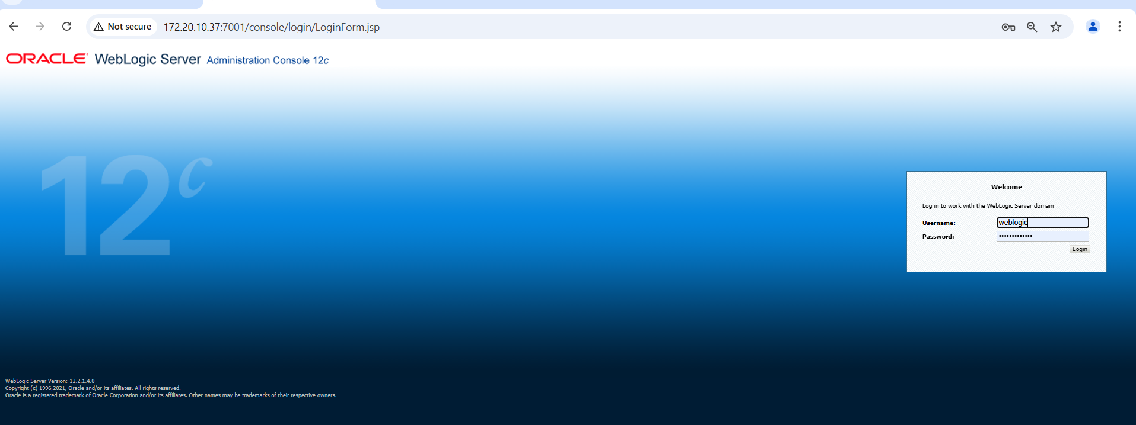

- Go to “SAF”: Home ServicesMessagingStore-and-Forward Agents
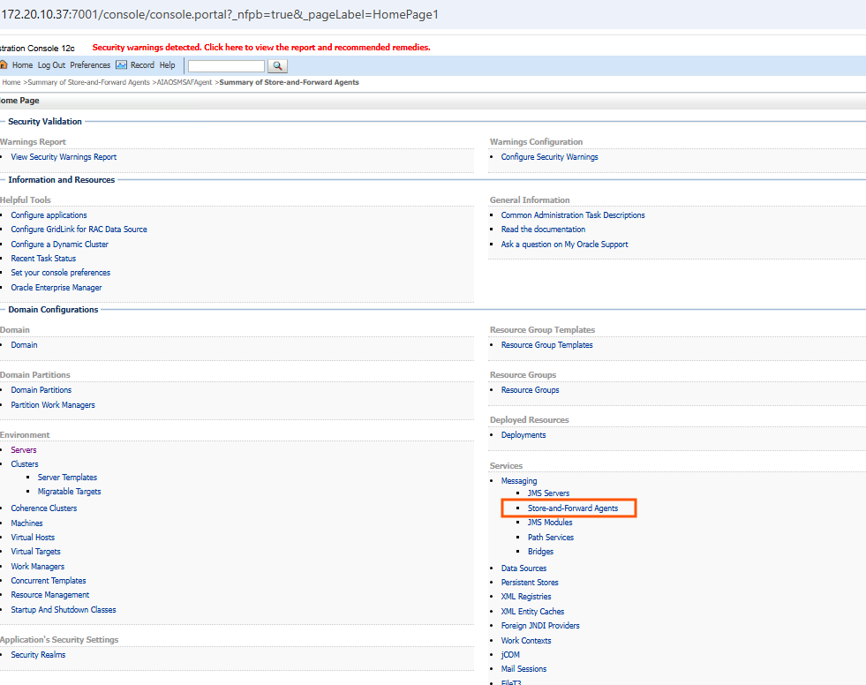
- Click on “AIAOSMSAFAgent” MonitoringStatistics
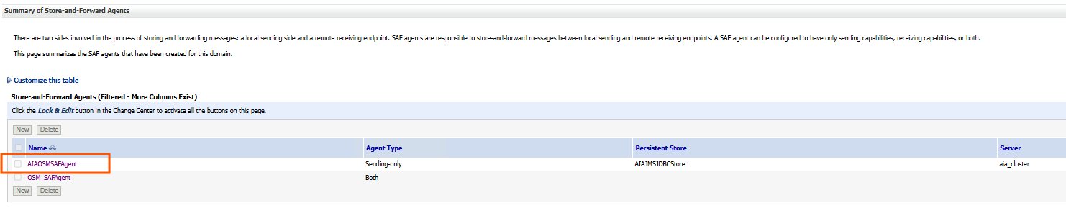

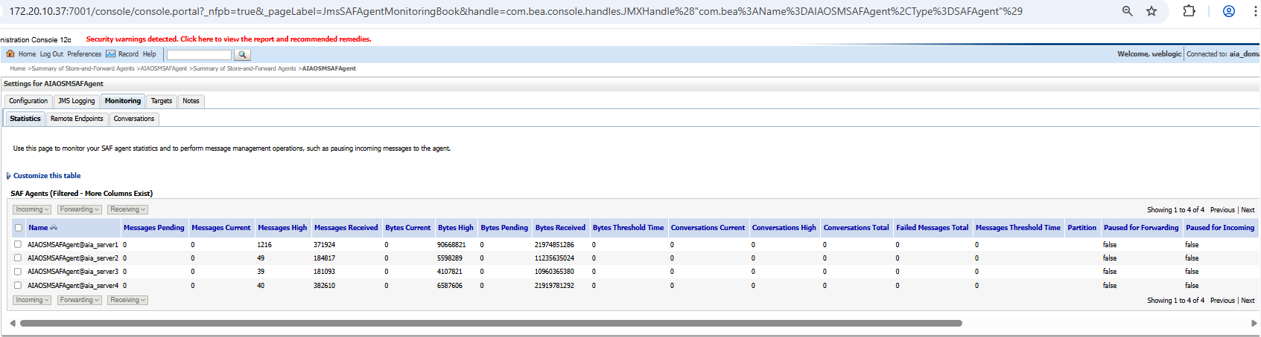
Note 1:
If you see message stuck for all queues on “node 1” then select the SAF agent hosted on node1 i.e. “AIAOSMSAFAgent@aia_server1” – “forwarding pause” – activate the change and then, “forwarding resume” – activate the change. Same logic applies for other nodes if issue seen on other nodes:
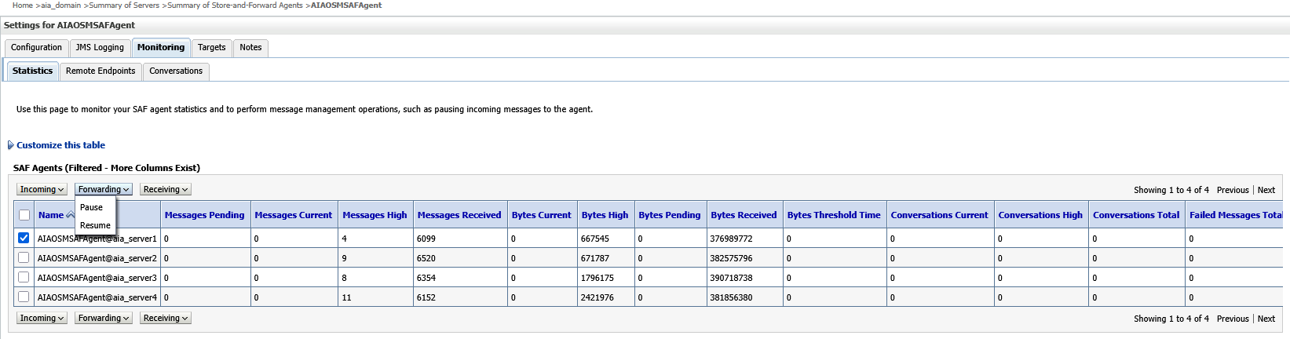
Note 2:
If issue is seen only for 1 Queue for all nodes, then do forwarding - pause and unpause for that queue only on all nodes like below. Here “AIA_CRTFO_IN_JMSQ” for all nodes. Ask OSM to do Consumption pause and unpause the same queue from OSM COM or SOM if it is COM Q or SOM Q from their own Weblogic JMS module:
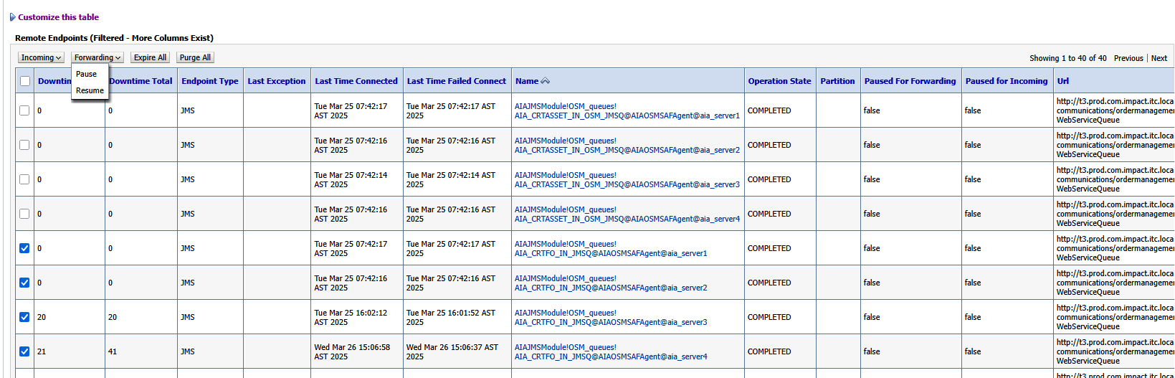

Note 3:
If the issue is seen for 1 Queue and only 1 node like node 1 then do the forwarding - pause and unpause only for that queue for that node only. Here “AIA_CRTFO_IN_JMSQ” for node 1:
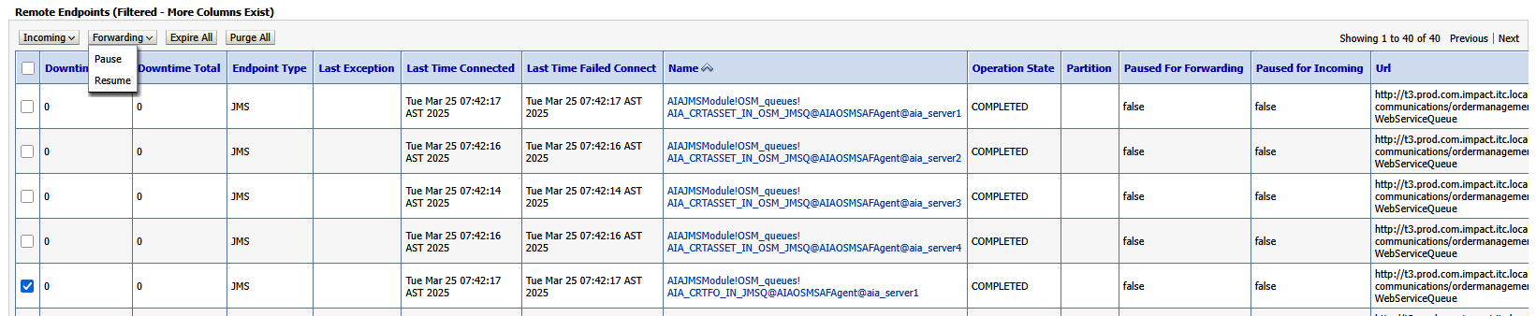
If this doesn’t solve problem then:
Step 2:
Important: Ask OSM SOM to take rolling bounce (rolling restart) 1st and then COM rolling bounce. Then take AIA rolling bounce as per below:
- Login to PRODUCTION AIA WebLogic Console
- Left side, expand “Environment”, click on “Servers”.
- In “Summary of Servers”, click on “Control”.
- Check each “Managed Servers” (MS): “aia_server1” to “aia_server4”.
- For each, click on “Shutdown” and them “Force shutdown now”.

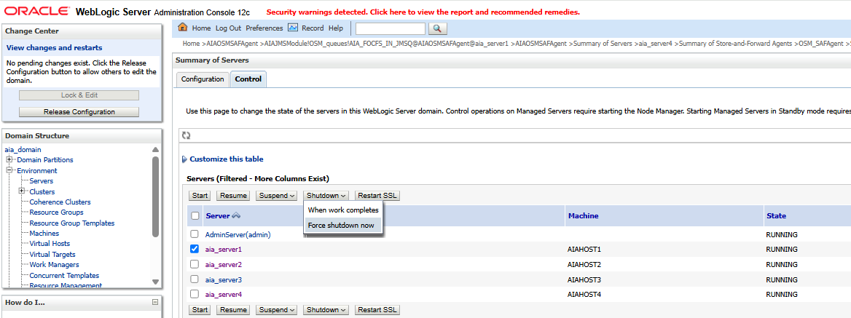

- Confirm “Yes”.
- Once the MS has the "SHUTDOWN" status, check it and click "Start".
- Confirm “Yes”.
- Verify that the MS status is "RUNNING".

Note: Please do clean restart of AIA Nodes if any milestones not progressing or Tablespace issues.

Perform the activity in rolling restart mode.
Shut down MS Nodes one by one

Login to all 4 AIA Nodes.
- Login 172.20.10.28
Use opc user to login
Sudo su Oracle
Goto below folder to move the tmp,cache and stage folder.
Cd /app/oracle/fmw_domains/mserver/aia_domain/servers/aia_server1
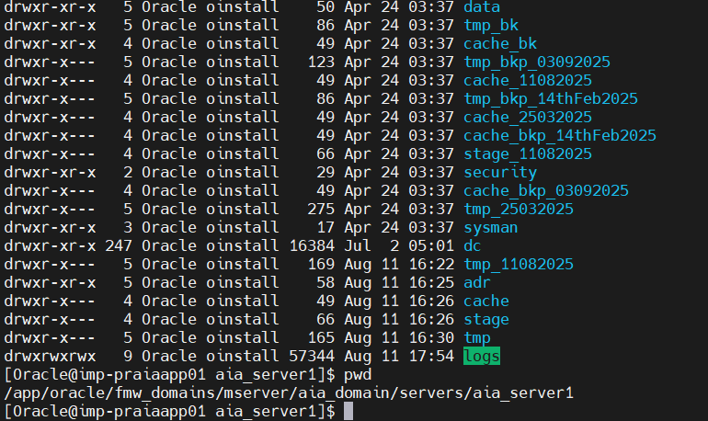
mv tmp tmp_$date
mv cache cache_$date
mv stage stage_$date

start the server from weblogic console.
Repeat same steps for all Nodes.

Appendix
Ongoing Work
Sl. No. | Activity | Work Description | Owner

Common problems
Sl. No. | Defect/Bug ID | Identification Phase | Issue Resolution

Known Issues
Sl. No. | Defect/Bug ID | Identification Phase | Issue Resolution

