

Tittle: | SOP_BRM_STUCK_ORDERS_HANDLING
Product: | BRM
Customer: | IMPACT
Scope Of Change: | SOP_BRM_STUCK_ORDERS_HANDLING
Approval:

Document Control

1.1 Version History
Sl. No | Date | Author | Version | Change Reference
 |  | Arun Kumar Bellamkonda | 1.0
 |  | Mauricio Quintero M | 1.1 | Change format document, scope, purpose and system overview

1.2 Reviewers
Sl. No | Reviewer | Position | Stream | Organization

1.3 Scope and Purpose of the document
This document is intended to provide a procedure for handling stuck orders from BRM based on the most common order errors for their management and attention.

1.4 Content
Table of Contents
1 Document Control 2
1.1 Version History 2
1.2 Reviewers 2
1.3 Scope and Purpose of the document 2
1.4 Content 3
2 System Overview 4
2.1 Introduction 4
2.2 System Impact 4
2.3 Operational Practice 4
2.4 Defeminations, Acronyms, Abbreviations 4
2.5 Assumptions, Dependencies, Constraints, Decisions 5
2.6 References 5
3 Step-by-step instructions 6
• Not eligible 9
• Eligible 14
• Not eligible 16
• Not eligible 21
Appendix 23

System Overview

Introduction
In the Order Management process, there are scenarios in which some orders may generate errors in BRM due to business validations (sufficient balance for plan upgrade/downgrade, active account, etc.). This document will show how to handle some stuck orders for the following types:
- Upgrade/Downgrade Orders
- Renew Orders
- Sales/Port in Orders with Error No Balance Issue

System Impact
The operational procedure in this document can be performed when orders are confirmed to be stuck due to an error in BRM. It must be validated whether the stuck order is eligible to execute the BRM process detailed here for its normalization.

Operational Practice
It is expected that operational staff check the below issues before executing this procedure:
- The stuck orders have some fault in BRM.
- The specific error returned by the BRM API has been previously reviewed in AIA, OSM, or Siebel.
- A query of the orders must be run in Siebel to validate the order's transaction type and perform the following steps detailed below.

Defeminations, Acronyms, Abbreviations

Assumptions, Dependencies, Constraints, Decisions
Sl. No | Assumptions
1.
2.

References
Sl. No | Document Name | Document Description
1.
2.

Step-by-step instructions
Steps to be followed.
Procedure to Stuck due to an error in BRM

Order Details (Get it from CRM if below query not working):

Procedure to Stuck due to an error in BRM

Get the Order Details from below CRM query. Pass the “Order_Num” as input
SELECT distinct
ORD.ORDER_NUM AS ORDER_NUMBER,
TYP.NAME AS ORDER_TYPE,
ORD.X_ITC_ORDER_SUBTYPE AS SUBTYPE,
ORD.CREATED AS ORDER_CREATED, ORD.X_ITC_CHANNEL,
ORD.STATUS_CD AS ORDER_STATUS,
ORD.FULFLMNT_STATUS_CD AS FULFMNT_STATUS,
ITM.SERVICE_NUM AS MSISDN,
EXT_CA.X_ITC_ACCOUNT_NUMBER AS CA_NUM,
EXT_SA.X_ITC_ACCOUNT_NUMBER AS SA_NUM,
EXT_BA.X_ITC_ACCOUNT_NUMBER AS BA_NUM
FROM
SIEBEL.S_ORDER@brm_sbl ORD,
SIEBEL.S_ORG_EXT@brm_sbl EXT_CA,
SIEBEL.S_ORG_EXT@brm_sbl EXT_SA,
SIEBEL.S_ORG_EXT@brm_sbl EXT_BA,
SIEBEL.S_ORDER_TYPE@brm_sbl TYP,
SIEBEL.S_ORDER_ITEM@brm_sbl ITM,
SIEBEL.S_PROD_INT@brm_sbl PRD
WHERE
1=1
AND ORD.ACCNT_ID = EXT_CA.ROW_ID
AND ORD.BILL_ACCNT_ID = EXT_BA.ROW_ID
AND ORD.SERV_ACCNT_ID = EXT_SA.ROW_ID
AND ORD.ROW_ID = ITM.ORDER_ID
AND ITM.PROD_ID = PRD.ROW_ID
AND ORD.ORDER_TYPE_ID = TYP.ROW_ID
and prd.integration_id is null
--and ITM.SERVICE_NUM in ('966506182283','966511383676');
--and EXT_SA.X_ITC_ACCOUNT_NUMBER in ('175731515') order by EXT_SA.X_ITC_ACCOUNT_NUMBER,order_created;100005161,100005829
AND ORD.ORDER_NUM in ('1-8296147068','1-8371366188');

Upgrade/Downgrade Orders

Stuck due to an error in BRM
Procedure to Stuck due to an error in BRM

Take SA Account from CRM.
Check the Eligibility of Upgrade/Downgrade.
Pass the SA Account_No as input to the query.
select tmp.*,
Case
when tmp.Eligible_check >=0 then 'Eligible'
Else 'Not Eligible'
END as "Eligible_Status"
from (
select a.account_no,p.name,pp.status,pp.purchase_fee_amt,pp.cycle_fee_amt,current_bal*-1 current_bal,
pp.poid_type,pp.poid_id0,
pp.account_obj_id0,
TO_CHAR(FROM_TZ(TO_TIMESTAMP('1970-01-01', 'YYYY-MM-DD') + NUMTODSINTERVAL(pp.created_t, 'SECOND'), 'GMT') AT TIME ZONE 'Asia/Riyadh', 'DD-MM-YYYY HH24:MI:SS') Created_t,
TO_CHAR(FROM_TZ(TO_TIMESTAMP('1970-01-01', 'YYYY-MM-DD') + NUMTODSINTERVAL(pp.cycle_start_t, 'SECOND'), 'GMT') AT TIME ZONE 'Asia/Riyadh', 'DD-MM-YYYY HH24:MI:SS') cycle_start_t,
TO_CHAR(FROM_TZ(TO_TIMESTAMP('1970-01-01', 'YYYY-MM-DD') + NUMTODSINTERVAL(pp.cycle_end_t, 'SECOND'), 'GMT') AT TIME ZONE 'Asia/Riyadh', 'DD-MM-YYYY HH24:MI:SS') cycle_end_t,
((current_bal*-1) -pp.cycle_fee_amt) Eligible_Check,pp.plan_obj_id0 bundle_poid
from pin.purchased_product_t pp,pin.product_t p ,pin.bal_grp_sub_bals_t c,pin.bal_grp_t bb , pin.CONFIG_BEID_BALANCES_T cbd,
pin.account_t a
where bb.account_obj_id0=pp.account_obj_id0
and c.obj_id0 = bb.poid_id0
and a.poid_id0=pp.account_obj_id0 and a.poid_id0=bb.account_obj_id0
and cbd.rec_id = c.rec_id2
and rec_id2 in (682)
and pp.product_obj_id0=p.poid_id0 and
pp.cycle_fee_amt<>0 and pp.status=1 and
pp.cycle_start_t > (select 86400 * (SELECT trunc(sysdate+1)-TO_date('01/01/1970', 'dd/mm/yyyy') DAYS FROM DUAL)-10800 timestamp from dual) and
a.account_no in ('646028315','671242115','205479115','112791715','544394915')
order by pp.account_obj_id0
) tmp
order by tmp.Eligible_check;

Refer Eligible_status column. And Cycle_start_t should be future date.

Not eligible
Need to cancel order and revert the changes happened as part of order.
- Cancel the product added as part of order.
- Revert the purchased Bundle (In initiate billing call, New bundle activated and Old bundle inactivated. Those need to be reverted.)
Validate Product
Case1 or Case2

select a.account_no,a.poid_id0 acc_poid,p.name,pp.poid_type,pp.poid_id0,pp.status,pp.cycle_fee_amt,--pp.purchase_fee_amt,inf2ora(pp.mod_t),pp.product_obj_id0,
pp.account_obj_id0,pp.plan_obj_id0,
TO_CHAR(FROM_TZ(TO_TIMESTAMP('1970-01-01', 'YYYY-MM-DD') + NUMTODSINTERVAL(pp.created_t, 'SECOND'), 'GMT') AT TIME ZONE 'Asia/Riyadh', 'DD-MM-YYYY HH24:MI:SS') Created_t,
TO_CHAR(FROM_TZ(TO_TIMESTAMP('1970-01-01', 'YYYY-MM-DD') + NUMTODSINTERVAL(pp.cycle_start_t, 'SECOND'), 'GMT') AT TIME ZONE 'Asia/Riyadh', 'DD-MM-YYYY HH24:MI:SS') cycle_start_t,
TO_CHAR(FROM_TZ(TO_TIMESTAMP('1970-01-01', 'YYYY-MM-DD') + NUMTODSINTERVAL(pp.cycle_end_t, 'SECOND'), 'GMT') AT TIME ZONE 'Asia/Riyadh', 'DD-MM-YYYY HH24:MI:SS') cycle_end_t
from pin.purchased_product_t pp,pin.product_t p,pin.account_t a where
pp.product_obj_id0=p.poid_id0 and
pp.account_obj_id0=a.poid_id0 and
pp.status=1 and
pp.cycle_start_t > (select 86400 * (SELECT trunc(sysdate+1)-TO_date('01/01/1970', 'dd/mm/yyyy') DAYS FROM DUAL)-10800 timestamp from dual) and
a.account_no in ('112791715','544394915','684505515');

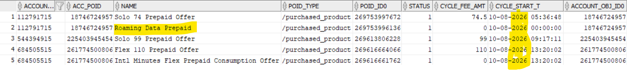
If Product Name like Roaming, then it should come under Case2 (UIM/OSM/CRM to take actions)
Else it should be Case1. (OSM/CRM to take actions)
Cancel Product:
SA Account_No need to pass as input

select 'r << 1 1'||CHR(10)|| '0 PIN_FLD_POID POID [0] 0.0.0.1 /account '||pp.account_obj_id0||' '||23||CHR(10)||
'0 PIN_FLD_PROGRAM_NAME STR [0] "DISCONNECT|IM-37262 Fix"'||CHR(10)||
'0 PIN_FLD_SERVICE_OBJ POID [0] 0.0.0.1 '||pp.service_obj_type||' '||pp.service_obj_id0||' '||34||CHR(10)||
'0 PIN_FLD_END_T TSTAMP [0] '||'('||(pp.Created_t + 1)||')'||CHR(10)||
'0 PIN_FLD_PRODUCTS ARRAY [0] allocated 20, used 3'||CHR(10)||
'1 PIN_FLD_PRODUCT_OBJ POID [0] 0.0.0.1 /product '||pp.product_obj_id0||' '||4||CHR(10)||
'1 PIN_FLD_OFFERING_OBJ POID [0] 0.0.0.1 /purchased_product '||pp.poid_id0||' '||1||CHR(10)||
'1 PIN_FLD_QUANTITY DECIMAL [0] 1' ||CHR(10)||'1'||CHR(10)||'d 1'||CHR(10)||
'xop PCM_OP_SUBSCRIPTION_CANCEL_PRODUCT 0 1'||CHR(10)
from pin.purchased_product_t pp,pin.account_t a
where a.poid_id0=pp.account_obj_id0
and pp.status = 1
and pp.cycle_start_t > (select 86400 * (SELECT trunc(sysdate+1)-TO_date('01/01/1970', 'dd/mm/yyyy') DAYS FROM DUAL)-10800 timestamp from dual)
and a.account_no in ('112791715','544394915','684505515');

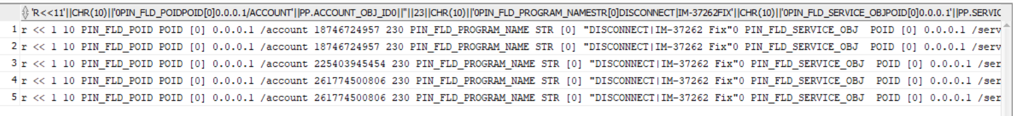
Copy into notepad and rearrange. Please find highlighted from below screenshot. We have to replace starting “ with blank.
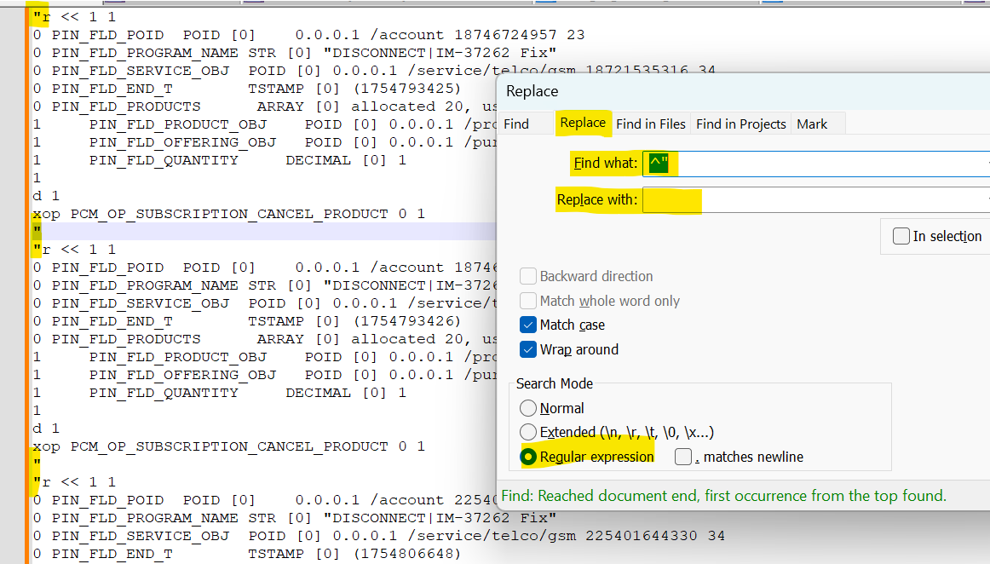
After replace
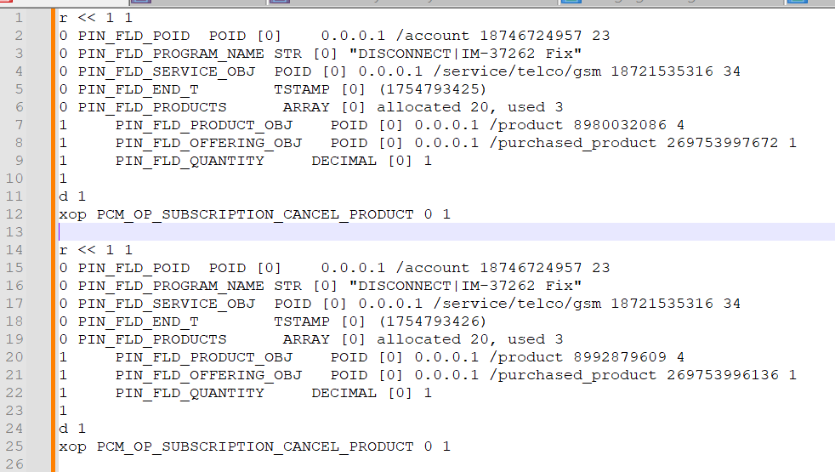

Bundle Activation:

Stuck due to an error in BRM
Procedure to Stuck due to an error in BRM

Pass the BA Account_no as input.
select distinct 'r << 1 1'||CHR(10)||
'0 PIN_FLD_POID POID [0] 0.0.0.1 /purchased_bundle '||pb.poid_id0||' '||0||CHR(10)||
'0 PIN_FLD_STATUS ENUM [0] 1'||CHR(10)||
'0 PIN_FLD_VALID_TO TSTAMP [0] ('||(0)||')'||CHR(10)||
'1'||CHR(10)||
'd 1'||CHR(10)||
'xop PCM_OP_WRITE_FLDS 0 1'||CHR(10)
from
pin.purchased_bundle_t pb,pin.account_t a,pin.purchased_product_t pp
where a.poid_id0=pb.account_obj_id0 and pp.plan_obj_id0=pb.poid_id0
and pb.status=3
and a.account_no in ('112791515','544377915','684465915');

Copy Output into Notepad and replace “ in starting.
New Bundle Deactivation:
Pass the BA Account_no as input.

select
'r << 1 1'||CHR(10)||
'0 PIN_FLD_POID POID [0] 0.0.0.1 /account '||pb.account_obj_id0||' '||0||CHR(10)||
'0 PIN_FLD_PROGRAM_NAME STR [0] "Order Data Fix"'||CHR(10)||
'0 PIN_FLD_BUNDLE_INFO ARRAY [0] allocated 20, used 5'||CHR(10)||
'1 PIN_FLD_NAME STR [0] "'||pb.Name||'"'||CHR(10)||
'1 PIN_FLD_DESCR STR [0] "'||pb.Descr||'"'||CHR(10)||
'1 PIN_FLD_POID POID [0] 0.0.0.1 /purchased_bundle '||pb.poid_id0||' '||0||CHR(10)||
'1 PIN_FLD_STATUS ENUM [0] 3'||CHR(10)||
'1 PIN_FLD_VALID_TO TSTAMP [0] ('||(pb.valid_from + 1)||') <null>'||CHR(10)||
'1'||CHR(10)||
'd 1'||CHR(10)||
'xop PCM_OP_SUBSCRIPTION_SET_BUNDLE 0 1'||CHR(10)
from pin.purchased_bundle_t pb,pin.account_t a
where a.poid_id0=pb.account_obj_id0
and pb.poid_id0 not in (
Select distinct pb.poid_id0
from
pin.purchased_bundle_t pb,pin.account_t a,pin.purchased_product_t pp
where a.poid_id0=pb.account_obj_id0 and pp.plan_obj_id0=pb.poid_id0
and a.account_no in ('112791515','544377915','684465915')
)
and pb.status=1
and a.account_no in ('112791515','544377915','684465915');

Copy Output into Notepad and replace “ in starting.
Connect to cm_batch testnap (Refer Incident handling SOP) and execute all flists in testnap path.
Go to path: /oms/sys/test
Command: testnap
Run the flists here.
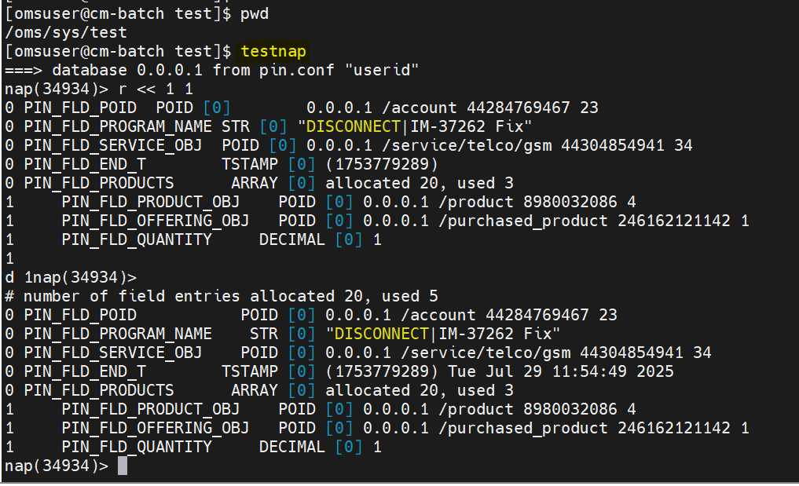
.0Then drop a mail to other teams to handle other systems in below format.
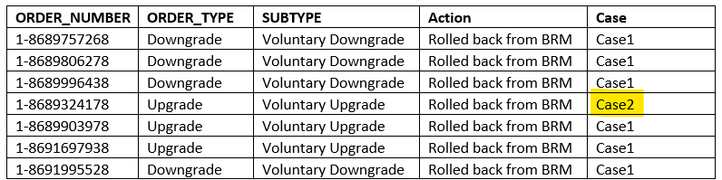

Eligible

Yet to prepare steps.

Renew Orders

Stuck due to an error in BRM
Procedure to Stuck due to an error in BRM
Take SA Account from CRM.
Check the Eligibility of Upgrade/Downgrade.
Pass the SA Account_No as input to the query.

select tmp.*,
Case
when tmp.Eligible_check >=0 then 'Eligible'
Else 'Not Eligible'
END as "Eligible_Status"
from (
select a.account_no,p.name,pp.status,pp.purchase_fee_amt,pp.cycle_fee_amt,current_bal*-1 current_bal,
pp.poid_type,pp.poid_id0,
pp.account_obj_id0,
TO_CHAR(FROM_TZ(TO_TIMESTAMP('1970-01-01', 'YYYY-MM-DD') + NUMTODSINTERVAL(pp.created_t, 'SECOND'), 'GMT') AT TIME ZONE 'Asia/Riyadh', 'DD-MM-YYYY HH24:MI:SS') Created_t,
TO_CHAR(FROM_TZ(TO_TIMESTAMP('1970-01-01', 'YYYY-MM-DD') + NUMTODSINTERVAL(pp.cycle_start_t, 'SECOND'), 'GMT') AT TIME ZONE 'Asia/Riyadh', 'DD-MM-YYYY HH24:MI:SS') cycle_start_t,
TO_CHAR(FROM_TZ(TO_TIMESTAMP('1970-01-01', 'YYYY-MM-DD') + NUMTODSINTERVAL(pp.cycle_end_t, 'SECOND'), 'GMT') AT TIME ZONE 'Asia/Riyadh', 'DD-MM-YYYY HH24:MI:SS') cycle_end_t,
((current_bal*-1) -pp.cycle_fee_amt) Eligible_Check,pp.plan_obj_id0 bundle_poid
from pin.purchased_product_t pp,pin.product_t p ,pin.bal_grp_sub_bals_t c,pin.bal_grp_t bb , pin.CONFIG_BEID_BALANCES_T cbd,
pin.account_t a
where bb.account_obj_id0=pp.account_obj_id0
and c.obj_id0 = bb.poid_id0
and a.poid_id0=pp.account_obj_id0 and a.poid_id0=bb.account_obj_id0
and cbd.rec_id = c.rec_id2
and rec_id2 in (682)
and pp.product_obj_id0=p.poid_id0 and
pp.cycle_fee_amt<>0 and pp.status=1 and
pp.cycle_start_t > (select 86400 * (SELECT trunc(sysdate+1)-TO_date('01/01/1970', 'dd/mm/yyyy') DAYS FROM DUAL)-10800 timestamp from dual) and
a.account_no in ('646028315','671242115','205479115','112791715','544394915')
order by pp.account_obj_id0
) tmp
order by tmp.Eligible_check;

Refer Eligible_status column. And Cycle_start_t should be future date.

Not eligible
Need to cancel order and revert the changes happened as part of order.
- Cancel the product added as part of order.
Validate Product
Case1 or Case2

select a.account_no,a.poid_id0 acc_poid,p.name,pp.poid_type,pp.poid_id0,pp.status,pp.cycle_fee_amt,--pp.purchase_fee_amt,inf2ora(pp.mod_t),pp.product_obj_id0,
pp.account_obj_id0,pp.plan_obj_id0,
TO_CHAR(FROM_TZ(TO_TIMESTAMP('1970-01-01', 'YYYY-MM-DD') + NUMTODSINTERVAL(pp.created_t, 'SECOND'), 'GMT') AT TIME ZONE 'Asia/Riyadh', 'DD-MM-YYYY HH24:MI:SS') Created_t,
TO_CHAR(FROM_TZ(TO_TIMESTAMP('1970-01-01', 'YYYY-MM-DD') + NUMTODSINTERVAL(pp.cycle_start_t, 'SECOND'), 'GMT') AT TIME ZONE 'Asia/Riyadh', 'DD-MM-YYYY HH24:MI:SS') cycle_start_t,
TO_CHAR(FROM_TZ(TO_TIMESTAMP('1970-01-01', 'YYYY-MM-DD') + NUMTODSINTERVAL(pp.cycle_end_t, 'SECOND'), 'GMT') AT TIME ZONE 'Asia/Riyadh', 'DD-MM-YYYY HH24:MI:SS') cycle_end_t
from pin.purchased_product_t pp,pin.product_t p,pin.account_t a where
pp.product_obj_id0=p.poid_id0 and
pp.account_obj_id0=a.poid_id0 and
pp.status=1 and
pp.cycle_start_t > (select 86400 * (SELECT trunc(sysdate+1)-TO_date('01/01/1970', 'dd/mm/yyyy') DAYS FROM DUAL)-10800 timestamp from dual) and
a.account_no in ('112791715','544394915','684505515');

If Product Name like Roaming, then it should come under Case2 (UIM/OSM/CRM to take actions)
Else it should be Case1. (OSM/CRM to take actions)

Cancel Product:
SA Account_No need to pass as input
select 'r << 1 1'||CHR(10)|| '0 PIN_FLD_POID POID [0] 0.0.0.1 /account '||pp.account_obj_id0||' '||23||CHR(10)||
'0 PIN_FLD_PROGRAM_NAME STR [0] "DISCONNECT|IM-37262 Fix"'||CHR(10)||
'0 PIN_FLD_SERVICE_OBJ POID [0] 0.0.0.1 '||pp.service_obj_type||' '||pp.service_obj_id0||' '||34||CHR(10)||
'0 PIN_FLD_END_T TSTAMP [0] '||'('||(pp.Created_t + 1)||')'||CHR(10)||
'0 PIN_FLD_PRODUCTS ARRAY [0] allocated 20, used 3'||CHR(10)||
'1 PIN_FLD_PRODUCT_OBJ POID [0] 0.0.0.1 /product '||pp.product_obj_id0||' '||4||CHR(10)||
'1 PIN_FLD_OFFERING_OBJ POID [0] 0.0.0.1 /purchased_product '||pp.poid_id0||' '||1||CHR(10)||
'1 PIN_FLD_QUANTITY DECIMAL [0] 1' ||CHR(10)||'1'||CHR(10)||'d 1'||CHR(10)||
'xop PCM_OP_SUBSCRIPTION_CANCEL_PRODUCT 0 1'||CHR(10)
from pin.purchased_product_t pp,pin.account_t a
where a.poid_id0=pp.account_obj_id0
and pp.status = 1
and pp.cycle_start_t > (select 86400 * (SELECT trunc(sysdate+1)-TO_date('01/01/1970', 'dd/mm/yyyy') DAYS FROM DUAL)-10800 timestamp from dual)
and a.account_no in ('112791715','544394915','684505515');

Copy into notepad and rearrange. Please find highlighted from below screenshot. We have to replace starting “ with blank.
After replace

Connect to cm_bacth testnap (Refer Incident handling SOP) and execute all flists in testnap path.
Go to path: /oms/sys/test
Command: testnap
Run the flists here.

Then drop a mail to other teams to handle other systems in below format.

Sales/Port in Orders with Error No Balance Issue
Stuck due to an error in BRM
Procedure to Stuck due to an error in BRM
Take SA Account from CRM.
Check the Eligibility of Upgrade/Downgrade.
Pass the SA Account_No as input to the query.

select tmp.*,
Case
when tmp.Eligible_check >=0 then 'Eligible'
Else 'Not Eligible'
END as "Eligible_Status"
from (
select a.account_no,p.name,pp.status,pp.purchase_fee_amt,pp.cycle_fee_amt,current_bal*-1 current_bal,
pp.poid_type,pp.poid_id0,
pp.account_obj_id0,
TO_CHAR(FROM_TZ(TO_TIMESTAMP('1970-01-01', 'YYYY-MM-DD') + NUMTODSINTERVAL(pp.created_t, 'SECOND'), 'GMT') AT TIME ZONE 'Asia/Riyadh', 'DD-MM-YYYY HH24:MI:SS') Created_t,
TO_CHAR(FROM_TZ(TO_TIMESTAMP('1970-01-01', 'YYYY-MM-DD') + NUMTODSINTERVAL(pp.cycle_start_t, 'SECOND'), 'GMT') AT TIME ZONE 'Asia/Riyadh', 'DD-MM-YYYY HH24:MI:SS') cycle_start_t,
TO_CHAR(FROM_TZ(TO_TIMESTAMP('1970-01-01', 'YYYY-MM-DD') + NUMTODSINTERVAL(pp.cycle_end_t, 'SECOND'), 'GMT') AT TIME ZONE 'Asia/Riyadh', 'DD-MM-YYYY HH24:MI:SS') cycle_end_t,
((current_bal*-1) -pp.cycle_fee_amt) Eligible_Check,pp.plan_obj_id0 bundle_poid
from pin.purchased_product_t pp,pin.product_t p ,pin.bal_grp_sub_bals_t c,pin.bal_grp_t bb , pin.CONFIG_BEID_BALANCES_T cbd,
pin.account_t a
where bb.account_obj_id0=pp.account_obj_id0
and c.obj_id0 = bb.poid_id0
and a.poid_id0=pp.account_obj_id0 and a.poid_id0=bb.account_obj_id0
and cbd.rec_id = c.rec_id2
and rec_id2 in (682)
and pp.product_obj_id0=p.poid_id0 and
pp.cycle_fee_amt<>0 and pp.status=1 and
pp.cycle_start_t > (select 86400 * (SELECT trunc(sysdate+1)-TO_date('01/01/1970', 'dd/mm/yyyy') DAYS FROM DUAL)-10800 timestamp from dual) and
a.account_no in ('646028315','671242115','205479115','112791715','544394915')
order by pp.account_obj_id0
) tmp
order by tmp.Eligible_check;

Refer Eligible_status column. And Cycle_start_t should be future date.

Not eligible
If not eligible then the payment received.
To Check payment event
To check the latest payment received.

select e.account_obj_id0,
TO_CHAR(FROM_TZ(TO_TIMESTAMP('1970-01-01', 'YYYY-MM-DD') + NUMTODSINTERVAL(e.created_t, 'SECOND'), 'GMT') AT TIME ZONE 'Asia/Riyadh', 'DD-MM-YYYY HH24:MI:SS') AS created_t,
e.poid_type,eb.amount,due,resource_id,e.sys_descr,e.program_name,descr
from pin.event_t e, pin.event_bal_impacts_t eb,pin.item_t i
where e.poid_id0=eb.obj_id0
and e.item_obj_id0=i.poid_id0
and eb.resource_id =682
and amount<>0
and i.poid_type in ('/item/payment')
and eb.account_obj_id0 in (118012975066 )
order by eb.account_obj_id0,e.created_t desc;

If No sufficient payment made then as per the request from Khalid approval.
CRM to do payment and repush order from OSM.

Appendix
Ongoing Work
Sl. No. | Activity | Work Description | Owner

Common problems
Sl. No. | Defect/Bug ID | Identification Phase | Issue Resolution

Known Issues
Sl. No. | Defect/Bug ID | Identification Phase | Issue Resolution

