ITC Salam MS BRM

L1 Application Monitoring

DOCUMENT MANAGEMENT
Document History

Version | Date of Revision | Description of Change | Affected Sections | Approved By
1.0 | 5-11-2023 | Initial document for BRM,PDC and BIP Application Monitoring | All

Approval
Name | Title | Signature | Version | Date
Authors/Reviewer
Name | Title
Suman Lakhlan | BRM Consultant

Table of contents
1 Introduction 5
2 Servers 5
2.1 Development 5
2.2 SIT 5
2.3 PROD 5
2.4 Disaster Recovery (DR) 5
3 BRM Application Access 5
3.1 Billing Care 5
4 PDC Application Access 7
4.1 Logging into Application 7
5 BIP Application Access 9
5.1 Logging into Application 9
6 Server health check 13
7 Starting and Stopping of Services 22
7.1 BRM 22
7.2 Weblogic 22
7.3 Business Operations Center 22
7.4 Billing Care 22
7.5 PDC-BRM Integration Services 23
7.6 PDC Application Process 23
7.7 BIP Application Process 24
8 Database 27
8.1 BRM Database Connectivity 27
8.2 PDC Database Connectivity 29
9 Code Repository 31
10 Code Deployment Process 32
11 Common Issue 32
12 Cron Jobs and Manual Jobs 32
13 Notes 32
14 Useful Links 32
14.1 Sharepoint 32
14.2 JIRA 32
14.3 GIT LAB 32
14.4 Manage Engine 32
14.5 ITSD 32
14.6 Jump Server 33
15 Open Issues 33
16 Closed Issues 33

Introduction
This document is the user guide for the monitoring of application and status of GUI of BRM, PDC and BIP. Starting and stopping the application servers. Details of daily activities related to server health check.

Servers
We are using BRM version 12.0 with patch set 3.
Below are the list of four servers which are currently used for development, testing and production:

Development

SIT

PROD

Disaster Recovery (DR)

Note: Disaster recovery environment is the replica of production environment. All the code changes deployed on production server shall be deployed on disaster recovery server also.

BRM Application Access

Billing Care
Launch the application and Sign in with provided credentials.
URL: http://172.31.22.22:7011/bc/index.html#

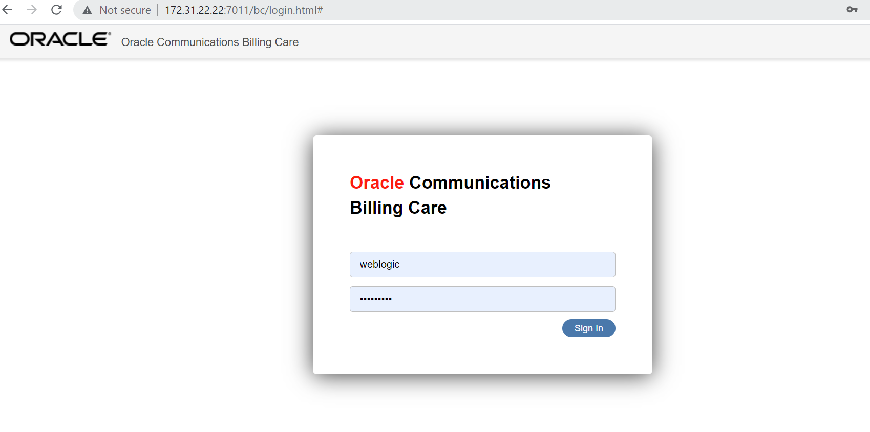
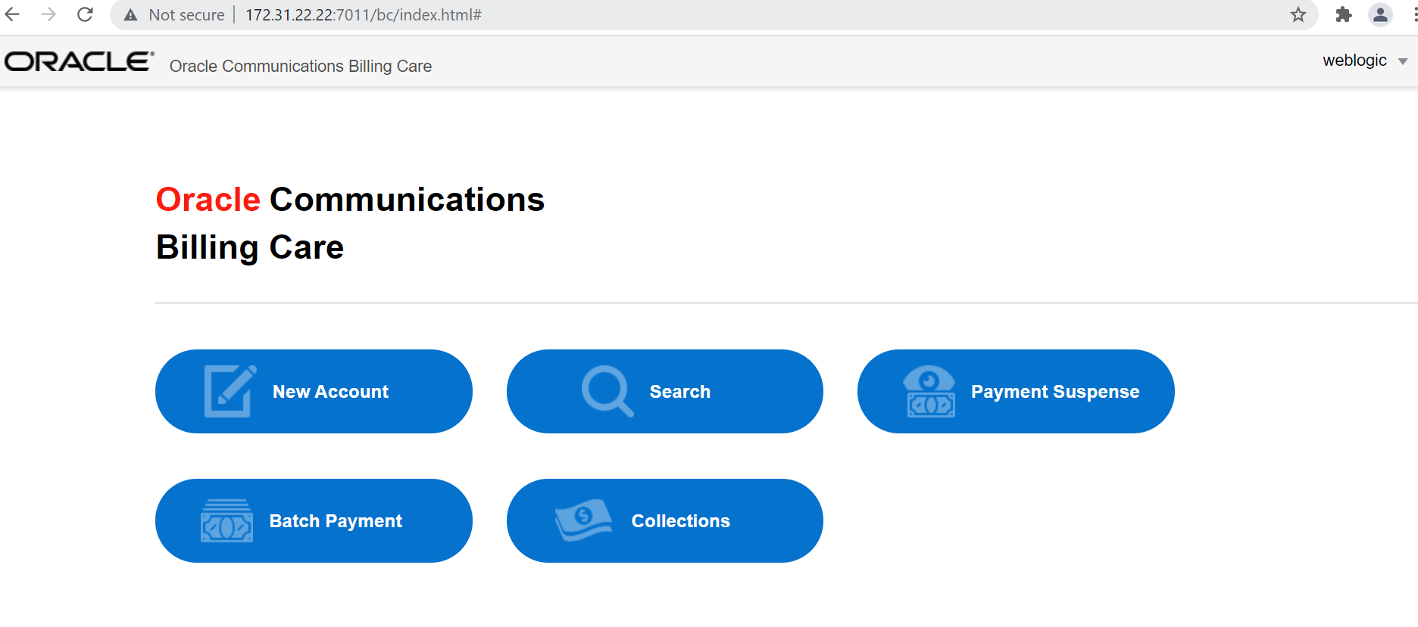

Log out the application from top right and click on Weblogic button and logout.

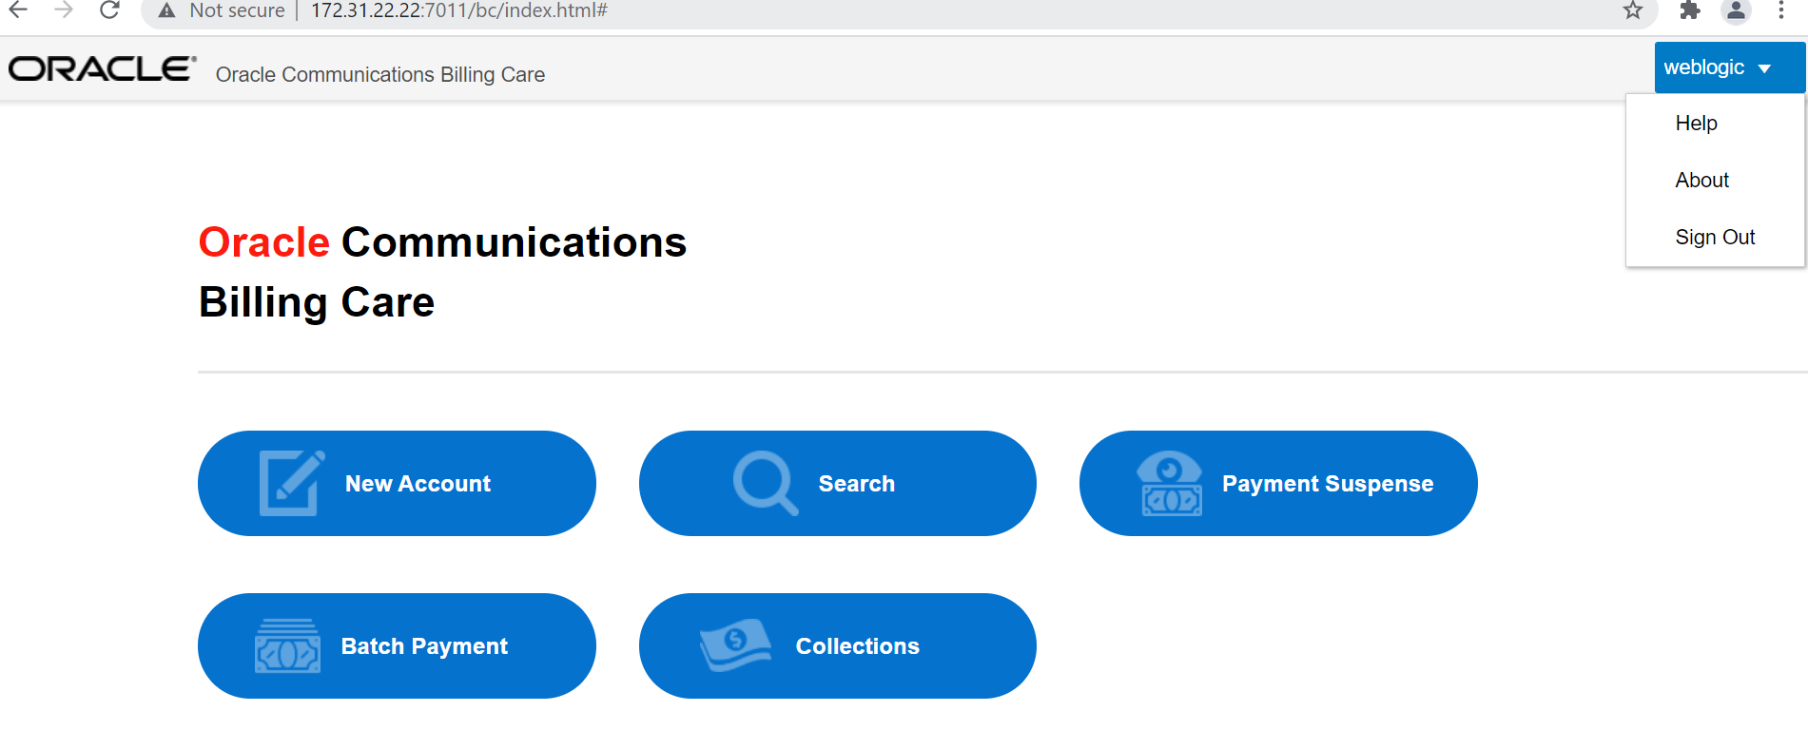

PDC Application Access

Logging into Application
Launch the application and Sign in with provided credentials.
URL: https://172.31.22.26:8001/pdc/faces/PricingDesignCenter

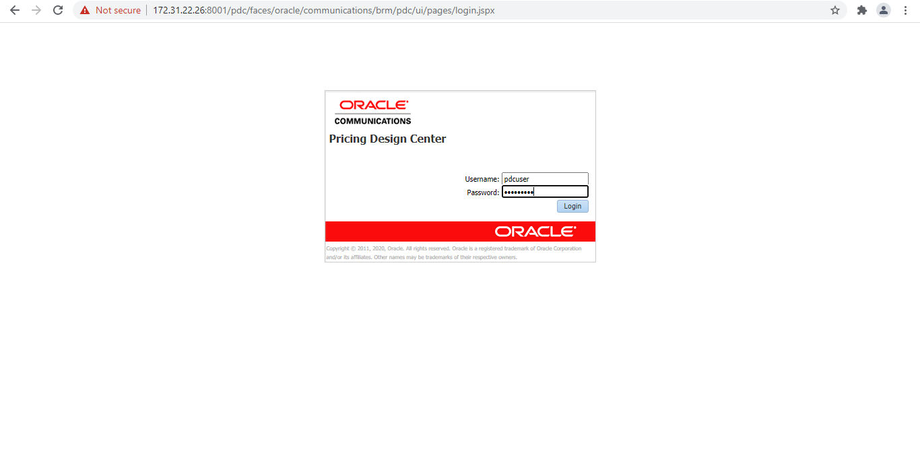
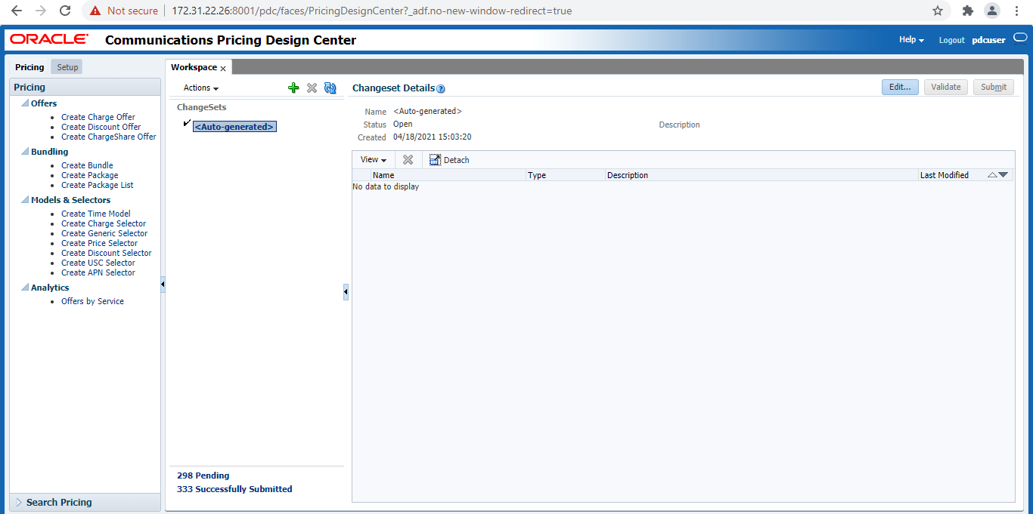

Log out the application from top right and click on logout button.

BIP Application Access

Logging into Application
Launch the application and Sign in with provided credentials.
URL: http://172.31.22.33:8003/xmlpserver/

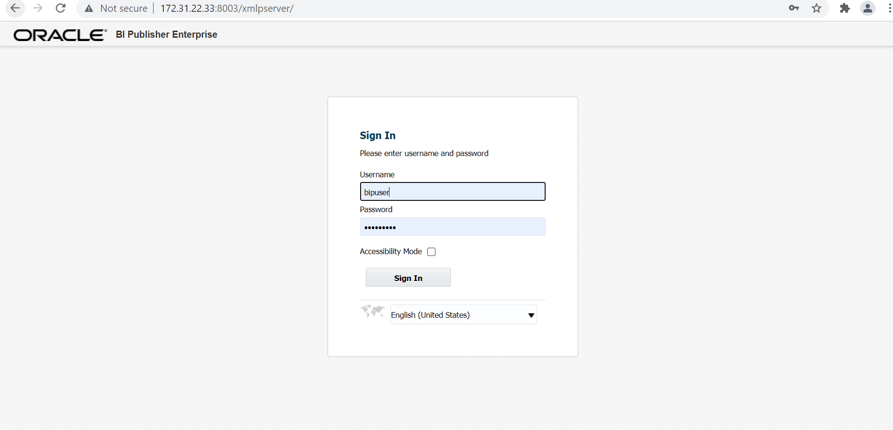

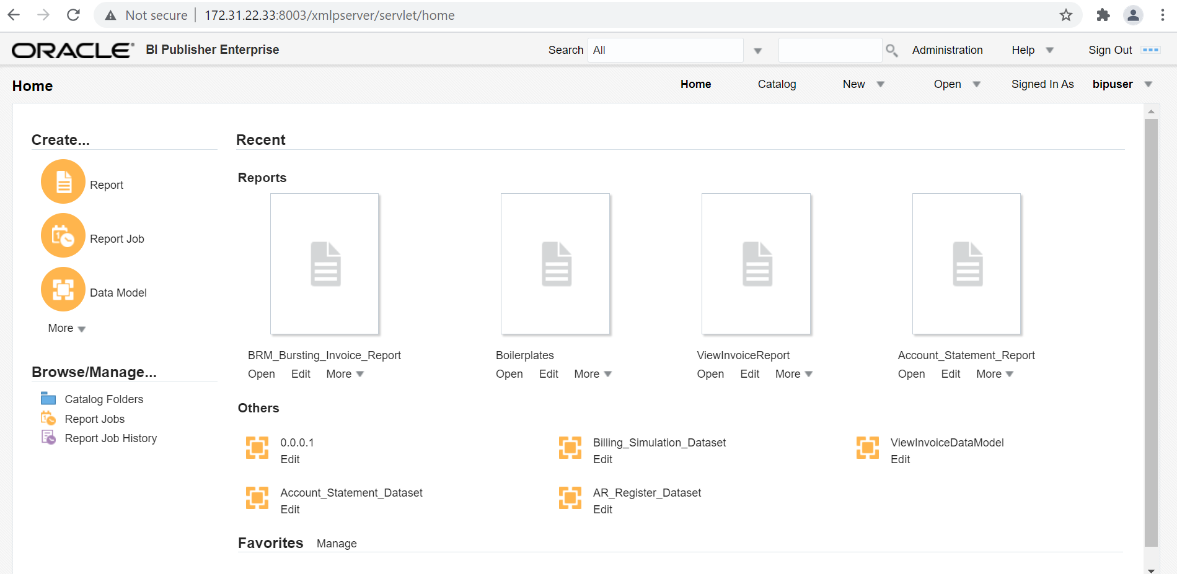

Log out the application from top right and click on ‘Sign Out’ button.

Server health check

Log into the BRM Server ‘172.31.22.22’.

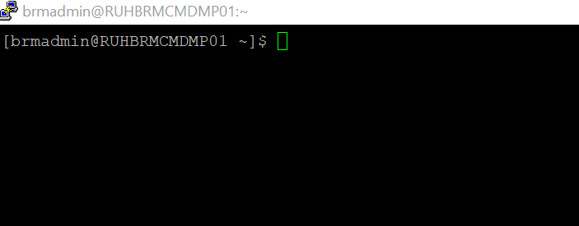

Now run the script ‘ITC-HEALTH-CHECK-SCRIPT.sh’ from the path ‘/backup/health_check’.

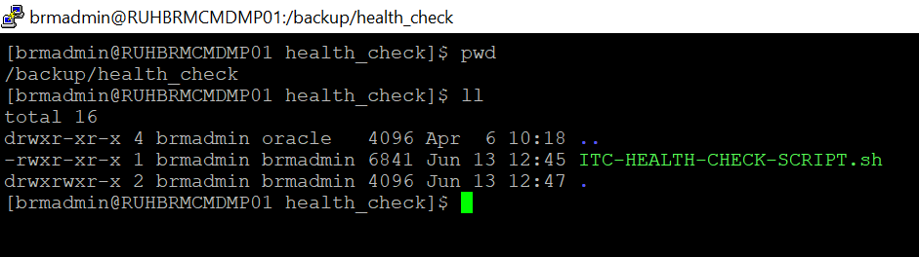

This will create a ‘.txt’ file which contains the server disk space and other memory consumption details.

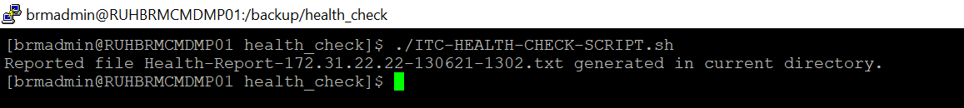

Log into the BRM Server ‘172.31.22.26’.

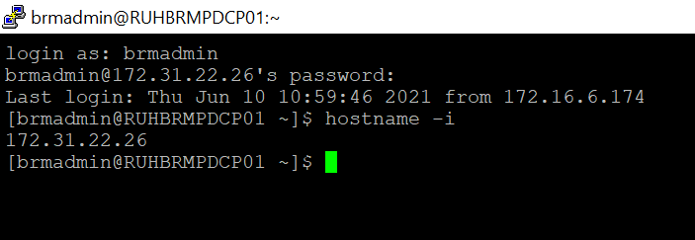

Now run the script ‘ITC-HEALTH-CHECK-SCRIPT.sh’ from the path ‘/backup/health_check’.

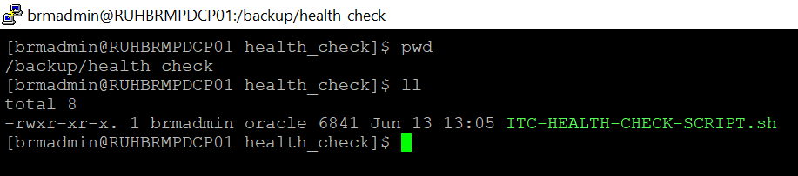

This will create a ‘.txt’ file which contains the server disk space and other memory consumption details.

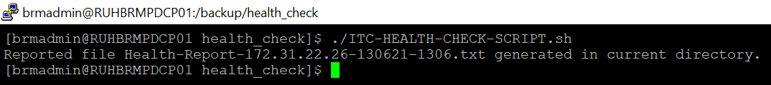

Log into the BRM Server ‘172.31.22.33’.

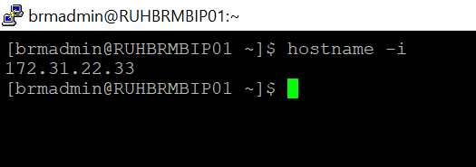

Now run the script ‘ITC-HEALTH-CHECK-SCRIPT.sh’ from the path ‘/backup/health_check’.

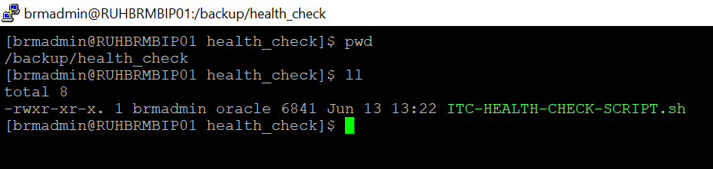

This will create a ‘.txt’ file which contains the server disk space and other memory consumption details.

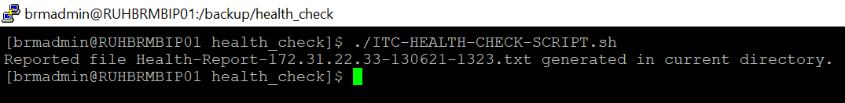

BRM Applications Processes

Log into the server ‘172.31.22.22’.

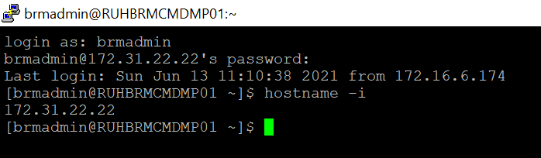

To check for Billing Care’s Weblogic process use the command ‘ps -ef | grep weblogic’
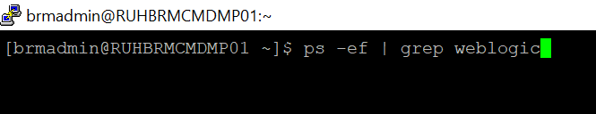

The below process must be running for Billing Care to be up and running.

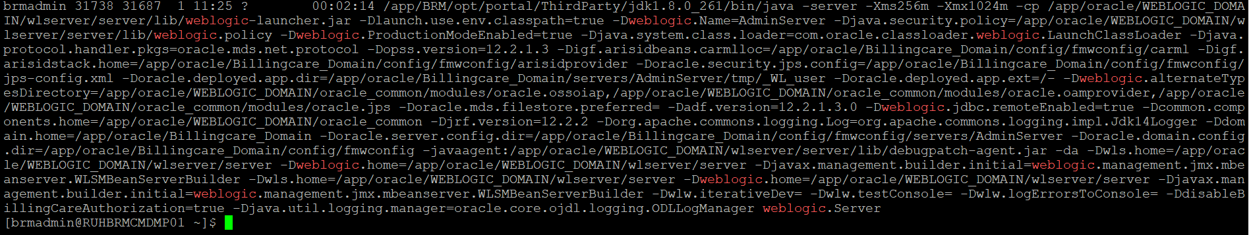

To check for BOC’s Weblogic process use the command ‘ps -ef | grep weblogic’

The below process must be running for BOC to be up and running.

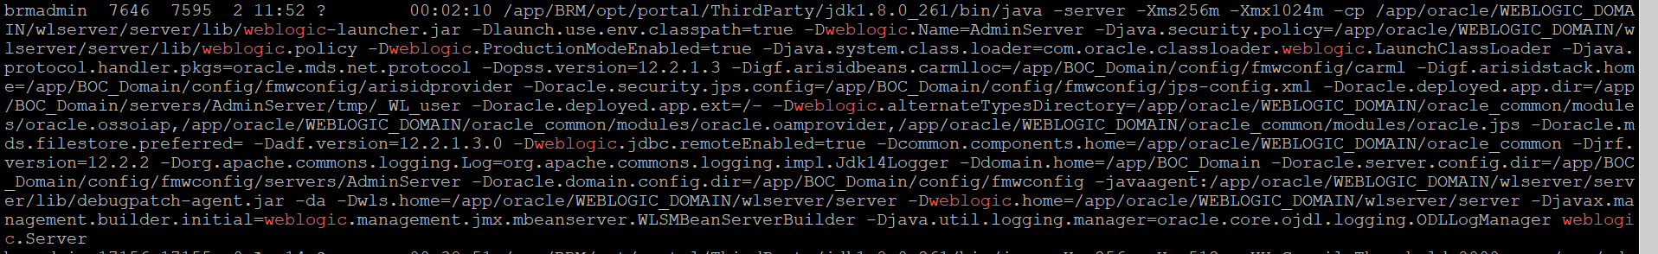

To check for ‘cm’ process use the command ps –ef | grep cm$

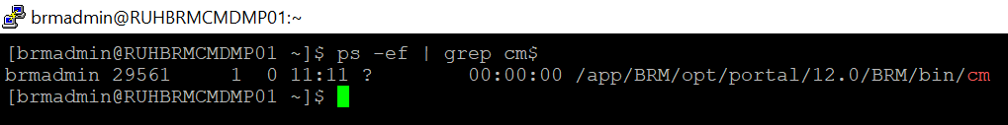

To check for ‘dm_oracle’ process use the command ps –ef | grep dm_oracle

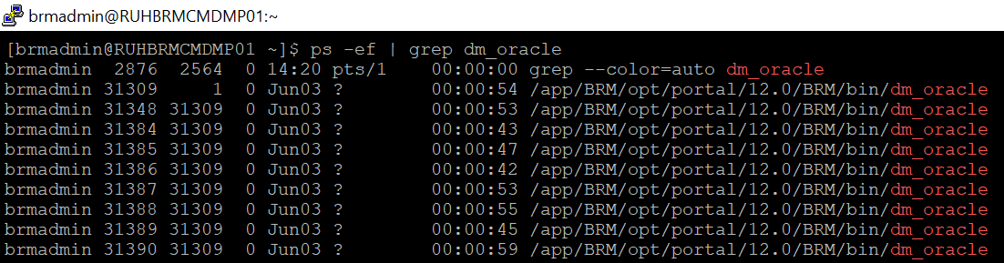

To check for ‘eai_js’ process use the command ps –ef | grep eai_js

To check for ‘dm_aq’ process use the command ps –ef | grep dm_aq

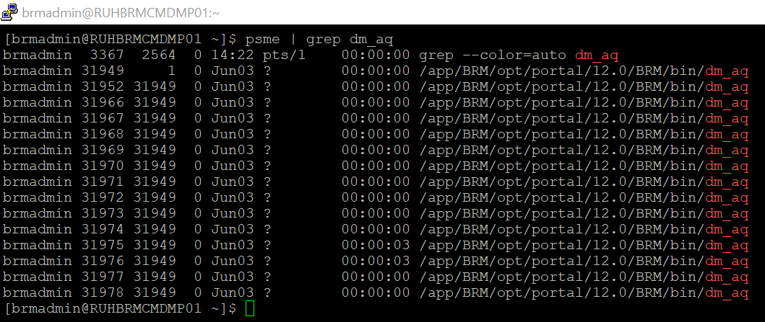

To check for ‘dm_ifw’ process use the command ps –ef | grep dm_ifw_sync

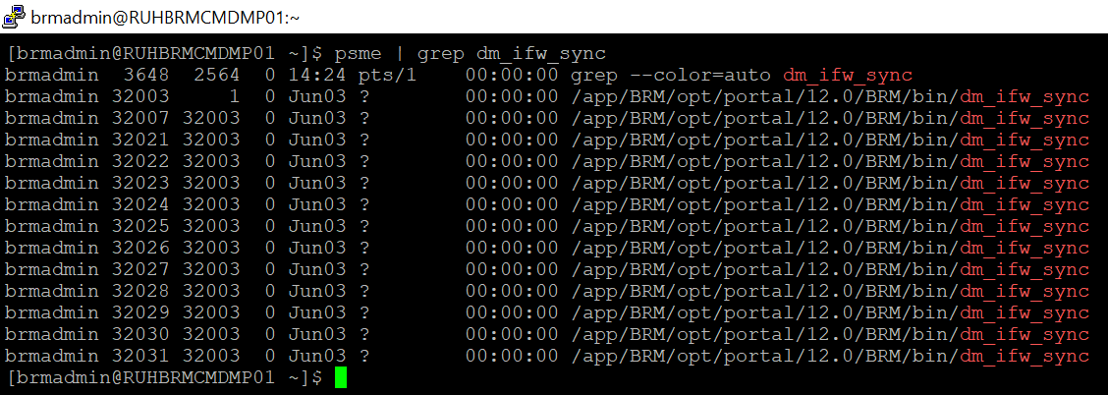

To check for ‘RRETransformationEngine’ process use the command ps –ef | grep RRETransformationEngine

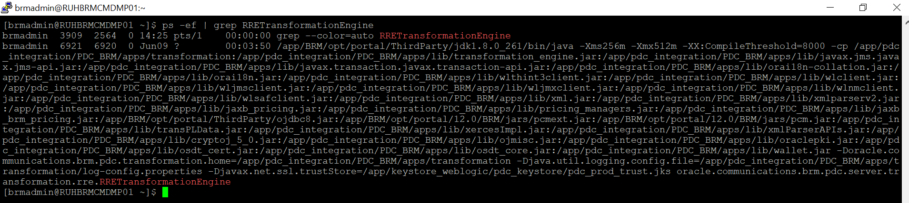

To check for ‘BRETransformationEngine’ process use the command ps –ef | grep BRETransformationEngine

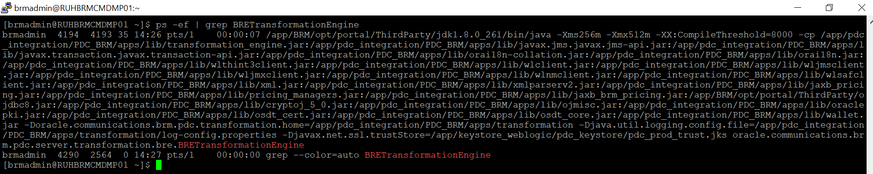

Starting and Stopping of Services

BRM

stop_dm_oracle | start_dm_oracle
stop_cm | start_cm
stop_dm_ifw_sync | start_dm_ifw_sync
stop_eai_js | start_eai_js
stop_dm_aq | start_dm_aq
stop_dm_email | start_dm_email

Weblogic

startup script : nohup ./startWebLogic.sh &
stopping : ./stopWebLogic.sh
To check : ps -ef | grep weblogic

Business Operations Center

PATH : /app/BOC_Domain/bin
LOGS PATH : /app/BOC_Domain/servers/AdminServer/logs

Billing Care

PATH : /app/oracle/Billingcare_Domain/bin
LOGS PATH : /app/oracle/Billingcare_Domain/servers/AdminServer/logs

PDC-BRM Integration Services

PATH : /app/pdc_integration/PDC_BRM/apps/bin

STARTUP SCRIPT

- nohup ./startRRETransformer < password &
- nohup ./startBRETransformer< password &
- nohup ./startSyncPDC< password &
tail -f nohup.out

STOP :
- ./stopBRETransformer
- ./ stopRRETransformer
- ./ stopSyncPDC

PDC Application Process

Log into the server ‘172.31.22.26’.

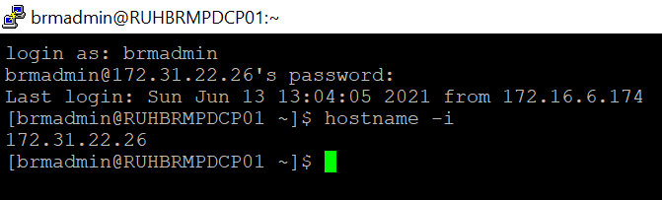

To check for PDC’s Weblogic process use the command ‘ps -ef | grep weblogic’

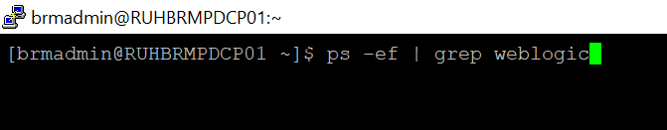

The below process must be running for PDC to be up and running.

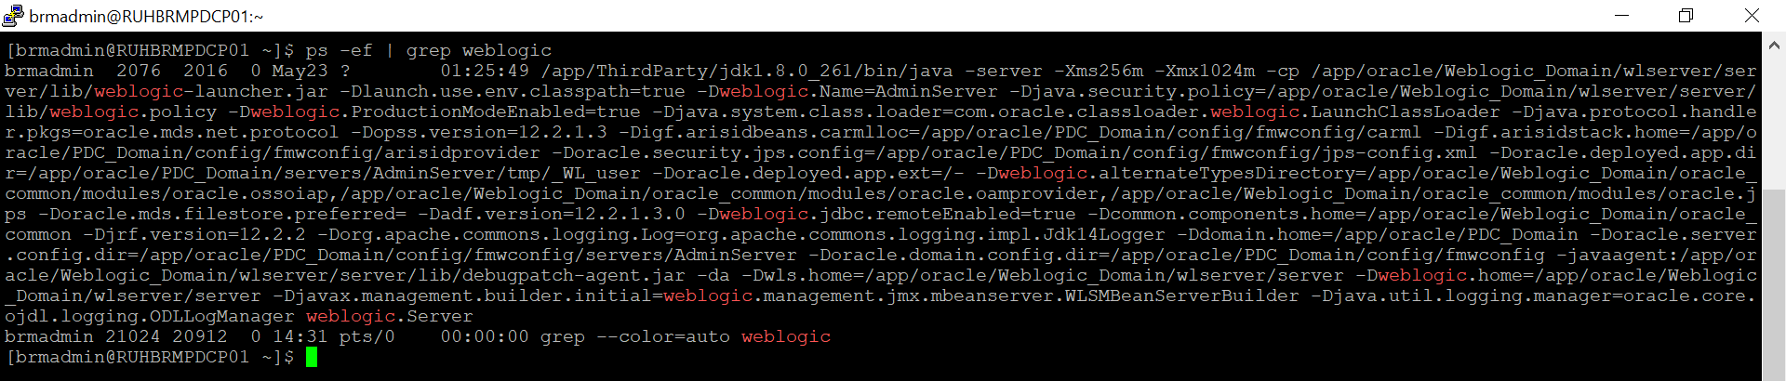

For start and Stop

SCRIPT PATH : /app/oracle/PDC_Domain/bin

Startup Scripts : nohup ./startWebLogic.sh &
STOPPING : ./stopWebLogic.sh

LOGS : /app/oracle/PDC_Domain/servers/AdminServer/logs

BIP Application Process

Log into the server ‘172.31.22.33’.

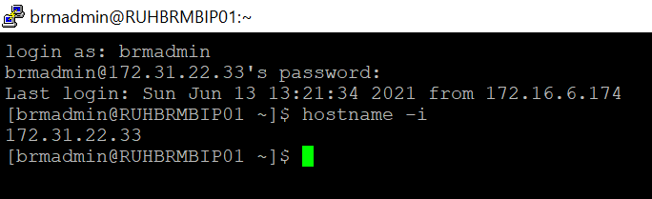

To check for BIP’s Weblogic process use the command ‘ps -ef | grep weblogic’

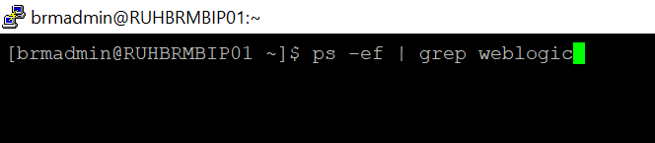

The below process must be running for PDC to be up and running.

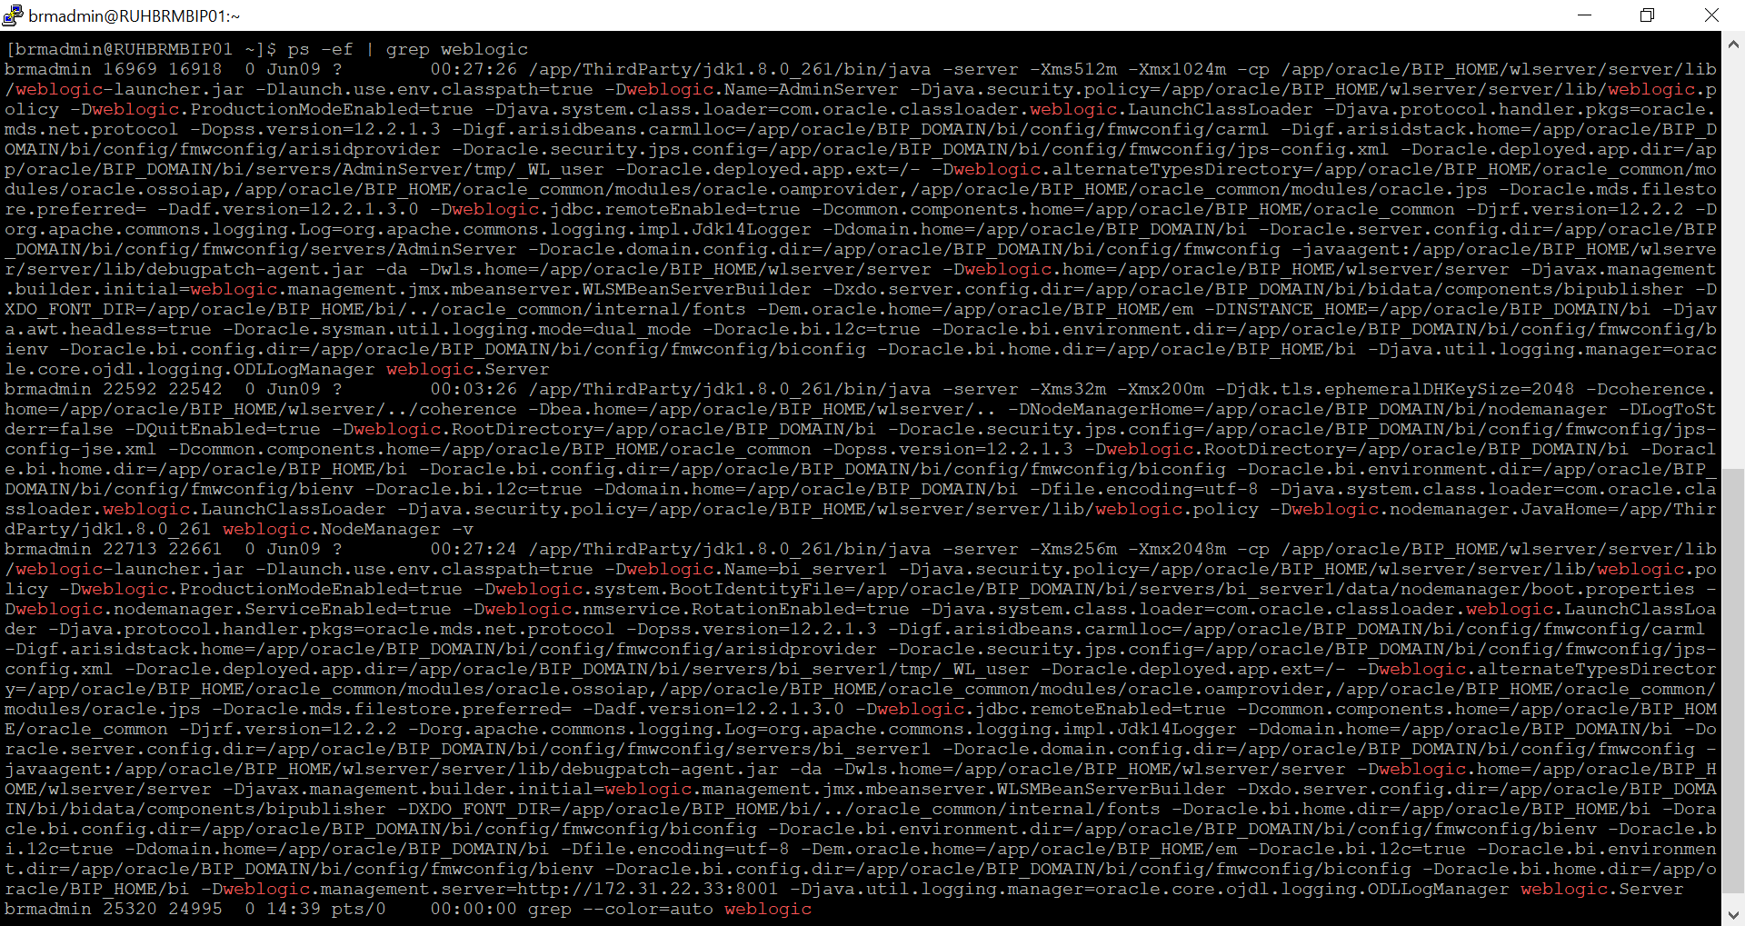

SCRIPT:

ADMIN SERVER
- nohup ./startWebLogic.sh &
tail -f nohup.out (for checking running process logs)
- ./stopweblogic.sh
MANAGE SERVER
- ./start.sh
- ./stop.sh

Scripts PATH
- Admin server PATH : app/BIP_DOMAIN/bi/bin
- MANAGE SERVER PATH: /app/BIP_DOMAIN/bi/bitools/bin

LOGS -
- Admin server PATH : app/BIP_DOMAIN/bi/servers/AdminServer/logs
- MANAGE SERVER PATH : /app/BIP_DOMAIN/bi/servers/bi_server1/logs

Database

BRM Database Connectivity

Open the SQl Developer and make a new connection with below details.

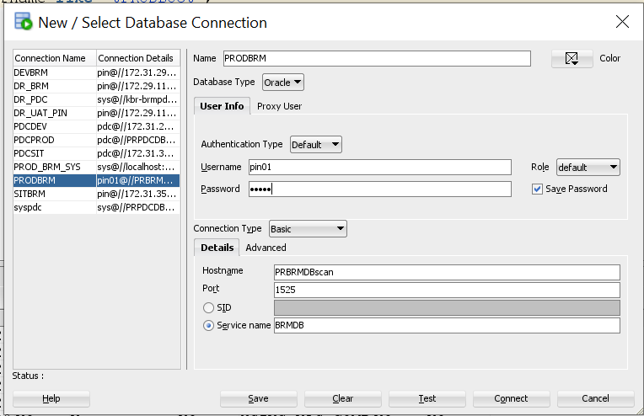

Click on ‘Test’ button to check the DB connectivity. The status should be success.

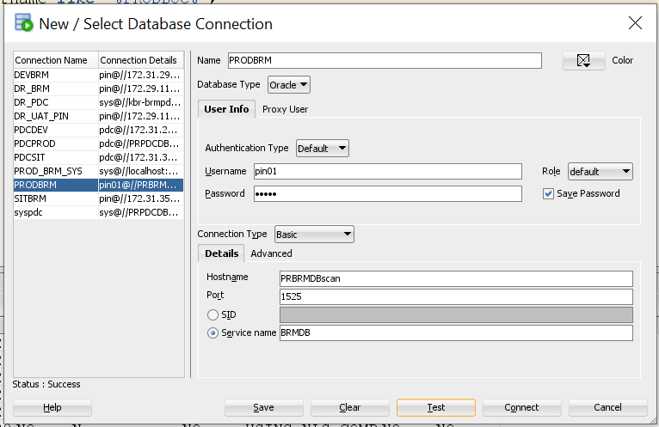

PDC Database Connectivity

Open the SQl Developer and make a new connection with below details.

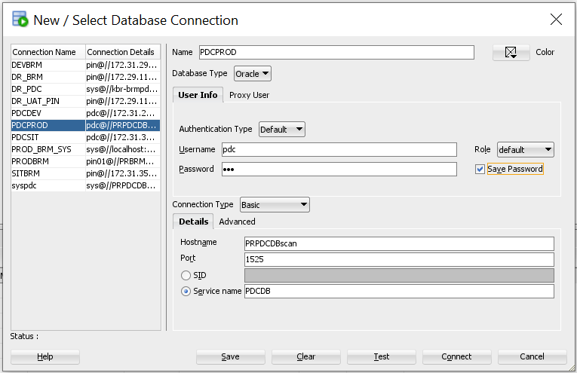

Click on ‘Test’ button to check the DB connectivity. The status should be success.

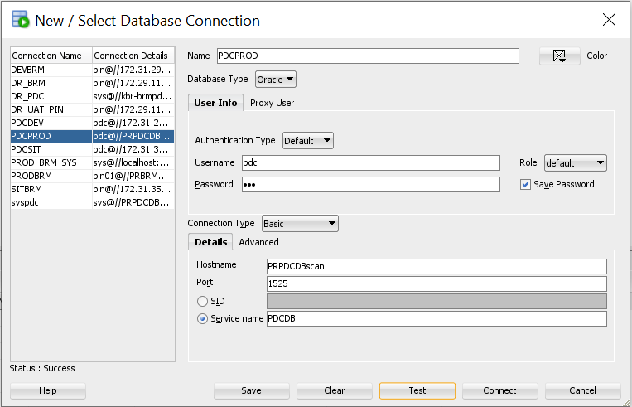

Code Repository

- ITC_BRM Repository : http://172.31.28.42/root/itc_brm
- Development Branch : http://172.31.28.42/root/itc_brm/-/tree/1B-development/
- Release Branch : http://172.31.28.42/root/itc_brm/-/tree/1B-release/
- Master Branch : http://172.31.28.42/root/itc_brm/-/tree/1B-master/

Code Deployment Process

- Upload code into Git.
- Merge the code.
- Create the Tag.
- Take the code from GIT and Deploy.

Common Issue
- Server not accessible
- Mount point space
- Application down

Cron Jobs and Manual Jobs

Notes
- Retention policy of CM and DM oracle logs is 90 days for SIT and 180 days for Production.

Useful Links

Sharepoint
https://itcsa0.sharepoint.com/:f:/r/sites/ApolloB2B2/Shared%20Documents/General?csf=1&web=1&e=UTkdtV

JIRA
https://salamdm.atlassian.net/jira/projects

GIT LAB
http://172.31.28.42/users/sign_in

Manage Engine
https://epc.salam.sa/client#/login

ITSD

https://itsd.itc.sa/

Jump Server

172.31.35.182 (riyadh)
172.29.114.161 (DR)

Open Issues

Closed Issues

