

Tittle: | SOP_AIA_JCA_CPOOL_RESET
Product: | AIA
Customer: | IMPACT
Scope Of Change: | SOP_AIA_JCA_CPOOL_RESET
Approval:

Document Control

1.1 Version History
Sl. No | Date | Author | Version | Change Reference
 |  | Mauricio Quintero | 1.1 | Inclusion of technical information, scope and purpose, introduction, system impact, operational practice, and greater detail in the steps.

1.2 Reviewers
Sl. No | Reviewer | Position | Stream | Organization

1.3 Scope and Purpose of the document
This document is intended to provide a procedure to reset the BRM JCA Adapter Connection Pool on the four (4) AIA nodes (Managed Servers) by executing a "Force Reset".

This SOP applies to cases where the below is required:
- Perform an optimal restart of the connections between the JCA BRM Adapter (deployed in AIA) and the BRM CMs (Connection Managers).
- Make some parameter changes at the BRM CM level.

1.4 Content
Table of Contents
1 Document Control 2
1.1 Version History 2
1.2 Reviewers 2
1.3 Scope and Purpose of the document 2
1.4 Content 3
2 System Overview 4
2.1 Introduction 4
2.2 System Impact 4
2.3 Operational Practice 4
2.4 Defeminations, Acronyms, Abbreviations 4
2.5 Assumptions, Dependencies, Constraints, Decisions 4
2.6 References 4
3 Step-by-step instructions 5
Appendix 9

System Overview

Introduction
In AIA, resetting a JCA adapter’s outbound connection pool can be achieved by discarding unused connections and recreating the pool (reset), or by immediately discarding all connections and recreating the pool, potentially using updated configuration (force reset).

System Impact
The operational procedure in this document can be performed when it is necessary to recreate the connections between the JCA and BRM (CMs) in case they become saturated or when a restart of the CMs/DMs in BRM is performed.

Operational Practice
It is expected that operational staff will take the necessary measures to not affect the current operation, if necessary, confirm whether before executing this procedure, the order queue in AIA "AIA_SALESORDERJMSQUEUE" should be paused through the "ProcessSalesOrderFulfillmentSiebelCommsJMSConsumer" AIA service (refer to the SOP document "SOP_AIA_PAUSE_AIA_QUEUE_SERVICE_V1.1.docx").

Defeminations, Acronyms, Abbreviations

Assumptions, Dependencies, Constraints, Decisions
Sl. No | Assumptions
1.
2.

References
Sl. No | Document Name | Document Description
1.
2.

Step-by-step instructions

This is the operational procedure in this document can be performed when it is necessary to recreate the connections between the JCA and BRM (CMs) in case they become saturated or when a restart of the CMs/DMs in BRM is performed.

Steps to be followed.
- Login to Weblogic console:
http://172.20.10.37:7001/console/
Enter username/password
username:weblogic
password:XXXXXXX
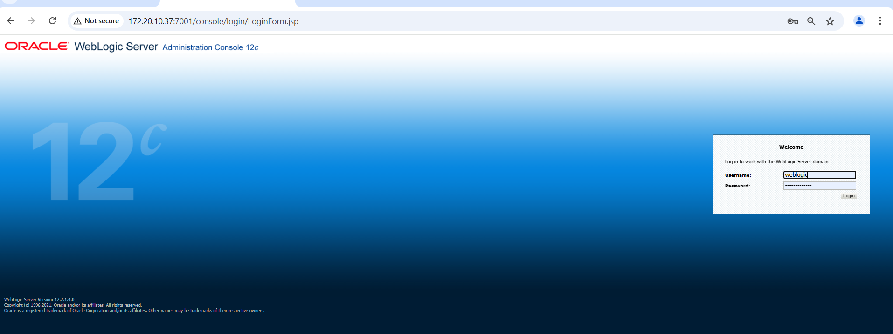

- Click on “Deployments”
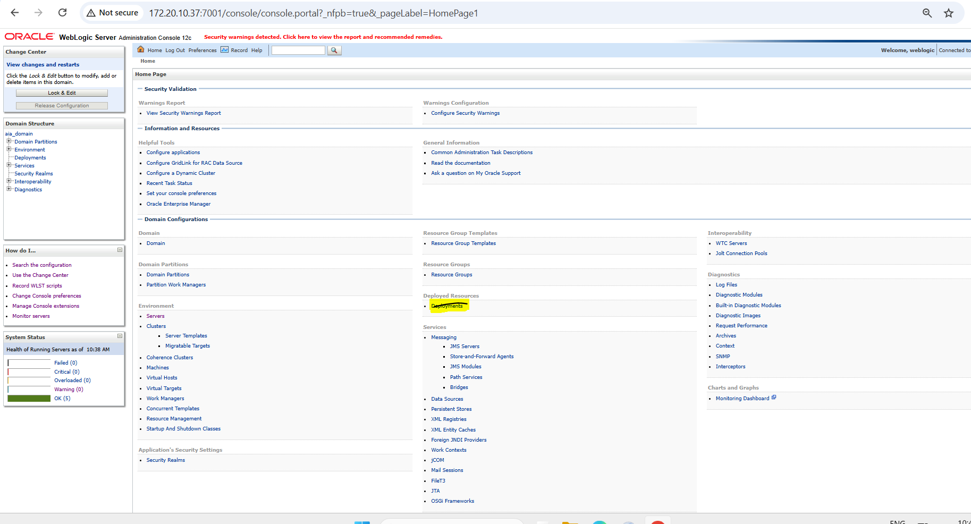

- Search with “OracleBRMJCA15Adapter”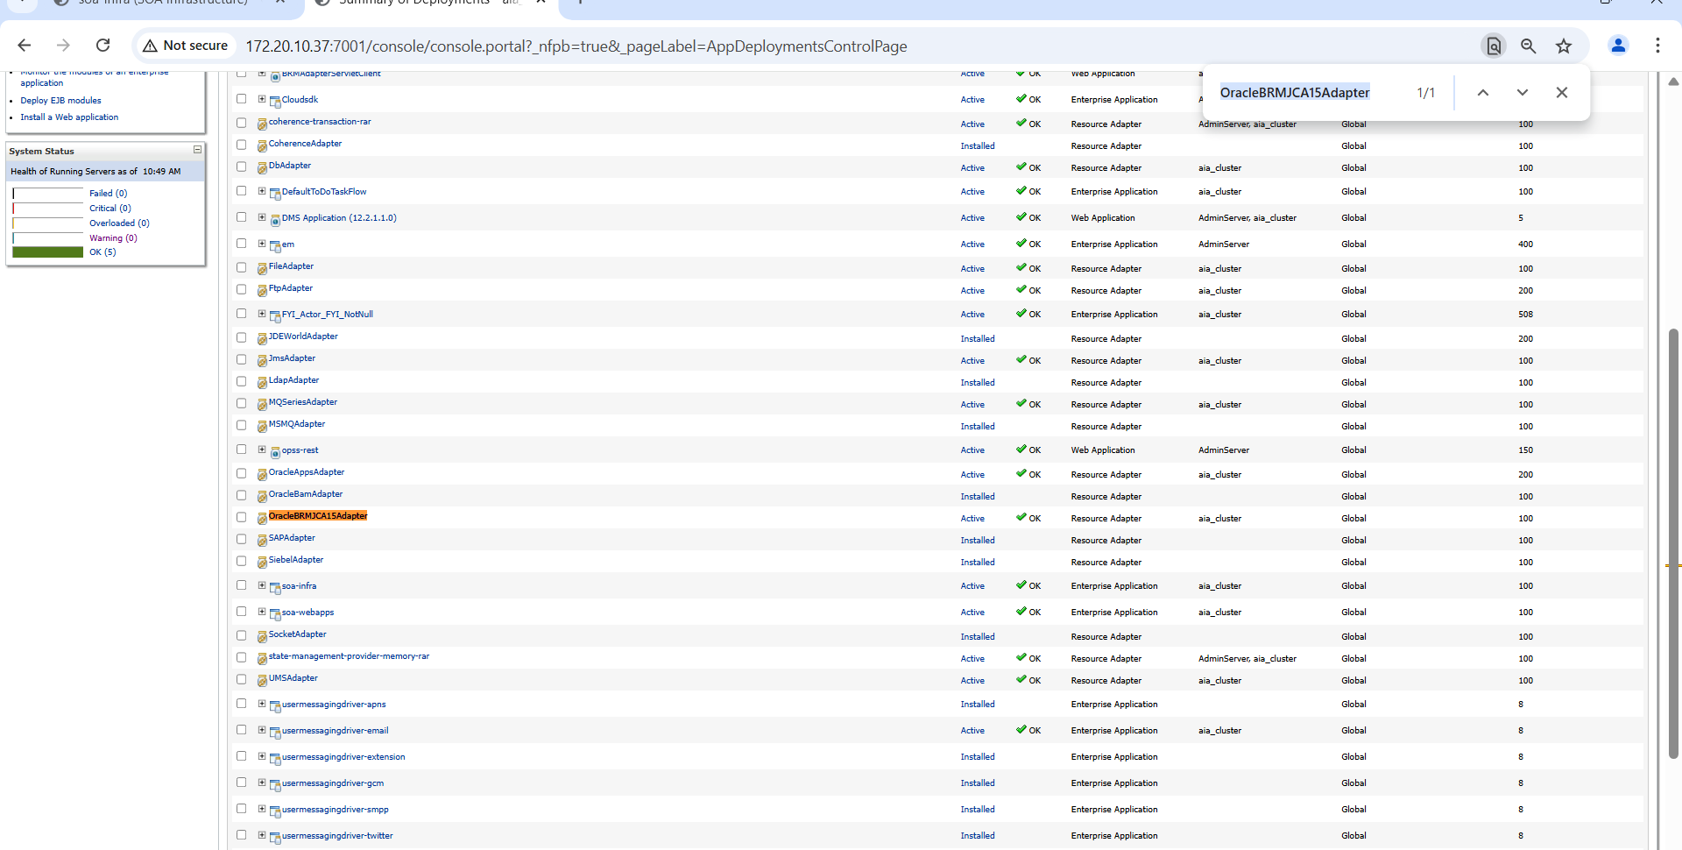

- Click on “OracleBRMJCA15Adapter”

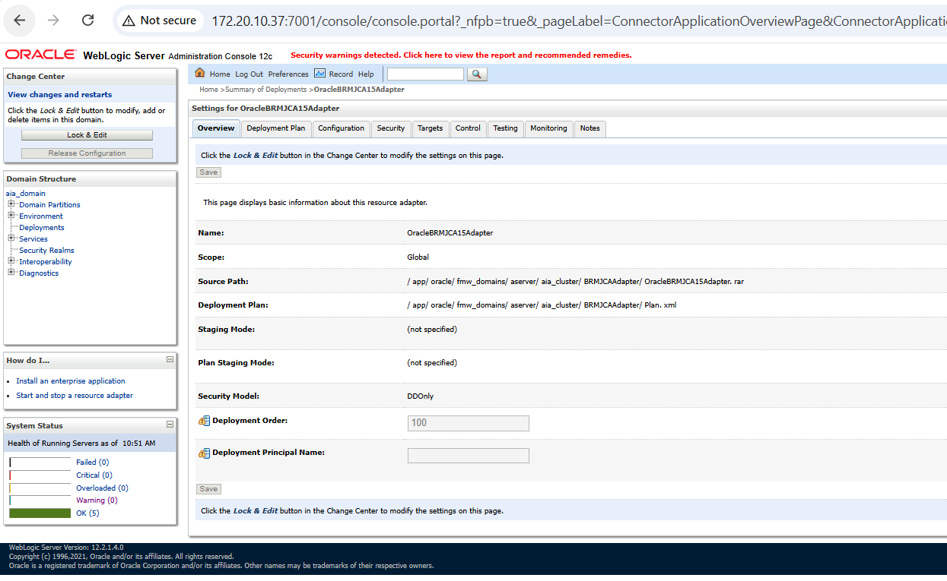
- Click on Control Outbound Connection Pools
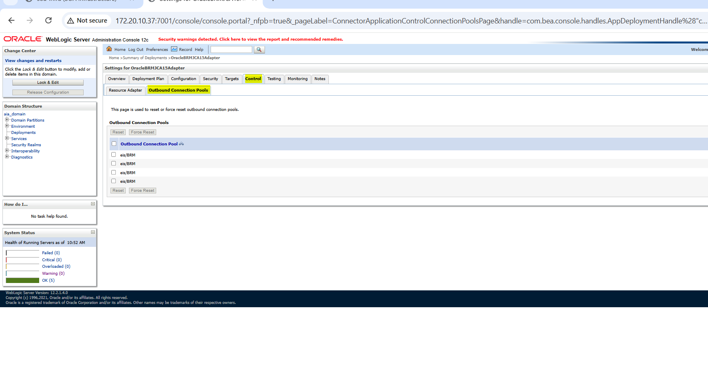
6. Select checkbox and click on “Force Reset”
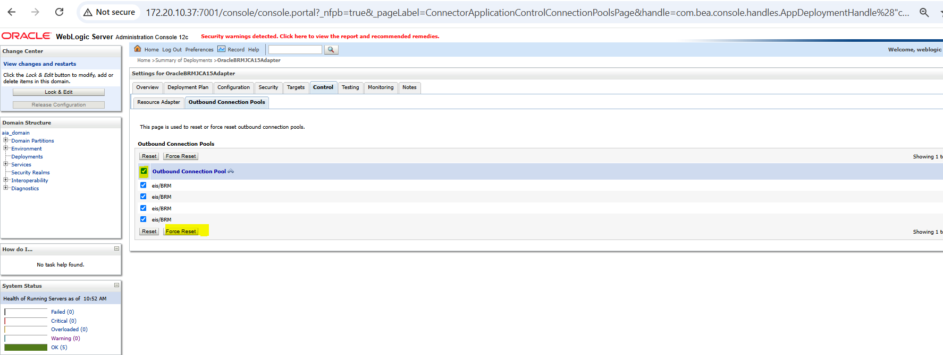

- Click on “Yes” button
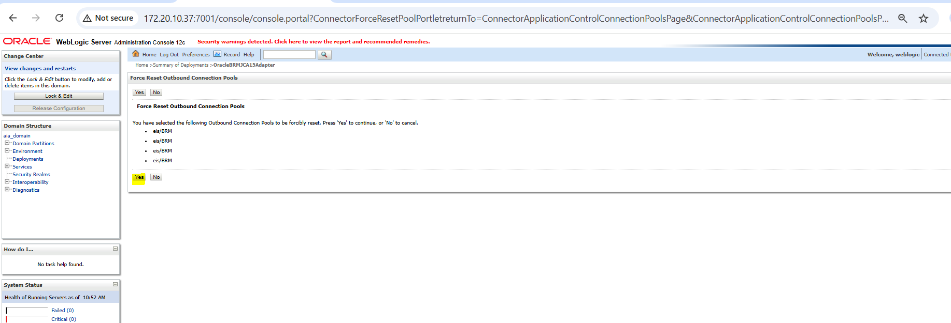

- Below screenshot for successful connect Reset.
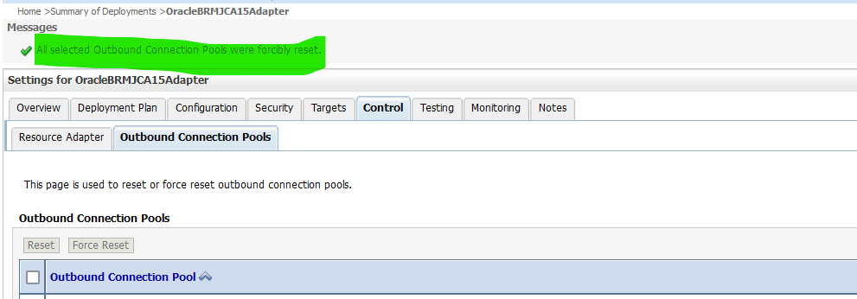

Appendix
Ongoing Work
Sl. No. | Activity | Work Description | Owner

Common problems
Sl. No. | Defect/Bug ID | Identification Phase | Issue Resolution

Known Issues
Sl. No. | Defect/Bug ID | Identification Phase | Issue Resolution

