

Tittle: | PAUSE_AIA QUEUE_SERVICE
Product: | AIA
Customer: | IMPACT
Scope Of Change: | PAUSE_AIA QUEUE_SERVICE
Approval:

Document Control

1.1 Version History
Sl. No | Date | Author | Version | Change Reference

1.2 Reviewers
Sl. No | Reviewer | Position | Stream | Organization

1.3 Scope and Purpose of the document
This document is intended to provide procedure to stop the consumption of "SalesOrderABM" (Siebel messages ABM) from “AIA_SALESORDERJMSQUEUE queue” and stop them from being passed to the " ProcessSalesOrderFulfillmentSiebelCommsReqABCSImpl" service so that message processing can continue.

This SOP applies to cases where the below is required:
- Perform an optimal restart of the connections between the JCA BRM Adapter (deployed in AIA) and the BRM CMs (Connection Managers).
- Make some parameter changes at the BRM CM level, redeployment of the JCA BRM Adapter, etc.
- Contingent processes or order operation check processes between Siebel/AIA/BRM.

1.4 Content
Table of Contents
1 Document Control 2
1.1 Version History 2
1.2 Reviewers 2
1.3 Scope and Purpose of the document 2
1.4 Content 3
2 System Overview 4
2.1 Introduction 4
2.2 System Impact 4
2.3 Operational Practice 4
2.4 Defeminations, Acronyms, Abbreviations 4
2.5 Assumptions, Dependencies, Constraints, Decisions 4
2.6 References 4
3 Step-by-step instructions 5
Appendix 8

System Overview

Introduction
The “ProcessSalesOrderFulfillmentSiebelCommsJMSConsumer” AIA service is in an active state during normal operations, so it must be temporarily stopped to perform connection reset procedures or changes at the JCA BRM Adapter and BRM CM/DM levels.

System Impact
Operational procedure in this document can only be performed in cases where the operations support team confirms its execution during a time window approved by the client, since orders sent from Siebel will not be processed in the E2E.

Operational Practice
It is expected that operational staff will take the necessary concerns and confirm that only the “ProcessSalesOrderFulfillmentSiebelCommsJMSConsumer” service will be temporarily paused.

Defeminations, Acronyms, Abbreviations
 | Service Restoration | The process of bringing a failed service back to normal operation
 | Incident | An unplanned interruption or reduction in the quality of an IT service
 | Outage | A period during which a service or system is unavailable or down.
 | Escalation | The process of escalating an issue to higher levels of support when it cannot be resolved within a predefined time frame.
 | AIA | Application Integration Architecture
 | PIP | Process Integration Pack. A pre-built set of integrated orchestration flows, application integration logic, and extensible enterprise services and objects required to manage the state and execution of defined sets of activities or tasks between specific Oracle applications associated with a given process.
 | EM | Oracle Enterprise Manager tool to monitor and manage Oracle AIA / SOA Suite

Assumptions, Dependencies, Constraints, Decisions
Sl. No | Assumptions
1. | The AIA service “ProcessSalesOrderFulfillmentSiebelCommsJMSConsumer” is in an active state
2.

References
Sl. No | Document Name | Document Description
1.
2.

Step-by-step instructions

The “ProcessSalesOrderFulfillmentSiebelCommsJMSConsumer” AIA service is in an active state during normal operations, so it must be temporarily stopped to perform connection reset procedures or changes at the JCA BRM Adapter and BRM CM/DM levels.
It is expected that operational staff will take the necessary concerns and confirm that only the “ProcessSalesOrderFulfillmentSiebelCommsJMSConsumer” service will be temporarily paused

Login to EM console
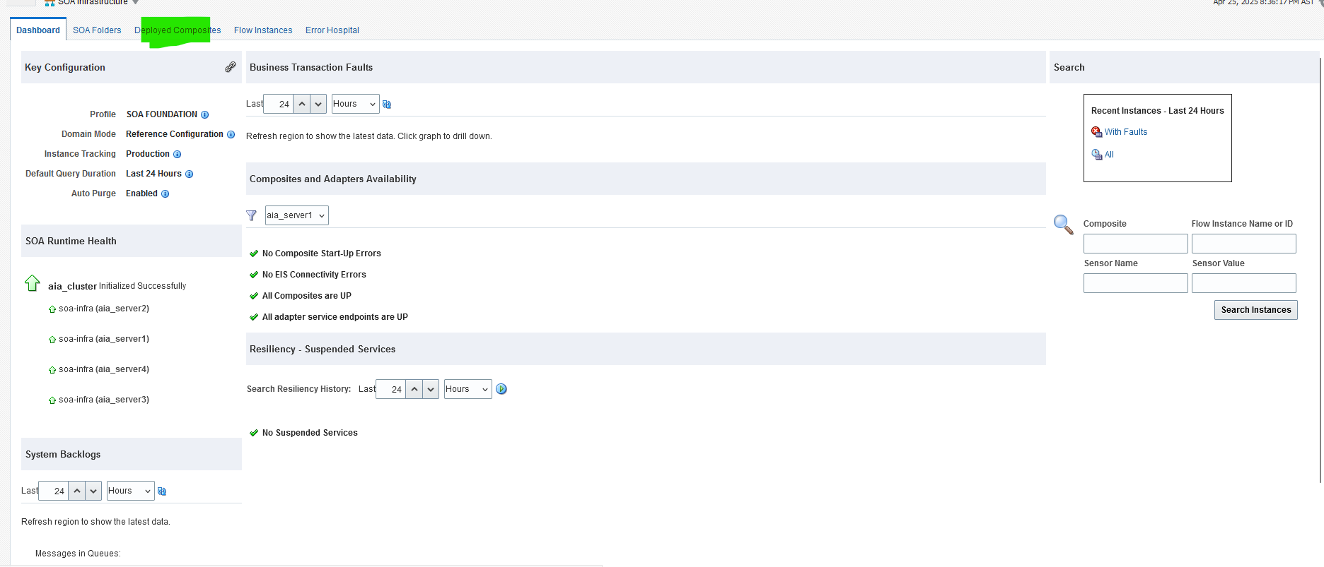
Search with “ProcessSalesOrderFulfillmentSiebelCommsJMSConsumer”
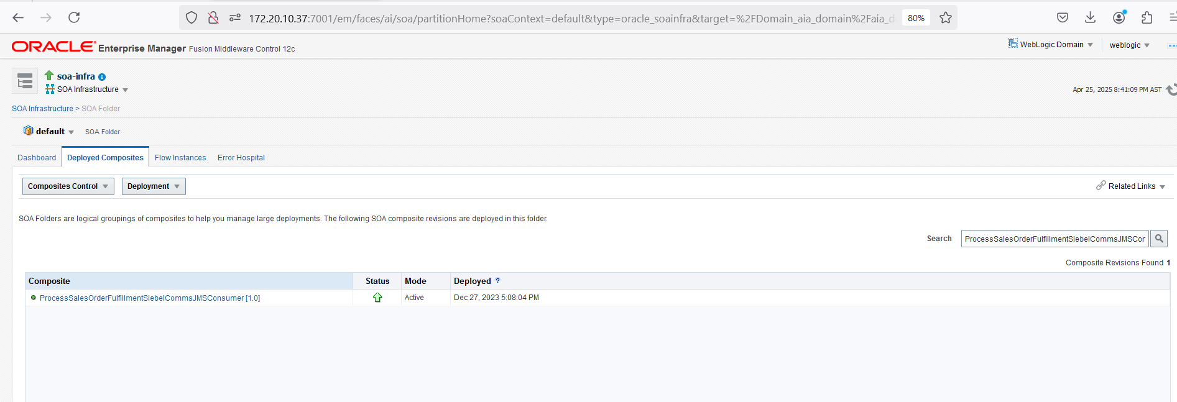

Click on Retire button to pause the messages flow.
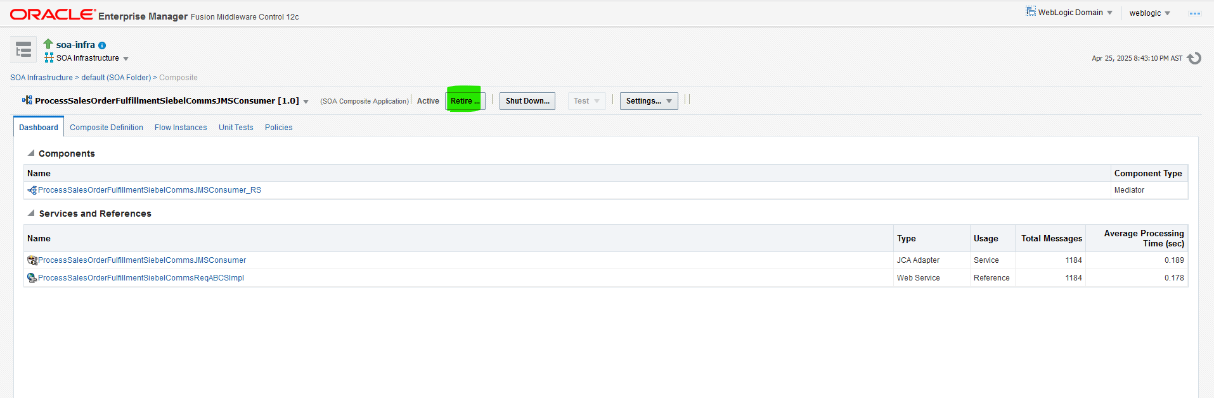

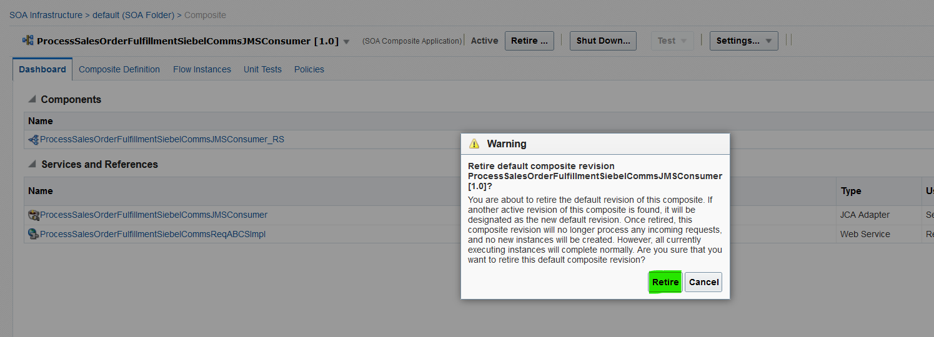

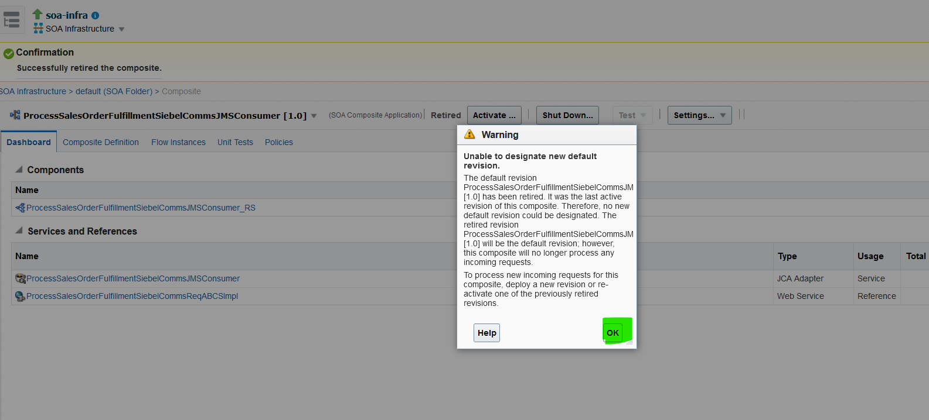

Activate the queues service After completion of Task:

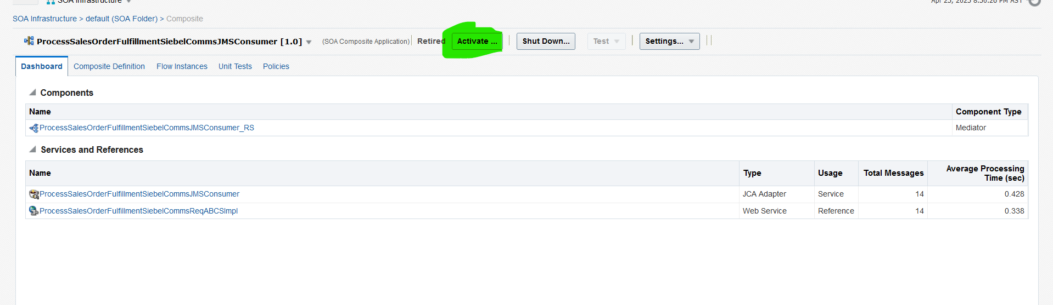

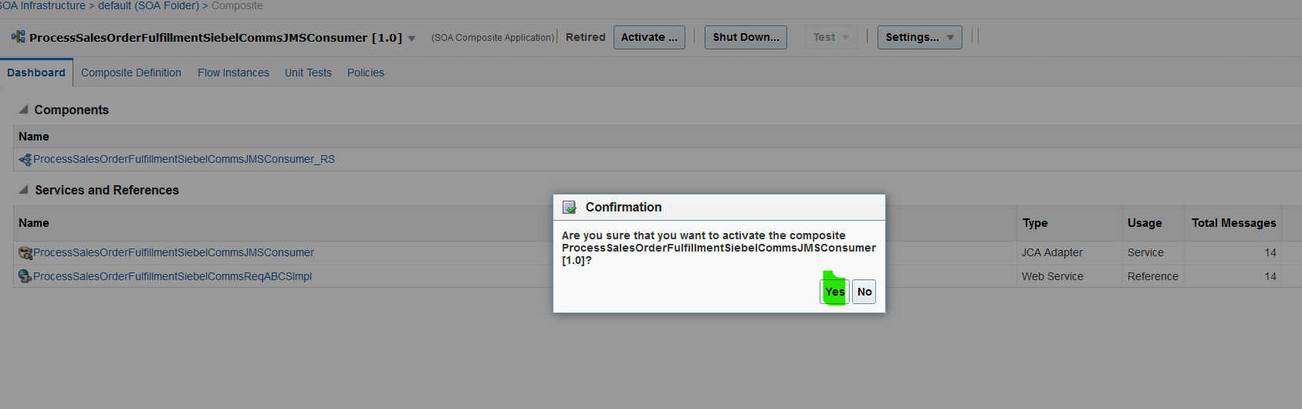

Appendix
Ongoing Work
Sl. No. | Activity | Work Description | Owner

Common problems
Sl. No. | Defect/Bug ID | Identification Phase | Issue Resolution

Known Issues
Sl. No. | Defect/Bug ID | Identification Phase | Issue Resolution

