How to Pause Queue Service
Process to Pause Queue Service
Login to EM console

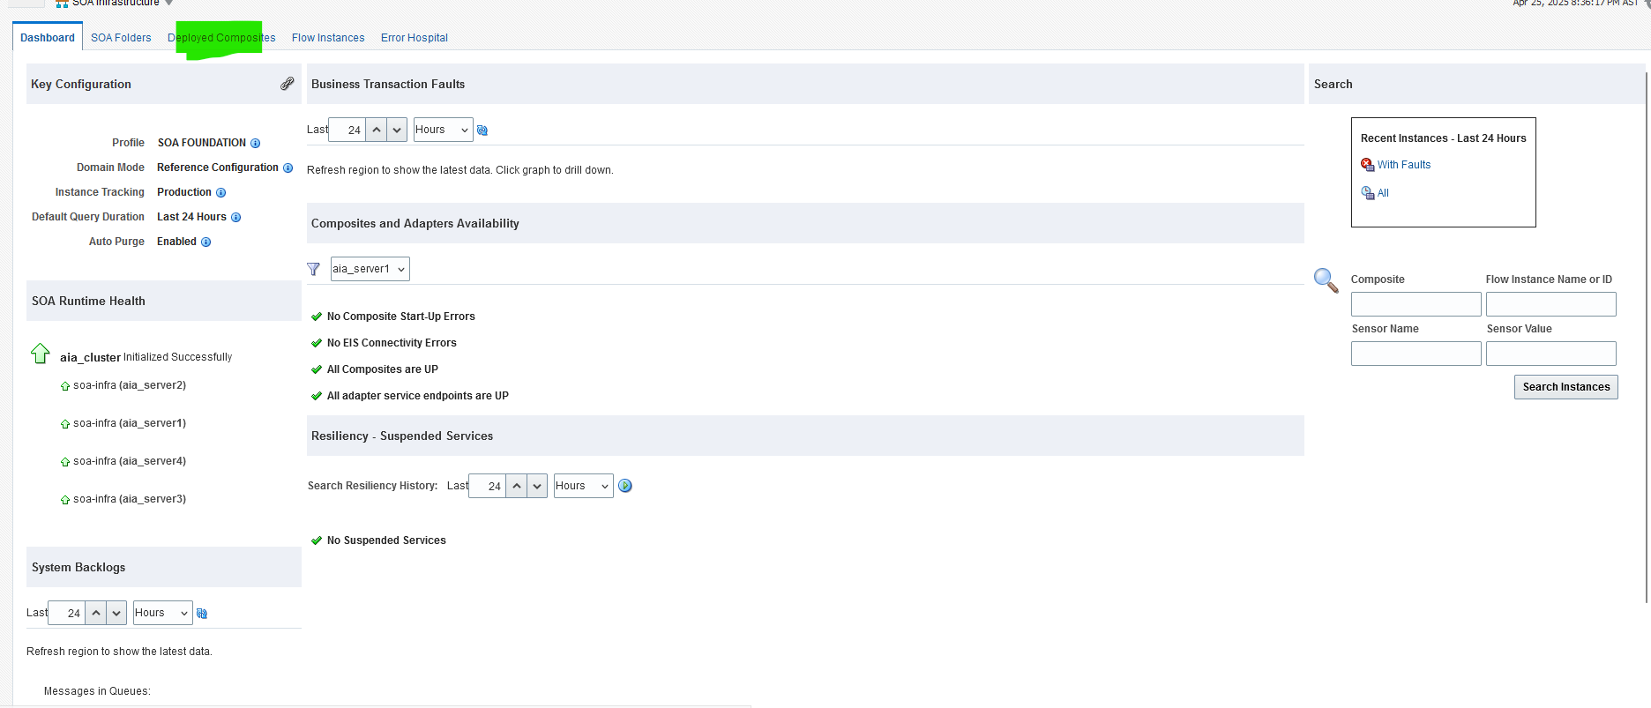

Search with “ProcessSalesOrderFulfillmentSiebelCommsJMSConsumer”
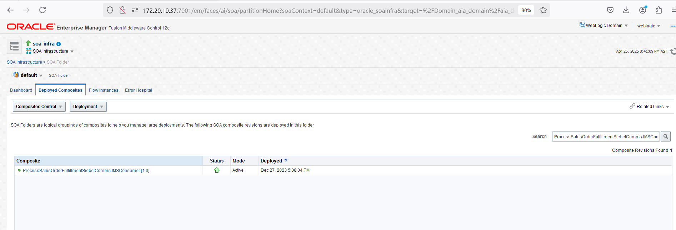

Click on Retire button to pause the messages flow.

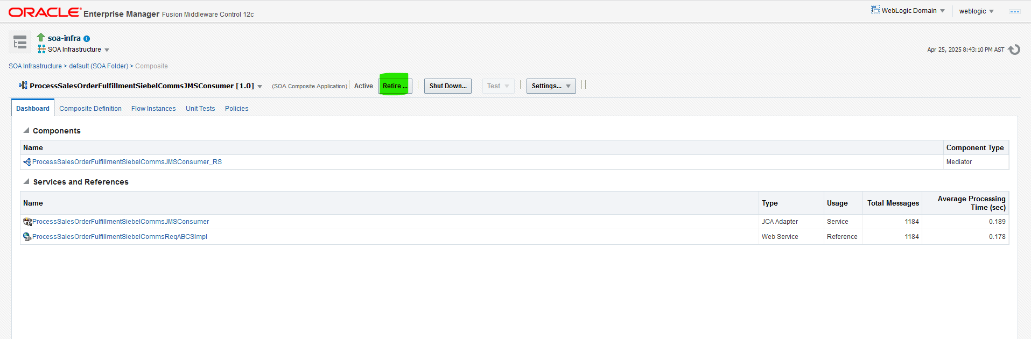

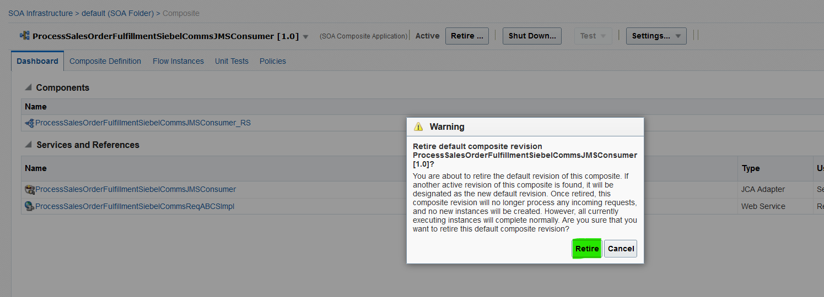

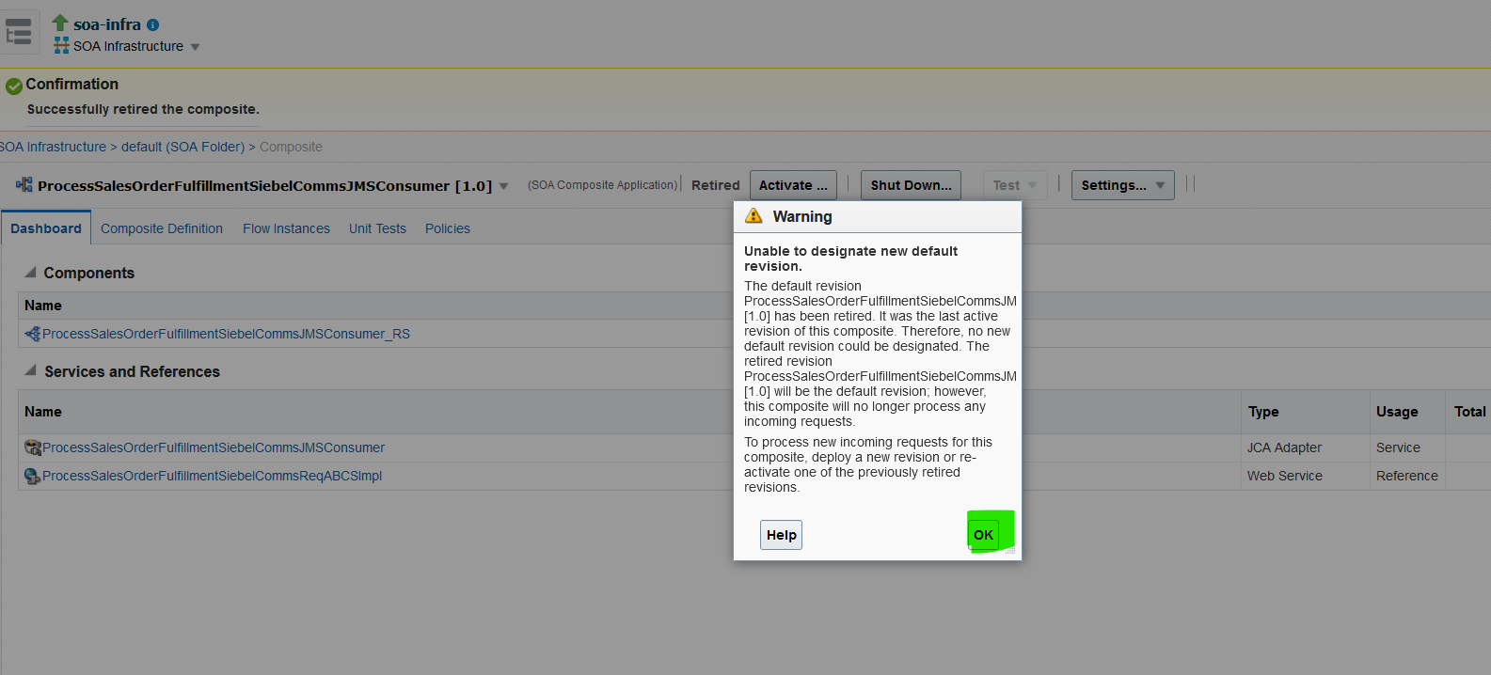

Activate the queues service After completion of Task:

