

Tittle: | AIA to Siebel Stuck Order Stuck Orders
Product: | AIA
Customer: | IMPACT
Scope Of Change: | AIA to Siebel Stuck Order Stuck Orders
Approval:

Document Control

1.1 Version History
Sl. No | Date | Author | Version | Change Reference

1.2 Reviewers
Sl. No | Reviewer | Position | Stream | Organization

1.3 Scope and Purpose of the document
This document is intended to provide procedures to extract stuck orders from Siebel and after checking them in AIA EM, those that are waiting for recovery (“re covery required” option) can be retried from AIA to complete them (Retry).

1.4 Content
Table of Contents
1 Document Control 2
1.1 Version History 2
1.2 Reviewers 2
1.3 Scope and Purpose of the document 2
1.4 Content 3
2 System Overview 4
2.1 Introduction 4
2.2 System Impact 4
2.3 Operational Practice 4
2.4 Defeminations, Acronyms, Abbreviations 4
2.5 Assumptions, Dependencies, Constraints, Decisions 4
2.6 References 4
3 Step-by-step instructions 5
Alarm 5
Steps to be followed. 5
Appendix 10

System Overview

Introduction
Through an SQL query from Siebel, the IDs of "stuck orders" (orders with status: 'Open', 'In Progress', 'Failed') can be extracted to check them in AIA and be able to retry those that are waiting for Recovery option.

System Impact
Operational procedure in this document can be performed when there is the alert "AIA to Siebel Stuck Order: StuckOrders_AIA-SBL is XX" in order to attend to those orders in AIA with the "Recovery" option.

Operational Practice
It is expected that operational staff will verify in AIA that the orders extracted from Siebel are waiting for Recovery to be able to execute "Retry".

Defeminations, Acronyms, Abbreviations
 | AIA | Application Integration Architecture
 | PIP | Process Integration Pack. A pre-built set of integrated orchestration flows, application integration logic, and extensible enterprise services and objects required to manage the state and execution of defined sets of activities or tasks between specific Oracle applications associated with a given process.
 | EM | Oracle Enterprise Manager tool to monitor and manage Oracle AIA / SOA Suite

Assumptions, Dependencies, Constraints, Decisions
Sl. No | Assumptions
1. | This procedure only applies to those stuck orders that in AIA are waiting for Recovery to be able to execute "Retry".
2. | Support teams must validate other alternatives for those stuck orders that have other errors or that the "retry" option from AIA does not work.

References
Sl. No | Document Name | Document Description
1.
2.

Step-by-step instructions

Through an SQL query from Siebel, the IDs of "stuck orders" (orders with status: 'Open', 'In Progress', 'Failed') can be extracted to check them in AIA and be able to retry those that are waiting for Recovery option.

Operational procedure in this document can be performed when there is the alert "AIA to Siebel Stuck Order: StuckOrders_AIA-SBL is XX" in order to attend to those orders in AIA with the "Recovery" option.

Alarm triggered
Alarm that triggers the checking process.
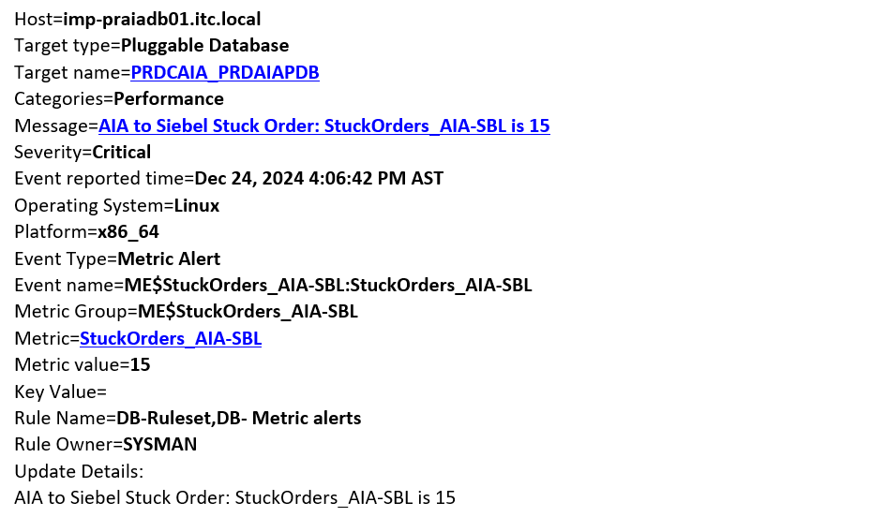

Steps to be followed.
Go to remote desktop
Please try to login to the RDP 172.31.35.182

itc\YOUR USERNAME (LAD L1 folks use, u.cardona.ora/Asd321!.)

– Open sql developer open below already saved connection
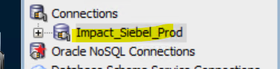
- Run the below query to check how many orders are on downstream:
with Total_Orders_Count as (
SELECT *
FROM
SIEBEL.S_ORDER
WHERE
ORDER_NUM NOT LIKE 'D-%'
AND STATUS_CD NOT IN ('Child Orders Created')
),
Total_Completed_orders as (
SELECT *
FROM
SIEBEL.S_ORDER
WHERE
STATUS_CD='Complete'
AND ORDER_NUM NOT LIKE 'D-%'
),
Today_Completed_orders as (
SELECT *
FROM
SIEBEL.S_ORDER
WHERE
STATUS_CD='Complete'
AND TO_CHAR(LAST_UPD + 3/24, 'DD-MON-YYYY') = TO_CHAR(SYSDATE, 'DD-MON-YYYY')
AND ORDER_NUM NOT LIKE 'D-%'
),
Today_created_Orders as (
SELECT *
FROM
SIEBEL.S_ORDER
WHERE
TO_CHAR(CREATED + 3/24, 'DD-MON-YYYY') = TO_CHAR(SYSDATE, 'DD-MON-YYYY')
AND ORDER_NUM NOT LIKE 'D-%'
),
Total_cancelled_orders as (
SELECT *
FROM
SIEBEL.S_ORDER
WHERE
STATUS_CD IN ('Cancelled','Abandoned','Closed')
AND ORDER_NUM NOT LIKE 'D-%'
),
Orders_Cancelled_Today as (
SELECT *
FROM
SIEBEL.S_ORDER
WHERE
STATUS_CD IN ('Cancelled','Abandoned','Closed')
AND TO_CHAR(LAST_UPD + 3/24, 'DD-MON-YYYY') = TO_CHAR(SYSDATE, 'DD-MON-YYYY')
AND ORDER_NUM NOT LIKE 'D-%'
),
Total_Pending_orders_in_SIEBEL as (
SELECT *
FROM
SIEBEL.S_ORDER
WHERE
STATUS_CD IN ('Pending','RU Pending')
AND ORDER_NUM NOT LIKE 'D-%'
),
Total_Inprogress_orders_in_Downstream as (
SELECT *
FROM
SIEBEL.S_ORDER
WHERE
STATUS_CD IN ('Open','In Progress','Failed')
AND ORDER_NUM NOT LIKE 'D-%'
)
select
(select count(*) from Total_Orders_Count) as Total_Orders_Count,
(select count(*) from Total_Completed_orders) as Total_Completed_orders,
(select count(*) from Today_Completed_orders) as Today_Completed_orders,
(select count(*) from Today_created_Orders) as Today_created_Orders,
(select count(*) from Total_cancelled_orders) as Total_cancelled_orders,
(select count(*) from Orders_Cancelled_Today) as Orders_Cancelled_Today,
(select count(*) from Total_Pending_orders_in_SIEBEL) as Total_Pending_orders_in_SIEBEL,
(select count(*) from Total_Inprogress_orders_in_Downstream) as Total_Inprogress_orders_in_Downstream
from dual
;

- Run below query to check the failed open order numbers.
SELECT order_num
FROM SIEBEL.S_ORDER WHERE STATUS_CD IN ('Open','In Progress','Failed') AND ORDER_NUM NOT LIKE 'D-%';

- Take those order numbers and check on below platform.
http://172.20.10.37:7001/em (You need UIM tunnel/Firefox)
weblogic | /passw0rd@2090

- Open any of the 4 soa servers
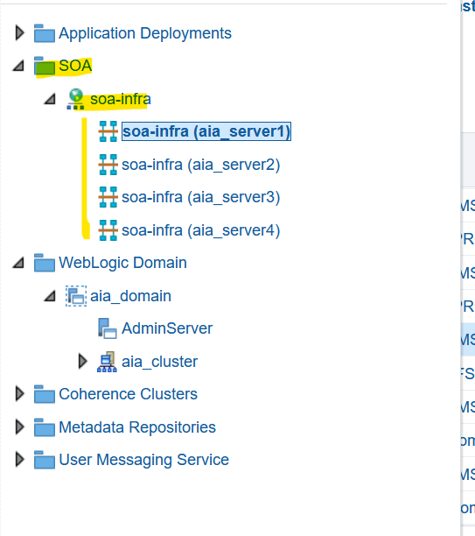

- Go to flow instance ID and paste order number.
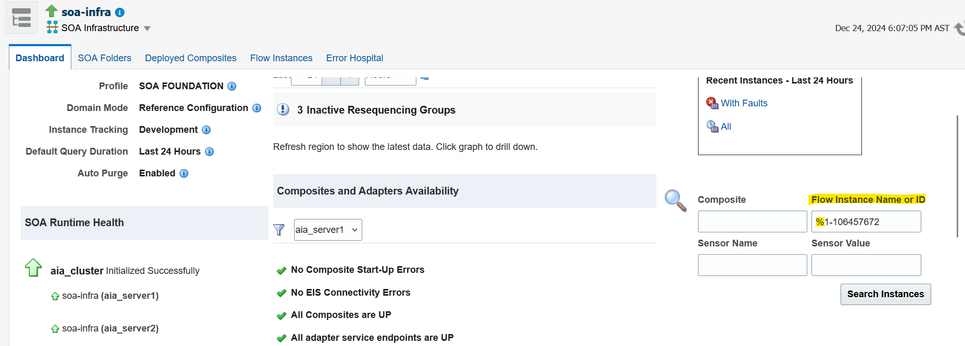

Check all orders to check which one is waiting for recovery and click recovery required (Retry) NEVER ABORT

Finally go to query 1 and check that no Total_Inprogress_orders_in_Downstream, it should be 0.

Appendix
Ongoing Work
Sl. No. | Activity | Work Description | Owner

Common problems
Sl. No. | Defect/Bug ID | Identification Phase | Issue Resolution

Known Issues
Sl. No. | Defect/Bug ID | Identification Phase | Issue Resolution

