How to BRM HCA Reset
Procedure to BRM JCA Reset
Login to Weblogic console:
http://172.20.10.37:7001/console/
enter username/password
username:weblogic
password:XXXXXXX
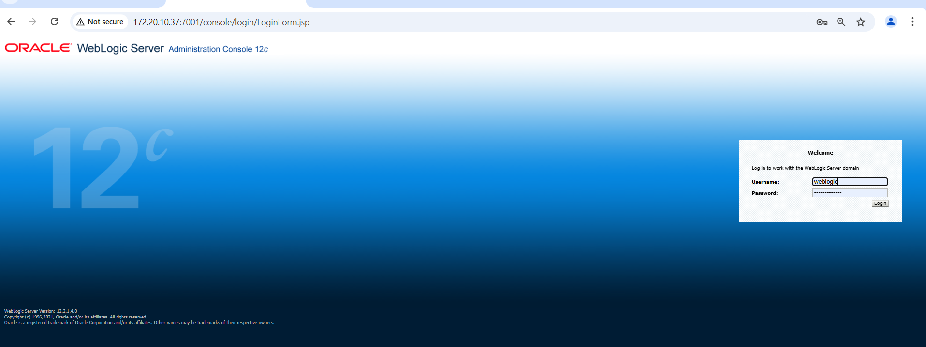

Click on “Deployments”
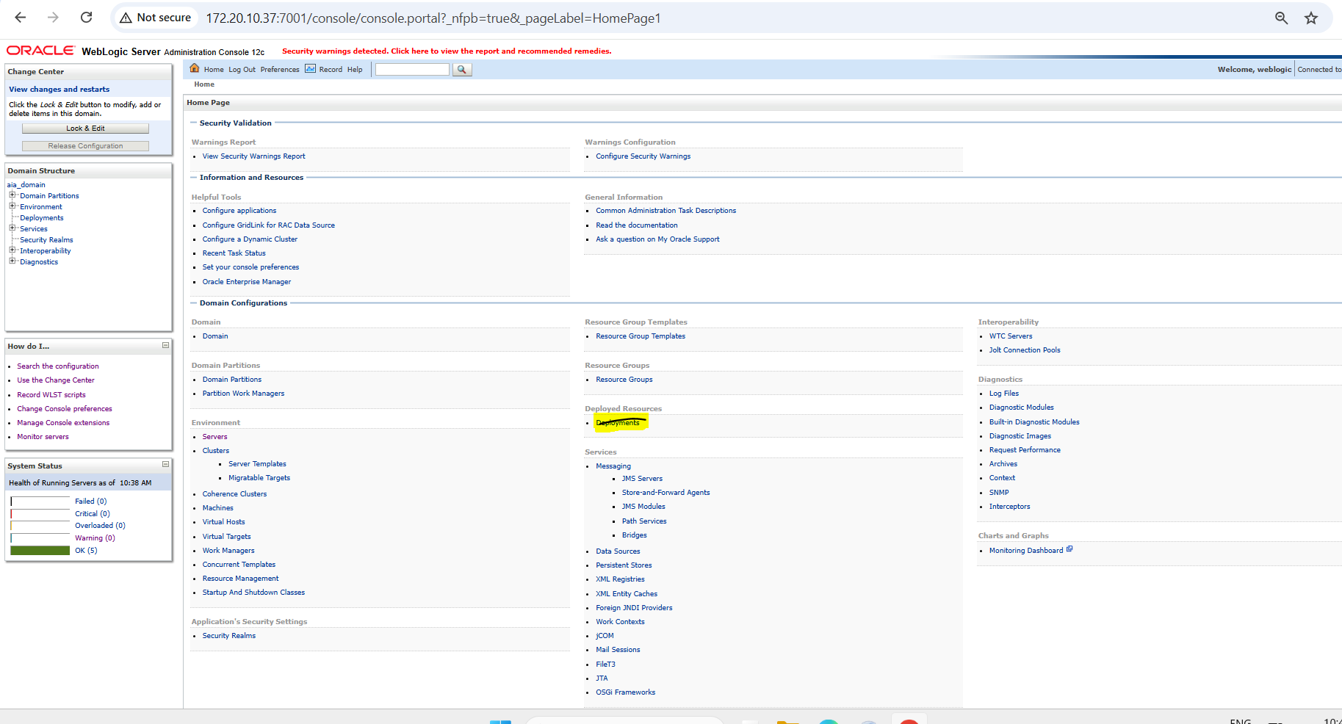

Search with “OracleBRMJCA15Adapter”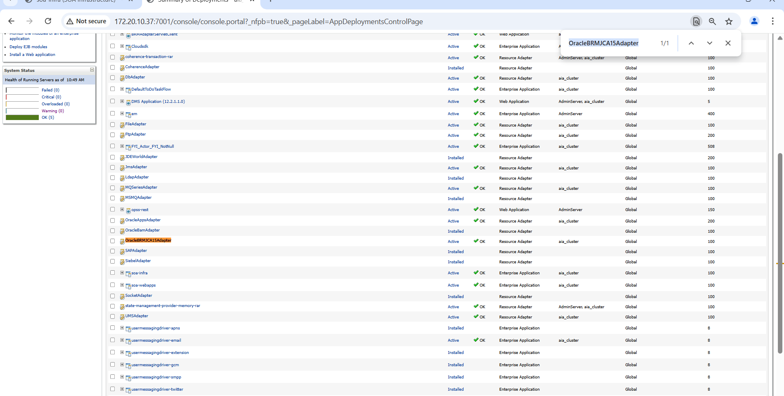

Click on “OracleBRMJCA15Adapter”

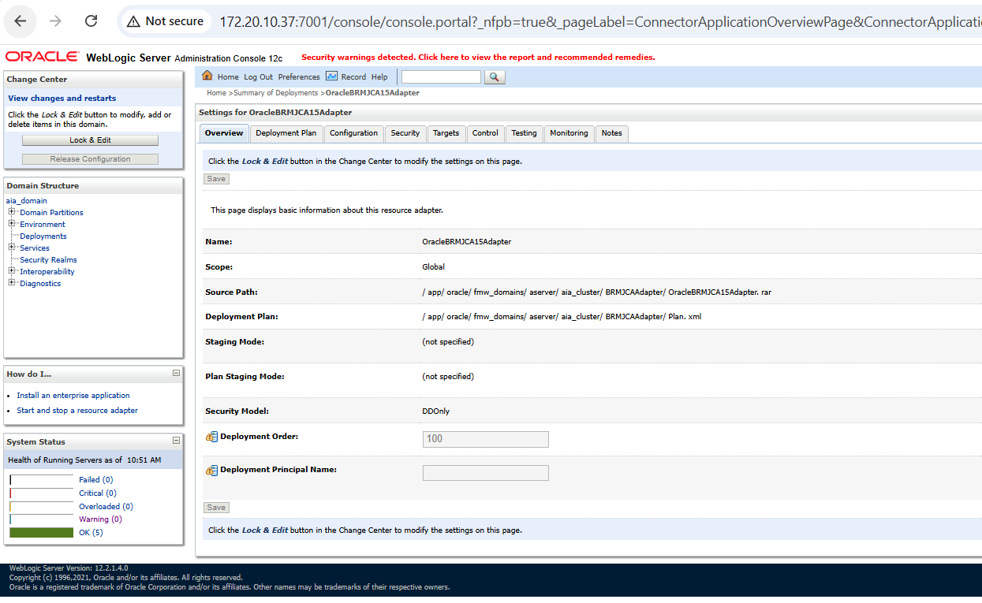

Click on control Outbound Connection Pools

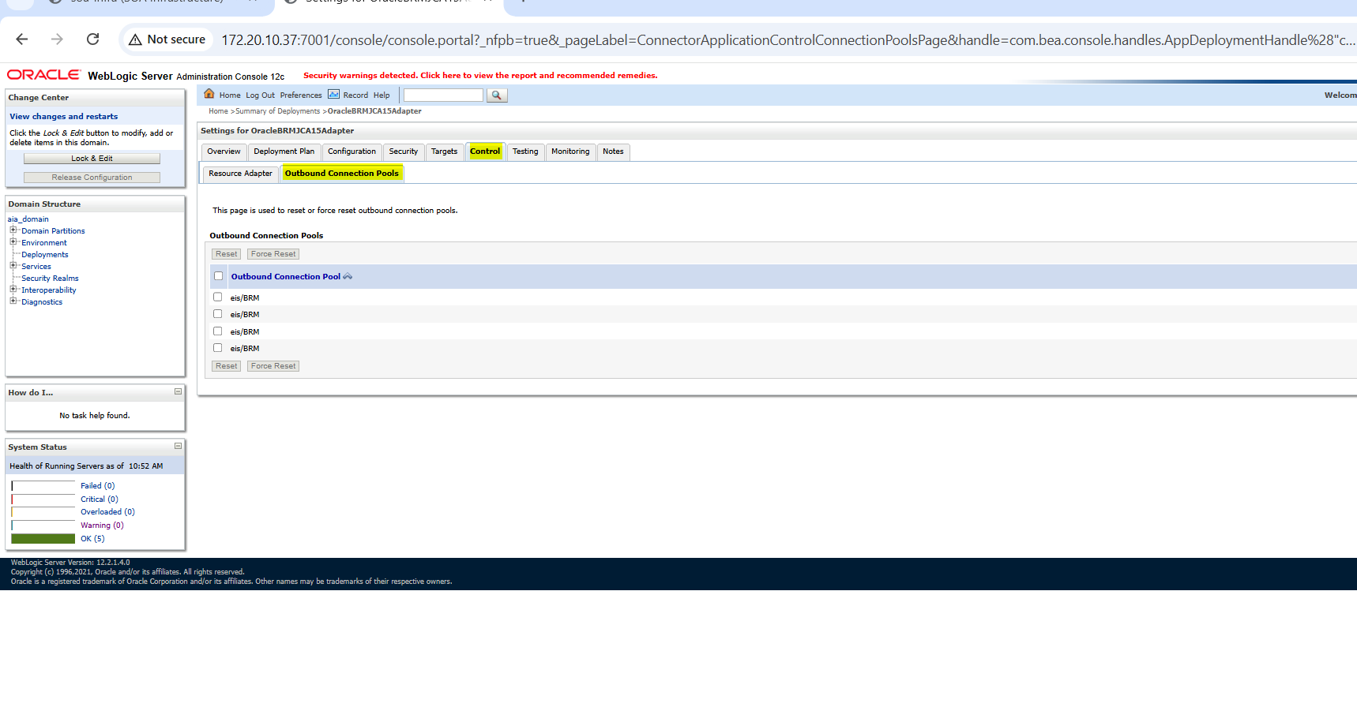
Select checkbox and click on “Force Reset”
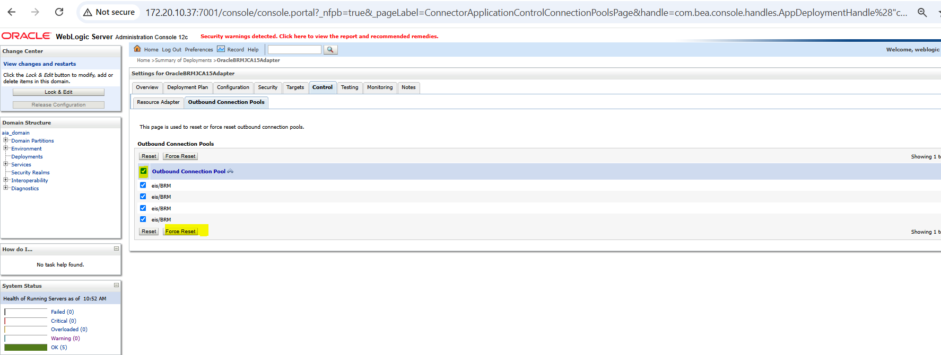

Click on “Yes” button
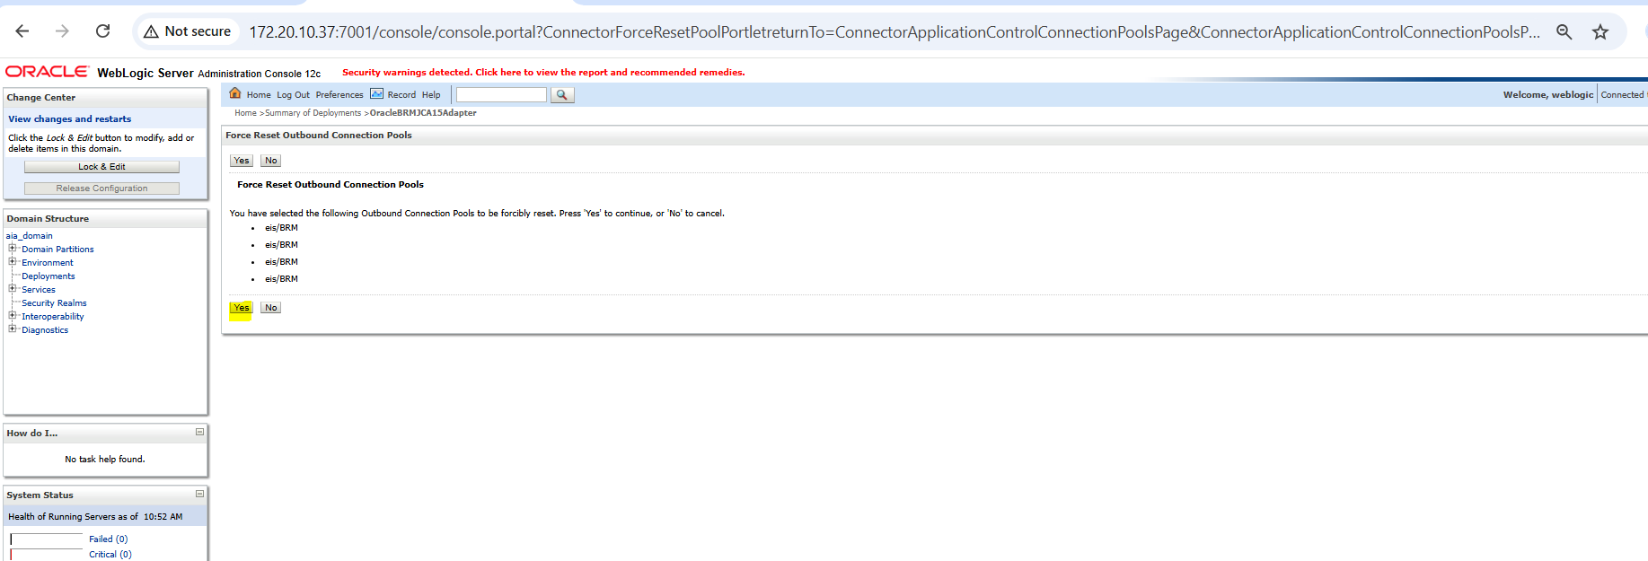

Below screenshot for successful connect Reset.
