

Tittle: | SOP_AIA_Session Pool Reset
Product: | AIA
Customer: | IMPACT
Scope Of Change: | SOP_AIA Session Pool Reset
Approval:

Document Control

1.1 Version History
Sl. No | Date | Author | Version | Change Reference
 |  | Bala | 1.0 | Inclusion of technical information, scope and purpose, introduction, system impact, operational practice, and greater detail in the steps.

1.2 Reviewers
Sl. No | Reviewer | Position | Stream | Organization

1.3 Scope and Purpose of the document
This document is intended to provide a procedure for performing the connection reset after Siebel restart. We need to perform this activity to reestablish the connection between AIA-Siebel

1.4 Content
Table of Contents
1 Document Control 2
1.1 Version History 2
1.2 Reviewers 2
1.3 Scope and Purpose of the document 2
1.4 Content 3
2 System Overview 4
2.1 Introduction 4
2.2 System Impact 4
2.3 Operational Practice 4
2.4 Defeminations, Acronyms, Abbreviations 4
2.5 Assumptions, Dependencies, Constraints, Decisions 4
2.6 References 4
3 Step-by-step instructions 5
Appendix 9

System Overview

Introduction
This document is created to performing the connection reset after Siebel restart. We need to perform this activity to reestablish the connection between AIA-Siebel

System Impact
The operational procedure in this document can be performed performing the connection reset after Siebel restart. We need to perform this activity to reestablish the connection between AIA-Siebel.
Also pause AIA queue before performing the SPM reset to avoid failures with milestone and order journey.

Operational Practice
It is expected that operational staff check the below issues before executing this procedure:
Team to check they have login details for putty session.

Defeminations, Acronyms, Abbreviations

Assumptions, Dependencies, Constraints, Decisions
Sl. No | Assumptions
1.
2.

References
Sl. No | Document Name | Document Description
1.
2.

SOP1: AIA Session Pool Reset
Steps to be followed.
Step 1:
Login to mobxterm session with Ip of 172.20.2.28
Click on “OK” button
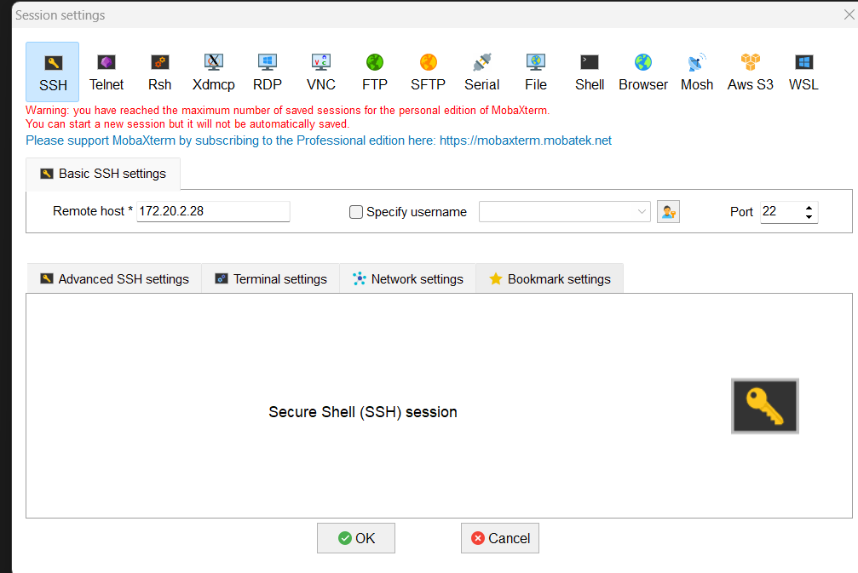
Enter “opc” username/password
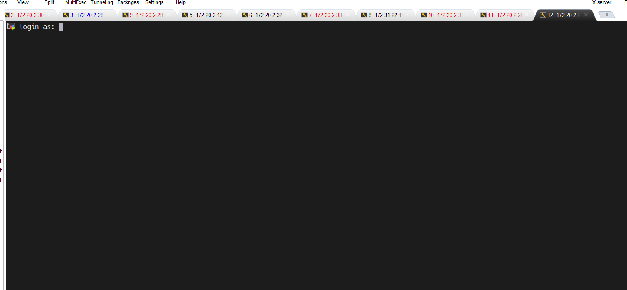

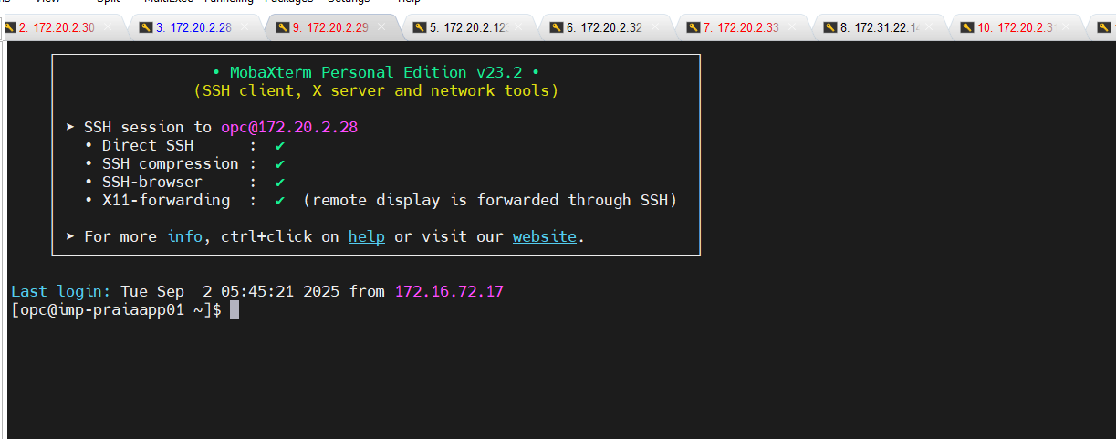

Now perform sudo su Oracle
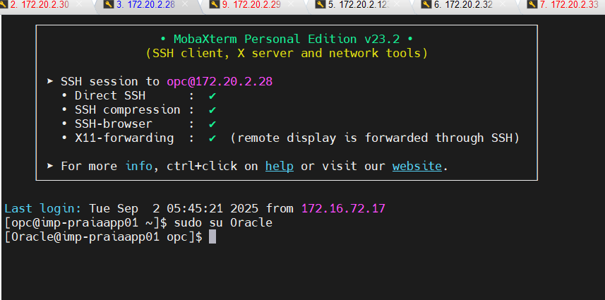

Goto below mentioned folder:
/home/Oracle
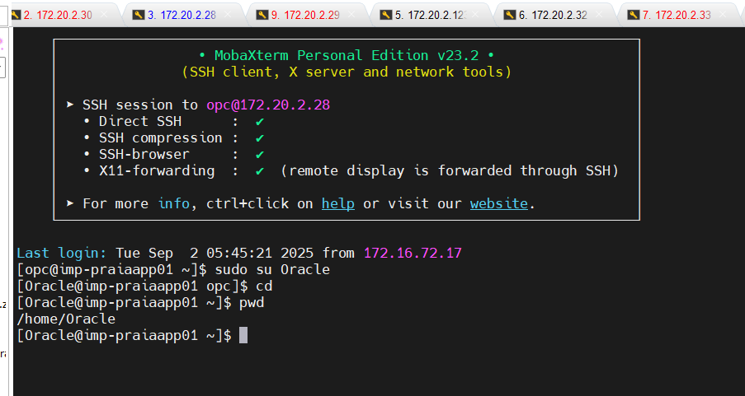

Run pr_spm_reset.sh to perform the SPM reset.

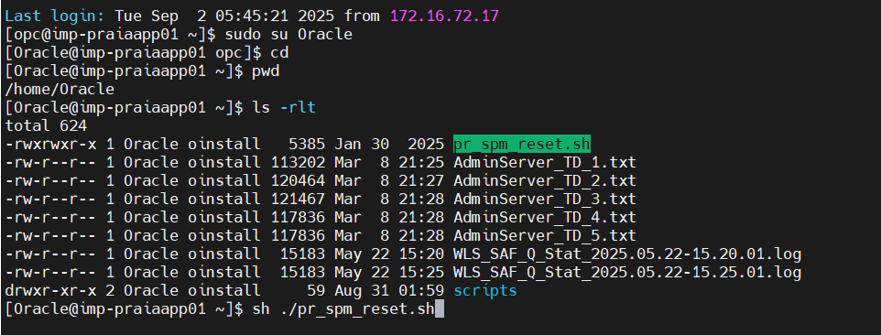

Appendix
Ongoing Work
Sl. No. | Activity | Work Description | Owner

Common problems
Sl. No. | Defect/Bug ID | Identification Phase | Issue Resolution

Known Issues
Sl. No. | Defect/Bug ID | Identification Phase | Issue Resolution

