PYTHON
BUILDING STUDENT PERFORMANCE DETECTOR PROJECT FROM SCRACH

FIRST DOWNLOAD VS CODE AND PYTHON FORM ONLINE AND INSTALL THEM

AFTER THAT CREATE A PYTHON ENVIRONMENT IN IT

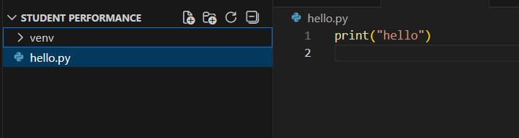

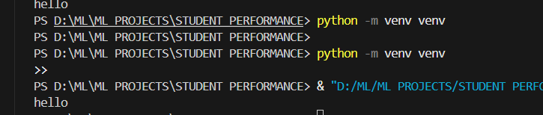
THIS CREATES A VIRTUAL ENVIRONMENT FOR THIS PROJECT
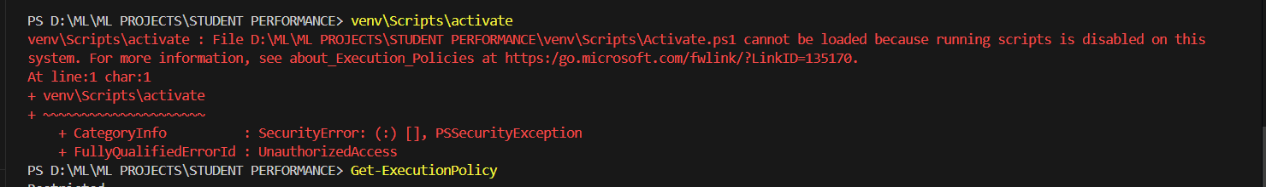
THIS ERROR OCCURES WHEN THE SYSTEM IN PROTECTING TO NOT RUN SCRIPTS
THE OS IS NOT ALLOWING IT TO CHANGE THINGS(RESTRICTED)

SO WE MAKE IT TO ALLOW DOING THINGS AND GIVE COMMAND GET EXECUTION POLICY SCOPE CURRENT USER
Yes, PowerShell is being instructed to change its own execution rule from Restricted to Unrestricted for the current user only, so that scripts like activate.ps1 can run.
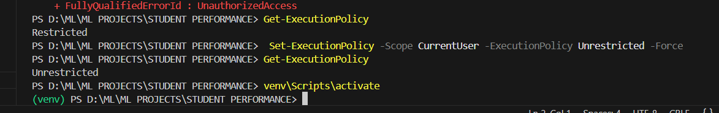
AFTER THAT WE HAVE TO INSTALL GIT INTO OUT LAPTOP

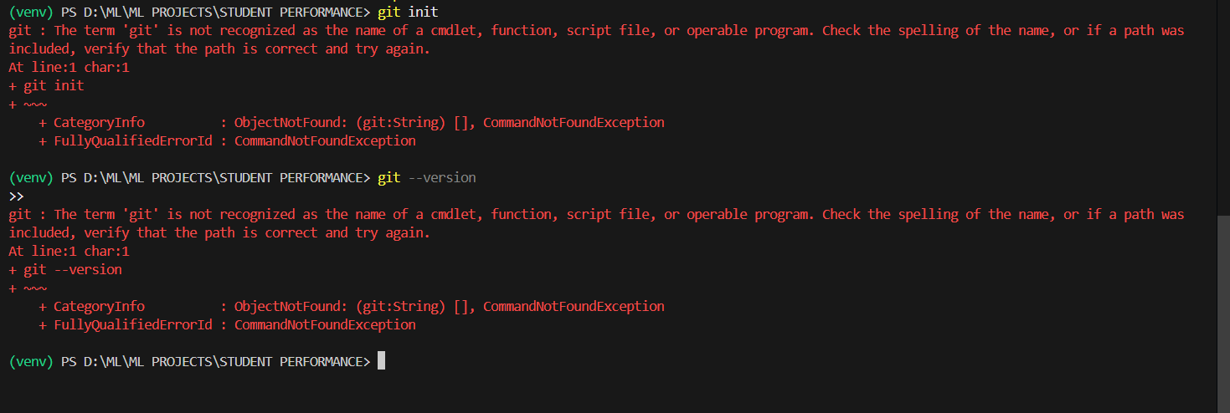here this means that git in not installed in you pcd
So go to git website and download the git for your particular os
After installing git it will show like this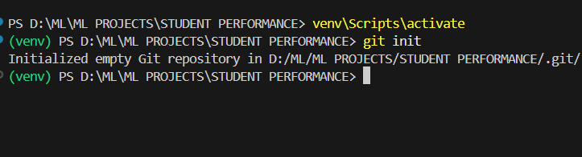
After this lets create a readme file and commit it into the git
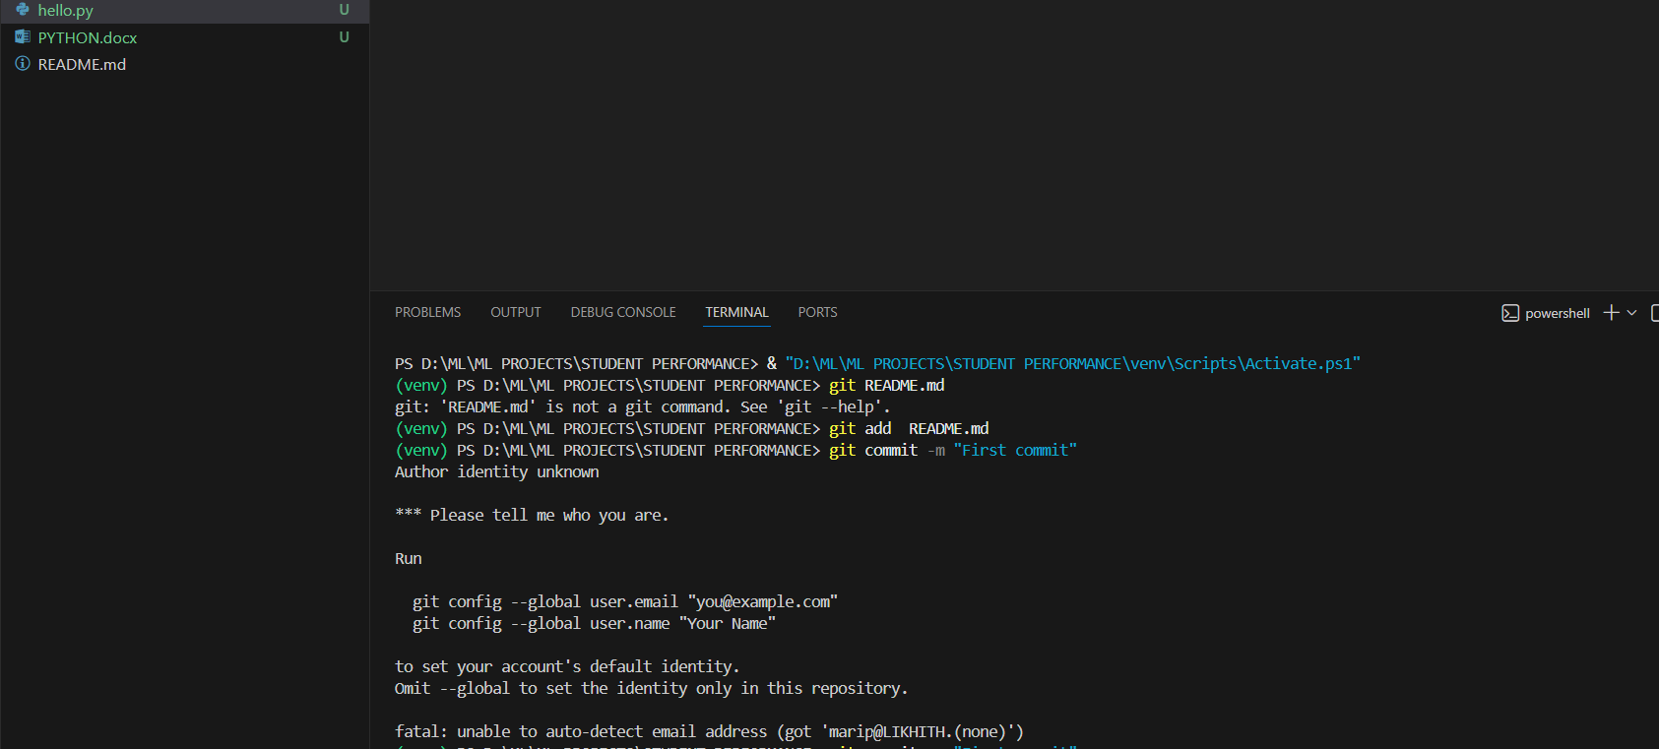
But here I haven’t connected the git and vscode
So go to setting and sync the git and vscode
After that also I have to tell that git is installed so
Type this in power shell
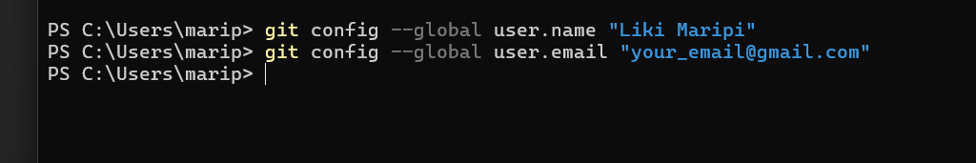
After doing this if we commit then it will store 