

Dynamic Simulation:

Description of

Outputs



|  |  |  |  |  |
| --- | --- | --- | --- | --- |
| Document Number: | | | | |
|  |  |  |  |  |
|  |  |  |  |  |
|  |  |  |  |  |
|  |  |  |  |  |
|  |  |  |  |  |
| **5/26/16** | **0** | **Ilias Ariston** | **Antoine Peiffer** | **Issue for comments** |
| **Date** | **Rev.** | **Written by** | **Checked by** | **Status/Comments** |

Document History

THIS DOCUMENT WAS CREATED BY PPI. 1PPI-WFA RPT-HY-25011

Confidentiality

ALL INFORMATION & DATA CONTAINED WITHIN THIS DOCUMENT IS STRICTLY CONFIDENTIAL AND IS THE PROPERTY OF PRINCIPLE POWER, INC. IT IS PROTECTED IN ACCORDANCE WITH PREVAILING LAW. IT SHALL ONLY BE USED FOR THE PURPOSE WHICH IT IS DELIVERED. THIS DOCUMENT AND THE INFORMATION THEREIN SHALL NOT BE REPRODUCED OR DISCLOSED TO ANY OTHER PARTY WITHOUT THE EXPRESS PRIOR WRITTEN AUTHORIZATION OF PRINCIPLE POWER, INC.

Revision Log

|  |  |  |
| --- | --- | --- |
| REVISION | SECTION | DESCRIPTION OF CHANGES |
|  |  |  |
|  |  |  |

Table of Contents

1 Summary 4

2 Sensors 4

3 Additional sensor notes and MatchMaker™ use 5

4 Test output summary 6

Table of Figures

Figure 1 5 test cases for the benchmarking output. 6

Figure 2 Surge motion for 5 test cases presented in Figure 1 7

Figure 3 Sway motion for 5 test cases presented in Figure 1 8

Figure 4 Heave motion for 5 test cases presented in Figure 1 8

Figure 5 Roll motion for 5 test cases presented in Figure 1 9

Figure 6 Pitch motion for 5 test cases presented in Figure 1 9

Figure 7 Yaw motion for 5 test cases presented in Figure 1 10

Table of Tables

Table 1 Sensors output from the aeroelastic simulations. Variables defined in ‘rotated’ column are further elaborated in Table 2. 4

Table 2 Rotation variables 5

Table 3 Additional notes and MatchMaker implementation of sensors presented in Table 3. 5

Table 4 Summary of test cases. 7

# Summary

The following document describes the outputs of the combined aero-hydro simulations on the WindFloat platform. As directional site data and platform degrees of freedom are considered in the simulations but structural model is ‘fixed,’ loads generated and transferred for structural design are to be rotated into the platform coordinate system.

The document outlines which sensors are selected from the coupled aero-hydrodynamic code and how the sensors are rotated and subsequently utilized in the matchmaker program.

# Sensors

Sensors output during the combined aero-elastic simulations are presented in Table 1. Line members, mooring lines, water entrapment plate track points as well as water column track points is model specific.

Table 1 Sensors output from the aeroelastic simulations. Variables defined in ‘rotated’ column are further elaborated in Table 2.

|  |  |  |  |  |  |  |
| --- | --- | --- | --- | --- | --- | --- |
| **Sensor output** | **OrcaFlex** | **Fast** | **Variable Name (Fast, OrcaFlex)** | **Output Coordinate system** | **Location** | **Rotated** |
| **accel (X,Y,Z)** | X |  | platform.X, platform Y, platform Z | Global | Platform Center | Wind_Dir-yawfix |
| **accel(Rx,Ry,Rz)** |  | X | 'PtfmRAxi';'PtfmRAyi';'PtfmRAzi' | Global |  | Wind_Dir-yawfix |
| **thrust** |  | X | 'LSShftFxs';'LSShftFys';'LSShftFzs';'LSShftMxs';'LSSGagMys';'LSSGagMzs' | Shaft Coordinate System |  | Wind_Dir+nacyaw_mean |
| **thrustraw** |  | X | 'LSShftFxs';'LSShftFys';'LSShftFzs';'LSShftMxs';'LSSGagMys';'LSSGagMzs' | Shaft Coordinate System |  | Wind_Dir+nacyaw_mean |
| **motions (X,Y,Z)** | X |  | platform.X, platform Y, platform Z | Global |  | Wind_Dir-yawfix |
| **motions (Rx,Ry,Rz)** |  | X | PtfmRoll';'PtfmPitch';'PtfmYaw' | Platform coordinate | Tower Center | Wind_Dir-yawfix |
| **velocity** |  | X | PtfmTVxi';'PtfmTVyi';'PtfmTVzi';'PtfmRVxi';'PtfmRVyi';'PtfmRVzi' | Platform coordinate | Tower Center | Wind_Dir-yawfix |
| **basebend** |  | X | 'TwrBsFxt';'TwrBsFyt';'TwrBsFzt';'TwHt1MLxt';'TwHt1MLyt';'TwHt1MLzt' | Tower Base Coordinate System |  | Wind_Dir |
| **naccel** |  | X | NcIMUTAxs';'NcIMUTAys';'NcIMUTAzs';'NcIMURAxs';'NcIMURAys';'NcIMURAzs' | Shaft Coordinate System |  | Wind_Dir+nacyaw_mean |
| **yaw** | X |  | 'PtfmYaw' | Global |  | Wind_Dir+nacyaw_mean+Wind_Dir |
| **BallastMass** |  | X | 'BallastMx';'BallastMy' | Platform coordinate (figure 20 Fast User Guide) |  | Wind_Dir-yawfix |
| **waveel** | X |  | 'Wave (1st order) Lx-Force' | Global | Environment Center (0,0,0) |  |
| **waveforce** | X |  | Wave (1st order)L-Force' | Local |  |  |
| **wavedrift** | X |  | Wave Drift (2nd order) L-Force' | Local |  |  |
| **addedmassdamp** | X |  | Added Mass & Damping L-Force' | Local |  |  |
| **otherdamping** | X |  | 'Other Damping Lx-Force' | Local |  |  |
| **hydrostiff** | X |  | Hydrostatic Stiffness x-Force' | Local |  |  |
| **WEPtrack** | X |  | Based on ColTrack input | Global | Based on WEP track points |  |
| **COLtrack** | X |  | Based on WEP track points | Global | Based on Col track points |  |
| **ml1** | X |  | 'End G-Force' , 'Tension' | Global |  | Wind_Dir-yawfix |
| **ml2** | X |  | 'End G-Force' , 'Tension' | Global |  | Wind_Dir-yawfix |
| **ml3** | X |  | 'End G-Force' , 'Tension' | Global |  | Wind_Dir-yawfix |
| **Line Members** | X |  | 'line' | Global |  | Wind_Dir-yawfix |

Table 2 Rotation variables

|  |  |
| --- | --- |
| **Sensor** | **Additional notes** |
| **Yawfix** | Wind_Dir + mean(OrcaFlex Platform rotation3) |
| **Wind_Dir** | Input Wind Direction Input (Coming from) |
| **Nacyaw_mean** | Input Initial Yaw |

# Additional sensor notes and MatchMaker implementation

The following section highlights some additional notes on the derivation of each sensor, and conversion. Additionally a column presents the utilization of the results in the Matchmaker program.

Table 3 Additional notes and MatchMaker implementation of sensors presented in Table 3.

|  |  |  |
| --- | --- | --- |
| **Sensor output** | **Additional notes** | **MatchMaker** |
| **accel (X,Y,Z)** | Based on diff(diff(motions))), rotated into platform coordinates | Radiation Force-WAMIT reference coordinate system Given to structure |
| **accel(Rx,Ry,Rz)** |  | Radiation Force-WAMIT reference coordinate system Given to structure |
| **thrust** | Removes rotor inertia, converted to N, rotated to remove tilt, rotated into platform coordinates. If there are large Yaw errors, this could be incorect | Used for information |
| **thrustraw** | converted to N, rotated to remove tilt, rotated into platform coordinates | Directly passed to structure |
| **motions (X,Y,Z)** |  | Used in diffraction coefficients and passed to structure |
| **motions (Rx,Ry,Rz)** |  | Used in diffraction coefficients and passed to structure |
| **velocity** |  | Radiation Force-WAMIT reference coordinate system |
| **basebend** | converted to N | Directly passed to structure |
| **naccel** | converted into platform coordinate | Used to calculate the Weight of the Nacelle |
| **yaw** | Gives absolute direction of nacelle | Used for information |
| **BallastMass** | converted to N | Directly passed to structure |
| **waveel** |  | Used for information |
| **waveforce** |  | Used for WAMIT comparison. Should be in the Mean/WAMIT coordinate system |
| **wavedrift** |  | Used for information |
| **addedmassdamp** |  | Compared to WAMIT. Should be in the Mean/WAMIT coordinate system |
| **otherdamping** |  | Used for information |
| **hydrostiff** |  | Compared to WAMIT. Should be in the Mean/WAMIT coordinate system |
| **WEPtrack** |  | Used to predict snapshot to give to structure |
| **COLtrack** |  | Used to predict snapshot to give to structure. Also used to calculate design buckling pressure. |
| **ml1** | rotated into platform coordinate | Directly passed to structure |
| **ml2** | rotated into platform coordinate | Directly passed to structure |
| **ml3** | rotated into platform coordinate | Directly passed to structure |
| **Line Members** | rotated into platform coordinate | Directly passed to structure |

# Test output summary

5 simulations are preformed to benchmark the output of the post-processing. These test cases are presented in Figure 1 and summarized in Table 4. 5 fully coupled simulations with steady wind set to 0 investigated the platform response to ramping load. The load magnitude is presented in Table 4

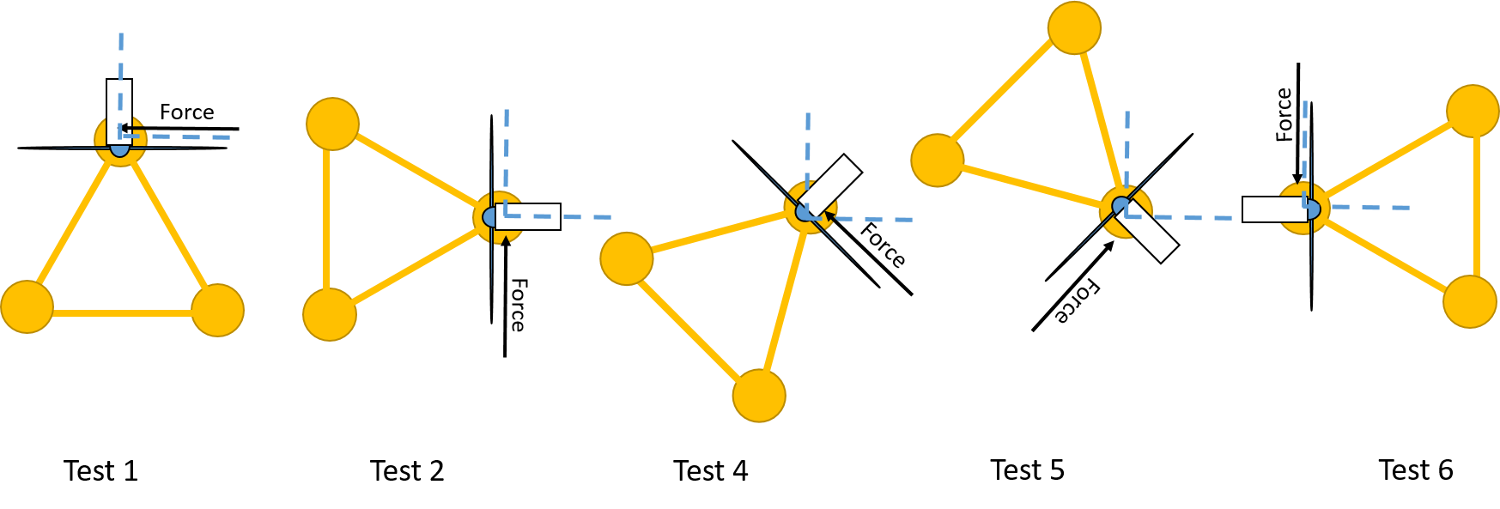

Figure 1 5 test cases for the benchmarking output.

Table 4 Summary of test cases.

|  |  |  |  |  |
| --- | --- | --- | --- | --- |
| **Test Case** | **Wind Direction** | **Steady Wind Speed** | **Nacelle Direction** | **Global OrcaFlex Load [X,Y]** |
| **1** | 0° | 0 | 0° | [-1E6,0] |
| **2** | 90° | 0 | -90° | [0,1E6] |
| **4** | 45° | 0 | -45° | [-7.07E5,7.07E5] |
| **5** | 135° | 0 | -135° | [7.07E5,7.07E5] |
| **6** | 270° | 0 | 90° | [0,-1E6] |

The following figures document the response of the system via a comparison of the output sensors. Results show a strong correlation between signals, validating the output of the post processed simulations.

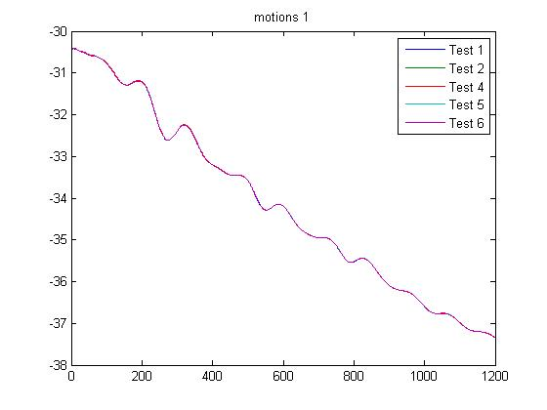

Figure 2 Surge motion for 5 test cases presented in Figure 1

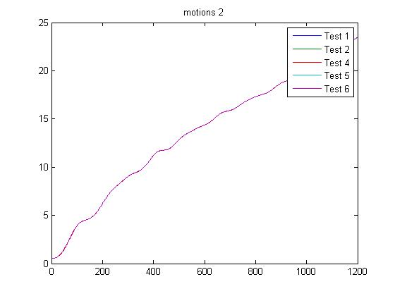

Figure 3 Sway motion for 5 test cases presented in Figure 1

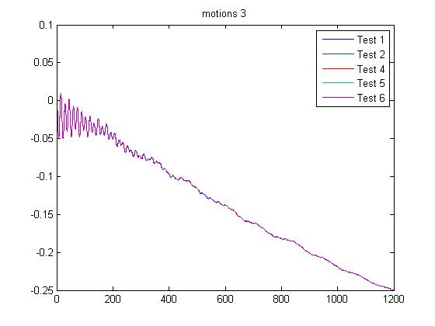

Figure 4 Heave motion for 5 test cases presented in Figure 1

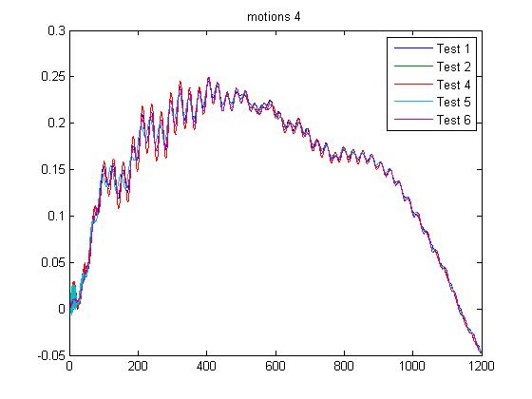

Figure 5 Roll motion for 5 test cases presented in Figure 1

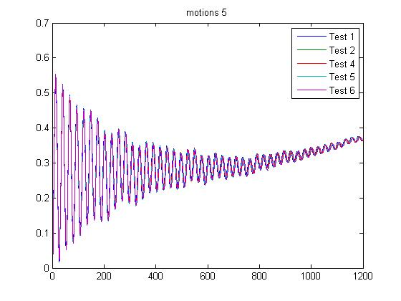

Figure 6 Pitch motion for 5 test cases presented in Figure 1

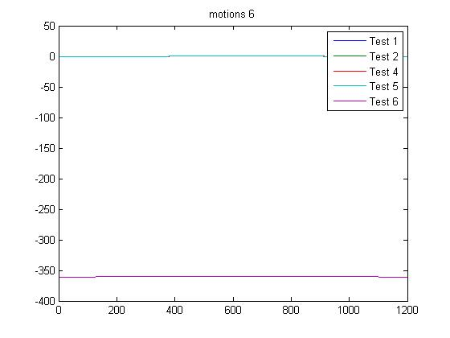

Figure 7 Yaw motion for 5 test cases presented in Figure 1