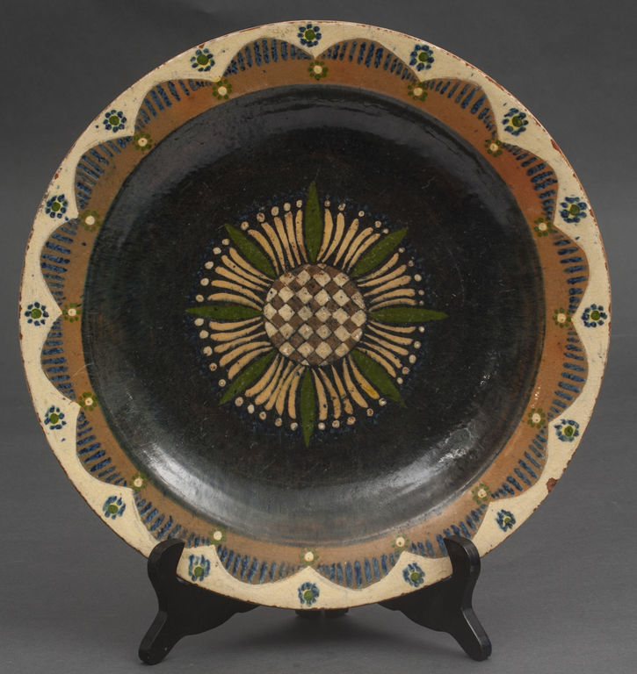
WEB BASED AND MOBILE VIRTUAL AND AUGMENTED REALITY SOLUTIONS 2026
Project Name | Latvian clay heritage. A Virtual Reference Studio
Your Name | Maris Bulats
Goal | Ceramic design reference center where craftsmen in immersive environment can explore traditional Latvian ceramic master peaces.
Target Hardware | PC. Meta Quest headsets
Visual & Audio Design | 3d scanned objects – ceramic  Environment - ceramic craftsman workshop  Realiastic....
Environment Description | Craftsmen workshop. (Traditional or modern?) At least main traid tools visible – potters wheel, kiln...
Reference Images, Mood Board | 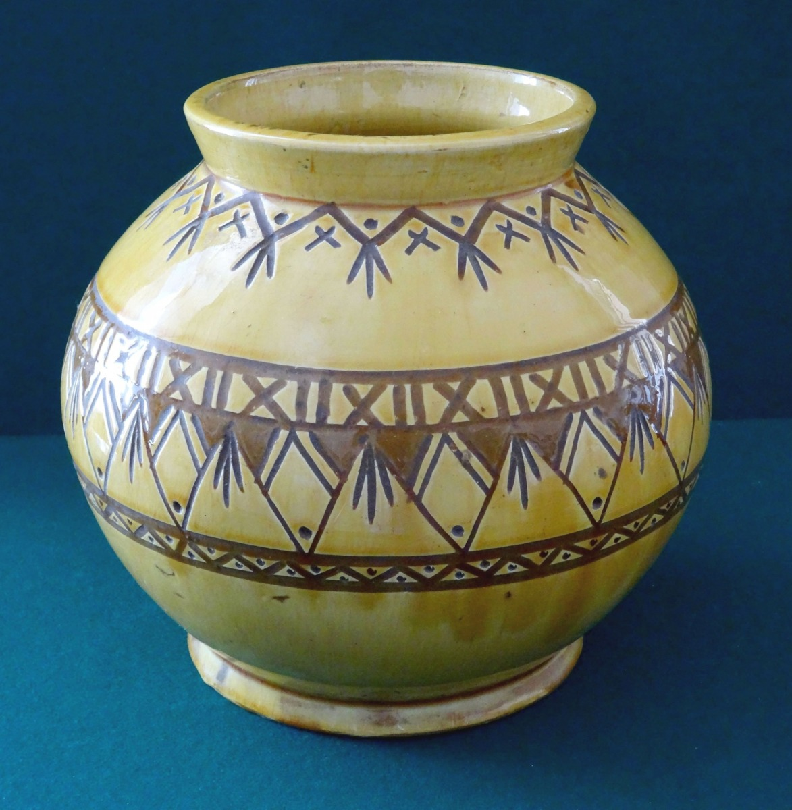  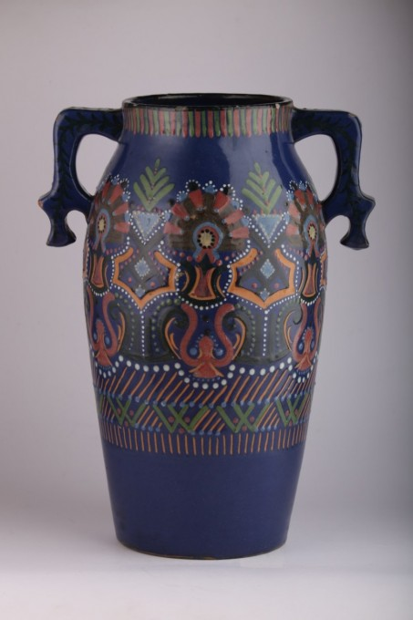  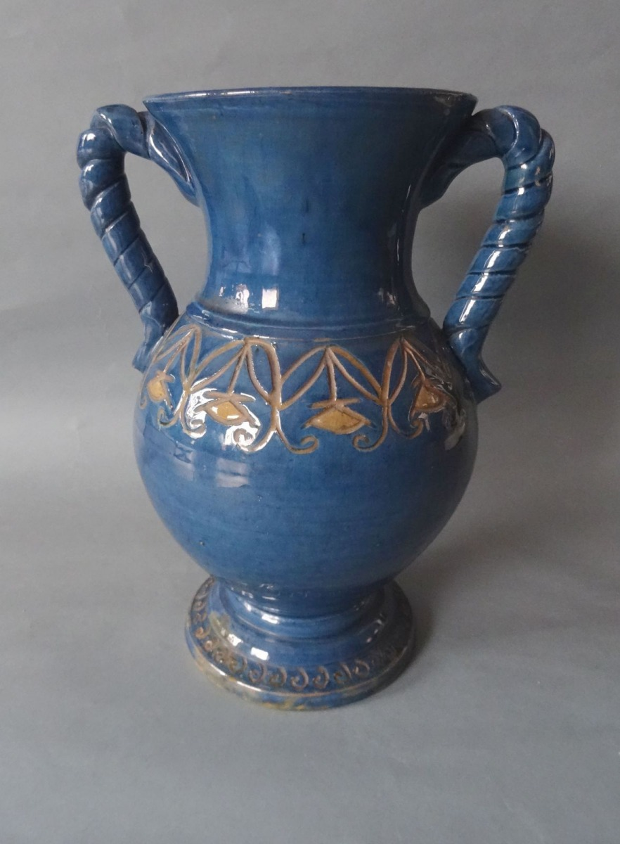  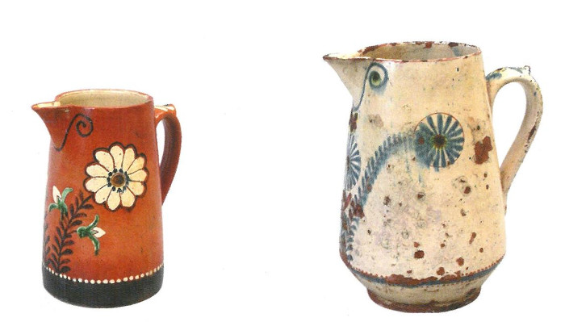
User Experience | VR
User Persona, target audience. | Craftsmen working with clay and seeking inspiration and reference.  Target audience - according to the research (Latvian Culture Accademy) – most common demographic profile of Latvian ceramic craftsmen (still flexible :) – women, 25-45 years....
User Journey | (Step 1: Spawns in workshop -> Step 2: Can pick up object (s), rotate, study from all sides -> Step 3 – Object reference text and related 2D graphics – ornaments, signs)
Interaction Model: | Movement in environment (virtual wokshop)  Interaction: - Hand tracking, grabbing.  Pop up Text and 2D graphics
Technical Implementation | 3D scans of the real object (s)  Environment - Gaussian splatting. VR workshop generation from real 2D images.
Tech Stack | Visual studio code, A-frame, Spark + A-Frame. Gaussian splatting using Marble AI model. 3D scanning.
Assets List | Visuals: 2D/3D models, textures, UI elements, animations, environments…  Sound: music, sound effects, ambient sounds…  Tools/code: scripts, shaders…
Calendar  (Reached specific goals at the end of day) | 10.01.2026  Project idea  Object grabbing and rotation  Pop up text and 2D Graphic  Spark + A-Frame (Gaussian splatting)  15.01.2026  Gaussian splatting  Main 3D objects  16.01.2026  22.01.2026  Finalized project demonstration.

