Can linguists better understand DNA?

Wang Liang

Huazhong University of Science and Technology, 430070, P.R. China

*To whom correspondence should be addressed. E-mail:[wangliang.f@gmail.com](mailto:wangliang.f@gmail.com)

**[Abstract]**Multilingual transfer ability, which reflects how well models fine-tuned on one source language can be applied to other languages, has been well studied in multilingual pre-trained models. However, the existence of such capability transfer between natural language and gene sequences/languages remains underexplored.This study addresses this gap by drawing inspiration from the sentence-pair classification task used for evaluating sentence similarity in natural language. We constructed two analogous tasks: DNA-pair classification(DNA sequence similarity) and DNA-protein-pair classification(gene coding determination). These tasks were designed to validate the transferability of capabilities from natural language to gene sequences. Even a small-scale pre-trained model like GPT-2-small, which was pre-trained on English, achieved an accuracy of 78% on the DNA-pair classification task after being fine-tuned on English sentence-pair classification data(XTREME PAWS-X). While training a BERT model on multilingual text, the precision reached 82%.On the more complex DNA-protein-pair classification task, however, the model's output was barely distinguishable from random output.Experiments suggest that there may be a capability transfer from natural language to genetic language, but further task testing is needed to confirm this.

# **1 introduction**

Advancements in large language models have transformed the landscape of artificial intelligence, with significant implications for bioinformatics. In the realm of nucleic acid analysis, specialized models like DNABert2, HyenaDNA, and ScBert have emerged to tackle classification and structural prediction challenges associated with DNA sequences (1~4). These models leverage the power of large language model to provide novel insights into genetic data.

Parallel developments have also occurred in protein-related research. Models such as ProTrans, ProteinBERT, and ESM2 have been introduced to excel in tasks like predicting protein structures and annotating their functions. These innovations highlight the versatility of large language models in addressing complex biological questions, bridging the gap between computational linguistics and molecular biology.

Furthermore, there are hybrid multi-modal large models that integrate natural language with DNA sequences, protein sequences, and structural data. Models such as BioMedGPT and InstructProtein are designed to address a variety of biological tasks. These models excel in applications like biological question answering, literature summarization, and predicting protein functions using natural language.

An interesting and important phenomenon associated with Multilingual Large Models (MLMs) is Language Capability Transfer. This phenomenon refers to the ability of a model, after being fine-tuned on one or more source languages, to effectively transfer the learned language understanding and generation capabilities to other unseen target languages. This not only demonstrates the model's strong generalization ability but also reveals the deep structures and patterns shared among different languages (14-17).

If such Language Capability Transfer also exists in gene-class large models, it would significantly expand the application scope of these gene models. Imagine if only supervised fine-tuning on English for tasks like summarization, question answering, and classification could then enable the model to handle DNA sequences for tasks such as summarization and classification. This would greatly enhance the efficiency of sequence search methods and other related processes.

**Challenges.** Due to the significant differences between natural language and gene language, evaluating and validating the transferability of capabilities from natural language to gene language presents a core challenge.

In natural language, typical evaluation datasets for cross-lingual pre-trained models include XTREME. XTREME encompasses four major categories—text classification, sequence labeling, sentence retrieval, and question answering—with nine sub-tasks in total. Models participating in XTREME are fine-tuned on English training data and then evaluated on test sets across 40 languages from 12 different language families. Although XTREME is not strictly parallel corpus-based, most multilingual data versions are still constructed based on English translations, with some data augmentation techniques such as word scrambling used to break one-to-one sentence correspondence while maintaining overall semantic alignment among languages (18).

If we aim to construct an evaluation dataset for transferring capabilities from English to DNA, it is essential to exclude tasks involving semantics, such as question answering and natural language inference, as the limited functional annotations of DNA sequences are insufficient to support building parallel corpora between English and DNA. Tasks like entity recognition and structure prediction also pose challenges because part-of-speech tagging in natural language and structural annotation in sequences differ significantly both quantitatively and qualitatively, making their construction difficult.

Among these tasks, sentence-pair similarity assessment is the least associated with semantics. While it evaluates sentence relationships, it focuses more on structural prediction capabilities. Therefore, we can draw inspiration from the PAWS-X dataset in XTREME, which is designed for sentence-pair similarity assessment, to construct a DNA sequence similarity judgment task dataset.

If a pre-trained model, after being fine-tuned on the English sentence similarity dataset from PAWS-X, can perform DNA sequence similarity judgments, this would indicate that natural language capabilities can be transferred to DNA language.

**Research Approach.**Our study draws on the PAWS-X dataset to construct two biosequence-related task datasets: DNA-pair classification for DNA sequence similarity judgment and DNA-protein-pair classification for gene-encoded protein similarity judgment. We then fine-tune GPT-2 and BERT series models on the PAWS-X English dataset and evaluate them on the aforementioned two biological sequence tasks. The results show that the precision of the DNA-pair classification task can reach up to 82%.

# **2 Materials and methods**

## **2.1 Training datasets**

Inspired by the PAWS-X evaluation dataset from XTREME, we constructed two biosequence similarity judgment datasets.

#### **PAWS-X Evaluation Dataset Overview**

PAWS-X is a sentence-pair similarity assessment task where each data entry consists of two sentences. A typical data entry looks like this:

1. {
2. 'sentence1': 'In Paris, in October 1560, he secretly met the English ambassador, Nicolas Throckmorton, asking him for a passport to return to England through Scotland.',
3. 'sentence2': 'In October 1560, he secretly met with the English ambassador, Nicolas Throckmorton, in Paris, and asked him for a passport to return to Scotland through England.',
4. 'label': 0
5. }

The task is to determine whether the two sentences express the same meaning, which is a binary classification problem. To extend this to other languages, the English sentence pairs were translated into six target languages (French, Spanish, German, Chinese, Japanese, and Korean) by professional translators and manually checked to ensure quality and consistency.

#### **DNA-Protein Pair Similarity Judgment Task**

Following a similar approach to PAWS-X, we first constructed a DNA-protein pair similarity judgment task based on gene coding rules. If a protein sequence corresponds to its DNA coding sequence, it is considered a positive example; otherwise, it is a negative example. The specific data design referenced the dataset used in Lucaone's paper. A typical data entry looks like this:

1. {
2. 'sentence1': 'ACCAGTGCTCAGGTTAACAAAATAATAAAAGGAA....',
3. 'sentence2': 'MASGRLQLLAFALALSGVSGVLAATLLPNWTVSVD...',
4. 'label': 0
5. }

The dataset contains approximately 25,600 entries, with a balanced number of positive and negative examples.

#### **DNA-DNA Sequence Pair Similarity Judgment Task**

For the DNA-DNA sequence pair similarity judgment task, we used the DNA sequences from the DNA-protein task as source sequences. To construct similar sequences, we utilized NCBI BLAST to search public databases for similar sequences and generated pairwise alignment results. By setting strict thresholds (such as an E-value less than 1e-5), we filtered out highly credible homologous or similar sequence pairs. For dissimilar sequences, we used genomic data from multiple model organisms, randomly selecting DNA sequences while ensuring similar lengths and low similarity scores (low local alignment scores). A typical data entry looks like this:

1. {
2. 'sentence1': 'ACCAGTGCTCAGGTTAACAAAATAATAAAAGGAA....',
3. 'sentence2': 'GGGCCGCCTTGCTGAAGCGGCATGGCCTCGGGG...',
4. 'label': 0
5. }

## **2.2 Training Strategy**

We used the GPT2-small model as a baseline for fine-tuning on the PAWS-X English dataset. Subsequently, we evaluated the model on two biosequence similarity judgment tasks: DNA-protein pair similarity judgment and DNA-DNA sequence pair similarity judgment. Building on this foundation, we also tested other parameter scales of GPT2 models as well as BERT models.

For classification tasks, we utilized the default GPT2 model from Hugging Face. The model's output layer is configured with a commonly used softmax classification head; see Fig. 1 for specifics.

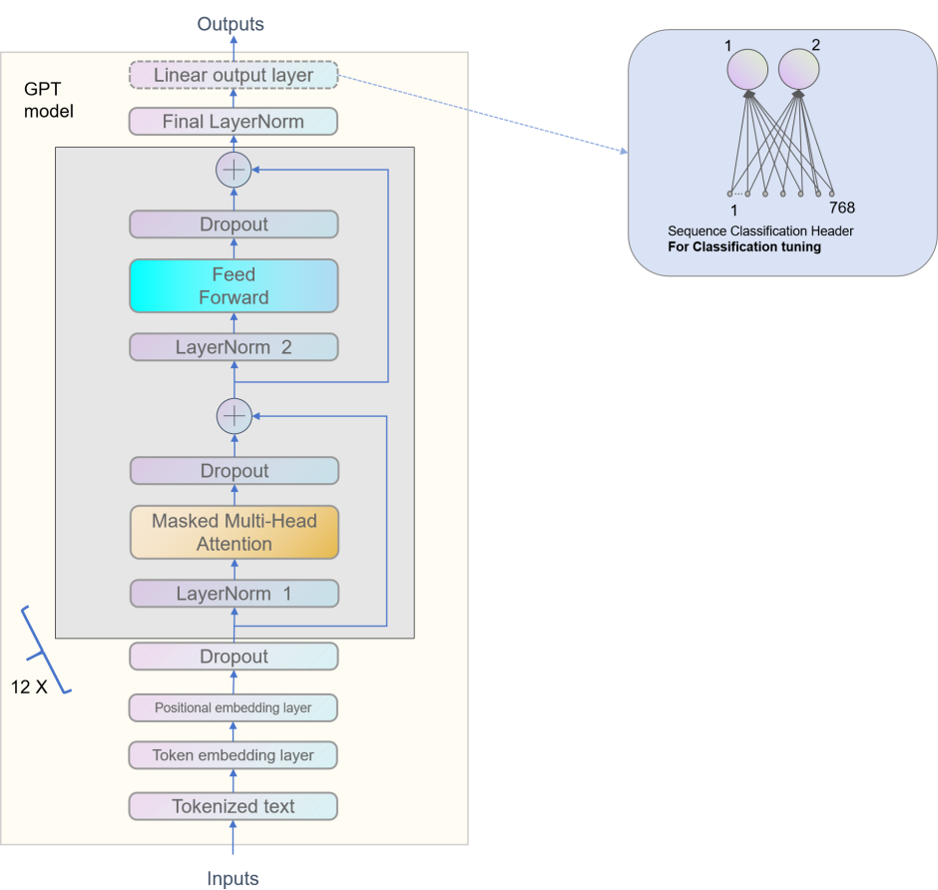

Fig.1 GPT2 model with sequence classification header

### **Input and Output Format**

To fine-tune GPT2, we concatenated the two sequences directly as the input string, with the label serving as the classification ID:

* **Input:** sequence1 + sequence2
* **Output:** label

**Note:** If using BERT-based models, the two sequences are connected using the [SEP] token. For GPT-based models, no separator is needed as the model itself determines the boundaries between the two sequences.

### **Tokenization**

Research on language capability transfer indicates that using a unified tokenizer is a necessary condition for transferring capabilities. Both the Byte Pair Encoding (BPE) tokenizer used in GPT2 models and the WordPiece tokenizer used in BERT models can process DNA and protein sequences. These tokenizers typically split sequences into tokens of one to three characters, which is a common method for feature extraction in biological sequences. Therefore, the choice of tokenizer does not affect our validation of language capability transfer.

### **Fine-tuning Procedure**

1. Fine-tuning GPT2 on PAWS-X English Data:
   * We fine-tuned the GPT2-small model on the PAWS-X English dataset.
   * The input format was sequence1 + sequence2, and the output was the corresponding label.
2. Evaluation on Biosequence Similarity Tasks:
   * After fine-tuning, we evaluated the model on the DNA-protein pair similarity judgment task and the DNA-DNA sequence pair similarity judgment task.
3. Testing Other Model Variants:
   * We extended our experiments to include other parameter scales of GPT2 models and BERT models to compare performance.

### **Tokenizer Considerations**

Given the importance of tokenization in language capability transfer, we ensured consistency by using:

* **GPT2 Models:** Utilized the BPE tokenizer.
* **BERT Models:** Used the WordPiece tokenizer with [SEP] tokens between sequences.

Both tokenizers effectively handle biological sequences, splitting them into short segments that are suitable for feature extraction in bioinformatics applications.

Due to the smaller scale of model parameters and the datasets size being in the tens of thousands of samples, we used the full-parameter fine-tuning method. Fine-tuning can be completed within about an hour on a single 4090 GPU.

# **3 Experimental Results**

As a binary classification task, we primarily used accuracy as the evaluation metric. Pre-trained models were fine-tuned on English datasets and then evaluated on gene-related tasks. For comparison, we also evaluated the models on French, German, and Chinese datasets.

For DNA sequences, we initially tested the raw DNA sequence pairs and found that the results were similar to random output. The main reason was that the two sentences in PAWS-X have an average string length of 113 characters, resulting in an average token length of 50 tokens after tokenization (approximately 4.5 characters per token). In contrast, the corresponding DNA sequences had an average string length of 1336 characters, resulting in an average token length of 982 tokens after tokenization (approximately 1.6 characters per token), showing a significant difference.

Therefore, we truncated the DNA strings to only include the first 40 base pairs (bp) and constructed similar or dissimilar DNA sequences with an average length of 40 bp. This way, the combined length of two DNA sequences became 80 bp. With an average of 1.6 characters per token, this resulted in a total of approximately 50 tokens, aligning closely with the PAWS-X dataset.

Table.1 Accuracy of DNA-pair classification(DNA sequence similarity)

|  |  |  |  |  |  |  |  |
| --- | --- | --- | --- | --- | --- | --- | --- |
| base model | pretrain | finetune | test-en | test-fr | test-de | test-zh | test-dna |
| gpt2-small | en | en | 0.92 | 0.74 | 0.73 | 0.61 | 0.78 |
| gpt2-medium | en | en | 0.92 | 0.80 | 0.76 | 0.62 | 0.55 |
| gpt2-large | en | en | 0.94 | 0.81 | 0.79 | 0.66 | 0.63 |
| bert | en | en | 0.91 | 0.77 | 0.73 | 0.52 | 0.54 |
| bert | multilan | en | 0.94 | 0.86 | 0.83 | 0.77 | 0.82 |
| gpt2-small-1 | en+DNA | en | 0.90 | 0.74 | 0.72 | 0.59 | 0.48 |
| gpt2-small-2 | en+DNA | en | 0.76 | 0.59 | 0.60 | 0.56 | 0.60 |

**gpt2-small-1** is a model based on the GPT2-small architecture, where the DNA vocabulary was expanded, and the model was further pre-trained using 4GB of DNA data. **gpt2-small-2** is a model that was trained from scratch using both English data and DNA data (500MB each).

From the table, it can be observed that among the GPT2 series models, the model with the fewest parameters, gpt2-small, exhibits the best language capability transfer performance. In models with more parameters, gpt2-medium only slightly outperforms random output, while gpt2-large shows a significant improvement. However, when gpt2-small is further pre-trained using DNA data, its performance becomes comparable to random output, which might be due to the limited amount of DNA training data or the method of continuous pre-training. Interestingly, training a GPT2-small model from scratch using a relatively smaller combined dataset of English and DNA data (500MB each) yields better transfer performance than continuous pre-training.

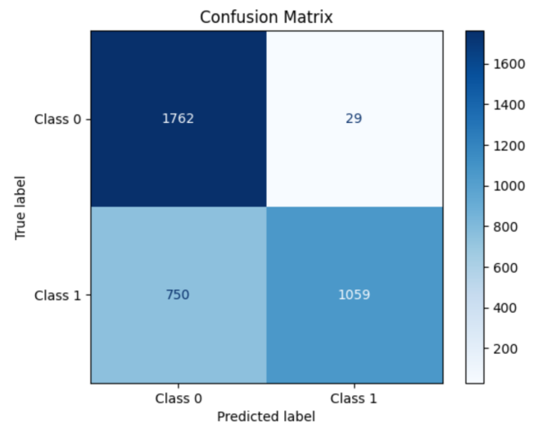

Fig.2 Confusion Matrix of DNA-pair classification, GPT2-small

In the BERT versions, the base English pre-trained model, after fine-tuning on English data, produced results on DNA sequence tasks similar to random output. However, its multilingual pre-trained version achieved a precision of 0.82 on DNA sequence tasks.**Note:** In the testing of BERT models, the labels 0 and 1 were swapped.

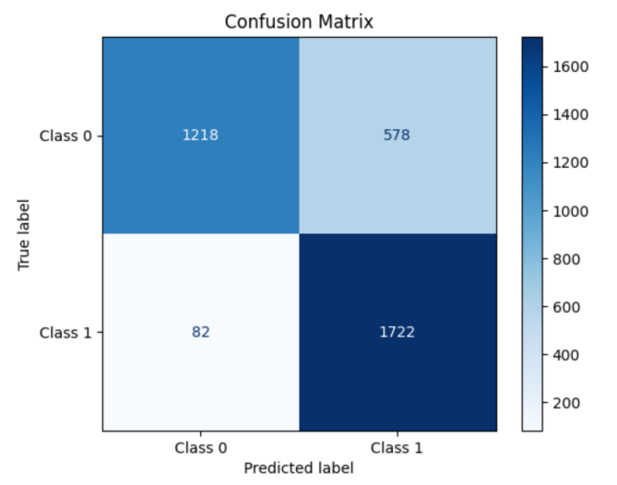

Fig.3 Confusion Matrix of DNA-pair classification, bert multilingual version

In the DNA-protein sequence pair similarity judgment task, all models achieved accuracies between 0.45 and 0.55, which is not significantly different from random output. This suggests that there was no evident capability transfer in this task.

The experimental results indicate that as the model parameter size increases, the effectiveness of language capability transfer to DNA does not necessarily improve. Additionally, increasing the amount of DNA data for continuous pre-training does not guarantee enhanced transfer performance.

# **4 Conclusion**

Language capability transfer in multilingual large models is one of their most attractive features, with structural similarity being key to enabling this capability. This paper builds on relevant research and draws inspiration from the PAWS-X evaluation dataset in XTREME to construct a biosequence similarity judgment evaluation set. This dataset is used to validate the transfer of natural language capabilities to genetic language.

Experimental results show that the multilingual version of the BERT model, after fine-tuning on the English sentence similarity judgment dataset from PAWS-X, can achieve an accuracy of 82% on DNA sequence similarity judgment tasks. In other words, a linguistics expert proficient in multiple natural languages but with no knowledge of biology would still score 82 out of 100 on DNA similarity judgment tests.

Our study is still in its preliminary stages, providing experimental results based on a limited number of evaluation tasks. Further validation of the transfer of natural language capabilities to biological language, along with exploration of corresponding transfer methods and patterns, could enable the powerful reasoning and deduction abilities of large language models to be applied to the niche language of biological sequences. This would undoubtedly introduce a new paradigm to bioinformatics research.

The code and data for this study are open-source and will be continuously updated (24).

# **Reference**

1. Z. Zhou, et al., Dnabert-2: Efficient foundation model and benchmark for multi-species
2. genome, arXiv preprint arXiv:2306.15006 (2023).
3. E. Nguyen, et al., Hyenadna: Long-range genomic sequence modeling at single nucleotide resolution, Advances in neural information processing systems 36 (2024).
4. F. Yang, et al., scbert as a large-scale pretrained deep language model for cell type annotation of single-cell rna-seq data, Nature Machine Intelligence 4, 852–866 (2022)
5. A. Elnaggar, et al., Prottrans: Toward understanding the language of life through selfsupervised learning, IEEE transactions on pattern analysis and machine intelligence 44, 7112–7127 (2021).
6. N. Brandes, D. Ofer, Y. Peleg, N. Rappoport, M. Linial, Proteinbert: a universal deeplearning model of protein sequence and function, Bioinformatics 38, 2102–2110 (2022).
7. Z. Lin, et al., Evolutionary-scale prediction of atomic-level protein structure with a language model, Science 379, 1123–1130 (2023)
8. Ji, Y., Zhou, Z., Liu, H. & Davuluri, R. V. DNABERT: Pre-trained bidirectional encoder representations from transformers model for DNA-language in genome. *Bioinformatics* **37**, 2112–2120 (2021). doi:[doi.org/10.1093/bioinformatics/btab083](https://doi.org/10.1093/bioinformatics/btab083)
9. Veniamin Fishman, et al.GENA-LM: A Family of Open-Source Foundational DNA Language Models for Long Sequences.BioRxiv 2023.06.12.544594. doi: <https://doi.org/10.1101/2023.06.12.544594>
10. Daoan Zhang, et al.DNAGPT: A Generalized Pretrained Tool for Multiple DNA Sequence Analysis Tasks. BioRxiv 2023.07.11.548628; doi: <https://doi.org/10.1101/2023.07.11.548628>
11. Wang, B. *et al.* Pre-trained Language Models in Biomedical Domain: A Systematic Survey. *ACM Comput. Surv.***56**, 1–52 (2023).doi:[doi.org/10.1145/3611651](https://doi.org/10.1145/3611651)
12. Chen, Z., Wei, L. & Gao, G. Foundation models for bioinformatics. *Quant. Biol.* (2024) doi:10.1002/qub2.69.
13. Benegas, G., Ye, C., Albors, C., Li, J. C. & Song, Y. S. Genomic Language Models: Opportunities and Challenges. *arXiv* (2024) doi:10.48550/arxiv.2407.11435.
14. Fei Yuan,etc.How Vocabulary Sharing Facilitates Multilingualism in LLaMA?*arXiv* (2024) doi:<https://doi.org/10.48550/arXiv.2306.06688>
15. Alexis Conneau, Shijie Wu, Haoran Li, Luke Zettlemoyer, and Veselin Stoyanov. 2020. [Emerging Cross-lingual Structure in Pretrained Language Models](https://aclanthology.org/2020.acl-main.536). In *Proceedings of the 58th Annual Meeting of the Association for Computational Linguistics*, pages 6022–6034, Online. Association for Computational Linguistics.
16. Jiacheng Ye, Xijia Tao, Lingpeng Kong.Language Versatilists vs. Specialists: An Empirical Revisiting on Multilingual Transfer Ability. *arXiv* (2024) doi:10.48550/arxiv.2407.11435.
17. Hetong Wang, Pasquale Minervini, and Edoardo Ponti. 2024. [Probing the Emergence of Cross-lingual Alignment during LLM Training](https://aclanthology.org/2024.findings-acl.724). In *Findings of the Association for Computational Linguistics: ACL 2024*, pages 12159–12173, Bangkok, Thailand. Association for Computational Linguistics.
18. Junjie Hu, etc.XTREME: A Massively Multilingual Multi-task Benchmark for Evaluating Cross-lingual Generalization. arXiv(2020) <https://arxiv.org/abs/2003.11080>
19. Thomas Hayes, et al.Simulating 500 million years of evolution with a language model. BioRxiv 2024.07.01.600583; doi: <https://doi.org/10.1101/2024.07.01.600583>
20. Yong He, et al. LucaOne: Generalized Biological Foundation Model with Unified Nucleic Acid and Protein Language. BioRxiv 2024.05.10.592927; doi: <https://doi.org/10.1101/2024.05.10.592927>
21. Zhang, K., Zhou, R., Adhikarla, E. et al. A generalist vision–language foundation model for diverse biomedical tasks. Nat Med (2024). <https://doi.org/10.1038/s41591-024-03185-2>
22. Minghao Xu, Xinyu Yuan, Santiago Miret, and Jian Tang. 2023. ProtST: multi-modality learning of protein sequences and biomedical texts. In Proceedings of the 40th International Conference on Machine Learning (ICML'23), Vol. 202. [JMLR.org](https://JMLR.org), Article 1615, 38749–38767.
23. Zeyuan Wang, etc. 2024. InstructProtein: Aligning Human and Protein Language via Knowledge Instruction. In Proceedings of the 62nd Annual Meeting of the Association for Computational Linguistics (Volume 1: Long Papers), pages 1114–1136, Bangkok, Thailand. Association for Computational Linguistics.
24. paper github, <https://github.com/maris205/find_central-dogma_again>