Early language experience in a Tseltal Mayan village

|  |
| --- |
| Marisa Casillas1, Penelope Brown1, & Stephen C. Levinson1 |
| 1 Max Planck Institute for Psycholinguistics |
|  |

# Author note

Correspondence concerning this article should be addressed to Marisa Casillas, P.O. Box 310, 6500 AH Nijmegen, The Netherlands. E-mail: [Marisa.Casillas@mpi.nl](mailto:Marisa.Casillas@mpi.nl)

Abstract

Daylong at-home audio recordings from 10 Tseltal Mayan children (0;2–3;0; Southern Mexico) were analyzed for how often children engaged in verbal interaction with others and whether their speech environment changed with age, time of day, household size, and number of speakers present. Children were infrequently directly spoken to, with most directed speech coming from adults, and no increase with age. Most directed speech came in the mornings, and interactional peaks contained nearly four times the baseline rate of directed speech. Coarse indicators of children’s language development (babbling, first words, first word combinations) suggest that Tseltal children manage to extract the linguistic information they need despite minimal directed speech. Multiple proposals for how they might do so are discussed.

*Keywords:* Child-directed speech, linguistic input, non-WEIRD, vocal maturity, turn taking, interaction, Mayan

Word count: 10930 (9216 not including references)

Early language experience in a Tseltal Mayan village

A great deal of work in developmental language science revolves around one central question: what kind of linguistic experience (and how much) is needed to support first language acquisition? In pursuing this topic, many researchers have fixed their sights on the speech addressed to children. In several languages, child-directed speech (CDS, speech designed for and directed toward a child recipient) has been demonstrated to be distinct from adult-directed speech (ADS) in that it is linguistically adapted for young listeners (e.g., Soderstrom, 2007), interactionally rich (Bruner, 1983), preferred by infants (ManyBabies Collaborative, 2017), and facilitates early word learning (Cartmill et al., 2013; Hoff, 2003; Rowe, 2008; Weisleder & Fernald, 2013).

However, the role of CDS in typical language development is less clear once we take a broad view of the world’s language learning environments. In any given linguistic community, the vast majority of children acquire the linguistic system and language behaviors that are needed for successful communication in the context in which they are raised. In many cases, prior ethnographic work suggests that successful adult-like communicative competence is typically achieved without frequent CDS (Brown, 2011; de León, 2011; Gaskins, 2006; Ochs & Schieffelin, 1984). If so, two important considerations arise: (a) while CDS is a powerful driver of learning in some contexts, it is unlikely to be universally fundamental for typical language development (Brown, 2014; Brown & Gaskins, 2014), and (b) we should do more to explore other types of linguistic experience and other features of the learning environment that allow children to extract the information they need to learn language, for example nearby speech addressed to other people.

Past work on child language development in communities with reportedly infrequent CDS (e.g., Brown, 2011; de León, 2011; Gaskins, 2006; Ochs & Schieffelin, 1984) has tended to use rich linguistic and ethnographic methods that, while well-suited to characterizing language socialization, lack the quantitative rigor that would otherwise enable reproducible results derived from reasonably representative participant samples (but see Shneidman & Goldin-Meadow, 2012). This situation calls for work that applies quantitative methods from developmental language science in diverse ethnolinguistic contexts in order to build more robust theories of language learning. In this paper we investigate the language environment and early vocal development of 10 Tseltal Mayan children growing up in a community where caregivers have been previously reported to infrequently directly speak to young children (Brown, 1998, 2011, 2014). Our aims are to quantitatively ground these prior qualitative claims in order to reason about the fundamental factors for learning language in Tseltal Mayan (and similar) communities.

## Child-directed speech

Prior work, conducted primarily in Western contexts, has shown that the amount of CDS children hear influences their language development; more CDS is associated with faster-growing receptive and productive vocabularies (e.g., Hart & Risley, 1995; Hoff, 2003; Shneidman & Goldin-Meadow, 2012), faster lexical retrieval (Weisleder & Fernald, 2013), and faster syntactic development (Huttenlocher, Waterfall, Vasilyeva, Vevea, & Hedges, 2010). Given that CDS is designed for a child hearer, it is more likely than ADS or other-directed speech to align with the child’s attention, and may thereby facilitate early language development. There are, however, a few caveats to the body of work relating CDS quantity and language development. We touch upon three issues here: its link to grammatical development, its varied use across activities, and its limited presence in other cultures.

First, while there is overwhelming evidence linking CDS quantity to vocabulary size, links to grammatical development are more scant (but see Brinchmann, Braeken, & Lyster, 2019; Frank, Braginsky, Marchman, & Yurovsky, in preparation; Huttenlocher et al., 2010). While the advantage of CDS for referential word learning is clear, it is less obvious how it facilitates syntactic learning (Yurovsky, 2018). On the other hand, there is a wealth of evidence that syntactic knowledge is lexically specified (e.g., Lieven, Pine, & Baldwin, 1997), and that, cross-linguistically, children’s vocabulary size is one of the most robust predictors of their early syntactic development (Frank et al., in preparation; Marchman, Martínez-Sussmann, & Dale, 2004)—what is good for the lexicon may also be good for syntax.

Second, most work on CDS quantity (i.e., how often children hear CDS) uses summary measures that average over the ebb and flow of the recorded session. In reality, verbal behaviors are highly temporally structured: infants’ and adults’ vocal behavior is clustered across multiple time scales of daylong recordings (Abney, Smith, & Yu, 2017), and nouns and verbs are used within short bursts separated by long periods across languages (Blasi, Schikowski, Moran, Pfeiler, & Stoll, in preparation). In fact, experimental work has shown that children sometimes learn better from bursty exposure to words (Schwab & Lew-Williams, 2016).

What’s more, the ebbs and flows in children’s language exposure are likely to be associated with different activities during the day, each of which may carry their own linguistic profile (e.g., vocabulary used during bookreading vs. mealtime; Bruner (1983); Tamis-LeMonda, Custode, Kuchirko, Escobar, and Lo (2018)). Different activities also elicit different quantities of talk; one study done in Canadian children’s homes and daycares found that the highest density of adult speech came during storytime and organized playtimes (e.g., sing-alongs, painting)—these activities contained nearly twice as much talk as some others (e.g., mealtime; Soderstrom & Wittebolle, 2013). Some of these activity-driven effects on CDS can even be observed based simply on time of day given the systematic timing of different activities in children’s daily routines (Greenwood, Thiemann-Bourque, Walker, Buzhardt, & Gilkerson, 2011; Soderstrom & Wittebolle, 2013). If children indeed benefit from bursty, activity-driven patterns in CDS (Schwab & Lew-Williams, 2016)—which appears to be characteristic of their input (Abney et al., 2017; Blasi et al., in preparation; Bruner, 1983; Tamis-LeMonda et al., 2018)—researchers should attend more to the typical range, distribution, and characteristics of the speech they encounter over the different parts of the day (Greenwood et al., 2011; Soderstrom & Wittebolle, 2013).

Third, prior work has typically focused on Western (primarily North American) populations, limiting our ability to generalize effects of CDS to children elsewhere (Brown & Gaskins, 2014; Henrich, Heine, & Norenzayan, 2010; M. Nielsen, Haun, Kärtner, & Legare, 2017). While we gain valuable insight by looking at within-population variation, we can more effectively find places where our assumptions break down by studying language development in communities that diverge meaningfully (linguistically and culturally) from those already well-studied. Linguistic anthropologists working in non-Western communities have long reported that caregiver-child interaction varies immensely from place to place, but that, despite this variation, children do not appear to show delays in the onset of major communicative benchmarks (e.g., pointing, first words; Brown, 2011, 2014; Brown & Gaskins, 2014; Gaskins, 2006; Liszkowski, Brown, Callaghan, Takada, & de Vos, 2012; Ochs & Schieffelin, 1984). These findings have had a limited impact on mainstream theories of language development, partly due to a lack of directly comparable methods (Brown, 2014; Brown & Gaskins, 2014).

A number of recent or ongoing research projects have used standard psycholinguistic methods to investigate language-learning environments in traditional, non-Western communities, with several substantiating the claim that children in many parts of the world hear little CDS. Scaff, Cristia, and colleagues (2017; in preparation) estimate, based on daylong recordings, that Tsimane children (Bolivian lowlands; forager-horticulturalist) hear a maximum of approximately 4.8 minutes of CDS per hour between ages 0;6 and 3;0 (Cristia et al., 2017; Scaff et al., in preparation; see also work by Vogt, Mastin, and Schots (2015) with Mozambican infants). Shneidman and Goldin-Meadow (2012) analyzed speech from one-hour at-home video recordings of children between 1;0 and 3;0 in a Yucatec Mayan and a North American community. Their analyses yielded four main findings: compared to the American children, (a) Yucatec children heard many fewer utterances per hour, (b) a much smaller proportion of the utterances they heard were child-directed, (c) the proportion of utterances that were child-directed increased dramatically with age, matching U.S. children’s CDS proportion by 3;0, and (d) most of the added CDS in the Yucatec sample came from other children (e.g., older siblings/cousins). The lexical diversity of the CDS that Yucatec Mayan children heard at 24 months—particularly from adult speakers—predicted their vocabulary knowledge at 35 months, suggesting that CDS characteristics still play a role in that context. Notably, links between activity-type and CDS (e.g., Soderstrom & Wittebolle, 2013) have not yet been systematically investigated in any non-WEIRD community; known high-density CDS activities (e.g., bookreading) are reported to be vanishingly rare in some of these communities, and so the peaks in interactive talk may be associated with different routine activities at different times of day.

The current study aimed to address two of these three issues by using both daylong audio recordings and standard measures of vocal development to better understand how much CDS Tseltal Mayan children hear over the first three years of life, what times of day they are most likely to hear CDS, and how their spontaneous vocalizations change in maturity during that same period.

## Vocal maturity of spontaneous speech

Past ethnographic work has reported that, despite hearing little CDS, children in some contexts show no evidence of language delay (e.g., Brown, 2011, 2014; Brown & Gaskins, 2014; Liszkowski et al., 2012). We investigate this claim by comparing Tseltal children’s achievement of major speech production milestones to those already known for Western children. In so doing, we report on the ‘vocal maturity’ of Tseltal children’s spontaneous speech. Vocal maturity measures indicate children’s use of adult-like syllables when they vocalize, and are distinct from their overall rate of producing vocalizations. The vocal maturity measure we use here is designed to capture the transition from (a) non-canonical babble to canonical (‘speech-like’) babble, (b) canonical babble to first words, and (c) single-word utterances to multi-word utterances. This measure is, at best, a coarse approximation of children’s true linguistic abilities, but it is an efficient means for getting a bird’s eye view of children’s speech as it becomes more linguistically complex over the first three years.

Importantly, children’s vocal maturity may be more subject to environmental factors as they grow older. The onset of canonical babbling during the first year appears to be overall relatively stable in response to variable language environments (e.g., Lee, Jhang, Relyea, Chen, & Oller, 2018; Oller, Eilers, Basinger, Steffens, & Urbano, 1995; Oller, Eilers, Neal, & Cobo-Lewis, 1998). That said, there is variation in the precise onset age of canonical babble; one longitudinal study showed an onset age range of 0;9 to 1;3 among British English-learning children (McGillion et al., 2017). The same study showed that the age of onset for canonical babbling significantly predicted the age of onset for first words. Once children begin producing recognizable words, environmental effects become more apparent; vocabulary size—even very early vocabulary—is known to be sensitive to language environment factors such as maternal education and birth order (see, e.g., Frank et al., in preparation). Early vocabulary size is also a robust cross-linguistic predictor of later syntactic development, including the age at which a child is likely to have begun combining words (Frank et al., in preparation; Marchman et al., 2004). Therefore, if we indeed find that Tseltal children hear relatively little CDS, prior literature would lead us to expect that the emergence of canonical babble would occur around the same age as it does in Western children, but that the emergence of single words and multi-word utterances would diverge from known middle-class Western norms. On the other hand, if prior ethnographic reports are accurate, then we should expect no sign of delay with respect to these vocal maturity benchmarks.

## The current study

We examined the early language experience of 10 Tseltal Mayan children under age 3;0 using daylong photo-linked audio recordings. Prior ethnographic work suggests that Tseltal caregivers do not frequently directly speak to their children until the children themselves begin to actively initiate verbal interactions (Brown, 2011, 2014). Nonetheless, Tseltal children develop language with no apparent delays (Brown, 2011, 2014; Liszkowski et al., 2012; see also Pye, 2017). We provide more details on the community and dataset in the Methods section. We analyzed two basic measures of Tseltal children’s language environments: (a) the quantity of speech directed to them (TCDS; target-child-directed speech) and (b) the quantity of other-directed speech (ODS; speech directed to anyone but the target child). We also then coarsely outline children’s linguistic development using vocal maturity estimates from their spontaneous vocalizations.

Based on prior work, we predicted that Tseltal Mayan children would be infrequently directly addressed, that the amount of TCDS would increase with age, that most TCDS would come from other children, that TCDS would be most common during the morning and afternoon family gatherings, and that children’s early vocal development would show no sign of delay with respect to known Western onset benchmarks.

# Method

## Corpus

The children in this dataset come from a small-scale, subsistence farming community in the highlands of Chiapas (Southern Mexico). The vast majority of children in the community grow up speaking Tseltal monolingually at home. Nuclear families are typically organized into patrlineal clusters of large, multi-generation households. Tseltal children’s language environments have previously been characterized as non-child-centered and non-object-centered (Brown, 1998, 2011, 2014).

During their waking hours, young infants are typically tied to their mother’s back while she goes about her daily activities. The arc of a typical day for a mother might include waking and dressing for the day, a meal including most of the household, dispersal of household members for work in the field, at home, or elsewhere, a late afternoon snack with the most of the household now back home, visiting nearby family, food preparation for the next day, a final meal, and then dispersal for evening activities and, when it comes, sleep. If the mother goes to work in the field, the infant is sometimes left with other family members at home (e.g., an aunt or sibling), but is sometimes taken along. Young children are often cared for by other family members, especially older siblings, and may themselves begin to help watch their infant siblings once they reach age three and older.

Typically, TCDS is limited until children themselves begin to initiate interactions, usually around age 1;0. Interactional exchanges, when they do occur, are often brief or non-verbal (e.g., object exchange routines) and take place within a multi-participant context (Brown, 2014). Interactions tend to focus on appropriate actions and responses (not on words and their meanings), and young children are socialized to attend to the activities taking place around them (see also de León, 2011; Rogoff, Paradise, Arauz, Correa-Chávez, & Angelillo, 2003). By age five, most children are competent speakers who engage in daily chores and the caregiving of their younger siblings. The Tseltal approach to caregiving is similar to that described for other Mayan communities (e.g., de León, 2011; Gaskins, 2000; Pye, 1986; Rogoff et al., 2003; Shneidman & Goldin-Meadow, 2012).

The current data come from the Casillas HomeBank Corpus (Casillas, Brown, & Levinson, 2017), which includes raw daylong recordings and other developmental language data from more than 100 children under 4;0 across two small-scale, traditional indigenous communities: the Tseltal Mayan community described here and a Papua New Guinean community described elsewhere (Brown, 2011, 2014). This Tseltal corpus, primarily collected in 2015, includes raw recordings from 55 children born to 43 mothers. The participating families typically only had 2 to 3 children (median = 2; range = 1–9), due to the fact that they come from a young subsample of the community (mothers: mean = 26.3 years; median = 25; range = 16–43 and fathers: mean = 30; median = 27; range = 17—52). Based on the ages of living children, we estimate that, on average, mothers were 20 years old when they had their first child (median = 19; range = 12–27), with a following average inter-child interval of 3 years (median = 2.8; range = 1–8.5). Twenty-eight percent of the participating families had two children under 4;0. Household size, defined in our dataset as the number of people sharing a kitchen or other primary living space, ranged between 3 and 15 people (mean = 7.2; median = 7). Although 32.7% of the target children are first-born, they were rarely the only child in their household. Most mothers had finished primary school (37%; 6 years of education) or secondary school (30%; 9 years of education), with a few more having completed preparatory school (12%; 12 years of education) or some university-level training (2% (one mother); 16 years of education); the remainder (23%) had no schooling or did not complete primary school. All fathers had finished primary school, with most completing secondary school (44%) or preparatory school (21%), and two completing some university-level training (5%). To our knowledge at the time of recording, all children were typically developing.

When possible, we collected dates of birth for children using a medical record card typically provided by the local health clinic within two weeks of birth. However, some children do not have this card. Cards are also sometimes created long after a child’s birth. We asked all parents to also tell us the approximate date of birth of the child, the child’s age, and an estimate of the time between the child’s birth and creation of the medical record card. We used these multiple sources of information to triangulate the child’s most likely date of birth if the medical record card appeared to be unreliable, following up for more details from the families if necessary.

We used a novel combination of a lightweight stereo audio recorder (Olympus WS-832) and wearable photo camera (Narrative Clip 1) fitted with a fish-eye lens to track children’s interactions over the course of a 9–11-hour period at home in which the experimenter was not present. Ambulatory children wore both devices at once (as shown in Figure 1) while other children wore the recorder in a onesie while their primary caregiver wore the camera on an elastic vest. The camera was set to take photos at 30-second intervals and was synchronized to the audio in post-processing to generate snapshot-linked audio (media post-processing scripts at: <https://github.com/marisacasillas/Weave>). We used these recordings to capture a wide range of the linguistic patterns children encounter as they participate in different activities over the course of their day (Bergelson, Amatuni, Dailey, Koorathota, & Tor, 2018; Greenwood et al., 2011; Tamis-LeMonda et al., 2018). Participant consent processes and data collection were conducted in accordance with ethical guidelines approved by the Radboud University Social Sciences Ethics Committee.

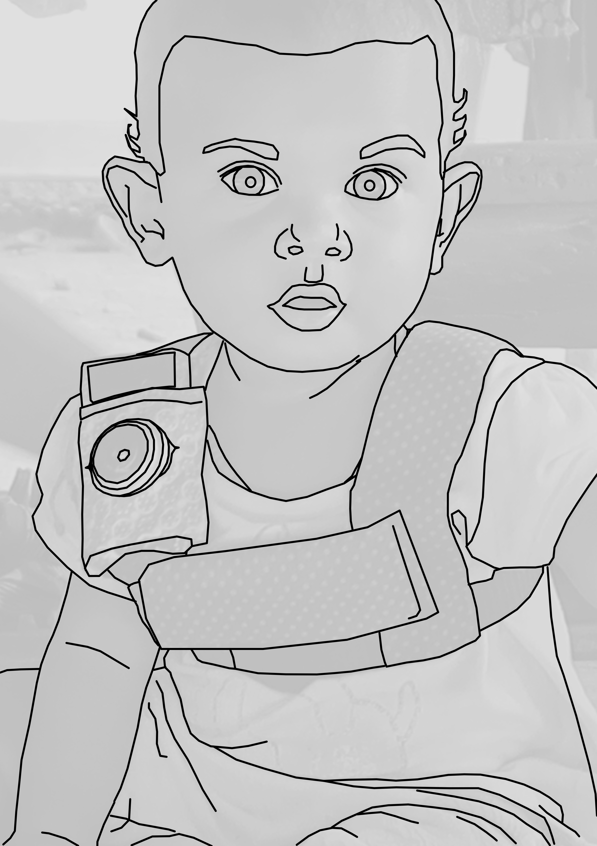

Figure 1 The recording vest included an Olympus audio recorder in the front horizontal pocket and a miniature camera with a fish-eye lens on the shoulder strap.

## Data selection and annotation

Although the Tseltal corpus contains more than 500 hours of raw photo-linked audio, very little of it is useful without adding manual annotation. We estimated that we could fully transcribe approximately 10 hours of the corpus over the course of three 6-week field stays in the village between 2015 and 2018, given full-time help from a native member of the community on each trip. This estimate was approximately correct: average exhaustive transcription time for one minute of audio was around 50 minutes, given that many clips featured overlapping multi-speaker talk and/or significant background noise. Given the resource-intensive nature of annotation, we strategically sampled clips in a way that would let us ask about age-related changes in children’s language experience, but with enough data per child to generate accurate estimates of their individual speech environments. Our solution was as follows:

We chose 10 children’s recordings based on maximal spread in child age (0;0–3;0), child sex, and maternal education (Table 1; all had native Tseltal-speaking parents). We selected one hour’s worth of non-overlapping clips for transcription from each recording in the following order: nine randomly selected 5-minute clips, five manually selected 1-minute top ‘turn-taking’ clips, five manually selected 1-minute top ‘vocal activity’ clips, and one manually selected 5-minute extension of the ‘best’ 1-minute clip (i.e., the clip with the most variable, most voluble interactive language use for that recording see Figure 2 for the clip distribution within recordings). The idea in creating these different subsamples was to measure properties of (a) children’s *average* language environments, (b) children’s most *interactive-input-dense* language environments, and (c) children’s most *mature vocal behavior*, with these three sub-samples known as the “random”, “turn-taking”, and “vocal activity” samples, respectively. All the samples were taken between the moment the experimenter departed and the moment she returned.

Table 1

*Demographic overview of the 10 children whose recordings are sampled in the current study, including from left to right: child’s age (years;months.days); child’s sex (M/F); mother’s age (years); level of maternal education (none/primary/secondary/preparatory/university); and the number of people living in the child’s household.*

|  |  |  |  |  |
| --- | --- | --- | --- | --- |
| Age | Sex | Mother’s age | Level of maternal education | People in household |
| 0;01.25 | M | 26 | none | 8 |
| 0;03.18 | M | 22 | preparatory | 9 |
| 0;05.29 | F | 17 | secondary | 15 |
| 0;07.15 | F | 24 | primary | 9 |
| 0;10.21 | M | 24 | secondary | 5 |
| 1;02.10 | M | 21 | none | 9 |
| 1;10.03 | F | 31 | preparatory | 9 |
| 2;02.25 | F | 17 | primary | 5 |
| 2;08.05 | F | 28 | secondary | 5 |
| 3;00.02 | M | 28 | primary | 6 |

The turn-taking and high-activity clips were chosen by two trained annotators (the first author and a student assistant) who listened to each raw recording in its entirety at 1–2x speed while actively taking notes about potentially useful clips. The first author then reviewed the list of candidate clips and chose the best five 1-minute samples for each of the two activity types. Note that, because the manually selected clips did not overlap with the initial “random” clip selection, the “true” peak turn-taking and vocal-activity clips for the day could have possibly occurred during the random clips. High-quality turn-taking activity was defined as closely timed sequences of contingent vocalization between the target child and at least one other person (i.e., frequent vocalization exchanges). High-quality vocal activity clips were defined as periods in which the target child produced the most and most diverse spontaneous (i.e., not imitative) vocalizations (full instructions at <https://git.io/fhdUm>).

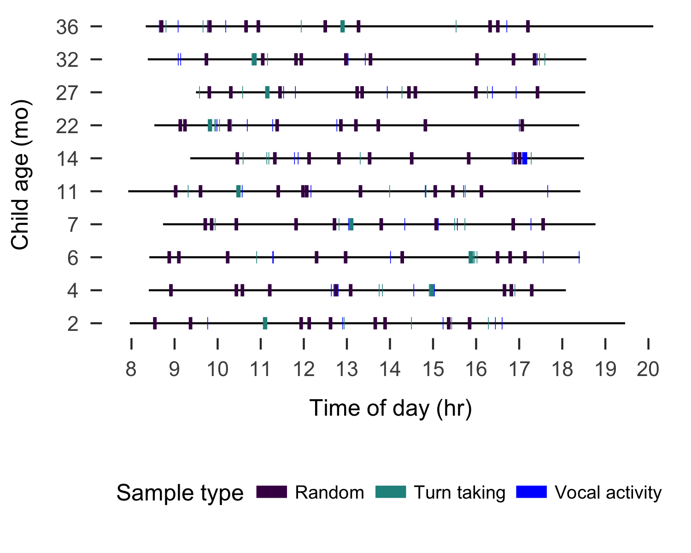

Figure 2 Recording duration (black line) and sampled clips (colored boxes) for each of the 10 recordings analyzed, sorted by child age in months.

The 10 hours of clips were then jointly transcribed and annotated by the first author and a native speaker of Tseltal who personally knows all the recorded families. Transcription was done in ELAN (Wittenburg, Brugman, Russel, Klassmann, & Sloetjes, 2006) using the ACLEW Annotation Scheme (full documentation at <https://osf.io/b2jep/wiki/home/>, Casillas et al., 2017). Utterance-level annotations included: an orthographic transcription (Tseltal), a loose translation (Spanish), a vocal maturity rating for each target child utterance (non-linguistic/non-canonical babbling/canonical babbling/single words/multiple words), and the intended addressee type for all non-target-child utterances (target-child/other-child/adult/adult-and-child/animal/other-speaker-type). Intended addressee was determined using contextual and interactional information from the photos, audio, and preceding and following footage; utterances with no clear intended addressee were marked as ‘unsure’. We annotated lexical utterances as single- or multi-word based on the word boundaries provided by the single native speaker who reviewed all transcriptions. Note that Tseltal is a mildly polysynthetic language, so words typically contain multiple morphemes. We did not annotate individual activity types in the clips; we instead use time of day as a proxy for the activities and daily routines associated with subsistence farming and family life in this community (see above).

## Data analysis

In what follows we first describe Tseltal children’s speech environments based on the nine randomly selected 5-minute clips from each child. We investigate the effects of child age, time of day, household size, and number of speakers on both TCDS min/hr and ODS min/hr. We then repeat these analyses, only now looking at the high “turn-taking” clips. Finally, we wrap up by outlining a coarse trajectory of Tseltal children’s early vocal development.

## Statistical models

All analyses were conducted in R with generalized linear mixed-effects regressions using the glmmTMB package, and all plots were generated with ggplot2 (M. E. Brooks et al., 2017; R Core Team, 2018; Wickham, 2009). All data and analysis code can be found at <https://github.com/marisacasillas/Tseltal-CLE> Notably, both speech environment measures are naturally restricted to non-negative (0–infinity) values. This implicit boundary restriction at zero causes the distributional variance of the measures to become non-gaussian (i.e., with a long right tail). We handle this issue by using a negative binomial linking function in the regression, which estimates a dispersion parameter (in addition to the mean and variance) that allows the model to more closely fit our non-negative, overdispersed data (M. E. Brooks et al., 2017; Smithson & Merkle, 2013). When, in addition to this, extra cases of zero were evident in the distribution (e.g., TCDS min/hr was zero because the child was alone), we also added a zero-inflation model to the regression. A zero-inflation negative binomial regression creates two models: (a) a binary model to evaluate the likelihood of none vs. some presence of the variable (e.g., no vs. some TCDS) and (b) a count model of the variable (e.g., ‘3’ vs. ‘5’ TCDS min/hr), using the negative binomial distribution as the linking function. Alternative, gaussian linear mixed-effects regressions with logged dependent variables are available in the Supplementary Materials, but the results are broadly similar to what we report here.

# Results

Our model predictors were as follows: child age (months), household size (number of people), and number of non-target-child speakers present in that clip, all centered and standardized, plus time of day at the start of the clip (as a factor; “morning” = up until 11:00; “midday” = 11:00–13:00; and “afternoon” = 13:00 onwards). In addition, the model included two-way interactions between child age and: (a) the number of speakers present, (b) household size, and (c) time of day. We also added a random effect of child. For the zero-inflation models, we included the number of speakers present. We only report significant effects in the main text; full model outputs are available in the Supplementary Materials.

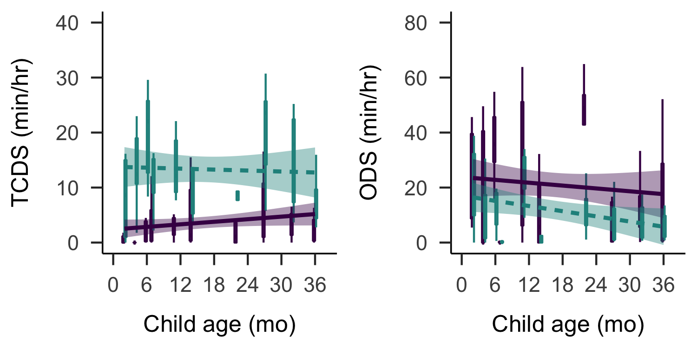

Figure 3 Estimates of TCDS min/hr (left) and ODS min/hr (right) across the sampled age range. Each box plot summarizes the data for one child from the randomly sampled clips (purple; solid) or the turn taking clips (green; dashed). Bands on the linear trends show 95% confidence intervals.

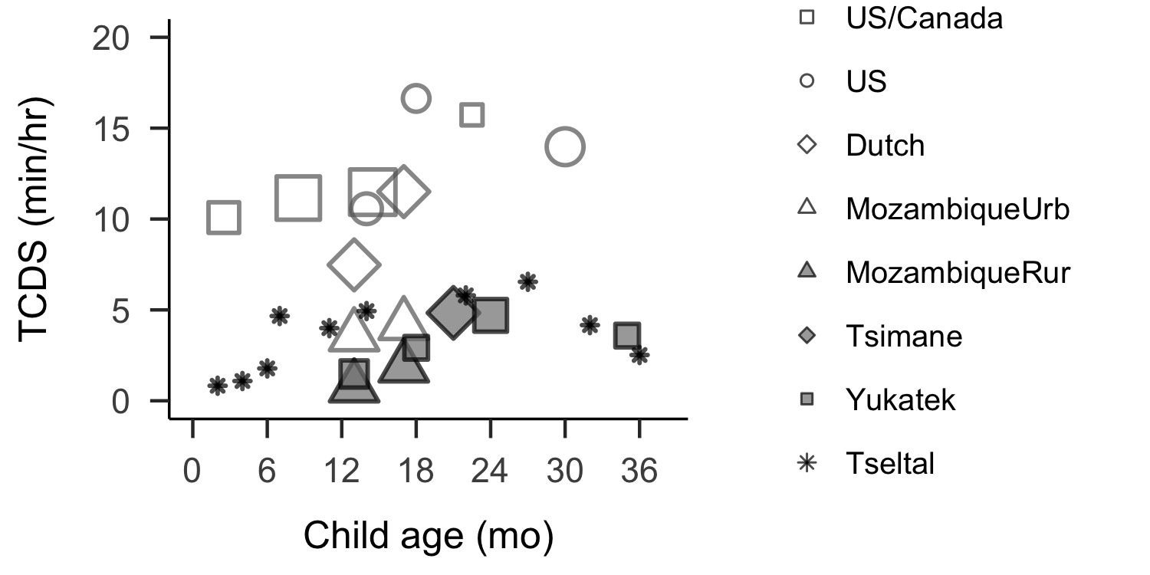

Figure 4 Average CDS rates reported from at-home recordings across various populations and ages, including urban (empty shape) and rural or indigenous (filled shape) samples. Point size indicates the number of children represented (range = 1–26). Data sources: Bergelson et al. (2019) US/Canada; Shneidman (2010) US and Yucatec; Vogt et al. (2015) Dutch, Mozambique urban and rural; Scaff et al. (in preparation) Tsimane.

## Target-child-directed speech (TCDS)

The children in our sample were directly spoken to for an average of 3.63 minutes per hour in the random sample (median = 4.08; range = 0.83–6.55; Figure 3). These estimates are similar to those reported for Yucatec Mayan children (Shneidman & Goldin-Meadow, 2012), as illustrated in Figure 4 (see Scaff et al. (in preparation) for more detailed cross-language comparisons). Note that, to make this comparison, we have converted Shneidman’s (2010) utterance/hr estimates to min/hr using the median Tseltal utterance duration for non-target child speakers (1029 msec), motivated by the fact that Yucatec and Tseltal are related languages spoken in comparably rural indigenous communities.

We modeled TCDS min/hr in the random clips with a zero-inflated negative binomial regression. TCDS rate numerically increased with age, but the effect was not significant (B = 0.60, SD = 0.36, z = 1.68, p = 0.09). The rate of TCDS in the randomly sampled clips *was* affected by factors relating to the time of day (see Figure 5 for an overview of time-of-day findings). The count model showed that the children were more likely to hear TCDS in the mornings than at midday (B = 0.83, SD = 0.40, z = 2.09, p = 0.04), with no difference between morning and afternoon (p = 0.21) or midday and afternoon (p = 0.19). These time-of-day effects also varied by age: while younger children heard little TCDS from midday onwards, older children showed a significantly larger decrease in TCDS only in the afternoon; TCDS rates in the afternoon were significantly lower for older children than they were at midday (B = -0.85, SD = 0.38, z = -2.26, p = 0.02) and marginally lower than they were morning (B = 0.57, SD = 0.30, z = 1.90, p = 0.06). Older target children were also significantly more likely to hear TCDS when more speakers were present, compared to younger children (B = 0.57, SD = 0.19, z = 2.95, p < 0.01). There were no other significant effects in either the count or the zero-inflation model.

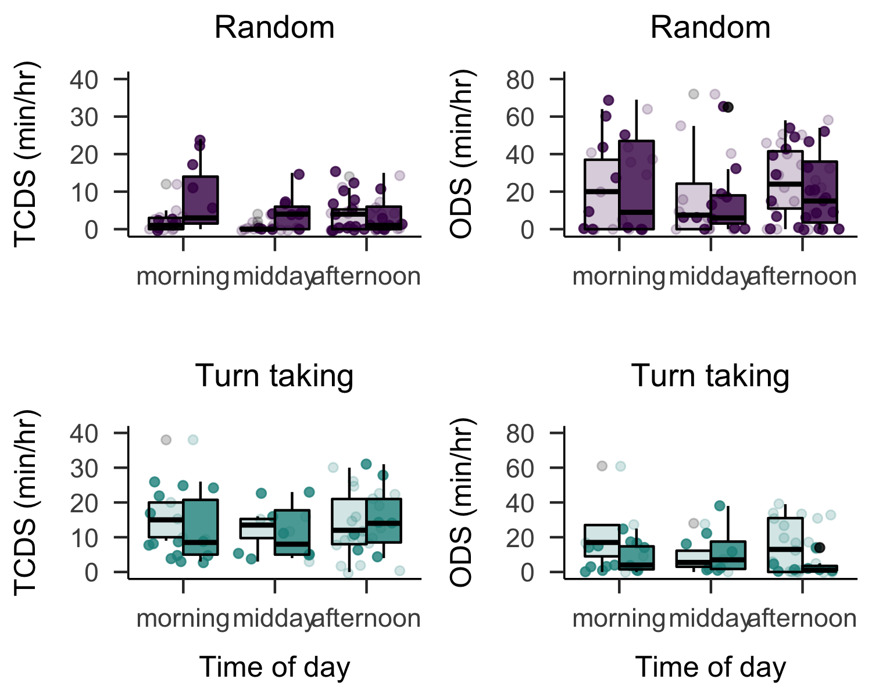

Figure 5 Estimates of TCDS min/hr (left panels) and ODS min/hr (right panels) across the recorded day in the random clips (top panels) and turn-taking (bottom panels) clips. Each box plot summarizes the data for children age 1;0 and younger (light) or age 1;0 and older (dark) at the given time of day.

In contrast to findings from Shneidman and Goldin-Meadow (2012) on Yucatec Mayan, most TCDS in the current data came from adult speakers (mean = 80.61%, median = 87.22%, range = 45.90%–100%), with no evidence that TCDS from *other* children increases with target child age (Spearman’s *rho* = -0.29; *p* = 0.42). Among adults, the vast majority of TCDS came from women: 4 children heard no adult male TCDS at all in the samples and, between the other 6 children, total TCDS from women was, on average, 16.77 times the total TCDS time from men (median = 12.23, range = 0.94–55.64).

## Other-directed speech (ODS)

Children heard an average of 21.05 minutes of ODS per hour in the random sample (median = 17.80; range = 3.57–42.80): that is, nearly six times as much speech as was directed to them, on average. We modeled ODS min/hr in the random clips with a zero-inflated negative binomial regression. The count model of ODS in the randomly selected clips revealed a significant decrease with child age (B = -0.39, SD = 0.16, z = -2.43, p = 0.02). In addition to this decrease in age, the model also revealed that the presence of more speakers was strongly associated with more ODS (B = 0.68, SD = 0.09, z = 7.29, p < 0.001). There were an average of 3.44 speakers present other than the target child in the randomly selected clips (median = 3; range = 0–10), more than half of whom were typically adults.

ODS was also strongly affected by time of day (Figure 5), showing its lowest point overall around midday. Compared to midday, target children were significantly more likely to hear ODS in both the mornings (B = 0.45, SD = 0.18, z = 2.49, p = 0.01) and the afternoons (B = 0.33, SD = 0.16, z = 1.99, p = 0.05), with no significant difference between ODS rates in the mornings versus afternoons (p = 0.41). As before, ODS rate varied across the day depending on the target child’s age: the increase in ODS between the midday and afternoon was significantly larger for older children (B = 0.42, SD = 0.17, z = 2.42, p = 0.02), with no significant differences in child age for the morning-to-midday difference (p = 0.19) or the difference between morning and afternoon (p = 0.33). There were no other significant effects on ODS rate, and no significant effects in the zero-inflation models.

## TCDS and ODS during interactional peaks

The estimates just given for TCDS and ODS are based on a random sample of clips from the day; they represent baseline rates of speech in children’s environment and the overall effects of child age, time of day, and number of speakers on the rates of speech. We could instead investigate these measures using clips where we know interaction is taking place: how much speech do children hear during the interactional peaks that are distributed throughout the day? To answer this question we repeated the same analyses of TCDS and ODS as above, only this time using the high turn-taking clips in the sample instead of the random ones (see the green/dashed summaries in Figures 3 and 5).

Children heard much more TCDS in the turn-taking clips—13.28 min/hr (nearly four times the random sample rate; median = 13.65; range = 7.32–20.19)—while also hearing less ODS—11.93 min/hr (nearly half the random sample rate; median = 10.18; range = 1.37–24.42). We analyzed both TCDS and ODS rate with parallel models to those used for the random sample, though this time we did not include a zero-inflation component for TCDS given that the child was, by definition, directly addressed at least once in these clips (i.e., there were no cases of zero TCDS in the turn-taking sample). Full model outputs are available in the Supplementary Materials.

The models revealed that none of the predictors—child age, time of day, household size, number of speakers present, or their combinations—significantly impacted the rate of TCDS children heard during peak interactivity clips. Put another way, although child age, time of day, and number of speakers impacted the pattern of TCDS when viewing children’s linguistic input in the *random* baseline, none of these factors significantly predicted the rate of TCDS used when we only look at the interactive peaks for the day, probably because the TCDS rate in this set of clips is near the ceiling of what caregivers do when interacting with young children.

In the model of ODS, we still saw a significant decrease with child age (B = -0.80, SD = 0.23, z = -3.43, p = < 0.001) and a significant increase when more speakers were present (B = 0.63, SD = 0.10, z = 6.44, p = < 0.01). This result suggests that child age and the number of speakers present are consistent predictors of ODS quantity across different language environment contexts.

The rate of ODS during interactional peaks was also still impacted by time of day, but the lowest point in ODS came later, in the afternoon, rather than at midday (morning-vs-afternoon: B = -0.61, SD = 0.25, z = -2.41, p = 0.02; afternoon-vs-midday: B = 0.61, SD = 0.29, z = 2.07, p = 0.04), with no difference between ODS rates at morning and midday (p = 0.99) and no interactions between child age and time of day. Finally, the model also revealed an unexpected significant decrease in ODS with increased household size (B = -0.18, SD = 0.09, z = -2.12, p = 0.03), a result we come back to in the Discussion section.

In sum, our results provide compelling evidence in support of prior work claiming that Tseltal children hear very little directly addressed speech (Brown, 1998, 2011, 2014) and that their speech input is non-uniformly distributed over the course of the day (Abney et al., 2017; Blasi et al., in preparation), primarily occurring in the mornings (TCDS and ODS) and afternoons (ODS), when most of the household is likely to be present. Do Tseltal children then show any obvious evidence of delay in their early vocal development?

## Vocal maturity

We assessed whether the Tseltal children’s vocalizations demonstrated transitions from (a) non-canonical babble to canonical babble, (b) canonical babble to first words, and (c) single-word utterances to multi-word utterances, at approximately the same ages as would be expected in a Western context. We generated descriptive statistics (summarized in Figure 6) for the proportional use of all linguistic vocalization types in the children’s utterances (non-canonical babble, canonical babble, single words, and multiple words). These figures are based on all annotated vocalizations from the random, turn-taking, and high vocal activity samples together (N = 4725 linguistic vocalizations; non-canonical babble, canonical babble, and lexical speech). As a reminder, we had predicted that the emergence of canonical babble would occur around the same age as it does in Western children, but that the emergence of single words and multi-word utterances might theoretically diverge from known middle-class Western norms if Tseltal children indeed hear little CDS.

In fact, we find that Tseltal children’s vocalizations closely resemble the typical “onset” benchmarks established for Western speech development, from canonical babble through first word combinations. Western children have been shown to begin producing non-canonical babbling around 0;2, with canonical babbling appearing sometime around 0;7, first words around 1;0, and first multi-word utterances appearing just after 1;6 (Frank et al., in preparation; Kuhl, 2004; Pine & Lieven, 1993; Slobin, 1970; Tomasello & Brooks, 1999; Warlaumont, Richards, Gilkerson, & Oller, 2014). These rough benchmarks can also be seen in the Tseltal children’s vocalizations, which are summarized in Figure 6: there is a decline in the use of non-canonical babble and an accompanying increase in the use of canonical babble between 0;6 and 1;0; recognizable words are observed for all six children of age 11;0 and older; and multi-word utterances appear in all five recordings from children age 1;2 and later, making up 45% of the oldest child’s (3;0) vocalizations.

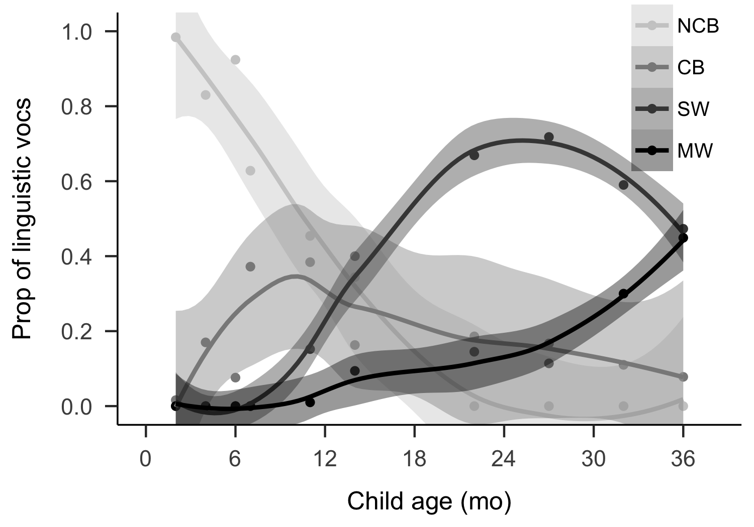

Figure 6 Proportion of vocalization types used by children across age (NCB = Non-canonical babble, CB = Canonical babble, SW = single word utterance, MW = multi-word utterance).

### Frequency of vocalizations

We can use these same data to roughly infer how *often* children use speech-like vocalizations (i.e., “usage” instead of “onset” measures; Warlaumont et al. (2014); Cychosz et al. (in preparation)). The six Tseltal children between 2 and 14 months demonstrated a large increase in the proportion of speech-like vocalizations (canonical babbling and lexical speech): from 9% before 0;6 to 58% between 0;10 and 1;2. Notably, this usage rate for speech-like syllables far exceeds the threshold associated with later language delay in American infants (Oller et al., 1998). There is very little published data with which we can directly compare these patterns, but we see that around age 1;0, the Tseltal children’s use of speech-like vocalizations (58%) is nearly identical to that reported by Warlaumont et al. (2014) for American children around age 1;0 in an socioeconomically diverse sample (approximately 60%). Further, in a separate study, a subset of these Tseltal vocalizations have been independently re-annotated and compared to vocalizations from children acquiring five other non-related languages, with very similar results: the ratio of speech-like vocalizations to all linguistic vocalizations (canonical babbling ratio, e.g., Lee et al., 2018) increases similarly under a variety of different linguistic and childrearing environments between ages 0;2 and 3;0, during which time children in all six communities begin to produce their first words and multi-word utterances (Cychosz et al., in preparation).

We also found that, in general, the Tseltal children did not vocalize very often: they produced an average of 7.88 linguistic vocalizations per minute (median = 7.55; range = 4.08–12.55) during their full one hour of annotated audio (including the high vocal activity minutes). This rate is consistent with prior estimates for the frequency of child-initiated prompts in Tseltal interaction (Brown, 2011). Given that our age range goes all the way up to 3;0, this rate is lower than what would be expected based on recordings made in the lab with American infant-caregiver pairs (e.g., Oller et al., 1995), in which a rate of 6–9 vocalizations per minute was evident at 16 months across a socioeconomically diverse sample. The lower rate of vocalization in Tseltal is consistent with caregivers’ encouragement that children attend to the events going on around them, but is also in-line with the idea that rate of vocalization is sensitive to the language environment (Oller et al., 1995; Warlaumont et al., 2014). However, vocalization rate estimates from daylong recordings would be necessary to more validly make this comparison.

# Discussion

We analyzed 10 Tseltal Mayan children’s speech environments to find out how often they had the opportunity to attend and respond to speech and to also sketch out a basic trajectory of their early vocal development. Based on prior work, we predicted infrequent and non-uniform use of TCDS throughout the day, an increase in TCDS with child age, and that a large proportion of children’s TCDS would come from other children. We had also predicted that children’s vocal development would show no obvious signs of delay compared to similar benchmarks in Western children. Only some of these predictions were borne out in the analyses. We did find evidence for infrequent use of TCDS and for its non-uniform use over the day; as predicted, children were most likely to hear speech in the mornings and afternoons—times of day when the household members are likely to be gathered for meals and socializing. Relatedly, the sheer number of speakers present was a robust predictor of the quantity of ODS the children heard, above and beyond the time of day. We also saw that Tseltal children’s speech showed approximately similar benchmark ages for the onset of canonical babble, first words, and first word combinations based on Western children’s data. These findings indicate no obvious delay in development: Tseltal children are able to extract enough information from their linguistic environments to produce at least some words and multi-word utterances at comparable ages to the emergence of those behaviors in Western children.

That said, we did *not* find evidence that an increasing majority of TCDS comes from other children. Instead, we saw that the majority of TCDS came from adults, and that the quantity of directed speech from both adults and children was stable across the first three years of life. The present findings therefore only partly replicate estimates of child language input in previous work on Yucatec Mayan and Tseltal Mayan communities (Yucatec: Shneidman & Goldin-Meadow 2012; Tseltal: Brown, 1998, 2011, 2014), and bring new questions to light regarding the distribution of child-directed speech over activities and interactant types in Mayan children’s speech environments.

## Learning Tseltal with little child-directed speech

A main goal of our analysis was to find out how much speech Tseltal children hear: we wanted to know how often they were directly spoken to and how often they might have been able to listen to speech directed to others. Consistent with prior work, the children were only infrequently directly spoken to: a day-wide average of 3.63 minutes per hour in the random sample. This average TCDS rate for Tseltal is approximately a third of that found for North American children (Bergelson et al., 2019), but is comparable to that for Tsimane children (Scaff et al., in preparation) and Yucatec Mayan children (Shneidman & Goldin-Meadow, 2012) in a similar age range. Meanwhile, we found that the children heard an enormous quantity of other-directed speech in their environment, averaging 21.05 minutes per hour in the random sample, which is more than has been previously reported for other cultural settings (e.g., Bergelson et al., 2019; Scaff et al., in preparation). In a nutshell, our findings from daylong recordings confirm prior claims that Tseltal children, like other Mayan children, are infrequently directly spoken to. Again, despite this, Tseltal children somehow extract enough information about their language to produce at least some canonical babbles, single words, and multi-word utterances at approximately the same ages that Western children do. The important question is then: how do children manage to extract the information they need from their language environments without frequent TCDS?

### Other-directed speech

One proposal is that Mayan children become experts at observing and learning from the interactions and behaviors taking place around them (de León, 2011; Rogoff et al., 2003; Shneidman, 2010; Shneidman & Goldin-Meadow, 2012). In the randomly selected clips, children were within hearing distance of other-directed speech for an average of 21.05 minutes per hour. This large quantity of ODS is likely due to the fact that Tseltal children tend to live in households with more people than the typical North American child does (Shneidman & Goldin-Meadow, 2012). Two factors in our analysis impacted the quantity of ODS children heard: the presence of more speakers was associated with more ODS, but older children heard less ODS than younger ones. This latter effect—that older children hear less ODS—is boosted by the complementary finding that older children are more likely to hear TCDS when more speakers are around, compared to younger children. Together, these results ring true with Brown’s (2011, 2014) claim that this Tseltal community is non-child-centric; the presence of more people primarily increases talk between those people (i.e., not to young children). But, as children become more sophisticated language users, they are more likely to participate in others’ talk or perhaps walk away from the other-directed talk to seek other activities. This latter hypothesis is, in fact, similar to one proposed for North American children based on manual annotations of daylong audio recordings (Bergelson et al., 2019). We also saw that, during the interactional peaks, children in larger households heard significantly less ODS. This effect goes against expectations, but may reflect both our relatively small sample (10 children) and the fact that household size is a less stable proxy for overheard speech than the number of speakers present at any given moment, which shows consistent strong effects on ODS in both the random and the turn-taking samples. The sum of evidence, in our view, does not support the idea that Tseltal children’s early vocal development relies heavily on ODS. First, it is most frequent when children are youngest and, if anything, we see less ODS at later ages, when children are independently mobile. Second, an increase in the number of speakers is also likely associated with an increase in the amount of overlapping speech, which likely presents additional processing difficulties (Scaff et al., in preparation). Third, just because speech is hearable does not mean the children are attending to it; follow-up work on the role of ODS in language development must better define what constitutes likely “listened to” speech by the child. For now, we suggest that attention to ODS is unlikely to be a primary mechanism driving early Tseltal development.

### Increased TCDS with age

Another possibility is that speakers more frequently address children who are more communicatively competent (i.e., increased TCDS with age, e.g., Warlaumont et al., 2014). In their longitudinal study of Yucatec Mayan children, Shneidman and Goldin-Meadow (2012) found that TCDS increased tremendously with age, though most of the increase came from other children speaking to the target child. Their finding is consistent with other reports that Mayan children are more often cared for by their older siblings from later infancy onward (Brown, 2011, 2014). In our data, there was no evidence for an overall increase in TCDS with age, neither from adult speakers nor from child speakers. This non-increase in TCDS with age may be due to the fact that TCDS from other children was, overall, simply rare in our data. TCDS from other children may have been rare because: (a) the target children were relatively young and so spent much of their time with their mothers, (b) these particular children did not have many older siblings, and (c) in the daylong recording context more adults were present to talk to each other than would be typical in a short-format recording (as used in Shneidman & Goldin-Meadow, 2012). That aside, we conclude for now that an increase in TCDS with age is also unlikely to be a primary mechanism driving early Tseltal development.

### Learning during interactional bursts

A third possibility is that children learn effectively from short, routine language encounters. Bursty input appears to be the norm across a number of linguistic and interactive scales (e.g., Abney et al., 2017; Blasi et al., in preparation), and experiment-based work suggests that children can benefit from massed presentation of new information (Schwab & Lew-Williams, 2016). We propose two mechanisms through which Tseltal children might capitalize on the distribution of speech input in their environment: (a) they experience most language input during routine activities, giving them a more constrained, predictable entry into early interaction (b) they consolidate their language experiences during the downtime between interactive peaks. Neither of these mechanisms are proposed to be particular to Tseltal children, but might be employed to help explain their language development without frequent CDS.

Tseltal children’s linguistic input is not uniformly distributed over the day: children were most likely to encounter directed, contingent speech in the mornings. Older children, who are less often carried and were therefore probably more free to seek out interactions, showed these time of day effects more strongly, eliciting TCDS both in the mornings (when the entire household was likely present) *and* around midday (when many people had likely dispersed for work), and hearing less ODS overall and less ODS in the presence of other speakers compared to younger children (see also Bergelson et al., 2019). Prior work with North American children’s daylong recordings has also shown a decrease in environmental speech just after midday (Greenwood et al., 2011; Soderstrom & Wittebolle, 2013). Similar time of day effects across multiple cultural contexts could arise from coincidental similarities in the types of activities that occur in the mornings and afternoons, for example, morning meal gatherings or short bouts of infant sleep (Soderstrom & Wittebolle, 2013). That said, in the North American data (Soderstrom & Wittebolle, 2013), the highest density speech input came during storytime and organized playtime (e.g., sing-alongs, painting), while mealtime was associated with less speech. We expect that follow-up research tracking TCDS during activities in Tseltal will lead to very different conclusions: storytime and organized playtime are vanishingly rare in this non-child-centric community, and mealtime may present opportunities for routine and rich linguistic experience. In both cases, however, the underlying association with activity (not hour) implies a role for action routines that help children optimally extract information about what words, agents, objects, and actions they will encounter and what they are expected to do in response (see, e.g., Bruner, 1983; Tamis-LeMonda et al., 2018). Our study is the first to show these time of day effects in a subsistence farming community, and to show that time of day effects differ depending on child age and that time of day differentially affects CDS and ODS. That said, without actual information about the ongoing activities in each household (as in Soderstrom & Wittebolle, 2013) we cannot accurately assess the potential role of routine in Tseltal language development.

A more speculative possibility is that Tseltal children learn language on a natural input-consolidation cycle: the rarity of interactional peaks throughout the day may be complemented by an opportunity to consolidate new information. Sleep has been shown to benefit language learning tasks in both adults (Frost & Monaghan, 2017; Mirković & Gaskell, 2016) and children (Gómez, Bootzin, & Nadel, 2006; Horváth, Liu, & Plunkett, 2016; Hupbach, Gómez, Bootzin, & Nadel, 2009), including word learning, phonotactic constraints, and syntactic structure. Our impression, both from the recordings and informal observations made during visits to the community, is that young Tseltal children frequently sleep for short periods throughout the day, particularly at younger ages when they spend much of their day wrapped within the shawl on their mother’s back. Mayan children tend to pick their own breastfeeding and resting times; there are no formalized “sleep” times, even at night (Morelli, Rogoff, Oppenheim, & Goldsmith, 1992), and Mayan mothers take special care to keep infants in a calm and soothing environment in the first few months of life (e.g., de León, 2011; Pye, 1986). There is little quantitative data on Mayan children’s daytime and nighttime sleeping patterns, but one study estimates that Yucatec Mayan children between 0;0 and 2;0 sleep or rest approximately 15% of the time between morning and evening (Gaskins, 2000), doing so at times that suited the child (Morelli et al., 1992). If Tseltal children’s interactional peaks are bookended by short sleeping periods, it could contribute to efficient consolidation of new information encountered. How often Tseltal children sleep, how deeply, and how their sleeping patterns may relate to their linguistic development is an important topic for future research.

## Limitations and Future Work

The current findings are based on a cross-sectional analysis of 600 annotated recording minutes, divided among only ten children. The data are limited to verbal activity; we cannot analyze gaze and gestural behavior. We have also used very coarse indices of language development in a small, cross-sectional sample with little existing data to which we can make direct comparisons (but see Oller et al., 1998; Warlaumont et al., 2014; Cychosz et al., in preparation). More detailed measures of phonological, lexical, and syntactic growth will be crucial for shedding light on the relation between what Tseltal children hear and how they develop early language skills, building on past work (Brown, 1998, 2011, 2014; Brown & Gaskins, 2014). In short, more and more diverse data are needed to enrich this initial description of Tseltal children’s language environments. Importantly, the current analyses are based on a corpus that is still under active development. We point those interested in citing these speech environment characteristics to check the most accurate and up-to-date summaries at <https://middycasillas.shinyapps.io/Tseltal_Child_Language_Environment/>, which will show analyses for all current data in the corpus, including new data, annotations, and analyses added after this publication.

## Conclusion

We estimate that, over the course of a waking day, Tseltal children under age 3;0 hear an average of 3.63 minutes of directed speech per hour. However, during their peak moments of interactivity, children hear TCDS at an average rate of 13.28 minutes per hour, and the quantity of speech they hear is influenced by the time of day, both on its own and in combination with the child’s age. Despite the fact that children hear infrequent TCDS, our preliminary measures of the onset of canonical babble, first words, and first word combinations show no delay compared to Western norms. These findings raising a challenge for future work: how do Tseltal children efficiently extract the information they need from their linguistic environments? In our view, a promising avenue for continued research is to more closely investigate how directed speech is distributed over daily activities and to explore a possible input-consolidation cycle for language exposure in early development. While this study substantiates prior ethnographic claims about the language environments of young Mayan children (and, indirectly, those of children in other small-scale traditional societies) it also adds important new complexity to prior quantitative descriptions of input (cf. Shneidman & Goldin-Meadow, 2012), particularly with respect to CDS over the course of the day and change with age. We use this new view of the children’s input to evaluate a number of mechanisms that could be used to explain how Tseltal children extract language from their speech environments, setting up multiple avenues for future observational and experimental research. By better understanding how children in this community learn Tseltal, we hope to help uncover how human language learning mechanisms are adaptive to the many thousands of ethnolinguistic environments in which children develop.

# Acknowledgements

We thank and ackowledge Rebeca Guzmán López, Humbertina Gómez Pérez, Juan Méndez Girón, and Antun Gusman Osil, who made the collection and annotation of these recordings possible. We are also enormously grateful to the participating families and to the community at large for their support. Thanks also go to Maartje Weenink and Daphne Jansen for their help with manual clip selection and vocal maturity annotation. This work is supported by a NWO Veni Innovational Scheme grant (275-89-033) to MC and by an ERC Advanced grant (269484 INTERACT) to SCL. This paper was written using the papaja library in RStudio (Aust & Barth, 2018).

# References

Abney, D. H., Smith, L. B., & Yu, C. (2017). It’s time: Quantifying the relevant time scales for joint attention. In G. Gunzelmann, A. Howes, T. Tenbrink, & E. Davelaar (Eds.), *Proceedings of the 39th Annual Meeting of the Cognitive Science Society* (pp. 1489–1494). London, UK.

Aust, F., & Barth, M. (2018). *papaja: Create APA manuscripts with R Markdown*. Retrieved from <https://github.com/crsh/papaja>

Bergelson, E., Amatuni, A., Dailey, S., Koorathota, S., & Tor, S. (2018). Day by day, hour by hour: Naturalistic language input to infants. *Developmental Science*, *22*, e12715.

Bergelson, E., Casillas, M., Soderstrom, M., Seidl, A., Warlaumont, A. S., & Amatuni, A. (2019). What do North American babies hear? A large-scale cross-corpus analysis. *Developmental Science*, *22*, e12724.

Blasi, D., Schikowski, R., Moran, S., Pfeiler, B., & Stoll, S. (in preparation). *Human communication is structured efficiently for first language learners: Lexical spikes*.

Brinchmann, E. I., Braeken, J., & Lyster, S.-A. H. (2019). Is there a direct relation between the development of vocabulary and grammar? *Developmental Science*, *22*, e12709.

Brooks, M. E., Kristensen, K., van Benthem, K. J., Magnusson, A., Berg, C. W., Nielsen, A., … Bolker, B. M. (2017). Modeling zero-inflated count data with glmmTMB. *bioRxiv*. <https://doi.org/10.1101/132753>

Brown, P. (1998). Conversational structure and language acquisition: The role of repetition in Tzeltal adult and child speech. *Journal of Linguistic Anthropology*, *2*, 197–221.

Brown, P. (2011). The cultural organization of attention. In A. Duranti, E. Ochs, & and B. B. Schieffelin (Eds.), *Handbook of Language Socialization* (pp. 29–55). Malden, MA: Wiley-Blackwell.

Brown, P. (2014). The interactional context of language learning in Tzeltal. In I. Arnon, M. Casillas, C. Kurumada, & B. Estigarribia (Eds.), *Language in interaction: Studies in honor of Eve V. Clark* (pp. 51–82). Amsterdam, NL: John Benjamins.

Brown, P., & Gaskins, S. (2014). Language acquisition and language socialization. In N. J. Enfield, P. Kockelman, & J. Sidnell (Eds.), *Handbook of Linguistic Anthropology* (pp. 187–226). Cambridge, UK: Cambridge University Press.

Bruner, J. (1983). *Child’s talk*. Oxford: Oxford University Press.

Cartmill, E. A., Armstrong, B. F., Gleitman, L. R., Goldin-Meadow, S., Medina, T. N., & Trueswell, J. C. (2013). Quality of early parent input predicts child vocabulary 3 years later. *Proceedings of the National Academy of Sciences*, *110*, 11278–11283.

Casillas, M., Brown, P., & Levinson, S. C. (2017). *Casillas HomeBank corpus*. <https://doi.org/10.21415/T51X12>

Casillas, M., Bunce, J., Soderstrom, M., Rosemberg, C., Migdalek, M., Alam, F., … Garrison, H. (2017). *Introduction: The ACLEW DAS template [training materials]*. Retrieved from <https://osf.io/aknjv/>

Cristia, A., Dupoux, E., Gurven, M., & Stieglitz, J. (2017). Child-directed speech is infrequent in a forager-farmer population: A time allocation study. *Child Development*, *Early View*, 1–15.

Cychosz, M., Warlaumont, A. S., Bergelson, E., Casillas, M., Yankowitz, L., Scaff, C., … Seidl, A. (in preparation). *Cross-linguistic canonical babbling ratio: A preliminary analysis*. Retrieved from <https://osf.io/p32gq/>

de León, L. (2011). Language socialization and multiparty participation frameworks. In A. Duranti, E. Ochs, & and B. B. Schieffelin (Eds.), *Handbook of Language Socialization* (pp. 81–111). Malden, MA: Wiley-Blackwell.

Frank, M. C., Braginsky, M., Marchman, V. A., & Yurovsky, D. (in preparation). *Variability and consistency in early language learning: The Wordbank project*. Retrieved from <https://langcog.github.io/wordbank-book/>

Frost, R. L. A., & Monaghan, P. (2017). Sleep-driven computations in speech processing. *PloS One*, *12*, e0169538.

Gaskins, S. (2000). Children’s daily activities in a Mayan village: A culturally grounded description. *Cross-Cultural Research*, *34*, 375–389.

Gaskins, S. (2006). Cultural perspectives on infant–caregiver interaction. In N. J. Enfield & S. Levinson (Eds.), *Roots of Human Sociality: Culture, Cognition and Interaction* (pp. 279–298). Oxford: Berg.

Gómez, R. L., Bootzin, R. R., & Nadel, L. (2006). Naps promote abstraction in language-learning infants. *Psychological Science*, *17*, 670–674.

Greenwood, C. R., Thiemann-Bourque, K., Walker, D., Buzhardt, J., & Gilkerson, J. (2011). Assessing children’s home language environments using automatic speech recognition technology. *Communication Disorders Quarterly*, *32*, 83–92.

Hart, B., & Risley, T. R. (1995). *Meaningful Differences in the Everyday Experience of Young American Children*. Paul H. Brookes Publishing.

Henrich, J., Heine, S. J., & Norenzayan, A. (2010). Beyond WEIRD: Towards a broad-based behavioral science. *Behavioral and Brain Sciences*, *33*, 111–135.

Hoff, E. (2003). The specificity of environmental influence: Socioeconomic status affects early vocabulary development via maternal speech. *Child Development*, *74*, 1368–1378.

Horváth, K., Liu, S., & Plunkett, K. (2016). A daytime nap facilitates generalization of word meanings in young toddlers. *Sleep*, *39*, 203–207.

Hupbach, A., Gómez, R. L., Bootzin, R. R., & Nadel, L. (2009). Nap-dependent learning in infants. *Developmental Science*, *12*, 1007–1012.

Huttenlocher, J., Waterfall, H., Vasilyeva, M., Vevea, J., & Hedges, L. V. (2010). Sources of variability in children’s language growth. *Cognitive Psychology*, *61*, 343–365.

Kuhl, P. K. (2004). Early language acquisition: Cracking the speech code. *Nature Reviews Neuroscience*, *5*, 831.

Lee, C.-C., Jhang, Y., Relyea, G., Chen, L.-m., & Oller, D. K. (2018). Babbling development as seen in canonical babbling ratios: A naturalistic evaluation of all-day recordings. *Infant Behavior and Development*, *50*, 140–153.

Lieven, E. V. M., Pine, J. M., & Baldwin, G. (1997). Lexically-based learning and early grammatical development. *Journal of Child Language*, *24*, 187–219.

Liszkowski, U., Brown, P., Callaghan, T., Takada, A., & de Vos, C. (2012). A prelinguistic gestural universal of human communication. *Cognitive Science*, *36*, 698–713.

ManyBabies Collaborative. (2017). Quantifying sources of variability in infancy research using the infant-directed speech preference. *Advances in Methods and Practices in Psychological Science*, 1–46.

Marchman, V. A., Martínez-Sussmann, C., & Dale, P. S. (2004). The language-specific nature of grammatical development: Evidence from bilingual language learners. *Developmental Science*, *7*, 212–224.

McGillion, M., Herbert, J. S., Pine, J., Vihman, M., DePaolis, R., Keren-Portnoy, T., & Matthews, D. (2017). What paves the way to conventional language? The predictive value of babble, pointing, and socioeconomic status. *Child Development*, *88*, 156–166.

Mirković, J., & Gaskell, M. G. (2016). Does sleep improve your grammar? Preferential consolidation of arbitrary components of new linguistic knowledge. *PloS One*, *11*, e0152489.

Morelli, G. A., Rogoff, B., Oppenheim, D., & Goldsmith, D. (1992). Cultural variation in infants’ sleeping arrangements: Questions of independence. *Developmental Psychology*, *28*, 604.

Nielsen, M., Haun, D., Kärtner, J., & Legare, C. H. (2017). The persistent sampling bias in developmental psychology: A call to action. *Journal of Experimental Child Psychology*, *162*, 31–38.

Ochs, E., & Schieffelin, B. (1984). Language acquisition and socialization: Three developmental stories and their implications. In R. A. Schweder & R. A. LeVine (Eds.), *Culture theory: Essays on mind, self, and emotion* (pp. 276–322). Cambridge University Press.

Oller, D. K., Eilers, R. E., Basinger, D., Steffens, M. L., & Urbano, R. (1995). Extreme poverty and the development of precursors to the speech capacity. *First Language*, *15*, 167–187.

Oller, D. K., Eilers, R. E., Neal, A. R., & Cobo-Lewis, A. B. (1998). Late onset canonical babbling: A possible early marker of abnormal development. *American Journal on Mental Retardation*, *103*, 249–263.

Pine, J. M., & Lieven, E. V. M. (1993). Reanalysing rote-learned phrases: Individual differences in the transition to multi-word speech. *Journal of Child Language*, *20*, 551–571.

Pye, C. (1986). Quiché Mayan speech to children. *Journal of Child Language*, *13*, 85–100.

Pye, C. (2017). *The Comparative Method of Language Acquisition Research*. University of Chicago Press.

R Core Team. (2018). *R: A language and environment for statistical computing*. Vienna, Austria: R Foundation for Statistical Computing.

Rogoff, B., Paradise, R., Arauz, R. M., Correa-Chávez, M., & Angelillo, C. (2003). Firsthand learning through intent participation. *Annual Review of Psychology*, *54*, 175–203.

Rowe, M. L. (2008). Child-directed speech: Relation to socioeconomic status, knowledge of child development and child vocabulary skill. *Journal of Child Language*, *35*, 185–205.

Scaff, C., Stieglitz, J., Casillas, M., & Cristia, A. (in preparation). *Language input in a hunter-forager population: Estimations from daylong recordings*.

Schwab, J. F., & Lew-Williams, C. (2016). Repetition across successive sentences facilitates young children’s word learning. *Developmental Psychology*, *52*, 879–886.

Shneidman, L. A. (2010). *Language Input and Acquisition in a Mayan Village* (PhD thesis). The University of Chicago.

Shneidman, L. A., & Goldin-Meadow, S. (2012). Language input and acquisition in a Mayan village: How important is directed speech? *Developmental Science*, *15*, 659–673.

Slobin, D. I. (1970). Universals of grammatical development in children. In G. B. Flores d’Arcais & W. J. M. Levelt (Eds.), *Advances in Psycholinguistics* (pp. 174–186). Amsterdam, NL: North Holland Publishing.

Smithson, M., & Merkle, E. (2013). *Generalized linear models for categorical and continuous limited dependent variables*. New York: Chapman; Hall/CRC.

Soderstrom, M. (2007). Beyond babytalk: Re-evaluating the nature and content of speech input to preverbal infants. *Developmental Review*, *27*, 501–532.

Soderstrom, M., & Wittebolle, K. (2013). When do caregivers talk? The influences of activity and time of day on caregiver speech and child vocalizations in two childcare environments. *PloS One*, *8*, e80646.

Tamis-LeMonda, C. S., Custode, S., Kuchirko, Y., Escobar, K., & Lo, T. (2018). Routine language: Speech directed to infants during home activities. *Child Development*, *Early View*, 1–18.

Tomasello, M., & Brooks, P. J. (1999). Early syntactic development: A Construction Grammar approach. In M. Barrett (Ed.), *The Development of Language* (pp. 161–190). New York: Psychology Press.

Vogt, P., Mastin, J. D., & Schots, D. M. A. (2015). Communicative intentions of child-directed speech in three different learning environments: Observations from the Netherlands, and rural and urban Mozambique. *First Language*, *35*, 341–358.

Warlaumont, A. S., Richards, J. A., Gilkerson, J., & Oller, D. K. (2014). A social feedback loop for speech development and its reduction in Autism. *Psychological Science*, *25*, 1314–1324.

Weisleder, A., & Fernald, A. (2013). Talking to children matters: Early language experience strengthens processing and builds vocabulary. *Psychological Science*, *24*, 2143–2152.

Wickham, H. (2009). *Ggplot2: Elegant graphics for data analysis*. Springer-Verlag New York.

Wittenburg, P., Brugman, H., Russel, A., Klassmann, A., & Sloetjes, H. (2006). ELAN: A professional framework for multimodality research. *Proceedings of the Fifth International Conference on Language Resources and Evaluation*, 1556–1559.

Yurovsky, D. (2018). A communicative approach to early word learning. *New Ideas in Psychology*, *50*, 73–79.