Early language experience in a Tseltal Mayan village

Marisa Casillas1, Penelope Brown1, & Stephen C. Levinson1

1Max Planck Institute for Psycholinguistics

# Author note

Correspondence concerning this article should be addressed to Marisa Casillas, P.O. Box 310, 6500 AH Nijmegen, The Netherlands. E-mail: [Marisa.Casillas@mpi.nl](mailto:Marisa.Casillas@mpi.nl)

Abstract

Daylong at-home audio recordings from 10 Tseltal Mayan children (0;2–3;0) were analyzed for how often children engaged in verbal interaction with others and whether their speech environment changed with age, time of day, household size, and number of speakers present. Tseltal children were infrequently directly spoken to, with most directed speech coming from adults, and no increase with age. Most directed speech came in the mornings or afternoons, and interactional peaks took the form of ~1-minute bursts of turn taking. An initial analysis of children’s vocal development suggested that, despite relatively little directed speech, Tseltal children develop early language skills on a similar timescale to Western children. Multiple proposals for how Tseltal children might learn language efficiently are discussed.

*Keywords:* Child-directed speech, linguistic input, non-WEIRD, vocal maturity, turn taking, interaction, Mayan

Word count: 10225 (8549 not including references)

Early language experience in a Tseltal Mayan village

# Introduction

A great deal of work in developmental language science revolves around one central question: what linguistic evidence is needed to support first language acquisition? In pursuing this topic, many researchers have fixed their sights on the speech addressed to children. In several languages, child-directed speech (CDS, speech designed for and directed toward a child recipient) has been demonstrated to be distinct from adult-directed speech (ADS) in that it is linguistically adapted for young listeners (e.g., Soderstrom, 2007), interactionally rich (Bruner, 1983), preferred by infants (ManyBabies Collaborative, 2017), and appears to facilitate early word learning (Cartmill et al., 2013; Hoff, 2003; Rowe, 2008; Weisleder & Fernald, 2013). However, ethnographic reports from a number of traditional, non-Western communities suggest that children easily acquire their language(s) even when they are only infrequently directly addressed (Brown, 2011). If so, frequent CDS may not be essential for learning language; just useful for facilitating certain aspects of language development. In this paper we investigate the language environment and early vocal development of 10 Tseltal Mayan children growing up in a community where caregivers have previously been reported to infrequently directly address speech to young children (Brown, 1998, 2011, 2014).

## Child-directed speech

Prior work in Western contexts has shown that the amount of CDS children hear influences their language development; more CDS is associated with faster-growing receptive and productive vocabularies (e.g., Hart & Risley, 1995; Hoff, 2003; Shneidman & Goldin-Meadow, 2012), faster lexical retrieval (Weisleder & Fernald, 2013), and faster syntactic development (Huttenlocher, Waterfall, Vasilyeva, Vevea, & Hedges, 2010). Given that CDS is designed for a child hearer, it is more likely than ADS or other-directed speech to align with the child’s attention, and may thereby comparatively facilitate early language development. There are, however, a few caveats to the body of work relating CDS quantity and language development.

First, while there is overwhelming evidence linking CDS quantity to vocabulary size, links to grammatical development are more scant (but see Brinchmann, Braeken, & Lyster, 2019; Frank, Braginsky, Marchman, & Yurovsky, in preparation; Huttenlocher et al., 2010). While the advantage of CDS for referential word learning is clear, it is less obvious how it facilitates syntactic learning (see also Yurovsky, 2018). On the other hand, there is a wealth of evidence that syntactic knowledge is lexically specified (e.g., Lieven, Pine, & Baldwin, 1997), and that, crosslinguistically, children’s vocabulary size is one of the most robust predictors of their early syntactic development (Frank et al., in preparation; Marchman, Martínez-Sussmann, & Dale, 2004)—what is good for the lexicon may also be good for syntax. For now, a direct link between CDS and grammatical development still needs further exploration.

Second, most work on CDS quantity uses summary measures that average over the ebb and flow of the recorded interaction (e.g., average proportion CDS). In reality, verbal behaviors are highly structured during interaction: while some occur at regular intervals, others occur in shorter, more intense bursts separated by long periods of inactivity. Infants’ and adults’ vocal behavior is clustered across multiple time scales of daylong recordings (Abney, Smith, & Yu, 2017) and nouns and verbs are used within short bursts separated by long periods across languages (Blasi, Schikowski, Moran, Pfeiler, & Stoll, in preparation). In experimental settings, two-year-olds have also been shown to learn novel words better from a massed presentation of object labels versus a distributed one (Schwab & Lew-Williams, 2016). The existence of multi-scale temporal structure in language exposure implies new roles for attention and memory in development. In particular, in order to know how CDS is distributed over a wide variety of daily experiences, we need to track language use across children’s entire waking days (i.e., with “daylong” recordings), rather than in short recordings made in the lab or at home (Soderstrom & Wittebolle, 2013; Tamis-LeMonda, Custode, Kuchirko, Escobar, & Lo, 2018).

Third, prior work has typically focused on Western (primarily North American) populations, limiting our ability to generalize effects of CDS quantity (Brown & Gaskins, 2014; Henrich, Heine, & Norenzayan, 2010; M. Nielsen, Haun, Kärtner, & Legare, 2017). While we gain valuable insight by looking at within-population variation (e.g., different socioeconomic groups), we can more effectively find places where our assumptions break down by studying new populations. Linguistic anthropologists working in non-Western communities have long reported that caregiver interaction styles vary immensely from place to place, with some caregivers using little child-directed speech (Brown & Gaskins, 2014; Gaskins, 2006; Ochs & Schieffelin, 1984). Despite this, children in these communities reportedly acquire language with ‘typical’-looking benchmarks. For example, they start pointing and talking around the same time we would expect for Western middle-class infants (Brown, 2011, 2014; Brown & Gaskins, 2014; Liszkowski, Brown, Callaghan, Takada, & de Vos, 2012). These findings have had little impact on mainstream theories of language development, partly due to a lack of directly comparable methods (Brown, 2014; Brown & Gaskins, 2014). If, however, children in these communities do acquire language without delay, developmental language science would need to re-assess current ideas about the precise role of CDS quantity in early language development.

Developmental language research using modern psycholinguistic methods has supported the idea that children in some indigenous, non-Western communities hear very little CDS. Scaff, Cristia, and colleagues (2017; in preparation) estimate, based on daylong recordings, that Tsimane children, growing up in a forager-horticulturalist population in the Bolivian lowlands, hear approximately 4.8 minutes of CDS per hour between the ages of 0;6 and 3;0 when considering all possible environmental speech (Cristia et al., 2017; Scaff et al., in preparation; see also Vogt, Mastin, and Schots (2015)). Shneidman and Goldin-Meadow (2012) analyzed speech from one-hour at-home video recordings of children between 1;0 and 3;0 in a Yucatec Mayan and a North American community. Their analyses yielded four main findings: compared to the American children, (a) Yucatec children heard many fewer utterances per hour, (b) a much smaller proportion of the utterances they heard were child-directed, (c) the proportion of utterances that were child-directed increased dramatically with age, matching U.S. children’s CDS proportion by 3;0, and (d) most of the added CDS in the Yucatec sample came from other children (e.g., older siblings/cousins). The lexical diversity of the CDS that Yucatec Mayan children heard at 24 months—particularly from adult speakers—predicted their vocabulary knowledge at 35 months, suggesting that CDS characteristics still play a role in that non-Western indigenous context. Note however that, in the non-Western context too, daylong recordings would be critical to accurately estimating the typical amount of speech encountered by children over the course of waking days at home.

## The current study

We examined the early language experience of 10 Tseltal Mayan children under age 3;0 using daylong photo-linked audio recordings. Prior ethnographic work suggests that Tseltal caregivers do not frequently directly address their children until the children themselves begin to actively initiate verbal interactions (Brown, 2011, 2014). Nonetheless, Tseltal children develop language with no apparent delays (Brown, 2011, 2014; Liszkowski et al., 2012; see also Pye, 2017). We provide more details on the community and dataset in the Methods section. We analyzed five basic measures of Tseltal children’s language environments including: (a) the quantity of speech directed to them (TCDS; target-child-directed speech), (b) the quantity of other-directed speech (ODS; speech directed to anyone but the target child), (c) the rate of contingent responses to their vocalizations, (d) the rate of their contingent responses to others’ vocalizations, and (e) the duration of their interactional dyadic sequences. We then also roughly estimated the number of minutes per day children spent in “high turn-taking” interaction and outlined a basic trajectory for the target children’s early vocal development.

Based on prior work, we predicted that Tseltal Mayan children would be infrequently directly addressed, that the amount of TCDS and contingent responses they heard would increase with age, that most TCDS would come from other children, and that, despite this, their early vocal development would be on par with Western children. We additionally predicted that children’s language environments would be bursty—that high-intensity interactions would be brief and sparsely distributed throughout the day, accounting for the majority of children’s daily TCDS.

# Methods

## Corpus

The children in this dataset come from a small-scale, subsistence farming community in the highlands of Chiapas (Southern Mexico). The vast majority of children in the community grow up speaking Tseltal monolingually at home. Nuclear families are typically organized into patrilineal clusters of large, multi-generation households. Tseltal children’s language environments have previously been characterized as non-child-centered and non-object-centered (Brown, 1998, 2011, 2014). During their waking hours, infants are typically tied to their mother’s back while she goes about her work for the day. When not on their mother’s back, young children are often cared for by other family members, especially older siblings. Typically, TCDS is limited until children themselves begin to initiate interactions, usually around age 1;0. Interactional exchanges, when they do occur, are often brief or non-verbal (e.g., object exchange routines) and take place within a multi-participant context (Brown, 2014). Interactions tend to focus on appropriate actions and responses (not on words and their meanings), and young children are socialized to attend to the activities taking place around them (see also de León, 2011; Rogoff, Paradise, Arauz, Correa-Chávez, & Angelillo, 2003). By age five, most children are competent speakers who engage in daily chores and the caregiving of their younger siblings. The Tseltal approach to caregiving is similar to that described for other Mayan communities (e.g., de León, 2011; Gaskins, 2000; Pye, 1986; Rogoff et al., 2003; Shneidman & Goldin-Meadow, 2012).

The current data come from the Casillas HomeBank Corpus (Casillas, Brown, & Levinson, 2017; VanDam et al., 2016) which includes daylong recordings and other developmental language data from more than 100 children under 4;0 across two indigenous, non-Western communities: the Tseltal Mayan community described here and a Papua New Guinean community described elsewhere (Brown 2011; 2014). This Tseltal corpus, primarily collected in 2015, includes recordings from 55 children born to 43 mothers. The participating families typically only had 2 to 3 children (median = 2; range = 1–9), due to the fact that they come from a young subsample of the community (mothers: mean = 26.3 years; median = 25; range = 16–43 and fathers: mean = 30; median = 27; range = 17—52). Based on data from living children, we estimate that, on average, mothers were 20 years old when they had their first child (median = 19; range = 12–27), with a following average inter-child interval of 3 years (median = 2.8; range = 1–8.5). As a result, 28% of the participating families had two children under 4;0. To our knowledge at the time of recording, all children were typically developing. Note that all ages should be taken with a grain of salt because documentation of birthdates in the village is not rigorous. Household size, defined in our dataset as the number of people sharing a kitchen or other primary living space, ranged between 3 and 15 people (mean = 7.2; median = 7). Although 32.7% of the target children are first-born, they were rarely the only child in their household. Most mothers had finished primary (37%; 6 years of education) or secondary (30%; 9 years of education) school, with a few more having completed preparatory school (12%; 12 years of education) or university (2% (one mother); 16 years of education); the remainder (23%) had no schooling or did not complete primary school. All fathers had finished primary school, with most completing secondary school (44%) or preparatory school (21%), and two completing university-level training (5%).

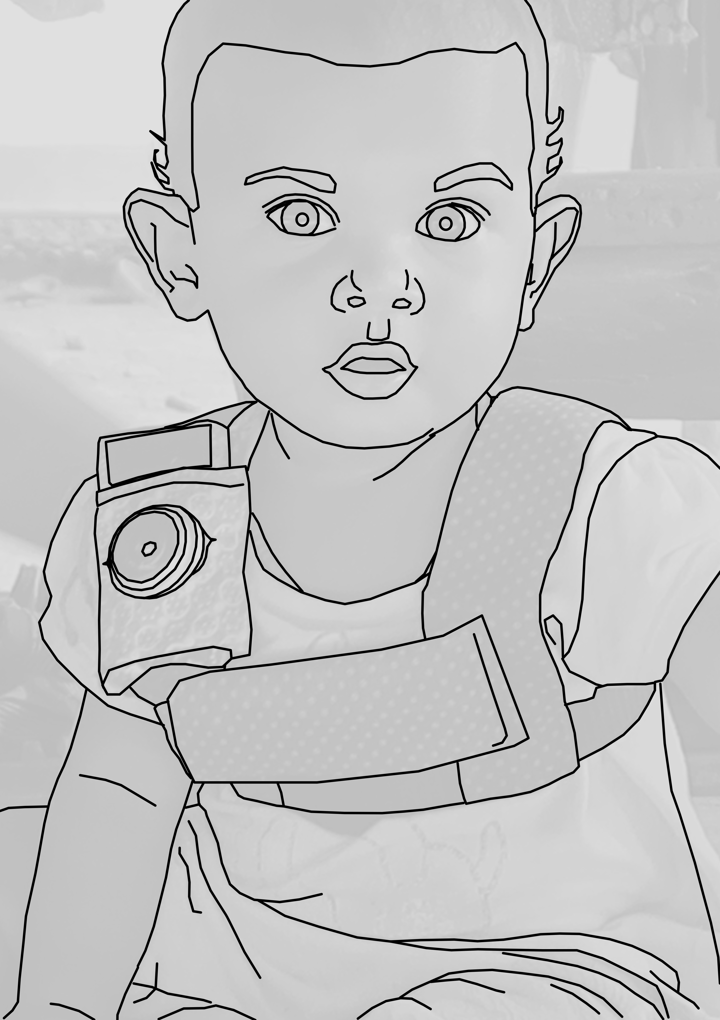

*Figure 1.* The recording vest included an audio recorder in the front horizontal pocket and a camera with a fish-eye lens on the shoulder strap.

We used a novel combination of a lightweight stereo audio recorder (Olympus WS-832) and wearable photo camera (Narrative Clip 1) fitted with a fish-eye lens to track children’s interactions over the course of a 9–11-hour period at home in which the experimenter was not present. Ambulatory children wore both devices at once (Figure 1) while other children wore the recorder in a onesie while their primary caregiver wore the camera on an elastic vest. The camera was set to take photos at 30-second intervals and was synchronized to the audio in post-processing to generate snapshot-linked audio (media post-processing scripts at: https://github.com/marisacasillas/Weave). We used these recordings to capture a wide range of the linguistic patterns children encounter as they participate in different activities over the course of their day (Bergelson, Amatuni, Dailey, Koorathota, & Tor, 2018; Greenwood, Thiemann-Bourque, Walker, Buzhardt, & Gilkerson, 2011; Tamis-LeMonda, Kuchirko, Luo, Escobar, & Bornstein, 2017; Tamis-LeMonda et al., 2018).

## Data selection and annotation

We chose 10 children’s recordings based on maximal spread in child age (0;0–3;0), child sex, and maternal education (Table 1; all had native Tseltal-speaking parents). We selected one hour’s worth of non-overlapping clips from each recording in the following order: nine randomly selected 5-minute clips, five manually selected 1-minute top ‘turn-taking’ clips, five manually selected 1-minute top ‘vocal activity’ clips, and one manually selected 5-minute extension of the best 1-minute clip (Figure 2). We created these different subsamples to measure properties of (a) children’s *average* language environments (“Random”), (b) their most *input-dense* language environments (“Turn-taking”), and (c) their most *mature vocal behavior* (“Vocal activity”).

Table 1

*Demographic overview of the 10 children whose recordings we sampled.*

|  |  |  |  |  |
| --- | --- | --- | --- | --- |
| Age | Sex | Mother’s age | Years of maternal education | People in house |
| 0;01.25 | M | 26 | none | 8 |
| 0;03.18 | M | 22 | preparatory | 9 |
| 0;05.29 | F | 17 | secondary | 15 |
| 0;07.15 | F | 24 | primary | 9 |
| 0;10.21 | M | 24 | secondary | 5 |
| 1;02.10 | M | 21 | none | 9 |
| 1;10.03 | F | 31 | preparatory | 9 |
| 2;02.25 | F | 17 | primary | 5 |
| 2;08.05 | F | 28 | secondary | 5 |
| 3;00.02 | M | 28 | primary | 6 |

The turn-taking and high-activity clips were chosen by two trained annotators (the first author and a student assistant) who listened to each recording in its entirety at 1–2x speed while actively taking notes about potentially useful clips. The first author then reviewed the list of candidate clips and chose the best five 1-minute samples for each of the two activity types. Note that, because the manually selected clips did not overlap with the initial “random” clip selection, the “true” peak turn-taking and vocal-activity clips for the day could have possibly occurred during the random clips. High-quality turn-taking activity was defined as closely timed sequences of contingent vocalization between the target child and at least one other person (i.e., frequent vocalization exchanges). High-quality vocal activity clips were defined as periods in which the target child produced the most and most diverse spontaneous (i.e., not imitative) vocalizations (full instructions at https://git.io/fhdUm).

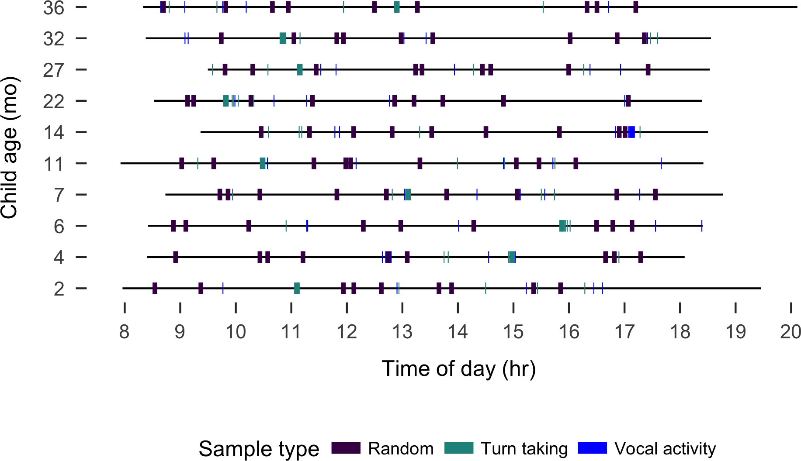

*Figure 2.* Recording duration (black line) and sampled clips (colored boxes) for each of the 10 recordings analyzed, sorted by child age.

The first author and a native speaker of Tseltal who personally knows all the recorded families jointly transcribed and annotated each clip in ELAN (Wittenburg, Brugman, Russel, Klassmann, & Sloetjes, 2006) using the ACLEW Annotation Scheme (full documentation at <https://osf.io/b2jep/wiki/home/>, Casillas et al., 2017). Utterance-level annotations included: an orthographic transcription (Tseltal), a loose translation (Spanish), a vocal maturity rating for each target child utterance (non-linguistic/non-canonical babbling/canonical babbling/single words/multiple words), and the intended addressee type for all non-target-child utterances (target-child/other-child/adult/adult-and-child/animal/other-speaker-type). Intended addressee was determined using contextual and interactional information from the photos, audio, and preceding and following footage; utterances with no clear intended addressee were marked as ‘unsure’. We annotated lexical utterances as single- or multi-word based on the word boundaries provided by the single native speaker who reviewed all transcriptions; Tseltal is a mildly polysynthetic language (words typically contain multiple morphemes).

## Data analysis

In what follows we first describe Tseltal children’s speech environments based on the nine randomly selected 5-minute clips from each child, including: the rate of target-child-directed speech (TCDS min/hr) and rate of other-directed speech (ODS min/hr), the rate of target-child-to-other turn transitions (TC–O transitions/min) and other-to-target-child turn transitions (O–TC transitions/min), and the duration of the target child’s interactional sequences. We investigate the effects of child age, time of day, household size, and number of speakers on each of these five measures. We then repeat these analyses, only now looking at the high “turn-taking” clips. We then wrap up with two descriptive analyses: a rough estimate of the amount of time Tseltal children spend in high turn-taking interaction over the course of an entire day and a basic trajectory for early Tseltal vocal development.

## Statistical models

All analyses were conducted in R with generalized linear mixed-effects regressions using the glmmTMB package, and all plots were generated with ggplot2 (M. E. Brooks et al., 2017; R Core Team, 2018; Wickham, 2009). All data and analysis code can be found at https://github.com/marisacasillas/Tseltal-CLE. Notably, all five speech environment measures are naturally restricted to non-negative (0–infinity) values. This implicit boundary restriction at zero causes the distributional variance of our measures to become non-gaussian (i.e., with a long right tail). We handle this issue by using a negative binomial linking function in the regression, which estimates a dispersion parameter (in addition to the mean and variance) that allows the model to more closely fit our non-negative, overdispersed data (M. E. Brooks et al., 2017; Smithson & Merkle, 2013). When, in addition to this, extra cases of zero were evident in the distribution (e.g., TCDS min/hr was zero because the child was by themselves), we also added a zero-inflation model to the regression. A zero-inflation negative binomial regression creates two models: (a) a binary model to evaluate the likelihood of none vs. some presence of the variable (e.g., no vs. some TCDS) and (b) a count model of the variable (e.g., ‘3’ vs. ‘5’ TCDS min/hr), using the negative binomial distribution as the linking function. Alternative, gaussian linear mixed-effects regressions with logged dependent variables are available in the Supplementary Materials, but the results are broadly similar to what we report here.

Our primary predictors were as follows: child age (months), household size (number of people), and number of non-target-child speakers present in that clip, all centered and standardized, plus time of day at the start of the clip (as a factor; “morning” = up until 11:00; “midday” = 11:00–13:00; and “afternoon” = 13:00 onwards). We also added two-way interactions between child age and: (a) number of speakers present, (b) household size, and (c) time of day. We also included a random effect of child. For the zero-inflation models, we included number of speakers present. We only report significant effects in the main text; full model outputs are available in the Supplementary Materials.

# Results

## Target-child-directed speech (TCDS)

The children in our sample were directly spoken to for an average of 3.63 minutes per hour in the random sample (median = 4.08; range = 0.83–6.55; Figure 3). These estimates are similar to those reported for Yucatec Mayan children (Shneidman & Goldin-Meadow, 2012), as illustrated in Figure 4 (see Scaff et al. (in preparation) for more detailed cross-language comparisons). Note that, to make this comparison, we have converted Shneidman’s (2010) utterance/hr estimates to min/hr using the median Tseltal utterance duration for non-target child speakers: (1029 msec), motivated by the fact that Yucatec and Tseltal are related languages spoken in comparable rural indigenous communities. We modeled TCDS min/hr in the random clips with a zero-inflated negative binomial regression.

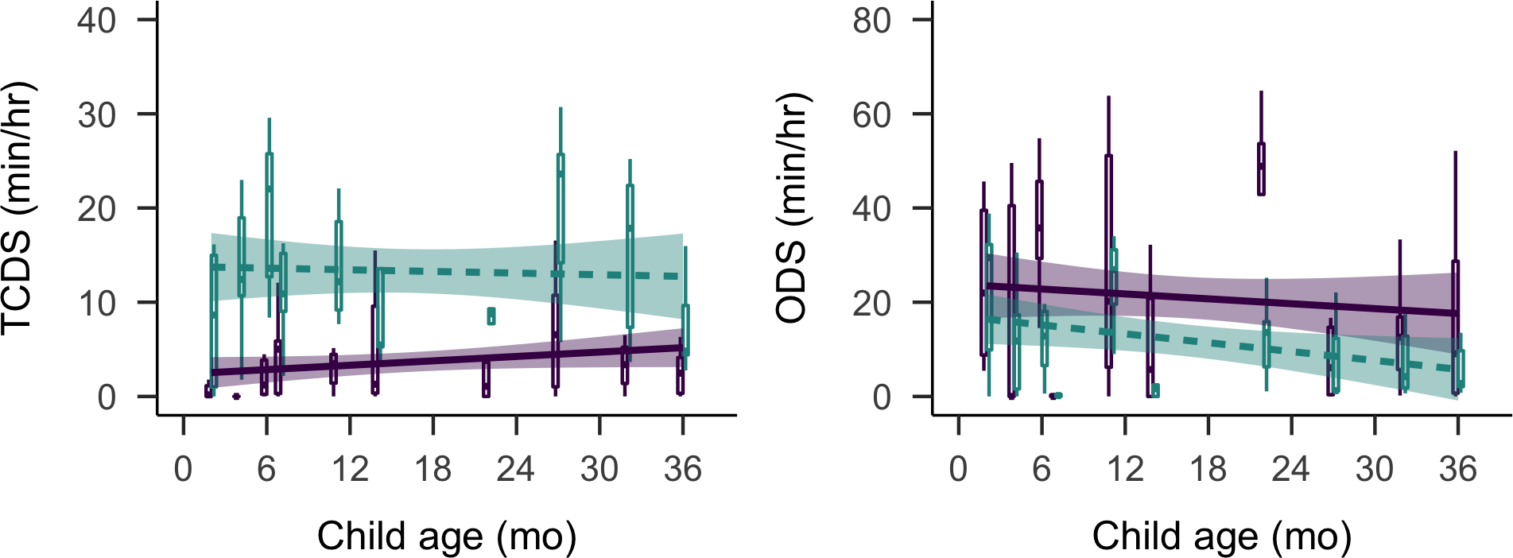

*Figure 3.* By-child estimates of minutes per hour of target-child-directed speech (left) and other-directed speech (right). Data are shown for the random (purple; solid) and turn taking (green; dashed) samples. Bands on the linear trends show 95% confidence intervals.

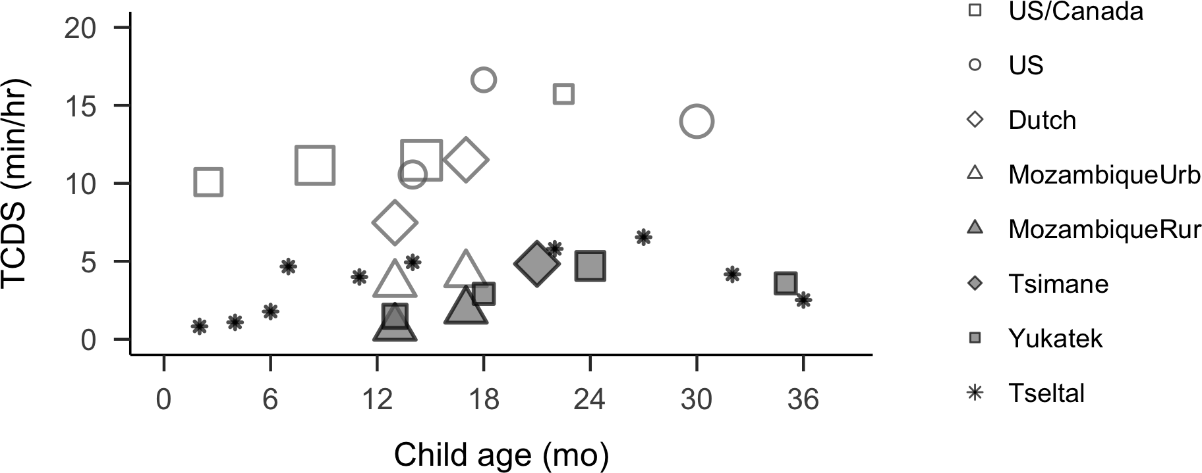

*Figure 4.* Average TCDS rates reported from (short or daylong) at-home recordings across various populations and ages, including urban (empty shape) and rural and/or indigenous (filled shape) samples. Point size indicates the number of children represented (range = 1–26). Data sources: Bergelson et al. (2019) US/Canada daylong recordings; Shneidman (2010) US and Yucatec short recordings; Vogt et al. (2015) Dutch, Mozambique urban and rural short recordings; Scaff et al. (in preparation) Tsimane daylong recordings.

The rate of TCDS in the randomly sampled clips was primarily affected by factors relating to the time of day (Figure 5). The count model showed that the children were more likely to hear TCDS in the mornings than around midday (B = 0.82, SD = 0.40, z = 2.06, p = 0.04), with no difference between morning and afternoon (p = 0.29) or midday and afternoon (p = 0.19). Time-of-day effects varied by age: older children showed a stronger afternoon dip in TCDS. Specifically, they were significantly more likely to hear TCDS at midday (B = 0.73, SD = 0.36, z = 2.04, p = 0.04) and marginally more likely to hear it in the morning (B = 0.46, SD = 0.28, z = 1.65, p = 0.10) compared to the afternoons. Older target children were also significantly more likely to hear TCDS when more speakers were present, compared to younger children (B = 0.61, SD = 0.20, z = 3.06, p < 0.01). There were no other significant effects in either the count or the zero-inflation model.

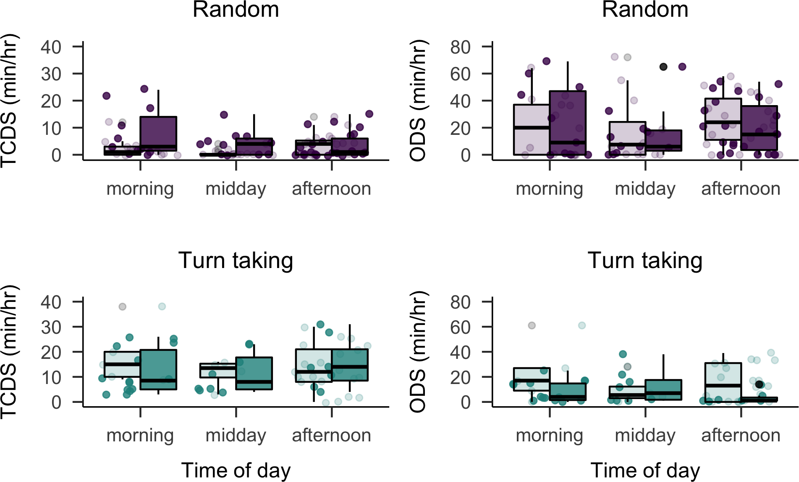

*Figure 5.* TCDS (left) and ODS (right) min/hr rates heard at different times of day in the random (top) and turn-taking (bottom) clip samples by children age 1;0 and younger (light) and 1;0 and older (dark).

In contrast to findings from Shneidman and Goldin-Meadow (2012) on Yucatec Mayan, most TCDS in the current data came from adult speakers (mean = 80.61%, median = 87.22%, range = 45.90%–100%), with no evidence for an increase in proportion of TCDS from children with target child age (Spearman’s *rho* = -0.29; *p* = 0.42).

## Other-directed speech (ODS)

Children heard an average of 21.05 minutes of ODS per hour in the random sample (median = 17.80; range = 3.57–42.80): that is, nearly six times as much speech as was directed to them, on average. We modeled ODS min/hr in the random clips with a zero-inflated negative binomial regression. The count model of ODS in the randomly selected clips revealed that the presence of more speakers was strongly associated with more ODS (B = 0.65, SD = 0.09, z = 7.32, p < 0.001). There were an average of 3.44 speakers present other than the target child in the randomly selected clips (median = 3; range = 0–10), more than half of whom were typically adults. Older target children were also significantly less likely to hear ODS in large households, compared to younger children (B = 0.32, SD = 0.13, z = 2.41, p = 0.02).

Like TCDS, ODS was also strongly affected by time of day (Figure 5), showing a dip around midday. Compared to midday, target children were overall significantly more likely to hear ODS in the mornings (B = 0.36, SD = 0.17, z = 2.09, p = 0.04) and marginally more likely to hear it in the afternoons (B = 0.29, SD = 0.16, z = 1.89, p = 0.06), with no significant difference between ODS rates in the mornings and afternoons (p = 0.63). As before, ODS rate varied across the day by target child age: older children were significantly more likely to hear ODS in the afternoon than at midday (B = 0.38, SD = 0.17, z = 2.21, p = 0.03), with no significant differences between afternoon and morning (p = 0.10) or midday and morning (p = 0.63). There were no other significant effects on ODS rate, and no significant effects in the zero-inflation models.

## Target-child-to-other turn transitions (TC–O)

Contingent responses by or to the target child are likely to occur at moments in which the child and another speaker are attentionally aligned, and so the rate at which these responses occur is a partial index of children’s experience with joint moments of high-quality linguistic evidence. We measured two types of contingent responses: target-child-to-other and other-to-target-child. We detect these contingent turn transitions based on utterance onset and offset times and the annotations of intended addressee for each non-target-child utterance (the solid and dashed lines connecting vocalizations in Figure 6). If a child’s vocalization is followed by a target-child-directed utterance within -1000 msec to 2000 msec after its end (Casillas, Bobb, & Clark, 2016; Hilbrink, Gattis, & Levinson, 2015), it is counted as a contingent response (i.e., a TC–O transition). We use the same idea to find other-to-target-child transitions (i.e., a target-child-directed utterance followed by a target child vocalization with the same timing restrictions).

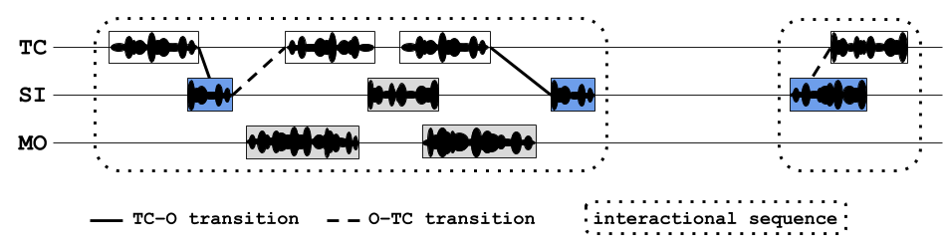

*Figure 6.* Illustration of an annotated audio clip including the target child (TC), an older sister (SI), and their mother (MO). Transitions between the target child and others are marked with solid and dashed lines. Interactional sequences are boxed in with dotted lines. Box color indicates TCDS (blue) and ODS (light gray).

In our analysis, each target child vocalization can have maximally one prompt and one response, and each target-child-directed utterance can maximally count once as a prompt and once as a response (e.g., in a TC–O–TC sequence, the ‘O’ is both a response and a prompt). These timing restrictions are based on prior studies of infant and young children’s spontaneous turn taking (e.g., Bornstein, Putnick, Cote, Haynes, & Suwalsky, 2015; T. Broesch, Rochat, Olah, Broesch, & Henrich, 2016; Casillas et al., 2016; Hilbrink et al., 2015).

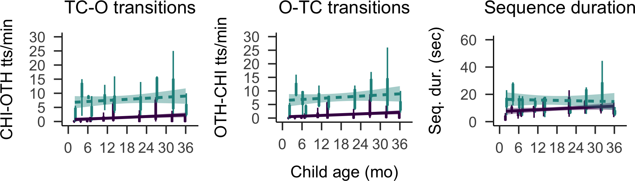

*Figure 7.* By-child estimates of target-child-to-other contingent responses (left), other-to-target-child contingent responses (middle), and the duration of interactional sequences (right). Each boxplot represents the variance across clips within the random (dark purple; solid) or turn taking (light green; dashed) samples for each child. Bands on the linear trends show 95% confidence intervals.

Other speakers responded contingently to the target children’s vocalizations at an average rate of 1.38 turn transitions per minute (median = 0.40; range = 0–8.60; Figure 7). We modeled TC–O transtions per minute in the random clips with a zero-inflated negative binomial regression. The rate of contingent responses to target child vocalizations varied across the day by target child age: older children heard significantly more contingent responses around midday (B = 1.08, SD = 0.44, z = 2.44, p = 0.01) and in the morning (B = 0.94, SD = 0.37, z = 2.51, p = 0.01), compared to the afternoon, with no significant difference between morning and midday (p = 0.77). Older target children also heard significantly more contingent responses then younger ones when there were more speakers present (B = 0.56, SD = 0.23, z = 2.48, p = 0.01). There were no further significant effects in the count or zero-inflation models.

## Other-to-target-child turn transitions (O–TC)

The children in our sample responded contingently to others’ target-child vocalizations at an average rate of 1.17 turn transitions per minute (median = 0.20; range = 0–8.80; Figure 7). We modeled O–TC transtions per minute in the random clips with a zero-inflated negative binomial regression. The rate at which target children responded contingently to others (O–TC turn transitions per minute) was similarly influenced by child age and time of day: older children responded contingently to others’ utterances significantly more often around midday (B = 1.46, SD = 0.46, z = 3.13, p = 0.002) and in the morning (B = 1.33, SD = 0.42, z = 3.19, p = 0.001), compared to the afternoon, with no significant difference between morning and midday (p = 0.81). Overall, older children responded to others’ utterances at a marginally higher rate (B = 1.14, SD = 0.66, z = 1.74, p = 0.08). Older target children also gave significantly more contingent responses then younger ones when there were more speakers present (B = 0.52, SD = 0.22, z = 2.30, p = 0.02). There were no further significant effects in the count or zero-inflation models.

## Sequence duration

We defined sequences of interaction as periods of contingent turn taking with at least one target child vocalization and one target-child-directed prompt or response from another speaker. To detect sequences of interaction, we used the same mechanism as before to detect contingent TC–O and O–TC transitions, but also allowed for speakers to continue speaking with multiple vocalizations in a row (e.g., TC–O–O–TC–OTH; Figure 6). We bounded sequences by the earliest and latest vocalization for which there was no contingent prompt or response, respectively. In our analysis, each target child vocalization could only appear in one sequence (i.e., each sequence had a unique set of vocalizations). We modeled these sequence durations in the random clips with negative binomial regression alone (i.e., with no zero-inflation model). We detected 311 interactional sequences in the 90 randomly selected clips, with an average sequence duration of 10.13 seconds (median = 7; range = 0.56–85.47; Figure 7). The average number of child vocalizations within these sequences was 3.75 (range = 1–29; median = 3). None of the predictors significantly impacted sequence duration (all *p* ≥ 0.21).

## Language experience in the turn-taking clips

As expected, the high-quality turn-taking clips featured a much higher rate of contingent turn transitions: the average TC–O transition rate was 7.73 transitions per minute (~5.5x the random sample rate; median = 7.80; range = 0–25) and the average O–TC rate was 7.56 transitions per minute (~6.5x the random sample rate; median = 6.20; range = 0–26). The interactional sequences were also slightly longer on average: 12.27 seconds (~1.2x the random sample rate; median = 8.10; range = 0.55–61.22). Crucially, children also heard much more TCDS in the turn-taking clips—13.28 min/hr (nearly 4x the random sample rate; median = 13.65; range = 7.32–20.19)—while also hearing less ODS—11.93 min/hr (nearly half the random sample rate; median = 10.18; range = 1.37–24.42).

We analyzed each of these speech environment measures with parallel models to those used for the random sample, though this time we did not include a zero-inflation model for TCDS, TC–O, and O–TC rates because, given the criteria for selecting a turn-taking clip, the child is never alone, and so there are no extra-zero cases. As a whole, children’s speech environments appeared quite different when viewed through the lens of interactional peaks rather than randomly sampled clips (Figures 3, 5, and 7), particularly with respect to time-of-day effects and the number of speakers present, which we focus on here. Full model outputs are available in the Supplementary Materials.

Time-of-day effects were consistently weaker or non-existent in the turn-taking sample. TCDS rates showed no time-of-day effects and no interaction between time-of-day and age, and ODS rates *did* show a dip, but later in the day than what we saw in the random sample (i.e., afternoon, not midday; afternoon-vs.-midday: B = 0.70, SD = 0.29, z = 2.39, p = 0.02, afternoon-vs.-morning: B = 0.72, SD = 0.25, z = 2.91, p < 0.01). Older children were also significantly more likely to hear ODS around midday compared to the morning (midday-vs.-morning: B = -0.56, SD = 0.28, z = -1.99, p = 0.05), but heard significantly less ODS overall than younger children (B = -0.45, SD = 0.21, z = -2.19, p = 0.03). There were no time-of-day effects at all on contingent response rates (TC–O and O–TC) in the turn-taking sample. However, running counter to this overall pattern, sequence duration in the turn-taking sample did show significant time-of-day effects not found in the random sample: sequences were significantly longer in the afternoon compared to morning and midday (afternoon-vs.-morning: B = -0.32, SD = 0.15, z = -2.12, p = 0.03; midday-vs.-afternoon: B = 0.38, SD = 0.15, z = 2.61, p = 0.01).

Effects relating to the number of speakers present were also somewhat weaker in the turn-taking sample, though inconsistently. In the turn taking sample, none of TCDS min/hr, TC–O transitions/min, or O–TC transitions/min were significantly impacted by the number of speakers present. On the other hand, the number of speakers present was associated with significantly more ODS in both the random and turn-taking samples (random sample: B = 0.71, SD = 0.11, z = 6.63, p < 0.001), suggesting that the number of speakers is a robust predictor of ODS quantity across different contexts.

**Peak minutes in the day**

Having now established the interactional timing characteristics of the “high” turn-taking clips, we looked for similarly temporally contingent 1-minute sections of interaction in the random samples in order to estimate the number of high interactivity minutes in the whole day. To do this, we scanned each 60-second window (e.g., 0–60 sec, 1–61 sec, etc.) of each random clip and recorded the observed turn-transition rate. We then compared the resulting 1-minute transition rates to those typical for the high turn-taking sample.

In total, 6 of the 10 children showed at least one minute of their random sample that equaled or exceeded the combined average contingent transition rate (12.89 transitions/min), and 7 of the 10 children showed at least one minute equaling or exceeding their *own* combined average turn transition rate from their turn-taking sample. Across the 6 children who did show turn-taking “peaks” in their random data, peak periods were relatively long, at an average of 88.95 seconds (median = 90.67 seconds; range = 71–103 seconds). Overall, children spent an average of 8.35 minutes per hour (median = 3.68; range = 0–34.98) in these peak interactions during the 45 scanned minutes. Assuming approximately 14 waking hours (Hart & Risley, 1995), we therefore very roughly estimate that the average Tseltal child under 3;0 spends an average of 116.85 minutes (1.95 hours) in high turn-taking, dyadic interaction during their day. Crucially, however, the range in the quantity of high turn-taking interaction varies enormously across children, starting at just a few minutes per day and topping out at more than 489.69 minutes (8.16 hours) in our 10-child sample. Much more data, particularly from other Tseltal children in this age range, is required to get stable estimates for the typical quantity and variance in peak interactional minutes experienced in a waking day.

## Vocal maturity

Tseltal children’s vocalizations appear to follow the normative benchmarks for productive speech development, as they are characterized by the onset of new production features. Decades of research in industrialized, typically Western populations has shown that, typically, children begin producing non-canonical babbling around 0;2, with canonical babbling appearing sometime around 0;7, first words around 1;0, and first multi-word utterances appearing just after 1;6 (Frank et al., in preparation; Kuhl, 2004; Pine & Lieven, 1993; Slobin, 1970; Tomasello & Brooks, 1999; Warlaumont, Richards, Gilkerson, & Oller, 2014). These benchmarks are mirrored in the Tseltal children’s vocalizations, which are summarized in Figure 9 based on all annotated vocalizations from the random, turn-taking, and high vocal activity samples (N = 4725 vocalizations). There is a decline in the use of non-canonical babble and an accompanying increase in the use of canonical babble between 0;6 and 1;0. Recognizable words are observed for every child from age 11;0 and older. Multi-word utterances appear in all recordings at 1;2 and later, making up 45% of the oldest child’s (3;0) vocalizations.

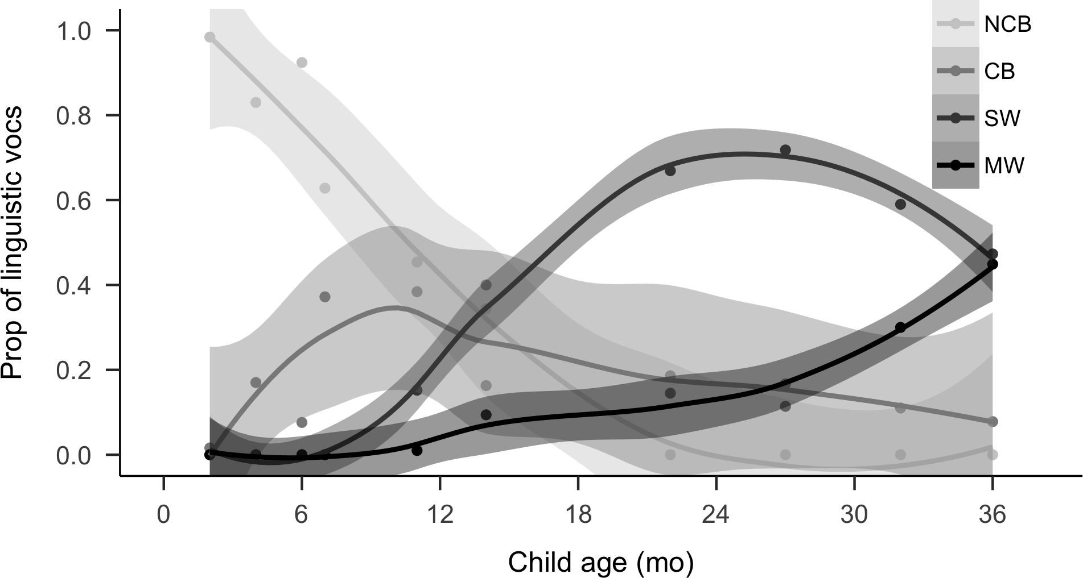

*Figure 8.* Proportion of vocalization types used by children across age (NCB = Non-canonical babble, CB = Canonical babble, SW = single word utterance, MW = multi-word utterance).

These data are consistent with usage statistics of speech-like vocalizations by English-acquiring infants (Warlaumont et al., 2014). Between 2 and 14 months, these Tseltal children demonstrated a large increase in the proportion of speech-like vocalizations (canonical babbling and lexical speech): from 9% before 0;6 to 58% between 0;10 and 1;2. Around age 1;0, their use of speech-like vocalizations (58%) is nearly identical to that reported by Warlaumont et al. (2014) for American children around age 1;0 in an SES-variable sample (approximately 60%).

# Discussion

We analyzed 10 Tseltal Mayan children’s speech environments in order to estimate how often they have the opportunity to attend and respond to speech. Based on prior work, we predicted infrequent, but bursty use of TCDS, an increase in TCDS with age, that a large proportion of TCDS would come from other children, and that vocal development would be on par with typically developing Western children. Only some of these predictions were borne out in the analyses. We did find evidence for infrequent use of TCDS and for a typical-looking trajectory of vocal development, but we also found that most directed speech came from adults, and that the quantity of directed speech was stable across the first three years of life. Within individual recordings, TCDS and contingent responding were influenced by the time of day and number of speakers present. That said, time of day and number of speakers less strongly impacted TCDS during high turn-taking clips, suggesting that interactional peaks are one source of stable, high-engagement linguistic experience available to Tseltal children in the first few years of life. These findings only partly replicate estimates of child language input and development in previous work on Yucatec Mayan and Tseltal Mayan communities (Yucatec: Shneidman & Goldin-Meadow 2012; Tseltal: Brown, 1998, 2011, 2014), and bring new questions to light regarding the distribution of child-directed speech over activities and interactant types in Mayan children’s speech environments.

## Robust learning with less child-directed speech

The bulk of our analyses were aimed at understanding how much speech Tseltal children hear: we wanted to know how often they were directly spoken to and how often they might have been able to listen to speech directed to others. Consistent with prior work, the children were only infrequently directly spoken to: an average of 3.63 minutes per hour in the random sample. This average TCDS rate for Tseltal is approximately a third of that found for North American children (Bergelson et al., 2019), but is comparable to that for Tsimane children (Scaff et al., in preparation) and Yucatec Mayan children (Shneidman & Goldin-Meadow, 2012) in a similar age range. Meanwhile, we found that the children had an enormous quantity of other-directed speech in their environment, averaging 21.05 minutes per hour in the random sample, which is more than has been previously reported for other cultural settings (e.g., Bergelson et al., 2019; Scaff et al., in preparation).

We also created two novel interactive measures to describe how often children were directly engaged with an interlocutor, either as a responder or as an addressee being responded to. Children’s vocalizations were responded to at a rate of 1.38 transitions per minute and children responded to others’ child-directed vocalizations at a rate of 1.17 transitions per minute. This rate is consistent with prior estimates for the frequency of child-initiated and other-initiated prompts in Tseltal interaction (Brown, 2011). Contingent interaction—and the joint attention that likely accompanies it—is a fertile context for language learning because the participants’ coordinated attentional states decrease referential uncertainty, increase the chances of dynamic feedback, and can spur further interactions (Bornstein et al., 2015; T. Broesch et al., 2016; Warlaumont et al., 2014). Because our measure is a novel one, we cannot directly compare Tseltal children’s data with those of children growing up in other communities. That said, contingent responses are rare across the day—more rare than TCDS in general. The rarity of contingent responses may be due to the fact that the children did not vocalize very often: preliminary analyses showed that they only produced an average of 7.88 vocalizations per minute (median = 7.55; range = 4.08–12.55) during their full one hour of annotated audio (including the high vocal activity minutes), much of which was crying and laughter. Interestingly, children tended to only vocalize 3.75 times per sequence (mean duration = 10.13 seconds), with silence, TCDS, and ODS taking up the rest of the interactional time. In other words, interactional peaks—sometimes containing the bulk of children’s directed speech for the day—were marked by longer streams of speech from an interlocutor, interspersed with occasional responses from the child.

In sum, our daylong recording results confirm prior claims that Tseltal children, like other Mayan children, are not often directly spoken to. When they are, much of their speech comes in interactional sequences in which children only play a minor part—directly contingent turn transitions between children and their interlocutors are relatively rare. However, we coarsely estimate that the typical child under age 3;0 experiences nearly two cumulative hours of high-intensity contingent interaction with TCDS per day. If child-directed speech quantity linearly feeds language development (such that more input begets more (advanced) output), then the estimates presented here would lead us to expect Tseltal to be delayed in their language development. However, our analyses suggest that Tseltal children demonstrate vocal maturity comparable to children from societies in which TCDS is known to be more frequent (Frank et al., in preparation; Kuhl, 2004; Pine & Lieven, 1993; Slobin, 1970; Tomasello & Brooks, 1999; Warlaumont et al., 2014). How might Tseltal children manage this feat?

**Other-directed speech**

One proposal is that Mayan children become experts at learning from observation during their daily interactions (de León, 2011; Rogoff et al., 2003; Shneidman, 2010; Shneidman & Goldin-Meadow, 2012). In the randomly selected clips, children were within hearing distance of other-directed speech for an average of 21.05 minutes per hour. This large quantity of ODS is likely due to the fact that Tseltal children tend to live in households with more people compared to North American children (Shneidman & Goldin-Meadow, 2012). In our data, the presence of more speakers was associated with significantly more other-directed speech, both based on the number of individual voices present in the clip and on the number of people living in the household (for younger children). The presence of more speakers had no overall impact on the quantity of TCDS children experienced, but older children were more likely than younger children to hear TCDS when more speakers were present. These findings ring true with Brown’s (2011, 2014) claim that this Tseltal community is a non-child-centric; the presence of more people primarily increases talk amongst the other speakers (i.e., not to young children). But, as children become more sophisticated language users, they are more likely to participate in others’ talk. However, given that an increase in the number of speakers is also likely associated with an increase in the amount of overlapping speech, we suggest that attention to ODS is unlikely to be the primary mechanism underlying the robustness of early vocal development in Tseltal. However, just because speech is hearable does not mean the children are attending to it. Follow-up work on the role of ODS in language development must better define what constitutes likely “listened to” speech by the child.

**Increased TCDS with age**

Another possibility is that speakers more frequently address children who are more communicatively competent (i.e., increased TCDS with age, e.g., Warlaumont et al., 2014). In their longitudinal study of Yucatec Mayan children, Shneidman and Goldin-Meadow (2012) found that TCDS increased significantly with age, though most of the increase came from other children speaking to the target child. Their finding is consistent with other reports that Mayan children are more often cared for by their older siblings from later infancy onward (2011, 2014). In our data, there was no evidence for an overall increase in TCDS with age, neither from adult speakers nor from child speakers. This non-increase in TCDS with age may be due to the fact TCDS from other children was overall infrequent in our data, possibly because: (a) the children were relatively young and so spent much of their time with their mothers, (b) these particular children did not have many older siblings, and (c) in the daylong recording context more adults were present to talk to each other than would be typical in a short-format recording (as used in Shneidman & Goldin-Meadow, 2012). That aside, we conclude from these findings, that an increase in TCDS with age is also unlikely to explain the robust pattern of Tseltal vocal development.

**Learning during interactional bursts**

A third possibility is that children learn effectively from short, routine language encounters. Bursty input appears to be the norm across a number of linguistic and interactive scales (e.g., Abney et al., 2017; Blasi et al., in preparation), and experiment-based work suggests that children can benefit from massed presentation of new information (Schwab & Lew-Williams, 2016). We propose two mechanisms through which Tseltal children might capitalize on the distribution of speech input in their environment: (a) they experience most language input during routine activities and (b) they consolidate their language experiences during the downtime between interactive peaks. Neither of these mechanisms are proposed to be particular to Tseltal children, but might be employed to explain their efficient learning.

Tseltal children’s linguistic input is not uniformly distributed over the day: children were most likely to encounter speech, particularly directed, contingent speech in the mornings and late afternoons, compared to midday. Older children, who are less often carried and were therefore more free to seek out interactions, showed these time of day effects most strongly, eliciting TCDS both in the mornings (when the entire household is present) and around midday (when many have dispersed for farming or other work). An afternoon dip in environmental speech, similar to what we report here, has been previously found for North American children’s daylong recordings (Greenwood et al., 2011; Soderstrom & Wittebolle, 2013). The presence of a similar effect in Tseltal suggests that non-uniform distributions of linguistic input may be the norm for children in a variety of different cultural-economic contexts. Our findings here are the first to show that those time of day effects change with age in the first few years across a number of speech environment features (TCDS, TC–O transitions, O–TC transitions, and (marginally) ODS). These time of day effects likely arise from the activities that typically occur in the mornings and late afternoons—meal preparation and dining in particular—while short bouts of sleep could contribute to the afternoon dip (Soderstrom & Wittebolle, 2013). That said, in data from North American children (Soderstrom & Wittebolle, 2013), the highest density speech input came during storytime and organized playtime (e.g., sing-alongs, painting), while mealtime was associated with less speech input. We expect that follow-up research tracking TCDS during activities in the Tseltal data will lead to very different conclusions: storytime and organized playtime are vanishingly rare in this non-child-centric community, and mealtime may represent a time of routine and rich linguistic experience. In both cases, however, the underlying association with activity (not hour) implies a role for action routines that help children optimally extract information about what words, agents, objects, and actions they will encounter and what they are expected to do in response (see, e.g., Bruner, 1983; Tamis-LeMonda et al., 2018).

A more speculative possibility is that Tseltal children learn language on a natural input-consolidation cycle: the rarity of interactional peaks throughout the day may be complemented by an opportunity to consolidate new information. Sleep has been shown to benefit language learning tasks in both adults (Frost & Monaghan, 2017; Mirković & Gaskell, 2016) and children (Gómez, Bootzin, & Nadel, 2006; Horváth, Liu, & Plunkett, 2016; Hupbach, Gómez, Bootzin, & Nadel, 2009), including word learning, phonotactic constraints, and syntactic structure. Our impression, both from the recordings and informal observations made during visits to the community, is that young Tseltal children frequently sleep for short periods throughout the day, particularly at younger ages when they spend much of their day wrapped within the shawl on their mother’s back. Mayan children tend to pick their own resting times; there are no formalized “sleep” times, even at bedtime (Morelli, Rogoff, Oppenheim, & Goldsmith, 1992), and Mayan mothers take special care to keep infants in a calm and soothing environment in the first few months of life (e.g., de León, 2011; Pye, 1986). There is little quantitative data on Mayan children’s daytime and nighttime sleeping patterns, but one study estimates that Yucatec Mayan children between 0;0 and 2;0 sleep or rest nearly 15% of the time between morning and evening (Gaskins, 2000), doing so at times that suited the child (Morelli et al., 1992). If Tseltal children’s interactional peaks are bookended by short sleeping periods, it could contribute to efficient consolidation of new information encountered. How often Tseltal children sleep, how deeply, and how their sleeping patterns may relate to their linguistic development is an important topic for future research.

## Limitations and Future Work

The current findings are based on a cross-sectional analysis of 600 annotated recording minutes, divided among only ten children. The data are limited mainly to verbal activity; we cannot analyze gaze and gestural behavior. We have also used overall vocal maturity as an index of language development, but further work should include receptive and productive measures of linguistic skill with both experiment- and questionnaire- based measures, as well as more in-depth analyses of children’s spontaneous speech, building on past work (Brown, 1998, 2011, 2014; Brown & Gaskins, 2014). In short, more and more diverse data are needed to enrich this initial description of Tseltal children’s language environments. Importantly, the current analyses are based on a corpus that is still under active development: as new data are added, up-to-date versions of these analyses will be available with the current data and analysis scripts at: https://middycasillas.shinyapps.io/Tseltal_Child_Language_Environment/.

## Conclusion

We estimate that, over the course of a waking day, Tseltal children under age 3;0 hear an average of 3.6 minutes of directed speech per hour, typically embedded in peak interactions that take up approximately 8.35 minutes per hour. Contingent turn taking tends to occur in sparsely distributed bursts often with a dip in the mid- to late-afternoon, particularly for older children. Tseltal children’s vocal maturity is on track with prior estimates from populations in which child-directed speech is much more frequent, raising a challenge for future work: how do Tseltal children efficiently extract information from their linguistic environments? In our view, a promising avenue for continued research is to more closely investigate how directed speech is distributed over activities over the course of the day and to explore a possible input-consolidation cycle for language exposure in early development. By better understanding how Tseltal children learn language, we hope to help uncover how human language learning mechanisms are adaptive to the many thousands of ethnolinguistic environments in which children develop.

# Acknowledgements

# We thank and ackowledge Rebeca Guzmán López, Humbertina Gómez Pérez, Juan Méndez Girón, and Antun Gusman Osil, who made the collection and annotation of these recordings possible. We are also enormously grateful to the participating families and to the community at large for their support. Thanks also go to Maartje Weenink and Daphne Jansen for their help with manual clip selection and vocal maturity annotation. This work is supported by a NWO Veni Innovational Scheme grant (275-89-033) to MC and by an ERC Advanced Grant (269484 INTERACT) to SCL. This paper was written using the papaja library in RStudio.

# References

Abney, D. H., Smith, L. B., & Yu, C. (2017). It’s time: Quantifying the relevant time scales for joint attention. In G. Gunzelmann, A. Howes, T. Tenbrink, & E. Davelaar (Eds.), *Proceedings of the 39th Annual Meeting of the Cognitive Science Society* (pp. 1489–1494). London, UK.

Bergelson, E., Amatuni, A., Dailey, S., Koorathota, S., & Tor, S. (2018). Day by day, hour by hour: Naturalistic language input to infants. *Developmental Science*, *22*(1), e12715. doi:[10.1111/desc.12715](https://doi.org/10.1111/desc.12715)

Bergelson, E., Casillas, M., Soderstrom, M., Seidl, A., Warlaumont, A. S., & Amatuni, A. (2019). What do North American babies hear? A large-scale cross-corpus analysis. *Developmental Science*, *22*(1), e12724. doi:[10.1111/desc.12724](https://doi.org/10.1111/desc.12724)

Blasi, D., Schikowski, R., Moran, S., Pfeiler, B., & Stoll, S. (in preparation). Human communication is structured efficiently for first language learners: Lexical spikes.

Bornstein, M. H., Putnick, D. L., Cote, L. R., Haynes, O. M., & Suwalsky, J. T. D. (2015). Mother-infant contingent vocalizations in 11 countries. *Psychological Science*, *26*(8), 1272–1284.

Brinchmann, E. I., Braeken, J., & Lyster, S.-A. H. (2019). Is there a direct relation between the development of vocabulary and grammar? *Developmental Science*, *22*(1), e12709. doi:[10.1111/desc.12709](https://doi.org/10.1111/desc.12709)

Broesch, T., Rochat, P., Olah, K., Broesch, J., & Henrich, J. (2016). Similarities and differences in maternal responsiveness in three societies: Evidence from Fiji, Kenya, and the United States. *Child Development*, *87*(3), 700–711. doi:[10.1111/cdev.12501](https://doi.org/10.1111/cdev.12501)

Brooks, M. E., Kristensen, K., van Benthem, K. J., Magnusson, A., Berg, C. W., Nielsen, A., … Bolker, B. M. (2017). Modeling zero-inflated count data with glmmTMB. *bioRxiv*. doi:[10.1101/132753](https://doi.org/10.1101/132753)

Brown, P. (1998). Conversational structure and language acquisition: The role of repetition in Tzeltal adult and child speech. *Journal of Linguistic Anthropology*, *2*, 197–221. doi:[10.1525/jlin.1998.8.2.197](https://doi.org/10.1525/jlin.1998.8.2.197)

Brown, P. (2011). The cultural organization of attention. In A. Duranti, E. Ochs, & and B. B. Schieffelin (Eds.), *Handbook of Language Socialization* (pp. 29–55). Malden, MA: Wiley-Blackwell.

Brown, P. (2014). The interactional context of language learning in Tzeltal. In I. Arnon, M. Casillas, C. Kurumada, & B. Estigarribia (Eds.), *Language in interaction: Studies in honor of Eve V. Clark* (pp. 51–82). Amsterdam, NL: John Benjamins.

Brown, P., & Gaskins, S. (2014). Language acquisition and language socialization. In N. J. Enfield, P. Kockelman, & J. Sidnell (Eds.), *Handbook of Linguistic Anthropology* (pp. 187–226). Cambridge, UK: Cambridge University Press. doi:[10.1017/CBO9781139342872.010](https://doi.org/10.1017/CBO9781139342872.010)

Bruner, J. (1983). *Child’s talk*. Oxford: Oxford University Press. doi:[10.1177/026565908500100113](https://doi.org/10.1177/026565908500100113)

Cartmill, E. A., Armstrong, B. F., Gleitman, L. R., Goldin-Meadow, S., Medina, T. N., & Trueswell, J. C. (2013). Quality of early parent input predicts child vocabulary 3 years later. *Proceedings of the National Academy of Sciences*, *110*(28), 11278–11283. doi:[10.1073/pnas.1309518110](https://doi.org/10.1073/pnas.1309518110)

Casillas, M., Bobb, S. C., & Clark, E. V. (2016). Turn taking, timing, and planning in early language acquisition. *Journal of Child Language*, *43*, 1310–1337. doi:[10.1017/S0305000915000689](https://doi.org/10.1017/S0305000915000689)

Casillas, M., Bunce, J., Soderstrom, M., Rosemberg, C., Migdalek, M., Alam, F., … Garrison, H. (2017). Introduction: The ACLEW DAS template [training materials]. Retrieved from <https://osf.io/aknjv/>

Cristia, A., Dupoux, E., Gurven, M., & Stieglitz, J. (2017). Child-directed speech is infrequent in a forager-farmer population: A time allocation study. *Child Development*, *Early View*, 1–15. doi:[10.1111/cdev.12974](https://doi.org/10.1111/cdev.12974)

de León, L. (2011). Language socialization and multiparty participation frameworks. In A. Duranti, E. Ochs, & and B. B. Schieffelin (Eds.), *Handbook of Language Socialization* (pp. 81–111). Malden, MA: Wiley-Blackwell. doi:[10.1002/9781444342901.ch4](https://doi.org/10.1002/9781444342901.ch4)

Frank, M. C., Braginsky, M., Marchman, V. A., & Yurovsky, D. (in preparation). *Variability and consistency in early language learning: The Wordbank project*. Retrieved from <https://langcog.github.io/wordbank-book/>

Frost, R. L. A., & Monaghan, P. (2017). Sleep-driven computations in speech processing. *PloS One*, *12*(1), e0169538. doi:[10.1371/journal.pone.0169538](https://doi.org/10.1371/journal.pone.0169538)

Gaskins, S. (2000). Children’s daily activities in a Mayan village: A culturally grounded description. *Cross-Cultural Research*, *34*(4), 375–389. doi:[10.1177/106939710003400405](https://doi.org/10.1177/106939710003400405)

Gaskins, S. (2006). Cultural perspectives on infant–caregiver interaction. In N. J. Enfield & S. Levinson (Eds.), *Roots of Human Sociality: Culture, Cognition and Interaction* (pp. 279–298). Oxford: Berg.

Gómez, R. L., Bootzin, R. R., & Nadel, L. (2006). Naps promote abstraction in language-learning infants. *Psychological Science*, *17*(8), 670–674. doi:[10.1111/j.1467-9280.2006.01764.x](https://doi.org/10.1111/j.1467-9280.2006.01764.x)

Greenwood, C. R., Thiemann-Bourque, K., Walker, D., Buzhardt, J., & Gilkerson, J. (2011). Assessing children’s home language environments using automatic speech recognition technology. *Communication Disorders Quarterly*, *32*(2), 83–92. doi:[10.1177/1525740110367826](https://doi.org/10.1177/1525740110367826)

Hart, B., & Risley, T. R. (1995). *Meaningful Differences in the Everyday Experience of Young American Children*. Paul H. Brookes Publishing.

Henrich, J., Heine, S. J., & Norenzayan, A. (2010). Beyond WEIRD: Towards a broad-based behavioral science. *Behavioral and Brain Sciences*, *33*(2–3), 111–135. doi:[10.1017/S0140525X10000725](https://doi.org/10.1017/S0140525X10000725)

Hilbrink, E., Gattis, M., & Levinson, S. C. (2015). Early developmental changes in the timing of turn-taking: A longitudinal study of mother–infant interaction. *Frontiers in Psychology*, *6:1492*, 1–12. doi:[10.3389/fpsyg.2015.01492](https://doi.org/10.3389/fpsyg.2015.01492)

Hoff, E. (2003). The specificity of environmental influence: Socioeconomic status affects early vocabulary development via maternal speech. *Child Development*, *74*(5), 1368–1378. doi:[10.3389/fpsyg.2015.01492](https://doi.org/10.3389/fpsyg.2015.01492)

Horváth, K., Liu, S., & Plunkett, K. (2016). A daytime nap facilitates generalization of word meanings in young toddlers. *Sleep*, *39*(1), 203–207. doi:[10.5665/sleep.5348](https://doi.org/10.5665/sleep.5348)

Hupbach, A., Gómez, R. L., Bootzin, R. R., & Nadel, L. (2009). Nap-dependent learning in infants. *Developmental Science*, *12*(6), 1007–1012. doi:[10.1111/j.1467-7687.2009.00837.x](https://doi.org/10.1111/j.1467-7687.2009.00837.x)

Huttenlocher, J., Waterfall, H., Vasilyeva, M., Vevea, J., & Hedges, L. V. (2010). Sources of variability in children’s language growth. *Cognitive Psychology*, *61*(4), 343–365. doi:[10.1016/j.cogpsych.2010.08.002](https://doi.org/10.1016/j.cogpsych.2010.08.002)

Kuhl, P. K. (2004). Early language acquisition: Cracking the speech code. *Nature Reviews Neuroscience*, *5*(11), 831. doi:[10.1038/nrn1533](https://doi.org/10.1038/nrn1533)

Lieven, E. V. M., Pine, J. M., & Baldwin, G. (1997). Lexically-based learning and early grammatical development. *Journal of Child Language*, *24*(1), 187–219. doi:[10.1017/S0305000996002930](https://doi.org/10.1017/S0305000996002930)

Liszkowski, U., Brown, P., Callaghan, T., Takada, A., & de Vos, C. (2012). A prelinguistic gestural universal of human communication. *Cognitive Science*, *36*(4), 698–713. doi:[10.1111/j.1551-6709.2011.01228.x](https://doi.org/10.1111/j.1551-6709.2011.01228.x)

ManyBabies Collaborative. (2017). Quantifying sources of variability in infancy research using the infant-directed speech preference. *Advances in Methods and Practices in Psychological Science*, 1–46. doi:[10.31234/osf.io/s98ab](https://doi.org/10.31234/osf.io/s98ab)

Marchman, V. A., Martínez-Sussmann, C., & Dale, P. S. (2004). The language-specific nature of grammatical development: Evidence from bilingual language learners. *Developmental Science*, *7*(2), 212–224. doi:[10.1111/j.1467-7687.2004.00340.x](https://doi.org/10.1111/j.1467-7687.2004.00340.x)

Mirković, J., & Gaskell, M. G. (2016). Does sleep improve your grammar? Preferential consolidation of arbitrary components of new linguistic knowledge. *PloS One*, *11*(4), e0152489. doi:[10.1371/journal.pone.0152489](https://doi.org/10.1371/journal.pone.0152489)

Morelli, G. A., Rogoff, B., Oppenheim, D., & Goldsmith, D. (1992). Cultural variation in infants’ sleeping arrangements: Questions of independence. *Developmental Psychology*, *28*(4), 604. doi:[10.1037/0012-1649.28.4.604](https://doi.org/10.1037/0012-1649.28.4.604)

Nielsen, M., Haun, D., Kärtner, J., & Legare, C. H. (2017). The persistent sampling bias in developmental psychology: A call to action. *Journal of Experimental Child Psychology*, *162*, 31–38. doi:[10.1016/j.jecp.2017.04.017](https://doi.org/10.1016/j.jecp.2017.04.017)

Ochs, E., & Schieffelin, B. (1984). Language acquisition and socialization: Three developmental stories and their implications. In R. A. Schweder & R. A. LeVine (Eds.), *Culture theory: Essays on mind, self, and emotion* (pp. 276–322). Cambridge University Press.

Pine, J. M., & Lieven, E. V. M. (1993). Reanalysing rote-learned phrases: Individual differences in the transition to multi-word speech. *Journal of Child Language*, *20*(3), 551–571. doi:[10.1017/S0305000900008473](https://doi.org/10.1017/S0305000900008473)

Pye, C. (1986). Quiché Mayan speech to children. *Journal of Child Language*, *13*(1), 85–100. doi:[10.1017/S0305000900000313](https://doi.org/10.1017/S0305000900000313)

Pye, C. (2017). *The Comparative Method of Language Acquisition Research*. University of Chicago Press.

R Core Team. (2018). *R: A language and environment for statistical computing*. Vienna, Austria: R Foundation for Statistical Computing. Retrieved from <https://www.R-project.org/>

Rogoff, B., Paradise, R., Arauz, R. M., Correa-Chávez, M., & Angelillo, C. (2003). Firsthand learning through intent participation. *Annual Review of Psychology*, *54*(1), 175–203. doi:[10.1146/annurev.psych.54.101601.145118](https://doi.org/10.1146/annurev.psych.54.101601.145118)

Rowe, M. L. (2008). Child-directed speech: Relation to socioeconomic status, knowledge of child development and child vocabulary skill. *Journal of Child Language*, *35*(1), 185–205. doi:[10.1017/S0305000907008343](https://doi.org/10.1017/S0305000907008343)

Scaff, C., Stieglitz, J., Casillas, M., & Cristia, A. (in preparation). Language input in a hunter-forager population: Estimations from daylong recordings.

Schwab, J. F., & Lew-Williams, C. (2016). Repetition across successive sentences facilitates young children’s word learning. *Developmental Psychology*, *52*(6), 879–886. doi:[10.1037/dev0000125](https://doi.org/10.1037/dev0000125)

Shneidman, L. A. (2010). *Language Input and Acquisition in a Mayan Village* (PhD thesis). The University of Chicago.

Shneidman, L. A., & Goldin-Meadow, S. (2012). Language input and acquisition in a Mayan village: How important is directed speech? *Developmental Science*, *15*(5), 659–673. doi:[10.1111/j.1467-7687.2012.01168.x](https://doi.org/10.1111/j.1467-7687.2012.01168.x)

Slobin, D. I. (1970). Universals of grammatical development in children. In G. B. Flores d’Arcais & W. J. M. Levelt (Eds.), *Advances in Psycholinguistics* (pp. 174–186). Amsterdam, NL: North Holland Publishing.

Smithson, M., & Merkle, E. (2013). *Generalized linear models for categorical and continuous limited dependent variables*. New York: Chapman; Hall/CRC. doi:[10.1201/b15694](https://doi.org/10.1201/b15694)

Soderstrom, M. (2007). Beyond babytalk: Re-evaluating the nature and content of speech input to preverbal infants. *Developmental Review*, *27*(4), 501–532. doi:[10.1016/j.dr.2007.06.002](https://doi.org/10.1016/j.dr.2007.06.002)

Soderstrom, M., & Wittebolle, K. (2013). When do caregivers talk? The influences of activity and time of day on caregiver speech and child vocalizations in two childcare environments. *PloS One*, *8*, e80646. doi:[10.1371/journal.pone.0080646](https://doi.org/10.1371/journal.pone.0080646)

Tamis-LeMonda, C. S., Kuchirko, Y., Luo, R., Escobar, K., & Bornstein, M. H. (2017). Power in methods: Language to infants in structured and naturalistic contexts. *Developmental Science*, *20*(6), e12456. doi:[10.1111/desc.12456](https://doi.org/10.1111/desc.12456)

Tamis-LeMonda, C. S., Custode, S., Kuchirko, Y., Escobar, K., & Lo, T. (2018). Routine language: Speech directed to infants during home activities. *Child Development*, *Early View*, 1–18.

Tomasello, M., & Brooks, P. J. (1999). Early syntactic development: A Construction Grammar approach. In M. Barrett (Ed.), *The Development of Language* (pp. 161–190). New York: Psychology Press.

Vogt, P., Mastin, J. D., & Schots, D. M. A. (2015). Communicative intentions of child-directed speech in three different learning environments: Observations from the Netherlands, and rural and urban Mozambique. *First Language*, *35*(4–5), 341–358. doi:[10.1177/0142723715596647](https://doi.org/10.1177/0142723715596647)

Warlaumont, A. S., Richards, J. A., Gilkerson, J., & Oller, D. K. (2014). A social feedback loop for speech development and its reduction in Autism. *Psychological Science*, *25*(7), 1314–1324. doi:[10.1177/0956797614531023](https://doi.org/10.1177/0956797614531023)

Weisleder, A., & Fernald, A. (2013). Talking to children matters: Early language experience strengthens processing and builds vocabulary. *Psychological Science*, *24*(11), 2143–2152. doi:[10.1177/0956797613488145](https://doi.org/10.1177/0956797613488145)

Wickham, H. (2009). *Ggplot2: Elegant graphics for data analysis*. Springer-Verlag New York. Retrieved from <http://ggplot2.org>

Wittenburg, P., Brugman, H., Russel, A., Klassmann, A., & Sloetjes, H. (2006). ELAN: A professional framework for multimodality research. In *Proceedings of the Fifth International Conference on Language Resources and Evaluation* (pp. 1556–1559).

Yurovsky, D. (2018). A communicative approach to early word learning. *New Ideas in Psychology*, *50*, 73–79. doi:[10.1016/j.newideapsych.2017.09.001](https://doi.org/10.1016/j.newideapsych.2017.09.001)