Supplementary Materials: Early language experience in a Tseltal Mayan village

Marisa Casillas1, Penelope Brown1, & Stephen C. Levinson1

1Max Planck Institute for Psycholinguistics

# Author note

Correspondence concerning this article should be addressed to Marisa Casillas, P.O. Box 310, 6500 AH Nijmegen, The Netherlands. E-mail: [Marisa.Casillas@mpi.nl](mailto:Marisa.Casillas@mpi.nl)

Supplementary Materials: Early language experience in a Tseltal Mayan village

# Full model outputs

In the main text we only report *significant* effects on the five speech environment variables: TCDS min/hr, ODS min/hr, TC–O transitions/min, O–TC transitions/min, and sequence duration. Here in the Supplementary Materials we give the full model outputs for each analysis, including re-leveled versions of each model to show all three of the two-way tests between the three-level time-of-day factor. We also show, for each of the five measures, a figure showing how the variable is distributed across clips and a figure showing the distribution of model residuals. We also include full model output and residuals for a pair of comparably constructed gaussian mixed-effects regressions using a logged dependent measure. A gaussian model with logged measures is a more common solution to analyzing non-normal distributions in current psycholinguistics, but is not suitable for the current data given how our five speech environment measures are distributed, particularly in the randomly sampled clips (see, e.g., Figures 1, 7, 10, 13, 19). Overall, however, the gaussian models show a qualitatively similar pattern of results. None of the gaussian model results are presented in the main text—only here as supplementary information.

In what follows, the same information is shown for each of the five speech environment measures. All models were run with the glmm-TMB library in R (Brooks et al., 2017a, 2017b). Note that in all negative binomial regressions, the dependent variables have been rounded to the nearest integer (e.g., 3.2 minutes of TCDS per hour becomes 3 minutes per hour in the model).

The predictors in the models are abbreviated as follows: tchiyr.std = centered, standardized target child age in months; stthr.tri = the start time of the clip as either morning, midday, or afternoon; hsz.std = centered, standardized household size of the target child; nsk.std = centered, standardized number of speakers present in the clip, aclew_child_it = the unique identifier for each child. The predictors are sometimes combined in two-way interactions, as shown below with a ‘:’ separator between predictor names (e.g., tchiyr.std:nsk.std = a two-way interaction of target child age and number of speakers present). In each model output table, the “component” shows what kind of model the estimate derives from (e.g., the zero-inflated models include both a conditional “cond” set of predictors, random effects, and zero-inflation “zi” predictors). The “term” is the estimated predictor. The “statistic” is the estimated *z*-statistic for each predictor’s effect. The other labels are self-explanatory.

As more data are added to this corpus, the analyses will also be updated, as will this supplementary model information, all of which will be available at: https://<retracted for review>.shinyapps.io/ <retracted for review>.

## Target-child-directed speech (TCDS)

**Random clips**TCDS rate in the random clips demonstrated a skewed distribution with extra cases of zero. We therefore modeled it using a zero-inflated negative binomial mixed-effects regression.

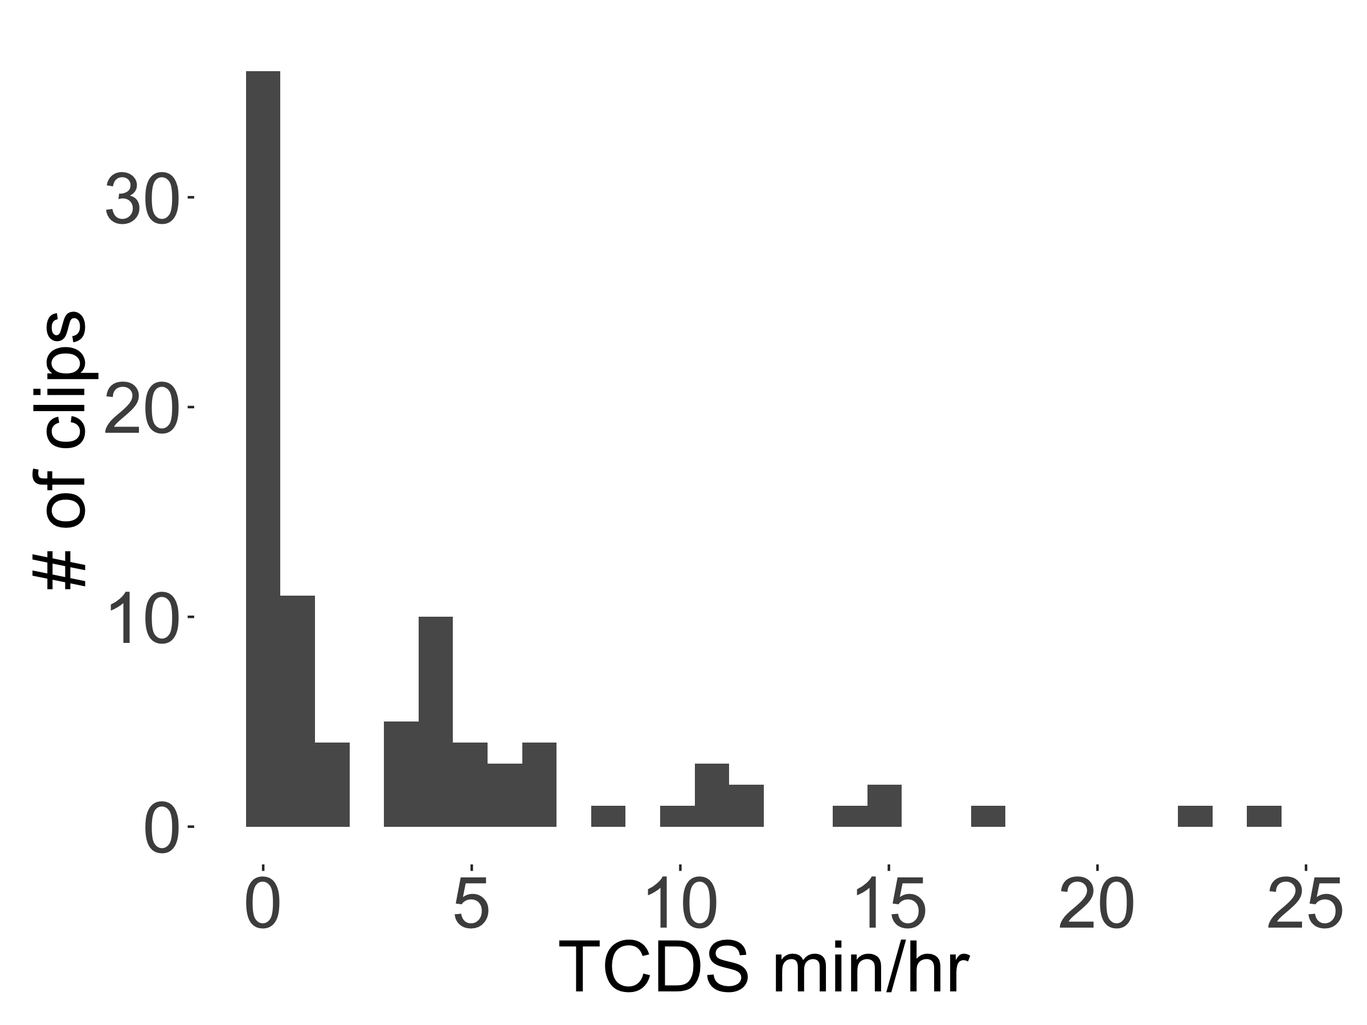

Figure 1 The distribution of TCDS rates found across the 90 random clips.

Table 1

*Full output of the zero-inflated negative binomial mixed-effects regression of TCDS min/hr for the random sample, with midday as the reference level for time of day.*

|  |  |  |  |  |  |
| --- | --- | --- | --- | --- | --- |
| component | term | estimate | std.error | statistic | p.value |
| cond | (Intercept) | 0.82 | 0.39 | 2.12 | 0.03 |
| cond | tchiyr.std | 0.44 | 0.42 | 1.05 | 0.29 |
| cond | stthr.trimorning | 0.82 | 0.40 | 2.06 | 0.04 |
| cond | stthr.triafternoon | 0.49 | 0.37 | 1.31 | 0.19 |
| cond | hsz.std | -0.09 | 0.26 | -0.33 | 0.74 |
| cond | nsk.std | -0.13 | 0.16 | -0.79 | 0.43 |
| cond | tchiyr.std:stthr.trimorning | -0.24 | 0.39 | -0.60 | 0.55 |
| cond | tchiyr.std:stthr.triafternoon | -0.81 | 0.38 | -2.15 | 0.03 |
| cond | tchiyr.std:hsz.std | -0.21 | 0.32 | -0.66 | 0.51 |
| cond | tchiyr.std:nsk.std | 0.61 | 0.20 | 3.06 | 0.00 |
| zi | (Intercept) | -56.90 | 14,003.31 | 0.00 | 1.00 |
| zi | nsk.std | -55.17 | 14,243.76 | 0.00 | 1.00 |
| random_effect | aclew_child_id | 0.30 | NA | NA | NA |

Table 2

*Model output of the zero-inflated negative binomial mixed-effects regression of TCDS min/hr for the random sample, with afternoon as the reference level for time of day.*

|  |  |  |  |  |  |
| --- | --- | --- | --- | --- | --- |
| component | term | estimate | std.error | statistic | p.value |
| cond | (Intercept) | 1.36 | 0.23 | 5.88 | 0.00 |
| cond | tchiyr.std | -0.31 | 0.25 | -1.22 | 0.22 |
| cond | stthr.tri.amidday | -0.49 | 0.38 | -1.29 | 0.20 |
| cond | stthr.tri.amorning | 0.30 | 0.29 | 1.06 | 0.29 |
| cond | hsz.std | -0.09 | 0.22 | -0.40 | 0.69 |
| cond | nsk.std | -0.11 | 0.18 | -0.60 | 0.55 |
| cond | tchiyr.std:stthr.tri.amidday | 0.73 | 0.36 | 2.04 | 0.04 |
| cond | tchiyr.std:stthr.tri.amorning | 0.46 | 0.28 | 1.65 | 0.10 |
| cond | tchiyr.std:hsz.std | -0.20 | 0.26 | -0.76 | 0.45 |
| cond | tchiyr.std:nsk.std | 0.57 | 0.20 | 2.83 | 0.00 |
| zi | (Intercept) | -58.40 | 13,710.05 | 0.00 | 1.00 |
| zi | nsk.std | -56.19 | 13,945.46 | 0.00 | 1.00 |
| random_effect | aclew_child_id | 0.00 | NA | NA | NA |

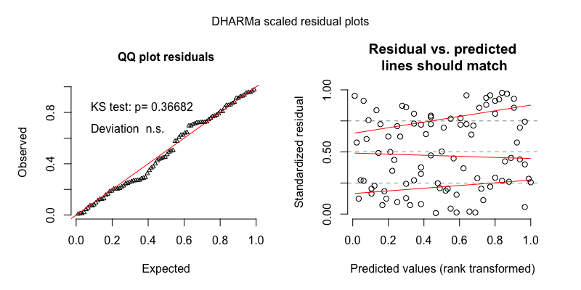

Figure 2 The model residuals from the zero-inflated negative binomial mixed-effects regression of TCDS min/hr for the random sample.

Table 3

*Full output of the gaussian mixed-effects regression of TCDS min/hr for the random sample, with midday as the reference level for time of day.*

|  |  |  |  |  |  |
| --- | --- | --- | --- | --- | --- |
| component | term | estimate | std.error | statistic | p.value |
| cond | (Intercept) | 0.78 | 0.22 | 3.44 | 0.00 |
| cond | tchiyr.std | 0.49 | 0.26 | 1.90 | 0.06 |
| cond | stthr.trimorning | 0.51 | 0.25 | 2.03 | 0.04 |
| cond | stthr.triafternoon | 0.29 | 0.22 | 1.32 | 0.18 |
| cond | hsz.std | -0.20 | 0.20 | -1.00 | 0.32 |
| cond | nsk.std | 0.23 | 0.12 | 1.96 | 0.05 |
| cond | tchiyr.std:stthr.trimorning | -0.16 | 0.27 | -0.59 | 0.55 |
| cond | tchiyr.std:stthr.triafternoon | -0.68 | 0.24 | -2.85 | 0.00 |
| cond | tchiyr.std:hsz.std | -0.08 | 0.24 | -0.36 | 0.72 |
| cond | tchiyr.std:nsk.std | 0.25 | 0.15 | 1.68 | 0.09 |
| random_effect | aclew_child_id | 0.20 | NA | NA | NA |
| random_effect | Residual | 0.84 | NA | NA | NA |

Table 4

*Model output of the gaussian mixed-effects regression of TCDS min/hr for the random sample, with afternoon as the reference level for time of day.*

|  |  |  |  |  |  |
| --- | --- | --- | --- | --- | --- |
| component | term | estimate | std.error | statistic | p.value |
| cond | (Intercept) | 1.07 | 0.19 | 5.75 | 0.00 |
| cond | tchiyr.std | -0.19 | 0.22 | -0.86 | 0.39 |
| cond | stthr.tri.amidday | -0.29 | 0.22 | -1.32 | 0.18 |
| cond | stthr.tri.amorning | 0.22 | 0.22 | 0.98 | 0.33 |
| cond | hsz.std | -0.20 | 0.20 | -1.00 | 0.32 |
| cond | nsk.std | 0.23 | 0.12 | 1.96 | 0.05 |
| cond | tchiyr.std:stthr.tri.amidday | 0.68 | 0.24 | 2.85 | 0.00 |
| cond | tchiyr.std:stthr.tri.amorning | 0.52 | 0.23 | 2.24 | 0.02 |
| cond | tchiyr.std:hsz.std | -0.08 | 0.24 | -0.36 | 0.72 |
| cond | tchiyr.std:nsk.std | 0.25 | 0.15 | 1.68 | 0.09 |
| random_effect | aclew_child_id | 0.20 | NA | NA | NA |
| random_effect | Residual | 0.84 | NA | NA | NA |

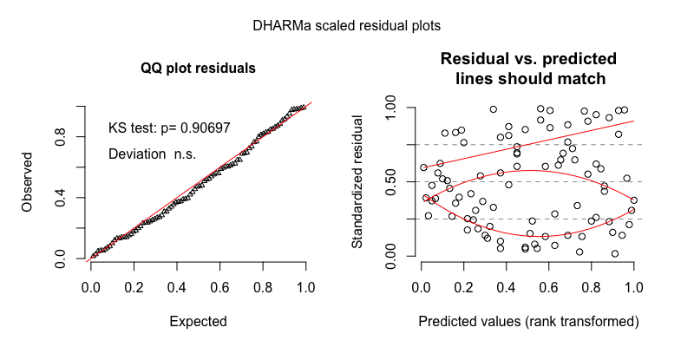

Figure 3 The model residuals from the gaussian mixed-effects regression of TCDS min/hr for the random sample.

**Turn-taking clips**TCDS rate in the turn-taking clips demonstrated a slightly skewed, but unimodal distribution. We therefore modeled it using a plain (i.e., non-zero-inflated) negative binomial mixed-effects regression.

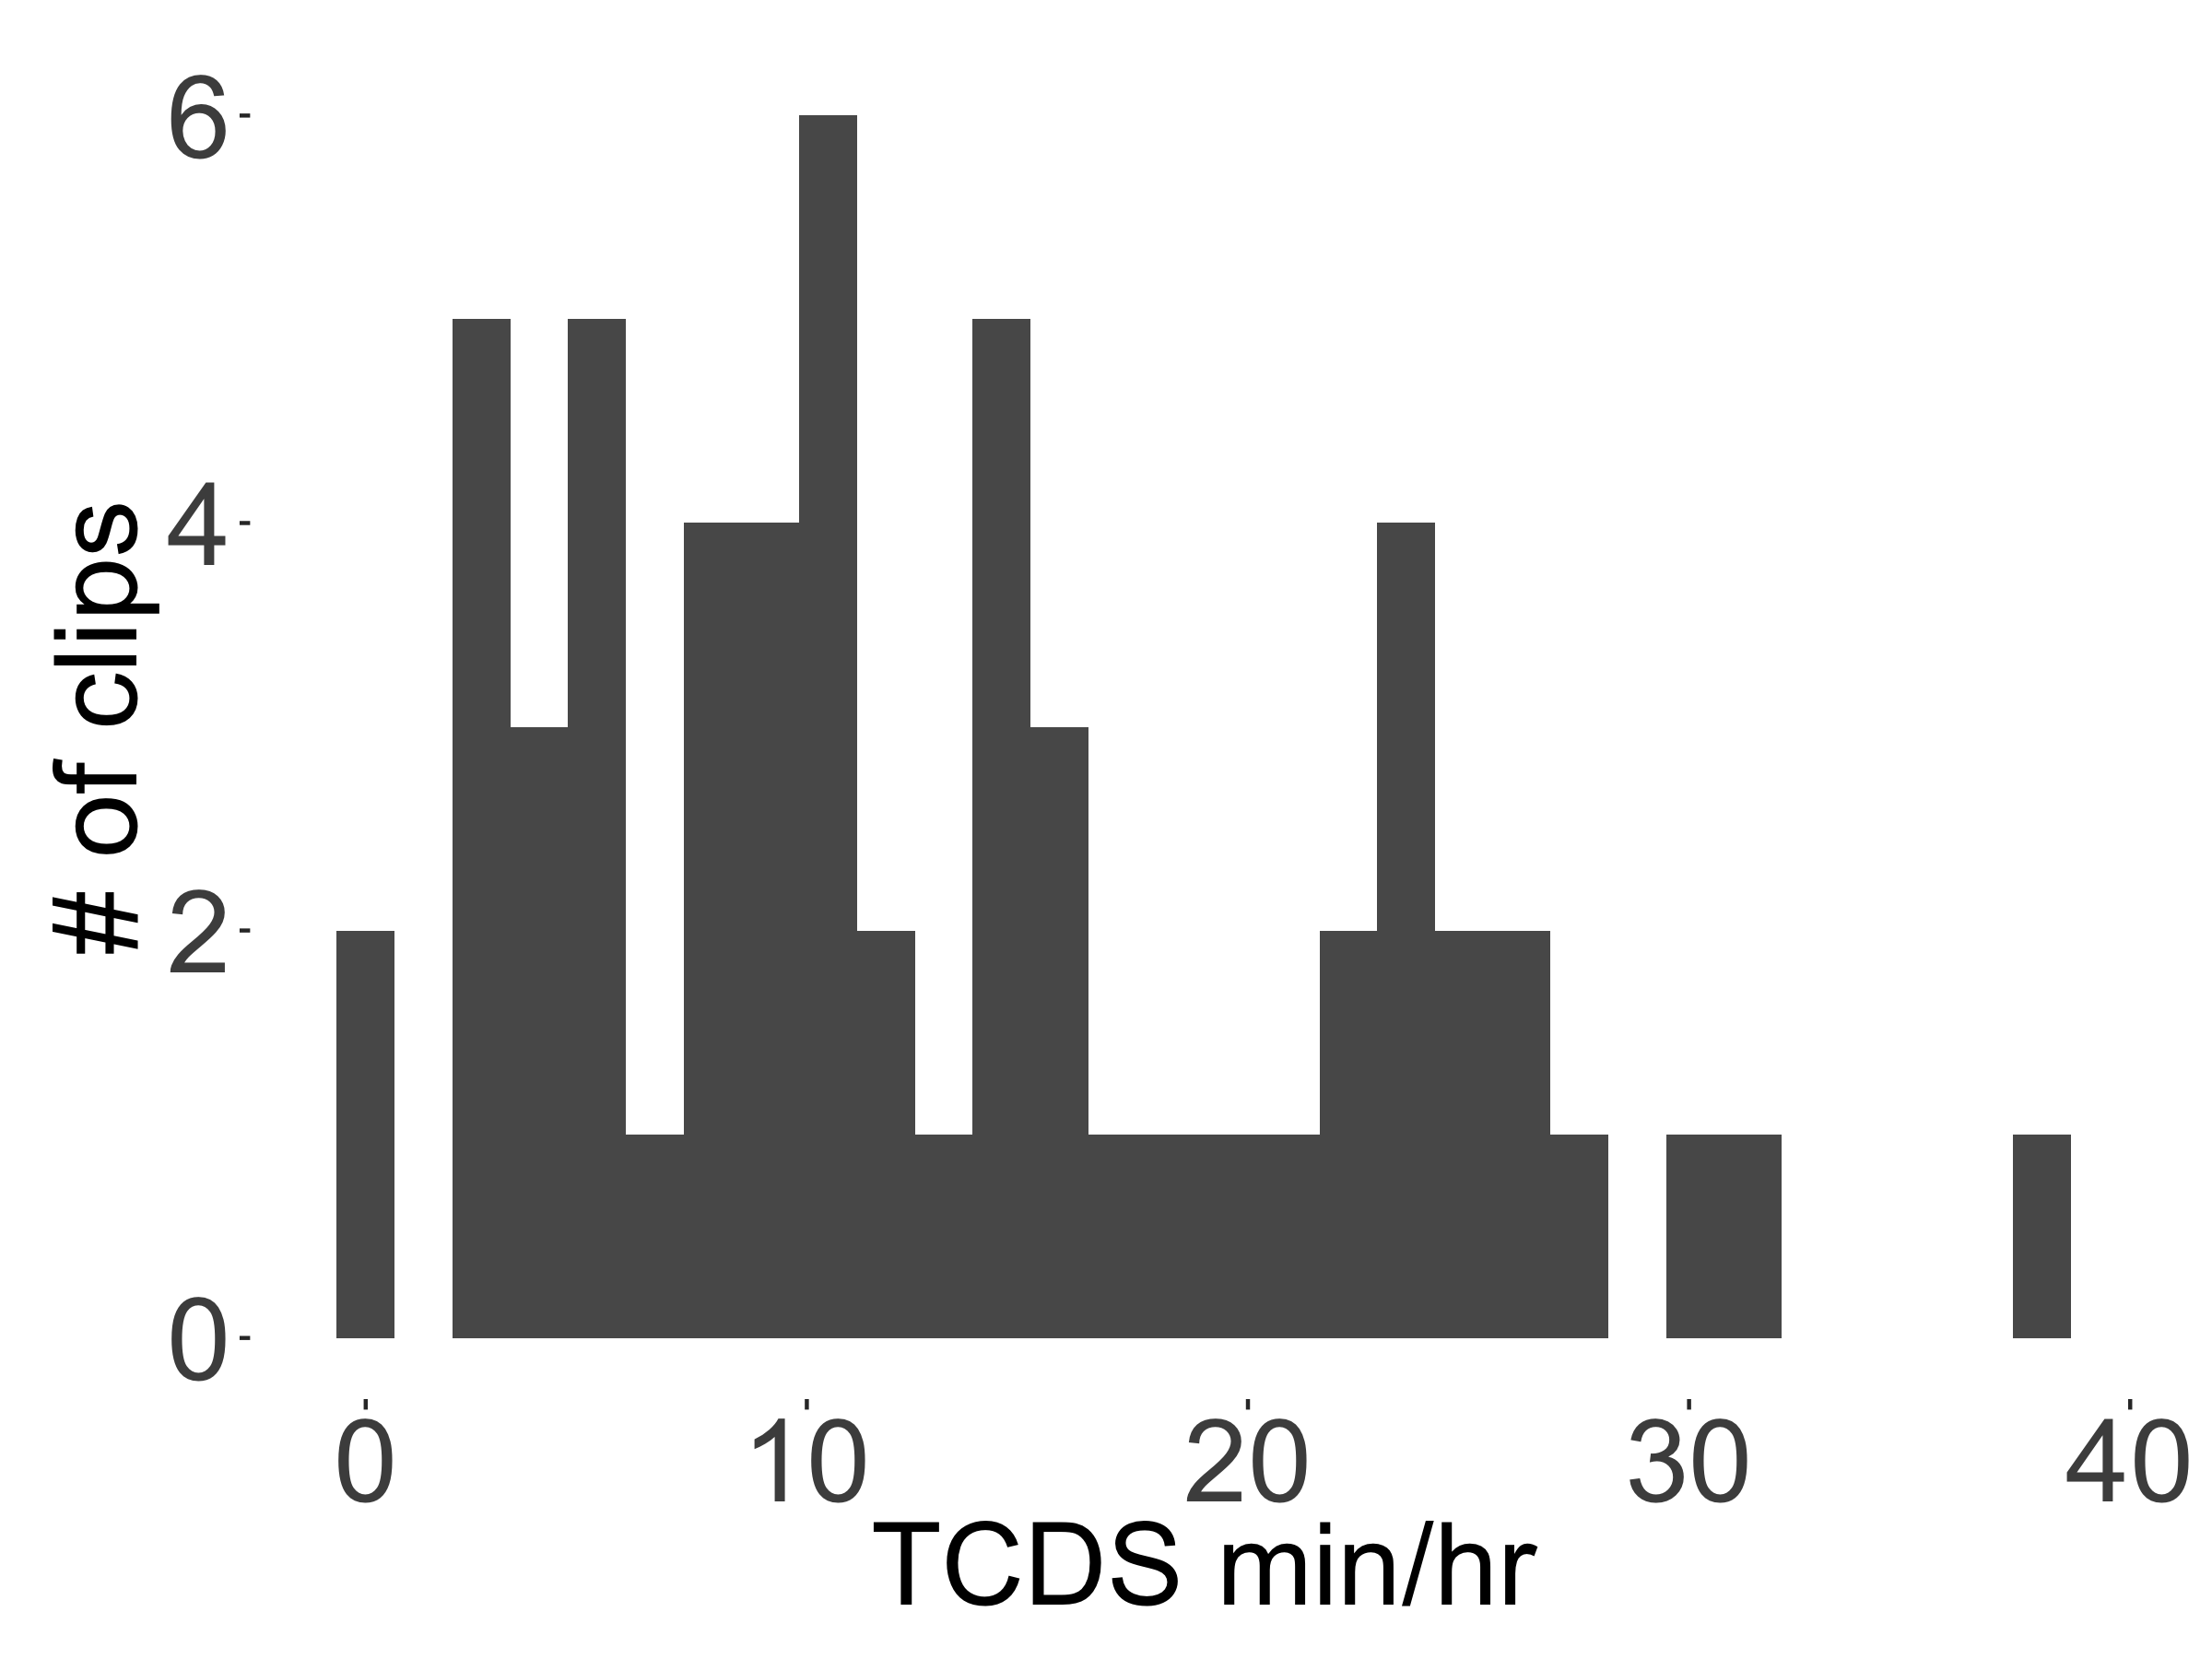

Figure 4 The distribution of TCDS rates found across the 59 turn-taking clips.

Table 5

*Full output of the negative binomial mixed-effects regression of TCDS min/hr for the turn-taking sample, with midday as the reference level for time of day.*

|  |  |  |  |  |  |
| --- | --- | --- | --- | --- | --- |
| component | term | estimate | std.error | statistic | p.value |
| cond | (Intercept) | 2.22 | 0.23 | 9.85 | 0.00 |
| cond | tchiyr.std | -0.16 | 0.21 | -0.77 | 0.44 |
| cond | stthr.trimorning | 0.33 | 0.25 | 1.32 | 0.19 |
| cond | stthr.triafternoon | 0.06 | 0.23 | 0.28 | 0.78 |
| cond | hsz.std | -0.16 | 0.16 | -1.01 | 0.31 |
| cond | nsk.std | -0.10 | 0.10 | -0.96 | 0.33 |
| cond | tchiyr.std:stthr.trimorning | -0.27 | 0.25 | -1.10 | 0.27 |
| cond | tchiyr.std:stthr.triafternoon | -0.03 | 0.21 | -0.16 | 0.88 |
| cond | tchiyr.std:hsz.std | -0.49 | 0.20 | -2.42 | 0.02 |
| cond | tchiyr.std:nsk.std | 0.14 | 0.12 | 1.15 | 0.25 |
| random_effect | aclew_child_id | 0.00 | NA | NA | NA |

Table 6

*Model output of the negative binomial mixed-effects regression of TCDS min/hr for the turn-taking sample, with afternoon as the reference level for time of day.*

|  |  |  |  |  |  |
| --- | --- | --- | --- | --- | --- |
| component | term | estimate | std.error | statistic | p.value |
| cond | (Intercept) | 2.29 | 0.20 | 11.32 | 0.00 |
| cond | tchiyr.std | -0.19 | 0.20 | -0.95 | 0.34 |
| cond | stthr.tri.amidday | -0.06 | 0.23 | -0.28 | 0.78 |
| cond | stthr.tri.amorning | 0.27 | 0.22 | 1.24 | 0.22 |
| cond | hsz.std | -0.16 | 0.16 | -1.01 | 0.31 |
| cond | nsk.std | -0.10 | 0.10 | -0.96 | 0.33 |
| cond | tchiyr.std:stthr.tri.amidday | 0.03 | 0.21 | 0.16 | 0.88 |
| cond | tchiyr.std:stthr.tri.amorning | -0.24 | 0.22 | -1.10 | 0.27 |
| cond | tchiyr.std:hsz.std | -0.49 | 0.20 | -2.42 | 0.02 |
| cond | tchiyr.std:nsk.std | 0.14 | 0.12 | 1.15 | 0.25 |
| random_effect | aclew_child_id | 0.00 | NA | NA | NA |

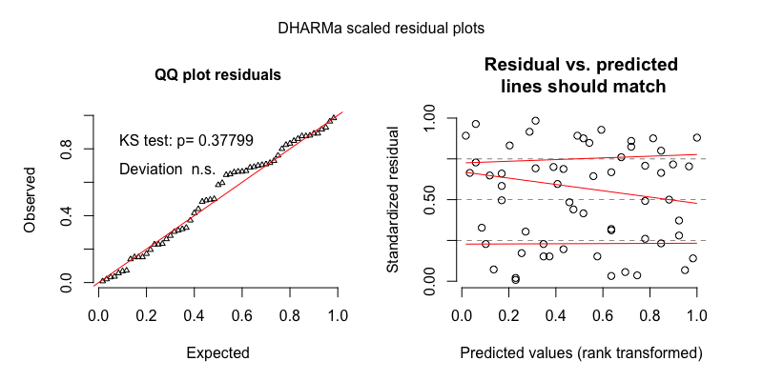

Figure 5 The model residuals from the negative binomial mixed-effects regression of TCDS min/hr for the turn-taking sample.

Table 7

*Full output of the gaussian mixed-effects regression of TCDS min/hr for the turn-taking sample, with midday as the reference level for time of day.*

|  |  |  |  |  |  |
| --- | --- | --- | --- | --- | --- |
| component | term | estimate | std.error | statistic | p.value |
| cond | (Intercept) | 2.08 | 0.24 | 8.55 | 0.00 |
| cond | tchiyr.std | -0.13 | 0.23 | -0.55 | 0.58 |
| cond | stthr.trimorning | 0.38 | 0.30 | 1.28 | 0.20 |
| cond | stthr.triafternoon | 0.11 | 0.27 | 0.40 | 0.69 |
| cond | hsz.std | -0.15 | 0.17 | -0.85 | 0.39 |
| cond | nsk.std | -0.08 | 0.12 | -0.67 | 0.50 |
| cond | tchiyr.std:stthr.trimorning | -0.34 | 0.30 | -1.16 | 0.24 |
| cond | tchiyr.std:stthr.triafternoon | 0.00 | 0.26 | -0.02 | 0.99 |
| cond | tchiyr.std:hsz.std | -0.49 | 0.22 | -2.24 | 0.02 |
| cond | tchiyr.std:nsk.std | 0.17 | 0.15 | 1.13 | 0.26 |
| random_effect | aclew_child_id | 0.00 | NA | NA | NA |
| random_effect | Residual | 0.71 | NA | NA | NA |

Table 8

*Model output of the gaussian mixed-effects regression of TCDS min/hr for the turn-taking sample, with afternoon as the reference level for time of day.*

|  |  |  |  |  |  |
| --- | --- | --- | --- | --- | --- |
| component | term | estimate | std.error | statistic | p.value |
| cond | (Intercept) | 2.19 | 0.21 | 10.47 | 0.00 |
| cond | tchiyr.std | -0.13 | 0.23 | -0.58 | 0.56 |
| cond | stthr.tri.amidday | -0.11 | 0.27 | -0.40 | 0.69 |
| cond | stthr.tri.amorning | 0.28 | 0.26 | 1.04 | 0.30 |
| cond | hsz.std | -0.15 | 0.17 | -0.85 | 0.39 |
| cond | nsk.std | -0.08 | 0.12 | -0.67 | 0.50 |
| cond | tchiyr.std:stthr.tri.amidday | 0.00 | 0.26 | 0.02 | 0.99 |
| cond | tchiyr.std:stthr.tri.amorning | -0.34 | 0.28 | -1.23 | 0.22 |
| cond | tchiyr.std:hsz.std | -0.49 | 0.22 | -2.24 | 0.02 |
| cond | tchiyr.std:nsk.std | 0.17 | 0.15 | 1.13 | 0.26 |
| random_effect | aclew_child_id | 0.00 | NA | NA | NA |
| random_effect | Residual | 0.71 | NA | NA | NA |

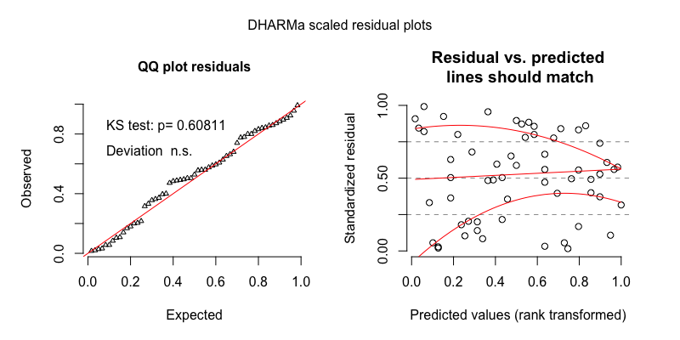

Figure 6 The model residuals from the gaussian mixed-effects regression of TCDS min/hr for the turn-taking sample.

## Other-directed speech (ODS)

**Random clips**ODS rate in the random clips demonstrated a skewed distribution with extra cases of zero. We therefore modeled it using a zero-inflated negative binomial mixed-effects regression.

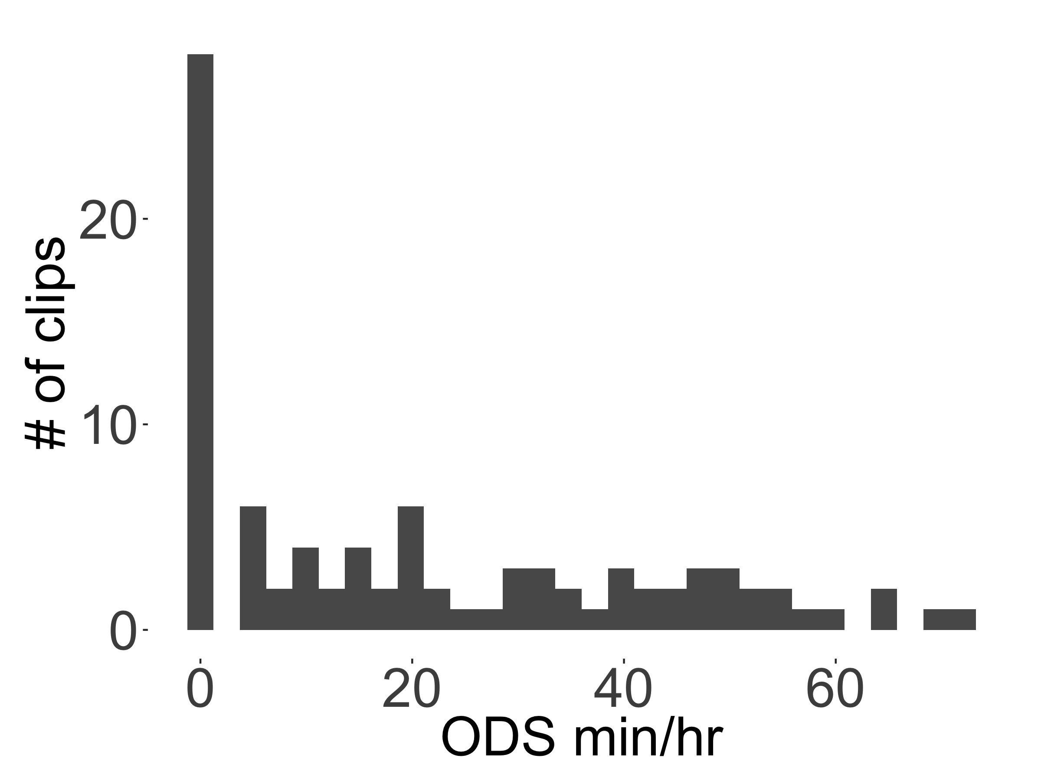

Figure 7 The distribution of ODS rates found across the 90 random clips.

Table 9

*Full output of the zero-inflated negative binomial mixed-effects regression of ODS min/hr for the random sample, with midday as the reference level for time of day.*

|  |  |  |  |  |  |
| --- | --- | --- | --- | --- | --- |
| component | term | estimate | std.error | statistic | p.value |
| cond | (Intercept) | 2.87 | 0.16 | 17.95 | 0.00 |
| cond | tchiyr.std | -0.13 | 0.18 | -0.70 | 0.49 |
| cond | stthr.trimorning | 0.36 | 0.17 | 2.09 | 0.04 |
| cond | stthr.triafternoon | 0.29 | 0.16 | 1.89 | 0.06 |
| cond | hsz.std | 0.04 | 0.10 | 0.44 | 0.66 |
| cond | nsk.std | 0.65 | 0.09 | 7.33 | 0.00 |
| cond | tchiyr.std:stthr.trimorning | 0.10 | 0.21 | 0.48 | 0.63 |
| cond | tchiyr.std:stthr.triafternoon | 0.38 | 0.17 | 2.21 | 0.03 |
| cond | tchiyr.std:hsz.std | 0.32 | 0.13 | 2.41 | 0.02 |
| cond | tchiyr.std:nsk.std | -0.02 | 0.13 | -0.15 | 0.88 |
| zi | (Intercept) | -50.25 | 10,421.88 | 0.00 | 1.00 |
| zi | nsk.std | -53.76 | 10,600.83 | 0.00 | 1.00 |
| random_effect | aclew_child_id | 0.00 | NA | NA | NA |

Table 10

*Model output of the zero-inflated negative binomial mixed-effects regression of ODS min/hr for the random sample, with afternoon as the reference level for time of day.*

|  |  |  |  |  |  |
| --- | --- | --- | --- | --- | --- |
| component | term | estimate | std.error | statistic | p.value |
| cond | (Intercept) | 3.16 | 0.11 | 28.09 | 0.00 |
| cond | tchiyr.std | 0.25 | 0.14 | 1.84 | 0.07 |
| cond | stthr.tri.amidday | -0.29 | 0.16 | -1.89 | 0.06 |
| cond | stthr.tri.amorning | 0.07 | 0.14 | 0.48 | 0.63 |
| cond | hsz.std | 0.04 | 0.10 | 0.44 | 0.66 |
| cond | nsk.std | 0.65 | 0.09 | 7.33 | 0.00 |
| cond | tchiyr.std:stthr.tri.amidday | -0.38 | 0.17 | -2.21 | 0.03 |
| cond | tchiyr.std:stthr.tri.amorning | -0.28 | 0.17 | -1.62 | 0.10 |
| cond | tchiyr.std:hsz.std | 0.32 | 0.13 | 2.41 | 0.02 |
| cond | tchiyr.std:nsk.std | -0.02 | 0.13 | -0.15 | 0.88 |
| zi | (Intercept) | -50.71 | 11,450.44 | 0.00 | 1.00 |
| zi | nsk.std | -54.22 | 11,647.05 | 0.00 | 1.00 |
| random_effect | aclew_child_id | 0.00 | NA | NA | NA |

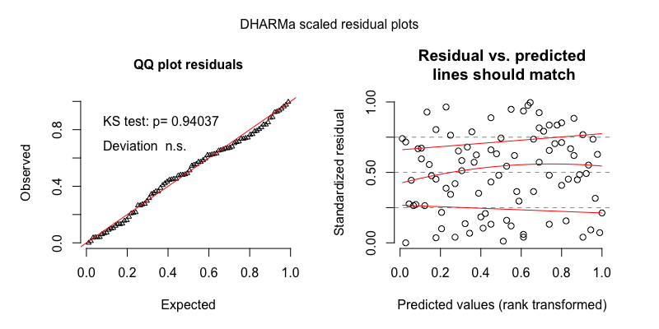

Figure 8 The model residuals from the zero-inflated negative binomial mixed-effects regression of ODS min/hr for the random sample.

Table 11

*Full output of the gaussian mixed-effects regression of ODS min/hr for the random sample, with midday as the reference level for time of day.*

|  |  |  |  |  |  |
| --- | --- | --- | --- | --- | --- |
| component | term | estimate | std.error | statistic | p.value |
| cond | (Intercept) | 2.21 | 0.17 | 12.75 | 0.00 |
| cond | tchiyr.std | -0.08 | 0.20 | -0.41 | 0.68 |
| cond | stthr.trimorning | 0.21 | 0.21 | 1.02 | 0.31 |
| cond | stthr.triafternoon | 0.34 | 0.19 | 1.80 | 0.07 |
| cond | hsz.std | -0.22 | 0.14 | -1.62 | 0.10 |
| cond | nsk.std | 1.53 | 0.09 | 16.25 | 0.00 |
| cond | tchiyr.std:stthr.trimorning | -0.01 | 0.23 | -0.03 | 0.98 |
| cond | tchiyr.std:stthr.triafternoon | 0.42 | 0.20 | 2.10 | 0.04 |
| cond | tchiyr.std:hsz.std | 0.32 | 0.17 | 1.90 | 0.06 |
| cond | tchiyr.std:nsk.std | 0.08 | 0.12 | 0.68 | 0.50 |
| random_effect | aclew_child_id | 0.00 | NA | NA | NA |
| random_effect | Residual | 0.72 | NA | NA | NA |

Table 12

*Model output of the gaussian mixed-effects regression of ODS min/hr for the random sample, with afternoon as the reference level for time of day.*

|  |  |  |  |  |  |
| --- | --- | --- | --- | --- | --- |
| component | term | estimate | std.error | statistic | p.value |
| cond | (Intercept) | 2.55 | 0.14 | 18.71 | 0.00 |
| cond | tchiyr.std | 0.34 | 0.16 | 2.12 | 0.03 |
| cond | stthr.tri.amidday | -0.34 | 0.19 | -1.80 | 0.07 |
| cond | stthr.tri.amorning | -0.12 | 0.18 | -0.66 | 0.51 |
| cond | hsz.std | -0.22 | 0.14 | -1.62 | 0.10 |
| cond | nsk.std | 1.53 | 0.09 | 16.25 | 0.00 |
| cond | tchiyr.std:stthr.tri.amidday | -0.42 | 0.20 | -2.10 | 0.04 |
| cond | tchiyr.std:stthr.tri.amorning | -0.43 | 0.20 | -2.19 | 0.03 |
| cond | tchiyr.std:hsz.std | 0.32 | 0.17 | 1.90 | 0.06 |
| cond | tchiyr.std:nsk.std | 0.08 | 0.12 | 0.68 | 0.50 |
| random_effect | aclew_child_id | 0.00 | NA | NA | NA |
| random_effect | Residual | 0.72 | NA | NA | NA |

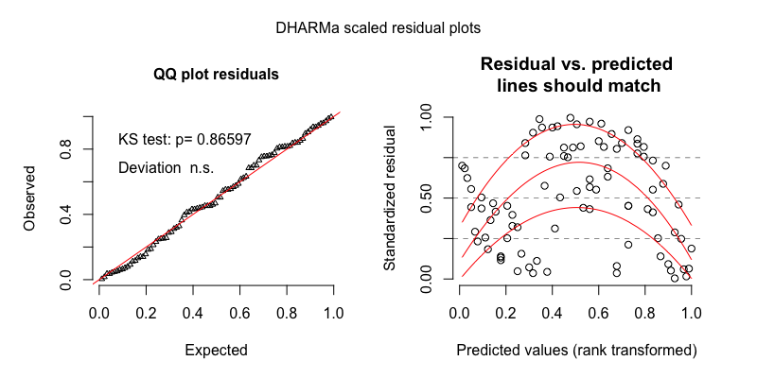

Figure 9 The model residuals from the gaussian mixed-effects regression of ODS min/hr for the random sample.

**Turn-taking clips**ODS rate in the turn-taking clips demonstrated a skewed distribution with extra cases of zero. We therefore modeled it using a zero-inflated negative binomial mixed-effects regression.

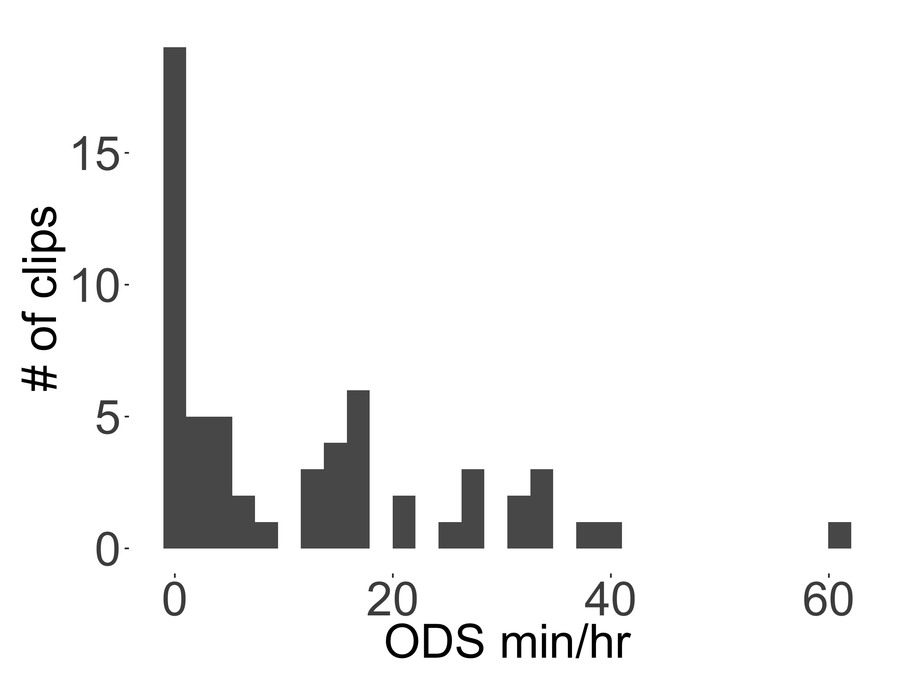

Figure 10 The distribution of ODS rates found across the 59 turn-taking clips.

Table 13

*Full output of the negative binomial mixed-effects regression of ODS min/hr for the turn-taking sample, with midday as the reference level for time of day.*

|  |  |  |  |  |  |
| --- | --- | --- | --- | --- | --- |
| component | term | estimate | std.error | statistic | p.value |
| cond | (Intercept) | 2.47 | 0.22 | 11.29 | 0.00 |
| cond | tchiyr.std | -0.45 | 0.20 | -2.19 | 0.03 |
| cond | stthr.trimorning | 0.02 | 0.26 | 0.09 | 0.93 |
| cond | stthr.triafternoon | -0.70 | 0.29 | -2.39 | 0.02 |
| cond | hsz.std | -0.44 | 0.17 | -2.60 | 0.01 |
| cond | nsk.std | 0.71 | 0.11 | 6.63 | 0.00 |
| cond | tchiyr.std:stthr.trimorning | -0.56 | 0.28 | -1.99 | 0.05 |
| cond | tchiyr.std:stthr.triafternoon | -0.14 | 0.30 | -0.47 | 0.64 |
| cond | tchiyr.std:hsz.std | -0.38 | 0.22 | -1.74 | 0.08 |
| cond | tchiyr.std:nsk.std | 0.10 | 0.14 | 0.73 | 0.47 |
| zi | (Intercept) | -32.21 | 12,233.79 | 0.00 | 1.00 |
| zi | nsk.std | -31.55 | 12,037.74 | 0.00 | 1.00 |
| random_effect | aclew_child_id | 0.00 | NA | NA | NA |

Table 14

*Model output of the negative binomial mixed-effects regression of ODS min/hr for the turn-taking sample, with afternoon as the reference level for time of day.*

|  |  |  |  |  |  |
| --- | --- | --- | --- | --- | --- |
| component | term | estimate | std.error | statistic | p.value |
| cond | (Intercept) | 1.77 | 0.27 | 6.64 | 0.00 |
| cond | tchiyr.std | -0.59 | 0.28 | -2.10 | 0.04 |
| cond | stthr.tri.amidday | 0.70 | 0.29 | 2.39 | 0.02 |
| cond | stthr.tri.amorning | 0.72 | 0.25 | 2.91 | 0.00 |
| cond | hsz.std | -0.44 | 0.17 | -2.60 | 0.01 |
| cond | nsk.std | 0.71 | 0.11 | 6.63 | 0.00 |
| cond | tchiyr.std:stthr.tri.amidday | 0.14 | 0.30 | 0.47 | 0.64 |
| cond | tchiyr.std:stthr.tri.amorning | -0.42 | 0.27 | -1.54 | 0.12 |
| cond | tchiyr.std:hsz.std | -0.38 | 0.22 | -1.74 | 0.08 |
| cond | tchiyr.std:nsk.std | 0.10 | 0.14 | 0.73 | 0.47 |
| zi | (Intercept) | -32.46 | 13,260.31 | 0.00 | 1.00 |
| zi | nsk.std | -31.79 | 13,047.81 | 0.00 | 1.00 |
| random_effect | aclew_child_id | 0.00 | NA | NA | NA |

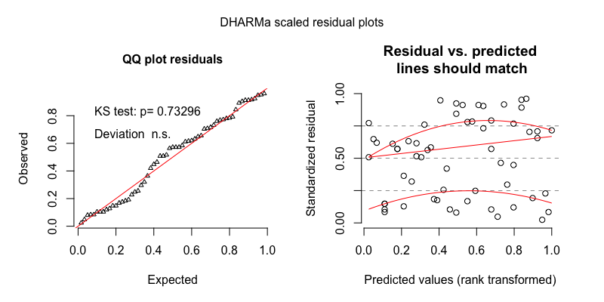

Figure 11 The model residuals from the zero-inflated negative binomial mixed-effects regression of ODS min/hr for the turn-taking sample.

Table 15

*Full output of the gaussian mixed-effects regression of ODS min/hr for the turn-taking sample, with midday as the reference level for time of day.*

|  |  |  |  |  |  |
| --- | --- | --- | --- | --- | --- |
| component | term | estimate | std.error | statistic | p.value |
| cond | (Intercept) | 2.24 | 0.24 | 9.52 | 0.00 |
| cond | tchiyr.std | -0.26 | 0.23 | -1.13 | 0.26 |
| cond | stthr.trimorning | -0.19 | 0.29 | -0.65 | 0.51 |
| cond | stthr.triafternoon | -0.75 | 0.26 | -2.89 | 0.00 |
| cond | hsz.std | -0.39 | 0.17 | -2.32 | 0.02 |
| cond | nsk.std | 1.12 | 0.11 | 10.06 | 0.00 |
| cond | tchiyr.std:stthr.trimorning | -0.29 | 0.29 | -1.01 | 0.31 |
| cond | tchiyr.std:stthr.triafternoon | 0.04 | 0.25 | 0.17 | 0.86 |
| cond | tchiyr.std:hsz.std | -0.21 | 0.21 | -1.00 | 0.32 |
| cond | tchiyr.std:nsk.std | -0.03 | 0.14 | -0.22 | 0.82 |
| random_effect | aclew_child_id | 0.00 | NA | NA | NA |
| random_effect | Residual | 0.69 | NA | NA | NA |

Table 16

*Model output of the gaussian mixed-effects regression of ODS min/hr for the turn-taking sample, with afternoon as the reference level for time of day.*

|  |  |  |  |  |  |
| --- | --- | --- | --- | --- | --- |
| component | term | estimate | std.error | statistic | p.value |
| cond | (Intercept) | 1.49 | 0.20 | 7.38 | 0.00 |
| cond | tchiyr.std | -0.21 | 0.22 | -0.96 | 0.34 |
| cond | stthr.tri.amidday | 0.75 | 0.26 | 2.89 | 0.00 |
| cond | stthr.tri.amorning | 0.56 | 0.26 | 2.18 | 0.03 |
| cond | hsz.std | -0.39 | 0.17 | -2.32 | 0.02 |
| cond | nsk.std | 1.12 | 0.11 | 10.06 | 0.00 |
| cond | tchiyr.std:stthr.tri.amidday | -0.04 | 0.25 | -0.17 | 0.86 |
| cond | tchiyr.std:stthr.tri.amorning | -0.33 | 0.27 | -1.24 | 0.21 |
| cond | tchiyr.std:hsz.std | -0.21 | 0.21 | -1.00 | 0.32 |
| cond | tchiyr.std:nsk.std | -0.03 | 0.14 | -0.22 | 0.82 |
| random_effect | aclew_child_id | 0.00 | NA | NA | NA |
| random_effect | Residual | 0.69 | NA | NA | NA |

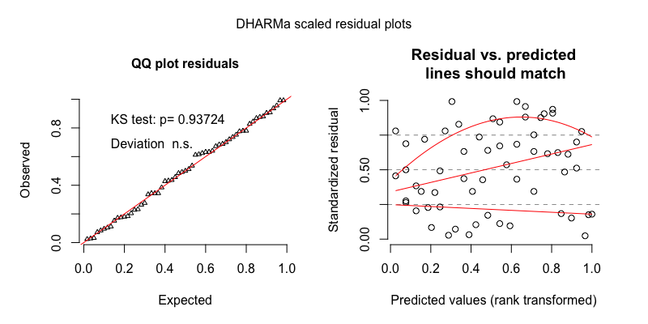

Figure 12 The model residuals from the gaussian mixed-effects regression of ODS min/hr for the turn-taking sample.

## Target-child-to-other turn transitions (TC–O)

**Random clips**Target-child-to-other contingent response rate (TC–O transitions/min) in the random clips demonstrated a skewed distribution with extra cases of zero. We therefore modeled it using a zero-inflated negative binomial mixed-effects regression.

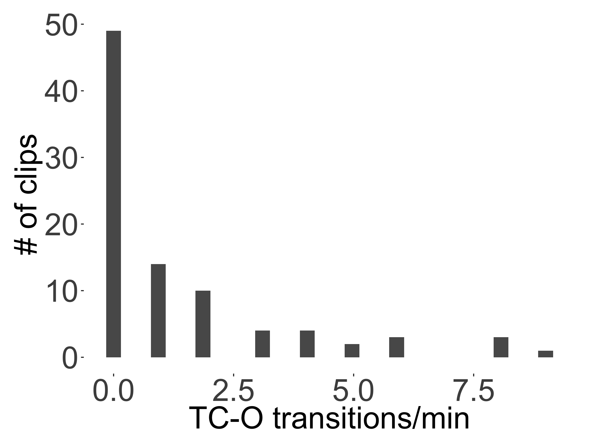

Figure 13 The distribution of TC–O turn transitions/min rates found across the 90 random clips.

Table 17

*Full output of the zero-inflated negative binomial mixed-effects regression of TC–O turn transitions/min for the random sample, with midday as the reference level for time of day.*

|  |  |  |  |  |  |
| --- | --- | --- | --- | --- | --- |
| component | term | estimate | std.error | statistic | p.value |
| cond | (Intercept) | -0.13 | 0.50 | -0.25 | 0.80 |
| cond | tchiyr.std | 0.89 | 0.61 | 1.46 | 0.14 |
| cond | stthr.trimorning | 0.48 | 0.45 | 1.07 | 0.28 |
| cond | stthr.triafternoon | 0.34 | 0.40 | 0.85 | 0.39 |
| cond | hsz.std | -0.17 | 0.45 | -0.38 | 0.70 |
| cond | nsk.std | -0.18 | 0.18 | -1.01 | 0.31 |
| cond | tchiyr.std:stthr.trimorning | -0.14 | 0.48 | -0.29 | 0.77 |
| cond | tchiyr.std:stthr.triafternoon | -1.08 | 0.44 | -2.44 | 0.02 |
| cond | tchiyr.std:hsz.std | 0.11 | 0.56 | 0.20 | 0.84 |
| cond | tchiyr.std:nsk.std | 0.56 | 0.23 | 2.48 | 0.01 |
| zi | (Intercept) | -116.67 | 53,056.16 | 0.00 | 1.00 |
| zi | nsk.std | -100.02 | 52,343.82 | 0.00 | 1.00 |
| random_effect | aclew_child_id | 0.71 | NA | NA | NA |

Table 18

*Model output of the zero-inflated negative binomial mixed-effects regression of TC–O turn transitions/min for the random sample, with afternoon as the reference level for time of day.*

|  |  |  |  |  |  |
| --- | --- | --- | --- | --- | --- |
| component | term | estimate | std.error | statistic | p.value |
| cond | (Intercept) | 0.22 | 0.40 | 0.54 | 0.59 |
| cond | tchiyr.std | -0.20 | 0.50 | -0.40 | 0.69 |
| cond | stthr.tri.amidday | -0.34 | 0.40 | -0.85 | 0.39 |
| cond | stthr.tri.amorning | 0.14 | 0.32 | 0.44 | 0.66 |
| cond | hsz.std | -0.17 | 0.45 | -0.38 | 0.70 |
| cond | nsk.std | -0.18 | 0.18 | -1.01 | 0.31 |
| cond | tchiyr.std:stthr.tri.amidday | 1.08 | 0.44 | 2.44 | 0.02 |
| cond | tchiyr.std:stthr.tri.amorning | 0.94 | 0.38 | 2.52 | 0.01 |
| cond | tchiyr.std:hsz.std | 0.11 | 0.56 | 0.20 | 0.84 |
| cond | tchiyr.std:nsk.std | 0.56 | 0.23 | 2.48 | 0.01 |
| zi | (Intercept) | -115.42 | 48,611.57 | 0.00 | 1.00 |
| zi | nsk.std | -99.00 | 48,061.56 | 0.00 | 1.00 |
| random_effect | aclew_child_id | 0.71 | NA | NA | NA |

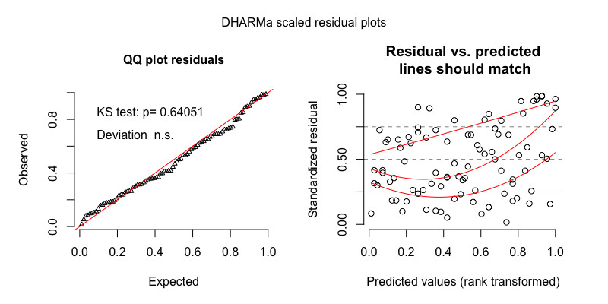

Figure 14 The model residuals from the zero-inflated negative binomial mixed-effects regression of TC–O turn transitions/min for the random sample.

Table 19

*Full output of the gaussian mixed-effects regression of TC–O turn transitions/min for the random sample, with midday as the reference level for time of day.*

|  |  |  |  |  |  |
| --- | --- | --- | --- | --- | --- |
| component | term | estimate | std.error | statistic | p.value |
| cond | (Intercept) | 1.06 | 0.14 | 7.80 | 0.00 |
| cond | tchiyr.std | 0.25 | 0.16 | 1.59 | 0.11 |
| cond | stthr.trimorning | 0.14 | 0.12 | 1.19 | 0.24 |
| cond | stthr.triafternoon | 0.01 | 0.10 | 0.13 | 0.90 |
| cond | hsz.std | -0.11 | 0.14 | -0.82 | 0.41 |
| cond | nsk.std | 0.09 | 0.06 | 1.56 | 0.12 |
| cond | tchiyr.std:stthr.trimorning | -0.02 | 0.12 | -0.20 | 0.84 |
| cond | tchiyr.std:stthr.triafternoon | -0.30 | 0.11 | -2.73 | 0.01 |
| cond | tchiyr.std:hsz.std | 0.00 | 0.16 | 0.02 | 0.99 |
| cond | tchiyr.std:nsk.std | 0.09 | 0.07 | 1.34 | 0.18 |
| random_effect | aclew_child_id | 0.21 | NA | NA | NA |
| random_effect | Residual | 0.38 | NA | NA | NA |

Table 20

*Model output of the gaussian mixed-effects regression of TC–O turn transitions/min for the random sample, with afternoon as the reference level for time of day.*

|  |  |  |  |  |  |
| --- | --- | --- | --- | --- | --- |
| component | term | estimate | std.error | statistic | p.value |
| cond | (Intercept) | 1.07 | 0.12 | 8.80 | 0.00 |
| cond | tchiyr.std | -0.05 | 0.14 | -0.37 | 0.71 |
| cond | stthr.tri.amidday | -0.01 | 0.10 | -0.13 | 0.90 |
| cond | stthr.tri.amorning | 0.12 | 0.10 | 1.24 | 0.22 |
| cond | hsz.std | -0.11 | 0.14 | -0.82 | 0.41 |
| cond | nsk.std | 0.09 | 0.06 | 1.56 | 0.12 |
| cond | tchiyr.std:stthr.tri.amidday | 0.30 | 0.11 | 2.73 | 0.01 |
| cond | tchiyr.std:stthr.tri.amorning | 0.28 | 0.11 | 2.59 | 0.01 |
| cond | tchiyr.std:hsz.std | 0.00 | 0.16 | 0.02 | 0.99 |
| cond | tchiyr.std:nsk.std | 0.09 | 0.07 | 1.34 | 0.18 |
| random_effect | aclew_child_id | 0.21 | NA | NA | NA |
| random_effect | Residual | 0.38 | NA | NA | NA |

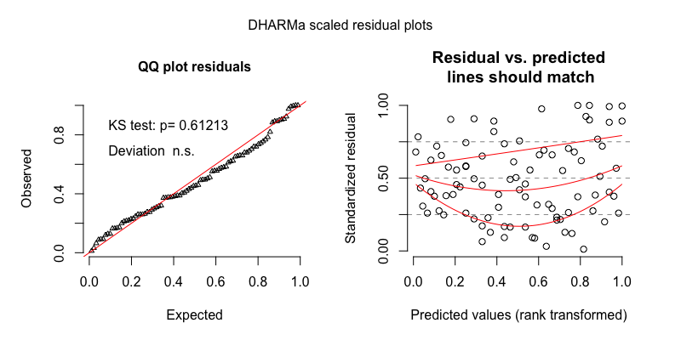

Figure 15 The model residuals from the gaussian mixed-effects regression of TC–O turn transitions/min for the random sample.

**Turn-taking clips**TC–O transitions/min in the turn-taking clips demonstrated a slightly skewed, unimodal distribution. We therefore modeled it using a plain (i.e., non-zero-inflated) negative binomial mixed-effects regression.

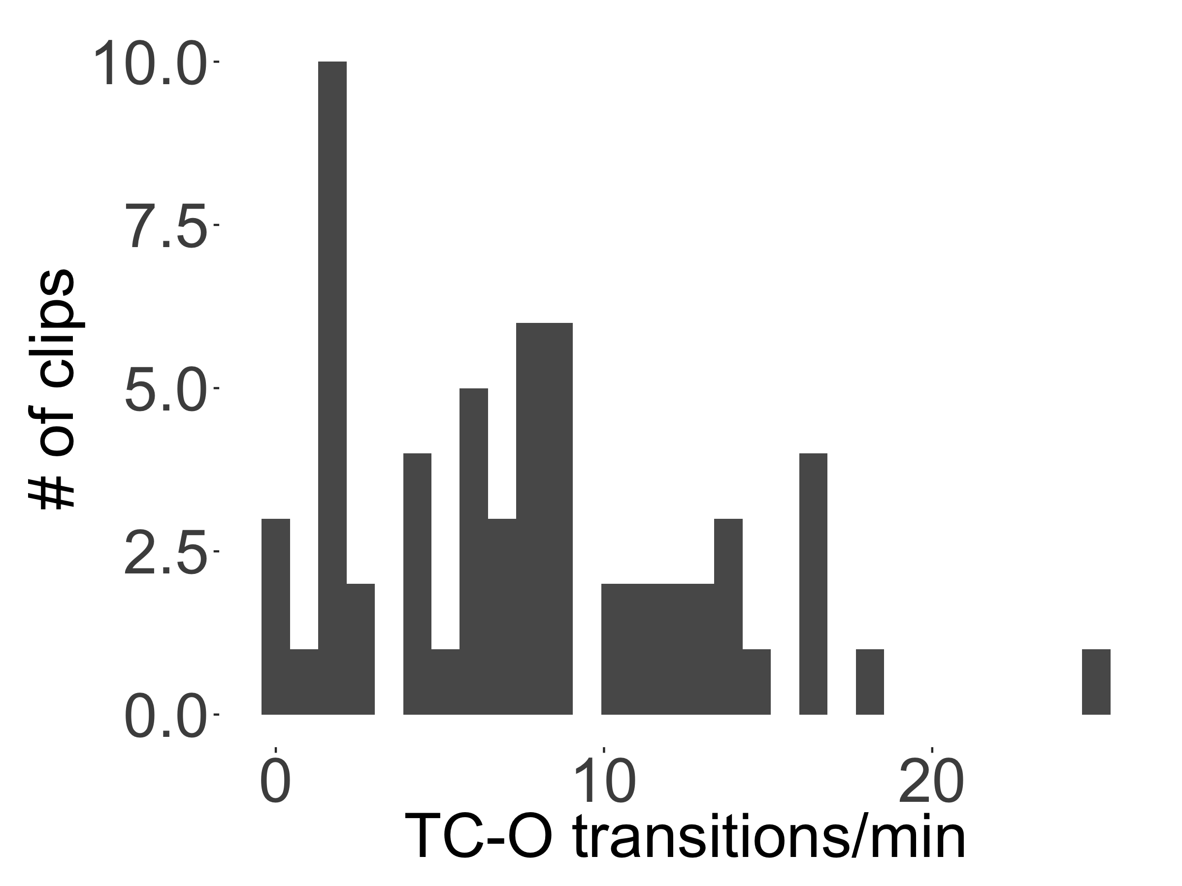

Figure 16 The distribution of TC–O turn transitions/min found across the 59 turn-taking clips.

Table 21

*Full output of the negative binomial mixed-effects regression of TC–O turn transitions/min for the turn-taking sample, with midday as the reference level for time of day.*

|  |  |  |  |  |  |
| --- | --- | --- | --- | --- | --- |
| component | term | estimate | std.error | statistic | p.value |
| cond | (Intercept) | 1.78 | 0.29 | 6.19 | 0.00 |
| cond | tchiyr.std | 0.12 | 0.29 | 0.40 | 0.68 |
| cond | stthr.trimorning | 0.06 | 0.32 | 0.18 | 0.86 |
| cond | stthr.triafternoon | 0.11 | 0.27 | 0.41 | 0.68 |
| cond | hsz.std | -0.04 | 0.23 | -0.17 | 0.86 |
| cond | nsk.std | -0.21 | 0.12 | -1.84 | 0.07 |
| cond | tchiyr.std:stthr.trimorning | -0.04 | 0.30 | -0.13 | 0.89 |
| cond | tchiyr.std:stthr.triafternoon | -0.19 | 0.25 | -0.75 | 0.45 |
| cond | tchiyr.std:hsz.std | -0.19 | 0.28 | -0.68 | 0.50 |
| cond | tchiyr.std:nsk.std | 0.05 | 0.13 | 0.41 | 0.68 |
| random_effect | aclew_child_id | 0.32 | NA | NA | NA |

Table 22

*Model output of the negative binomial mixed-effects regression of TC–O turn transitions/min for the turn-taking sample, with afternoon as the reference level for time of day.*

|  |  |  |  |  |  |
| --- | --- | --- | --- | --- | --- |
| component | term | estimate | std.error | statistic | p.value |
| cond | (Intercept) | 1.90 | 0.24 | 7.88 | 0.00 |
| cond | tchiyr.std | -0.07 | 0.27 | -0.26 | 0.79 |
| cond | stthr.tri.amidday | -0.11 | 0.27 | -0.41 | 0.68 |
| cond | stthr.tri.amorning | -0.05 | 0.24 | -0.21 | 0.83 |
| cond | hsz.std | -0.04 | 0.23 | -0.17 | 0.86 |
| cond | nsk.std | -0.21 | 0.12 | -1.84 | 0.07 |
| cond | tchiyr.std:stthr.tri.amidday | 0.19 | 0.25 | 0.75 | 0.45 |
| cond | tchiyr.std:stthr.tri.amorning | 0.15 | 0.27 | 0.56 | 0.58 |
| cond | tchiyr.std:hsz.std | -0.19 | 0.28 | -0.68 | 0.50 |
| cond | tchiyr.std:nsk.std | 0.05 | 0.13 | 0.41 | 0.68 |
| random_effect | aclew_child_id | 0.32 | NA | NA | NA |

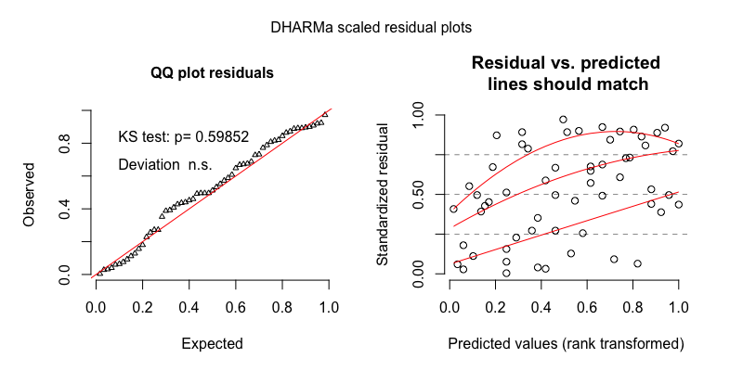

Figure 17 The model residuals from the negative binomial mixed-effects regression of TC–O turn transitions/min for the turn-taking sample.

Table 23

*Full output of the gaussian mixed-effects regression of TC–O turn transitions/min for the turn-taking sample, with midday as the reference level for time of day.*

|  |  |  |  |  |  |
| --- | --- | --- | --- | --- | --- |
| component | term | estimate | std.error | statistic | p.value |
| cond | (Intercept) | 2.07 | 0.20 | 10.19 | 0.00 |
| cond | tchiyr.std | -0.02 | 0.23 | -0.09 | 0.93 |
| cond | stthr.tri.amidday | -0.11 | 0.21 | -0.52 | 0.60 |
| cond | stthr.tri.amorning | -0.08 | 0.20 | -0.40 | 0.69 |
| cond | hsz.std | -0.02 | 0.20 | -0.12 | 0.90 |
| cond | nsk.std | -0.18 | 0.10 | -1.86 | 0.06 |
| cond | tchiyr.std:stthr.tri.amidday | 0.11 | 0.20 | 0.55 | 0.58 |
| cond | tchiyr.std:stthr.tri.amorning | 0.09 | 0.22 | 0.42 | 0.67 |
| cond | tchiyr.std:hsz.std | -0.17 | 0.25 | -0.68 | 0.50 |
| cond | tchiyr.std:nsk.std | 0.09 | 0.12 | 0.79 | 0.43 |
| random_effect | aclew_child_id | 0.30 | NA | NA | NA |
| random_effect | Residual | 0.51 | NA | NA | NA |

Table 24

*Model output of the gaussian mixed-effects regression of TC–O turn transitions/min for the turn-taking sample, with afternoon as the reference level for time of day.*

|  |  |  |  |  |  |
| --- | --- | --- | --- | --- | --- |
| component | term | estimate | std.error | statistic | p.value |
| cond | (Intercept) | 2.07 | 0.20 | 10.19 | 0.00 |
| cond | tchiyr.std | -0.02 | 0.23 | -0.09 | 0.93 |
| cond | stthr.tri.amidday | -0.11 | 0.21 | -0.52 | 0.60 |
| cond | stthr.tri.amorning | -0.08 | 0.20 | -0.40 | 0.69 |
| cond | hsz.std | -0.02 | 0.20 | -0.12 | 0.90 |
| cond | nsk.std | -0.18 | 0.10 | -1.86 | 0.06 |
| cond | tchiyr.std:stthr.tri.amidday | 0.11 | 0.20 | 0.55 | 0.58 |
| cond | tchiyr.std:stthr.tri.amorning | 0.09 | 0.22 | 0.42 | 0.67 |
| cond | tchiyr.std:hsz.std | -0.17 | 0.25 | -0.68 | 0.50 |
| cond | tchiyr.std:nsk.std | 0.09 | 0.12 | 0.79 | 0.43 |
| random_effect | aclew_child_id | 0.30 | NA | NA | NA |
| random_effect | Residual | 0.51 | NA | NA | NA |

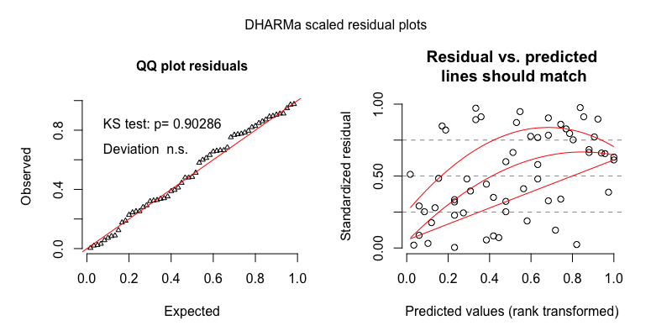

Figure 18 The model residuals from the gaussian mixed-effects regression of TC–O turn transitions/min for the turn-taking sample.

## Other-to-target-child turn transitions (O–TC)

**Random clips**Other-to-target-child contingent response rate (O–TC transitions/min) in the random clips demonstrated a skewed distribution with extra cases of zero. We therefore modeled it using a zero-inflated negative binomial mixed-effects regression.

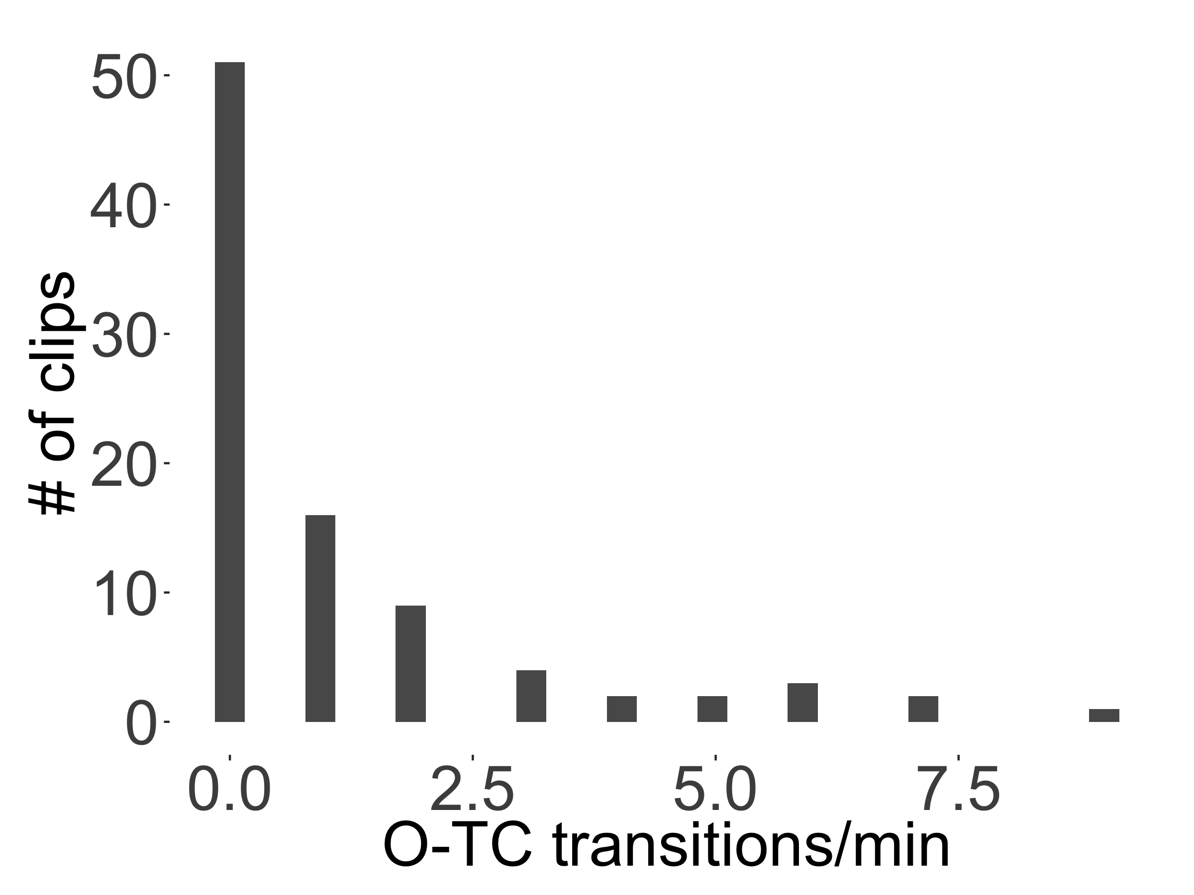

Figure 19 The distribution of O–TC turn transitions/min rates found across the 90 random clips.

Table 25

*Full output of the zero-inflated negative binomial mixed-effects regression of O–TCturn transitions/min for the random sample, with midday as the reference level for time of day.*

|  |  |  |  |  |  |
| --- | --- | --- | --- | --- | --- |
| component | term | estimate | std.error | statistic | p.value |
| cond | (Intercept) | -0.46 | 0.54 | -0.84 | 0.40 |
| cond | tchiyr.std | 1.14 | 0.66 | 1.74 | 0.08 |
| cond | stthr.trimorning | 0.32 | 0.49 | 0.65 | 0.52 |
| cond | stthr.triafternoon | 0.50 | 0.41 | 1.21 | 0.22 |
| cond | hsz.std | -0.20 | 0.50 | -0.41 | 0.68 |
| cond | nsk.std | -0.14 | 0.18 | -0.79 | 0.43 |
| cond | tchiyr.std:stthr.trimorning | -0.12 | 0.51 | -0.24 | 0.81 |
| cond | tchiyr.std:stthr.triafternoon | -1.46 | 0.46 | -3.13 | 0.00 |
| cond | tchiyr.std:hsz.std | 0.14 | 0.61 | 0.23 | 0.82 |
| cond | tchiyr.std:nsk.std | 0.52 | 0.22 | 2.30 | 0.02 |
| zi | (Intercept) | -115.46 | 43,943.60 | 0.00 | 1.00 |
| zi | nsk.std | -98.63 | 42,142.48 | 0.00 | 1.00 |
| random_effect | aclew_child_id | 0.80 | NA | NA | NA |

Table 26

*Model output of the zero-inflated negative binomial mixed-effects regression of O–TC turn transitions/min for the random sample, with afternoon as the reference level for time of day.*

|  |  |  |  |  |  |
| --- | --- | --- | --- | --- | --- |
| component | term | estimate | std.error | statistic | p.value |
| cond | (Intercept) | 0.04 | 0.43 | 0.08 | 0.93 |
| cond | tchiyr.std | -0.32 | 0.54 | -0.59 | 0.56 |
| cond | stthr.tri.amidday | -0.50 | 0.41 | -1.21 | 0.22 |
| cond | stthr.tri.amorning | -0.18 | 0.36 | -0.49 | 0.62 |
| cond | hsz.std | -0.20 | 0.50 | -0.41 | 0.68 |
| cond | nsk.std | -0.14 | 0.18 | -0.79 | 0.43 |
| cond | tchiyr.std:stthr.tri.amidday | 1.46 | 0.46 | 3.13 | 0.00 |
| cond | tchiyr.std:stthr.tri.amorning | 1.33 | 0.42 | 3.19 | 0.00 |
| cond | tchiyr.std:hsz.std | 0.14 | 0.61 | 0.23 | 0.82 |
| cond | tchiyr.std:nsk.std | 0.52 | 0.22 | 2.30 | 0.02 |
| zi | (Intercept) | -115.66 | 41,463.41 | 0.00 | 1.00 |
| zi | nsk.std | -98.60 | 38,727.01 | 0.00 | 1.00 |
| random_effect | aclew_child_id | 0.80 | NA | NA | NA |

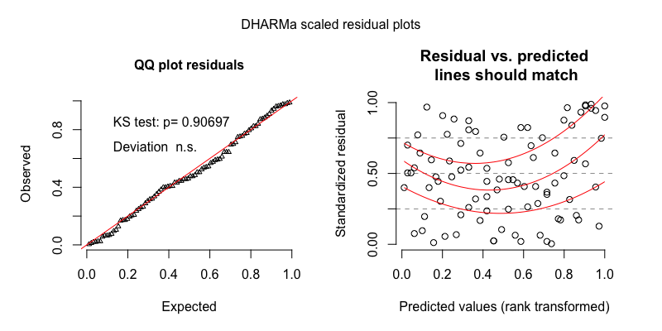

Figure 20 The model residuals from the zero-inflated negative binomial mixed-effects regression of O–TC turn transitions/min for the random sample.

Table 27

*Full output of the gaussian mixed-effects regression of O–TC turn transitions/min for the random sample, with midday as the reference level for time of day.*

|  |  |  |  |  |  |
| --- | --- | --- | --- | --- | --- |
| component | term | estimate | std.error | statistic | p.value |
| cond | (Intercept) | 1.01 | 0.12 | 8.09 | 0.00 |
| cond | tchiyr.std | 0.23 | 0.14 | 1.57 | 0.12 |
| cond | stthr.trimorning | 0.10 | 0.11 | 0.92 | 0.36 |
| cond | stthr.triafternoon | 0.00 | 0.10 | 0.00 | 1.00 |
| cond | hsz.std | -0.12 | 0.12 | -0.96 | 0.34 |
| cond | nsk.std | 0.07 | 0.05 | 1.33 | 0.18 |
| cond | tchiyr.std:stthr.trimorning | -0.02 | 0.12 | -0.17 | 0.87 |
| cond | tchiyr.std:stthr.triafternoon | -0.29 | 0.10 | -2.76 | 0.01 |
| cond | tchiyr.std:hsz.std | -0.03 | 0.15 | -0.19 | 0.85 |
| cond | tchiyr.std:nsk.std | 0.08 | 0.07 | 1.13 | 0.26 |
| random_effect | aclew_child_id | 0.19 | NA | NA | NA |
| random_effect | Residual | 0.36 | NA | NA | NA |

Table 28

*Model output of the gaussian mixed-effects regression of O–TC turn transitions/min for the random sample, with afternoon as the reference level for time of day.*

|  |  |  |  |  |  |
| --- | --- | --- | --- | --- | --- |
| component | term | estimate | std.error | statistic | p.value |
| cond | (Intercept) | 1.01 | 0.11 | 9.04 | 0.00 |
| cond | tchiyr.std | -0.06 | 0.13 | -0.45 | 0.66 |
| cond | stthr.tri.amidday | 0.00 | 0.10 | 0.00 | 1.00 |
| cond | stthr.tri.amorning | 0.10 | 0.09 | 1.06 | 0.29 |
| cond | hsz.std | -0.12 | 0.12 | -0.96 | 0.34 |
| cond | nsk.std | 0.07 | 0.05 | 1.33 | 0.18 |
| cond | tchiyr.std:stthr.tri.amidday | 0.29 | 0.10 | 2.76 | 0.01 |
| cond | tchiyr.std:stthr.tri.amorning | 0.27 | 0.10 | 2.66 | 0.01 |
| cond | tchiyr.std:hsz.std | -0.03 | 0.15 | -0.19 | 0.85 |
| cond | tchiyr.std:nsk.std | 0.08 | 0.07 | 1.13 | 0.26 |
| random_effect | aclew_child_id | 0.19 | NA | NA | NA |
| random_effect | Residual | 0.36 | NA | NA | NA |

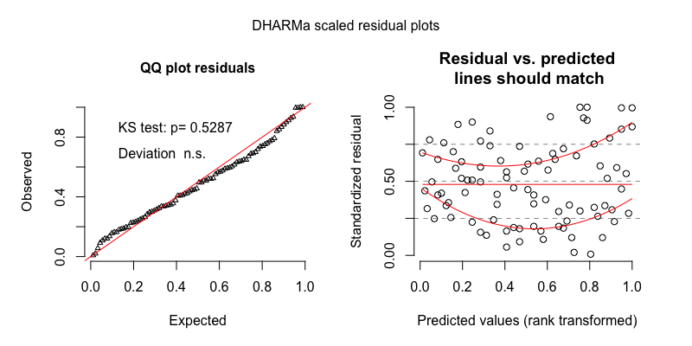

Figure 21 The model residuals from the gaussian mixed-effects regression of O–TC turn transitions/min for the random sample.

**Turn-taking clips**O–TC transitions/min in the turn-taking clips demonstrated a fairly normal distribution. We therefore modeled it using a plain (i.e., non-zero-inflated) negative binomial mixed-effects regression.

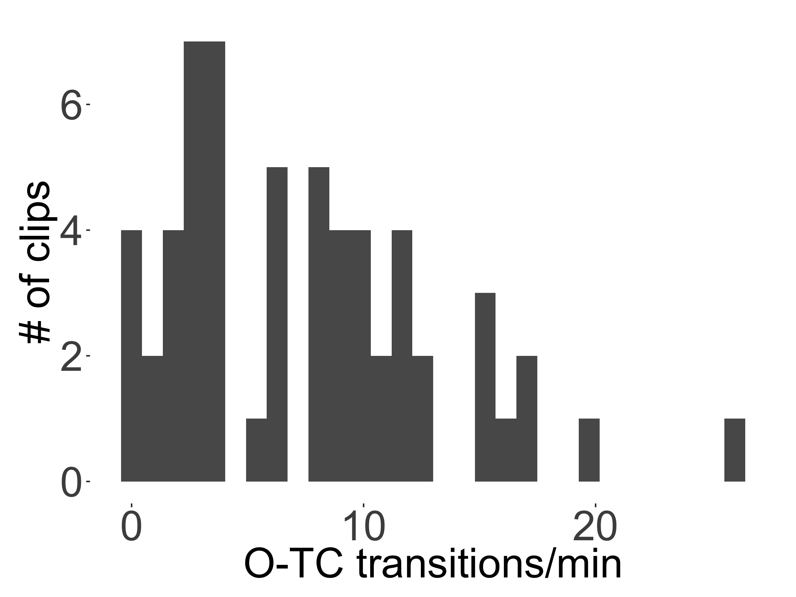

Figure 22 The distribution of O–TC turn transitions/min found across the 59 turn-taking clips.

Table 29

*Full output of the negative binomial mixed-effects regression of O–TC turn transitions/min for the turn-taking sample.*

|  |  |  |  |  |  |
| --- | --- | --- | --- | --- | --- |
| component | term | estimate | std.error | statistic | p.value |
| cond | (Intercept) | 1.84 | 0.29 | 6.32 | 0.00 |
| cond | tchiyr.std | 0.06 | 0.30 | 0.20 | 0.84 |
| cond | stthr.trimorning | -0.05 | 0.33 | -0.15 | 0.88 |
| cond | stthr.triafternoon | 0.03 | 0.28 | 0.10 | 0.92 |
| cond | hsz.std | -0.04 | 0.23 | -0.16 | 0.88 |
| cond | nsk.std | -0.23 | 0.12 | -1.88 | 0.06 |
| cond | tchiyr.std:stthr.trimorning | 0.12 | 0.31 | 0.39 | 0.69 |
| cond | tchiyr.std:stthr.triafternoon | -0.08 | 0.26 | -0.30 | 0.77 |
| cond | tchiyr.std:hsz.std | -0.19 | 0.28 | -0.66 | 0.51 |
| cond | tchiyr.std:nsk.std | 0.08 | 0.14 | 0.62 | 0.53 |
| random_effect | aclew_child_id | 0.31 | NA | NA | NA |

Table 30

*Model output of the negative binomial mixed-effects regression of O–TC turn transitions/min for the turn-taking sample, with afternoon as the reference level for time of day.*

|  |  |  |  |  |  |
| --- | --- | --- | --- | --- | --- |
| component | term | estimate | std.error | statistic | p.value |
| cond | (Intercept) | 1.87 | 0.25 | 7.55 | 0.00 |
| cond | tchiyr.std | -0.02 | 0.27 | -0.06 | 0.95 |
| cond | stthr.tri.amidday | -0.03 | 0.28 | -0.10 | 0.92 |
| cond | stthr.tri.amorning | -0.08 | 0.26 | -0.30 | 0.77 |
| cond | hsz.std | -0.04 | 0.23 | -0.16 | 0.88 |
| cond | nsk.std | -0.23 | 0.12 | -1.88 | 0.06 |
| cond | tchiyr.std:stthr.tri.amidday | 0.08 | 0.26 | 0.30 | 0.77 |
| cond | tchiyr.std:stthr.tri.amorning | 0.20 | 0.27 | 0.73 | 0.46 |
| cond | tchiyr.std:hsz.std | -0.19 | 0.28 | -0.66 | 0.51 |
| cond | tchiyr.std:nsk.std | 0.08 | 0.14 | 0.62 | 0.53 |
| random_effect | aclew_child_id | 0.31 | NA | NA | NA |

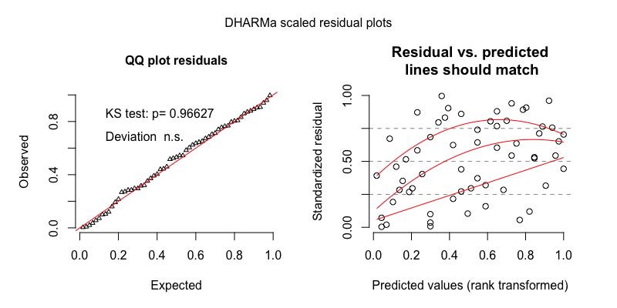

Figure 23 The model residuals from the negative binomial mixed-effects regression of O–TC turn transitions/min for the turn-taking sample.

Table 31

*Full output of the gaussian mixed-effects regression of O–TC turn transitions/min for the turn-taking sample, with midday as the reference level for time of day.*

|  |  |  |  |  |  |
| --- | --- | --- | --- | --- | --- |
| component | term | estimate | std.error | statistic | p.value |
| cond | (Intercept) | 2.01 | 0.25 | 8.10 | 0.00 |
| cond | tchiyr.std | 0.04 | 0.25 | 0.16 | 0.87 |
| cond | stthr.trimorning | -0.09 | 0.27 | -0.34 | 0.74 |
| cond | stthr.triafternoon | 0.04 | 0.22 | 0.16 | 0.87 |
| cond | hsz.std | 0.00 | 0.21 | -0.01 | 0.99 |
| cond | nsk.std | -0.20 | 0.10 | -1.98 | 0.05 |
| cond | tchiyr.std:stthr.trimorning | 0.17 | 0.25 | 0.66 | 0.51 |
| cond | tchiyr.std:stthr.triafternoon | 0.00 | 0.21 | -0.02 | 0.99 |
| cond | tchiyr.std:hsz.std | -0.13 | 0.26 | -0.52 | 0.61 |
| cond | tchiyr.std:nsk.std | 0.08 | 0.12 | 0.69 | 0.49 |
| random_effect | aclew_child_id | 0.30 | NA | NA | NA |
| random_effect | Residual | 0.53 | NA | NA | NA |

Table 32

*Model output of the gaussian mixed-effects regression of O–TC turn transitions/min for the turn-taking sample, with afternoon as the reference level for time of day.*

|  |  |  |  |  |  |
| --- | --- | --- | --- | --- | --- |
| component | term | estimate | std.error | statistic | p.value |
| cond | (Intercept) | 2.04 | 0.21 | 9.74 | 0.00 |
| cond | tchiyr.std | 0.04 | 0.24 | 0.15 | 0.88 |
| cond | stthr.tri.amidday | -0.04 | 0.22 | -0.16 | 0.87 |
| cond | stthr.tri.amorning | -0.13 | 0.22 | -0.59 | 0.56 |
| cond | hsz.std | 0.00 | 0.21 | -0.01 | 0.99 |
| cond | nsk.std | -0.20 | 0.10 | -1.98 | 0.05 |
| cond | tchiyr.std:stthr.tri.amidday | 0.00 | 0.21 | 0.02 | 0.99 |
| cond | tchiyr.std:stthr.tri.amorning | 0.17 | 0.23 | 0.75 | 0.46 |
| cond | tchiyr.std:hsz.std | -0.13 | 0.26 | -0.52 | 0.61 |
| cond | tchiyr.std:nsk.std | 0.08 | 0.12 | 0.69 | 0.49 |
| random_effect | aclew_child_id | 0.30 | NA | NA | NA |
| random_effect | Residual | 0.53 | NA | NA | NA |

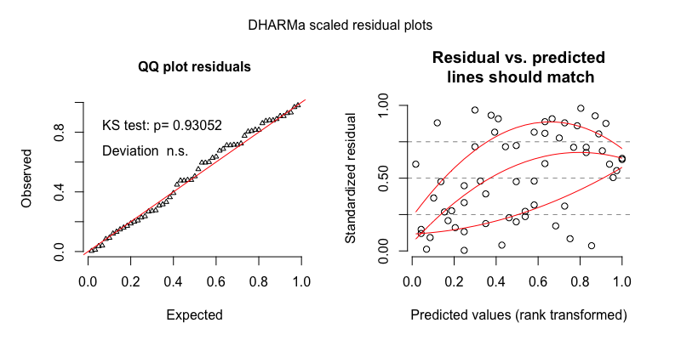

Figure 24 The model residuals from the gaussian mixed-effects regression of O–TC turn transitions/min for the turn-taking sample.

## Interactive sequence duration

**Random clips**Interactive sequence duration (in seconds) in the random clips demonstrated a slightly skewed, but unimodal distribution. We therefore modeled it using a plain (i.e., non-zero-inflated) negative binomial mixed-effects regression.

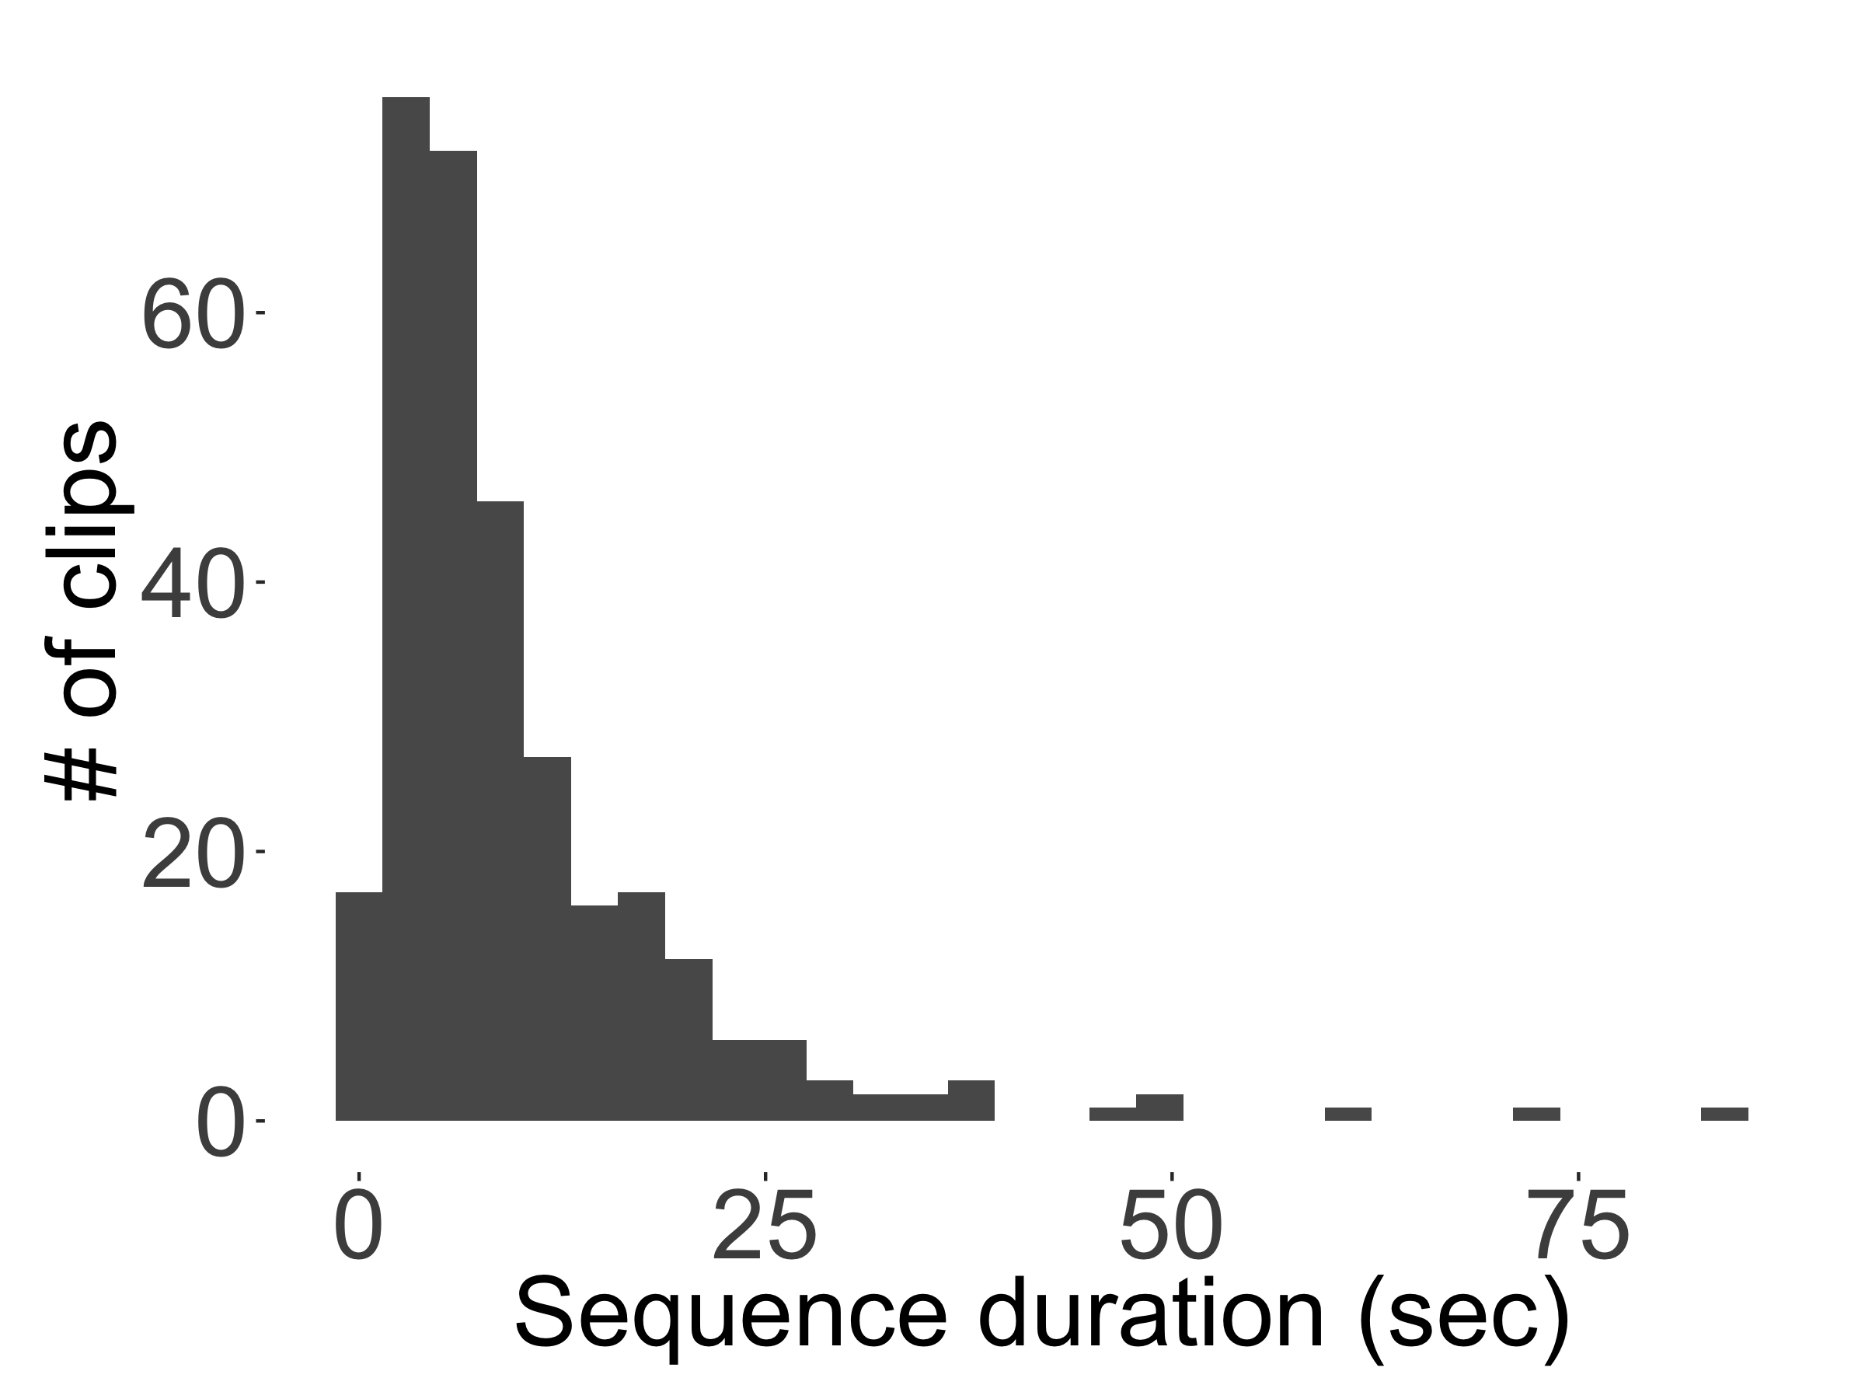

Figure 25 The distribution of interactive sequence duration (sec) found across the 90 random clips.

Table 33

*Full output of the negative binomial mixed-effects regression of interactive sequence duration (sec) for the random sample, with midday as the reference level for time of day.*

|  |  |  |  |  |  |
| --- | --- | --- | --- | --- | --- |
| component | term | estimate | std.error | statistic | p.value |
| cond | (Intercept) | 2.22 | 0.14 | 15.56 | 0.00 |
| cond | tchiyr.std | 0.11 | 0.19 | 0.55 | 0.58 |
| cond | stthr.trimorning | 0.14 | 0.17 | 0.78 | 0.44 |
| cond | stthr.triafternoon | 0.13 | 0.16 | 0.80 | 0.42 |
| cond | hsz.std | 0.01 | 0.08 | 0.12 | 0.90 |
| cond | nsk.std | 0.01 | 0.05 | 0.13 | 0.90 |
| cond | tchiyr.std:stthr.trimorning | 0.20 | 0.19 | 1.05 | 0.30 |
| cond | tchiyr.std:stthr.triafternoon | 0.04 | 0.18 | 0.26 | 0.80 |
| cond | tchiyr.std:hsz.std | 0.14 | 0.11 | 1.26 | 0.21 |
| cond | tchiyr.std:nsk.std | -0.03 | 0.06 | -0.51 | 0.61 |
| random_effect | uniq.segment | 0.11 | NA | NA | NA |
| random_effect | aclew_child_id | 0.00 | NA | NA | NA |

Table 34

*Model output of the negative binomial mixed-effects regression of interactive sequence duration (sec) for the random sample, with afternoon as the reference level for time of day.*

|  |  |  |  |  |  |
| --- | --- | --- | --- | --- | --- |
| component | term | estimate | std.error | statistic | p.value |
| cond | (Intercept) | 2.35 | 0.09 | 27.16 | 0.00 |
| cond | tchiyr.std | 0.15 | 0.12 | 1.26 | 0.21 |
| cond | stthr.tri.amidday | -0.13 | 0.16 | -0.80 | 0.42 |
| cond | stthr.tri.amorning | 0.01 | 0.12 | 0.06 | 0.95 |
| cond | hsz.std | 0.01 | 0.08 | 0.12 | 0.90 |
| cond | nsk.std | 0.01 | 0.05 | 0.13 | 0.90 |
| cond | tchiyr.std:stthr.tri.amidday | -0.04 | 0.18 | -0.26 | 0.80 |
| cond | tchiyr.std:stthr.tri.amorning | 0.15 | 0.13 | 1.17 | 0.24 |
| cond | tchiyr.std:hsz.std | 0.14 | 0.11 | 1.26 | 0.21 |
| cond | tchiyr.std:nsk.std | -0.03 | 0.06 | -0.51 | 0.61 |
| random_effect | uniq.segment | 0.11 | NA | NA | NA |
| random_effect | aclew_child_id | 0.00 | NA | NA | NA |

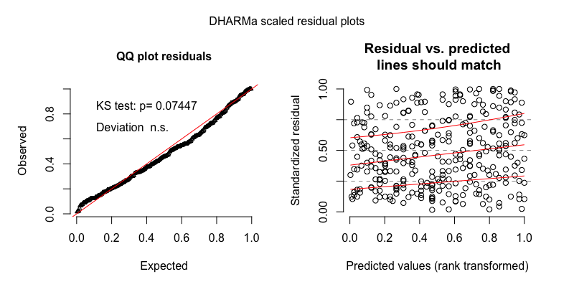

Figure 26 The model residuals from the negative binomial mixed-effects regression of interactive sequence duration (sec) for the random sample.

Table 35

*Full output of the gaussian mixed-effects regression of interactive sequence duration (sec) for the random sample, with midday as the reference level for time of day.*

|  |  |  |  |  |  |
| --- | --- | --- | --- | --- | --- |
| component | term | estimate | std.error | statistic | p.value |
| cond | (Intercept) | -2.24 | 0.18 | -12.46 | 0.00 |
| cond | tchiyr.std | 0.10 | 0.25 | 0.41 | 0.68 |
| cond | stthr.trimorning | 0.08 | 0.22 | 0.36 | 0.72 |
| cond | stthr.triafternoon | 0.13 | 0.20 | 0.65 | 0.51 |
| cond | hsz.std | 0.01 | 0.11 | 0.07 | 0.94 |
| cond | nsk.std | 0.01 | 0.06 | 0.17 | 0.87 |
| cond | tchiyr.std:stthr.trimorning | 0.34 | 0.24 | 1.39 | 0.16 |
| cond | tchiyr.std:stthr.triafternoon | 0.11 | 0.22 | 0.49 | 0.62 |
| cond | tchiyr.std:hsz.std | 0.17 | 0.14 | 1.15 | 0.25 |
| cond | tchiyr.std:nsk.std | -0.06 | 0.08 | -0.74 | 0.46 |
| random_effect | uniq.segment | 0.19 | NA | NA | NA |
| random_effect | aclew_child_id | 0.00 | NA | NA | NA |
| random_effect | Residual | 0.85 | NA | NA | NA |

Table 36

*Model output of the gaussian mixed-effects regression of interactive sequence duration (sec) for the random sample, with afternoon as the reference level for time of day.*

|  |  |  |  |  |  |
| --- | --- | --- | --- | --- | --- |
| component | term | estimate | std.error | statistic | p.value |
| cond | (Intercept) | -2.11 | 0.11 | -19.42 | 0.00 |
| cond | tchiyr.std | 0.21 | 0.16 | 1.36 | 0.18 |
| cond | stthr.tri.amidday | -0.13 | 0.20 | -0.65 | 0.51 |
| cond | stthr.tri.amorning | -0.05 | 0.15 | -0.36 | 0.72 |
| cond | hsz.std | 0.01 | 0.11 | 0.07 | 0.94 |
| cond | nsk.std | 0.01 | 0.06 | 0.17 | 0.87 |
| cond | tchiyr.std:stthr.tri.amidday | -0.11 | 0.22 | -0.49 | 0.62 |
| cond | tchiyr.std:stthr.tri.amorning | 0.22 | 0.17 | 1.34 | 0.18 |
| cond | tchiyr.std:hsz.std | 0.17 | 0.14 | 1.15 | 0.25 |
| cond | tchiyr.std:nsk.std | -0.06 | 0.08 | -0.74 | 0.46 |
| random_effect | uniq.segment | 0.19 | NA | NA | NA |
| random_effect | aclew_child_id | 0.00 | NA | NA | NA |
| random_effect | Residual | 0.85 | NA | NA | NA |

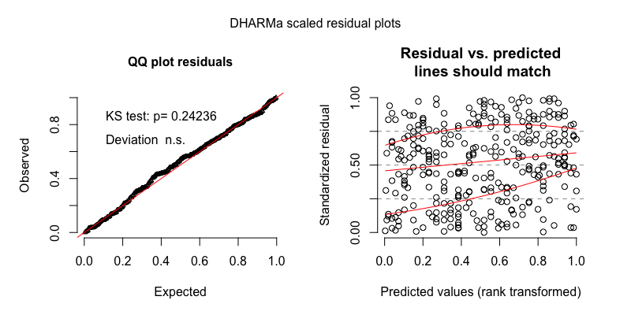

Figure 27 The model residuals from the gaussian mixed-effects regression of interactive sequence duration (sec) for the random sample.

**Turn-taking clips**Interactive sequence duration (in seconds) in the turn-taking clips also demonstrated a slightly skewed, but unimodal distribution. We therefore modeled it using a plain (i.e., non-zero-inflated) negative binomial mixed-effects regression.

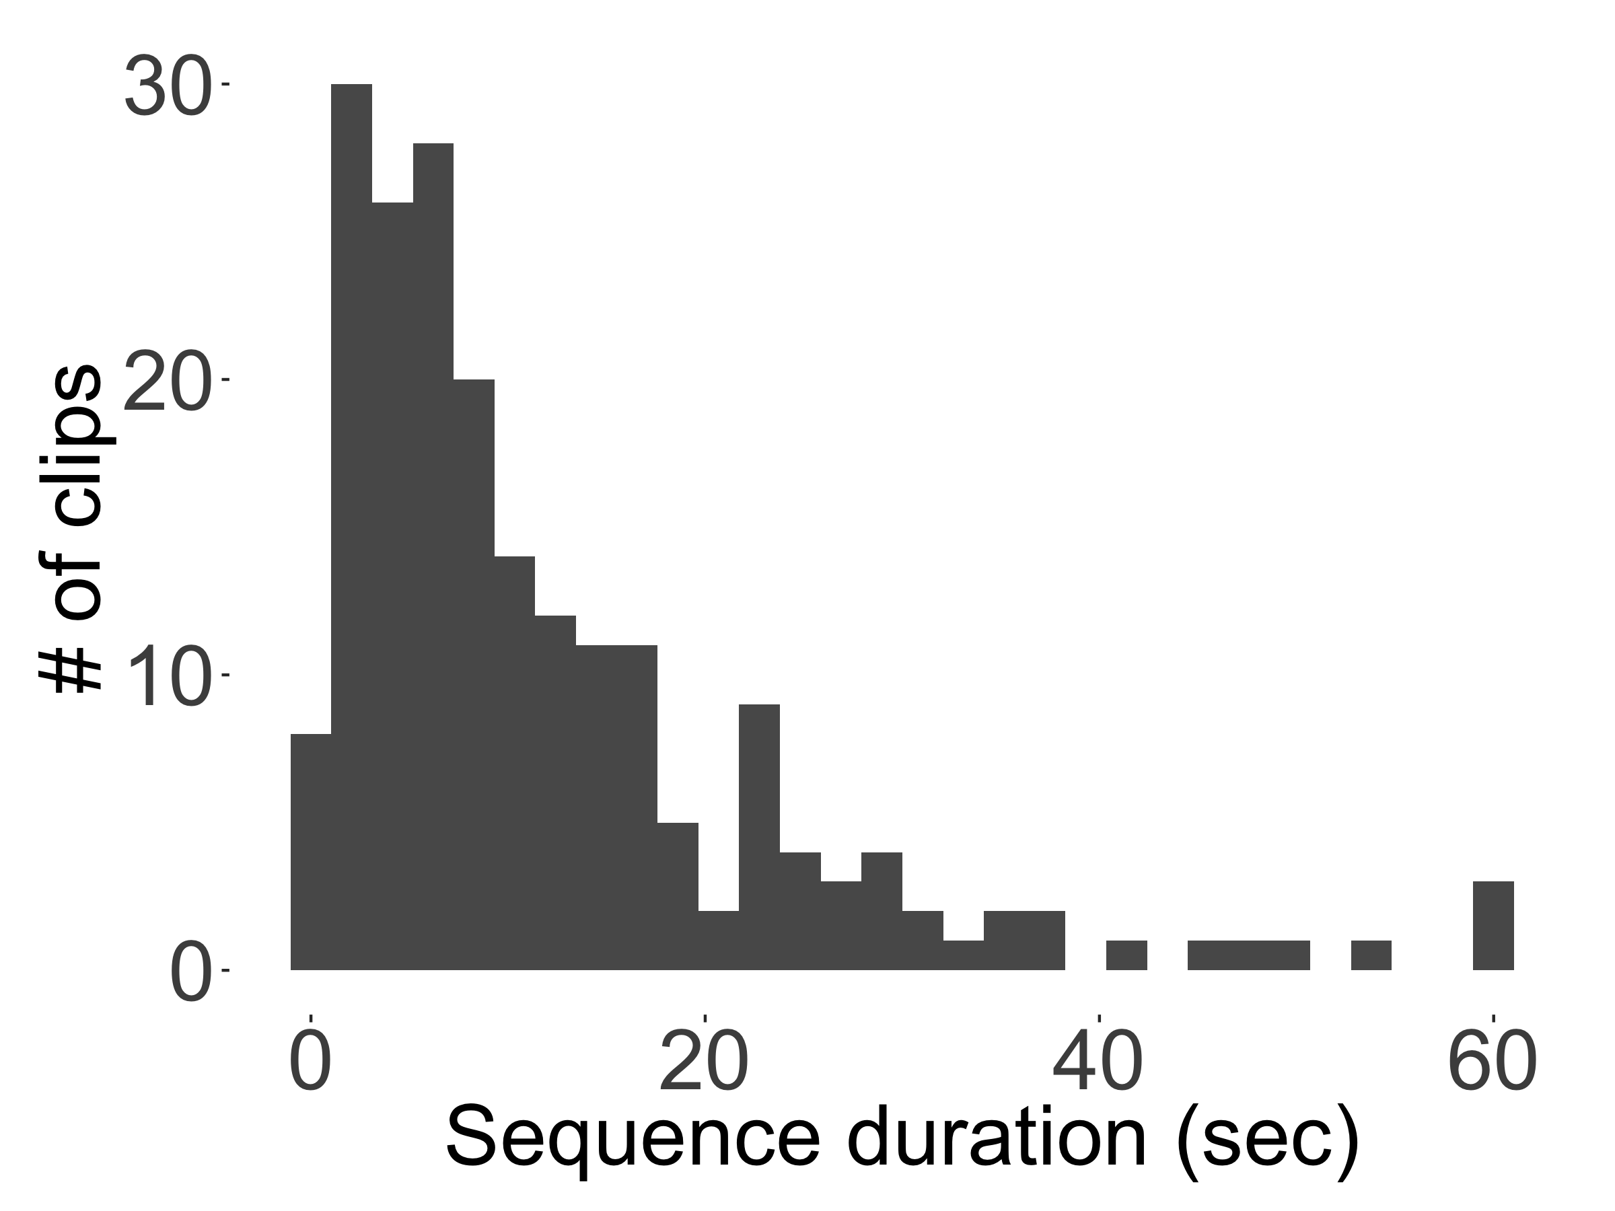

Figure 28 The distribution of interactive sequence duration (sec) found across the 59 turn-taking clips.

Table 37

*Full output of the negative binomial mixed-effects regression of interactive sequence duration (sec) for the turn-taking sample.*

|  |  |  |  |  |  |
| --- | --- | --- | --- | --- | --- |
| component | term | estimate | std.error | statistic | p.value |
| cond | (Intercept) | 2.25 | 0.14 | 16.54 | 0.00 |
| cond | tchiyr.std | -0.18 | 0.12 | -1.51 | 0.13 |
| cond | stthr.trimorning | 0.06 | 0.16 | 0.37 | 0.71 |
| cond | stthr.triafternoon | 0.38 | 0.14 | 2.61 | 0.01 |
| cond | hsz.std | -0.17 | 0.10 | -1.74 | 0.08 |
| cond | nsk.std | -0.01 | 0.06 | -0.18 | 0.85 |
| cond | tchiyr.std:stthr.trimorning | -0.02 | 0.17 | -0.12 | 0.90 |
| cond | tchiyr.std:stthr.triafternoon | 0.02 | 0.14 | 0.14 | 0.89 |
| cond | tchiyr.std:hsz.std | -0.18 | 0.13 | -1.37 | 0.17 |
| cond | tchiyr.std:nsk.std | 0.03 | 0.08 | 0.38 | 0.70 |
| random_effect | uniq.segment | 0.00 | NA | NA | NA |
| random_effect | aclew_child_id | 0.00 | NA | NA | NA |

Table 38

*Model output of the negative binomial mixed-effects regression of interactive sequence duration (sec) for the turn-taking sample, with afternoon as the reference level for time of day.*

|  |  |  |  |  |  |
| --- | --- | --- | --- | --- | --- |
| component | term | estimate | std.error | statistic | p.value |
| cond | (Intercept) | 2.63 | 0.12 | 20.93 | 0.00 |
| cond | tchiyr.std | -0.16 | 0.13 | -1.23 | 0.22 |
| cond | stthr.tri.amidday | -0.38 | 0.14 | -2.61 | 0.01 |
| cond | stthr.tri.amorning | -0.32 | 0.15 | -2.12 | 0.03 |
| cond | hsz.std | -0.17 | 0.10 | -1.74 | 0.08 |
| cond | nsk.std | -0.01 | 0.06 | -0.18 | 0.85 |
| cond | tchiyr.std:stthr.tri.amidday | -0.02 | 0.14 | -0.14 | 0.89 |
| cond | tchiyr.std:stthr.tri.amorning | -0.04 | 0.17 | -0.24 | 0.81 |
| cond | tchiyr.std:hsz.std | -0.18 | 0.13 | -1.37 | 0.17 |
| cond | tchiyr.std:nsk.std | 0.03 | 0.08 | 0.38 | 0.70 |
| random_effect | uniq.segment | 0.00 | NA | NA | NA |
| random_effect | aclew_child_id | 0.00 | NA | NA | NA |

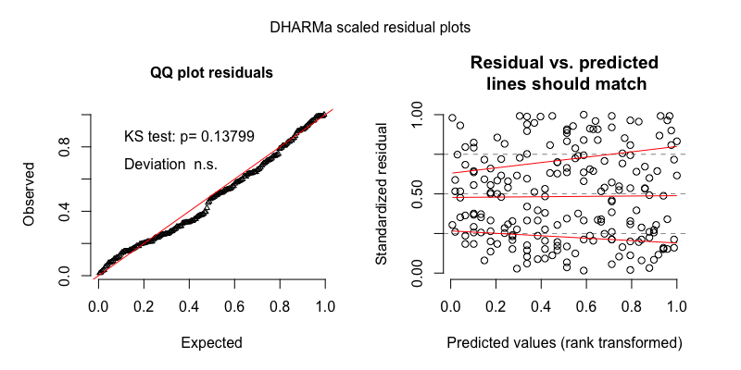

Figure 29 The model residuals from the negative binomial mixed-effects regression of interactive sequence duration (sec) for the turn-taking sample.

Table 39

*Full output of the gaussian mixed-effects regression of interactive sequence duration (sec) for the turn-taking sample, with midday as the reference level for time of day.*

|  |  |  |  |  |  |
| --- | --- | --- | --- | --- | --- |
| component | term | estimate | std.error | statistic | p.value |
| cond | (Intercept) | -2.33 | 0.16 | -14.96 | 0.00 |
| cond | tchiyr.std | -0.20 | 0.14 | -1.40 | 0.16 |
| cond | stthr.trimorning | 0.08 | 0.19 | 0.39 | 0.70 |
| cond | stthr.triafternoon | 0.57 | 0.18 | 3.11 | 0.00 |
| cond | hsz.std | -0.23 | 0.12 | -2.01 | 0.04 |
| cond | nsk.std | -0.02 | 0.07 | -0.32 | 0.75 |
| cond | tchiyr.std:stthr.trimorning | 0.02 | 0.20 | 0.08 | 0.94 |
| cond | tchiyr.std:stthr.triafternoon | -0.01 | 0.19 | -0.08 | 0.94 |
| cond | tchiyr.std:hsz.std | -0.20 | 0.15 | -1.32 | 0.19 |
| cond | tchiyr.std:nsk.std | 0.05 | 0.10 | 0.49 | 0.62 |
| random_effect | uniq.segment | 0.00 | NA | NA | NA |
| random_effect | aclew_child_id | 0.00 | NA | NA | NA |
| random_effect | Residual | 0.89 | NA | NA | NA |

Table 40

*Model output of the gaussian mixed-effects regression of interactive sequence duration (sec) for the turn-taking sample, with afternoon as the reference level for time of day.*

|  |  |  |  |  |  |
| --- | --- | --- | --- | --- | --- |
| component | term | estimate | std.error | statistic | p.value |
| cond | (Intercept) | -1.75 | 0.16 | -11.17 | 0.00 |
| cond | tchiyr.std | -0.22 | 0.17 | -1.29 | 0.20 |
| cond | stthr.tri.amidday | -0.57 | 0.18 | -3.11 | 0.00 |
| cond | stthr.tri.amorning | -0.50 | 0.19 | -2.58 | 0.01 |
| cond | hsz.std | -0.23 | 0.12 | -2.01 | 0.04 |
| cond | nsk.std | -0.02 | 0.07 | -0.32 | 0.75 |
| cond | tchiyr.std:stthr.tri.amidday | 0.01 | 0.19 | 0.08 | 0.94 |
| cond | tchiyr.std:stthr.tri.amorning | 0.03 | 0.21 | 0.14 | 0.89 |
| cond | tchiyr.std:hsz.std | -0.20 | 0.15 | -1.32 | 0.19 |
| cond | tchiyr.std:nsk.std | 0.05 | 0.10 | 0.49 | 0.62 |
| random_effect | uniq.segment | 0.00 | NA | NA | NA |
| random_effect | aclew_child_id | 0.00 | NA | NA | NA |
| random_effect | Residual | 0.89 | NA | NA | NA |

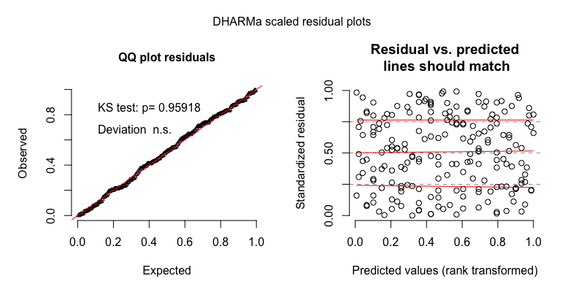

Figure 30 The model residuals from the gaussian mixed-effects regression of interactive sequence duration (sec) for the turn-taking sample.

# References

Brooks, M. E., Kristensen, K., van Benthem, K. J., Magnusson, A., Berg, C. W., Nielsen, A., … Bolker, B. M. (2017a). glmmTMB balances speed and flexibility among packages for zero-inflated generalized linear mixed modeling. *The R Journal*, *9*(2), 378–400. Retrieved from <https://journal.r-project.org/archive/2017/RJ-2017-066/index.html>

Brooks, M. E., Kristensen, K., van Benthem, K. J., Magnusson, A., Berg, C. W., Nielsen, A., … Bolker, B. M. (2017b). Modeling zero-inflated count data with glmmTMB. *bioRxiv*. doi:[10.1101/132753](https://doi.org/10.1101/132753)