Early language experience in a Papuan community

Abstract

Daylong recordings capture many patterns within children’s typical language experience, including how linguistic input rate varies depending on child age, time of day, and number of speakers present. We used daylong recordings to investigate how much speech is available to young children (0;0–3;0) on Rossel Island, Papua New Guinea; a community where prior ethnographic study demonstrated face-to-face contingency-seeking interactional styles with infants and young children. We found that the patterns of children’s daylong language experience were somewhat different from that seen in prior ethnographic work. Children were infrequently directly addressed and their linguistic input rates were primarily affected by circumstantial aspects of everyday life (e.g., the presence of other speakers). We discuss the different insights afforded by these approaches in a comparative cross-cultural framework and how the daylong and ethnographic findings together shed light on the question of how minimal direct linguistic input can support first language development.

*Keywords:* Child-directed speech, linguistic input, non-WEIRD, vocal maturity, interaction, Papuan

Word count: 12606 (10871 not including references)

Early language experience in a Papuan community

# Introduction

In their first few years of life, children hear an extraordinary amount of language. The sum of this linguistic and interactional experience (referred to as their “input”) is the basis for their lexical, grammatical, and sociolinguistic development. In particular, much developmental language research focuses on the value of child-directed speech as a tailored source of linguistic input that can boost lexical and syntactic development (Bates & Goodman, 1997; Brinchmann, Braeken, & Lyster, 2019; Frank, Braginsky, Marchman, & Yurovsky, in preparation; Hart & Risley, 1995; Hoff, 2003; Huttenlocher, Waterfall, Vasilyeva, Vevea, & Hedges, 2010; Lieven, Pine, & Baldwin, 1997; Marchman, Martínez-Sussmann, & Dale, 2004; Shneidman & Goldin-Meadow, 2012; Weisleder & Fernald, 2013). However, we also know that language environments—e.g., who is around, talking about what to whom, and where—vary dramatically within and across families, with children in some communities hearing very little directed talk yet not showing any apparent delays in their linguistic development (Brown, 2011, 2014; Brown & Gaskins, 2014; Casillas, Brown, & Levinson, 2019; Gaskins, 2006; Ochs & Schieffelin, 1984). The key puzzle is then unmasking how the human cognitive toolkit for language learning can flexibly adapt to the variable contexts under which it successfully occurs. The first step along the way is actually documenting this variation.

Tracking the distribution and characteristics of this linguistic input over multiple interactional contexts, across developmental time, and between different families is a difficult task. Traditionally, developmental language science has relied on short cross-sectional or longitudinal video recordings of caregiver-child interaction, at home or in the lab, to get a grasp on what kinds of language children typically hear. This approach has been fruitful in teasing out individual and group-based differences in interactional behaviors (Cartmill et al., 2013; Hoff, 2003; Hurtado, Marchman, & Fernald, 2008; Rowe, 2008). However, over the last decade or so, a new method for tracking child language experience has gained rapid popularity: daylong recordings. Daylong recordings are typically made from a single audio recorder worn by the target child at home, unleashing participants from the constraint of being within direct view of a fixed camera or a mobile camera operator, and thereby allowing them to more freely navigate their environment for multiple hours at a time. Unfortunately, however, daylong recordings often require immense resources in order to extract linguistic information from the audio signal.

Daylong recordings may therefore appear at first blush to have little value in settings where researchers can instead invest their time in ethnographic microanalysis with selective, short video recordings that have high emic validity and which are typically annotated with detailed linguistic and interactional information. In particular, researchers investigating language development outside of their own cultural context may struggle in deciding which approach is best; identifying ‘typical’ or ‘representative’ behaviors to record and measure requires intensive familiarization with participating families and the community at large, but hasty collection and analysis of daylong data risks mischaracterizing language use and language learning in that community. In the present study we investigate the differing perspectives offered by intensive, close analysis of short video recordings collected during ethnographic study and broad, panoramic audio recordings of the language landscape using daylong methods. We contrast the use of these two approaches—hereafter the Close Study approach and the Panoramic approach—in a single language community: Rossel Island (Milne Bay Province, Papua New Guinea).

## The Close Study approach

Short, multimodal recordings (e.g., audio plus video data, motion tracking, or eye movements), give rich insight into the moment-to-moment characteristics of interaction. The increased context provided by multi-modal recordings helps discern the meaning of each communicative behavior documented. Such recordings can be made in nearly any context and each individual video takes little time to collect. When richly transcribed, annotated, and paired with intensive ethnographic study, these recordings become potent samples of language development in the studied community that can be used again and again for a wide variety of linguistic and interactional analyses.

In the Close Study approach, ethnographic work is essential for appropriately situating recording collection, choosing behaviors for analysis, and interpreting data within the realm of normal and relevant behaviors for the studied community. In practice, this approach means that decisions on what to study and precisely how to study it are informed by knowledge of daily tasks, typical household relations and responsibilities, attitudes about childrearing, considerations about when children qualify as co-interactants, and what behaviors are expected of children and caregivers in the first years of life. In a situation where the researcher is a member of the community under study (e.g., middle-class US researchers investigating language development in middle-class US families), assumptions about what to study and how are implicitly enriched by this knowledge. However, when the researcher is a visitor to the community, selecting the right measures and finding ways to compare them to child development outcomes in other sites is an serious challenge.

The drawbacks of the Close Study approach are few but significant. First, the time and financial investment needed to gain familiarity with a community and to add detailed, comprehensive annotation and transcription to the gathered recordings limit the feasible sample size of most studies; language development in a handful of focal children may provide many insights, but may take decades of dedicated work to explore in depth. Second, while researchers using this method can diligently track a variety of interactional contexts, the anchoring effect of a single video camera or audio recorder on the child (and caregivers) makes it difficult to capture daily activities that involve a lot of free motion (e.g., talking while running around) or talk during activities that are not readily accessible to others, even researchers on close terms with the recorded family (e.g., pre-sleep routines). There may be important sources of linguistic information during these hard-to-capture activities. In brief, it is difficult to capture the wide variety of activities involving language across the course of whole waking days. Finally, unless a microphone is worn by the child (e.g., Demuth, Culbertson, & Alter, 2006), whispered speech, speech to self, and other quiet but hearable events are difficult to capture from a third-person recording perspective.

## The Panoramic approach

Improved recording hardware and advances in speech technology in the last 20 years have allowed us to peek into children’s broader language landscapes. These recordings give a bird’s eye view into the ebb and flow of everyday language activity, inclusive of both animated chatter while running with siblings and comforting whispers that guide the child into a bout of sleep. This broadened view is uniquely suited to estimating the total linguistic input children encounter, and the typical axes on which this input rate varies (e.g., specific speakers, times of day, etc.). Accurate measures of linguistic input are critical for investigating how much experience is needed to acquire a given linguistic or communicative phenomenon. Starting up daylong recordings is quick and straightforward—the main hurdle is getting the child to wear the vest/shirt in which the recorder is placed—and researchers have had success implementing these recordings in multiple cultural contexts (e.g., with English-, Tseltal-, bilingual Quechua-Spanish-, Tsimane-, and Spanish-learning children, among others, see Bergelson et al., in preparation for more; Bergelson, Amatuni, Dailey, Koorathota, & Tor, 2019a; Casillas et al., 2019; Cychosz et al., under reviewa; Weisleder & Fernald, 2013). The most popular daylong recording system is the LENA, which comes with a recording device that captures up to 16 hours of audio at a time and comes with software for automatically analyzing basic properties of the speech signal (Xu, Yapanel, & Gray, 2009). The LENA system is expensive, but is not the only route to daylong data; several groups have successfully experimented with daylong recordings using other devices (e.g., Olympus, Zoom, USB recorder) paired with manual and/or automated annotation (for a review, see Casillas & Cristia, 2019). Once an efficient pipeline for annotation is established, daylong recordings can also be used to collect comparable recordings from large, representative samples of a given language community.

The Panoramic approach has several significant drawbacks (Casillas & Cristia, 2019; Cychosz et al., acceptedb), particularly for research questions that involve linguistic analysis. Here we focus on those drawbacks that prevail even when we assume that the researcher has some resources to add manual or automated linguistic annotation. First, the resulting recording collections are typically too large for comprehensive transcription or annotation, with no easy way to scan for the specific phenomena of interest. Researchers must therefore employ some strategic sub-sampling technique in order to annotate the data, even though best practices for doing so are not yet well established (Casillas & Cristia, 2019). Second, even once clips are sampled from the daylong recording, adding relevant annotations to them can take nearly as long as a Close Study approach, but with reduced likelihood of capturing interesting or relevant caregiving and language use behaviors. Third, while a whole day of recording feels, relatively, like a lot of data, it is unlikely to yield an estimate that holds stably across multiple days in the week (Anderson & Fausey, 2019). A fourth drawback is that properly collecting, processing, and archiving daylong data is not easily achieved; the fact that participants habituate to the recorder is fantastic for documenting ecologically valid language use, but raises urgent questions about participant privacy standards (Cychosz et al., acceptedb). Fourth, at time of writing, there are few options for capturing visual information across the day (but see Casillas et al. (2019) and our method below), limiting this method primarily to acoustic phenomena. Even if researchers add manual annotation to these audio files, they typically do so without the benefit of visual context; a difficulty compounded by the diversity of activities and interlocutors captured over the recording.

## Differing perspectives on the child language environment

Which approach should one choose when describing children’s language environments? The Close Study approach takes the general stance that richer data is better data, with the primary problem being that the researcher can’t know how well their zoomed-in perspective generalizes to the rest of the population. The Panoramic approach takes the general stance that more data is better data, with the primary problem being that the researcher can’t know if they are measuring the right phenomena, particularly when importing pre-conceived notions about learning into culturally unfamiliar contexts. The ideal solution, of course, is to thoroughly annotate and analyze large, representative samples of data, but doing so would require many years of well-funded multi-researcher commitment—a risky prospect for a basic descriptive question.

One alternative approach is to add complementary data to a community where one approach has already been taken. For example, extensive ethnographic research among multiple indigenous Mayan communities of Southern Mexico and Guatemala has forged a consistent view of childrearing and child-directed speech: adult caregivers shape infants’ and young children’s worlds such that the children learn to attend to what is going on around them rather than expecting to be the center of attention (e.g., Brown, 2011, 2014; de León, 2011; Gaskins, 2000; Pye, 1986; Rogoff, Paradise, Arauz, Correa-Chávez, & Angelillo, 2003). These findings lay out an extensive ideology of caregiving, including a number of component attitudes (e.g., infants as inappropriate/inadequate conversational partners) that can be used to make predictions about quantitative features of Mayan children’s linguistic input. Importantly, however, it is not clear how these attitudes play out on the scale of daylong averages; preferences for when and how to talk to children are balanced by the many other demands of everyday life. On this view, we may feel certain that the Panoramic view indeed captures the transmission of critical linguistic and cultural knowledge, but we can’t point to where it happens. That said, a handful of findings up until now suggest a promising, though imperfect link between the attitudes and ideologies described in Close Study work and the average behavioral patterns from Panoramic work in those same communities.

In the case of Mayan child language environments, findings using a larger-sample or Panoramic-type approach have been fairly consistent with the caregiving practices described in previous Close Study work. Shneidman (2012) used short videos of interaction to conduct a quantitative, longitudinal study of the Yucatec children’s typical speech experiences. She indeed found that infants were rarely spoken to, but that the prevalence of speech directed to children increased enormously with age, mostly due to an influx of speech from other children. That said, the input rate from adults predicted children’s later vocabulary size more than their total input rate. Casillas and colleagues (2019) used daylong recordings with children in a Tseltal Mayan community, again finding that infants and young children were spoken to rarely. However, they found no increase in speech input with age, and the majority of speech came from adult women, even when children were old enough to independently follow their older siblings and cousins around. The studies collectively suggest that, consistent with Close Study work in these and similar communities, (female) adult speech to infants and young children is relatively rare, but is a prominent and predictive source of linguistic input in Mayan children’s language development.

Studies in a North American context, in which North American researchers can more reliably depend on their own intuitions about language learning, have also tried to pinpoint the differences in close and panoramic views of the child language environment: short recordings display much denser input, with some changes in the types of language used, compared to longer recordings (Bergelson et al., 2019a; Tamis-LeMonda, Kuchirko, Luo, Escobar, & Bornstein, 2017). For example, Bergelson and colleagues (Bergelson et al., 2019a) analyzed the noun use encountered by 44 6- and 7-month-old children in the US in both hour-long at-home videos and comparable sub-samples of daylong audio recordings. The video and daylong data were markedly different in linguistic input rate; nouns were used 2–4 times more often in the videos. The authors also found some differences in input type: nouns were more likely to come embedded in questions in the videos, but the daylong data featured more noun types and noun input from more speakers (see Bergelson et al. (2019a) for the full range of differences). Other than these differences, the overall profile of input *type* was quite similar between the video data and the daylong recording sub-samples (e.g., relative use of speech act types). Other work using varying durations of video (i.e., short-structured vs. longer-unstructured) with US child-caregiver pairs also found lower estimates for the rate of linguistic input in longer recordings, but found that children’s relative rank was stable across the two recording contexts (Tamis-LeMonda et al., 2017).

Based on these findings from both the Mayan and US contexts, one might infer that the language use captured by Panoramic recordings is driven, at least in part, by the same factors driving language patterns highlighted in Close Study work. However, these preliminary results also hint at divergences between what caregivers do when they know they are being recorded for a short period versus what they do when juggling childcare with the diverse activities and interlocutors encountered during a longer stretch at home. In trying to understand how children’s language environments impact their language learning, researchers seek meaningful variation in children’s linguistic experience; it may be that, with panoramic data, much of the variation children encounter has less to do with their caregivers’ ideological stance toward talking to young children and more to do with who else is around and what other tasks are at hand. Relatedly, shorter recordings may be more likely to face the Observer’s Paradox (Labov, 1972, p. 209), in which the participants’ behaviors are changed by the mere presence of the researcher, even if only via their equipment left behind. This paradox is likely still an issue for daylong recordings, but potentially in more subtle ways (e.g., a household member spending the recording day elsewhere to avoid having to self-monitor for hours at a time).

Whether the circumstantial variation documented in daylong recordings has significant predictive validity for a range of linguistic skills is a question in need of further research. For example, it is difficult at present to determine the extent to which Mayan children hear less directed input because of the childrearing practices traditional to these communities or because of other features of their lifestyle (e.g., subsistence farming effects on who is present, number of other children present, etc.; see also Shneidman and Goldin-Meadow (2012)). The other population for which we have findings, US families, differs greatly from these Mayan communities in the circumstances of their everyday life (e.g., work patterns, number of co-residents, child sleeping routines), not to mention the structure of society as a whole (e.g., massive and systemic economic inequality in the US vs. near-level economic standing across these Mayan subsistence farming families). In brief, the Mayan and US study contexts differ not only in reported caregiver ideologies about talking to children, but also in how daily life is fundamentally structured; it is therefore unclear which of these two sources of variation (ideology or the structure of daily life) can explain the findings that Mayan children hear relatively little child-directed speech. In order to disentangle these two potential causes, we need to collect Close Study and Panoramic findings in a *third* population; one in which caregivers consider infants and young children to be potential conversational partners (i.e., more child-centric; similar to the US context) and, at the same time, maintaining a comparable subsistence farming lifestyle to the Mayans. We here analyze child language environments from one such community.

## The current study

In this study we present analyses of daylong recordings from a small-scale indigenous community, on Rossel Island, Papua New Guinea (PNG), in which prior ethnographic work by the second and third authors and prior Close Study work by the first and second authors (Brown & Casillas, in press) has painted a clear picture of early caregiver-child interaction: child-centric, face-to-face interaction from the first days of infancy. Based on those findings, which we detail below, we made four predictions about children’s speech environments. First, we predicted that children on Rossel Island would hear frequent child-directed speech from a wide variety of caregiver types throughout the day. Second, given that infants are frequently passed between caregivers, we expected to see somewhat weaker effects of the subsistence farming schedule on Rossel children’s input than has been found in other subsistence farming societies like the Tseltal Mayans (Casillas et al., 2019). Third, as children get older, we expected to see a large increase in the proportion of child-directed speech coming from other children, as seen in the Yucatec Mayan community (Shneidman & Goldin-Meadow, 2012). Fourth, we expected a large quantity of other-directed speech around them, given the large number of family numbers typically present.

We also expected to replicate three language environment patterns that have consistently emerged across Western and non-Western daylong recording studies (i.e., not specific to Rossel Island): (a) stability in child-directed speech rate across age (i.e., no increase; Bergelson et al., 2019b; Casillas et al., 2019; Scaff, Stieglitz, Casillas, & Cristia, in preparation), (b) a decrease in other-directed speech rate across age (Bergelson et al., 2019b; Casillas et al., 2019), and (c) a non-uniform, bursty distribution of directed talk over the day (Abney, Smith, & Yu, 2017; Casillas et al., 2019).

In what follows we will review the ethnographic work done in this community previously, describe our methods for following up on these findings with daylong recordings, present the current findings, and discuss the differences that arose. This study was completed as part of a larger comparative project focusing on children’s speech environments and linguistic development at two sites: the Tseltal Mayan community mentioned above and this Rossel Island community. Therefore all methods for annotation and analysis in this study parallel those reported elsewhere for Tseltal Mayan children’s speech environments (Casillas et al., 2019).

# Method

## Corpus

The participants in this study live in a collection of small hamlets on north-eastern Rossel Island, approximately 250 nautical miles off the southern tip of mainland Papua New Guinea with only intermittent access to and contact with the outside world. The traditional language of Rossel Island is Yélî Dnye, an isolate (Papuan), which features a phonological inventory and set of grammatical features that are unlike any other in the (predominantly Austronesian) languages of the region. The islanders are subsistence farmers, cultivating taro, sweet potato, manioc, yam, coconut, and more for their daily subsistence, with protein coming from fishing and (occasionally) slaughtering pigs or local animals. Children also often forage independently for shellfish and wild nuts, providing an extra source of protein. Most children on Rossel Island grow up speaking Yélî Dnye monolingually at home, beginning to learn English as a second language once they begin school around age 7 or 8. Children grow up in patrilocal household clusters (i.e., their family and their father’s brothers’ families), usually arranged such that there is some shared open space between households.

During their waking hours, infants are typically carried in a caregiver’s arms as they go about daily activities. Infants, even very young ones, are frequently passed between different family members (male and female, young and elderly) throughout the day, returning to the mother to suckle when hungry. The arc of a typical day for an infant might include waking, being dressed and fed, then a mix of (a) spending time with nearby adults or older children as they walk around socializing and completing tasks with others and (b) more feeding, perhaps followed by short bouts of sleep in the late morning and afternoon, usually with the mother. Sometimes children are also taken to the gardens with their caregivers after the morning meal. Afternoon meals are cooked from around 15:00 onward, with another meal time and more socializing at home before resting for the night. Starting around age two or three, children also begin to spend a lot of their time in large, independent child playgroups involving up to 10 or more cousins and neighbors at a time who freely travel near and around the village searching for nuts and fruits, bathing in nearby rivers, and engaging in group games (e.g., tag, pretend play, etc.).

Interaction with infants and young children on Rossel Island is initiated by women, men, girls, and boys alike in a face-to-face, contingency-seeking, and affect-laden style (Brown, 2011; Brown & Casillas, in press). Children are considered a shared responsibility, but also a source of joy and entertainment for the wider network of caregivers in their community. In her prior ethnographic work, Brown details some ways in which interactants make bids for joint attention and act as if the infant can understand what is being said (Brown, 2011). Infants pick up on this pattern of caregiving, initiating interactions with others twice as frequently as Tseltal children, who are encouraged instead to be observers of the interactions going on around them (Brown, 2011). At the same time, Brown and Casillas (in press) document how Rossel caregivers encourage early independence in their children, observing their autonomy in choosing what to do, wear, eat, and say while finding other ways to promote pro-social behavior (e.g., praise). Overall, Rossel Island could be characterized as a child-centered language environment (but see Brown & Casillas, in press; Ochs & Schieffelin, 1984), in which children, even very young ones, are considered interactional and conversational partners whose interests are often allowed to shape the topic and direction of conversation.

The data presented here come from the Rossel Island subset of the Casillas HomeBank Corpus (Casillas, Brown, & Levinson, 2017), a collection of raw daylong recordings and supplementary data from over 100 children under age four growing up on Rossel Island and in the Tseltal Mayan community described elsewhere (Casillas et al., 2019). The Rossel Island subcorpus was collected in 2016 and includes daylong audio recordings and experimental data from 57 children born to 43 mothers. These children had 0–2 younger siblings (mean = 0.36; median = 0) and 0–5 older siblings (mean = 2; median = 2); most participating caregivers were on the younger end of those in the community (including two pairs of primary caregivers who are their child’s biological grandparents: mean = 33.9 years; median = 32; range = 24–70 and fathers: mean = 35.6; median = 34; range = 24—57). Based on available demographic data for 40 of the biological mothers we estimate that mothers are typically 21.4 years old when they give birth to their first child (median = 21.5; range = 12–30). On the basis of sufficient demographic data for 34 of those mothers, we estimate an average inter-child interval of 2.8 years (median = 2.6; range = 1.75–5.2). Notably, however, we received several reports, including from nursing staff at the local health clinic, that mothers now are having children younger and closer together than in generations past. Household size, defined here as the number of people sharing kitchen and sleeping areas on a daily basis, ranged between 3 and 12 (mean = 7; median = 7). Households are clustered into small patrilocal hamlets which form a wider group of communal caregivers and playmates. The hamlets themselves are clustered together into patches of more distantly related patrilocal residents. The average hamlet in our corpus comprises 5.8 households (median = 5; range = 3–11); the typical household in our dataset has 2 children under age seven (i.e., not yet attending school) and 2 adults, leading us to estimate that there are around 10 young children and 10 adults present within a hamlet throughout the day. This estimate does not include visitors to the target child’s hamlet or relatives the target child encounters while visiting others. Therefore, while 24.6% of the target children in our corpus are first born to their mothers, these children are incorporated into a larger pool of young children whose care is divided among numerous caregivers. Among our participating families, most mothers had finished their education at one of the island’s schools (6 years of education = 32.6%; 8 years of education = 37.2%)[1], with about a quarter having attended secondary school off the island (10 years of education = 25.6%; 12 years of education = 2%). Only one mother had less than six years of education. Similarly, most fathers had finished their education at one of the island’s schools (6 years of education = 44.2%; 8 years of education = 20.9%) or at an off-island secondary school (10 years of education = 27.9%), with only 7% having less than six years of education. Note that in Table 1 we use a different set of educational levels than is used on the island so that we can more easily compare the present sample to that used in Casillas et al. (2019) (see the table caption for details). To our knowledge at the time of recording, all but two children were typically developing; one showed signs of significant language delay and one showed signs of multiple developmental delay (motor, language, intellectual). Both children’s delays were consistently observed in follow-up trips in 2018 and 2019. Their recordings are not included in the analyses reported below.

Dates of birth for children were initially collected via parent report. We were able to verify the vast majority of birth dates using the records at the island health clinic. Because not all mothers give birth at the clinic and because dates are written by hand, some births are not recorded, are inaccurately recorded, or otherwise significantly diverge from what the parents report. In these cases we gathered information from as many sources as possible and followed up with the families, often using the dates of neighboring children born around the same time to home in on the correct date.

The data we present come from 7–9-hour recordings of a waking day at home for the child. Children wore the recording device: an elastic vest containing a small stereo audio recorder (Olympus WS-832 or WS-853) and a miniature camera that captured photos of the child’s frontal view at a fixed interval (every 15 seconds; Narrative Clip 1). The camera was outfitted with a fisheye lens that, while distorting the images, allowed us to capture 180 degrees of the child’s frontal view. This technique allows us to use daylong recordings while also partially getting around the lack of visual context typical for daylong recordings, thereby increasing the ease and reliability of our transcription and annotation. However, because the camera and recorder are separate devices, we had to synchronize them manually after the recordings were made. To do this, we used an external wristwatch to record the current time at start of recording on each device individually, with accuracy down to the second (photographed by the camera and spoken into the recorder). The camera’s software timestamps each image file such that we can calculate the number of seconds that have elapsed between photos. These timestamps can be used with the cross-device time synchronization cue to create photo-linked audio files of each recording, which we then format as video files (see URL_MASKED_FOR_REVIEW for post-processing scripts and more information). The informed consent process used with participants, as well as data collection and storage, were conducted in accordance with ethical guidelines approved by the Radboud University Social Sciences Ethics Committee.

Table 1:

*Demographic overview of the 10 children whose recordings are sampled in the current study, including from left to right: child’s age (years;months.days); child’s sex (M/F); mother’s age (years); highest level of maternal education achieved (none (0 years)/primary (6 years)/secondary (8 years)/preparatory (12 years)); and the number of people living in the child’s household.*

|  |  |  |  |  |
| --- | --- | --- | --- | --- |
| Age | Sex | Mother’s age | Level of maternal education | People in household |
| 00;01.09 | F | 31 | secondary | 8 |
| 00;03.19 | M | 37 | primary | 9 |
| 00;04.13 | M | 24 | preparatory | 5 |
| 00;07.18 | M | 24 | secondary | 5 |
| 00;09.03 | F | 29 | secondary | 5 |
| 01;00.29 | F | 30 | primary | 9 |
| 01;05.02 | M | 25 | secondary | 6 |
| 01;08.03 | F | 33 | primary | 9 |
| 02;01.22 | F | 21 | secondary | 4 |
| 02;11.29 | M | 41 | primary | 8 |

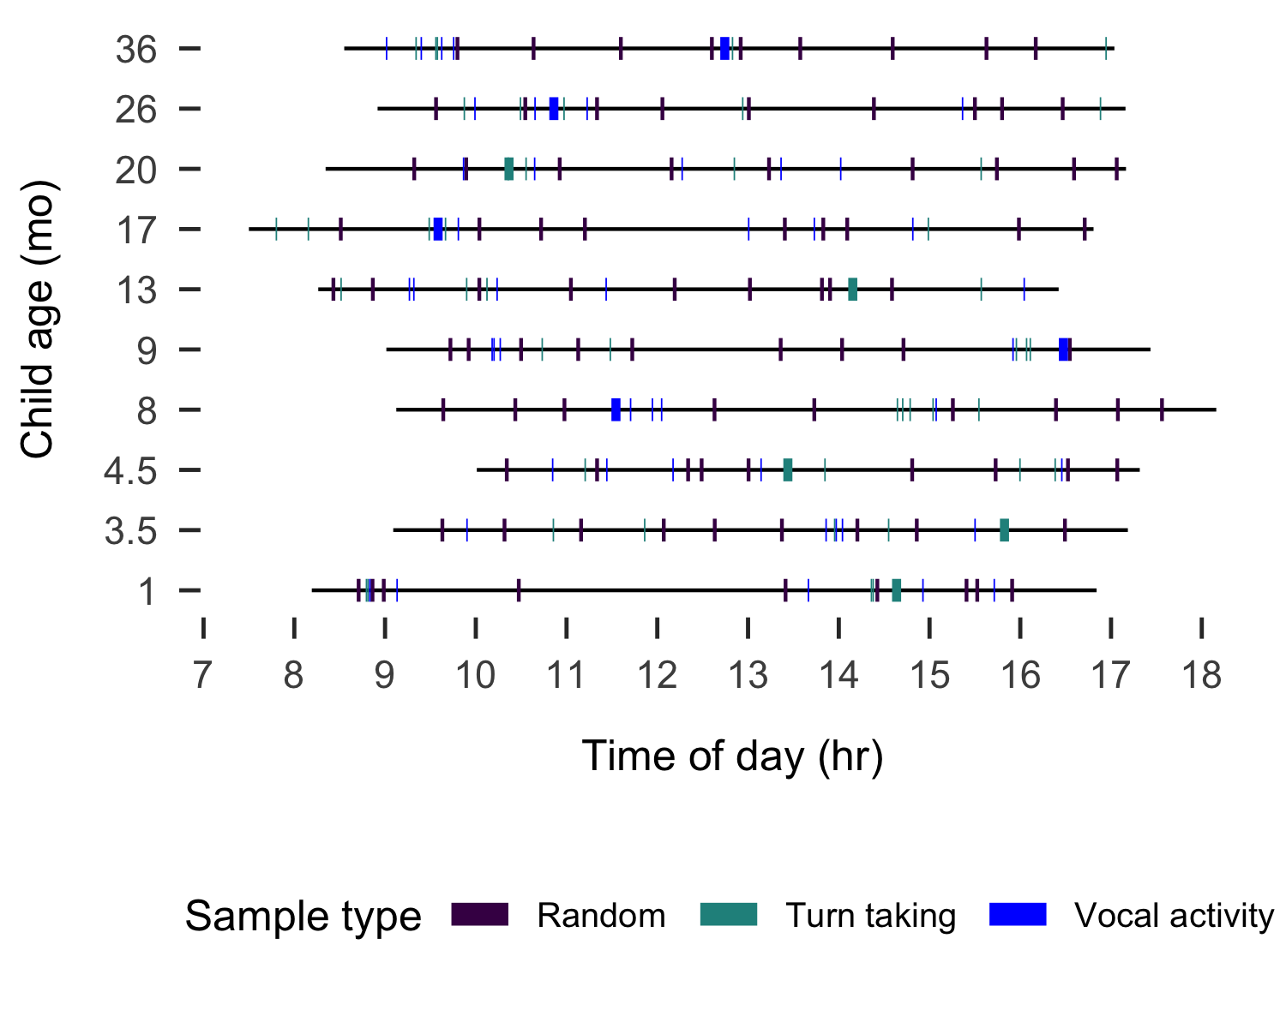

Figure 1: Recording duration (black line) and sampled clips (colored boxes) for each of the 10 recordings analyzed, sorted by child age in months.

## Data selection and annotation

From the daylong recordings of 57 Rossel children, we selected 10 representative children between ages 0;0 and 3;0 for transcription and analysis in the current study. The 10 children were selected to be spread between the target age range (0;0–3;0) while also representing a range of typical maternal education levels found in the community and being evenly split between male and female children (Table 1). For each child we then selected a series of non-overlapping sub-clips from the day for transcription (Figure 1) in the following order: nine randomly-selected 2.5-minute clips, five manually-selected ‘peak’ turn-taking activity 1-minute clips, five manually-selected ‘peak’ vocal activity 1-minute clips, and one manually-selected 5-minute expansion of the best one-minute clip, for a total of 37.5 minutes of transcribed audio for each child (6.25 audio hours in total). The criteria for manual clip selection are identical to those described in Casillas and colleagues (2019) (see <https://git.io/fhdUm>).

We were limited to selecting sub-clips from 10 children for analysis because of the time-intensive nature of transcribing these naturalistic data; 1 minute of audio typically took approximately 60–70 minutes to be segmented into utterances, transcribed, annotated, and loosely translated into English (~400 hours total). Given that Yélî Dnye is nearly exclusively spoken on Rossel Island, where there is no electricity (our team uses solar panels) and unreliable access to mobile data, transcription could only be completed over the course of three 4–6 week visits by our research group to the island in 2016, 2018, and 2019.

We used the ACLEW Annotation Scheme (Casillas et al., 2017) in ELAN (Wittenburg, Brugman, Russel, Klassmann, & Sloetjes, 2006) to transcribe and annotate all hearable speech—both near and distant—in the clips. Using both the audio and photo context, we first segmented out the utterances and ascribed them to individual speakers (e.g., older brother, mother, aunt, etc.). We then annotated the vocal maturity of each utterance produced by the target child (non-canonical babble/canonical babble/single word/multi-word/unsure) and annotated the addressee of all speech from other speakers (addressed to the target child/one or more other children/one or more adults/a mix of adults and children/any animal/other/unsure). Transcription and annotation was done together by the first author and one of three community members (all native speakers of Yélî Dnye). The community-based research assistants personally knew all the families in the recordings, and were able to use their own experience, the discourse context, and information from the accompanying photos in reporting what was said and to whom speech was addressed for each utterance. Detailed manuals and self-guided training materials, including a ‘gold standard test’ for this annotation scheme can be found at <https://osf.io/b2jep/wiki/home/> (Casillas et al., 2017).

In what follows we first analyze the nine randomly selected 2.5-minute clips from each child to establish a baseline view of their speech environment, focusing on the effects of child age, time of day, household size, and number of speakers on the rate of target child-directed (TCDS) and other-directed speech (ODS). Next, we repeat these analyses, focusing instead only on the turn-taking clips to gain a view of the speech environment as it appears during the peak interactions for the day. This latter set of analyses may more closely mirror results from prior ethnographic work; ideas about how caregivers talk to children were based in part on the communicative behaviors that were on display during periods of interaction. Then as a first approximation of children’s linguistic development, we map a coarse trajectory of children’s use of babble, first words, and multi-word utterances. Finally, we wrap up by integrating our Panoramic-approach results with those from prior Close Study work, relating these findings to the larger literature on child-directed speech and its role in language development.

## Statistical models

We conducted all analyses in R, using the glmmTMB package to run generalized linear mixed-effects regressions on our dependent measures (M. E. Brooks et al., 2017; R Core Team, 2019). We used ggplot2 to generate all plots (Wickham, 2016). The dataset and scripts used in this study can be found at URL_MASKED_FOR_REVIEW. As in previous work on child speech environment measures (Casillas et al., 2019), TCDS and ODS minutes per hour are naturally restricted to non-negative (0–infinity) values, causing the distributional variance of those measures to become positively skewed. To address this issue we use negative binomial regressions, which can better fit non-negative, overdispersed data (M. E. Brooks et al., 2017; Smithson & Merkle, 2013). There were also many cases of zero minutes of TCDS across the clips—for example, this often occurred in the randomly sampled clips when the child was sleeping in a quiet area. To handle this additional distributional characteristic of the data, we added a zero-inflation model to TCDS analysis which, in addition to the count model of TCDS (e.g., testing effects of age on the input rate), creates a binary model to evaluate the likelihood of TCDS being used at all. More conventional, gaussian linear mixed-effects regressions with log-transformed dependent variables are available in the Supplementary Materials. The results of those alternative models are qualitatively similar to what we report here.

# Results

The models included the following predictors: child age (months; centered and standardized), household size (number of people; centered and standardized), number of non-target-child speakers present in that clip (centered and standardized), and time of day at the start of the clip (factor: “morning” = before 11:00; “midday” = 11:00–13:00; “afternoon” = after 13:00). In addition, we included two-way interactions: (a) child age and the number of speakers present and (b) child age and time of day. We also added a random effect of child. For the zero-inflation model of TCDS, we included the number of speakers present. We limit our discussion here to significant effects in the models; full model results, including gaussian alternative models, are available in the Supplementary Materials.

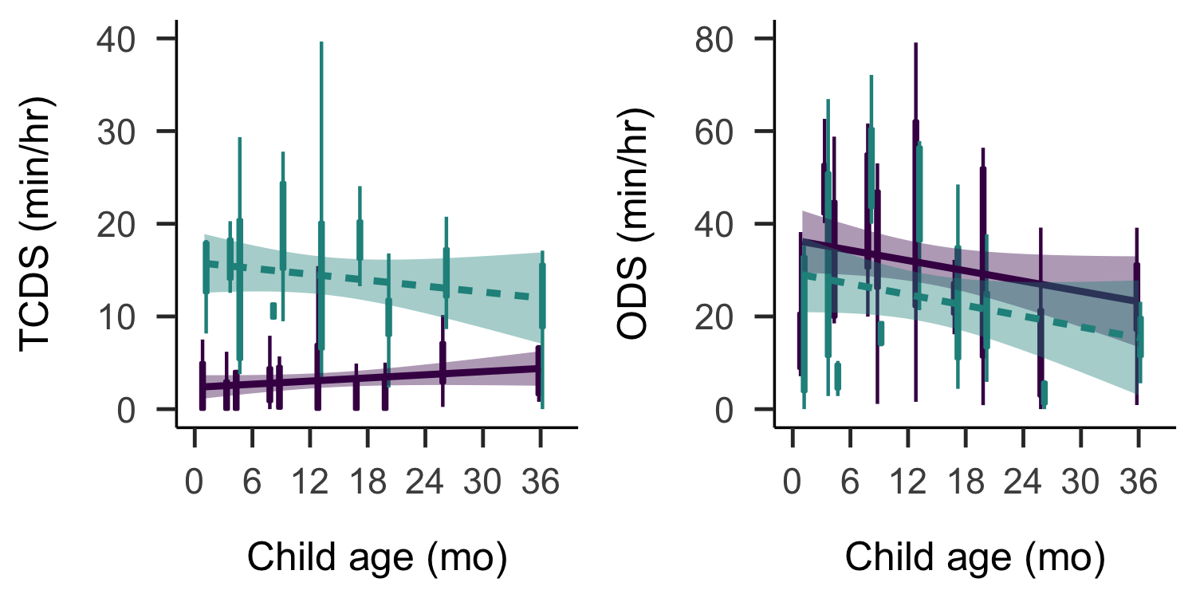

Figure 2: Estimates of TCDS min/hr (left) and ODS min/hr (right) across the sampled age range. Each box plot summarizes the data for one child from the randomly sampled clips (purple; solid) or the turn taking clips (green; dashed). Bands on the linear trends show 95% confidence intervals.

## Target-child-directed speech (TCDS)

In the random sample, these 10 children heard an average of 3.13 minutes of speech directly addressed to them per hour (median = 2.95; range = 1.58–6.26; Figure 2 left panel, purple/solid summaries). For comparison, this is slightly less than reported values using a near-identical method of data collection, annotation, and analysis in a Tseltal Mayan community (3.6 minutes per hour for children under 3;0; Casillas et al. (2019)) and comparable to what has been reported using a similar method in a Tsimane community (4.8 minutes per hour for children under 3;0 including all hearable speech; 1.6 minutes when excluding overlap and far-away speech; Scaff et al. (in preparation)).

The zero-inflated negative binomial regression of TCDS minutes per hour (N = 90, log-likelihood = -195.26, overdispersion estimate = 3.37) suggested significant effects of child age, time of day, and their interaction on the rate at which children hear speech addressed directly to them. First, the older children heard a small but significantly greater amount of TCDS per hour (Figure 2 left panel purple/solid summaries; B = 0.73, SD = 0.23, z = 3.20, p < 0.01). Overall, these children were also more likely to hear TCDS in the mornings (Figure 3 top left panel), with significantly higher TCDS rates in the morning compared to both midday (midday-vs-morning: B = 0.80, SD = 0.36, z = 2.23, p = 0.03) and the afternoon (afternoon-vs-morning: B = 0.54, SD = 0.26, z = 2.10, p = 0.04), and no significant difference in TCDS rate between midday and the afternoon. However, the time-of-day pattern changed with child age. Older children were more likely than younger children to show a peak in TCDS during midday, with a decrease in TCDS between midday and the afternoon (midday-vs-afternoon: B = -0.60, SD = 0.29, z = -2.04, p = 0.04) and marginally less TCDS in the morning than at midday (midday-vs-morning: B = -0.59, SD = 0.30, z = -1.94, p = 0.05). There were no other significant effects in either the count or the zero-inflation model.

Children heard TCDS from a variety of different speakers. Overall, most TCDS came from adults (mean = 72.65%, median = 75.51%, range = 41.41–100%). On average, 82.35% of the total TCDS minutes from adults came from women. That said, an increasing quantity of TCDS with age came from child speakers (child-TCDS, e.g., from siblings, cousins, or neighbors; C-TCDS); a Spearman’s correlation showed a significant positive relationship between the average proportion of C-TCDS in a clip and target child age (Spearman’s *rho* = 0.78; *p* = 0.01).

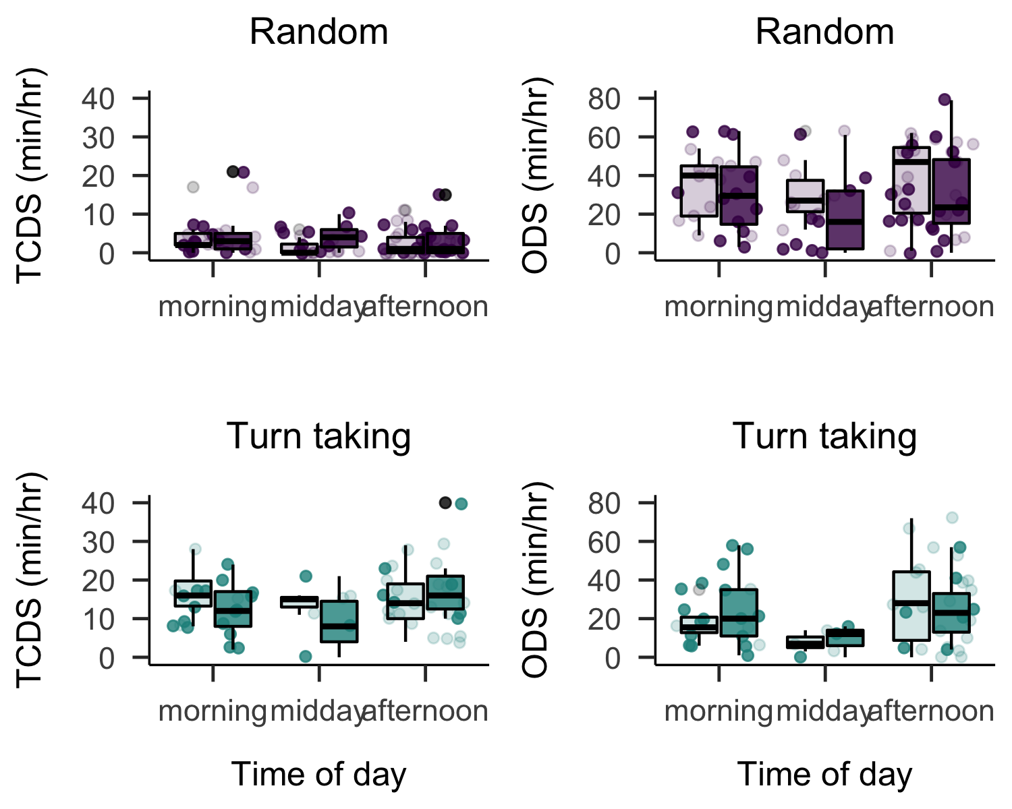

Figure 3: Estimates of TCDS min/hr (left panels) and ODS min/hr (right panels) across the recorded day in the random clips (top panels) and turn-taking (bottom panels) clips. Each box plot summarizes the data for children age 1;0 and younger (light) or age 1;0 and older (dark) at the given time of day.

## Other-directed speech (ODS)

In the random sample, these children heard an average of 35.90 minutes of other-directed speech per hour (Figure 2 right panel, purple/solid summaries; median = 32.37; range = 20.20–53.78): that is more than eleven times the average quantity of speech directed to them, with some children experiencing near-continuous background speech. For comparison, a prior estimate for Tseltal Mayan children using near-parallel methods to the present study found an average of 21 minutes of overhearable speech per hour (Casillas et al., 2019), and a recent study of North American children’s daylong recordings found that adult-directed speech (a subset of ODS) occurred at a rate of 7.3 minutes per hour (Bergelson et al., 2019a).

The negative binomial regression of other-directed speech rate (N = 90, log-likelihood = -370.87, overdispersion estimate = 9.14) revealed effects of child age, number of speakers present, and time of day on the rate of ODS encountered. The rate of ODS significantly decreased with child age (Figure 2 right panel, purple/solid summaries; B = -0.57, SD = 0.17, z = -3.28, p < 0.01) and significantly increased in the presence of more speakers (B = 0.50, SD = 0.05, z = 10.07, p < 0.001). Across the randomly selected clips, there were an average of 6.19 speakers present other than the target child (median = 6; range = 1–19), an average of 59.99% of whom were adults. Comparing again to Tseltal and North American English, in which the average number of speakers present, not including the target child, was 3.44 and 3.9 respectively (Bergelson et al., 2019a; Casillas et al., 2019), we can infer that the increased rate of ODS on Rossel Island is due in part to there simply being more speakers present. Time-of-day effects on ODS only came through in an interaction with child age (Figure 3 top right panel). In particular, older children heard a pattern of ODS mirroring the general pattern of TCDS; significantly more ODS in the mornings compared to midday (midday-vs-morning: B = 0.65, SD = 0.20, z = 3.23, p < 0.01) and the afternoon (afternoon-vs-morning: B = 0.37, SD = 0.15, z = 2.50, p = 0.01). There were no other significant effects on ODS rate in the model.

In sum, the random baseline rates of TCDS and ODS in children’s speech environments are influenced by child age (TCDS increases, ODS decreases), time of day (both generally peak in the morning), and their interaction (older children hear more TCDS and less ODS at midday). The rate of ODS is also impacted by the large number of speakers present in some clips. Correlational results suggest that TCDS comes increasingly from other children over the first three years. That said, the baseline rate of TCDS is low, on par with estimates in other small-scale farming communities (Casillas et al., 2019; Scaff et al., in preparation); while the ODS rate is quite high relative to estimates in prior work.

## TCDS and ODS during interactional peaks

If we instead investigate the rates of TCDS and ODS encountered by these children during their interactional peaks for the day, a different picture emerges (Figures 2 and 3 green/dashed summaries). In particular, the children heard much more TCDS in the turn-taking clips—14.45 min/hr; that is, more than four times the rate of TCDS in the random baseline (Figure 2, left panel, green/dashed summaries; median = 15.07; range = 9.61–18.73). During these same clips, children heard a reduced rate of ODS: 25.27 min/hr (70.39% of the random-sample ODS rate, Figure 2, right panel, green/dashed summaries; ; median = 19.59; range = 6.68–60.18).

The negative binomial mixed-effects regression of TCDS (N = 55, log-likelihood = -183.25, overdispersion estimate = 2.91) revealed a significant decrease with child age (B = -0.63, SD = 0.27, z = -2.33, p = 0.02) and a significant interaction between child age and time of day; TCDS rate during interactional peaks was marginally higher for older children at morning compared to midday (midday-vs-morning: B = 0.53, SD = 0.28, z = 1.89, p = 0.06) and significantly higher in the afternoon than at midday (midday-vs-afternoon: B = 0.61, SD = 0.28, z = 2.17, p = 0.03; see Figure 3, bottom left panel).

As in the random sample, an increasing portion of TCDS during interactional peaks came from other children. While, overall, *more* of the TCDS in interactional peaks came from adults than in the random clips (mean = 82.68%, median = 88.04%, range = 50–100%), a Spearman’s correlation showed an even stronger positive relationship between the average proportion of child TCDS in a clip and target child age (Spearman’s *rho* = 0.92; *p* = < 0.001). Notably, women contributed proportionally less TCDS during interactional peaks than they did during the random clips: on average, women contributed 61.55% of the children’s TCDS minutes from adults in the turn-taking clips (compared to 82.35% in the random clips). In brief, interactional peaks include more directed speech from men and, for older target children, more directed speech from other children.

The negative binomial mixed-effects regression of ODS (N = 55, log-likelihood = -202.60, overdispersion estimate = 4.66) only revealed a significant effect of number of speakers. As before, ODS rates were higher when more speakers were present (B = 0.56, SD = 0.08, z = 6.76, p < 0.001). There were no other significant effects on ODS rate in the turn-taking clips (Figure 3, bottom right panel).

Overall, the results suggest that these children typically hear very little directly addressed speech, but that interactional peaks provide opportunities for dense input at multiple points during the day. While the majority of directed speech comes from women, an increasing portion of it comes from other children with age, and directed speech from men is more likely during interactional peaks. Directed and overhearable speech is most likely to occur during the morning, before most of the household has dispersed for their work activities, similar to other findings from subsistence farming households (Casillas et al., 2019). However, older children are more likely than younger children to show higher input rates at midday, perhaps due to their increased interactions with other children while adults attend to gardening and domestic tasks; we leave investigation of this idea to future work. Possibly because of the large number of speakers typically present, these children were also in the vicinity of a high rate of overhearable speech, underscoring the availability of other-addressed speech as a resource for linguistic input in this context.

## Vocal maturity

Given the low overall rate of directed speech in these children’s environments, we might expect that their early linguistic development, particularly the onset and use of single- and multi-word utterances, is delayed in comparison to children growing up in more CDS-rich environments. To briefly investigate this we plotted the proportion of all linguistic vocalizations for each child (i.e., discarding laughter, crying, or unknown-type vocalizations; leaving a total of 4308 vocalizations) that fell into the following categories: non-canonical babble, canonical babble, single-word utterance, or multi-word utterance. With development, children are expected to traverse all four types of vocalization, such that they primarily produce single- and multi-word utterances by age three.

In the onset of use for canonical babble, first words, and multi-word utterances, these Rossel children’s vocalization data closely resemble expectations based on populations of children who hear more CDS (Figure 4). That is, canonical babble appears in the second half of the first year, first words appear around the first birthday, and multi-word utterances appear a few months after that (Frank et al., in preparation; Kuhl, 2004; Pine & Lieven, 1993; Slobin, 1970; Tomasello & Brooks, 1999; Warlaumont, Richards, Gilkerson, & Oller, 2014). Notably, these children also far exceed the usage rate of speech-like vocalizations associated with major developmental delay. The canonical babbling ratio (CBR; proportional use of speech-like vocalizations) associated with developmental delay is 0.15 or below at age 0;10 or older. This 0.15 threshold is exceeded by all the Rossel children above 0;9, with a minimum CBR of 0.22 at age 0;9 (mean = 0.63; median = 0.68; range = 0.22–0.86; see also Cychosz et al. (under reviewa)).

Over all annotated clips, children produced an average of 7.18 linguistic vocalizations per minute (median = 7.79; range = 4.57–8.95), which is less than might be expected in short recordings of American infant-caregiver interaction (Oller, Eilers, Basinger, Steffens, & Urbano, 1995). However, this rate does align well with estimates for Tseltal Mayan children, who hear a similar quantity of directed speech during this age range (Brown, 2011; Casillas et al., 2019).

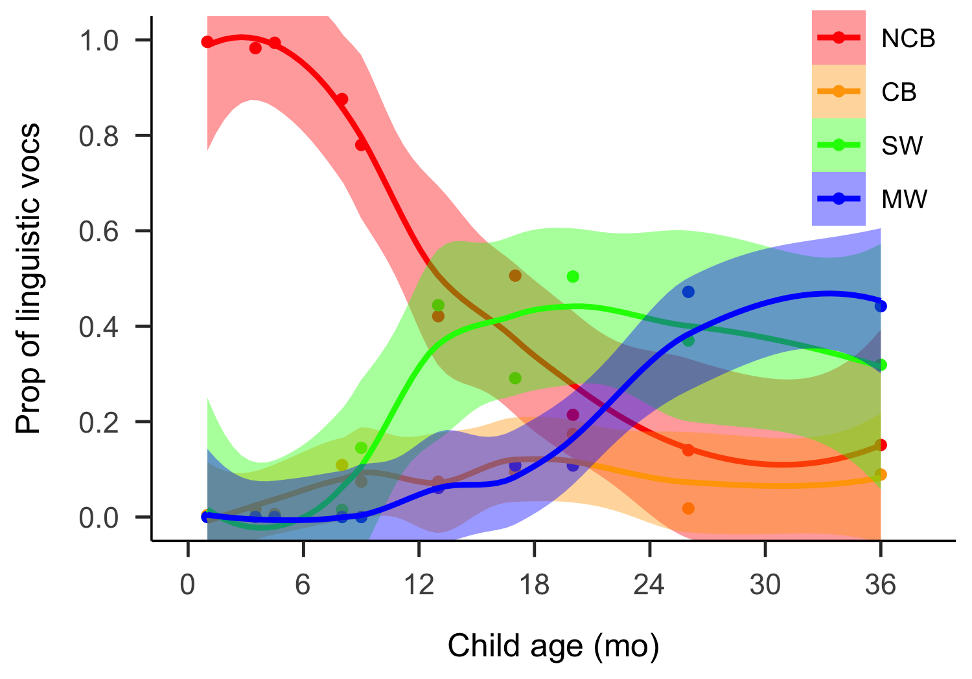

Figure 4: Proportion of vocalization types used by children across age (NCB = Non-canonical babble, CB = Canonical babble, SW = single word utterance, MW = multi-word utterance).

# Discussion

We analyzed the speech environments of 10 Rossel children under age 3;0 to investigate: (a) how often children were spoken to directly, (b) how much other overhearable speech is available to them, (c) how these sources of linguistic input are shaped by child age and interactional context, and (d) whether this (relatively) low rate of directed input appears to impact their early production milestones.

Based on prior ethnographic work, we expected that these children would hear frequent child-directed speech from a wide variety of caregivers and frequent speech directed to others (Brown & Casillas, in press). In fact, in the daylong audio recordings children were rarely directly addressed. This low baseline rate of TCDS is comparable—even slightly less—than that found in a Tseltal Mayan community where minimal TCDS is one means to socializing children into attending to their surroundings. On the other hand, the Rossel child speech environment contains ample overhearable speech; much more than has been reported in other communities at time of writing. We suspect that both the low relative rate of TCDS and the high incidence of ODS are partly attributable to the fact that multiple speakers are typically present in the recordings, as discussed further below.

Prior work using similar methods to those presented here also led us to expect that the quantity of TCDS would be stable across the age range studied (Bergelson et al., 2019b; Casillas et al., 2019; Scaff et al., in preparation), and that an increasing proportion of it would come from other children (Brown, 2011; Brown & Casillas, in press; Shneidman & Goldin-Meadow, 2012). Counter to expectations, we found a small but significant increase in TCDS rate with child age in the random clips but a small and significant *decrease* in TCDS rate with age in the turn-taking clips. The age-related baseline increase in TCDS may derive from more frequent participation in independent play with other children; in prior work, increased proportional input from other children was also associated with an increase in overall input rate (Shneidman & Goldin-Meadow, 2012). The age-related decrease in TCDS rate during peak interactional moments was not expected, but may be attributable to this change in interactional partners with age; if adults are more likely to be the source of TCDS during interactional peaks for younger children, they may also provide more voluminous speech during those peaks than other children do during interactional peaks later in development. We also don’t know precisely when children were sleeping during the day; if younger children slept more during recording hours than older children, it might partly explain why older children hear more TCDS during random but not peak-based clips. All of these explanations require follow-up work from a larger sample of children and, ideally, from a larger sample of their interactions throughout the day. We also saw the same age-related tendency for ODS discovered in prior Panoramic studies with both Western and non-Western samples (Bergelson et al., 2019b; Casillas et al., 2019): a significant decrease.

Finally, while we anticipated that the children’s input would be non-uniformly distributed over the recording day (Abney et al., 2017; Casillas et al., 2019), we also expected to see a somewhat more even distribution of directed speech from morning to evening than found in other subsistence farming contexts (Casillas et al., 2019) given that young Rossel children have been reported to pass between multiple caregivers during a typical day at home. Specifically, we expected that this care-sharing practice might weaken the effect of farming activities on linguistic input rate, found in the late morning and early afternoon in previous work with Tseltal Mayan subsistence farmers (Casillas et al., 2019). In fact, we found that children’s rate of linguistic input was still significantly impacted by time of day, similar to the prior work with Tseltal Mayans. In particular, most TCDS and ODS came during the morning, with older children more likely to hear TCDS at midday than younger children, possibly because midday is when most adults are likely attending to gardening and domestic duties while children congregate in large play groups.

## Diverging Close Study and Panoramic perspectives

We predicted that infants on Rossel Island would hear more frequent directed speech than has been found in other subsistence farming contexts (e.g., Brown, 2011, 2014; Brown & Casillas, in press; Casillas et al., 2019; de León, 2000; Frye, 2019; Ochs & Schieffelin, 1984; Pye, 1986; Rumsey, San Roque, & Schieffelin, 2013). We made this prediction on the basis of two prior ethnographic observations (see (Brown & Casillas, in press) for details). First, Rossel adults and children have been shown to like ‘talking’ to children, even young infants, as if they can understand and respond to what is being said. Second, infants and young children were observed to have access to a wide network of caregivers who derive much joy from interacting with them. Our Panoramic findings, based on daylong audio data from 10 children, differ from these expectations: there is minimal TCDS to young children, time of day strongly impacts the rate of linguistic input, and there is limited variability in the type of speakers typically talking to children.

We found that the 10 Rossel children here heard slightly less TCDS than was documented for the Tseltal children. Taking the Mayan and Papuan findings together, we suggest that the Panoramic approach is not effective for distinguishing distinct caregiver attitudes toward talking to young children. While Rossel caregivers view their children, even their young infants, as potential co-interactants in conversational play (Brown & Casillas, in press), the circumstances of everyday life shape the children’s broader linguistic landscape such that most of what children hear is talk between others. Specifically we suggest that, in the daylong context, caregivers from these two subsistence farming communities are preoccupied for most of the day with social and domestic commitments in which they are motivated to converse with the other adults and (older) children present; not just to get their daily tasks done but also because these more mature speakers enable more complex verbal interactions and social routines. Given the multi-generational and patrilocal settlement patterns in both communities, there are frequent opportunities to engage with other adults and older children. This same explanation extends to the variability in linguistic input encountered by children over the day and from different speaker types; rather than being passed between caregivers who are ‘available’ to interact with them, young children may accompany their varied caregivers in their shared daily tasks, switching from lap to lap without the activity context necessarily changing.

When it comes to quantifying how much linguistic input children encounter, the Panoramic view yields the important insight that direct linguistic input is rare on average; it exists, but only during short interactional peaks. We suspect that it is during these interactional peaks that caregiver attitudes about how to engage children in interaction are most clearly expressed. Indeed it is during interactional peaks when we see not only more TCDS but also TCDS from more diverse speaker types. In contrast, the randomly sampled Panoramic data demonstrate how the number of speakers present and the routines of everyday life strongly shape the overall rate of linguistic input available in children’s environments. That is, the forces shaping the *frequency* of Rossel children’s linguistic input are somewhat independent from the forces shaping the *content* of their linguistic input. This insight is critical in trying to join cognitive and social models of children’s early language development. After all, children—particularly children in contexts with minimal TCDS—may do most of their language learning during these short bursts in the day when they are jointly attending to language during interactions with others. If so, it would be more efficient to aim our models of learning and annotation time at these interactional peaks. Indeed, such a hybrid approach may be optimal for accessing varied, ecologically valid, culturally distinct codes of verbal interaction while also sketching a stable picture of early language exposure specific to those same communities (Shneidman, 2010; Shneidman & Goldin-Meadow, 2012). Further cross-cultural work on children’s ability to learn from massed vs. distributed and directed vs. overhearable language use (e.g., Akhtar, Jipson, & Callanan, 2001; Schwab & Lew-Williams, 2016) is a critical route for further investigation into how these sources of linguistic input may be leveraged for language development.

## Independence and child-TCDS

The increase in TCDS from other children in this Rossel data recalls findings from Shneidman and Goldin-Meadow (2012) in which Yucatec Mayan children’s directed speech rate increased enormously between ages one and three, primarily due to increased input from other children. We saw a significant, but much smaller overall increase in TCDS in these 10 Rossel children’s recordings, with an increasing proportion of that input coming from children. Interestingly, a prior study using near-identical methods to this one with a Tseltal Mayan community—culturally more similar to the Yucatec community studied in Shneidman and Goldin-Meadow (2012) and focusing on a similar age range (0;0–3;0)—found no evidence for increased input from other children (Casillas et al., 2019). The lack of child TCDS in that study was attributed to the observation that Tseltal Mayan children only begin to engage in independent, extended play with older siblings and cousins after age three, older than the sampled children in the study. In comparison, prior ethnographic work on Rossel Island highlights independence as a primary concern for parents of young children; from early toddlerhood Rossel children are encouraged to choose how they dress, when and what to eat, and who to visit (Brown & Casillas, in press). The formation of hamlets in a cluster around a shared open area, typically close to a water source with a shallow area, further nurtures a sense of safe, free space in which children can wander. These features of childhood on Rossel Island support extended independent play with siblings and cousins from an early age and may therefore explain the strongly increasing presence of child TCDS in the present data. Further work, combining the time of day effects and interlocutor effects found here with ethnographic interview data, are needed to explore these ideas in full. The consequence of this pattern for learning is that children’s linguistic input shifts in the first three years, with proportionally more speech coming from less mature talkers; how this influences their early production and comprehension patterns, particularly given the minimal overall amount of TCDS, is an open question.

## Trade-offs in the use of Panoramic methods

The present study used Panoramic methods to get a broader view of 10 Rossel children’s linguistic landscapes, but was limited in both the number of children represented and the number of annotated minutes analyzed per child. The data presented here, though transcribed, were only analyzed for superficial features of children’s linguistic environment: input rates of directed and overhearable speech and children’s overall vocal maturity. A Close Study approach is needed in order to make semantically rich interpretations of what children are saying and hearing or to delineate cross-cultural differences in the content or style of child-directed speech (features sometimes referred to with respect to CDS ‘quality’).

While our Panoramic approach effectively captured circumstantial variation over the course of a waking day, it did *not* completely avoid the Observer’s Paradox (Labov, 1972); upon transcribing the data we found a mix of moments in which the speakers seemed to ignore the recorder and moments when it was the focus of discussion. This was particularly the case when new interactants came into contact with the child—a relatively frequent event—which usually prompted the caregiver to comment and warn about the devices. There was also at least one case when a mother reported that another family member, who is typically at home, avoided our recorder by spending the entire day elsewhere. Daylong methods then may decrease the intensity and continuity of the Observer’s Paradox, but do not eliminate it entirely, and may result in some more subtle changes from the typical linguistic environment encountered by children. With this in mind, close ethnographic work over a longer period with a handful of families may, in fact, be the key to minimizing these effects—however, this severely limits the possible sample size of the study. What, then, is the ideal approach for exploring the variable linguistic environments in which children are raised?

When it comes to drawing inferences about the deeper forces shaping caregiver-child interaction and how they vary across cultures or, for that matter, any other task that requires researchers to grapple with what is actually *meant* during interaction, a Close Study approach is the only real option. Even when taking a microanalytic approach to short clips from daylong recordings, the researcher is likely to lack sufficient visual and interactional context to fully reconstruct the scene. In this use case, short recordings maintain an advantage, particularly when Observer Paradox effects can be reduced, for example, by spending plenty of time with each observed family.

However, when it comes to quantifying the use of linguistic features in order to explore the feasibility of specific learning mechanisms (e.g., CDS as a faciltatory context for referential word learning), daylong data are crucial for establishing the frequency and circumstances under which the critical linguistic or interactional “data” are encountered. Given our present findings and those of Casillas et al. (2019), studies focused on particular features of CDS (e.g., frequency of certain syntactic structures) may benefit from focusing most annotation time on interactional peaks throughout the day, dedicating less time to establishing a baseline estimate for CDS frequency (see also Bergelson et al. (2019a)). Importantly, researchers making daylong recordings in a context where they are a cultural outsider should always do their recording collection in parallel with or (better) after some ethnographic work to avoid the serious and potentially harmful pitfalls discussed in the Introduction (see Cychosz et al. (acceptedb) for a review).

We suggest that the most promising long-term version of an approach testing the feasibility of individual learning mechanisms is to use daylong sampling to investigate within-community variation and/or cross-community variation among related but distinct ethnolinguistic populations (e.g., Moran, Schikowski, Pajović, Hysi, & Stoll, 2016; Pye, 2017; Weisleder & Fernald, 2013), maintaining comparable speech environment measures whenever possible. The current study pales in comparison to this ideal; we are here limited to comparing Rossel children’s language environment to findings from ethnolinguistically unrelated communities. We hope to see this vision realized in future work.

## Conclusion

We estimate that, on average, children on Rossel Island under age 3;0 hear 3.13 minutes of directed speech per hour, with an average of 14.45 minutes per hour during peak interactive moments during the day. Most of directed speech comes from adults, but older children hear more directed speech from other children. There is also an average 35.90 minutes per hour of overhearable speech present. Older children heard more directed speech and less overhearable speech than younger children. Bursts of speech featuring mostly TCDS appear to be present from infancy onward. Despite this relatively low rate of directed speech, these children’s vocal maturity appears on-track with norms for typically developing children in multiple diverse populations (Cychosz et al., under reviewa; Lee, Jhang, Relyea, Chen, & Oller, 2018; Warlaumont et al., 2014).

Our findings diverged in several ways from expectations developed on the basis of prior ethnographic work in this community, including the frequency of child-directed talk, the diversity of talkers, and the distribution of talk over the course of the day. When considered together with data from a Mayan community, the findings suggest that the Panoramic approach, while well suited to gathering inclusive, ecologically valid estimates of how much linguistic input children hear, is also far more sensitive to circumstantial variation (e.g., the number of speakers present) than it is to established ideological variation in how caregivers talk to children. For the latter, a Close Study or hybrid approach is needed (e.g., analyzing interactional peaks). Whether child language development is better predicted by meaningful individual differences in average circumstantial variation (e.g., Panoramic input quantity), ideologically-based variation (e.g., Close Study input characteristics; attitudes toward pedagogical talk), or something inbetween is a question for future work. Cross-cultural and cross-linguistic data will have a major role to play in teasing out the causal factors at play in this larger issue relating children’s early linguistic experience to their later language development.

Importantly, the data presented here come from an evolving corpus of Yélî Dnye developmental data; any reader interested in citing descriptive features of the Rossel child language environment is strongly encouraged to visit the following address for up-to-date estimates: URL_MASKED_FOR_REVIEW. The information on that linked page will include any new data, annotations, and analyses added after the publication of this study.

# Acknowledgements

# References

Abney, D. H., Smith, L. B., & Yu, C. (2017). It’s time: Quantifying the relevant time scales for joint attention. In G. Gunzelmann, A. Howes, T. Tenbrink, & E. Davelaar (Eds.), *Proceedings of the 39th Annual Meeting of the Cognitive Science Society* (pp. 1489–1494). London, UK.

Akhtar, N., Jipson, J., & Callanan, M. A. (2001). Learning words through overhearing. *Child Development*, *72*(2), 416–430.

Anderson, H., & Fausey, C. (2019). Modeling nonuniformities in infants’ everyday speech environments. presented at the biennial meeting of the society for research on child development. baltimore, md.

Bates, E., & Goodman, J. C. (1997). On the inseparability of grammar and the lexicon: Evidence from acquisition, aphasia, and real-time processing. *Language and Cognitive Processes*, *12*(5–6), 507–584. doi:[10.1080/016909697386628](https://doi.org/10.1080/016909697386628)

Bergelson, E., Alphen, P. van, Benneti, L., Bunce, J., Casillas, M., Guez, A., … Cristia, A. (in preparation). Child language environments in >2500 daylong recordings across 5 continents.

Bergelson, E., Amatuni, A., Dailey, S., Koorathota, S., & Tor, S. (2019a). Day by day, hour by hour: Naturalistic language input to infants. *Developmental Science*, *22*(1), e12715. doi:[10.1111/desc.12715](https://doi.org/10.1111/desc.12715)

Bergelson, E., Casillas, M., Soderstrom, M., Seidl, A., Warlaumont, A. S., & Amatuni, A. (2019b). What do North American babies hear? A large-scale cross-corpus analysis. *Developmental Science*, *22*(1), e12724. doi:[10.1111/desc.12724](https://doi.org/10.1111/desc.12724)

Brinchmann, E. I., Braeken, J., & Lyster, S.-A. H. (2019). Is there a direct relation between the development of vocabulary and grammar? *Developmental Science*, *22*(1), e12709. doi:[10.1111/desc.12709](https://doi.org/10.1111/desc.12709)

Brooks, M. E., Kristensen, K., van Benthem, K. J., Magnusson, A., Berg, C. W., Nielsen, A., … Bolker, B. M. (2017). Modeling zero-inflated count data with glmmTMB. *bioRxiv*. doi:[10.1101/132753](https://doi.org/10.1101/132753)

Brown, P. (2011). The cultural organization of attention. In A. Duranti, E. Ochs, & and B. B. Schieffelin (Eds.), *Handbook of Language Socialization* (pp. 29–55). Malden, MA: Wiley-Blackwell.

Brown, P. (2014). The interactional context of language learning in Tzeltal. In I. Arnon, M. Casillas, C. Kurumada, & B. Estigarribia (Eds.), *Language in interaction: Studies in honor of Eve V. Clark* (pp. 51–82). Amsterdam, NL: John Benjamins.

Brown, P., & Casillas, M. (in press). Childrearing through social interaction on Rossel Island, PNG. In A. J. Fentiman & M. Goody (Eds.), *Esther Goody revisited: Exploring the legacy of an original inter-disciplinarian* (pp. XX–XX). New York, NY: Berghahn.

Brown, P., & Gaskins, S. (2014). Language acquisition and language socialization. In N. J. Enfield, P. Kockelman, & J. Sidnell (Eds.), *Handbook of Linguistic Anthropology* (pp. 187–226). Cambridge, UK: Cambridge University Press. doi:[10.1017/CBO9781139342872.010](https://doi.org/10.1017/CBO9781139342872.010)

Cartmill, E. A., Armstrong, B. F., Gleitman, L. R., Goldin-Meadow, S., Medina, T. N., & Trueswell, J. C. (2013). Quality of early parent input predicts child vocabulary 3 years later. *Proceedings of the National Academy of Sciences*, *110*(28), 11278–11283. doi:[10.1073/pnas.1309518110](https://doi.org/10.1073/pnas.1309518110)

Casillas, M., & Cristia, A. (2019). A step-by-step guide to collecting and analyzing long-format speech environment (lfse) recordings. *Collabra: Psychology*, *5*(1), 24. doi:[10.1525/collabra.209](https://doi.org/10.1525/collabra.209)

Casillas, M., Brown, P., & Levinson, S. C. (2017). Casillas HomeBank corpus. doi:[10.21415/T51X12](https://doi.org/10.21415/T51X12)

Casillas, M., Brown, P., & Levinson, S. C. (2019). Early language experience in a tseltal mayan village. *Child Development*, *OnlineOpen*(X), XX–XX.

Casillas, M., Bunce, J., Soderstrom, M., Rosemberg, C., Migdalek, M., Alam, F., … Garrison, H. (2017). Introduction: The ACLEW DAS template [training materials]. Retrieved from <https://osf.io/aknjv/>

Cychosz, M., Cristia, A., Bergelson, E., Casillas, M., Baudet, G., Warlaumont, A. S., … Seidl, A. (under reviewa). Canonical babble development in a large-scale crosslinguistic corpus. Retrieved from <https://osf.io/ca6qu/>

Cychosz, M., Romeo, R., Soderstrom, M., Scaff, C., Ganek, H., Cristia, A., … Weisleder, A. (acceptedb). Longform recordings of everyday life: Ethics for best practices.

de León, L. (2000). The emergent participant: Interactive patterns in the socialization of Tzotzil (Mayan) infants. *Journal of Linguistic Anthropology*, *8*(2), 131–161.

de León, L. (2011). Language socialization and multiparty participation frameworks. In A. Duranti, E. Ochs, & and B. B. Schieffelin (Eds.), *Handbook of Language Socialization* (pp. 81–111). Malden, MA: Wiley-Blackwell. doi:[10.1002/9781444342901.ch4](https://doi.org/10.1002/9781444342901.ch4)

Demuth, K., Culbertson, J., & Alter, J. (2006). Word-minimality, epenthesis and coda licensing in the early acquisition of english. *Language and Speech*, *49*(2), 137–173.

Frank, M. C., Braginsky, M., Marchman, V. A., & Yurovsky, D. (in preparation). *Variability and consistency in early language learning: The Wordbank project*. Retrieved from <https://langcog.github.io/wordbank-book/>

Frye, H. (2019). *Child directed speech in Qaqet* (PhD thesis). University of Cologne.

Gaskins, S. (2000). Children’s daily activities in a Mayan village: A culturally grounded description. *Cross-Cultural Research*, *34*(4), 375–389. doi:[10.1177/106939710003400405](https://doi.org/10.1177/106939710003400405)

Gaskins, S. (2006). Cultural perspectives on infant–caregiver interaction. In N. J. Enfield & S. Levinson (Eds.), *Roots of Human Sociality: Culture, Cognition and Interaction* (pp. 279–298). Oxford: Berg.

Hart, B., & Risley, T. R. (1995). *Meaningful Differences in the Everyday Experience of Young American Children*. Paul H. Brookes Publishing.

Hoff, E. (2003). The specificity of environmental influence: Socioeconomic status affects early vocabulary development via maternal speech. *Child Development*, *74*(5), 1368–1378. doi:[10.3389/fpsyg.2015.01492](https://doi.org/10.3389/fpsyg.2015.01492)

Hurtado, N., Marchman, V. A., & Fernald, A. (2008). Does input influence uptake? Links between maternal talk, processing speed and vocabulary size in spanish-learning children. *Developmental Science*, *11*(6), F31–F39.

Huttenlocher, J., Waterfall, H., Vasilyeva, M., Vevea, J., & Hedges, L. V. (2010). Sources of variability in children’s language growth. *Cognitive Psychology*, *61*(4), 343–365. doi:[10.1016/j.cogpsych.2010.08.002](https://doi.org/10.1016/j.cogpsych.2010.08.002)

Kuhl, P. K. (2004). Early language acquisition: Cracking the speech code. *Nature Reviews Neuroscience*, *5*(11), 831. doi:[10.1038/nrn1533](https://doi.org/10.1038/nrn1533)

Labov, W. (1972). *Sociolinguistic patterns*. Philadelphia: University of Pennsylvania.

Lee, C.-C., Jhang, Y., Relyea, G., Chen, L.-m., & Oller, D. K. (2018). Babbling development as seen in canonical babbling ratios: A naturalistic evaluation of all-day recordings. *Infant Behavior and Development*, *50*, 140–153.

Lieven, E. V. M., Pine, J. M., & Baldwin, G. (1997). Lexically-based learning and early grammatical development. *Journal of Child Language*, *24*(1), 187–219. doi:[10.1017/S0305000996002930](https://doi.org/10.1017/S0305000996002930)

Marchman, V. A., Martínez-Sussmann, C., & Dale, P. S. (2004). The language-specific nature of grammatical development: Evidence from bilingual language learners. *Developmental Science*, *7*(2), 212–224. doi:[10.1111/j.1467-7687.2004.00340.x](https://doi.org/10.1111/j.1467-7687.2004.00340.x)

Moran, S., Schikowski, R., Pajović, D., Hysi, C., & Stoll, S. (2016). The acqdiv database: Min(d)ing the ambient language. In *Proceedings of the tenth international conference on language resources and evaluation (lrec 2016)* (pp. 4423–4429). Portorož, Slovenia.

Ochs, E., & Schieffelin, B. (1984). Language acquisition and socialization: Three developmental stories and their implications. In R. A. Schweder & R. A. LeVine (Eds.), *Culture theory: Essays on mind, self, and emotion* (pp. 276–322). Cambridge University Press.

Oller, D. K., Eilers, R. E., Basinger, D., Steffens, M. L., & Urbano, R. (1995). Extreme poverty and the development of precursors to the speech capacity. *First Language*, *15*(44), 167–187.

Pine, J. M., & Lieven, E. V. M. (1993). Reanalysing rote-learned phrases: Individual differences in the transition to multi-word speech. *Journal of Child Language*, *20*(3), 551–571. doi:[10.1017/S0305000900008473](https://doi.org/10.1017/S0305000900008473)

Pye, C. (1986). Quiché Mayan speech to children. *Journal of Child Language*, *13*(1), 85–100. doi:[10.1017/S0305000900000313](https://doi.org/10.1017/S0305000900000313)

Pye, C. (2017). *The Comparative Method of Language Acquisition Research*. University of Chicago Press.

R Core Team. (2019). *R: A language and environment for statistical computing*. Vienna, Austria: R Foundation for Statistical Computing. Retrieved from <https://www.R-project.org/>

Rogoff, B., Paradise, R., Arauz, R. M., Correa-Chávez, M., & Angelillo, C. (2003). Firsthand learning through intent participation. *Annual Review of Psychology*, *54*(1), 175–203. doi:[10.1146/annurev.psych.54.101601.145118](https://doi.org/10.1146/annurev.psych.54.101601.145118)

Rowe, M. L. (2008). Child-directed speech: Relation to socioeconomic status, knowledge of child development and child vocabulary skill. *Journal of Child Language*, *35*(1), 185–205. doi:[10.1017/S0305000907008343](https://doi.org/10.1017/S0305000907008343)

Rumsey, A., San Roque, L., & Schieffelin, B. B. (2013). The acquisition of ergative marking in Kaluli, Ku Waru and Duna (Trans New Guinea). In E. L. Bavin & S. Stoll (Eds.), *Sabine* (pp. 139–188). Amsterdam; New York: John Benjamins Publishing Company.

Scaff, C., Stieglitz, J., Casillas, M., & Cristia, A. (in preparation). Language input in a hunter-forager population: Estimations from daylong recordings.

Schwab, J. F., & Lew-Williams, C. (2016). Repetition across successive sentences facilitates young children’s word learning. *Developmental Psychology*, *52*(6), 879–886. doi:[10.1037/dev0000125](https://doi.org/10.1037/dev0000125)

Shneidman, L. A. (2010). *Language Input and Acquisition in a Mayan Village* (PhD thesis). The University of Chicago.

Shneidman, L. A., & Goldin-Meadow, S. (2012). Language input and acquisition in a Mayan village: How important is directed speech? *Developmental Science*, *15*(5), 659–673. doi:[10.1111/j.1467-7687.2012.01168.x](https://doi.org/10.1111/j.1467-7687.2012.01168.x)

Slobin, D. I. (1970). Universals of grammatical development in children. In G. B. Flores d’Arcais & W. J. M. Levelt (Eds.), *Advances in Psycholinguistics* (pp. 174–186). Amsterdam, NL: North Holland Publishing.

Smithson, M., & Merkle, E. (2013). *Generalized linear models for categorical and continuous limited dependent variables*. New York: Chapman; Hall/CRC. doi:[10.1201/b15694](https://doi.org/10.1201/b15694)

Tamis-LeMonda, C. S., Kuchirko, Y., Luo, R., Escobar, K., & Bornstein, M. H. (2017). Power in methods: Language to infants in structured and naturalistic contexts. *Developmental Science*, *20*(6), e12456. doi:[10.1111/desc.12456](https://doi.org/10.1111/desc.12456)

Tomasello, M., & Brooks, P. J. (1999). Early syntactic development: A Construction Grammar approach. In M. Barrett (Ed.), *The Development of Language* (pp. 161–190). New York: Psychology Press.

Warlaumont, A. S., Richards, J. A., Gilkerson, J., & Oller, D. K. (2014). A social feedback loop for speech development and its reduction in Autism. *Psychological Science*, *25*(7), 1314–1324. doi:[10.1177/0956797614531023](https://doi.org/10.1177/0956797614531023)

Weisleder, A., & Fernald, A. (2013). Talking to children matters: Early language experience strengthens processing and builds vocabulary. *Psychological Science*, *24*(11), 2143–2152. doi:[10.1177/0956797613488145](https://doi.org/10.1177/0956797613488145)

Wickham, H. (2016). *Ggplot2: Elegant graphics for data analysis*. Springer-Verlag New York. Retrieved from <https://ggplot2.tidyverse.org>

Wittenburg, P., Brugman, H., Russel, A., Klassmann, A., & Sloetjes, H. (2006). ELAN: A professional framework for multimodality research. In *Proceedings of the Fifth International Conference on Language Resources and Evaluation* (pp. 1556–1559).

Xu, D., Yapanel, U., & Gray, S. (2009). LENA tr-05: Reliability of the lena language environment analysis system in young children’s natural language home environment. Boulder, CO: LENA Foundation.

1. Local schools include elementary (~3 years; ages ~7–10) and primary (~6 years; ages ~10–16) education. Subsequent education is not locally available and students pursuing this route must find accommodations on the nearby island Misima or on mainland PNG.