NADL Rossel

|  |
| --- |
| Rebecca L. A. Frost1 & Marisa Casillas1 |
| 1 Max Planck Institute for Psycholinguistics |
|  |

# Author note

Correspondence concerning this article should be addressed to Rebecca L. A. Frost, Wundtlaan 1, 6525 XD, Nijmegen, The Netherlands. E-mail: [rebecca.frost@mpi.nl](mailto:rebecca.frost@mpi.nl)

Abstract

Enter abstract here. Each new line herein must be indented, like this line.

*Keywords:* keywords

Word count: X

NADL Rossel

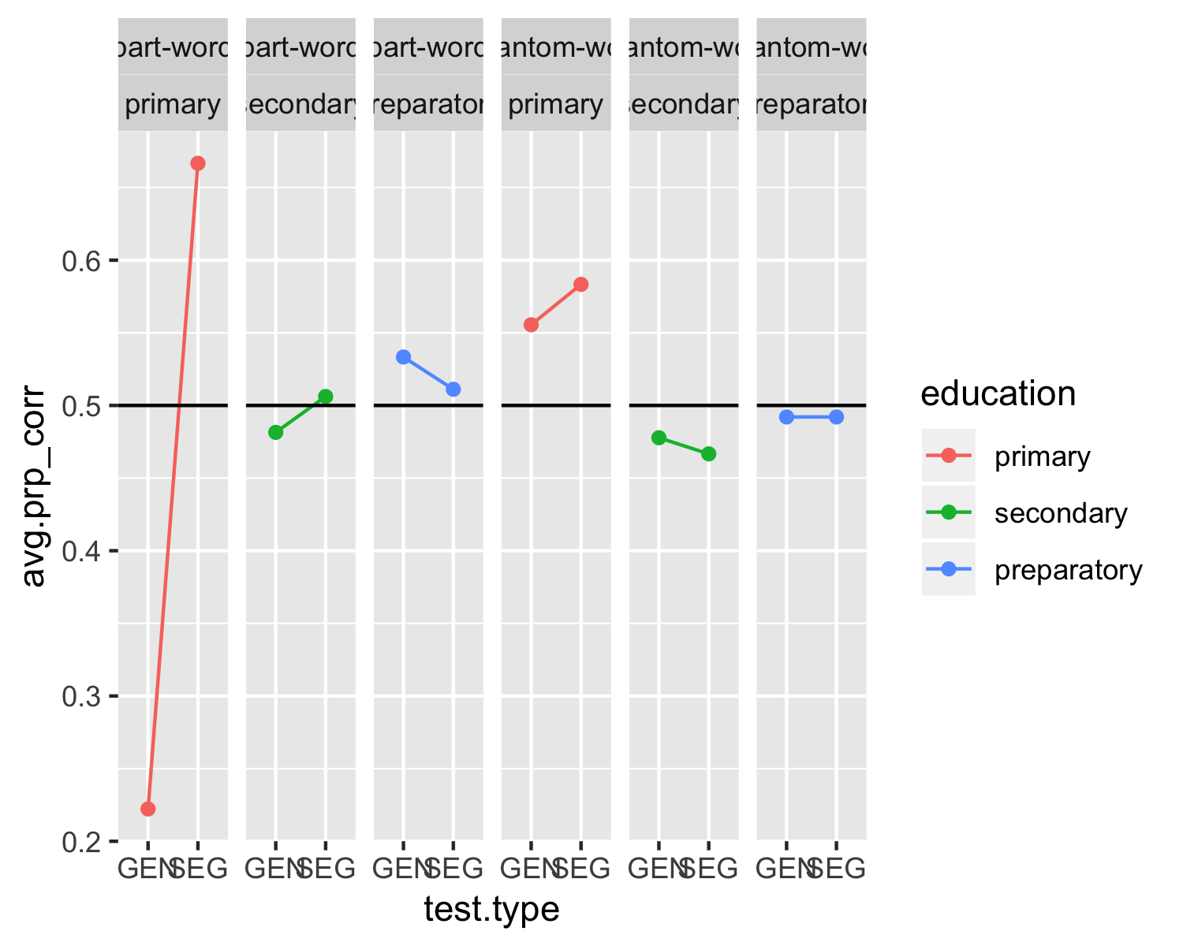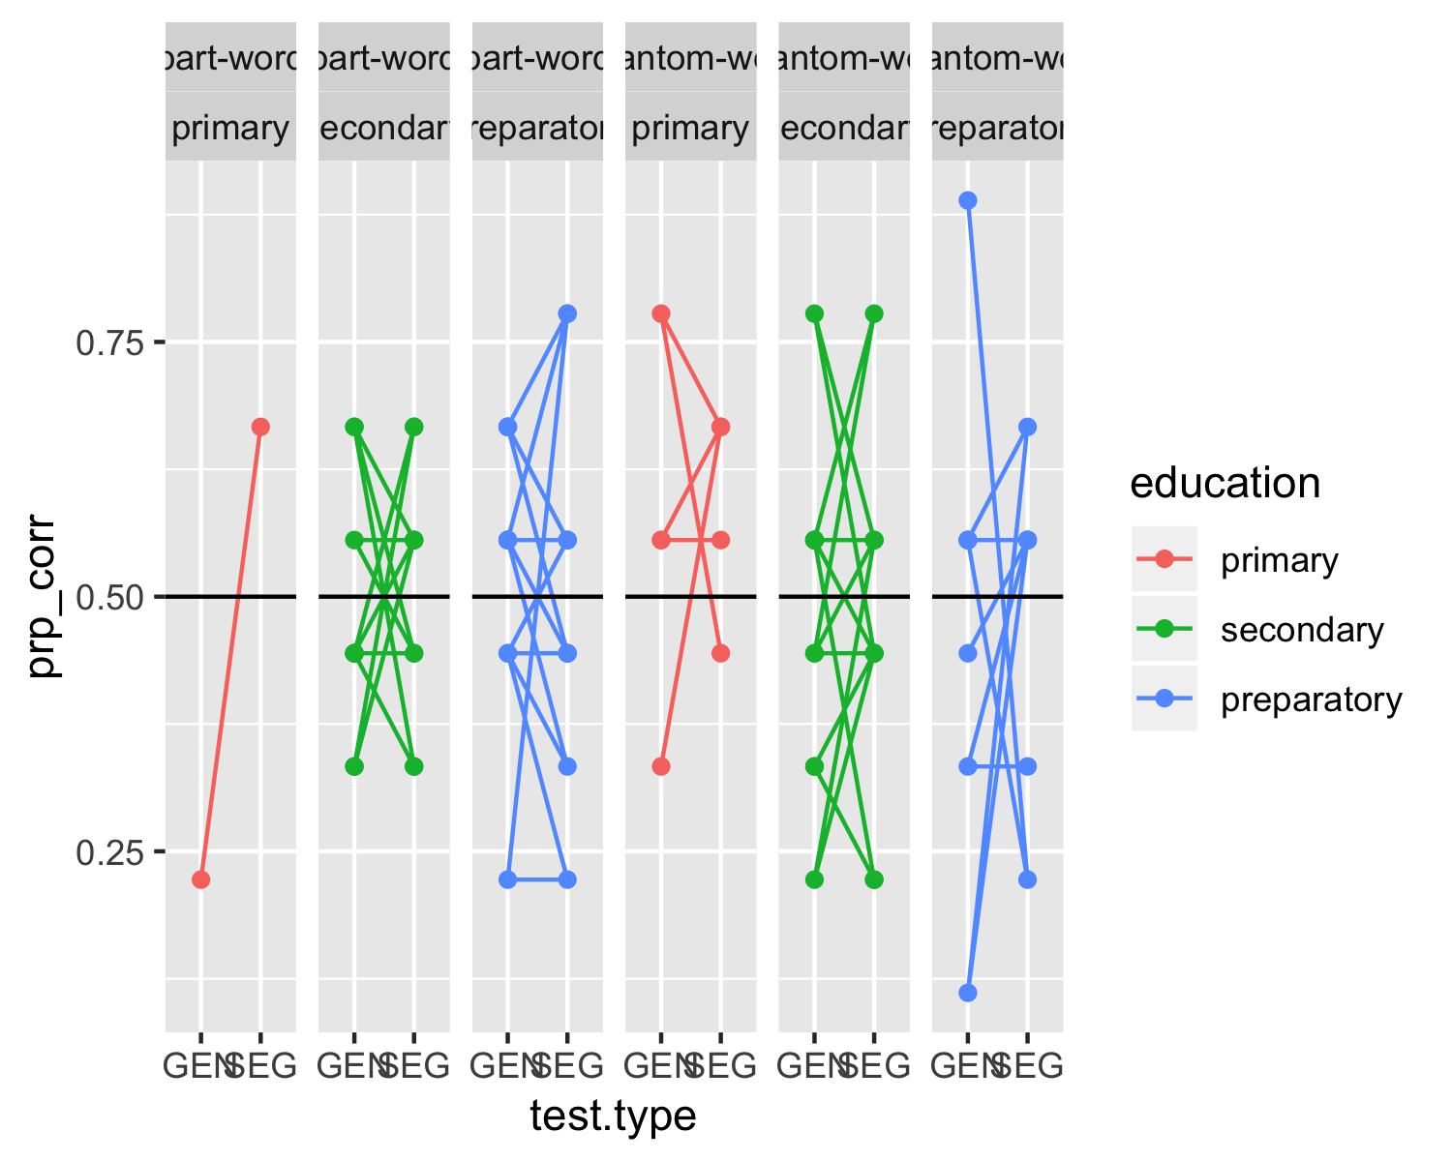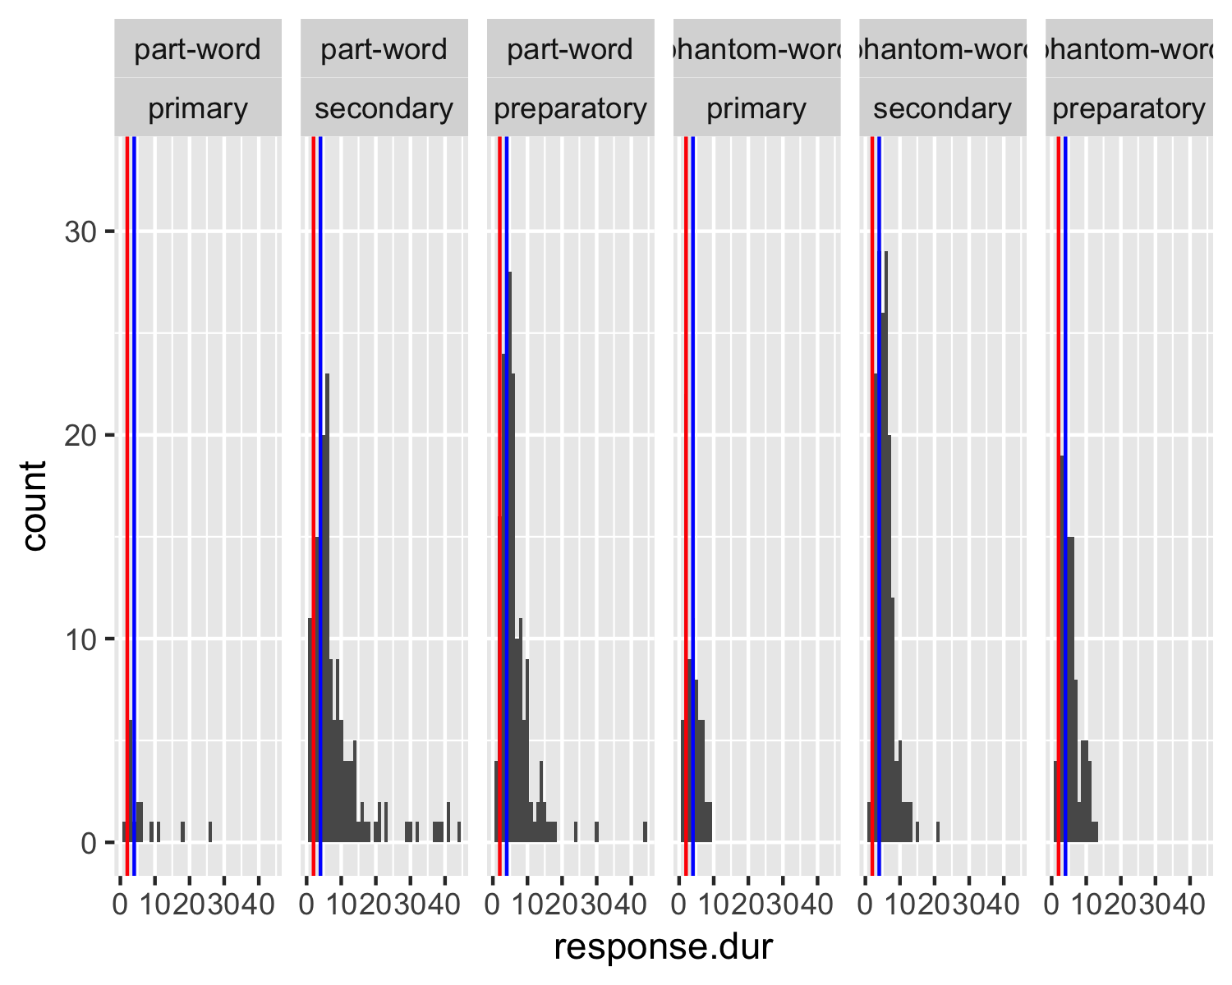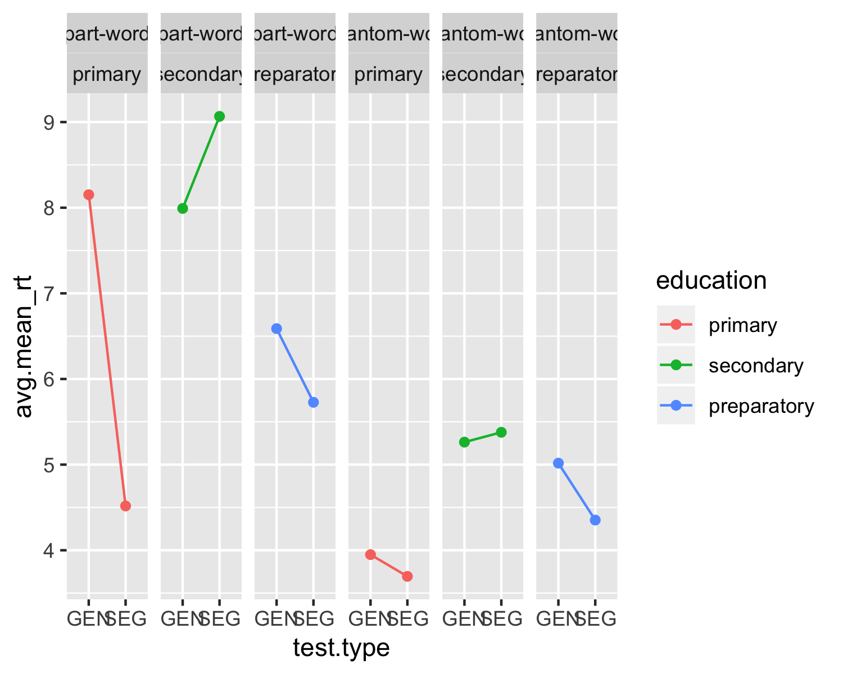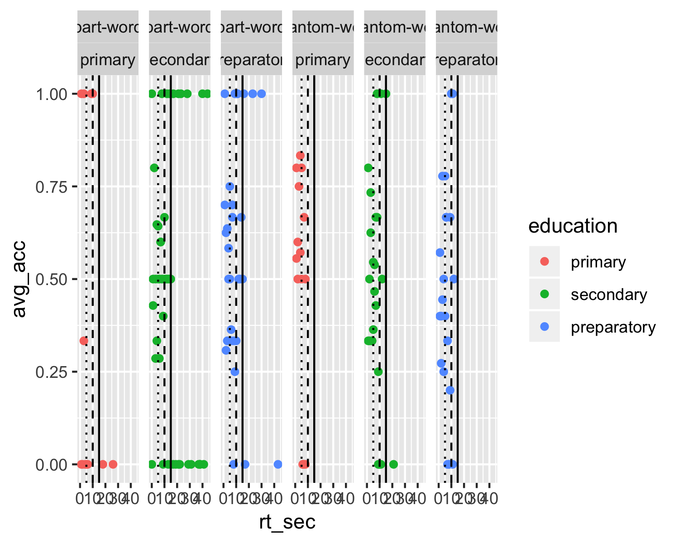

## [1] 0.8929539

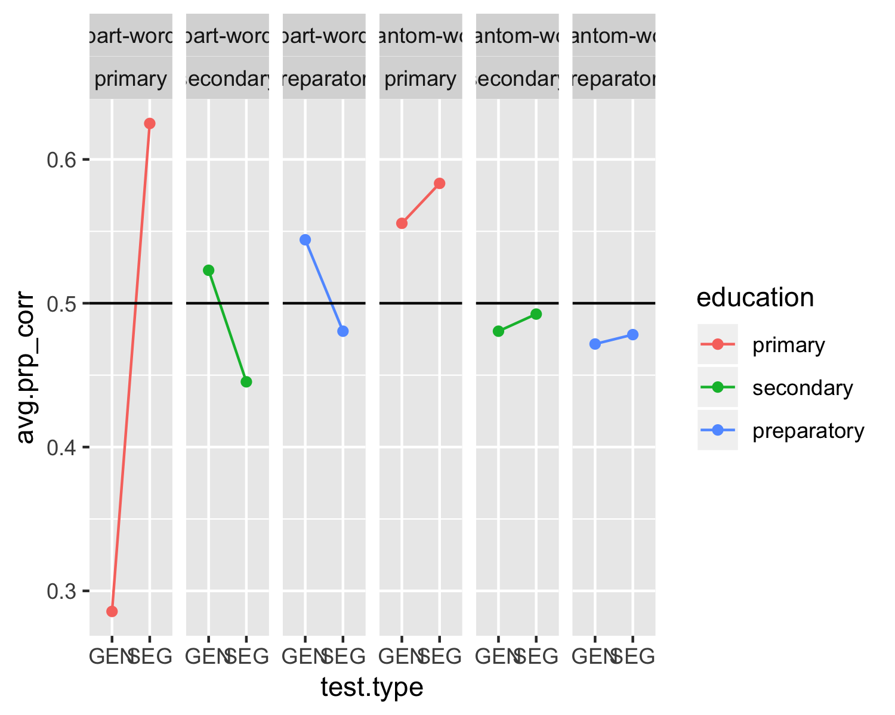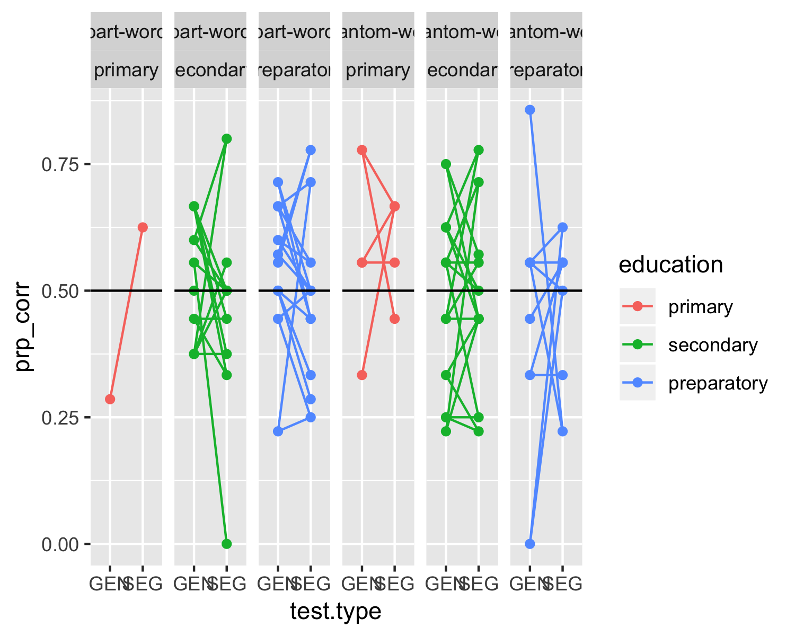

# Methods

We report how we determined our sample size, all data exclusions (if any), all manipulations, and all measures in the study.

## Participants

## Material

## Procedure

## Data analysis

We used R (Version 3.6.1; R Core Team, 2019) for all our analyses.

# Results

# Discussion

# References

## Warning in utils::citation(x[pkg], auto = if (no_citations[pkg]) TRUE else  
## NULL): no date field in DESCRIPTION file of package 'tidyr'

## Warning in utils::citation(x[pkg], auto = if (no_citations[pkg]) TRUE else  
## NULL): no date field in DESCRIPTION file of package 'tidyverse'

R Core Team. (2019). *R: A language and environment for statistical computing*. Vienna, Austria: R Foundation for Statistical Computing. Retrieved from <https://www.R-project.org/>